eFigure 1 Summary of two stage survey process
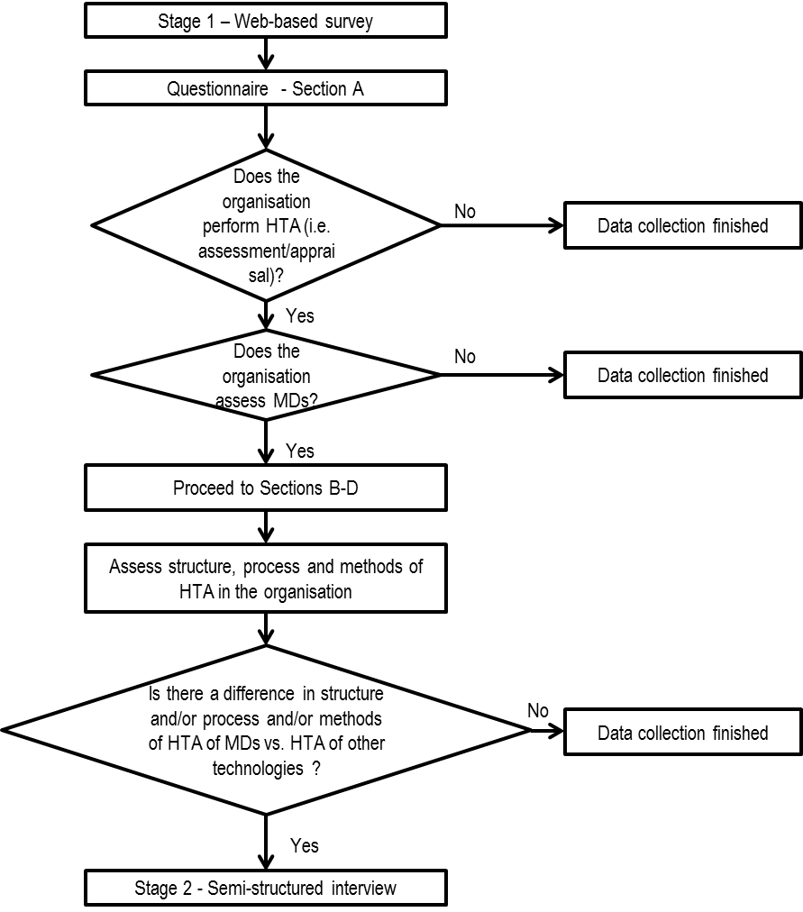

eFigure 2. Selection Sampling of non-EU HTA organisations
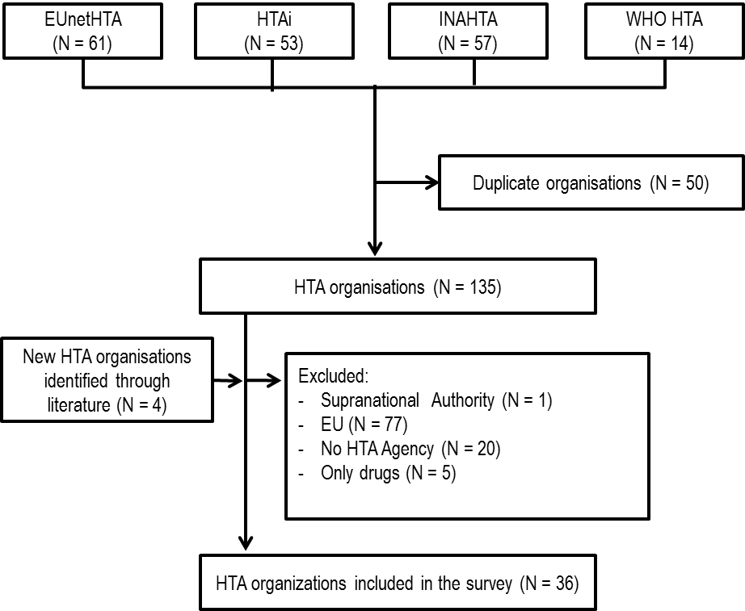

EUnetHTA = European network for health technology assessment; HTAi = Health Technology Assessment International; INAHTA = International Network of Agencies for Health Technology Assessment; WHO HTA = World Health Organization HTA Collaborating Centres.

eTable 1. Qualitative interview data analysis: summary of key points addressing the issues associated with HTA of medical devices
HTA  perspectives | Value | Key Point Summary | Categorisationª
Structure | Positive | Decision Making  - The framework in place has evolved to meet the needs of funding programmes. | Some
 | Negative | Capacity  - Insufficient resources (e.g., budget, economists, and pharmacists) create challenges for organisation to deliver according to its purpose. | Many
Process | Positive | Capacity  - Experts from external networks augment agencies’ capability to meticulously review applications. | Some
 |  | Coordination  - Integrating feedback from external parties (e.g., patients, clinicians) facilitates stakeholder buy-in and informs the contextualization of data. | Some
 |  | Decision Making  - Standard operating procedures (i.e., approval channels via subcommittees) support the translation of evidence into policy. | Some
 | Negative | Coordination  - Heterogeneity of devices makes the coordination of evidence assessment on different system levels difficult.  - Disconnect between the regulator and reimbursement body adversely impacts the timeframe of HTAs. | Many
Methods | Positive | Evidence  - Consistent application facilitates sound evidence synthesis and appropriately informs appraisal. | Some
 | Negative | Capacity  - Staff lacks skills to appropriately assess various types of data (e.g., RCT, qualitative). | Some
 |  | Transferability  - Cannot generalise findings due to variation of (local) social context. | Many
 |  | Evidence  - Poor quality evidence limits the ability to answer desired questions.  - Industry is unclear about the definition of [adequate] evidence. | Most
- “Some” corresponds to key points made by 10-30% of interviewees, “Many” corresponds to key points made by 31-65% of interviewees, and “Most” corresponds to key points made by 66-100% of interviewees

