Supplementary Tables
Supplementary Table 1. Baseline Characteristics of Patients in Studies of RVS-RFA vs. US-RFA
Author (Year) Country | Population | Criteria for Guidance | Treatment Guidance | Patients  # | Lesion # | Tumor size (Mean+SD, cm) | Follow-up (Mean+SD, Months) | Age  (Mean+SD) | Male,  # (%)
Comparative Cohort studies
Hirooka (2006); Japan | HCC, no metastasis; tumor size ≤3.5 cm; 72% and 90% with Class A, 33% and 22% with no prior treatment in RVS and US groups; | HCC difficult to identify by US but clearly detected by CT | RVS | 18 | 21 | 1.4+0.8 | NA | 69.3+8.1 | 14 (78)
 |  |  | US | 32& | 37 | 1.6+0.8 | NA | 68.6+5.3 | 26 (81)
Minami (2008); Japan | HCC, no metastasis; tumor size ≤3 cm; 84% and 90% with Class A, 11% and 13% with prior RFA, PEI or TAE in RVS and US groups | HCC difficult to identify by US but clearly detected by CT | RVS | 51 | 65 | 1.6+0.6 | 10.7+4.2 | 66.2+7.2 | 42 (82)
 |  |  | US | 50& | 63 | 1.7+0.6 | 10.8+6.6 | 66.0+7.0 | 42 (84)
Kitada (2008); Japan | Solitary HCC; tumor size ≤3.5 cm; 75% and 64% with Class A, 38% and 31% with prior TAE treatment in RVS and US group | HCC difficult to identify by US | RVS | 24 | 24 | 2.1+0.7 | >24 | 71.1+7.9 | 14 (58)
 |  | HCC clearly detectable by US | US | 39 | 39 | 2.0+0.5 | >24 | 69.0+7.5 | 26 (67)
Zhong  (2013);  China | HCC; tumor size ≤3 cm; tumor number ≤2 | No information about the selection criteria | RVS | 17 | NA | NA | 6 | NA | NA
 |  |  | US | 24 | NA | NA | 6 | NA | NA
Case series
Kawasoe (2007); Japan | HCC; tumor size ≤3 cm; tumor number ≤3; 86% with Class A | HCC not detected by US but detectable by CT | RVS | 21 | 25 | 2.4+1.6 | NA | 73 | 7  (33)
Minami (2007); Japan | HCC, metastasis; tumor size ≤3 cm; 70% with Class A, 70% with prior RFA or TAE treatment | HCC difficult to identify by US but clearly detected by CT | RVS | 12 | 19 | 1.5+0.6 | 7.8+2.1 | 66.8 | 9  (75)
Nakai (2009); Japan | Solitary HCC; tumor size ≤3.5 cm; 70% with Class A; 75% with prior TAE | HCC not detected by US but detectable by CT/MRI | RVS | 20 | 20 | 2.4+0.4 | 13.5 | 69.3 | 13 (65)
Liu  (2012); China | Solitary HCC; tumor size ≤4 cm; MW ablation; 94% with Class A; 28% with prior TAE | HCC not detected by US but detectable by CECT/MRI | RVS | 18 | 18 | 1.9+0.8 | 6* | 59.3+9.9 | 17 (94)
Lee (2012);  Korea | HCC, no metastasis; tumor size ≤4 cm; 97% with Class A; no prior treatment | HCC with poor ultrasound conspicuity | RVS | 30 | 30 | 1.0+0.3 | 8.1 | 58.8+8.8 | 29  (97)
NOTE. RFA, radiofrequency ablation; RVS, real-time virtual sonography; US, ultrasound; Class, Child-Pugh class; TAE, transarterial chemoembolization; PEI, percutaneous ethanol injection; CECT, contrast enhanced CT.
#: number of cases; &: retrospective study, history control group; *: median

Supplementary Table 2: Clinical outcomes reported by studies comparing RVS-RFA to US-RFA
Author (Year) | Treatment  (#) | Complete Ablation*,  % (p value) |  | Local Recurrence,  % (p value) |  | Mortality  # | Complication&  # | Treatment sessions,  Mean+SD (p value) |  | Note
Comparative Cohort studies
Hirooka (2006) | RVS (18) | NA |  | 0.0 | (p>0.05) | 0 | 0 | 1.2+0.4 | (p=0.003) | Historical control
 | US (32) | NA |  | 2.7 |  | 0 | 1 | 2.1+0.9
Minami (2008) | RVS (51) | 92 | (p=0.017) | 3.0 | (p=0.98) | 0 | 0 | 1.1+0.1 | (p=0.021) | Historical control
 | US (50) | 72 |  | 3.0 |  | 0 | 1 | 1.3+0.3
Kitada (2008) | RVS (24) | NA |  | 8.3 | (p>0.05) | 0 | 0 | NA |  | Patients in the US arm have HCC clearly detectable by US and thus were not directly comparable to those in the RVS arm, whose HCC were difficult to detect by US
 | US (39) | NA |  | 7.7 |  | 0 | 0 | NA
Zhong (2013) | RVS (17) | 94 | (p=0.014) | 5.9 | (p=0.028) | NA | 0 | NA |  | Publication only as a conference abstract and thus lacking details on patient characteristics and methodology
 | US (24) | 58 |  | 37.5 |  | NA | 6 | NA
Case series
Kawasoe (2007) | RVS (21) | 100 |  | NA |  | NA | NA | 1
Minami (2007) | RVS (12) | 90 |  | 0 |  | 0 | 0 | 1.1+0.3
Nakai (2009) | RVS (20) | 100 |  | 0 |  | 0 | 0 | 1
Liu (2012) | RVS (18) | 94 |  | 0 |  | 0 | 0 | NA
Lee (2012) | RVS (27) | 90$ |  | 0 |  | 0 | 0 | NA
NOTE. *, local tumor progression during the follow up period. &, major complication includes hemorrhage, infection, needle track seeding or hepatic failure.
$: the complete ablation rate is 90% in the intention to treat analysis, and 100% in the actual treatment analysis.

Supplementary Table 3. One-way sensitivity analysis: list of variables and respective threshold values influencing the cost-saving result of the model
Variable | Base case value | Threshold value
Probability of complete ablation in US-RFA | 0.72 | 0.80
Probability of complete ablation in RFA-RFA | 0.94 | 0.87
Annual probability of local recurrence in US-RFA | 0.19 | 0.09
Median survival for progressive HCC (years) | 1.73 | 0.4
Probability of additional ablation for recurrent HCC | 0.7 | 0.9
Needle cost | 12,500 (1,984) | 4,310 (684)
Navigation cost | 5,000 (794) | 6,290 (998)
Inpatient cost per RFA session | 15,000 (2,381) | 6,810 (1,081)
NOTE. Cost are shown as CNY (US$)

Supplementary Table 4. Two-way sensitivity analysis: Complete ablation rate VS Local Recurrence rate of RVS-RFA in difficult case.
 | Delta Cost (CNY) |  |  |  |  | Delta Effectiveness (QALY) |  |  |  |  | ICER (CNY/QALY)
CA  LR | 0.76 | 0.82 | 0.88 | 0.94 | 1 | 0.76 | 0.82 | 0.88 | 0.94 | 1 | 0.76 | 0.82 | 0.88 | 0.94 | 1
0 | 3,444 | 1,073 | -1,207 | -3,399 | -5,508 | 1.2 | 1.4 | 1.5 | 1.6 | 1.7 | 2,786 | 788 | - | - | -
0.02 | 4,295 | 1,954 | -299 | -2,467 | -4,554 | 1.1 | 1.2 | 1.3 | 1.4 | 1.5 | 4,001 | 1,637 | - | - | -
0.04 | 5,080 | 2,767 | 538 | -1,608 | -3,677 | 0.9 | 1.0 | 1.1 | 1.2 | 1.3 | 5,509 | 2,667 | 471 | - | -
0.06 | 5,809 | 3,521 | 1,315 | -812 | -2,863 | 0.8 | 0.9 | 1.0 | 1.1 | 1.2 | 7,439 | 3,949 | 1,323 | - | -
0.08 | 6,491 | 4,226 | 2,041 | -68 | -2,104 | 0.6 | 0.8 | 0.9 | 0.9 | 1.0 | 9,999 | 5,594 | 2,390 | - | -
0.10 | 7,130 | 4,889 | 2,722 | 630 | -1,391 | 0.5 | 0.6 | 0.7 | 0.8 | 0.9 | 13,559 | 7,787 | 3,768 | 777 | -
0.12 | 7,734 | 5,513 | 3,365 | 1,289 | -719 | 0.4 | 0.5 | 0.6 | 0.7 | 0.8 | 18,845 | 10,855 | 5,619 | 1,885 | -
LR: local recurrence rate; CA: complete ablation rate of RFA.
Delta cost: positive values indicate additional costs, and negative values indicate cost savings. Smaller ICER, more cost-effective.

Supplementary Figures
0
169 records identified from electronic database search
PubMed=48, EMBASE=51, Science Citation Index=70
No additional record from other source
98 records after duplicates removed
98 titles and abstracts screened
22 articles evaluated in full-text
4 comparative studies and 5 case series included
76 records excluded
13 full-text articles excluded with reasons: wrong intervention, incomplete data, small sample size
Supplementary Figure 1. Studies identified and retrieved through database

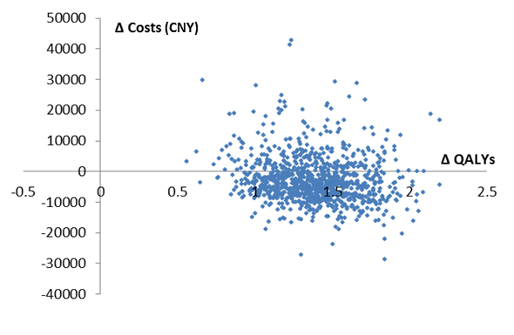
Supplementary Figure 2. Cost-effectiveness plane (RVS-RFA V.S. US-RFA)

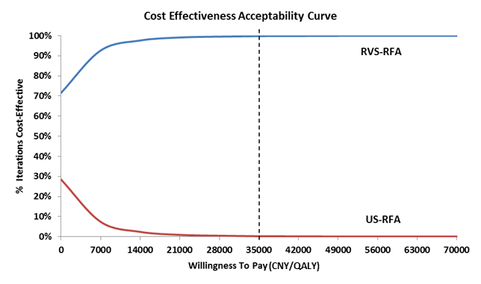
Supplementary Figure 3. Probability of alternative being cost-effective

