**Supplemental File**

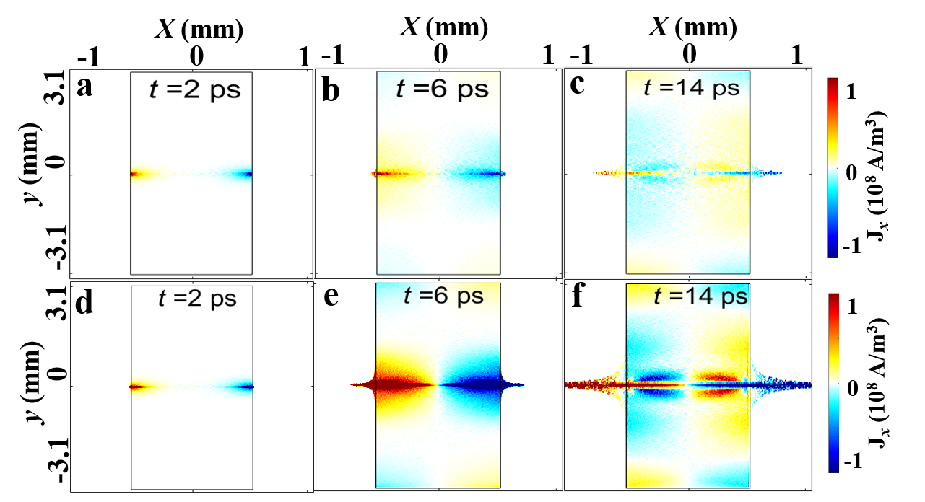

**Fig. s1.** **(****supplemental file) Distribution of the longitudinal current density in the *xoy* plane at time *t* = 2 ps in (a), (d), *t* = 6 ps in (b), (e), and *t* = 14 ps in (c), (f). The black rectangular box denotes the outline of the plasma in the *xoy* plane. In the first row (a-c), the** **initial temperature of the plasma is *T* = 0 keV at time *t* = 0 ps. In the second row (d-f), the initial temperature of the plasma is *T* = 1 keV at time *t* = 0 ps.**

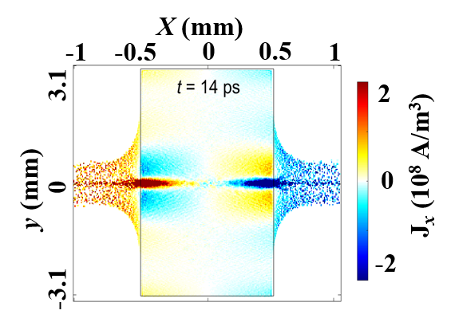

**Fig****. s2****. (supplemental file) Distribution of the longitudinal current density in the *xoy* plane without the applied magnetostatic field at time *t* = 14 ps. The black rectangular box denotes the outline of the plasma in the *xoy* plane.**

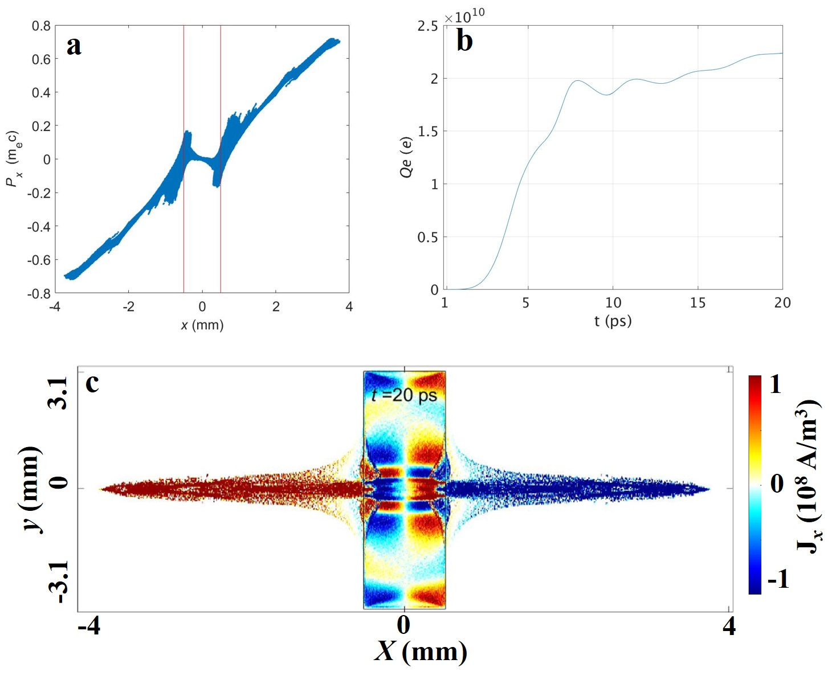

**Fig. s3. (supplemental file) The applied electrostatic field is set as****with a 2 ps delay of the applied magnetostatic field. (a) Distribution of the longitudinal electron momentum** *Px* **normalized to  within** ** (around the *x*-axis) at time *t* = 20 p, the red lines  denote the end points of the plasma in the *x* direction. (b) The total charge of the ejected electrons whose energy is above 10 keV. (c) Distribution of the longitudinal current density *Jx* at*****t* = 20 ps, where the black rectangular box denotes the outline of the plasma in the *xoy* plane.**