Supplementary material
Response of fusion plasma materials to nanosecond pulses of extreme ultraviolet radiation
Jaroslav Straus ª, Karel Kolacek ^{a, *}, Jiri Schmidt ª, Oleksandr Frolov ª, Monika Vilemova ª, Jiri Matejicek ª, Ales Jager ^{b}, Libor Juha ^{b}, Martina Toufarova ^{b}, Andrey Choukourov ^{c}, Koichi Kasuya ^{d}
ª Institute of Plasma Physics of the Czech Academy of Sciences, Za Slovankou 1782/3, 182 00 Prague 8, Czech Republic
^{b} Institute of Physics of the Czech Academy of Sciences, Na Slovance 1999/2, 182 21 Prague 8, Czech Republic
^{c} Faculty of Mathematics and Physics, Charles University in Prague, Ke Karlovu 3, 121 16 Prague 2, Czech Republic
^{d} Institute of Applied Flow, 3-24-4 Utsukushigaoka-Nishi, Aoba, Yokohama, Kanagawa 225-0001 Japan
1. Simulation of pulsed laser heating
Following Xu et al. [1] a short laser pulse is considered (approximated by delta function δ(t) ) incident normally (along –z) on the interface (z = 0) of an absorbing medium in contact with a transparent substance at t = 0. The laser pulse is characterized by pulse energy Q and Gaussian profile Exp[-(x²+y²)/w²]. Instantaneous energy deposition causes a local heating of the absorbing medium. The deposited local energy density has form
(S.1)
where F_{refl} is reflected and scattered energy fraction that does not contribute to heating, F_{desorp} is energy fraction deposited into desorption region, which remains outside of this computation model, and l_{at} is attenuation length. Variation of temperature distribution T(x, y, z, t) in the absorbing medium upon laser pulse heating and ensuing heat dissipation is governed by the heat diffusion equation
(S.2)
with α = k / (c_{p} ρ_{m}), where c_{p}, ρ_{m}, and k are by turns the heat capacity, the mass density, and the thermal conductivity. Defining the dimensionless variables Z = z/w, R = (x²+y²)^{1/2}/w, W = w/l_{at}, τ = t/t₀ with t₀ = πw²/α denoting the heat diffusion time, the equation (2) changes to
. (S.3)
The initial condition everywhere is T(R, Z, τ = 0) = T_{R}, where T_{R} is the room temperature (T_{R} = 293 K). The boundary conditions are
T(Z=0) = T_{c}(Z=0) (S.4)
T(R→∞) = T_{R}, T_{c}(R→∞) = T_{R}
T(|Z|→∞) = T_{R}, T_{c}(|Z|→∞) = T_{R}
where subscript c refers to transparent medium that is in contact with the absorbing medium. Analytical solution of equation (S.3) with above given initial condition and with boundary conditions (S.4) (with the help of Laplace transformation) is in detail described in Supplementary material to [1] and yields
(S.5)
where
(S.6)
Since our transparent medium is vacuum, its thermal conductivity k_{c} = 0, and the second term in square brackets in equation (S.5) is zero:
(S.7)
Such solution, after substitution of (a) appropriate attenuation length for given radiation and absorbing material l_{at} and (b) material constants of absorbing material, can be easily displayed.
2. Attenuation length l_{at}
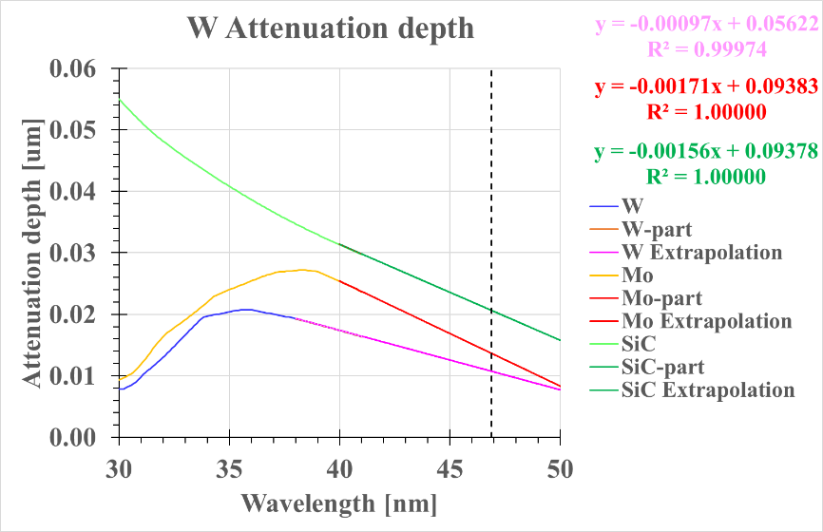
Since attenuation length is given in [2] up to 41 nm only, we took data from 30 nm to 41 nm and linearly extrapolated graphs according to their derivatives in last few nanometers (see Fig. S.1).
Figure S1 Attenuation lengths l_{at} as a function of wavelength from 30 nm to 41 nm according to [2] and their linear extrapolations to laser wavelength 46.88 nm (dashed vertical line).
From these extrapolations we received for individual materials and laser wavelength 46.88 nm the following attenuation lengths:
Table S.1 Attenuation lengths
Material W Mo SiC
Attenuation length l_{at} [μm] 0.010746 0.013665 0.020647
3. Material constants
Material constants for W, and Mo are taken from Wikipedia [3, 4, 5], material constants for SiC are taken from [6, 7]. They are summarized in the Table S.2
Table S.2 Material constants
Material W Mo SiC
Standard atomic/molecular weight saw 183.84 95.95 [7] 40.1
Mass density at room temperature ρ_{m rt} [kg m⁻³] 19250 10280 [7] 3160
Mass density at melting point ρ_{m rt} [kg m⁻³] 17600 9330
Mass density mean ρ_{m} [kg m⁻³] 18425 9805 3160
Heat capacity at room temperature c_{p rt} [J kg⁻¹ K⁻¹] [4] 134 250.756 690
Heat capacity at 2000 ºC c_{p 2000} [J kg⁻¹ K⁻¹] [4] 172
Heat capacity mean c_{p} [J kg⁻¹ K⁻¹] 153 250.756 690
Thermal conductivity k [W m⁻¹ K⁻¹] 173 138 490
Melting point T_{mp} [K] 3695 2896 3103
If more values for some quantity are available (namely values valid for different temperatures, as it is for mass density, or heat capacity), then the mean values are used.
4. Temperature field development
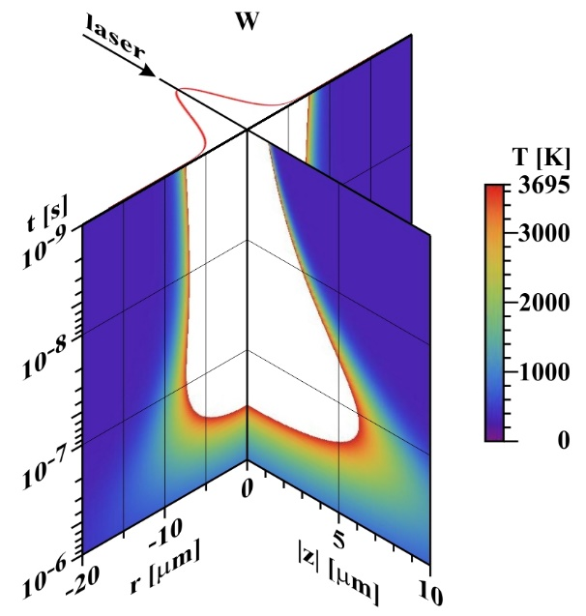
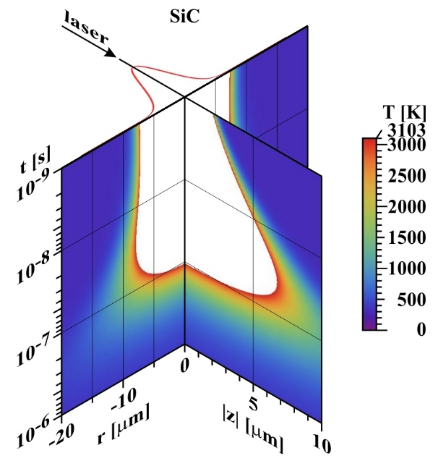
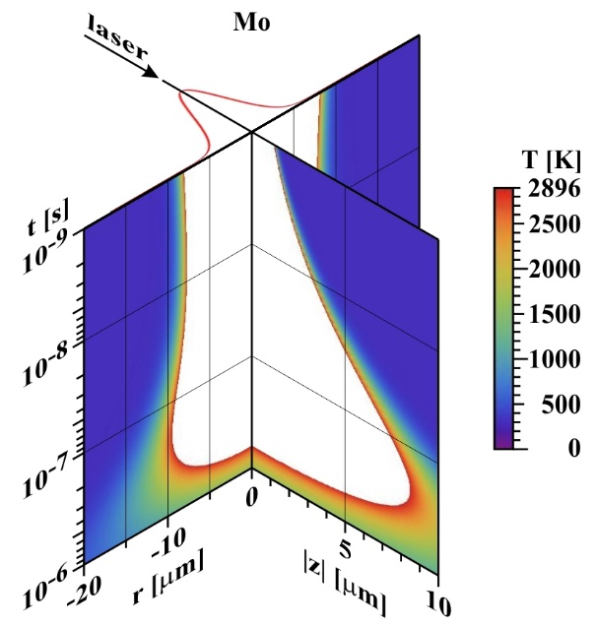
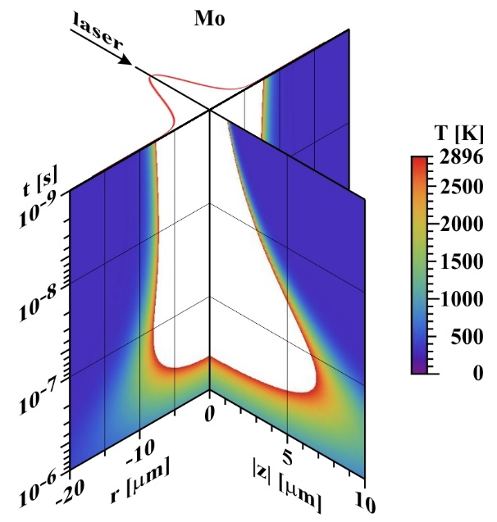
Substituting values from Table S.1 and S.2 into (S.7), we get for individual materials the following time-resolved temperature maps:
Figure S.2 Time development of radial and depth profiles of temperature field. In the plain t = 10⁻⁹ s the incident laser beam is shown together with its Gaussian profile deduced from top part of Fig. 18 (FWHM = 5.43 μm) and used for calculation. The fraction of reflected and scattered energy is taken to be 0.1, the fraction of energy deposited into desorption area is also taken to be 0.1. Top left: W (Q = 23 μJ). Top right: SiC (Q = 21 μJ). Bottom left: Mo (Q = 23 μJ – to have comparison with W, and SiC at the same energy level). Bottom right: Mo (Q = 40 μJ – to have idea, how the time development of temperature field might look like at the energy level used for Mo). The depth (z) scale is twice enlarged r-scale. The white colour in the graphs means that the melting point is surpassed.
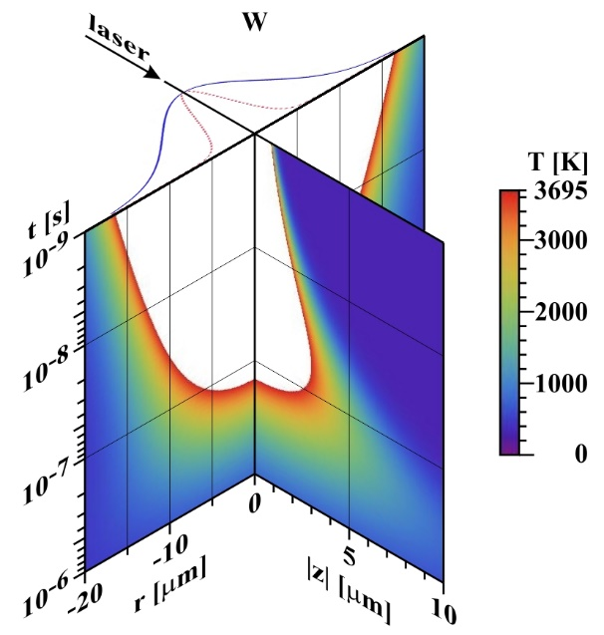
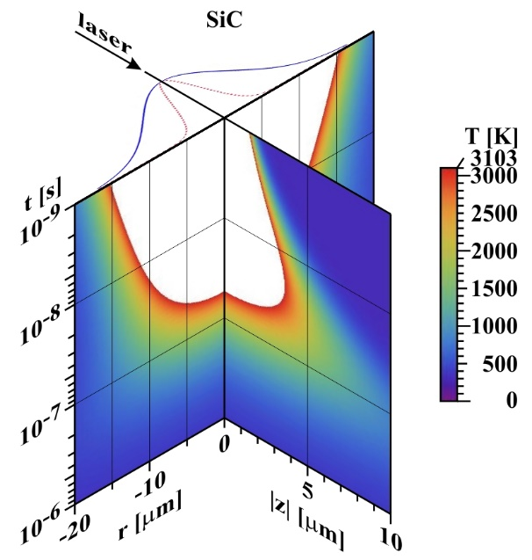
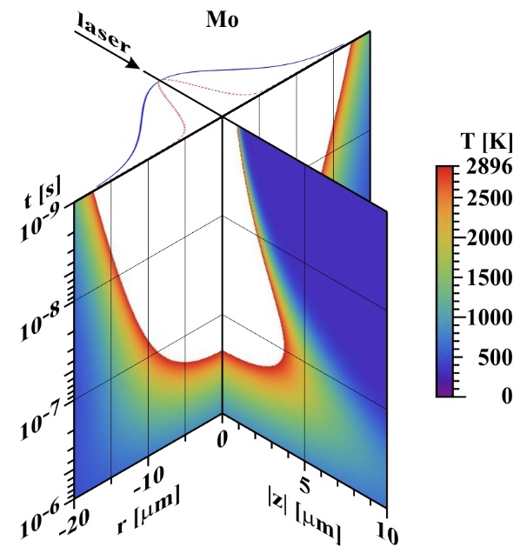
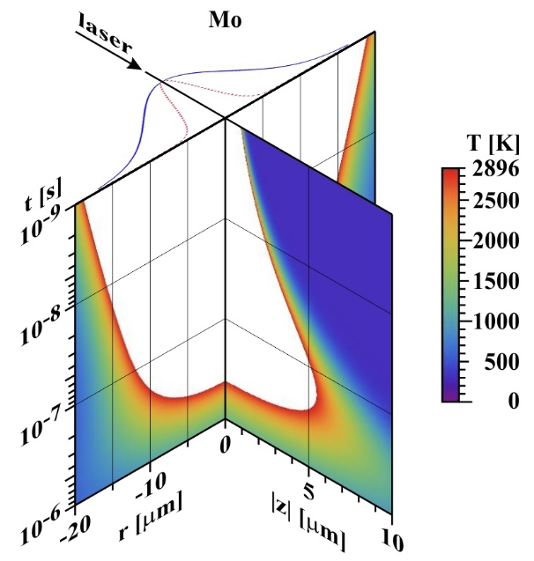
Comparing the above shown time development of temperature maps it is visible that molybdenum due to its lowest melting point and lowest thermal conductivity remains melted the longest time (approaching 1 μs). Contrary silicon carbide due to its remarkably highest thermal conductivity stops to sublimate after ~100 ns. On the other hand, the melted radius and depth is for all three investigated materials at comparable conditions practically the same. How the situation changes, when the deposition radius is tripled (FWHM ~ 16.3 μm), is visible in the Figure S.3.
Figure S.3 The same conditions as in Fig. S.2, with the only one difference: the diameter of the deposition region is tripled (FWHM ~ 16.3 μm) – see the blue curve in the plane t = 10⁻⁹ s showing the actual laser beam profile; the red dotted curve shows the previous laser beam profile (FWHM ~ 5.4 μm).
It is apparent that in the previous case with higher fluency in the centre the radius of melted region a little bit enlarges with time, or remains the same, while in the later case with smaller fluency in the centre the radius of melted region immediately starts to reduce. The depth of the melted/sublimated region enlarges with time (due to higher temperature gradient than in radial direction), but less than in the previous case.
References
[1] Y. Xu, R. Wang, Sh. Ma, L. Zhou, Y. R. Shen, and Ch. Tian, Theoretical analysis and simulation of pulsed laser heating at interface. J. Appl. Phys. 123 (2018), 025301.
[2] B. L. Henke, E. M. Gullikson, and J. C. Davis, X-ray interactions: photoabsorption, scattering, transmission, and reflection at E=50-30000 eV, Z=1-92. Atomic Data and Nuclear Data Tables 54, (no.2), 181-342. http://henke.lbl.gov/optical_constants/
[3] https://en.wikipedia.org/wiki/Tungsten
[4] https://cs.wikipedia.org/wiki/Wolfram
[5] https://en.wikipedia.org/wiki/Molybdenum
[6] http://www.ioffe.ru/SVA/NSM/Semicond/SiC/thermal.html
[7] https://en.wikipedia.org/wiki/Silicon_carbide

