*Supplementary figures* (*Figure* I, II *and* III)

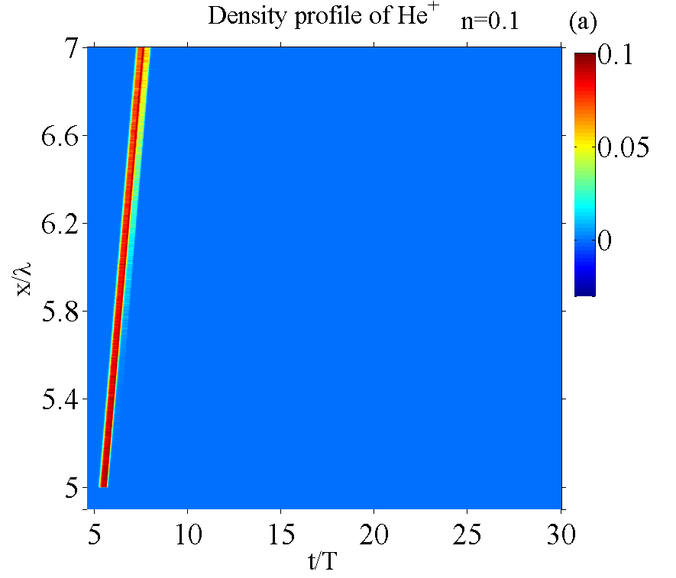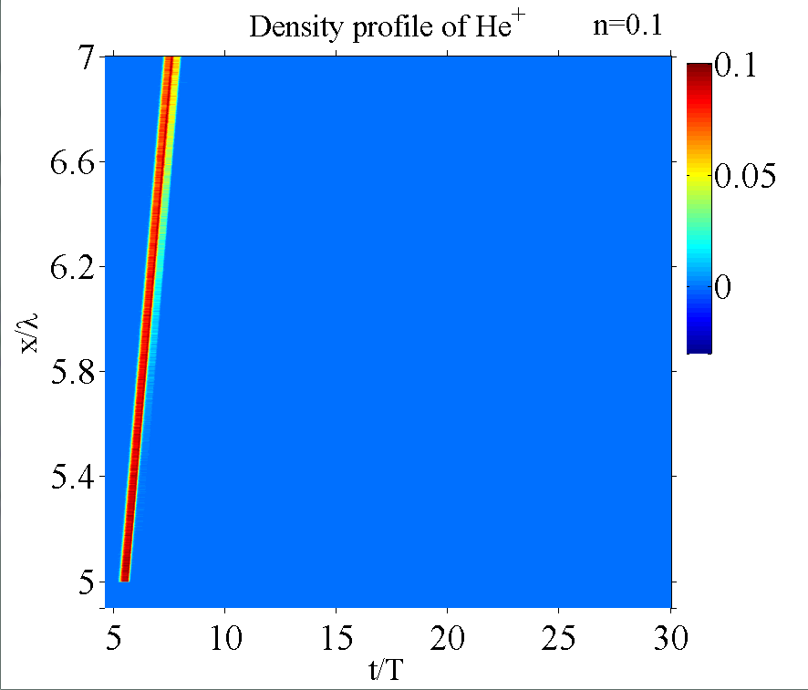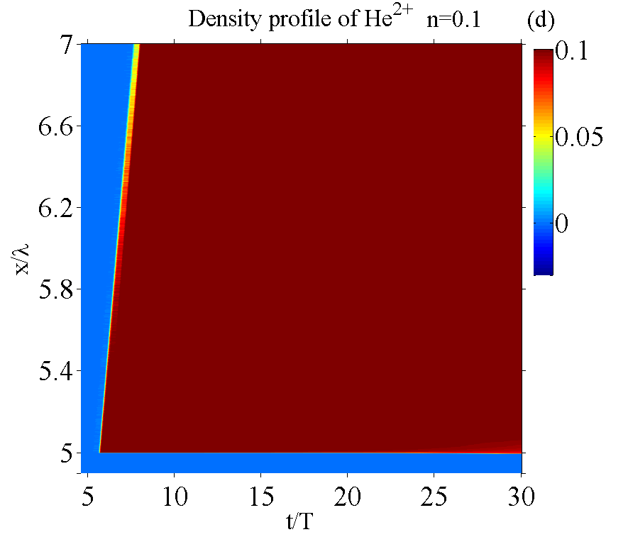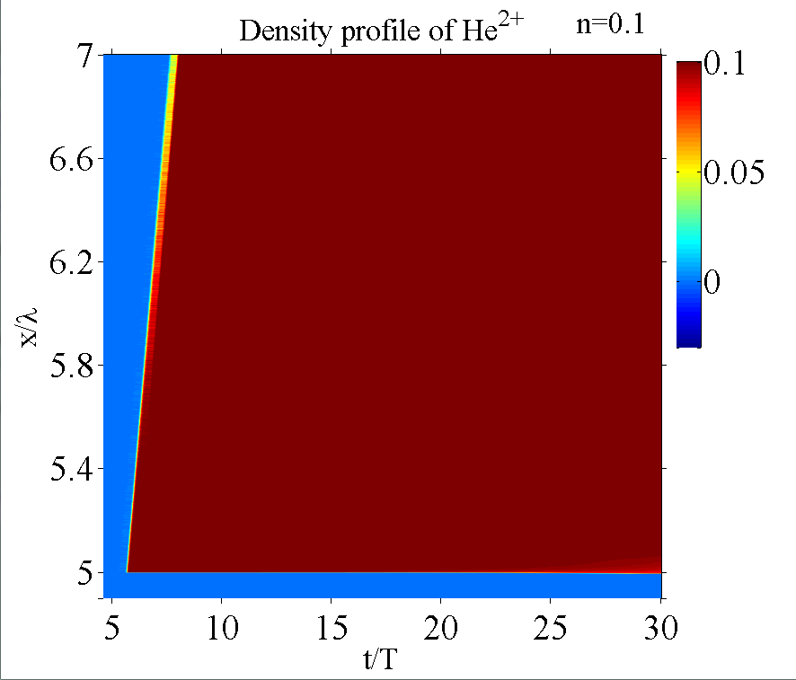

Figure I. The spatio-temporal evolutions of (top) and(bottom) for n=0.1. The left two plots are for field ionization; the right two plots are for both collisional ionization and field ionization.

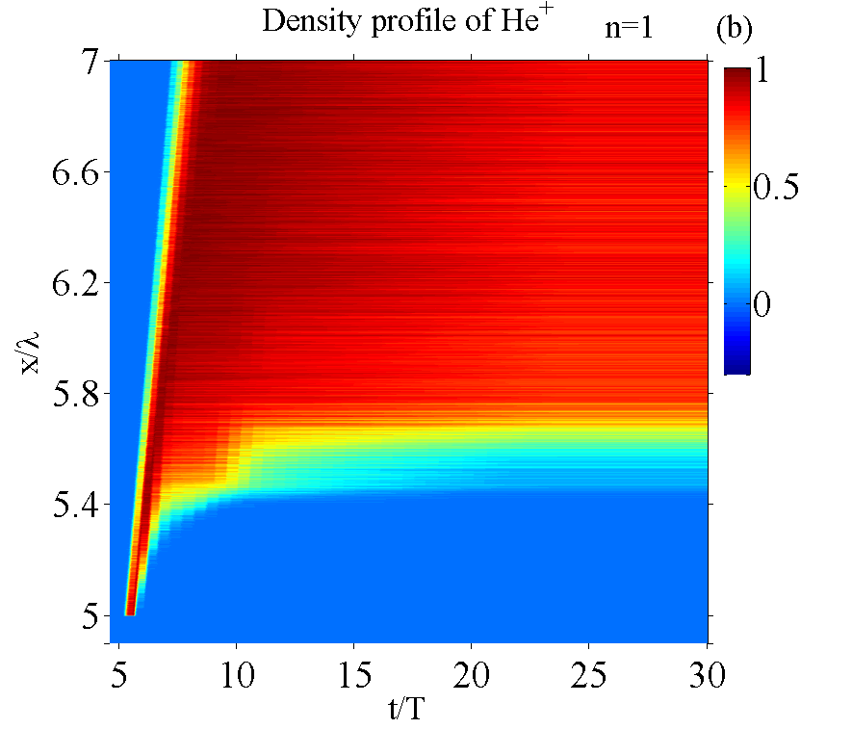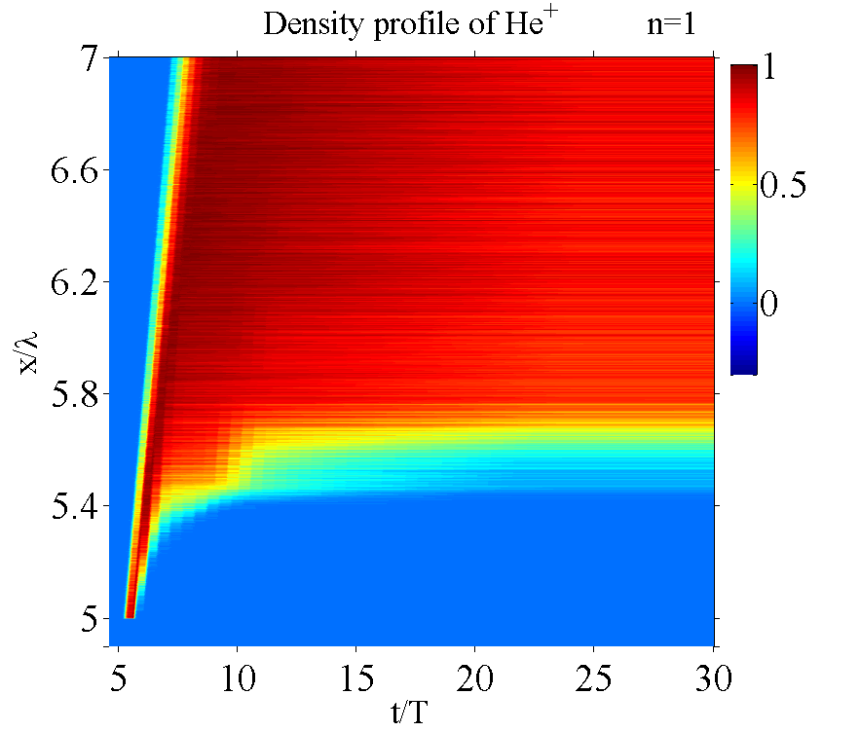

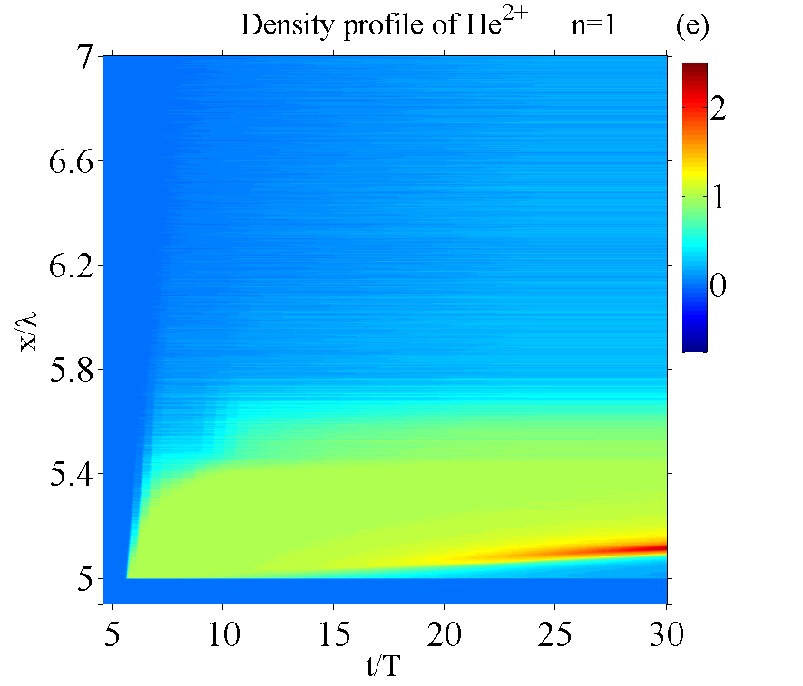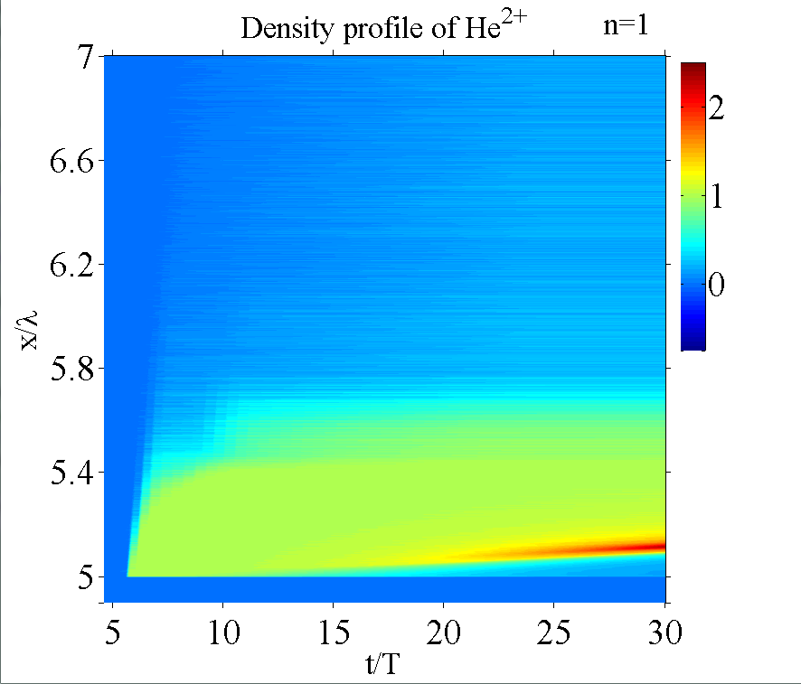

Figure II. The spatio-temporal evolutions of (top) and(bottom) for n=1, the left two plots are for field ionization; the right two plots are for both collisional ionization and field ionization.

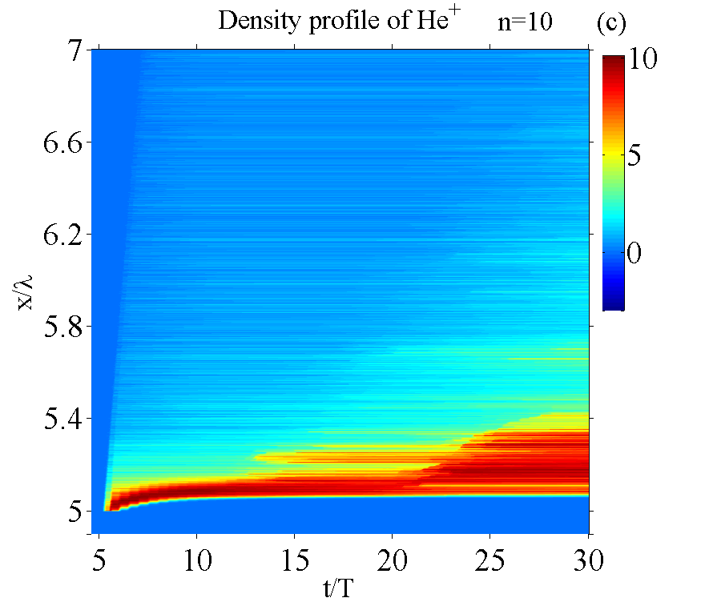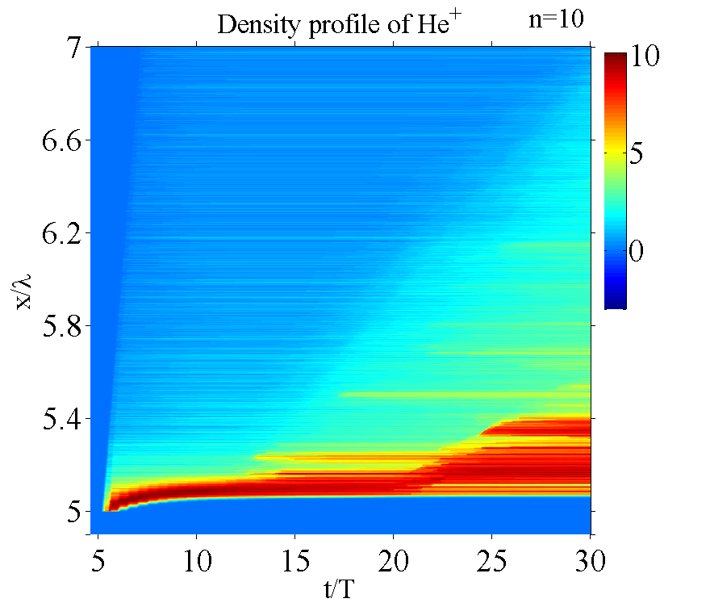

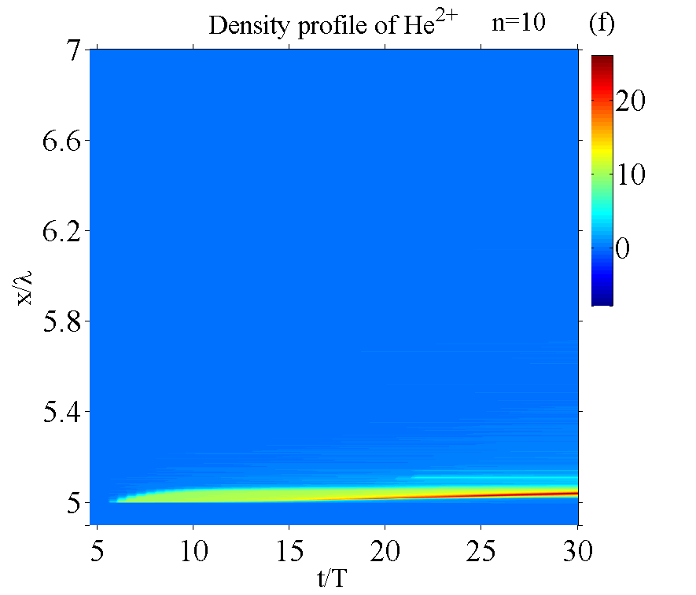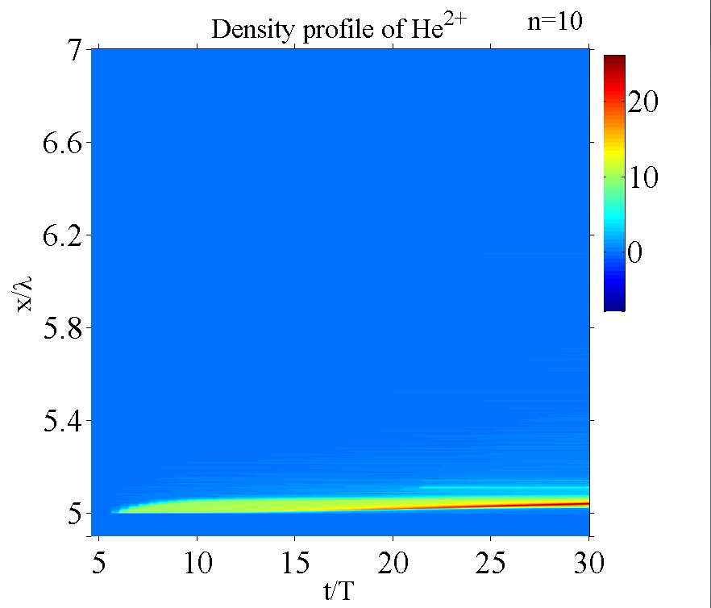

Figure III. The spatio-temporal evolutions of (top) and(bottom) for n=10, the left two plots are for field ionization; the right two plots are for both collisional ionization and field ionization.