LIDT measurement system
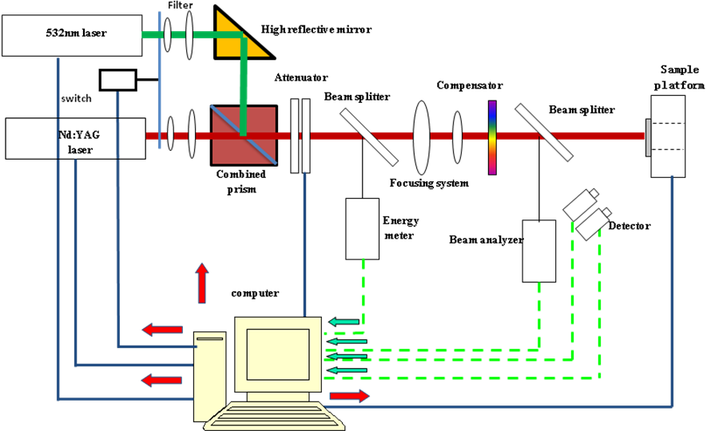

The laser-induced damage threshold (LIDT) testing system was established following ISO11254-1 standards using the setup shown in. The testing system shown in Fig. 3 was operated using a 1-on-1 zero rate of damage.

