Figure 1
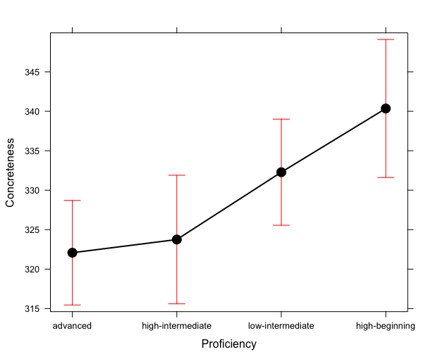Figure 1: Word concreteness use based on proficiency levels. High beginning speakers produced significantly more concrete words when compared to the high intermediate and advanced speakers.

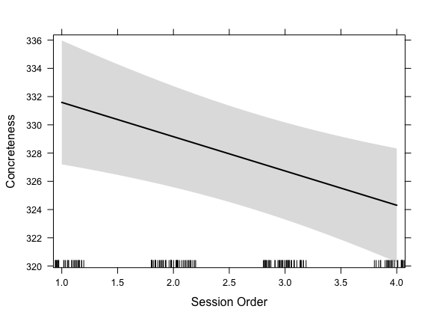
Figure 2: Effect of time on average word concreteness. Average word concreteness decreased significantly as participants completed more conversation sessions.

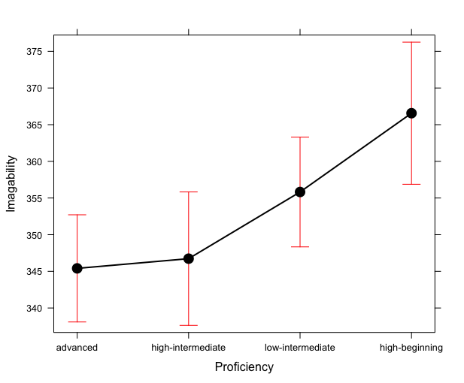
Figure 3: Word imageability use based on proficiency levels. High beginning speakers produced significantly more imageable words when compared to the high intermediate and advanced speakers.

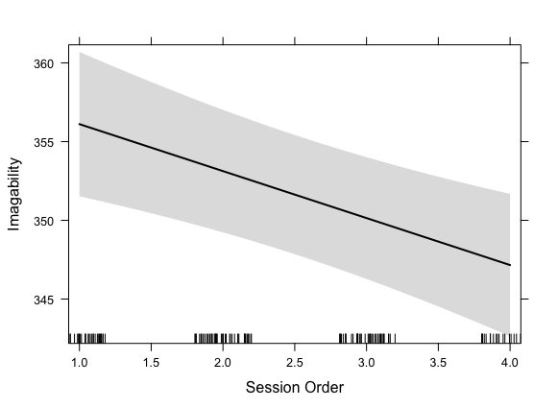Figure 4: Effect of time on average word imageability. Average word imageability decreased significantly as participants completed more conversation sessions.

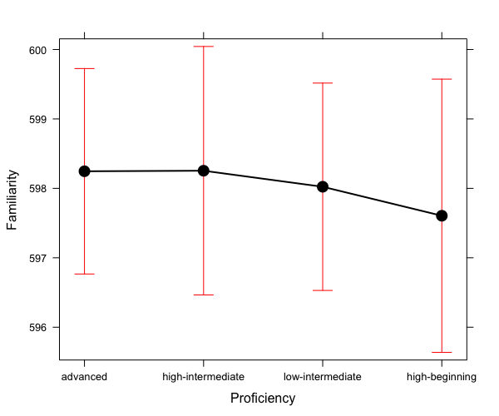Figure 5: Word familiarity use based on proficiency levels. There were no significant differences in average word familiarity production among the different proficiency levels.

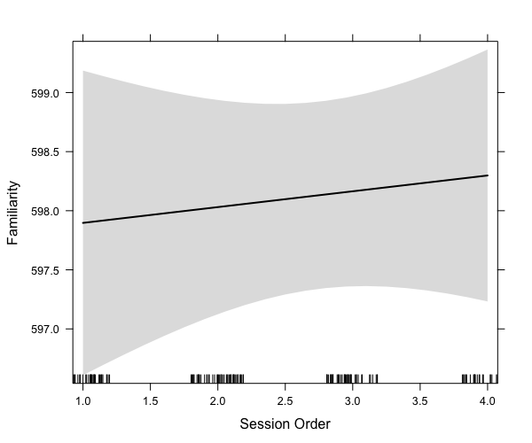
Figure 6: Effect of time on average word familiarity. Average word familiarity did not change significantly as participants completed more conversation sessions.

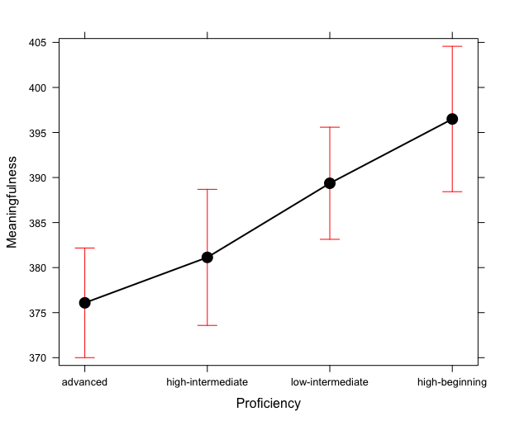Figure 7: Word meaningfulness use based on proficiency levels. Advanced speakers had significantly lower word meaningfulness when compared to high beginner and low intermediate speakers, and high intermediate speakers had significantly lower amounts of word meaningfulness when compared to high beginner speakers.

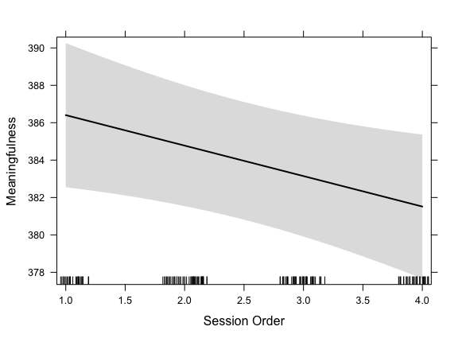Figure 8: Effect of time on average word meaningfulness. Average word meaningfulness decreased significantly as participants completed more conversation sessions.

