Table A1: Mass balance measured at the ablation stakes, m w.e. (ρ = 850 kg m⁻³), network 2013–2020
Stake ID | 2019/20 | 2018/19 | 2017/18 | 2016/17 | 2015/16 | 2014/15 | 2013/14
2 | -3.05 | -2.11 | -2.39 | -2.94 | -2.69 | -1.45 | -1.05
3 | -2.62 | -1.65 | -2.24 | — | -2.28 | -1.37 | -0.98
6 | -2.18 | -1.07 | -1.91 | -1.64 | -2.45 | -0.85 | -0.71
7 | -1.80 | -0.35 | -0.96 | -1.24 | -1.06 | -0.76 | -0.23
8 | -1.95 | -0.81 | -1.72 | -1.99 | -1.24 | -0.30 | -0.55
9 | -1.94 | -0.84 | -1.57 | -1.54 | -1.80 | -1.08 | -0.70
10 | -2.08 | -1.38 | -1.65 | -1.84 | -1.94 | -1.81 | -0.88
11 | — | — | — | — | — | -1.19 | -1.21
12 | -1.45 | -0.87 | -0.96 | -1.22 | -3.16 | — | -0.34
13 | -1.63 | -0.71 | -1.16 | -1.21 | -1.12 | -0.95 | -0.43
14 | -2.44 | -1.23 | -1.73 | -1.94 | -1.17 | -1.10 | -0.93
15 | -3.09 | -2.10 | -2.50 | -2.74 | -1.87 | -1.15 | -1.05
16 | — | — | — | — | — | — | -1.03
17 | — | — | — | — | — | — | -0.50
18 | -2.15 | -1.03 | -1.51 | — | -2.96 | -2.08 | -0.69
20 | -2.49 | -1.69 | -2.14 | -2.39 | -2.05 | -1.08 | -0.38
21 | -1.46 | -0.91 | -1.14 | -1.13 | -1.22 | -0.80 | -0.73

Table A2: Coordinates of the ablation stakes (WGS84/UTM zone 33N), network 2013–2020
Stake ID | Northing, m | Easting, m | Elevation above  sea level, m
2 | 8656167 | 478699 | 209
3 | 8655856 | 478806 | 207
6 | 8655112 | 478922 | 241
7 | 8654379 | 478063 | 342
8 | 8654791 | 477810 | 306
9 | 8655389 | 477573 | 285
10 | 8655894 | 477281 | 292
11 | — | — | 124
12 | 8654346 | 476808 | 442
13 | 8654451 | 476960 | 408
14 | 8655914 | 478163 | 245
15 | 8656101 | 479048 | 173
16 | — | — | 88
17 | — | — | 336
18 | 8655244 | 478255 | 269
20 | 8655428 | 479645 | 182
21 | 8654448 | 477218 | 377

Table A3: Mass balance measured at the ablation stakes, m w.e. (ρ = 850 kg m⁻³), network 2007–2010
Stake ID | 2009/10 | 2008/09 | 2007/08
1 | -0.41 | -0.76 | -0.53
2 | -0.39 | -0.82 | -0.41
2a | — | — | -0.48
3 | -0.28 | -0.69 | -0.54
4 | -0.41 | -0.61 | -0.45
5 | -0.37 | -0.77 | -0.48
6 | -0.37 | -0.53 | -0.39
7 | -0.25 | -0.51 | -0.37
8 | -0.24 | -0.53 | -0.36
8a | — | — | -0.25
9 | — | — | -0.40
10 | — | -0.66 | -0.35
10s | — | — | -0.37
11 | -0.08 | -0.56 | -0.27
12 | -0.16 | -0.35 | -0.22
13 | — | — | -0.09
14 | — | — | -0.22
15 | -0.24 | -0.65 | -0.25
16 | -0.23 | -0.36 | -0.35
17 | -0.19 | -0.66 | -0.25
18 | -0.42 | -0.55 | -0.22
Table A4: Coordinates of the ablation stakes (WGS84/UTM zone 33N), network 2007–2010
Stake ID | Easting, m | Northing, m | Elevation above  sea level, m
1 | 479282 | 8656284 | 175
2 (2a) | 478920 | 8656022 | 212
3 | 478681 | 8655791 | 241
4 | 478589 | 8656105 | 242
5 | 478487 | 8656453 | 243
6 | 478090 | 8655867 | 266
7 | 477574 | 8656066 | 303
8 (8a) | 477255 | 8655870 | 308
9 | 477537 | 8655675 | 298
10 (10s) | 477483 | 8655174 | 303
11 | 477265 | 8654564 | 374
12 | 477703 | 8654702 | 322
13 | 477911 | 8654151 | 371
14 | 478290 | 8654581 | 328
15 | 478141 | 8655152 | 289
16 | 478755 | 8655009 | 272
17 | 478965 | 8655195 | 251
18 | 479688 | 8655474 | 195

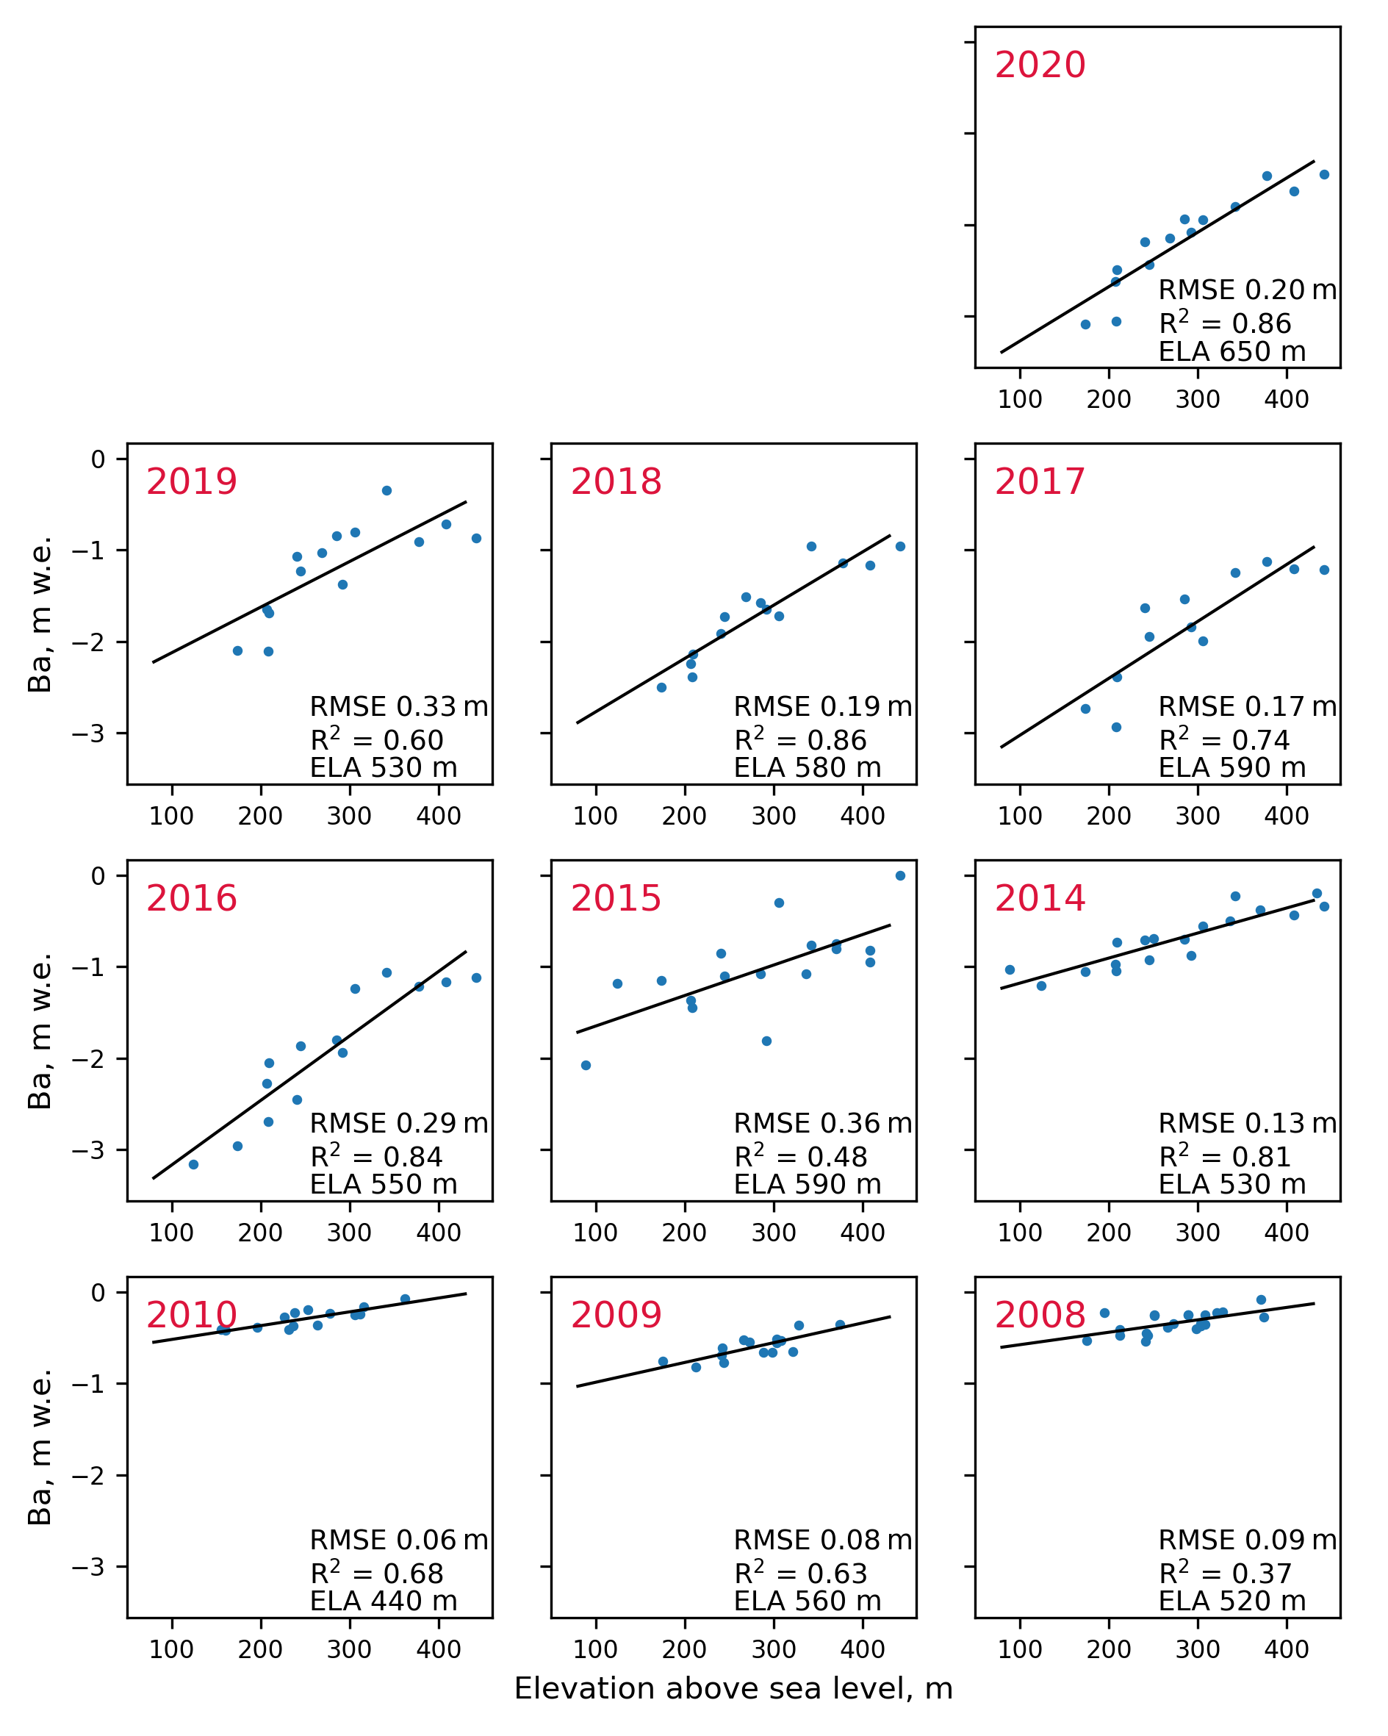
Figure A1: Vertical mass-balance profiles for Aldegondabreen

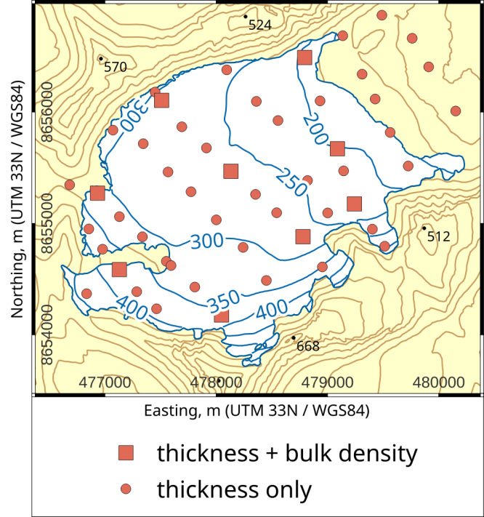
Figure B1: The typical snow survey layout for Aldegondabreen since 2015

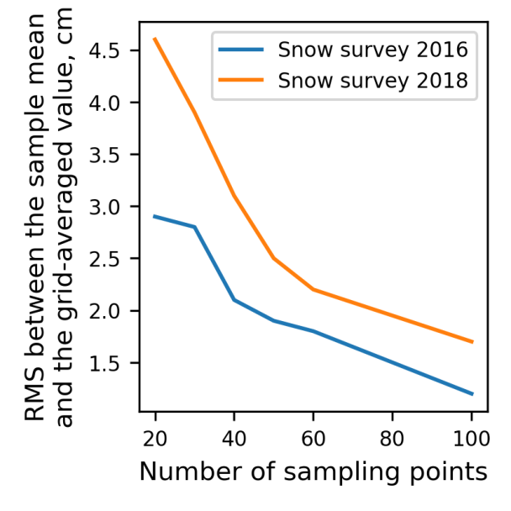
Figure B2: The empirical curves of the relationship between snow thickness uncertainty and the number of sampling points
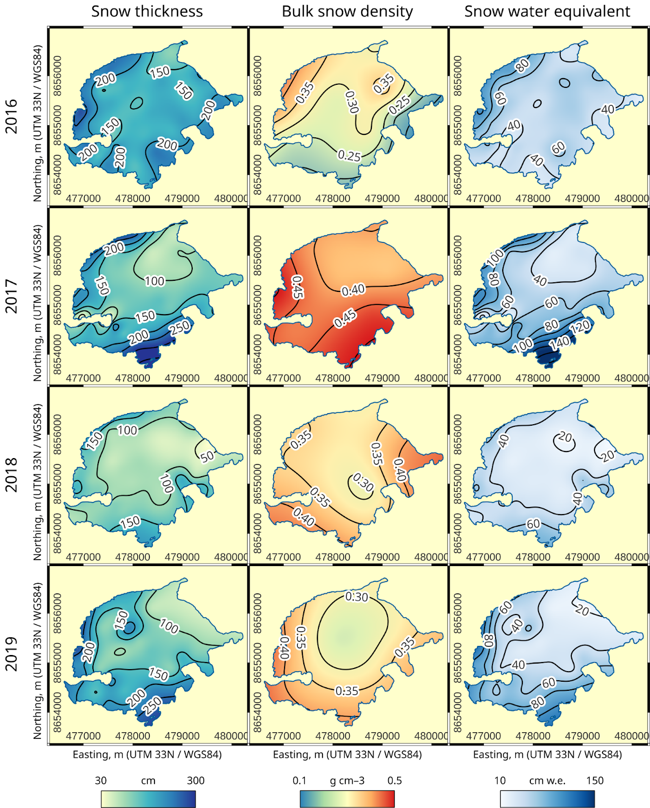
Figure B3: The examples of the spatial distribution of snow thickness, density and water equivalent on Aldegondabreen

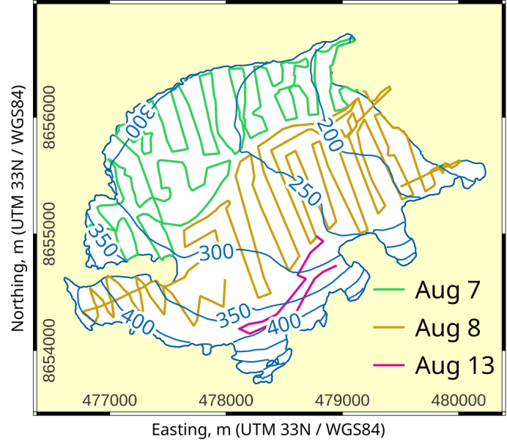
Figure C1: Routes and dates of the ground-based GNSS survey of Aldegondabreen in 2018

Table C1: Annual surface velocities observed between Aug 2018 and Aug 2019
Stake ID | Velocity, m a⁻¹ | Stake ID | Velocity, m a⁻¹
2 | < 0.10 | 12 | 0.87 ± 0.10
3 | 1.55 ± 0.10 | 13 | 1.97 ± 0.10
6 | 1.01 ± 0.10 | 14 | < 0.10
7 | < 0.10 | 15 | < 0.10
8 | < 0.10 | 18 | 0.63 ± 0.10
9 | < 0.10 | 20 | 0.38 ± 0.10
10 | < 0.10 | 21 | < 0.10

