Using a Web Map Service to map Little Ice Age glacier extents at regional scales

Johannes Reinthaler¹, Frank. Paul¹
¹ Department of Geography, University of Zurich, Zurich, Switzerland
E-mail: johannes.reinthaler@geo.uzh.ch

Supplement material
Contents of this file:
Tables S1 and S2
Figure S1

Table S1: List of regions and subregions and mountain ranges with their specific number of analysed glaciers, LIA area as well as approximate coordinates. Subregions of the 2nd order also appear in Table 4.
RGI first order region code and name | Subregion  2nd order | Subregion  3rd order | Number of glaciers | Mean LIA Date | Area LIA [km²] | Lat. [°] | Long. [°]
[1] Alaska | Brooks Range | Brooks Range | 53 | 1890 | 168.26 | 69.23 | -144.04
 | South Alaska | Talkeetna Mountains | 37 | 1850 | 317.17 | 62.04 | -148.76
 |  | Ahklun Mountains | 7 | 1860 | 18.00 | 60.03 | -159.29
 |  | Delta Range | 10 | 1850 | 480.53 | 63.30 | -145.09
 |  | Kenai Mountains | 9 | 1851 | 917.40 | 59.87 | -150.24
 |  | Chilkoot Ranges | 13 | 1850 | 178.12 | 59.82 | -135.69
 |  | South Boundary Ranges | 22 | 1850 | 379.70 | 56.08 | -130.21
[4] Arctic Canada South | Baffin Island | Pond Inlet | 20 | 1850 | 208.18 | 72.64 | -77.14
 |  | Bruce Mountains | 18 | 1850 | 95.53 | 71.50 | -72.31
 |  | Kangok Fjord | 2 | 1850 | 21.61 | 68.68 | -68.94
 |  | Mount Viewforth | 13 | 1850 | 58.16 | 68.18 | -67.10
 |  | Quajon & Maktak Fjord | 22 | 1850 | 95.65 | 67.50 | -64.86
 |  | North Pangnirtung & Kangert Fjord | 21 | 1850 | 241.09 | 66.97 | -64.26
 |  | White Wind Peak | 30 | 1850 | 478.19 | 66.54 | -62.49
[9] Russian Arctic | Novaya Zemlya |  | 85 | 1850 | 644.10 | 73.40 | 55.29
[16] Tropics | Mexico | Iztaccíhuatl | 1 | 1850 | 6.60 | 19.18 | -98.64
 |  | Pico de Orizaba | 1 | 1850 | 8.53 | 19.03 | -97.27
 | Sierra Nevada de Santa Marta |  | 37 | 1650 | 44.21 | 10.84 | -73.68
 | Sierra Nevado del Cocuy |  | 15 | 1650 | 61.05 | 6.45 | -72.30
 | Peru | Cordillera Blanca | 23 | 1630 | 97.70 | -8.99 | -77.65
 | Bolivia | Cordillera Real | 16 | 1658 | 32.83 | -16.24 | -68.18
 |  | Cordillera Quimsa Cruz | 19 | 1652 | 39.44 | -16.94 | -67.39
 | Africa | Rwenzori | 7 | 1880 | 6.55 | 0.38 | 29.89
 |  | Mt Kenya | 9 | 1880 | 1.69 | -0.15 | 37.31
 |  | Kilimanjaro | 1 | 1880 | 19.61 | -3.07 | 37.35
 | Papua | Puncak Jaya | 1 | 1875 | 21.26 | -4.06 | 137.16

Table S2: Glaciers with dating records. Glaciers from Africa were taken from photographs and field campaign and Kaser and Osmaston (2002) estimates the area to be about 90% of the LIA maximum extent.
Region | Name | Extent | Year LIA | Reference | Year modern | Area LIA [km²] | Area modern [km²] | Area change rate [% a⁻¹]
Alaska | Tustemena Glacier | LIA Max | 1864 | (Wiles and Calkin, 1994) | 2007 | 316.06 | 307.54 | -0.02
 | Bear Glacier | LIA Max | 1888 | (Wiles and Calkin, 1994) | 2005 | 222.68 | 198.09 | -0.09
 | Pederson Glacier | LIA Max | 1885 | (Wiles and Calkin, 1994) | 2005 | 38.83 | 31.63 | -0.15
 | Dinglestadt Glacier | LIA Max | 1824 | (Wiles and Calkin, 1994) | 2005 | 87.18 | 75.89 | -0.07
 | Yalik Glacier | LIA Max | 1889 | (Wiles and Calkin, 1994) | 2005 | 52.01 | 42.25 | -0.16
 | Nuka Glacier | LIA Max | 1724 | (Wiles and Calkin, 1994) | 2005 | 21.64 | 16.40 | -0.09
 | Petrof Glacier | LIA Max | 1904 | (Wiles and Calkin, 1994) | 2005 | 54.12 | 45.45 | -0.16
 | Exit Glacier | LIA Max | 1825 | (Wiles and Calkin, 1994) | 2005 | 41.99 | 37.30 | -0.06
 | Grewingk Glacier | LIA Max | 1858 | (Wiles and Calkin, 1994) | 2007 | 82.89 | 68.63 | -0.12
South America | Huayna Potosi western glaciers | LIA Max | 1657 | (Rabatel and others, 2008) | 1998 | 3.58 | 1.82 | -0.14
 | Huayna Potosi eastern glaciers (Zongo) | LIA Max | 1680 | (Rabatel and others, 2008) | 1998 | 6.45 | 3.47 | -0.15
 | Charquini Sureste | LIA Max | 1664 | (Rabatel and others, 2006) | 1998 | 1.56 | 0.54 | -0.20
 | Charquini Oeste | LIA Max | 1663 | Rabatel and others, 2006) | 1998 | 0.70 | 0.00 | -0.30
 | Charquini Norte | LIA Max | 1663 | Rabatel and others, 2006) | 1998 | 0.93 | 0.22 | -0.23
 | Charquini Sur | LIA Max | 1686 | Rabatel and others, 2006) | 1998 | 1.23 | 0.38 | -0.22
 | Charquini Noreste | LIA Max | 1662 | Rabatel and others, 2006) | 1998 | 0.84 | 0.23 | -0.22
 | Jankhu Uyu & Wila Lluxita glaciers | LIA Max | 1660 | (Rabatel and others, 2008) | 1998 | 1.85 | 0.84 | -0.16
 | San Enrique & Malla Chuma glaciers | LIA Max | 1665 | (Rabatel and others, 2008) | 1998 | 6.91 | 4.64 | -0.10
 | Yaypuri & Jankho Loma glaciers | LIA Max | 1660 | (Rabatel and others, 2008) | 1998 | 5.57 | 3.75 | -0.10
Africa | Kolbe | ~90% | 1913 | (Hastenrath, 2005) | 1993 | 0.07 | 0
 | Mt Baker | ~90% | 1906 | (Kaser and Osmaston, 2002) | 2021 | 1.27 | 0.01 | -0.86

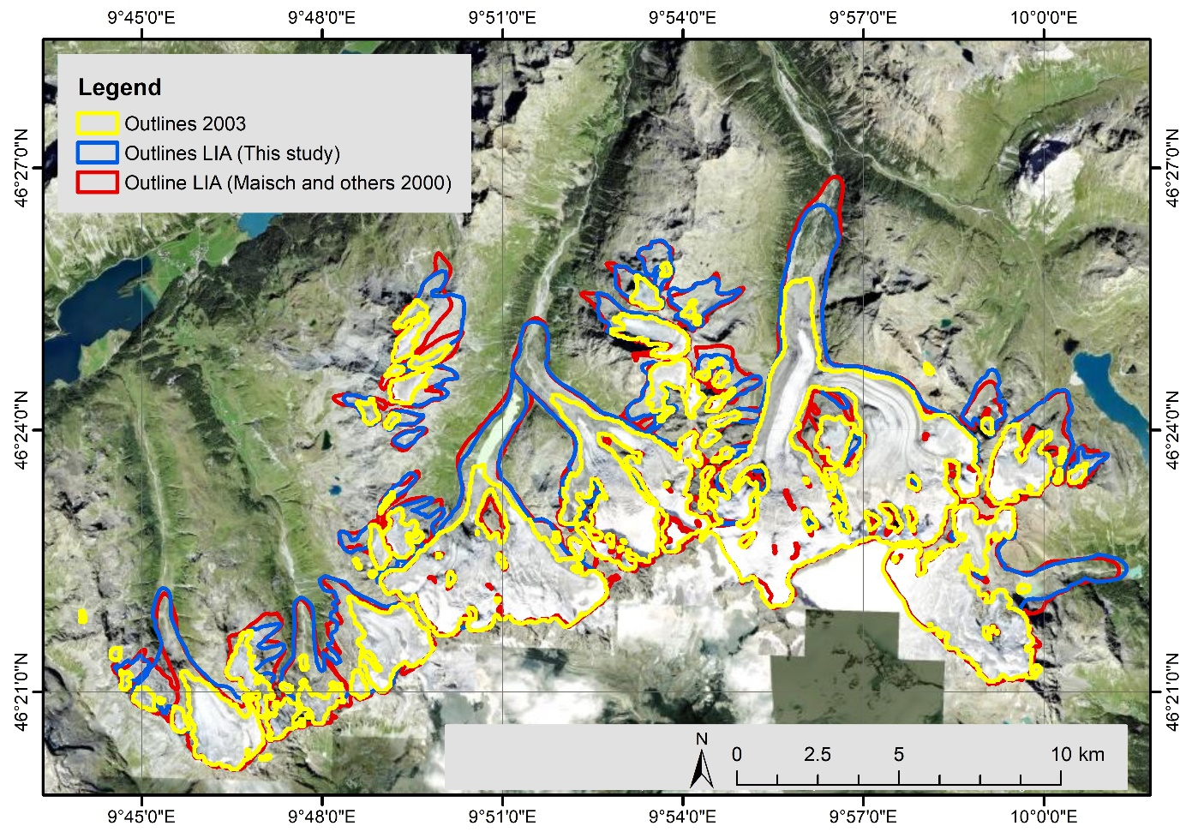
Figure S1: Overlay of LIA outlines in the Bernina group (Switzerland). In red the outlines from Maisch and others (2000) and in blue outlines from this study.

References:
Hastenrath SL (2005) The glaciers of Mount Kenya 1899-2004. Erdkunde 59(2), 112–115 (doi:https://www.jstor.org/stable/25647750)
Kaser G and Osmaston H (2002) Glaciers and glaciations of the Rwenzori Mountains, Uganda. Tropical Glaciers. Cambridge University Press, Cambridge, 207
Maisch M, Wipf A, Denneler B, Battaglia J and Benz C (2000) Die Gletscher der Schweizer Alpen: Gletscherhochstand 1850, Aktuelle Vergletscherung, Gletscherschwundszenarien. Schlussbericht NFP 31, second edition. Hochschulverlag ETH Zurich, Zurich, 373p (doi:https://doi.glamos.ch/data/inventory/inventory_sgi1850_r1992.html)
Rabatel A, Francou B, Jomelli V, Naveau P and Grancher D (2008) A chronology of the Little Ice Age in the tropical Andes of Bolivia (16°S) and its implications for climate reconstruction. Quaternary Research 70(2), 198–212 (doi:10.1016/j.yqres.2008.02.012)
Rabatel A, Machaca A, Francou B and Jomelli V (2006) Glacier recession on Cerro Charquini (16°S), Bolivia, since the maximum of the Little Ice Age (17th century). Journal of Glaciology 52(176), 110–118 (doi:10.3189/172756506781828917)
Wiles GC and Calkin PE (1994) Late Holocene, high-resolution glacial chronologies and climate, Kenai Mountains, Alaska. Geological Society of America Bulletin 106(2), 281–303 (doi:https://doi.org/10.1130/0016-7606(1994)106<0281:LHHRGC>2.3.CO;2)

