Mechanism for the subglacial formation of cryogenic brines
Sarah U. Neuhaus¹, Slawek M. Tulaczyk¹
¹Earth and Planetary Sciences, University of California Santa Cruz, Santa Cruz, CA, 95064, USA
Correspondence to: Sarah U. Neuhaus (suneuhau@ucsc.edu)

1 Derivation of Model Equation
We modelled the formation and vertical dispersal of cryogenic brines using a one-dimensional finite-difference code solving the vertical advection-diffusion equation of the form:

$\frac{∂C}{∂t}=∇∙\left(D_{sed}∇C\right)-∇∙\left(vC\right)$ (S1)

Where C is chemical concentration, t is time, D_{sed} is the diffusion coefficient of the chemical parameter through sediments, and v is the vertical velocity of the brine. We modelled the concentrations of Cl⁻ and δ¹⁸O because we expect that they did not chemically react with the sediments, and compared the results to the measured porewater concentrations of the AND-1B and AND-2A cores (Pompilio and others, 2007; Frank and others, 2010).
We calculated the diffusion coefficients for Cl⁻ and δ¹⁸O in sediments (D_{sed}) from measurements reported in Li and Gregory (1974) and Wang (1951) respectively, using equation 12 from Li and Gregory (1974):

$D_{sed}=D\frac{α}{θ^{2}}$ (S2)

Where D is the coefficient in free water, α is the ratio of viscosity of the bulk solution to the average viscosity of the interstitial solution, and θ is tortuosity. Because α is a constant close to one (Li and Gregory, 1974), we assumed that it was one for simplicity. We calculated θ using equation 10 from Boudreau (1996):

$θ^{2}=1-ln\left(φ^{2}\right)$ (S3)

Where ϕ is porosity, taken here to be 0.4 (Engelhardt and others, 1990; Tulaczyk and others, 2001). Because our domain extends from 0 – 2000 mbsf, the temperatures over which we model diffusion vary widely (-2.4 - 150 ºC [Morin et al., 2010]), which, in turn, varies the diffusivities. The coefficients in free water were reported at 0 ºC, 18 ºC, and 25 ºC for Cl⁻ (Li and Gregory, 1974), and at 0 ºC, 5 ºC, 15 ºC, 25 ºC, 35 ºC, 45 ºC, and 55 ºC for δ¹⁸O (Wang, 1951). We converted these measured coefficients to D_{sed} and then fit an Arrhenius equation to the data to obtain a temperature dependence of D_{sed}. We then converted the calculated temperature dependence of D_{sed} to depth dependence using the temperature-depth relationship calculated from measurements at the AND-1B borehole (Morin and others, 2010). The range in D_{sed} used in the model was 0.0105-0.2217 m²/yr for Cl⁻ and 0.0153-0.3177 m²/yr for δ¹⁸O.
In addition to diffusion, we accounted for density-driven vertical flow of the brine in our finite-difference code. We calculated the vertical velocity (v) using an expression based on Darcy’s Law (Wooding, 2007):

$v=K\frac{∆ρ}{ρ}$ (S4)

Where K is the hydraulic conductivity of the sediments and ρ is the density of the porewater. Δρ represents the difference in porewater density between one element and the element directly above it. When Δρ is negative – i.e., the porewater density of the lower element is higher – density stratification is stable and we set the velocity to zero. When Δρ is positive, it is divided by the density to calculate the downward hydraulic gradient. In our model runs we examined values of K ranging from 0.001 – 0.1 m/yr, which we keep constant throughout the model domain. We calculated the density of the porewater from the concentration of Cl⁻ by assuming that our porewater had a ratio of total dissolved solids (TDS) to Cl⁻ of 1.8 (the ratio of TDS to chlorinity in standard seawater). Because changes in oxygen isotopes do not vary the density of the porewater noticeably, we relied on the concentration of chloride to determine whether density-driven flow occurred. Thus, we ran the model for both chemical parameters in parallel, using the velocities calculated from the Cl⁻ density gradients to calculate vertical advection of δ¹⁸O.
In our model, we assume that the differences in concentration of Cl⁻ and δ¹⁸O are negligible in the horizontal direction. Thus, while we expect that there is a horizontal exchange of Cl⁻ and δ¹⁸O on the microscale (e.g., due to salt fingering under unstable stratification), we assume that the horizontal gradients in chemical concentration and velocity are much smaller than the vertical gradients at the spatial scale of our model resolution (5 meters). This allows us to simplify Equation S1 by ignoring tracer advection and diffusion in the horizontal directions. After making this assumption and differentiating the diffusive term in Equation S1, the equation becomes:

$\frac{∂C}{∂t}=D_{sed}\frac{∂^{2}C}{∂z^{2}}+\frac{∂D_{sed}}{∂z}\frac{∂C}{∂z}+K\frac{∆ρ}{ρ}\frac{∂C}{∂z}$ (S5)

Where z is depth below the seafloor (zero at the top of the sedimentary column and positive downward).

2 Boundary Conditions
In our model runs, we exposed the simulated sedimentary column to three different upper boundary conditions (Fig. 2): seawater periods (representing interglacial periods), freezing periods (representing periods when ice is overriding the site, and is frozen to the bed), and melting periods (representing periods where ice is overriding the site, but melting is occurring at the bed).
To simulate the different boundary conditions, we changed the values of Cl⁻ and δ¹⁸O concentration in the topmost element of the model. During seawater periods, we changed the values of Cl⁻ and δ¹⁸O concentration in the topmost element to reflect the composition of seawater as measured from samples obtained from above the boreholes (Frank et al., 2010; Pompilio et al., 2007). During meltwater periods we added meltwater to the uppermost element at a rate determined by the ice melt rate, thus lowering the Cl⁻ concentration. To account for the added meltwater in our calculations of δ¹⁸O, we assumed that the melted ice had a δ¹⁸O ranging from -60 to -40 ‰ (Wang et al., 2010) and settled on a value that fit the observations from AND-1B and AND-2A best (Table S1). We then took the weighted average of the meltwater and porewater based on volume.
During freezing periods, we altered the values of Cl⁻ concentration and δ¹⁸O by extracting freshwater at a rate set by the freezing rate (Table S1). The extracted water leaves the simulated domain, and, in reality, would become part of a frozen basal ice layer (Christoffersen et al., 2010). We began with the assumption that the freezing rate was the same order of magnitude as the melting rate (10⁻⁴) and then modified it as a control parameter to fit the observations from AND-1B and AND-2A (Table S1). We increased the Cl⁻ concentration in the topmost element by subtracting the mass of water that froze. This is equivalent to assuming that during freezing no significant Cl⁻ is incorporated into the basal ice and all of it stays in the pore spaces beneath the ice base. Although Cl⁻ is soluble in ice, meaning that ice that forms from Cl-bearing fluids (e.g. seawater or brine) will contain some chlorine, the amount of Cl⁻ incorporated in the ice amounts to ca. 0.1% of the Cl⁻ concentration in the fluid (Gross et al., 1977). Because this is such a small proportion of the Cl⁻ concentration in the brine, we feel justified in neglecting this effect. To calculate the δ¹⁸O evolution in the topmost element during freezing, we relied on the observation that δ¹⁸O of sea ice is 3 ‰ more positive than the remaining seawater from which it froze (Toyota et al., 2013). We thus lowered the value of δ¹⁸O in the topmost element accounting for the difference in volume between the frozen water and the water remaining in the pore spaces. A visual representation of the effects on the concentration of the uppermost element caused by changing between seawater, freezing, and melting periods can be seen in Fig. S1 and Fig. S2.
We ran the model, using a spatial resolution of 5 m and a temporal resolution of 10 years. We ran each simulation by repeating 100,000-year cycles, containing periods of exposure to seawater, melting, and freezing. We ended each model run with a 10,000 year seawater period because the ice sheet has been absent from both the AND-1B and AND-2A sites during Holocene (McKay et al., 2016; Spector et al., 2017). For each set of observations (i.e. AND-1B and AND-2A), we varied the lengths and arrangements of the periods of seawater, melting, and freezing to fit our model outputs to the observations (Fig. S1; Fig S2). We also tested a wide variety of values for K, freezing rate, and melting rate. We determined the fit for the modeled concentrations of Cl⁻ and δ¹⁸O to the observations by performing a regression and calculating the R² value. We found the model outcome that produced the best fit for the combination of Cl⁻ and δ¹⁸O occurred after six glacial cycles for AND-1B and after 18 cycles for AND-2A (Fig. 3). Visual representation of the cycles and upper boundary conditions are shown in Fig. S1 and Fig. S2.

3 Choice of Free Parameters
In modeling the porewater composition, we varied the free parameters shown in Table S1 until we obtained a model output that fit the observations. Our resulting selections for the free parameters are described below.
For the simulation of the AND-1B core, the model was best able to fit the observations within ten synthetic 100,000-year glacial cycles (Fig. 3 a-c). The solution we found that best fit the observations required the first five glacial cycles to differ slightly from the following five cycles. For cycles 1-5 the sediments were exposed to 10,000 years of seawater conditions, followed by 40,000 years of freezing conditions, 40,000 years of melting conditions, and 10,000 years of seawater conditions. For cycles 6-10 we increased the amount of time the sediments were exposed to seawater: 70,000 years of seawater conditions, 10,000 years of freezing conditions, 10,000 years of melting conditions, and 10,000 years of seawater conditions. These cycles are visually represented in Fig. S1. For all glacial cycles K was 0.09 m/yr, the freezing rate was 4x10⁻⁵ m/yr, and the melting rate was 0.01 m/yr. We initially calculated a melt rate of 5 x10⁻⁴ m/yr using equation 9 from Christoffersen and Tulaczyk (2003). However, because that calculation required several assumptions about ice sheet conditions, we opted to use that value as just a starting point and tested a variety of similar melt rates (Table S1) before settling on 0.01m/yr.
For the AND-2A core, the solution we found that best fit the observed data required more than ten 100,000-year glacial cycles (Fig. 3 d-f). The first five glacial cycles were the coldest with a freezing rate of 9x10⁻⁵ m/yr and a melt rate of 0.001 m/yr. These cycles began with 10,000 years of seawater conditions, followed by 40,000 years of freezing conditions, 40,000 years of melting conditions, and a final 10,000 years of seawater conditions. During glacial cycles 6-15 the sediments experienced slightly longer periods of freezing conditions, but the conditions at the bed were slightly warmer, resulting in a lower freezing rate (2x10⁻⁵ m/yr) and a higher melting rate (0.1 m/yr). The glacial cycles followed the pattern of 10,000 years of seawater conditions, 50,000 years of freezing conditions, 30,000 years of melting conditions, and 10,000 years of seawater conditions. The final five glacial cycles (cycles 16-20) consisted of cycles of 60,000 years of seawater conditions, 10,000 years of freezing conditions (freezing rate of 10⁻⁵ m/yr), 20,000 years of melting conditions (melting rate of 10⁻³ m/yr), and 10,000 years of seawater conditions. These cycles are visually represented in Fig. S2. Throughout all glacial cycles, the value for K was 0.09 m/yr.

4 Addition of Vertical Advection
An important observation from the modelling process was that we were unable to recreate the brine concentrations at depth without incorporating downward advection of the brine. Diffusion alone was unable to account for the high concentrations at depth. We used density-driven flow as the mechanism of vertical advection, which is not without precedent in cryogenic brine formation models as previous models require the denser brines to sink to the bottom of an isolated marine basin and percolate deep into the sediments (Starinsky and Katz, 2003; Grasby and others, 2013).
Additionally, we tested what effect imposing a background vertical groundwater flow (as opposed to density-driven flow) would have on our results. Such background flow could be due to sediment compaction or regional groundwater flow. Imposing a background downward vertical velocity appeared to affect the changes in the brine composition during the freezing periods more than it did the seawater or melting periods, resulting in greater changes to the Cl⁻ concentration (which increases during the freezing periods) than the δ¹⁸O (which becomes more negative during the melting phases). We attempted to fit the model outcomes to the observations by altering the length of freezing periods and changing the freezing rate but found that we were unable to reproduce a reasonable fit for the entire Cl⁻ profile. Thus, although we do not rule out a background flow entirely, we conclude that density-driven flow is the dominant mode of vertical flow of fluids at the AND-1B and AND-2A field sites.

References
Boudreau BP (1996) The diffusive tortuosity of fine-grained unlithified sediments. Geochim. Cosmochim. Acta 60(16), 3139–3142 (doi:10.1016/0016-7037(96)00158-5)
Christoffersen P and Tulaczyk S (2003) Thermodynamics of basal freeze-on: Predicting basal and subglacial signatures of stopped ice streams and interstream ridges. Ann. Glaciol. 36, 233–243 (doi:10.3189/172756403781816211)
Engelhardt H, Humphrey N, Kamb B and Fahnestock M (1990) Physical conditions at the base of a fast moving Antarctic ice stream. Science (80-. ). 248(4951), 57–59 (doi:10.1126/science.248.4951.57)
Frank TD, Gui Z and ANDRILL SMS Science Team (2010) Cryogenic origin for brine in the subsurface of southern McMurdo Sound, Antarctica. Geology 38(7), 587–590 (doi:10.1130/G30849.1)
Grasby SE, Rod Smith I, Bell T and Forbes DL (2013) Cryogenic formation of brine and sedimentary mirabilite in submergent coastal lake basins, canadian arctic. Geochim. Cosmochim. Acta 110, 13–28 (doi:10.1016/j.gca.2013.02.014)
Li Y-H and Gregory S (1974) Diffusion of ions in sea water and in deep-sea sediments. Geochim. Cosmochim. Acta. Geochim. Cosmochim. Acta 38(5), 703–714 (doi:10.1016/0016-7037(74)90145-8)
Morin RH, Williams T, Henrys SA, Magens D, Niessen F and Hansaraj D (2010) Heat flow and hydrologic characteristics at the AND-1B borehole, ANDRILL McMurdo Ice Shelf project, Antarctica. Geosphere 6(4), 370–378 (doi:10.1130/GES00512.1)
Pompilio M, Dunbar N, Gebhardt AC, Helling D, Kuhn G, Kyle P, McKay R, Talarico F, Tulaczyk S, Vogel S, Wilch T and Team A-MS (2007) Petrology and geochemistry of the AND-1B core, ANDRILL McMurdo Ice Shelf Project, Antartica. Terra Antart. 14(3), 255–288
Starinsky A and Katz A (2003) The formation of natural cryogenic brines. Geochim. Cosmochim. Acta 67(8), 1475–1484 (doi:10.1016/S0016-7037(02)01295-4)
Tulaczyk S, Kamb B and Engelhardt HF (2001) Estimates of effective stress beneath a modern West Antarctic ice stream from till preconsolidation and void ratio. Boreas 30(2), 101–114 (doi:10.1111/j.1502-3885.2001.tb01216.x)
Wang JH (1951) Self-diffusion and Structure of Liquid Water. II. Measurement of Self-diffusion of Liquid Water with O18 as Tracer. 73(9), 4181–4183 (doi:10.1021/ja01153a039)
Wooding RA (2007) Variable-density saturated flow with modified Darcy’s law: The salt lake problem and circulation. Water Resour. Res. 43(2), 1–10 (doi:10.1029/2005WR004377)

Figures/Tables

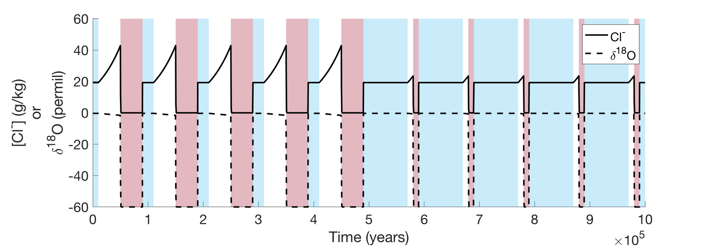
Figure S1: Surface boundary conditions for model runs for AND-1B core. The black lines represent Cl⁻ concentration or the δ¹⁸O for the uppermost element. The blue, white, and red backgrounds indicate the timing of seawater, freezing, and melting periods respectively.
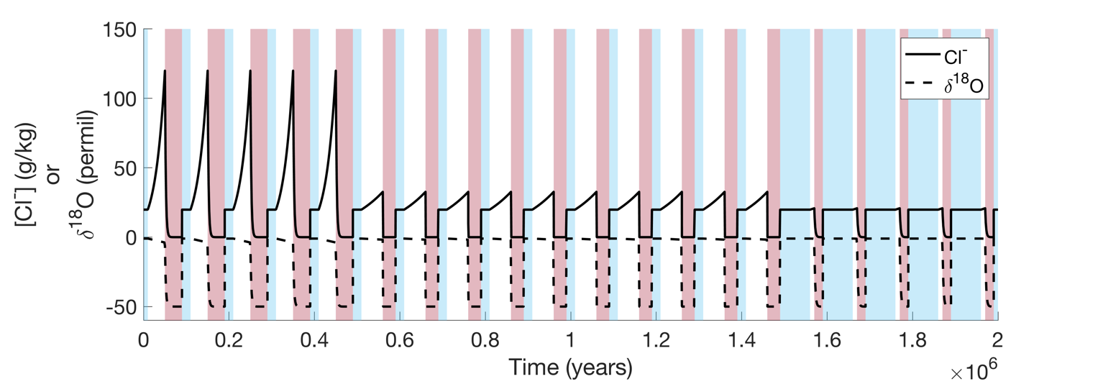
Figure S2: Surface boundary conditions for model runs for AND-2A core. The black lines represent Cl⁻ concentration or the δ¹⁸O for the uppermost element. The blue, white, and red backgrounds indicate the timing of seawater, freezing, and melting periods respectively.

Table S1: List of free model parameters and the ranges over which they were allowed to vary in the model runs.
Parameter | Range Examined | Units
K | 0.001-0.1 | m/yr
Freezing Rate | 10⁻⁵-10⁻³ | m/yr
Melting Rate | 10⁻⁴-10⁻¹ | m/yr
Freezing Periods | 0-90,000 | Years
Melting Periods | 0-90,000 | Years
Seawater Periods | 10,000-100,000 | Years

