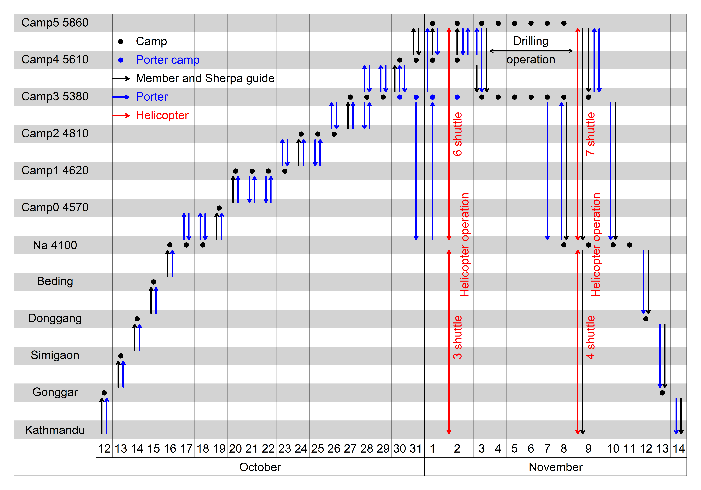
Figure S1. Timeline of the 2019 ice core drilling expedition. Elevations of the camps are also listed (in m asl).
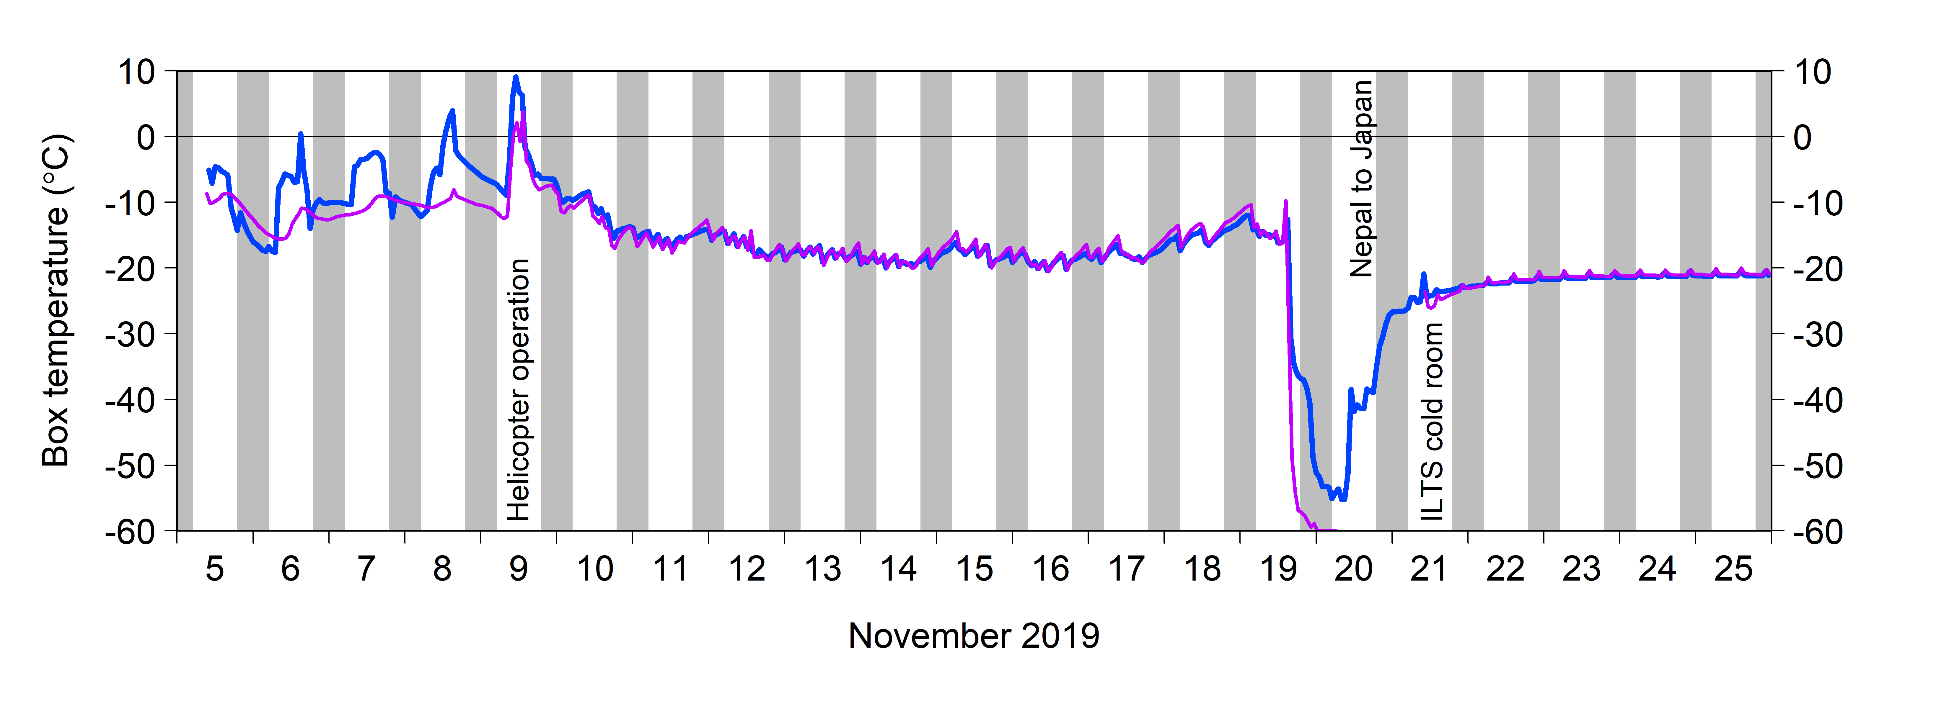
Figure S2. Temporal changes in temperatures inside the ice core storage box. One temperature logger (purple) did not work during the transportation between Nepal and Japan, probably due to overcooling by dry ice. Shading indicates night periods.

