SUPPLEMENTARY INFORMATION
Using under-ice hyperspectral transmittance to determine land-fast sea-ice algal biomass in Saroma-ko Lagoon, Hokkaido, Japan

Pat WONGPAN,^{1,2*} Daiki NOMURA,^{3,4,5,6} Takenobu TOYOTA,¹
Tomonori TANIKAWA,⁷ Klaus M. MEINERS,^{8,9}
Tomomi ISHINO,¹⁰ Tetsuya P. TAMURA,¹⁰
Manami TOZAWA,¹⁰ Yuichi NOSAKA,¹¹
Toru HIRAWAKE,^{4,5} Atsushi OOKI,^{4,5} Shigeru AOKI,¹

¹Institute of Low Temperature Science, Hokkaido University, Japan
²JSPS International Research Fellow, Japan Society for the Promotion of Science, Tokyo, Japan
³Field Science Center for Northern Biosphere, Hokkaido University, Japan
⁴Faculty of Fisheries Sciences, Hokkaido University, Japan
⁵Arctic Research Center, Hokkaido University, Japan
⁶Global Station for Arctic Research, Global Institution for Collaborative Research and Education,
Hokkaido University, Japan
⁷Meteorological Research Institute, Japan Meteorological Agency, Japan
⁸Australian Antarctic Division, Department of Agriculture, Water and the Environment, Kingston, Tasmania, Australia
⁹Australian Antarctic Program Partnership, Institute for Marine and Antarctic Studies, University of Tasmania, Hobart, Tasmania, Australia
¹⁰School of Fisheries Sciences, Hokkaido University, Japan
¹¹School of Biological Sciences, Tokai University, Japan

*Current address: Australian Antarctic Program Partnership, Institute for Marine and Antarctic Studies,
University of Tasmania, Hobart, Tasmania, Australia
Correspondence: Pat Wongpan pat.wongpan@utas.edu.au

Site | C1 | C2 | C3 | C4 | C5
Snow depth (m) | 0.09 | 0.10 | 0.08 | 0.08 | 0.09
Freeboard (m) | 0.03 | 0.01 | 0.03 | 0.03 | 0.03
Ice thickness (m) | 0.50 | 0.46 | 0.45 | 0.47 | 0.51
Chl. a (mg m⁻²) | 29.42 | 26.96 | 16.97 | 21.22 | 28.06
Bottom 0.1 m  Chl. a (mg m⁻³) | 250.36 | 229.32 | 144.76 | 180.65 | 220.66
PAR Transmittance | 3.5$×$10⁻³ | 3.0$×$10⁻³ | 5.8$×$10⁻³ | 6.1$×$10⁻³ | 2.8$×$10⁻³
Columnar-ice percentage (%) | 5.3 | 11.5 | 13.8 | 0 | 10.9

Table S1 Snow depth, freeboard, ice thickness, and vertical integrated Chl. a at sites C1-C5.
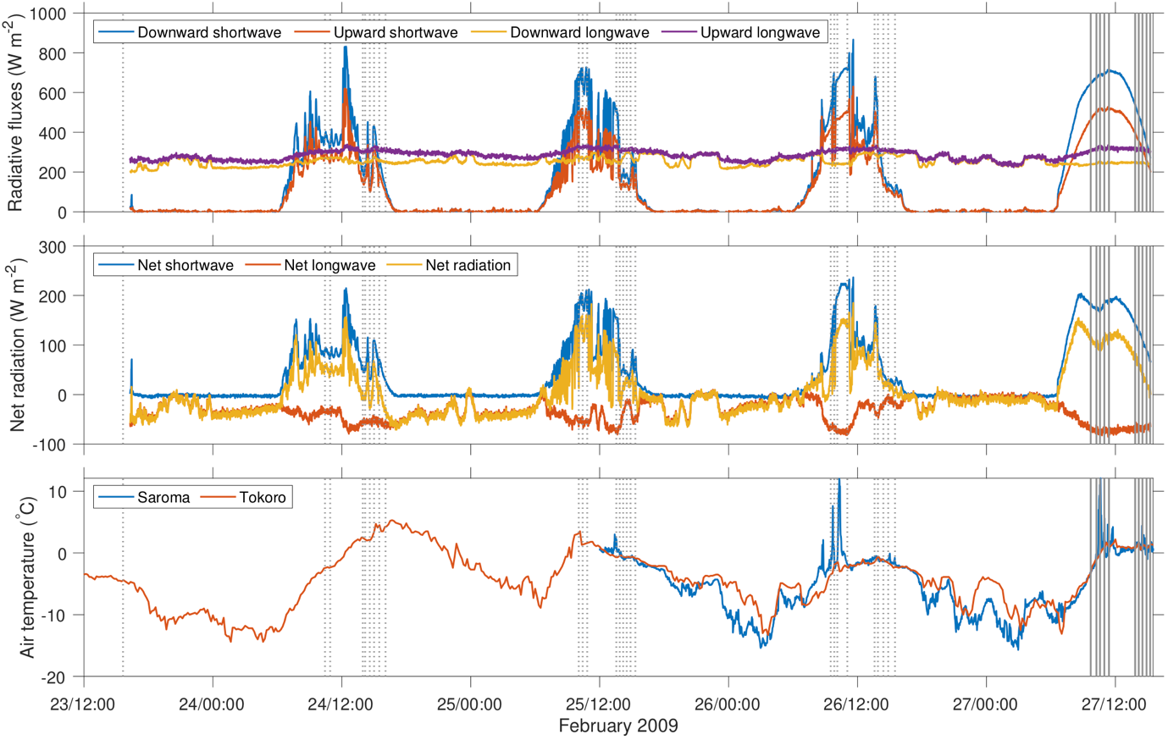
Fig. S1 Short-term change of solar radiation and air temperature during the observation. Temporal vertical dashed lines represent the sampling times for 27 stations. Vertical solid lines show the sampling times of the NDI-estimate survey.

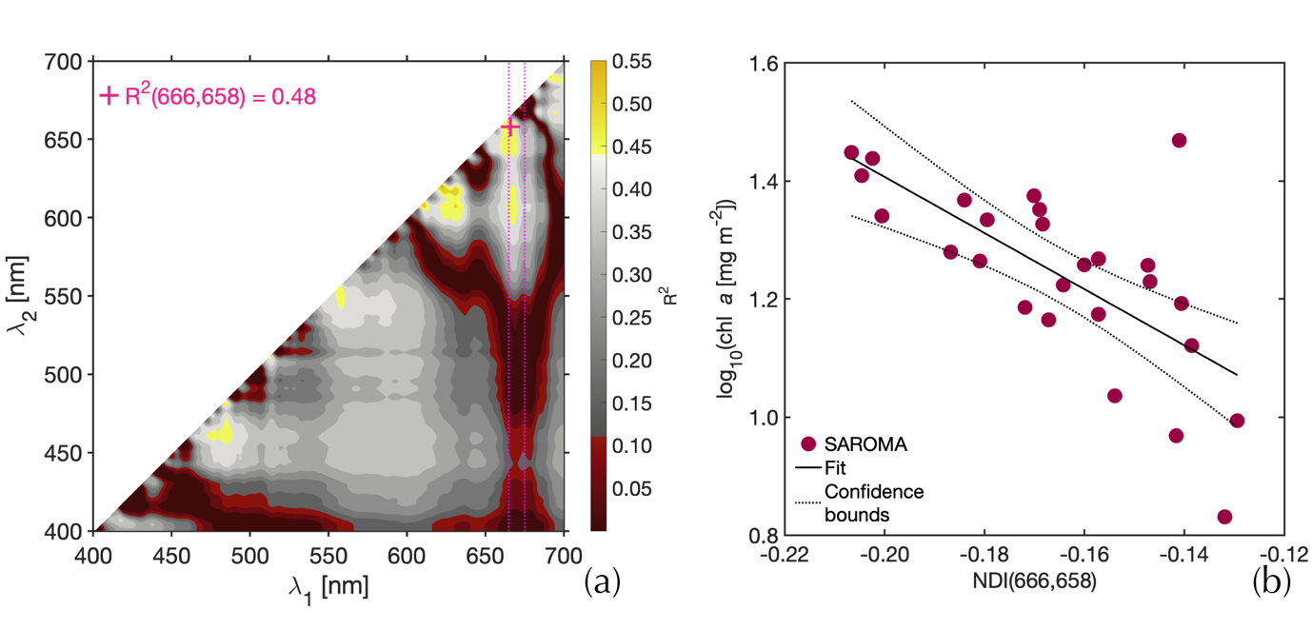
Fig. S2 The NDI analysis for under-ice irradiance. (a) The coefficient of determination (R²) surface constructed from all possible wavelength pairs in $\log_{10}(Chl.a[mg m^{-2}]) =a×NDI\left(λ_{1},λ_{2}\right)+b$. (b) An example (and the best pair) of the linear fit used to construct the NDI relationship for under ice irradiance and represented as a pink cross in (a).

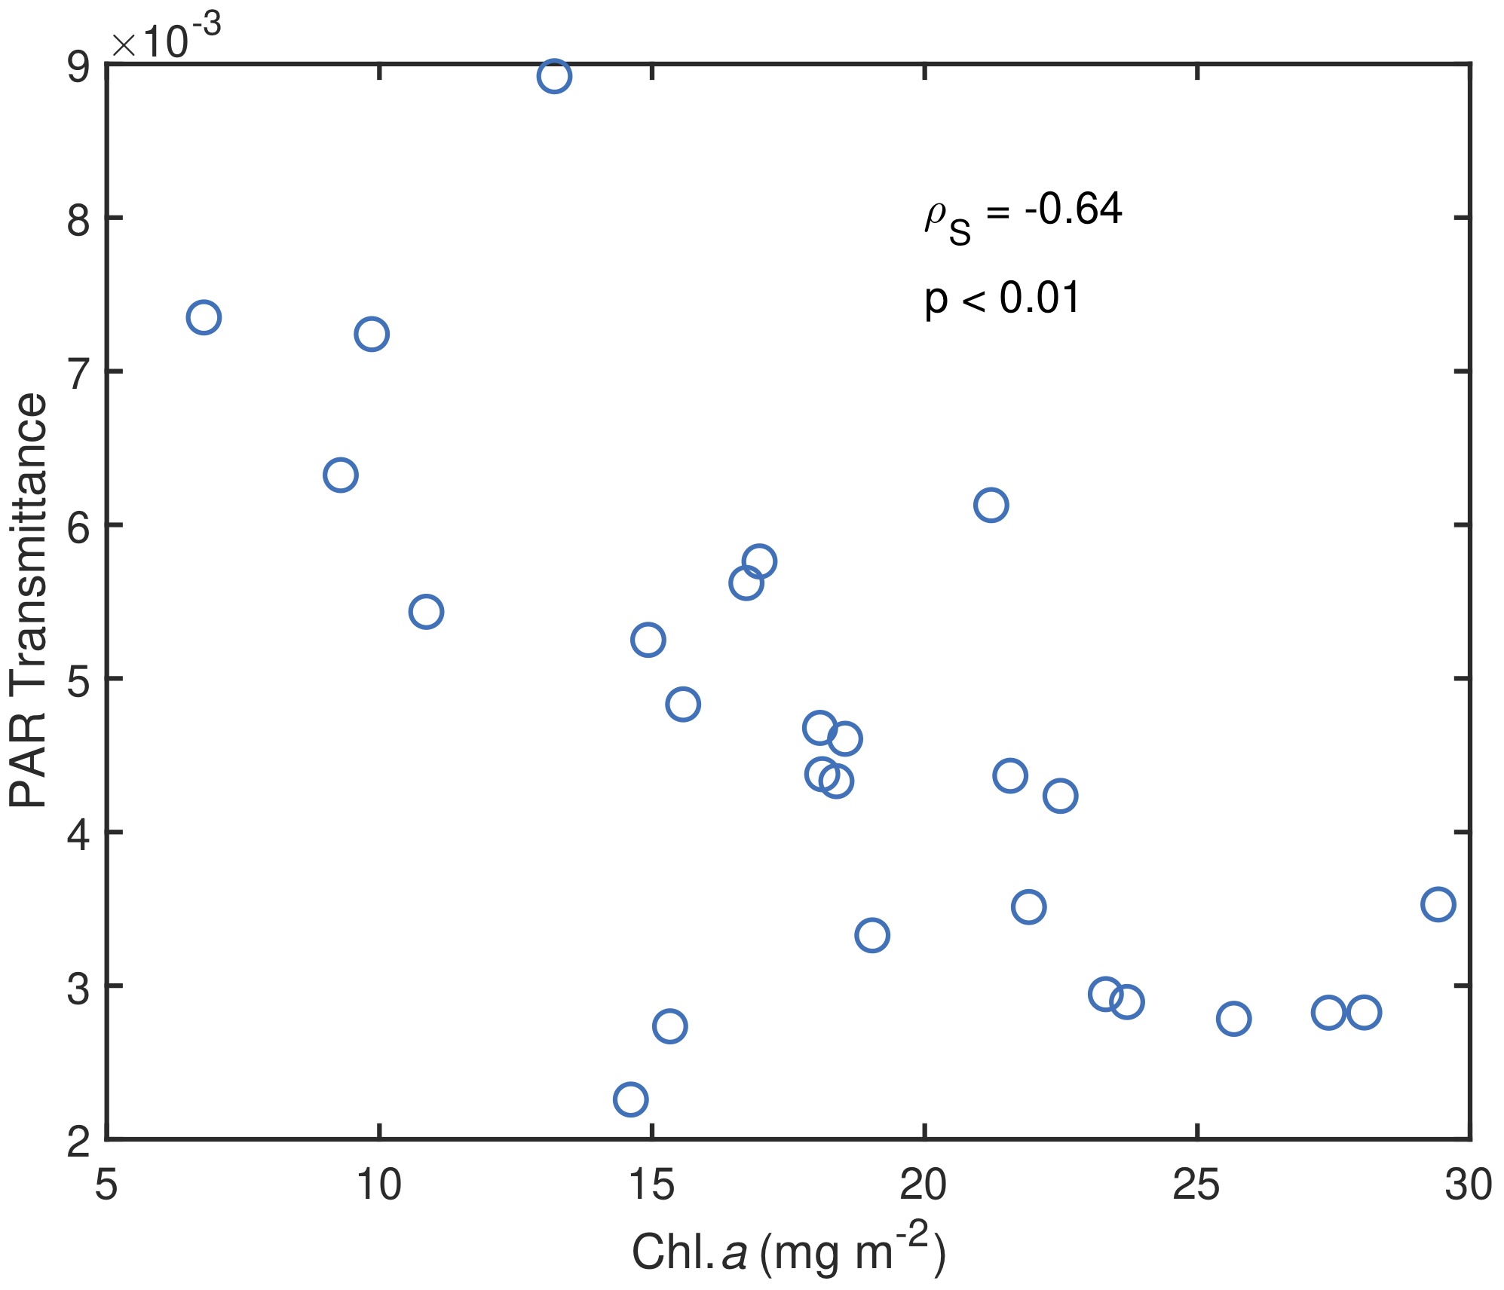

Fig. S3 Spearman’s rank correlation coefficient of PAR Transmittance and Chl. a. PAR Transmittance is defined as:
$PAR TRANSMITTANCE= \frac{\int_{400 nm}^{700 nm}{T_{E}(λ)E_{S}(λ)dλ}}{\int_{400 nm}^{700 nm}{E_{S}(λ)dλ}}.$
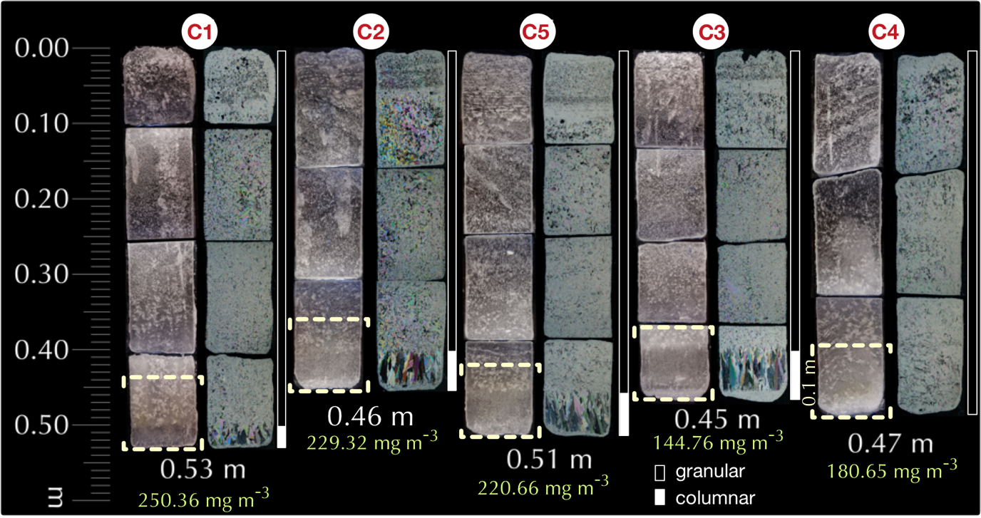
Fig. S4. Variability of sea-ice textures for selected sampling sites (C-sites). Ice thicknesses and Chl. a concentration in the bottom 0.1 m of the sea-ice cores are indicated under each ice core in white and green, respectively. Granular and columnar texture are highlighted with filled and unfilled vertical white boxes. Vertical dashed brackets denote the bottom 0.1 m of the ice cores. Snow depth, freeboard, and vertical integrated Chl. a are shown in Table S1.

