Supplementary material for ImpDAR: An open-source impulse radar processor
David A. Lilien, Benjamin H. Hills, Joshua Driscol, Robert Jacobel, and Knut Christianson

Installation
A full set of instructions, intended for users with little or no experience with Python or git, is presented in Section S1.1. Users with existing Anaconda installations can follow this first set of instructions, skipping the first step. For users who wish to use some other Python installation, a list of the packages to install follows in Section S1.2. For users who wish to get the latest development updates to ImpDAR, rather than the most stable version, instructions are in Section S1.3.

Installation with Anaconda
For users who are new to Python, do not have Python installed, or do not have experience with git, this method is most straightforward and has no prerequisites.

- A current (2.7 or 3.5+) Python installation is the first requirement. We recommend getting Python 3, since Python 2 is no longer supported. Straightforward installation is available from Anaconda (http://anaconda.com). Anaconda can be installed on Windows, MacOS, or Linux, and it can set up path variables to make programs executable from any directory. On Windows, Anaconda does not recommend modifying path variables—if users opt to leave the path unchanged, they should perform subsequent steps from the “Anaconda prompt” rather than from the command prompt. Follow the instructions on the Anaconda website for your particular operating system. In order to avoid complications, it is easiest just to restart the terminal (MacOS/Linux) or open the Anaconda prompt after Anaconda installation to ensure that the new path specifications are loaded. For the most basic installation, with ability to pick layers and process data from a limited set of inputs, once can skip directly to step 4, but the next two steps will add support for geographic projections and additional data formats.
- After installing Anaconda, there are several recommended dependencies for ImpDAR. Because the dependencies are hosted at different places, installation takes two steps. First, install GDAL (https://gdal.org), which provides the tools to reproject the geographic coordinates associated with radar data and segyio, (https://segyio.readthedocs.io/en/latest/), which is needed to export to the SEGY format. These can be installed using:
conda install -c conda-forge gdal segyio

- One more package, h5py (https://www.h5py.org), needed for data from Blue Systems radars, can be installed with:
conda install h5py

- Your computer should now be set up to install ImpDAR. The latest stable version of ImpDAR can be obtained with
pip install impdar

If no newer features are needed, the version corresponding to the time of this publication can be installed with
pip install impdar==1.0

ImpDAR should now be set up and available for use. All functionality will be included, except for certain migration routines which rely on the external SeisUnix library (https://github.com/JohnWStockwellJr/SeisUnix/wiki). Installation of those tools is more complex and is operating system dependent, so the user should follow the instructions from SeisUnix if those routines are desired. However, ImpDAR provides several migration algorithms, which make for a fully functional installation without installing SeisUnix. SeisUnix (as well as GDAL, segyio, and h5py) are searched for at the time that ImpDAR needs them, so they can always be added later with no reinstallation of ImpDAR if need arises the additional functionality.

Dependencies when using other Python versions
Users with an existing Python installation may wish to use that rather than Anaconda. All required dependencies (numpy, scipy, and matplotlib) and some optional dependencies (h5py, and segyio) can be installed with pip. GDAL, required for reprojection, and PyQt5, required for the picking GUI, depend on external libraries that cannot simply be installed with pip. Rather, these external libraries must be compiled for pip to access. Since this installation will vary across operating systems, we cannot provide a full set of instructions here. ImpDAR will work without these optional packages (and without SeisUnix as discussed above), and they can be added later.

Development version of ImpDAR
New development of the ImpDAR package is not immediately made available through pip so as to permit testing without interrupting most users. However, this also means that access to readers for additional data types and other improvements are not immediately accessible through the installation method in step 4 of Section S1.1. Instead, users needing such developments will need to get the latest version of ImpDAR from github.com then install it. Here, we assume that required dependencies (numpy, scipy, matplotlib) have already been installed.
- There are two options to get the code:
- Users without a git installation can download the development source code as a zip file from https://github.com/dlilien/ImpDAR/tree/devel.
- Users with Git installations can use

git clone -b devel https://github.com/dlilien/ImpDAR.git

- Unzip the file (platform dependent) and enter the impdar folder. This step will vary based on where the files were placed, but on MacOS or Linux, this will require a command similar to

cd impdar

- Install ImpDAR for all users with

python setup.py install

or for the current user only with

python setup.py install –user

Processing steps corresponding to manuscript figures
Here we give scripts to perform the full processing for Figures 2 and 3 in the main text. Comments give an indication of what is done each step, so these can be used as examples that users can modify as needed for their particular use.

Northeast Greenland
The full processing used to get to the radargram displayed in Figure 3b can be performed with:
- #! /bin/bash

- # Begin by simply loading data into ImpDAR
- # in this case, all the files we will use are listed in proc_list.txt
- impdar load gecko $(cat proc_list.txt)

- # Reduce noise by vertically bandpassing
- impproc vbp 1 5 nline5_raw.mat

- # Adaptive horizontal filter
- # Uses average of 100 surrounding traces, tapering off to preserve deep reflections
- impproc ahfilt nline5_bandpassed.mat

- # Next, crop the data to reduce the file size
- # First take off the pretrigger
- impproc crop top snum 512 nline5_bandpassed_ahfilt.mat

- # Crop off the bottom using a value from visual inspection
- impproc crop bottom twtt 38 nline5_bandpassed_ahfilt_cropped.mat

- # Rename to limit length
- mv nline5_bandpassed_ahfilt_cropped_cropped.mat nline5_bandpassed_ahfilt_cropped.mat

- # Interpolate the data to constant horizontal spacing
- impproc interp --gps_fn kinematic_gps.mat 8 nline5_bandpassed_ahfilt_cropped.mat

- # Migrate using SeisUnix T-K migration as in the figure
- impproc migrate --mtype sumigtk --htaper 20 nline5_bandpassed_ahfilt_cropped_interp.mat -o nline5_bandpassed_ahfilt_cropped_interp_sumigtk.mat

- # Convert to depth while accounting for the spacing between antennas
- impproc nmo 169.4 nline5_bandpassed_ahfilt_cropped_interp_sumigtk.mat

- # Export a shapefile to plot the maps for the paper.
- impdar convert -t_srs 3413 nline5_bandpassed_ahfilt_cropped_interp.mat shp

South Cascade Glacier
The processing for Figure 4b and c is:
- #! /bin/bash

- # Begin by simply loading data into ImpDAR
- impdar load pe LINE03.DT1 LINE04.DT1

- # Attach the precision GPS data, fine tuning the location using cross-correlation with NMEA strings
- impproc geolocate --guess digestible_gps.mat LINE*_raw.mat

- # Concatenate the different profiles
- impproc cat LINE0[3-4]_geolocate.mat

- # Clean up the file name
- mv LINE0?_geolocate_cat.mat LINES.mat

- # Bandpass filter
- impproc vbp 300 700 LINES.mat

- # Pick a reasonable set of traces to get an average trace to subtract
- impproc hfilt 10000 12000 LINES_bandpassed.mat

- # Crop to the returns
- impproc crop top twtt 0.02 LINES_bandpassed_hfilted.mat

- # Convert travel time to depth using wavespeeds inferred from variable densities
- impproc nmo 0 --rho_profile densities.txt LINES_bandpassed_hfilted_cropped.mat

- # Move to constant trace spacing, removing static traces
- impproc interp --minmove 0.02 0.1 LINES_bandpassed_hfilted_cropped_nmo.mat

- # Produce the variable-surface version for Figure 4c
- impproc elev LINES_bandpassed_hfilted_cropped_nmo_interp.mat

- # Convert to shapefile for plotting on map in Figure 1
- impdar convert -t_srs 32610 LINES_bandpassed_hfilted_cropped_nmo_interp_elev.mat shp

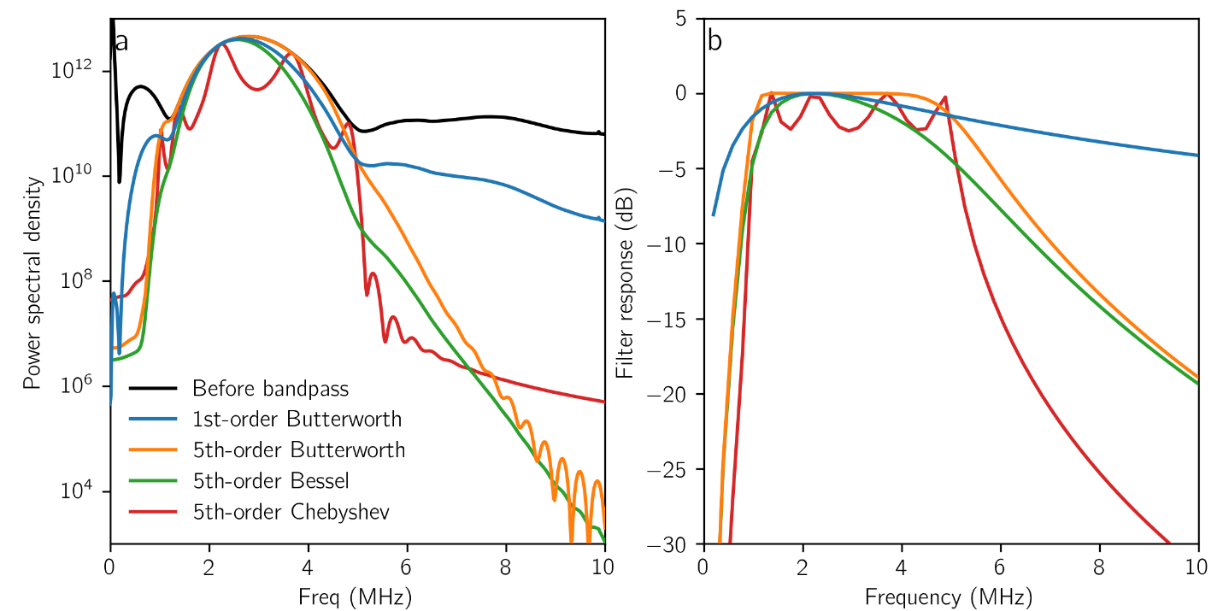
Figure S1. Comparison of several finite impulse response filters applied to data from Northeast Greenland. a. Power spectral density, calculated per-trace then averaged, before processing (black) and after bandpass filtering between 1 and 5 MHz using a 1st-order Butterworth (blue), 5th-order Butterworth (orange), 5th-order Bessel (green), or 5-th order Chebyshev type-I (red) filter. The goal in filter selection is to preserve the shape of the original data in the pass band but cause the amplitude to decay smoothly outside it. b. Filter response as a function of frequency for the three filters in a.

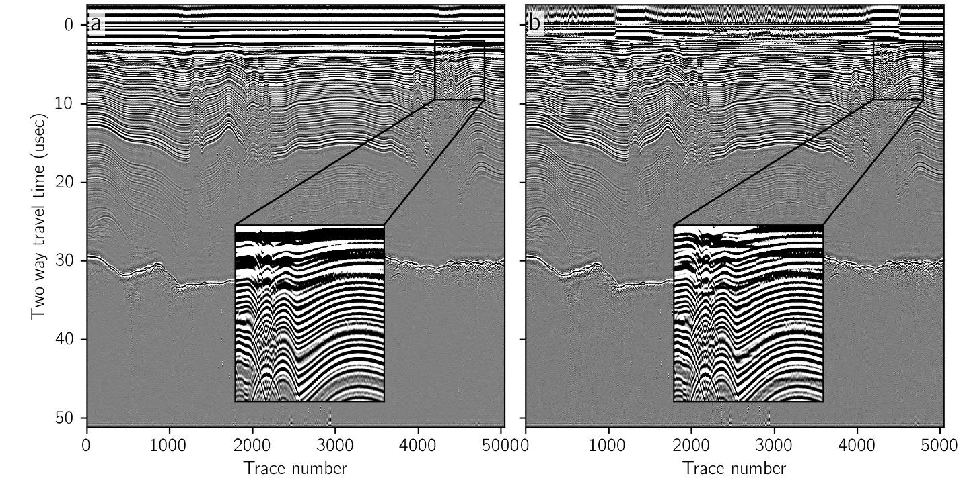
Figure S2. Effect of adaptive horizontal filter. a. Echogram before horizontal filter. b. Echogram after filter. Note that the filter tapers with depth, so deep layers are unaffected, but the filter brings layers out through the noise in some shallow areas (inset in both panels).

