[Annals of Glaciology]
Supplementary Material for

[Freeboard and snow depth observed by floating GPS on land-fast sea-ice in Nella Fjord, Antarctica]

Qingchuan ZHANG¹, Fei LI¹, Jintao LEI^{1,2}, Shengkai ZHANG¹, Zhuoming DING³, Wu CHEN², Wenhao LI¹

[¹Chinese Antarctic Centre of Surveying and Mapping, Wuhan University, Wuhan, China
E-mail: jintao.lei@whu.edu.cn
²Department of Land Surveying and Geo-informatics, The Hong Kong Polytechnic University, Hong Kong, China
³National Marine Environmental Forecasting Center (NMEFC), Beijing, China]

Contents of this file

Figure S1 ~ S3

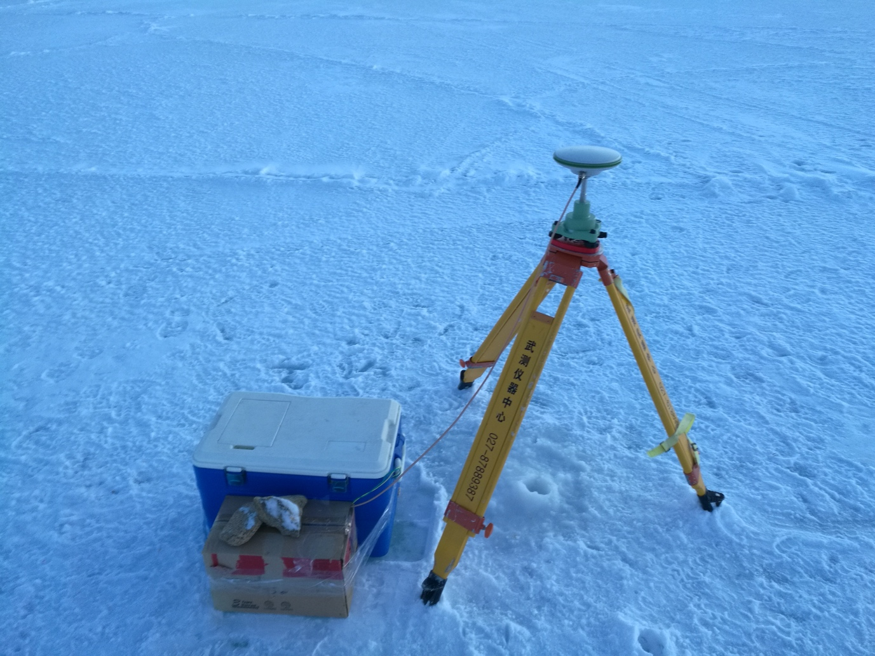
Figure S1. Photo of floating GPS deployed on land-fast sea-ice in Nella Fjord. The Leica dual-frequency GPS receiver is approximately 100 m away from the coastline. The fractures (black arrows) makes sea-ice could hydrostatically move up and down with seawater (King et al. 2003; Lei et al., 2018)

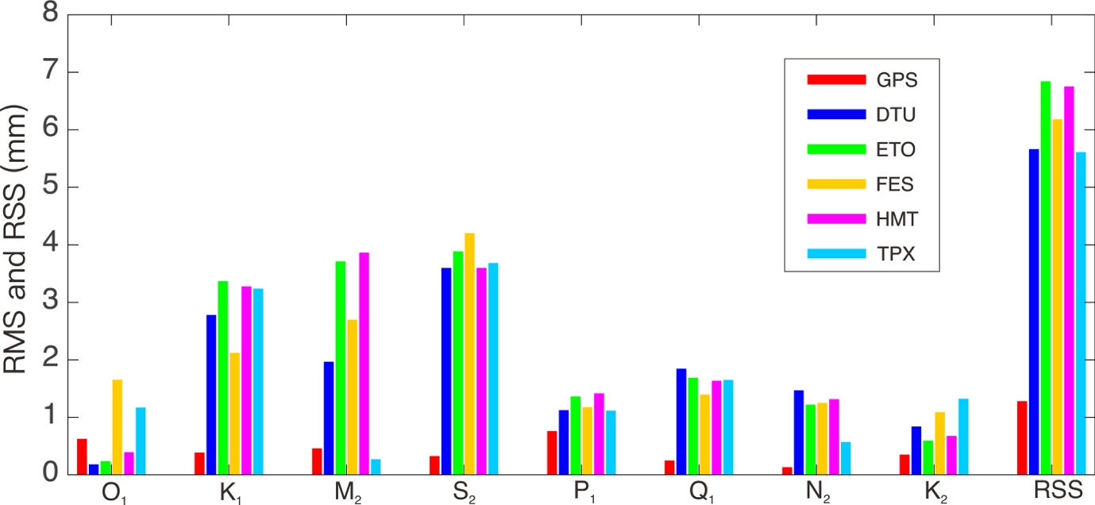
Figure S2. The RMS and RSS of tidal constants on eight main components extracted from GPS and global ocean tide modes, by using the BPG values as ground truth (Lei et al., 2018). Five global ocean tide models are selected: DTU10, EOT11a, FES2014, HAMTIDE and TPXO9 (Cheng & Andersen, 2011; Savcenko & Bosch, 2012; Lyard et al., 2006(update); Taguchi et al., 2014; Dushaw et al., 1997 (update)). The consistency between the tidal constants extracted from GPS and BPG is the best, with an RSS of only 1.3 cm. The accuracies of other numerical models are 5.6 cm (TPXO9), 5.7 cm (DTU10), 6.2 cm (FES2014), 6.7 cm (HAMTIDE), and 6.8 cm (EOT11a). So the effect of using different global ocean tide models on freeboard is approximately 1 cm. TPXO9 model shows the best performance with respect to BPG data and is taken as the representative model in our study. For those long-term constituents (e.g. fortnight m_{f}, monthly m_{m}) the BPG values are used.

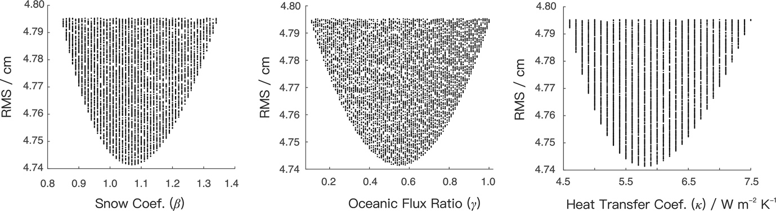
Figure S3. The best 1% parameters of sea ice growth simulation based on the Stefan's law. The optimum of snow coefficient $β$ is 1.07, the optimum of oceanic heat flux factor $γ$ is 0.55, and the optimum of air-snow effective heat transfer coefficient $κ$ is 5.8 W m⁻² K⁻¹.

