APPENDIX A – TRANSMITTED VARIABLES
Table 1. A description of the relevant meta data transmitted for each capture
Row/s | Variable | Units | Description
1 | time | s | current time (UTC)
3 | ID |  | buoy ID
4 | mode_default |  | default mode for capture rate
5 | mode_mode |  | current mode for capture rate
6 | mode_until | s | length of time in current mode
17 | temperature | degrees | internal temperature of case
20 | battery_voltage | deci-volts | battery voltage
21 | device_uptime | s | uptime of board
22 | device_runtime | s | uptime of software
23 | memory_used | % | memory used
26 | sd_used | % | SD card space used
27 | gps_lat | decimal degrees | latitude at start of capture
28 | gps_lon | decimal degrees | longitude at start of capture
29 | gps_sats |  | number of satellites locked
33 | iridim_signal |  | quality of iridium signal (1 – 5)

Table 2. A description of the relevant wave data transmitted for each capture
Row/s | Variable | Units | Description
1 – 4 | Hz_max | m | maximum wave height (trough – crest) in a 256 each segment
5 – 8 | H_{cm}_max | m | maximum height of a crest above mean water level in each 256 s segment
9 – 12 | H_{tm}_max | m | maximum depth of a trough below mean water level in each 256 s segment
13 - 16 | T_{z}_mean | s | mean wave period in each 256 s segment
17 | T_{p} | s | peak period from full (non averaged) spectra
18 | H_{mo} | m | significant wave height from deterministic analysis – 4 x standard deviation of elevation
19 - 73 | psd | m²/Hz | the power spectral density for the 55 wave frequency bins
74-80 | moments |  | spectral moments
90 | qf_mvar | m | quality flag: mean vertical acceleration removed
91 | qf_kist |  | quality flag: Kistler passed (0), Kistler failed (1)
92 | qf_imu |  | quality flag: IMU passed (0), IMU failed (1)
93 | qf_p_kist |  | quality flag: percentage of flagged Kistler samples
94 | qf_p_accel |  | quality flag: percentage of flagged acceleration samples (averaged across 3 axis)
95 | qf_p_gyro |  | quality flag: percentage of flagged gyroscope samples (averaged across 3 axis)
96 | qf_p_mag |  | quality flag: percentage of flagged magnetometer samples (averaged across 3 axis)
98 | power_diff |  | difference between power in the time and frequency domains
101 | Hz_mean | m | deterministic mean wave height

APPENDIX B – ASPECT OBSERVATIONS
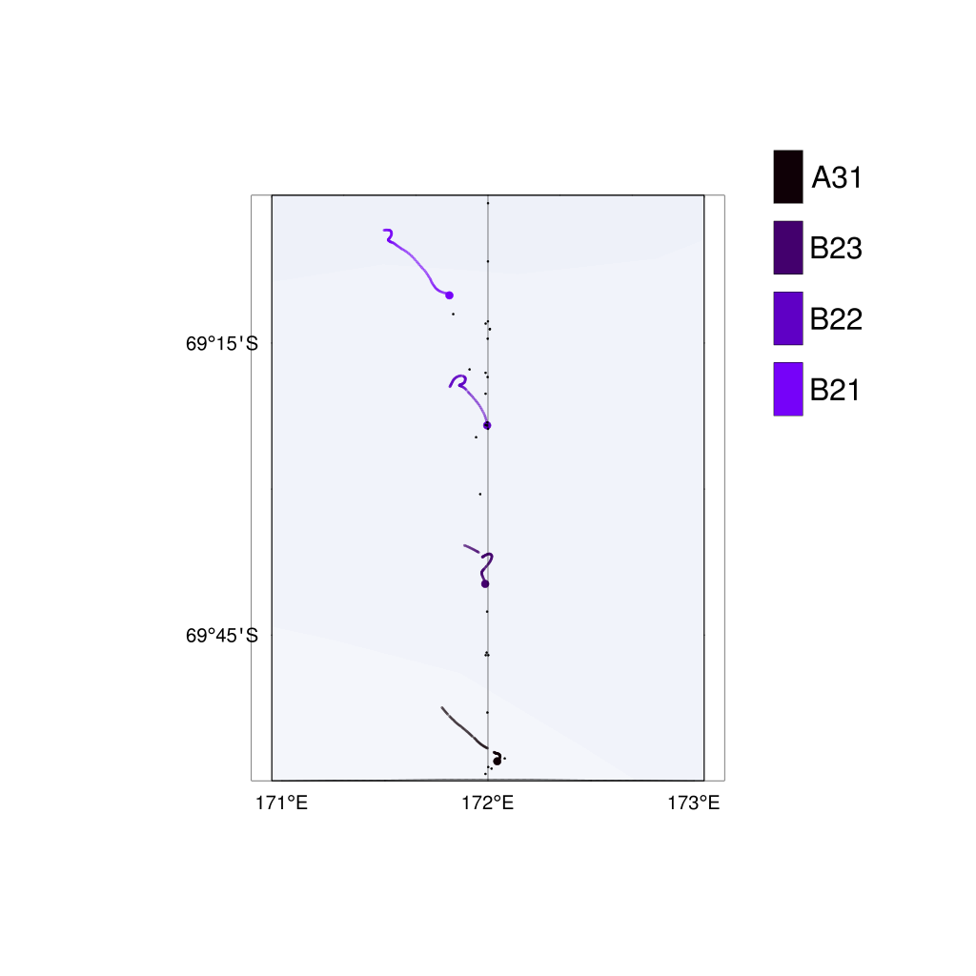
Fig. 18. A map of the location of the ASPeCt observations (small black dots) relative to the inbound deployments (coloured large dots). The lines show the first 24 hrs of the buoy tracks.

Table 3. Details of each ASPeCt observation between buoys during the inbound deployments.
Buoy ID | Ice Thickness (m) | Floe size (m) | Ice Type (m) | Ice Concentration (%)
B21
 | 0.5 | Pancakes | Pancakes | 100
 | 0.3 | Pancakes | Pancakes | 100
 | 0.3 | Pancakes | Pancakes | 100
 | 0.3  0.3  0.3  0.5  0.3  0.25  0.3  0.5  0.15 | Pancakes  Pancakes  Pancakes  Pancakes  Pancakes  Pancakes  Pancakes  Pancakes  Small floes (20 – 100) | Pancakes  Pancakes  Pancakes  Pancakes  Pancakes  Pancakes  Pancakes  Pancakes  Young grey ice (0.1 – 0.15) | 100  100  100  100  100  100  100  80  80
B22
 | 0.5 | Pancakes | Pancakes | 100
 | 0.15 | Small floes (20 – 100) | Young grey ice (0.1 – 0.15) | 100
 | 0.5 | Pancakes | Pancakes | 100
 | 0.5 | Cake ice (< 20 m) | Pancakes | 100
B23
 | 0.5 | Pancakes | Pancakes | 100
 | 0.5 | Pancakes | Pancakes | 100
 | 0.5 | Pancakes | Pancakes | 100
 | 0.5 | Pancakes | Pancakes | 100
 | 0.5 | Cake ice (< 20 m) | Pancakes | 90
 | 0.4 | Large floes (500 - 2000) | Pancakes | 90
A31

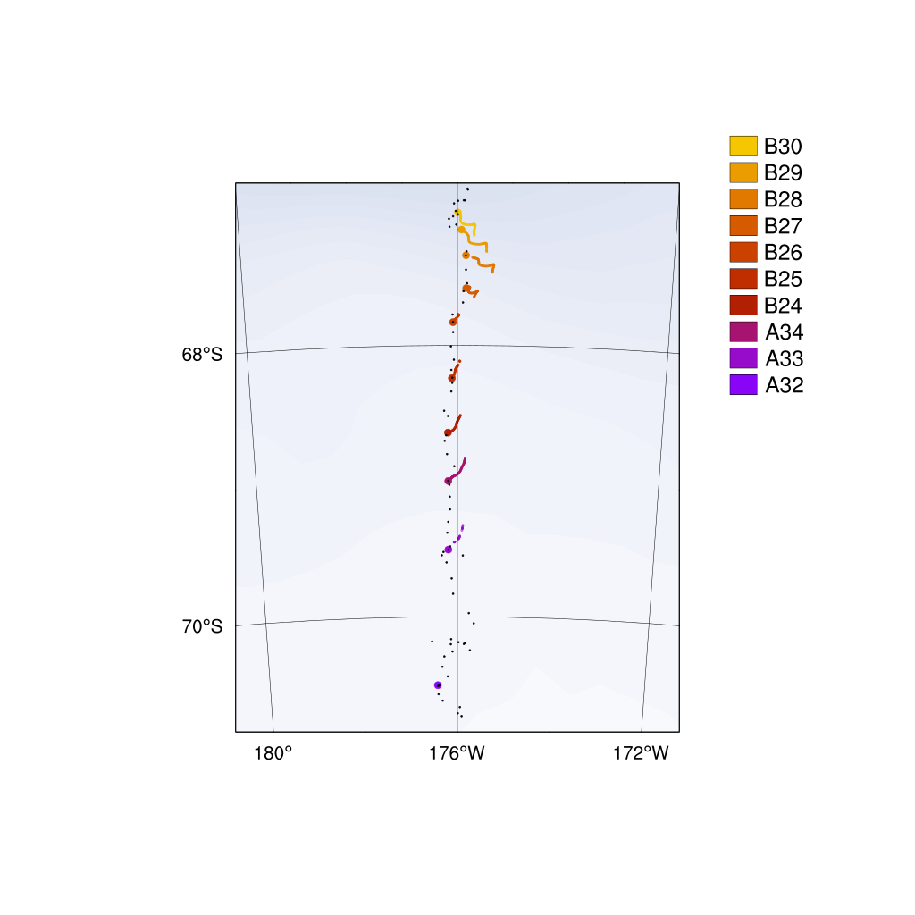
Fig. 19. A map of the location of the ASPeCt observations (small black dots) relative to the outbound deployments (coloured large dots). The lines show the first 24 hrs of the buoy tracks.

Table 4. Details of each ASPeCt observation between buoys during the outbound deployments.
Buoy ID | Ice Thickness (m) | Floe size (m) | Ice Type (m) | Ice Concentration (%)
A32
 | 0.6 | Medium floes (100 - 500) | First year (0.3 – 0.7) | 80
 | 0.4 | Medium floes (100 - 500) | First year (0.3 – 0.7) | 80
 | 0.35 | Large floes (500 - 2000) | First year (0.3 – 0.7) | 70
 | 0.15 | Large floes (500 - 2000) | Young grey-white ice (0.15 - 0.3) | 100
 | 0.4 | Vast floes (> 2000) | First year (0.3 – 0.7) | 100
 | 0.4 | Large floes (500 - 2000) | First year (0.3 – 0.7) | 100
 | 0.3 | Large floes (500 - 2000) | First year (0.3 – 0.7) | 100
 | 0.4 | Large floes (500 - 2000) | First year (0.3 – 0.7)) | 90
 | 0.3 | Large floes (500 - 2000) | First year (0.3 – 0.7) | 100
 | 0.35 | Large floes (500 - 2000) | First year (0.3 – 0.7) | 100
 | 0.4 | Large floes (500 - 2000) | First year (0.3 – 0.7) | 100
 | 0.3 | Large floes (500 - 2000) | Young grey-white ice (0.15 - 0.3) | 100
 | 0.3 | Medium floes (100 - 500) | Young grey-white ice (0.15 - 0.3) | 100
 | 0.2 | Medium floes (100 - 500) | Young grey-white ice (0.15 - 0.3) | 100
 | 0.3 | Large floes (500 - 2000) | Young grey-white ice (0.15 - 0.3) | 100
 | 0.2 | Large floes (500 - 2000) | Young grey-white ice (0.15 - 0.3) | 100
 | 0.3 | Medium floes (100 - 500) | Young grey-white ice (0.15 - 0.3) | 100
 | 0.3 | Medium floes (100 - 500) | Young grey-white ice (0.15 - 0.3) | 100
 | 0.4 | Medium floes (100 - 500) | First year (0.3 – 0.7) | 100
A33
 | 0.6 | Large floes (500 - 2000) | First year (0.3 – 0.7) | 100
 | 0.25 | Large floes (500 - 2000) | Young grey-white ice (0.15 - 0.3) | 100
 | 0.5 | Vast floes (> 2000) | First year (0.3 – 0.7) | 100
 | 0.25 | Large floes (500 - 2000) | Young grey-white ice (0.15 - 0.3) | 100
 | 0.4 | Large floes (500 - 2000) | First year (0.3 – 0.7) | 100
 | 0.4 | Medium floes (100 - 500) | First year (0.3 – 0.7) | 90
 | 0.5 | Medium floes (100 - 500) | First year (0.3 – 0.7) | 100
A34
 | 0.5 | Medium floes (100 - 500) | First year (0.3 – 0.7) | 100
 | 0.25 | Medium floes (100 - 500) | Young grey-white ice (0.15 - 0.3) | 100
 | 0.4 | Small floes (20 - 100) | First year (0.3 – 0.7) | 100
 | 0.6 | Large floes (500 - 2000) | First year (0.3 – 0.7) | 100
 | 0.4 | Medium floes (100 - 500) | First year (0.3 – 0.7) | 100
B24
 | 0.3 | Small floes (20 - 100) | Young grey-white ice (0.15 - 0.3) | 100
 | 0.25 | Small floes (20 - 100) | Young grey-white ice (0.15 - 0.3) | 100
 | 0.35 | Small floes (20 - 100) | First year (0.3 – 0.7) | 100
 | 0.4 | Small floes (20 - 100) | First year (0.3 – 0.7) | 100
B25
 | 0.75 | Small floes (20 - 100) | First year (0.7 – 1.2) | 100
 | 0.15 | Small floes (20 - 100) | Young grey-white ice (0.15 - 0.3) | 100
 | 0.15 | Large floes (500 - 2000) | Young grey-white ice (0.15 - 0.3) | 100
 | 0.5 | Small floes (20 - 100) | First year (0.3 – 0.7) | 100
 | 0.4 | Small floes (20 - 100) | First year (0.3 – 0.7) | 100
B26
 | 0.3 | Small floes (20 - 100) | First year (0.3 – 0.7) | 100
 | 0.3 | Small floes (20 - 100) | First year (0.3 – 0.7) | 100
 | 0.3 | Small floes (20 - 100) | First year (0.3 – 0.7) | 100
 | 0.3 | Small floes (20 - 100) | First year (0.3 – 0.7) | 50
B27
 | 0.5 | Small floes (20 - 100) | First year (0.3 – 0.7) | 100
 | 0.5 | Small floes (20 - 100) | First year (0.3 – 0.7) | 100
 | 0.5 | Small floes (20 - 100) | First year (0.3 – 0.7) | 100
B28
 | 0.5 | Cake ice (< 20) | First year (0.3 – 0.7) | 100
B29
 | 0.3 | Cake ice (< 20) | First year (0.3 – 0.7) | 100
 | 0.3  0.2  0.3  0.3 | Cake ice (< 20)  Pancakes  Cake ice (< 20)  Small floes (20 - 100) | First year (0.3 – 0.7)  Pancakes  First year (0.3 – 0.7)  First year (0.3 – 0.7) | 100  100  90  100
B30

APPENDIX C – WIIOS DEPLOYMENTS
b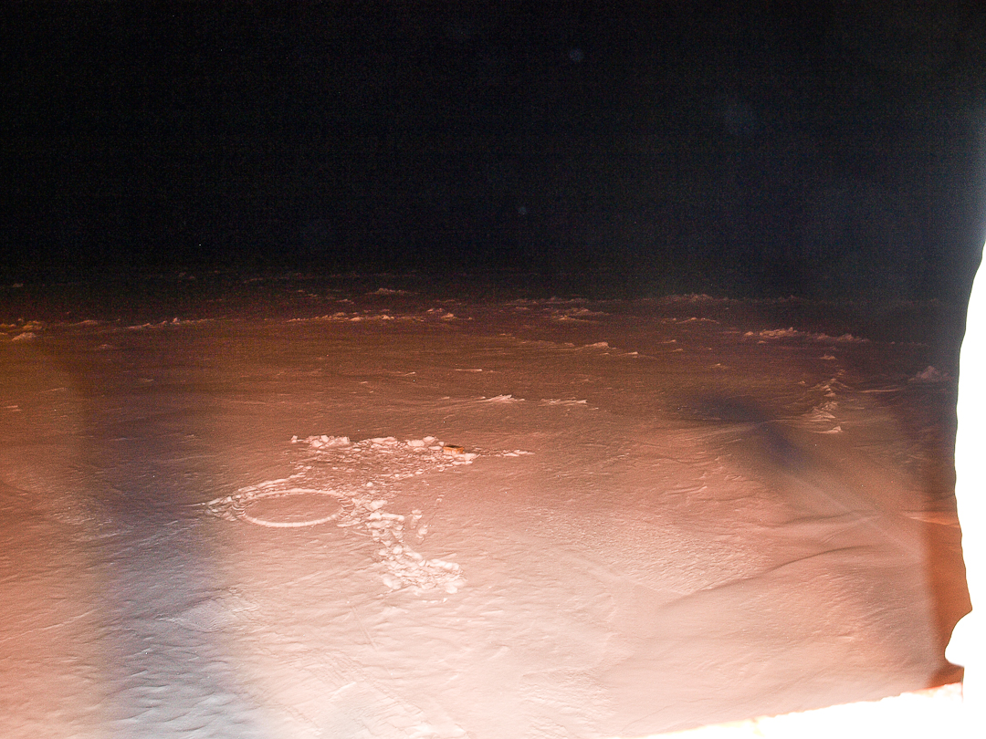

Fig. 20. Images of inbound deployments. (a) WIIOS B21 at 03:50 on 21st April 2017 at 69.1715833 S and 171.8200167 E. (b) WIIOS B22 at 10:40 on 21st April 2017 at 69.394453 S and 171.996 E. (c) WIIOS B23 at 16:20 on 21st April 2017 at 69.666 S and 171.9866667 E. (d) WIIOS A31 at 01:20 on 22nd April 2017 at 69.96966667 S and 172.0448333 E. Photo credits: Lettie Roach.

Fig. 21. Images of outbound deployments. (a) WIIOS A32 at 01:00 on 30th May 2017 at 70.5025 S and 176.4193833 W. (b) WIIOS A33 at 12:40 on 1st June 2017 at 69.5055 S and 176.1855833 W. (c) WIIOS A34 at 20:30 on 1st June 2017 at 68.9995 S and 176.1828333 W. (d) WIIOS B24 at 07:00 on 2nd June 2017 at 68.6434167 S and 176.186W. (e) WIIOS B25 at 15:00 on 2nd June 2017 at 68.24175 S and 176.10725 W. (f) WIIOS B26 at 21:00 on 2nd June 2017 at 67.8286833 S and 176.0849333 W. (g) WIIOS B27 at 03:30 on 3rd June 2017 at 67.5772333 S and 175.8371167 W. (h) WIIOS B28 at 08:30 on 3rd June 2017 at 67.33425 S and 175.8421667 W. (i) WIIOS B29 at 11:00 on 3rd June 2017 at 67.14455 S and 175.9256667 W. (j) WIIOS B30 at 12:30 on 3rd June 2017 at 67.0181167 S and 175.9898333 W. Photo credits: Lettie Roach.

