Analyzing the Impact of CryoSat-2 Ice Thickness Initialization on Seasonal Arctic Sea Ice Prediction
Richard ALLARD¹, E. Joseph METZGER¹, Neil BARTON², Li LI³, Nathan KURTZ⁴, Michael PHELPS⁵, Deborah FRANKLIN⁵, Ole Martin SMEDSTAD⁵, Julia CROUT⁵, Pamela POSEY⁵
¹Naval Research Laboratory, Ocean Science Division, Stennis Space Center, MS, USA
²Naval Research Laboratory, Marine Meteorology Division, Monterey, CA, USA
³Naval Research Laboratory, Remote Sensing Division, Washington DC, USA
⁴NASA, Cryospheric Sciences Laboratory, NASA Goddard Space Flight Center, Greenbelt, MD, USA
⁵Perspecta, Inc., Stennis Space Center, MS, USA

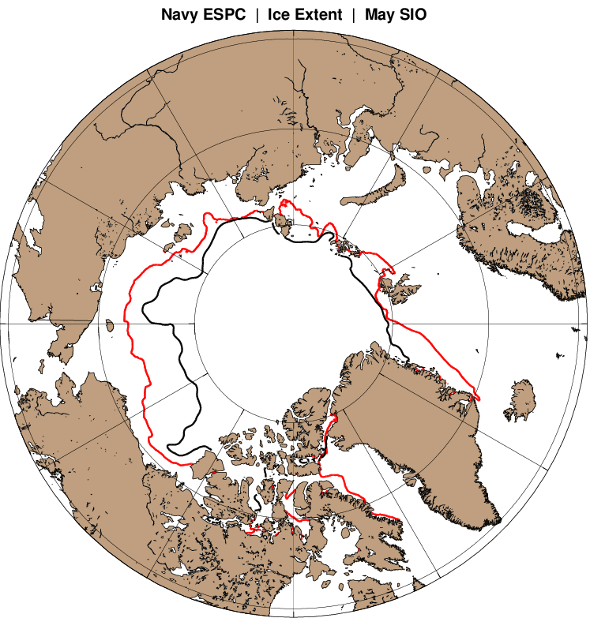
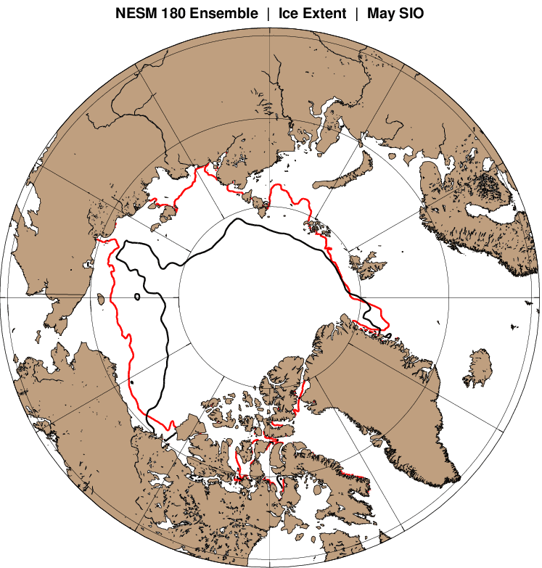
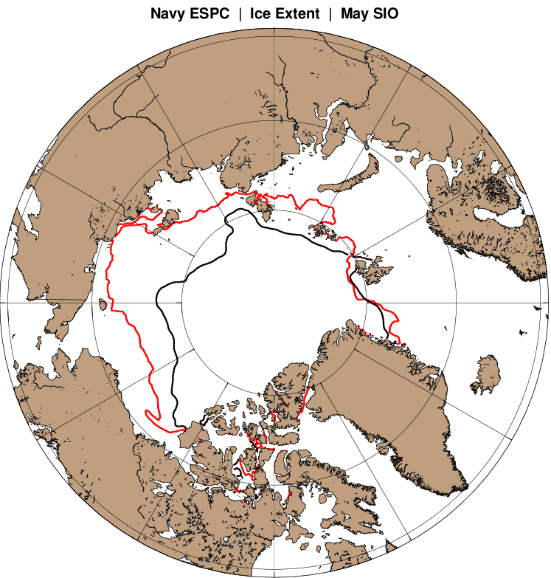
a
b
c

Fig. S1 September observed mean minimum ice extent (black) versus ESPC minimum extent (red) for a) 2017, b) 2018, and c) 2019. None of the ESPC results shown above were initialized with CS2 ice thickness.

a

