Supplementary Material
For: Willams, H.B. and Koppes, M.N.: A comparison of glacial and paraglacial responses to rapid glacial retreat

Contained within these Supplementary Materials are detailed descriptions of the methodologies used in the analyses of changes in glacier surface elevation and changes in sediment delivery from the non-glaciated tributaries and from Tyndall Glacier into Taan Fjord from 1957 on.
Estimation of sediment stored within each fan-delta in Taan Fjord is then discussed in detail, including the generation of the volumetric models used and their estimated errors. Finally, the methods used to derive annual glacier sediment yields and associated erosion rates from acoustic reflection (seismic) profiles of the fjord sediments is described in detail.
The bulk of the analyses were performed using aerial photos, and DEMs at various times, the details of which are provided in Table S1. General physiographic characteristics of each tributary basin are presented in Table S2.
Supporting information and the seismic reflection data can be obtained from the UTIG Academic seismic portal at doi:10.1594/IEDA/500191 and 500192.

- Change in tributary base level

In this study, aerial photographs taken of Tyndall Glacier and Taan Fjord by the US Geological Survey (USGS) in 1957, 1969, 1973, and 1986 were orthorectified and compared to DEMs generated in 2000, 2012, 2014, and 2016, to interpret changes in glacier terminus position and in base level and morphology of the eight tributary basins, over time.
Four orthoimages were created for Taan Fjord using stereo-pairs of historical aerial imagery taken by the US Geological Survey (USGS) (Table S1) using Agisoft PhotoScan version 1.2.6. To estimate elevations of the glacier surface and of the tributary streams, we compared each orthoimage to a 2016 reference LiDAR-derived DEM (Table S1). It should be noted that the historical aerial photos were collected by the USGS with the intent of documenting the condition of Tyndall Glacier, and hence the tributary basins were captured only at the edges of these photographs. This resulted in a general lack of overlap in the images of the tributary basins and made it impossible to reconstruct the entire 3-dimensional surfaces of the basins. Thus, the orthoimages could not be meaningfully differenced to assess overall surface erosion in the basins. However, longitudinal profiles of the lower reaches of each tributary stream could be digitized in two or more years for all of the tributary basins, allowing for an assessment of qualitative and quantitative morphological changes in these sections of the tributary streams.

Table S1. Imagery used for glacier retreat and tributary basin analyses.
Date | Imagery Type | Resolution (m) | Source
7/1957 | Aerial Photos | - | USGS: unknown
7/1957 | Aerial Photos | - | USGS: Austin Post
8/1969 | Aerial Photos | - | USGS: Austin Post
8/1969 | Aerial Photos | - | USGS: Austin Post
9/1973 | Aerial Photos | - | USGS: Austin Post
9/1973 | Aerial Photos | - | USGS: Austin Post
9/1986 | Aerial Photos | - | USGS: Austin Post
9/1986 | Aerial Photos | - | USGS: Austin Post
7/1994 | Landsat 4-5 | 30 | USGS
7/1998 | Landsat 4-5 | 30 | USGS
8/2000 | IfSAR DEM | 5 | Geographic Information  Network of Alaska (GINA)
8/2006 | Landsat 4-5 | 30 | USGS
11/2012 | DEM | 2 | ArcticDEM
2/2014 | DEM | 2 | ArcticDEM
3/2014 | DEM | 2 | ArcticDEM
9/2014 | Satellite Image | 0.5 | Worldview-2
5/2016 | DEM | 2 | ArcticDEM
6/2016 | DEM | 2 | ArcticDEM
6/2016 | LiDAR | 0.2 | Chris Larsen  (University of Alaska Fairbanks)
6/2016 | Orthoimage | 0.1 | Chris Larsen (UAF)
8/2016 | DEM | 2 | ArcticDEM
8/2016 | Bathymetry (DEM) | 1 | USGS
9/2017 | Satellite Image | 10 | Copernicus Sentinel Data

To create longitudinal profiles of the tributary streams, transect lines were manually digitized down the visibly active channels for all streams in all available orthoimages. These transect lines ended where the stream either flowed directly into the glacier, an ice-marginal lake, or the ocean, depending on the year the photo was taken. The lines were drawn to the extent of coverage in the orthoimage or DEM which, due to limitations pertaining to image overlap described above, meant that the complete longitudinal profiles for most of the tributaries were not captured.

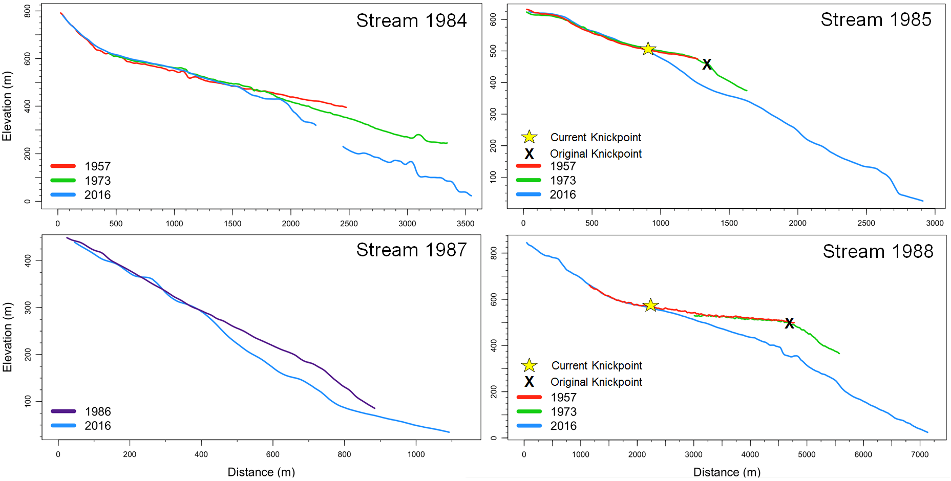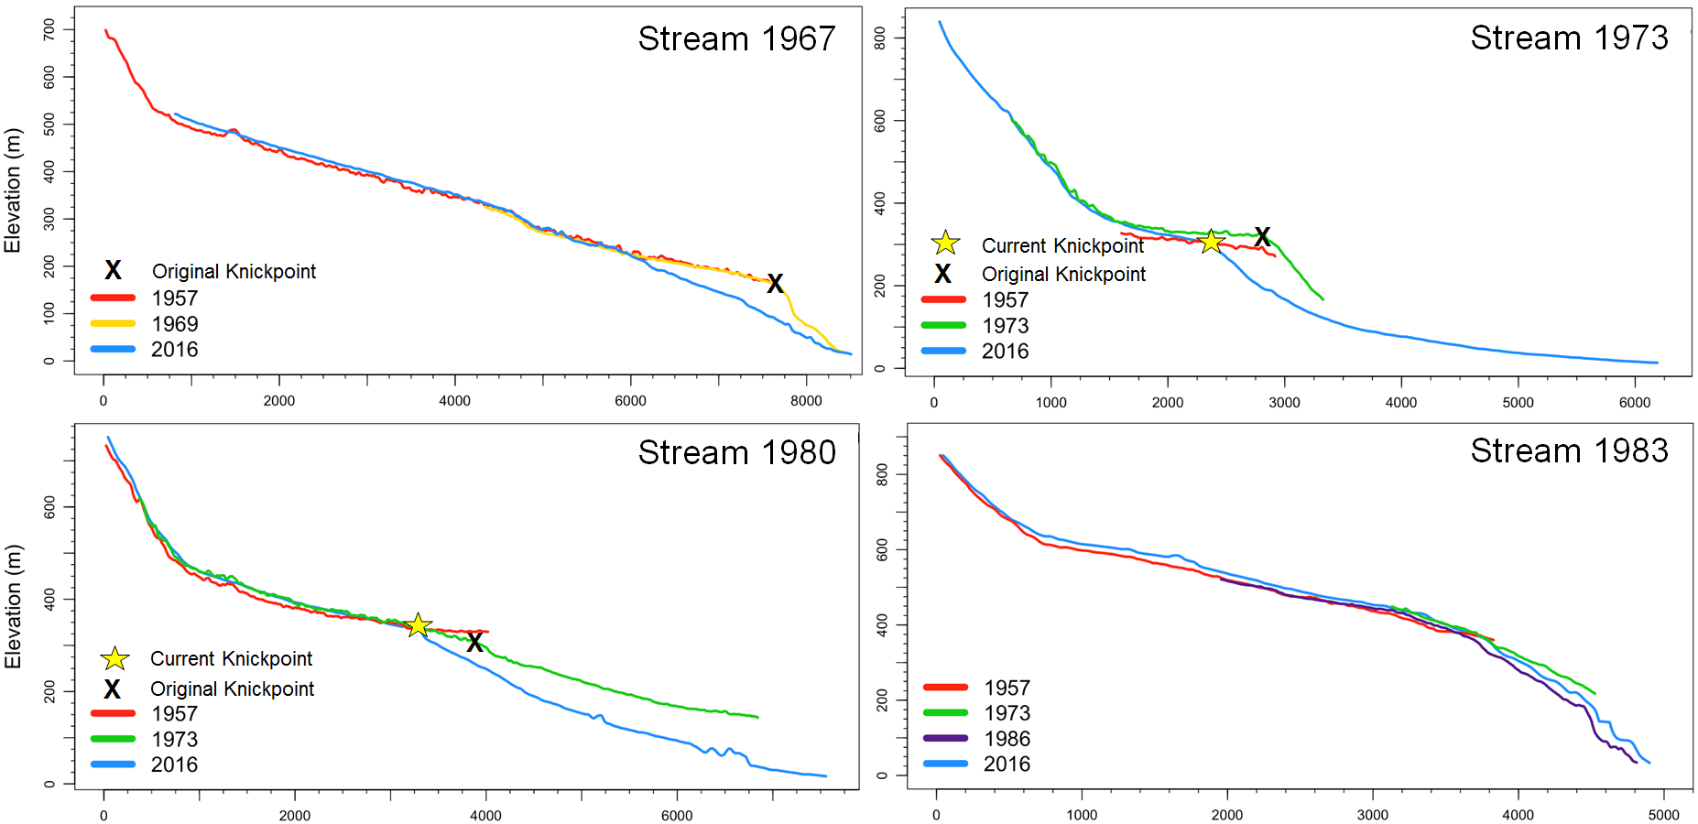

Figure S1. Longitudinal profiles for each stream with black x marking the original knickpoints that developed following base-level fall. Where they exist, knickpoints observed in 2016 are denoted with a yellow star.

Rapid lowering of base-level often leads to the formation of knickpoints along the lower reaches of a stream profile (Schumm, 1993) and this was observed in six of the eight tributary streams (Figure S3). For stream 1967, a knickpoint over 70 m above the 2016 channel bed formed between 1957 and 1969. It was quickly eroded from the profile with no evidence of continued migration upstream, suggesting it was primarily composed of non-cohesive, easily erodible sediment. Knickpoints were still prominent features in the 2016 profiles of streams 1973, 1980, 1985, and 1988 and they had migrated significant distances upstream. For instance, the knickpoint of stream 1988 had migrated 2.2 km upstream between 1957 and 2016 at a rate of approximately 50 m yr⁻¹. The persistence of these knickpoints in the longitudinal profiles of these streams along with their rapid rate of migration suggests that these knickpoints once eroded through non-cohesive lake sediment and have likely encountered relatively cohesive material or bedrock that has slowed their progression upstream. No clear knickpoints were seen in streams 1983, 1984, and 1987.

Table S2. Fan-delta, stream, and watershed characteristics as well as general geologic setting for each tributary basin.
 | 1967 | 1973 | 1980 | 1983 | 184 | 1985 | 1987 | 1988
Fan-Delta Characteristics
Years Exposed | 49 | 43 | 36 | 33 | 32 | 31 | 29 | 28
Area (km²) | 0.73 | 0.85 | 1.18 | 0.04 | 0.13 | 0.21 | 0.09 | 0.60
Depth of Fan Front b.s.l. (m) | 118.53 | 112.11 | 100.53 | 101.22 | 103.33 | 100.94 | 71.28 | 101.41
Avg. Subaerial Gradient | 11.80° | 3.81° | 3.73° | --- | 8.29° | 14.03° | 15.46° | 9.90°
Avg. Subaqueous Gradient | 15.58° | 14.42° | 9.83° | 25.18° | 16.07° | 22.87° | 20.45° | 19.38°
Apex Elevation a.s.l. (m) | 20.65 | 26.03 | 26.08 | 0 | 6.62 | 25.38 | 29.70 | 66.63
Stream Characteristics
Total 2016 Length (km) | 7.78 | 6.24 | 7.60 | 4.94 | 3.59 | 2.96 | 1.14 | 7.18
Length added since 1957 or 1986 (km) | 0.95 | 3.30 | 3.56 | 0.10 | 1.09 | 1.67 | 0.23 | 2.38
Knickpoint Migration (km) | --- | 0.48 | 0.70 | --- | --- | 0.34 | --- | 2.22
Knickpoint Migration Rate (m yr⁻¹) | --- | 11.26 | 16.30 | --- | --- | 8.00 | --- | 51.63
Watershed Characteristics
Watershed Area (km²) | 19.7 | 11.9 | 23.7 | 9.6 | 5.4 | 1.6 | 0.9 | 12.1
Average Gradient | 28.09° | 20.12° | 25.70° | 24.31° | 23.27° | 34.16° | 31.98° | 26.13°
Geology
Lithology | Yakataga | Yakataga | Yakataga | Yakataga | Yakataga | Yakataga/  Poul Creek | Yakataga | Yakataga/  Kulthieth/ Poul Creek

2. Modeling the evolution of fan-deltas from tributary basins
The original volumes contained within the fans in 2016 provided the foundation for our sediment yields and basin-averaged erosion rates. It would be these volumes that would be used to determine sediment yields and basin-averaged erosion rates for each tributary basin. Thus, total volume within each fan-delta was obtained using a Monte Carlo (MC) analysis on three geometric models of the fan-deltas as they appeared in 2016 imagery (Figure S2).

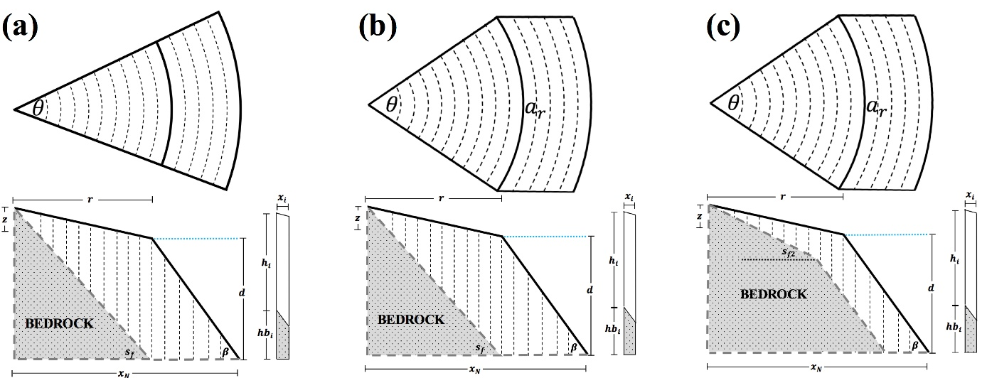
Figure S2. Fan-delta geometries for three different models: (a) represents a fan-shaped wedge of sediment that increases in width with increased distance from the fan apex, (b) depicts those fans that stop increasing in width at sea level, and (c) shows a geometry similar to (b), but with a convex bedrock geometry.

The three models vary according to differences in planar and profile geometry. The first model represents a fan-shaped wedge of sediment that increases in width with increased distance from the fan apex and is underlain by a linearly sloped fjord wall and horizontal base that is at the same elevation as the delta toe. This was used for fan deltas 1967, 1983 and 1988. The second model (Figure S2b) has the same underlying fjord wall geometry, however the width does not increase on the subaqueous portion of the fan-delta. This model was used for fan-deltas 1980, 1984, 1985 and 1987. The final model (Figure S2c), used for FD 1973, uses the same planar geometry, however the underlying fjord wall geometry is convex.
All of the fan deltas were assigned to one of the three geometries and each was divided into equal segments with a length, width, and height. These segments were then summed to provide an estimate of total volume using the basic equation:
$V= \sum_{i=1}^{N}{l_{i}∙w_{i}∙h_{i}}$ [1]
where $N$ represents the user-defined segments to sum volumes across, and $l_{i}$ , $w_{i}$ , and $h_{i}$ are the length, width, and height of each segment respectively. For each of the MC volumetric models, the number of segments per model run, $N$, was 10,000. Determining the length, width, and height variables for each model varied and is discussed in detail for each model below.
The models required between 7 and 8 input variables to determine volume (Table S3). To reduce error associated with defining static input variables, a maximum and minimum value for each was defined and a random uniform distribution (N = 100,000) was created using these values as bounds. The error associated with the stochastic processes ongoing in the basins and the fjord (recorded by only limited data) were deemed to be best captured using PDFs for each fan-delta. By treating the input variables of the volumetric model as random distributions of physically plausible values and applying a Monte Carlo simulation to each volumetric model, our results represent reasonable estimates of the sediment evacuated from each tributary basin.

Table S3. Model parameters needed to obtain volumes for the fan-deltas of Taan Fjord.
Model Parameter | Definition | Models Using Parameter
N | number of segments to calculate volume for (N = 10,000) | 1, 2, 3
$$θ$$ | splay angle of the fan apex (rad) | 1, 2, 3
$$β$$ | average gradient of the delta and subaqueous foreset bed angle (rad) | 1, 2, 3
r | radius of subaerial fan from apex to sea level (m) | 1, 2, 3
z | elevation of the apex of the fan (m) | 1, 2, 3
d | depth of the delta toe (m) | 1, 2, 3
$$S_{f}$$ | fjord wall gradient and fjord wall gradient under subaerial fan-delta 1973 (rad) | 1, 2, 3
$$S_{f2}$$ | fjord wall gradient under subaqueous fan-delta 1973 (rad) | 3

The bounds of the uniform distributions for each variable that were used in the volume calculations were determined in various ways (see Williams, 2018). We determined the minimum and maximum splay angle of the fan-deltas at their apexes, $θ$_{max} and $θ$_{min}, by measuring angles of what we deemed to be conservative extremes. For the subaqueous gradient/foreset bed angles, $β$_{max} and $β$_{min}, multiple 3-dimensional transect lines were run down the delta fronts using the 2016 bathymetry and a distribution of mean gradients were created.
The minimum and maximum radius of each fan-delta was determined by lines drawn from the fan apex to the edge of the subaerial fan for each fan-delta. We took the maximum measured length for $r$_{max} and the minimum length for $r$_{min} as bounds for this variable. Given the vertical resolution of the 2016 imagery (Table S1), the elevation of the apex was considered to be relatively accurate and thus no bounds were used for z.
The fan-deltas interfinger with glacigenic sediment in the fjord for some distance below the sea bed. For this reason, the maximum depth, $d$_{max,} was found using isopach maps of the basement bedrock derived from the acoustic reflections profiles in 2016 and 1999 presented in Haeussler and others (2018) and Koppes and Hallet (2006). It was assumed that each fan-delta began to prograde on this basement bedrock while simultaneously starting to interfinger with glacigenic sediment coming from Tyndall Glacier, and hence maximum depth to bedrock was considered to be between 10 and 50 m below the seabed, depending on the proximity to the glacier source. The minimum depth, $d$_{min}, was the average depth of the fan front where it intersected the seabed in the 2016 bathymetry.
The fjord slope gradient beneath the fan deltas was determined using the same methods that were used to find $β$_{max} and $β$_{min}. Transect lines were run down the fjord walls directly adjacent to the fan-deltas and a distribution of the average gradients was created. The minimum and maximum gradient of that distribution was taken as the $S_{f}$_{max} and $S_{f}$_{min}. The same methods were used to find $S_{f2}$_{max} and $S_{f2}$_{min}, only these variables represented the underlying slope of the sub-aerial component of the 1973 fan-delta.
Once uniform distributions were defined for each parameter, they were then input into the volumetric models using a Monte-Carlo simulation (N = 100,000) to create a probability density function (PDF) of fan-delta volume (Figure S3).
The PDFs were slightly positive-skewed towards a larger volume estimate, with the exception of watershed 1983, which had a significant positive skew. To account for skewness, the volume for each fan-delta was calculated from the median value for each PDF.
The 25th and 75th percentiles were used as the standard error of the volume estimates, the proportion of the standard error to the median value was taken as the error estimate for both the sediment yield and erosion rate for each tributary basin. As an example, for tributary 1988, the maximum standard error of the volumetric model was approximately 11% of the median value. This corresponded to a total volume of 34.2 ± 3.8 million m³. The average annual erosion rate was 71 mm yr⁻¹, and with this standard error applied, the standard error of this estimate was predicted to be ±7.8.

Figure S3. Monte Carlo volume distributions for each fan-delta in Taan Fjord. Red lines indicate the median volume and the dotted blue lines represent +/- one standard error.
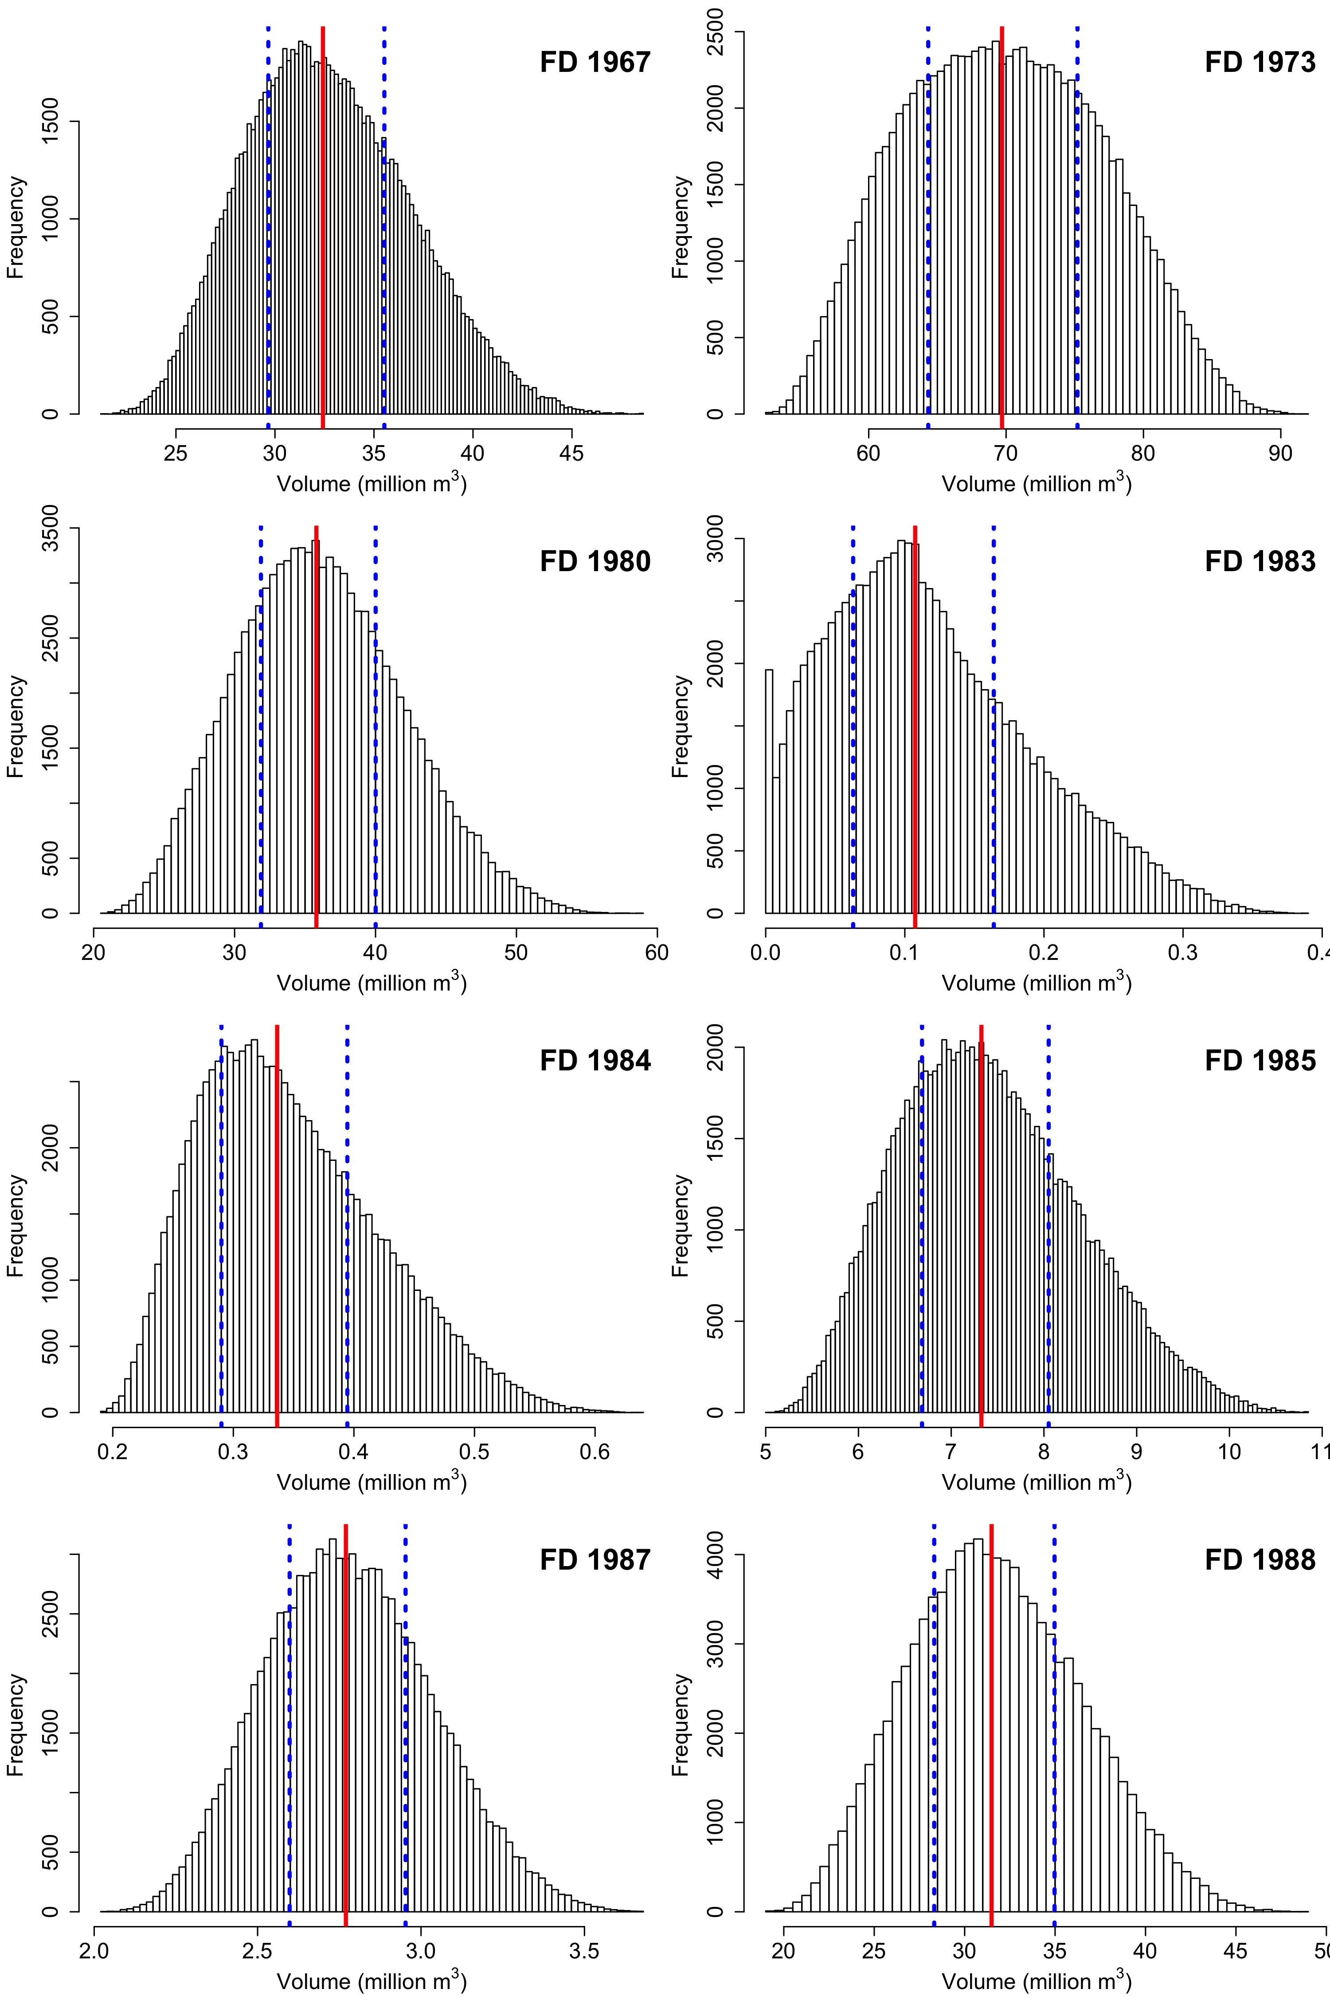

Fan-Delta Volume Model 1
The first model is the simplest of all three models. This fan-delta type is assumed to be a fan-shaped wedge of sediment that increases in width with increased distance from the fan apex (figure 2-2a). The only fan-deltas exhibiting this shape were fan-deltas 1983 and 1988 and their volumes were found using the equation:
$V_{1}= \sum_{i=1}^{N}{\left(θ* x_{i}\right)*\left(x_{2}\right)*(h_{i}-{hb}_{i})}$ [2]
where $θ$ is the splay angle of the fan at its apex and $x$is the horizontal distance from the fan apex to delta toe along the base of the fan-delta from $i=1$ to $N$ number of segments. $h$ is the elevation of the fan-delta surface and ${hb}_{i}$ is the elevation of the underlying bedrock surface. $x_{2}$ is the horizontal distance between the apex of the fan and start of the second segment and thus represents the width of each segment. The total length of x is given by:
$x=r+d(tanβ)$ [3]
where $d$ is delta toe depth and $r$ is the radius of the subaerial fan. $β$ is the foreset bed angle.
The elevation of the fan-delta surface above the delta toe, $h$, is composed of two elevation vectors: $h_{sae}$ for the elevation of each segment of the fan above sea level (subaerial heights) and $h_{saq}$ for elevation of each segment of the delta surface below sea level (subaqueous heights) and can be seen in more detail in figure 2-3. These two variables were found by:
$h_{sae}= \sum_{i=1}^{r}{(r-x_{i})}*S_{sae}+d$ [4]
$h_{saq}= \sum_{i=r}^{N}{d-(x_{i}-r)}*tan⁡(β)$ [5]
where $S_{sae}$ is the slope of the subaerial fan (m/m) obtained by dividing the fan apex elevation, $z$, by the subaerial radius, $r$. This $h$ variable is the height of the surface of the fan-delta above the delta toe elevation, and so the geometry of the fjord wall must be subtracted from these heights to prevent including bedrock in the volume estimations. The elevation of the fjord wall beneath the fan-delta, ${hb}_{i},$ is given by the linear function:
${hb}_{i}= \sum_{i=1}^{N}{\left(z+d\right)+ S_{f}*x_{i}}$ [6]
where $S_{f}$ is the assumed slope of the fjord wall, $z$ is the fan apex elevation, and $d$ is average depth of the delta toe.
We note that the volume for fan-delta 1983 was also calculated using this model, however this fan-delta is completely subaqueous. To account for this, the input for radius of the subaerial fan-delta, $r$, was set at 0 m. The model therefore only considered volumes below sea level for fan-delta 1983.
Fan-Delta Volume Model 2
Five of the fan-deltas had a geometry similar to that of figure 2-2b. These deltas are characterized by a fan-shaped wedge of sediment above sea level, but below sea level the width of the fan does not increase. Fan-deltas 1967, 1980, 1984, 1985, and 1987 all fit this category of fan-delta. The formula for model 2 is almost exactly the same as that of model 1, however the radial increase of each segment stops at sea level and remains the same until the delta toe. Thus, the equation looks similar to equation 2:
$V_{2}= \sum_{i=1}^{N}{\left(a_{i}\right)*\left(x_{2}\right)*(h_{i}-{hb}_{i})}$ [7]
with the only difference being in the use of $a$. In this case, $a_{i}$ is an arclength that consists of two vectors,${ a}_{sae}$ and ${ a}_{saq}$. They account for the termination of radial increase at sea level and ${ a}_{sae}$ is found by:
${ a}_{sae}= \sum_{i=1}^{r}{θ*(r-x_{i})}$ [8]
which creates a fan shape of increasing arc length components with increasing distance from the fan apex until the radius of the subaerial fan, $r$, is reached. ${ a}_{saq}$ is simply a repetition of the final value of ${ a}_{sae}$ until the distance to the delta toe is reached:
${ a}_{saq}= \sum_{i=r}^{N}{θ*r}$ [9]
Fan-Delta Volume Model 3
Model 3 was only used on fan-delta 1973 and it uses elements of both model 1 and 2. It has the same geometry as model 2, however the fjord wall underneath the fan delta has a convex shape instead of a simple linear shape (figure 2-2c). Volume for fan-delta 1973 was thus found by summing the volume of the subaerial and subaqueous portions of the fan separately:
$V_{3}= V_{sae}+V_{saq}$ [10]
To find the subaerial volume, $V_{sae}$, we used equation 2, but terminates at sea level, thus only calculated subaerial volume:
$V_{sae}= \sum_{i=1}^{r}{θ*(r-x_{i})*\left(x_{2}\right)*(h_{i}-{hb}_{i})}$ [11]
For the subaqueous volume, $V_{saq}$ , we assumed that there was no radial increase below sea level for this fan, as we did in model 2. We therefore used an equation similar to equation 7 to find the subaqueous volume:
$V_{saq}= \sum_{i=r}^{N}{\left({ a}_{{saq}_{i}}\right)*\left({ x}_{2}\right)*(h_{i}-{hb}_{i})}$ [12]
In both equations, $h$ still represents a vector of the elevation of the surface of the fan-delta above the delta toe, only $h$ in equation 11 is the elevation above sea level and $h$ in equation 12 is the elevation below sea level of each segment. The elevation of the fjord wall beneath the fan, ${hb}_{i}$, in both equations 11 and 12 is found by a linear function representing the fjord wall geometry, as was detailed in equation 6. There are two different fjord wall slopes $S_{f}$ and $S_{f2}$ that were applied in this model, and hence ${hb}_{i}$ varies for each equation. The fjord wall slope beneath the subaerial portion of the fan-delta is less than that under the subaqueous portion, thereby producing a prominent break beneath the fan-delta at sea level (figure S2c).

Pre-2016 Volume Estimation

Alluvial fans share a constant volume-area proportionality with increased growth that follows a power-law trend (Giles and others, 2010). This suggests that as the fan-delta grows in surface area, its volume also grows in constant relation to that area increase. Therefore, to generate sediment yields for the basins in Taan Fjord, we calculated the total volume of the fan-deltas in 2016 using the methodology described previously and created a constant of proportionality between the observed fan-delta area and modelled fan-delta volume. Then, a subaerial to subaqueous surface area ratio was found for each fan-delta in 2016 and used to determine total surface areas in years where no bathymetric data existed. Finally, the total area derived from this ratio was multiplied by the surface area-to-volume relation for each fan-delta in the year of interest. This allowed for an estimation of fan-delta volume in historical aerial imagery in which only subaerial components of the fan-deltas were visible. Doing so yielded a volume that could then be used to calculate sediment yields from the tributary watersheds since 1957.

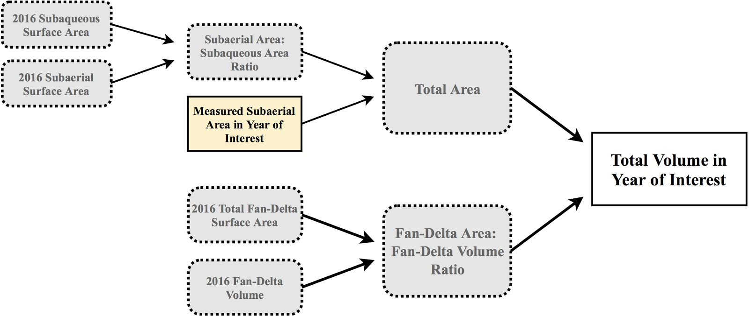

Figure S4. Workflow used to obtain fan-delta volumes from subaerial surface areas.

- Quantifying glacier sediment yields

In August 1999 and again August 2016, we collected a high-resolution acoustic reflection data in Taan Fjord, using a 300-Hz Datasonics bubble pulser in 1999 and a 500-J DuraSpark sparker with a 600-Hz dominant frequency in 2016 (see Koppes and Hallet, 2006 and Haeussler and others, 2018). Additional information on the seismic data acquisition and processing in 2016 is in the supporting information from Haeussler and others (2018). The theoretical vertical resolution of the data is ±1–3 m. The maximum distance between track lines was approximately 500 m.

To calculate the sediment yields from Tyndall Glacier, the total volume of glacially-derived sediment deposited in Taan Fjord since 1957 was interpolated between the seabed and the base of the post-retreat sediment package from the submarine moraine at the entrance of Taan Fjord (the 1957 position) to the current terminus, using both the inverse distance weighting (IDW) and triangular irregular network (TIN) methods in ArcGIS. The difference between the top and bottom surfaces provides the volume of sediment that accumulated during retreat of Tyndall Glacier. The base of the post-retreat sediment package was determined from a strong acoustic basement reflector, which correlates with exposures of the glacimarine Yakataga Formation along the shoreline (Haeussler and others, 2018). We determined sediment thickness using the velocity of sound in seawater (1,500 m/s) from the seismic profiles. This velocity approximates a minimum for fine-grained water saturated sediments and is a value commonly used in seismic reflection studies of glacimarine muds (e.g., Cai and others, 1997; Cowan and others, 2010). Thickness values will be most accurate at shallow depths below the seafloor. We note that the seismic velocity used is likely too slow for the more consolidated sediments found at the base of these deposits, hence all sediment thickness and volume estimates are also minima; we estimate the uncertainties in sediment thickness could be 3-10% greater if the sediments have undergone dewatering and compaction (Love and others, 2016). Assuming that sediment reworking through turbidity flows and slumping is efficient at smoothing the sediment surface, the interpolated surface of the reconstructed bed using the TIN and IDW methods appears to adequately represent the sediment thickness between track lines, with an additional 10% uncertainty.
We also identified each fan-delta complex and any fjord wall slumps by their seismic facies and excluded them from the glacimarine sediment thickness measurements. A few of the submarine fan facies (notably FD 1973) appeared interfingered with distal glacimarine sediments along the fan edge, and thus were included in the fjord volume computation. We also note that the fan-delta surfaces represent only the coarser fractions of the paraglacially derived sediments; the fraction of fines from these streams was deposited distally in the fjord and would appear indistinguishable from the distal glacimarine facies, but the magnitude is unknown. We emphasize the counteracting effect of these uncertainties: whereas the glacier-supplied sediment flux/volume would be overestimated if some of the sediment entered from these paraglacial sources other than the glacier, it will also be underestimated if some of the finer fractions of both glacially and paraglacially derived sediment were transported out of and deposited beyond the fjord.
To quantify the uncertainties in the yields and volume estimates of the glacimarine sediments, we summed the errors in vertical resolution due to uncertainties in seismic velocity chosen (using the 1500 m/s standard) and picking errors for the top and bottom of the glacimarine package (estimated from the resolution of the acoustic reflection software to be ± 1m), with uncertainties in the mapped lateral extent of the sediments in the basin using the interpolation methods (estimated using leave-one-out cross validation to be 10% (Koppes and Hallet, 2006)). We then multiplied the vertical uncertainty by the lateral uncertainty to obtain the volume uncertainty. We note that these combined uncertainties are small relative to the total volumes. Thus, summing all of the uncertainties, we assign a ±30% uncertainty to the sediment volume and flux calculations, and stress that our results likely underestimate the total volume of sediment delivered by Tyndall Glacier during its retreat.

To explore the history and variability of sediment fluxes from Tyndall Glacier during retreat, we employ a numerical model of annual sedimentation into Taan Fjord first described in Koppes and Hallet (2002), and further built upon in Koppes and Hallet (2006) and Love and others (2016). We model the yearly sediment delivery as a function of the sediment accumulation and redistribution rate and the terminus retreat rate. The sediment thickness S at any point in the fjord is the integral of the evolving sedimentation rate at the ice front S₀ and the evolving distance from ice front as the terminus retreats R :

$$S=\frac{∂S_{0}}{R}$$
[13]

The sedimentation rate is modeled yearly as exponentially decreasing with distance downfjord, based on field observations of rapid sediment accumulation near the terminus of tidewater glaciers and lower (but significant) accumulation extending several kilometers downfjord (e.g., Cowan and Powell, 1991; Koppes and others, 2009). The resulting glacial sediment flux Q_{sed ,} per unit time (t = year) is then calculated as the integral of the sediment accumulation S over the entire fjord bottom and the fjord width W:
$$Q_{sed}(t) = \int_{0}^{∞}{S(x,t)W(x)dx}$$
[14]

To arrive at basin‐averaged glacial erosion rates, we then divide the sediment flux Q_{sed} by the contributing glacier catchment area, and take into account the difference in density between the eroded bedrock and the glacimarine sediment in the fjord. The effective erosion rate, E, is annually averaged over the period of retreat and the entire glacierized area, A, where:

$\dot{E}=\frac{ρ_{sed}Q_{sed}/ρ_{rock}}{A}$
[15]

We assume an average bedrock density, ρ_{rock}, of 2350 kg m⁻³, a reasonable mean value for the metasedimentary and sedimentary bedrock that underly Tyndall Glacier based on rocks of similar age and burial history within the Yakutat Terrane (Mankhemthong et al., 2013; Saltus et al., 2016). We use an average dry bulk density of glacimarine sediments, ρ_{sed}, of 1300 kg m⁻³, measured from sediment cores collected in many fjord settings (e.g. Milliken and others, 2009; Love and others, 2016). For our calculated average sediment flux of Q_{sed} = 1.3 × 10⁷ m³a⁻¹, the average flux of eroded bedrock from Tyndall Glacier divided by the contributing basin area (256 km² for the watershed in 1957, decreasing in a stepwise fashion to 154 km² by 1991), yields a basin‐averaged erosion rate of 26 ± 5 mma⁻¹ since 1957.

Additional references cited in Supplemental Materials:

Agisoft, L.L.C., 2014. Agisoft PhotoScan user manual: professional edition.

Cai, J., Powell, R.D., Cowan, E.A. and Carlson, P.R., 1997. Lithofacies and seismic-reflection interpretation of temperate glacimarine sedimentation in Tarr Inlet, Glacier Bay, Alaska. Marine Geology, 143(1-4): 5-37.

Cowan, E.A., and Powell, R.D.,1991. Ice-proximal sediment accumulation rates in a temperate glacial fjord, southeastern Alaska, in Glacial Marine Sedimentation: Paleoclimatic Significance, edited by J. B. Anderson and G. M. Ashley, Geological Society of America, Boulder, CO, p. 61-73.

Koppes, M.N., Hallet, B., and Anderson, J.B., 2009. Synchronous acceleration of ice loss and glacial erosion, Glaciar Marinelli, Chilean Tierra del Fuego. Journal of Glaciology, 55, 207–220, doi:10.3189/002214309788608796.

Milliken, K. T., J. B. Anderson, J. S. Wellner, S. M. Bohaty, and P. L. Manley, 2009. High-resolution Holocene climate record from Maxwell Bay, South Shetland Islands, Antarctica, Geological Society of America Bulletin, 121(11-12), 1711-1725, doi:10.1130/B26478.1
Saltus, R.W., Stanley, R.G., Haeussler, P.J., Jones III, J.V., Potter, C.J. and Lewis, K.A., 2016. Late Oligocene to present contractional structure in and around the Susitna basin, Alaska—Geophysical evidence and geological implications. Geosphere, 12(5), pp.1378-1390.
Schumm, S.A., 1993. River response to baselevel change: implications for sequence stratigraphy. The Journal of Geology, 101(2), pp.279-294.
Westoby, M.J., Brasington, J., Glasser, N.F., Hambrey, M.J. and Reynolds, J.M., 2012. ‘Structure-from-Motion’photogrammetry: A low-cost, effective tool for geoscience applications. Geomorphology, 179, pp.300-314.
Williams, H. B. (2018). Paraglacial landscape evolution in a rapidly deglaciating environment: A case study of Taan Fjord, Southeast Alaska, USA. MSc. Thesis, University of British Columbia, 83 pp.

