SUPPLEMENTARY MATERIAL
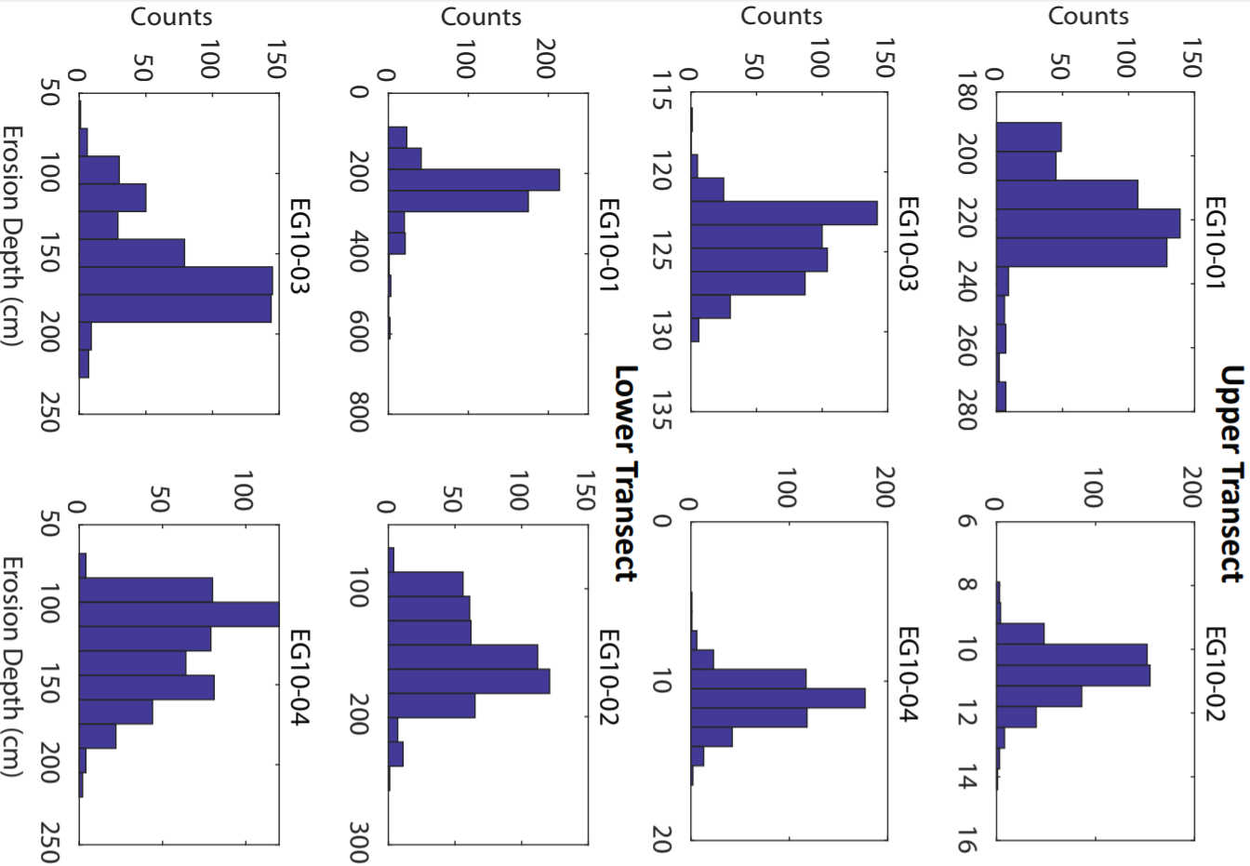
Figure S2. Histograms showing the results of the 500-point Monte Carlo bootstrapping calculation done to determine the errors on our erosion depth calculations. Note the flatter distribution of lower transect results and in particular the non-normal distributions for samples EG10-10 and EG10-12, indicating our lower confidence in erosion depths for the lower transect.

