SUPPLEMENTARY MATERIAL
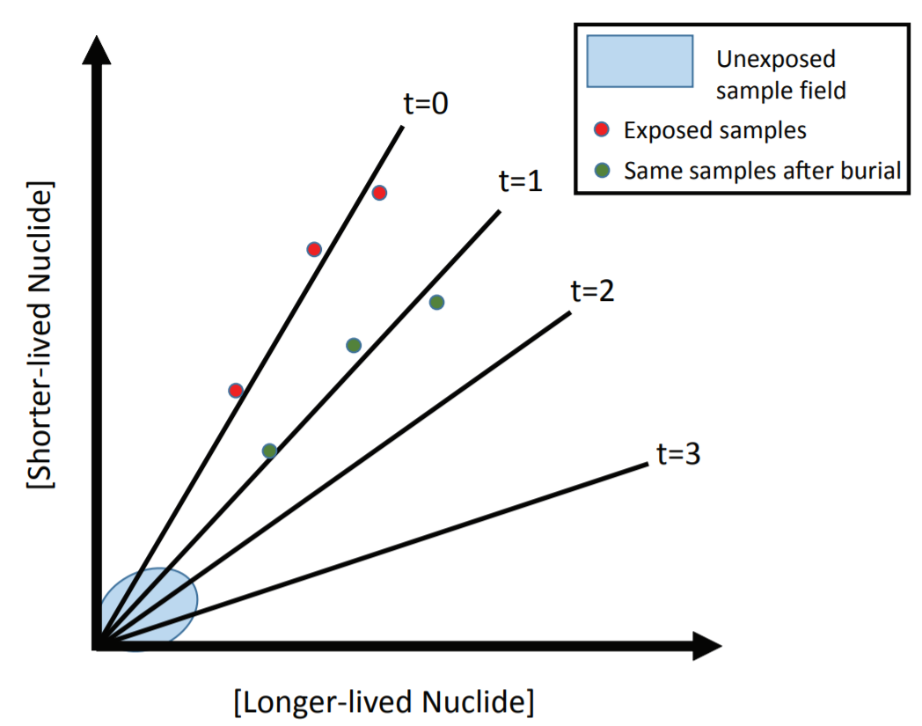
Figure S1. Any set of samples that are exposed simultaneously will plot along a line on a two-nuclide graph regardless of the concentrations of those nuclides in the samples at the time of exposure. In the example shown here, the three samples (circles) were initially exposed and began to accumulate both the shorter- and longer-lived nuclides. While these concentrations were low, all three samples plotted within the unexposed sample field near the origin. As concentrations increased, all three samples plotted progressively further from the origin along the t=0 isochron (the line labeled “t=0”). The slope of this isochron equals the production rate ratio of the two nuclides. At some point, two or more of the samples were eroded, reducing their concentrations (red circles; the samples ‘slid back down’ the isochron, plotting nearer the origin). If all three samples are buried simultaneously, they will continue to plot along a line (green circles). The longer they remain buried, the shallower the slope of the line will be (i.e., as burial duration increases, the isochron ‘tilts’ towards the axis on which the longer-lived nuclide is plotted).

