Supplementary Material for

Subglacial sediment distribution from constrained seismic inversion, using MuLTI software: Examples from Midtdalsbreen, Norway
S. F. Killingbeck¹, A. D. Booth¹, P. W. Livermore¹, L. J. West¹, B.T.I Reinardy² and A. Nesje³
¹School of Earth and Environment, University of Leeds
²Department of Physical Geography, Stockholm University and Bolin Centre for Climate Research, Stockholm
³Department of Earth Science, University of Bergen
The MuLTI algorithm can be found at: https://github.com/eespr/MuLTI, DOI 10.5281/zenodo.1489959.
Table S1. Inversion parameters used in MuLTI for the synthetic feasibility study and 1D and 2D real data inversions, explained further in Killingbeck and others, 2018.

Inversion Parameter | Value
Number of Layers | 3
Minimum number of total nuclei | 3
Maximum number of total nuclei | 33
Maximum depth | 40 m
Burn in number | 10 000
Number of Iterations (including burn in) | 1 000 000
Number of MCMC chains | 1
Sigma change | 20 m/s
Sigma move | 1 m
Sigma birth | 400 m/s

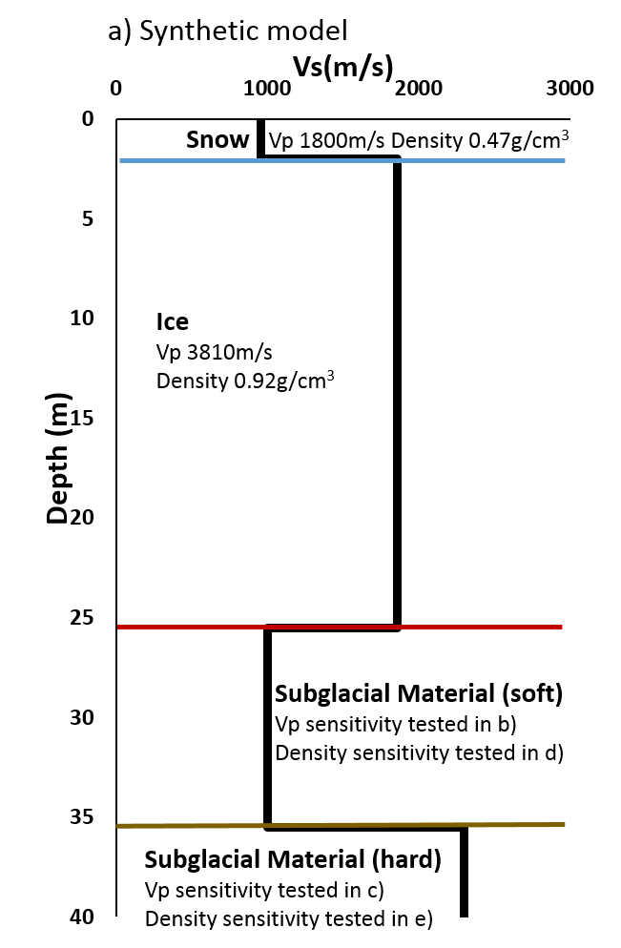

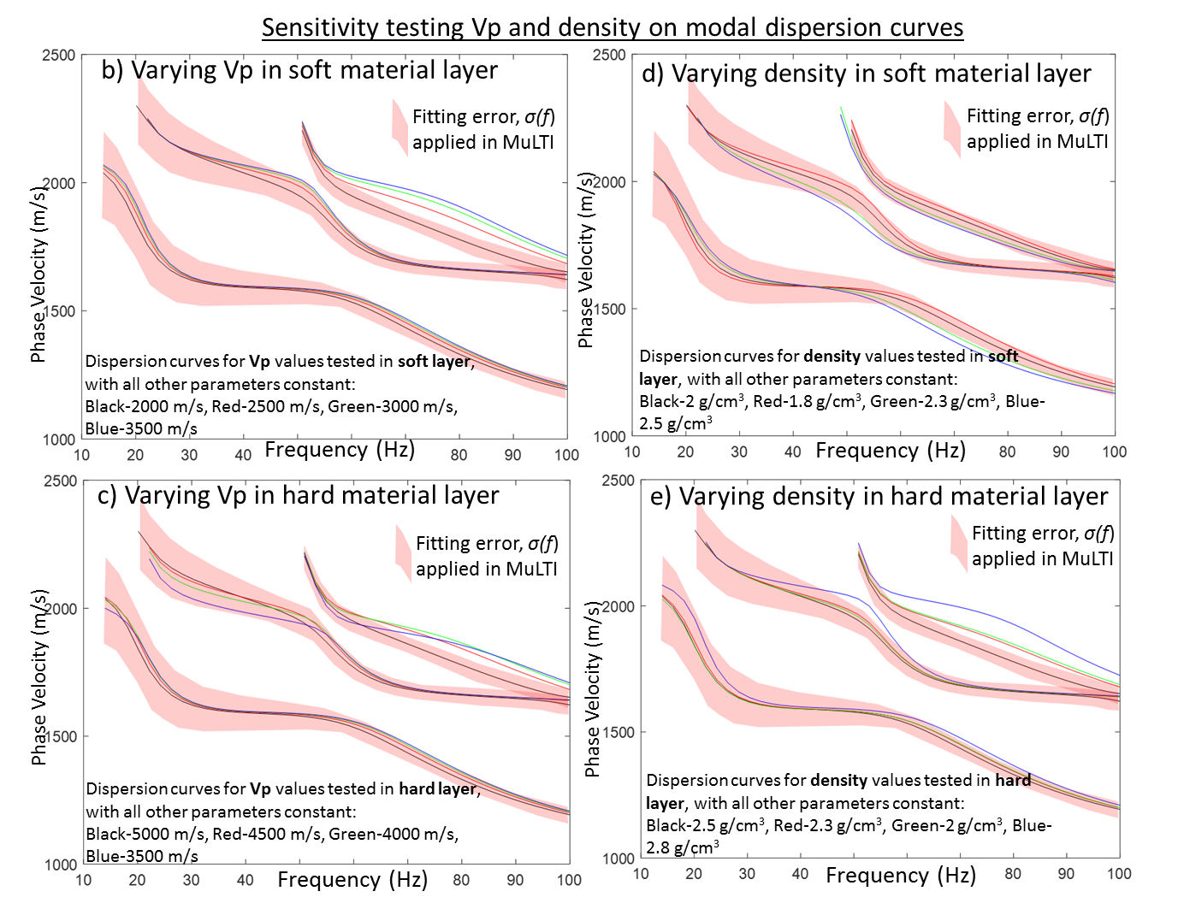

Figure S1 Sensitivity testing Vp (b and c) and density (d and e) on modal dispersion curves for the synthetic model shown in a).

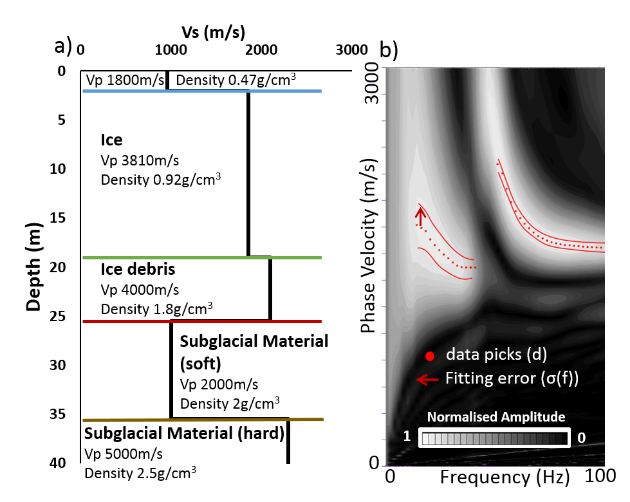

Figure S2 a) Complex synthetic model with added ice-debris layer and b) corresponding DWN synthetic dispersion curve.

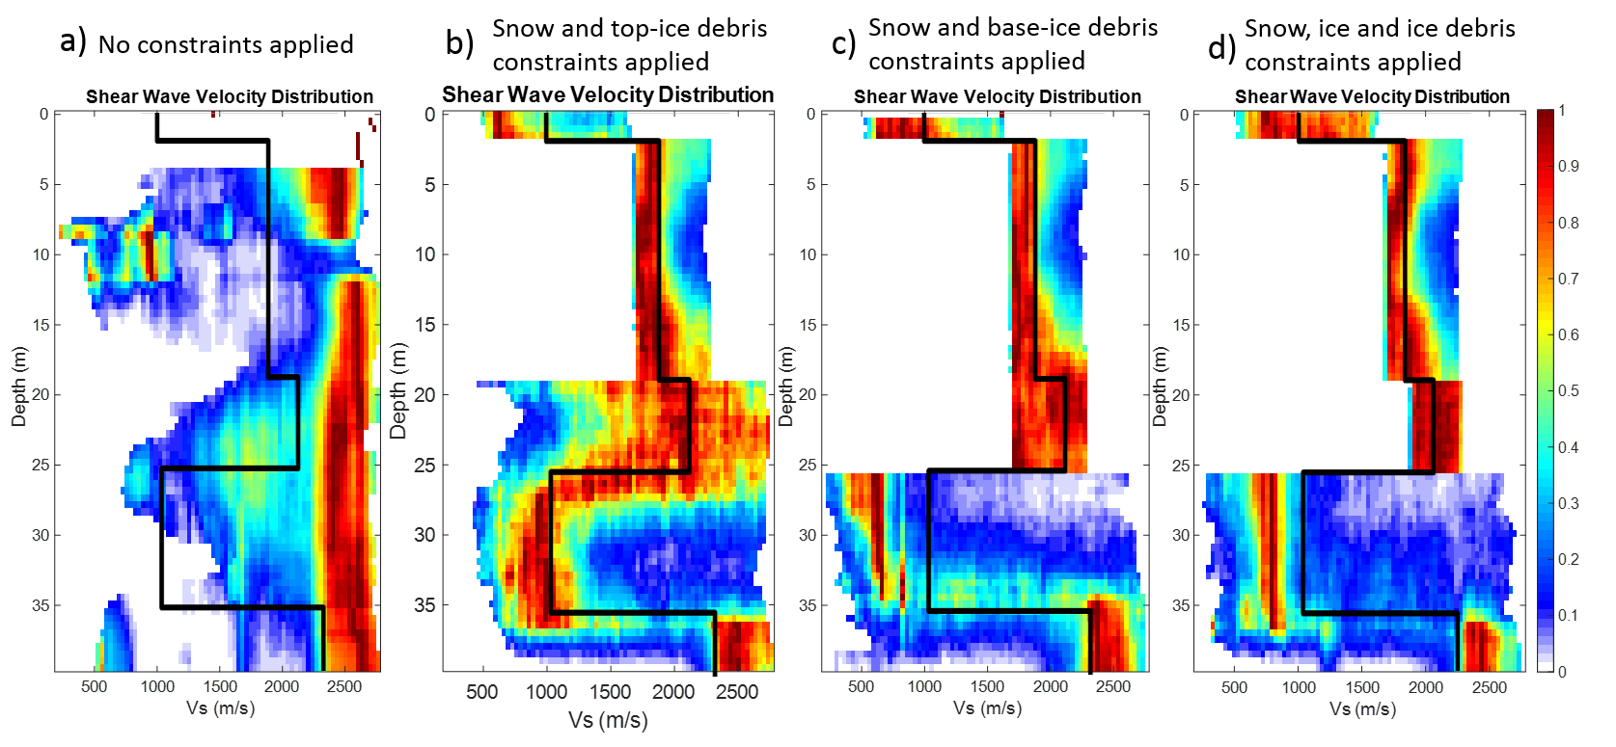
Figure S3. MuLTI inversion results from the ice-debris synthetic model (Figure S1) with a) no constraints applied, b) snow and top-ice debris depth constraints applied, c) snow and base-ice debris depth constraints applied and d) snow, top-ice debris and base-ice debris depth constrains applied.

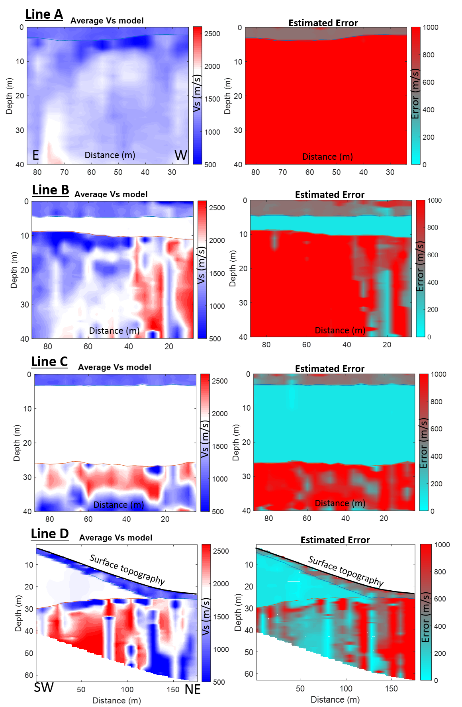
Figure S4. Resulting 2D average Vs profiles after applying multiple 1D MuLTI inversions, with GPR constraints, at each CMPCC along the seismic lines A-D (diverging colour scale centred, in white, on Vs of ice (1750-1900m/s)) and corresponding estimated error plots, calculated from the 95% credible interval half width. The snow and ice depth horizons are plotted in blue and red respectively.
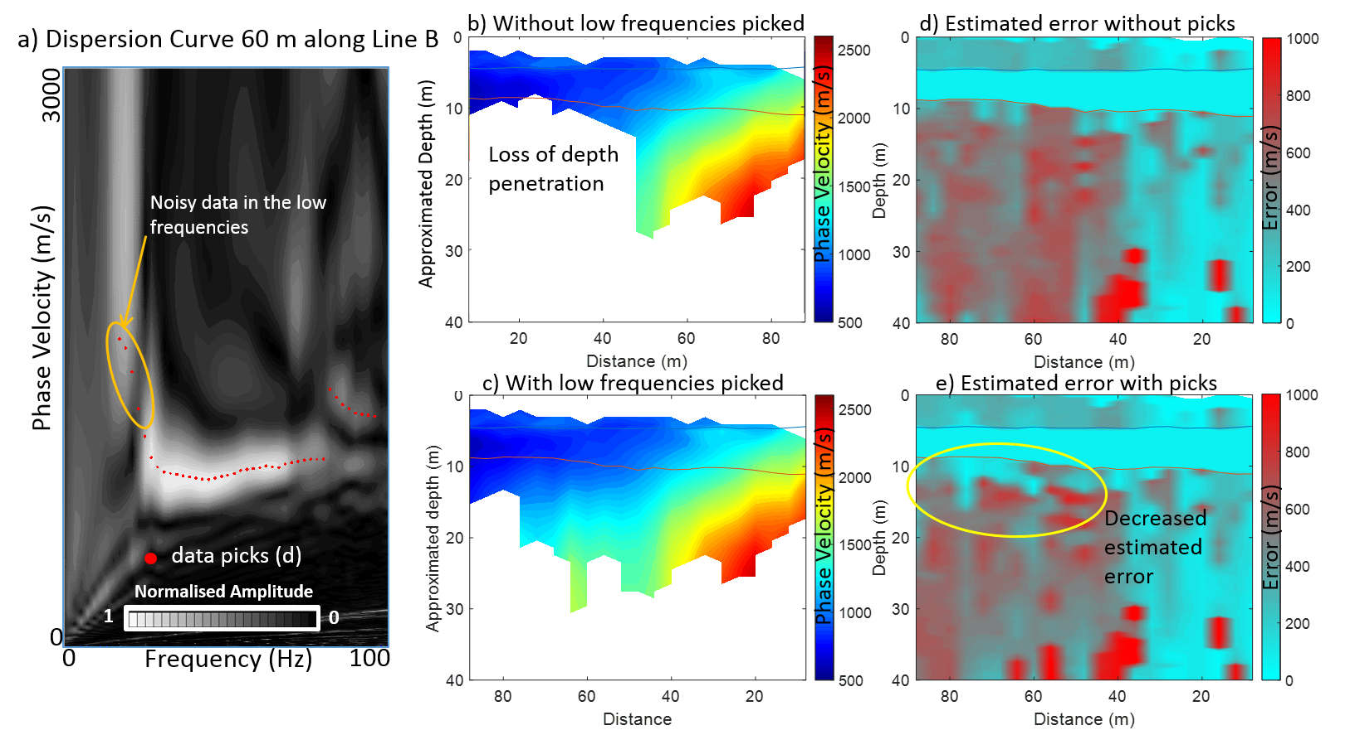
Figure S5. a) Example dispersion curve from Line B highlighting the noisy low frequency picks. We believe these high phase velocities at the low frequencies are real and associated with the thin (4 m thick) ice layer at this location in Line B. Approximated depths of picked phase velocities without noisy low frequencies picked (b) and with noisy low frequencies picked (c). Corresponding estimated errors, calculated from half the interquartile range, using dispersion picks without noisy low frequencies (d) and with noisy low frequencies (e).

