The heart of bureaucratic power:
Explaining international bureaucracies’ expert authority
–
Supplementary Online Appendix (“Appendix”)

Table of contents
A: Selected international bureaucracies, policy fields, thematic areas, and survey sample 2
B: Questionnaire 3
Survey question on the dependent variable 4
Survey questions on the independent variables 5
IMPARTIALITY 5
OBJECTIVITY 5
IMPACT 5
Survey questions on the control variables 6
CONGRUENCE 6
PRESSURE 6
COERCION 7
C: Response rate 8
D: Distribution of responses for the dependent variable EXPERT AUTHORITY 10
E: IOs’ formal independence (delegated authority) and the perceived impartiality of their work 12
F: Correlations between GDP and other indicators of a country’s cognitive resources 13
G: Comparison of the frequency of responses for different degrees of EXPERT AUTHORITY conditional on CONGRUENCE and PRESSURE 14
H: Robustness checks 15
I: Regression results for model 2 controlling for IMF loan obtainment 27

A: Selected international bureaucracies, policy fields, thematic areas, and survey sample

For our survey, we chose international bureaucracies that provide policy advice on eight specific thematic areas in two broader policy fields (Table A.1).

Table A.1 Selected policy fields, thematic areas, and international bureaucracies
Policy field  Thematic areas  International bureaucracies | Agriculture |  |  |  | Finance
 | Agribusiness policy | Biodiversity policy in agric. | Bioenergy policy in agric. | Climate change policy in agric. | Banking regulation policy | Debt management policy | Monetary policy | Tax policy
Bank for International Settlements, BIS |  |  |  |  | x | x | x
Food and Agriculture Organization, FAO | x | x | x | x
International Fund for Agricultural Development, IFAD | x | x | x | x
International Monetary Fund, IMF |  |  |  |  | x | x | x | x
Organisation for Economic Co-operation and Development, OECD | x | x | x | x | x | x | x | x
UN Conference on Trade and Development, UNCTAD | x | x | x | x |  | x
United Nations Department of Economic and Social Affairs, UN DESA |  |  |  |  |  |  |  | x
UN Environment Programme, UNEP | x | x | x | x
World Bank | x | x | x | x | x | x | x | x

The survey population consisted of all UN member states. We excluded Nauru due to missing income data and San Marino due to the lack of a ministry of agriculture or comparable institution. To avoid selection bias, we opted for a stratified sampling process. We used the UN region and World Bank income classification to create 18 groups of countries. For each group, we randomly selected a representative number of countries so that the sample mirrors the overall distribution of countries by income group and regional classification. Anticipating a low response rate and due to rounding values, our final survey sample included 121 countries.

B: Questionnaire

All variables were measured along a response scale with values ranging from 1 to 7. Non-substantive response options such as “secretariat’s work not known”, “not aware of any advice”, or “prefer not to say” were offered for most of the questions. This was important to avoid response bias that may occur, for instance, when respondents attribute certain levels of expert authority to international bureaucracies without having any actual familiarity with their work. However, we excluded non-substantive response options from the data set for the regression analysis as they are not relevant to our research question. Obviously, an international bureaucracy whose advice or work is not known to the respondent cannot hold expert authority as defined in this article. In addition, respondents who were unaware of any advice or of the secretariat’s work could not give informed assessments for the independent and control variables, i.e., rate the impartiality or impact of an international bureaucracy. Finally, the hypotheses refer to (different levels of) expert authority only. One would need other explanations to capture why, for instance, the advice and/or work of certain international bureaucracies is better known than the advice and/or work of other international bureaucracies.

Except for the questions regarding hypotheses 1a and 1b on impartiality and objectivity, we restricted answers to the past 24 months in order to increase consistency and comparability. Especially regarding the question on impact, this helped to avoid that respondents thought only of extreme cases at a particular point in time.

Introduction of the questionnaire “International public administrations as experts in [thematic area]?”

The secretariats of international organizations (or “international public administrations”) perform a multitude of different tasks and duties in support of their member states. Their tasks involve providing advice in line with their organizations’ general mandates and strategies. For example, they formulate policy guidelines for reforming national policies or introducing new policies (whether for all of the member states or for individual states), and prepare for meetings where state delegates discuss new policies. To this end, secretariats generate, process, and disseminate policy-relevant knowledge.
In this questionnaire, we would like to ask you if, to what extent, and why your unit considers advice on [thematic area] policy from the secretariats of international organizations when deciding on the activities and policies of your ministry. When answering these questions, please assess the prevalent practices of your unit.

Survey question on the dependent variable
Figure A.1 Question on the dependent variable EXPERT AUTHORITY

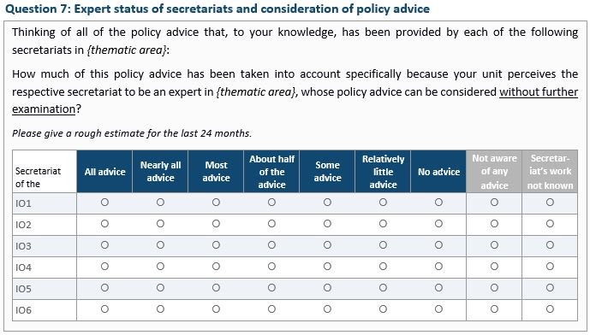

Survey questions on the independent variables

IMPARTIALITY
Question 8: Bias towards the interests of specific countries
To what extent does your unit agree or disagree with the following statement:
“The following secretariats’ work on [thematic area] policy is biased towards the interests of specific countries.”
Secretariat  of the | Strongly agree | Agree | Somewhat agree | Neither agree nor disagree | Somewhat disagree | Disagree | Strongly disagree | Don’t know/ Prefer not to say
IO 1
IO 2
…

OBJECTIVITY
Question 9: Bias towards specific values and ideologies
To what extent does your unit agree or disagree with the following statement:
“The following secretariats’ work on [thematic area] policy is biased towards particular values and ideologies.”
Secretariat  of the | Strongly agree | Agree | Somewhat agree | Neither agree nor disagree | Somewhat disagree | Disagree | Strongly disagree | Don’t know/ Prefer not to say
IO 1
IO 2
…

IMPACT
Question 10: Performance at the global level
In the view of your unit, to what extent do the following secretariats contribute to effectively addressing current challenges in [thematic area] policy at the global level?
When answering, please consider not only each secretariat’s policy advice but also any other programs and activities it carries out in this area. Please give a rough estimate for the last 24 months.
Secretariat  of the | To an extremely large extent | To a very large extent | To a relatively large extent | To a moderate extent | To a relatively small extent | To a very small extent | Not at all | Secretar-iat’s work not known
IO 1
IO 2
...

Survey questions on the control variables

CONGRUENCE
Question 14: Congruence with national preferences
In the view of your unit, how similar has the policy advice of the following secretariats on [thematic area] policy been to your country’s own specific policy preferences in this area?
Please give a rough estimate for the last 24 months.
Secretariat  of the | Comple-tely identical | Overall very similar | Overall fairly similar | About half and half | Overall fairly different | Overall very different | Comple-tely different | Not aware of any advice | Secretar-iat’s work not known
IO 1
IO 2
...

PRESSURE
Question 16: Pressure from other actors
Other actors might also exert pressure on ministries to act on particular policy advice given by the secretariats of international organizations.
In the last 24 months, to what extent have any other actors tried to pressure your unit or your ministry to act on the advice of the following secretariats on [thematic area] policy?
Please consider actors of all kinds.
Secretariat  of the | To an extreme-ly large extent | To a very large extent | To a relatively large extent | To a moderate extent | To a relatively small extent | To a very small extent | Not at all | Secretar-iat’s work not known | Prefer not to say
IO 1
IO 1
...

COERCION
Question 17: Level of conditionality and enforcement
This question refers to international organizations as a whole, in contrast to the previous questions, which referred specifically to the secretariats of international organizations.
Several international organizations seek to achieve the implementation of policies at the national level through conditionality and/or enforcement.
Please rate your unit’s general perception of the following international organizations’ overall ability to achieve implementation of certain [thematic area] policy through these means in your country within the last 24 months?
Conditionality: The provision of certain political, economic, and/or monetary benefits is linked to the adoption and/or adjustment of certain policies.
Enforcement: Certain decisions may be imposed to ensure that the requirements of collectively binding international agreements and treaties are being followed and implemented.
Internatio-nal Organi-zation | Very high ability | High ability | Somewhat high ability | Moderate ability | Somewhat low ability | Low ability | No ability at all | Don’t know/ Prefer not to say
IO 1
IO 2
...

Question 3: Importance of [thematic area] on your government’s agricultural / financial policy agenda
In the view of your unit, how high or low do you rank [thematic area] on your government’s agricultural/financial policy agenda on average in the last 24 months?
Very high | High | Moderately high | Average | Moderately low | Low | Very low

C: Response rate

As our survey targeted the main public official in a given policy unit who is responsible for each of the eight thematic areas, we theoretically targeted 984 different policy units (i.e., respondents). Due to the lack of national officials responsible for some thematic areas in a small number of countries, however, we de facto targeted 932 units. The questionnaires are identical for each thematic area, except for the name of the specific thematic area and the specific international bureaucracies. In a few cases, respondents were responsible for more than one thematic area. In these instances, we asked them to answer the questionnaires for all thematic areas for which they were responsible. In some countries, we also found that more than one department or administrative unit shared responsibility for one thematic area. In those cases, we sent the same questionnaire to all responsible departments or administrative units (i.e., two to three questionnaires for one thematic area). In total, we received 362 questionnaires from 106 countries, covering 354 different thematic area units. Based on these 354 covered units, our response rate is 38 percent (see Table A.2 for the response rates for each policy field and region).

Table A.2: Response rate by policy fields and regions (based on n=354)
 | Agricultural policy | Financial policy | Total
Africa | 33% | 33% | 33%
Americas | 45% | 38% | 42%
Asia & Oceania | 35% | 31% | 33%
Europe | 44% | 51% | 47%
Total | 38% | 38% | 38%

A central advantage of our survey sample is that we know the entire population and its particular characteristics. Therefore, we can easily test whether the responses we received are representative (for either the entire population or certain groups of countries). For that reason, the response rate is also not as critical as in other surveys.

We calculated the response rate based on Response Rate 1 (RR1) of the American Association for Public Opinion Research (AAPOR). RR1 is also called the “minimum response rate” and is the most conservative response rate. It is calculated by dividing the number of responses (questionnaires completed) by the number of eligible respondents in the sample.

In 20 cases, we were unable to transmit the questionnaires, for instance, because no responsible public officials could be identified or neither postal nor email services were in operation. Therefore, our cooperation rate (COOP1) is 39 percent.

D: Distribution of responses for the dependent variable EXPERT AUTHORITY

Figure A.2: Distribution of expert authority among IOs in the four thematic areas in agricultural policy (7=highest expert authority, 1=lowest expert authority)
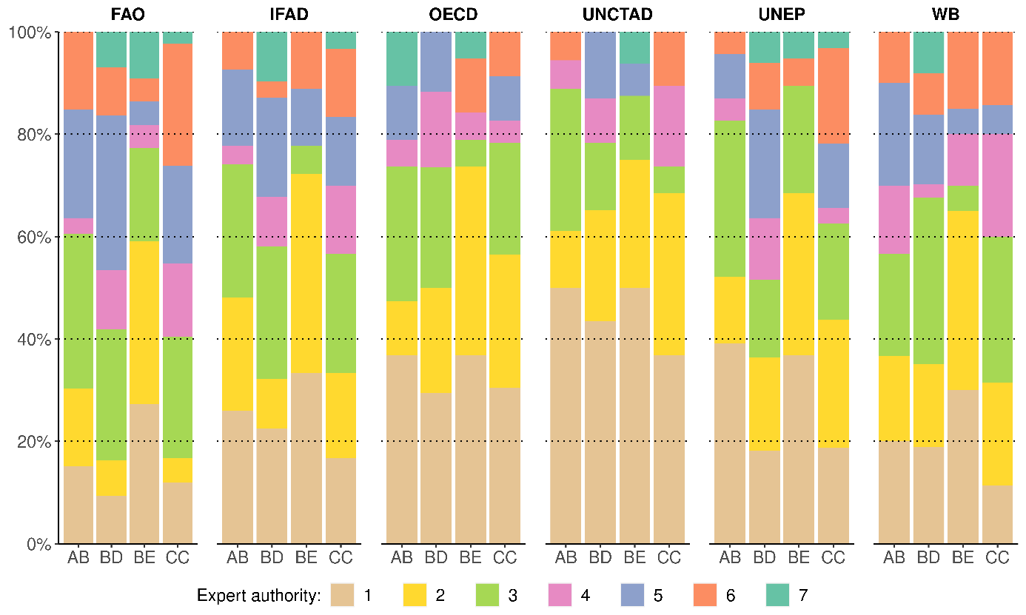

* WB = World Bank
The four thematic areas are: AB = agribusiness policy; BD = biodiversity policy in agriculture, BE = bioenergy policy in agriculture, CC = climate change policy in agriculture.

Figure A.3: Distribution of expert authority among IOs in the four thematic areas in financial policy (7=highest expert authority, 1=lowest expert authority)
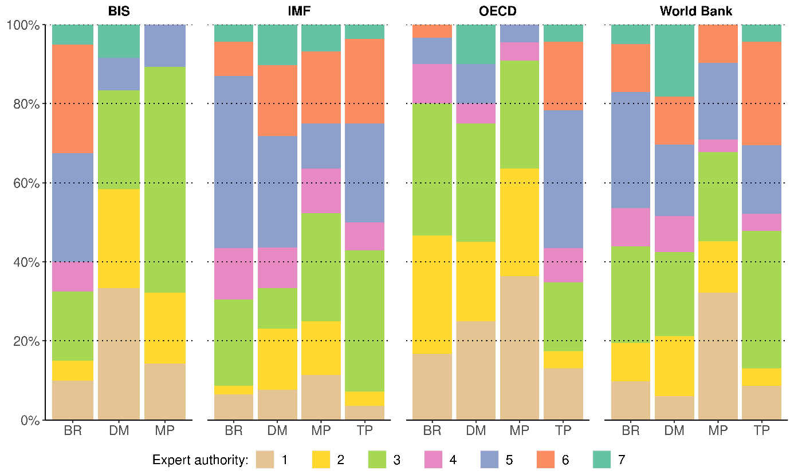

* WB = World Bank
The four thematic areas are: BR = banking regulation policy; DM = debt management policy; MP = monetary policy; TP = tax policy.

E: IOs’ formal independence (delegated authority) and the perceived impartiality of their work

Figure A.4: Correlation between international organizations’ delegated authority and the perceived impartiality of their work

Source: data on delegated authority from Liesbet Hooghe, Gary Marks, Tobias Lenz, Jeanine Bezuijen, Besir Ceka, and Svet Derderyan, Measuring International Authority: A Postfunctionalist Theory of Governance (Oxford: Oxford University Press, 2017), data on perceived impartiality from own survey. Data on perceived impartiality are weighted by international bureaucracy and the respondent’s country income group according to the World Bank classification.

F: Correlations between GDP and other indicators of a country’s cognitive resources

Average Pearson’s r is at 0.85.

Table A.3: Pearson Correlations
 | GDP (nominal) | GDP (PPP)
UNESCO_GERD | 0.935 | 0.900
Sum of citable documents by country in “Agricultural and Biological Sciences” | 0.812 | 0.900
Sum of citable documents by country in “Economics, Econometrics, and Finance” | 0.661 | 0.768

G: Comparison of the frequency of responses for different degrees of EXPERT AUTHORITY conditional on CONGRUENCE and PRESSURE

Figure A.5: Expert authority conditional on low versus high congruence

Figure A.6: Expert authority conditional on low versus high pressure

H: Robustness checks

In order to increase the validity of our results, we performed a series of robustness tests. First, an ordered logistic regression for models 1 and 2 confirms the results from the OLS regression. Second, we estimated models 1 and 2 with non-response-adjusted survey weights to check for potential bias induced by non-response, given the (slightly) diverging response rates in the different regions and thematic areas. For this purpose, we used weights at four different levels: i) region, ii) international bureaucracy and region, iii) income group, and iv) international bureaucracy and income group. The key estimates retain significance, with only some of the coefficient values changing and by not more than 0.1. To reduce the complexity of the estimations and potential drawbacks associated with the use of weights, we reported the regression results without non-response adjusted survey weights. Third, we also estimated the models using standard errors clustered at the country level instead of the respondent level. While standard errors were smaller, the results and statistical significance of the coefficient estimations did not change. Fourth, we added further control variables at the country level to our regression models. The key results are not substantially changed. Fifth, we validated our measurement of COERCION by using a dummy variable for recipients of IMF loans. We compared whether the responses to our survey differed between countries with or without a conditional IMF loan. Although we find that the IMF’s coercive potential is perceived to be much higher in countries that have received conditional IMF loans, the dummy variable remains statistically insignificant when used in model 2 (IMF responses only, Appendix I). Hence, de facto expert authority is independent of actual experience with an IMF program. Finally, we calculated the variance inflation factor (VIF) to rule out multicollinearity. For each of our explanatory variables, the VIF is less than 2. Consequently, we cannot confirm any multicollinearity.

Table A.4: Regression model (1) and (2) with non-response-adjusted survey weights at the level of regions and regions & international bureaucracy
 | Model 1  Region | Model 2  Region | Model 1  Region/IO | Model 2  Region/IO
IMPARTIALITY | -0.054 | -0.050 | -0.070 | -0.036
 | (0.056) | (0.061) | (0.055) | (0.062)
OBJECTIVITY | 0.131* | 0.154* | 0.144** | 0.153*
 | (0.055) | (0.060) | (0.055) | (0.061)
IMPACT | 0.529*** | 0.349*** | 0.524*** | 0.337***
 | (0.043) | (0.060) | (0.045) | (0.065)
ASYMMETRY | 0.159*** | 0.120* | 0.156** | 0.154**
 | (0.045) | (0.050) | (0.048) | (0.052)
COERCIVE POTENTIAL |  | 0.105 |  | 0.102
 |  | (0.053) |  | (0.056)
CONGRUENCE PREFERENCES |  | 0.218*** |  | 0.226***
 |  | (0.048) |  | (0.049)
PRESSURE |  | 0.121** |  | 0.108*
 |  | (0.040) |  | (0.044)
Intercept | 0.218 | 0.422** | 0.231 | 0.442***
 | (0.145) | (0.129) | (0.136) | (0.128)
R² | 0.455 | 0.525 | 0.445 | 0.520
Num. obs. | 873 | 644 | 857 | 634
Notes: OLS regression with two-tailed significance for estimates. ’p<0.1; *p<0.05; **p<0.01; ***p<0.001. Standardized coefficients with robust standard errors clustered by respondent (in parentheses). Fixed effects for the international bureaucracies in their thematic areas are omitted from table.

Table A.5: Regression model (1) and (2) with survey with non-response-adjusted survey weights at the level of country income and country income & international bureaucracy
 | Model 1  Income | Model 2  Income | Model 1  Income/IO | Model 2  Income/IO
IMPARTIALITY | -0.035 | -0.041 | -0.054 | -0.027
 | (0.053) | (0.060) | (0.051) | (0.056)
OBJECTIVITY | 0.118* | 0.143* | 0.136** | 0.123*
 | (0.053) | (0.060) | (0.050) | (0.056)
IMPACT | 0.527*** | 0.358*** | 0.530*** | 0.350***
 | (0.042) | (0.059) | (0.042) | (0.060)
ASYMMETRY | 0.152*** | 0.118* | 0.151** | 0.135**
 | (0.045) | (0.049) | (0.049) | (0.051)
COERCIVE POTENTIAL |  | 0.120* |  | 0.129*
 |  | (0.055) |  | (0.059)
CONGRUENCE PREFERENCES |  | 0.206*** |  | 0.226***
 |  | (0.047) |  | (0.047)
PRESSURE |  | 0.104* |  | 0.083
 |  | (0.041) |  | (0.043)
Intercept | 0.237 | 0.461*** | 0.181 | 0.380**
 | (0.152) | (0.129) | (0.156) | (0.139)
R² | 0.454 | 0.512 | 0.451 | 0.508
Num. obs. | 873 | 644 | 857 | 634
Notes: OLS regression with two-tailed significance for estimates. ’p<0.1; *p<0.05; **p<0.01; ***p<0.001. Standardized coefficients with robust standard errors clustered by respondent (in parentheses). Fixed effects for the international bureaucracies in their thematic areas are omitted from table.

Table A.6: Regression models (1) and (2) with policy importance as control variable
 | Model 1 | Model 2
IMPARTIALITY | -0.053 | -0.069
 | (0.058) | (0.068)
OBJECTIVITY | 0.131* | 0.162*
 | (0.058) | (0.067)
IMPACT | 0.492*** | 0.337***
 | (0.044) | (0.058)
ASYMMETRY | 0.169*** | 0.147**
 | (0.050) | (0.056)
IMPORTANCE | 0.146** | 0.093
 | (0.048) | (0.052)
COERCIVE POTENTIAL |  | 0.112*
 |  | (0.054)
CONGRUENCE PREFERENCES |  | 0.211***
 |  | (0.049)
PRESSURE |  | 0.114**
 |  | (0.041)
Intercept | 0.229 | 0.452**
 | (0.159) | (0.142)
R² | 0.469 | 0.518
Adj. R² | 0.439 | 0.479
Num. obs. | 863 | 640
Notes: OLS regression with two-tailed significance for estimates. ’p<0.1; *p<0.05; **p<0.01; ***p<0.001. Standardized coefficients with robust standard errors clustered by respondent (in parentheses). Fixed effects for the international bureaucracies in their thematic areas are omitted from table.

Table A.7: Regression models (1) and (2) with GDP/capita (log) as control variable
 | Model 1 | Model 2
IMPARTIALITY | -0.038 | -0.049
 | (0.057) | (0.067)
OBJECTIVITY | 0.117* | 0.142*
 | (0.056) | (0.065)
IMPACT | 0.516*** | 0.346***
 | (0.042) | (0.059)
ASYMMETRY | 0.131* | 0.118’
 | (0.053) | (0.060)
GDP/capita (log) | -0.102* | -0.080
 | (0.050) | (0.053)
COERCIVE POTENTIAL |  | 0.104’
 |  | (0.056)
CONGRUENCE PREFERENCES |  | 0.222***
 |  | (0.050)
PRESSURE |  | 0.109**
 |  | (0.042)
Intercept | 0.217 | 0.436**
 | (0.153) | (0.138)
R² | 0.459 | 0.516
Adj. R² | 0.430 | 0.477
Num. obs. | 873 | 644
Notes: OLS regression with two-tailed significance for estimates. ’p<0.1; *p<0.05; **p<0.01; ***p<0.001. Standardized coefficients with robust standard errors clustered by respondent (in parentheses). Fixed effects for the international bureaucracies in their thematic areas are omitted from table.

Table A.8: Regression models (1) and (2) controlling for political rights and civil liberties (Freedom House’s Freedom in the World Index)
 | Model 1 | Model 2
IMPARTIALITY | -0.047 | -0.058
 | (0.057) | (0.066)
OBJECTIVITY | 0.124* | 0.152*
 | (0.056) | (0.064)
IMPACT | 0.525*** | 0.353***
 | (0.042) | (0.059)
ASYMMETRY | 0.163** | 0.139*
 | (0.051) | (0.056)
COERCIVE POTENTIAL |  | 0.104’
 |  | (0.055)
CONGRUENCE PREFERENCES |  | 0.214***
 |  | (0.048)
PRESSURE |  | 0.109**
 |  | (0.041)
FHI | 0.084’ | 0.084
 | (0.043) | (0.051)
Intercept | 0.220 | 0.443**
 | (0.156) | (0.141)
R² | 0.459 | 0.518
Adj. R² | 0.429 | 0.479
Num. obs. | 873 | 644
Notes: OLS regression with two-tailed significance for estimates. ’p<0.1; *p<0.05; **p<0.01; ***p<0.001. Standardized coefficients with robust standard errors clustered by respondent (in parentheses). Fixed effects for the international bureaucracies in their thematic areas are omitted from table.

Table A.9: Regression models (1) and (2) controlling for corruption
 | Model 1 | Model 2 | Model 1 | Model 2
IMPARTIALITY | -0.035 | -0.042 | -0.033 | -0.055
 | (0.056) | (0.066) | (0.058) | (0.067)
OBJECTIVITY | 0.111* | 0.135* | 0.104’ | 0.143*
 | (0.055) | (0.065) | (0.058) | (0.067)
IMPACT | 0.530*** | 0.356*** | 0.539*** | 0.361***
 | (0.042) | (0.058) | (0.043) | (0.060)
ASYMMETRY | 0.175*** | 0.151** | 0.173** | 0.108
 | (0.052) | (0.056) | (0.059) | (0.071)
COERCIVE POTENTIAL |  | 0.095’ |  | 0.086
 |  | (0.055) |  | (0.057)
CONGRUENCE |  | 0.219*** |  | 0.230***
PREFERENCES |  | (0.049) |  | (0.051)
PRESSURE |  | 0.122** |  | 0.116**
 |  | (0.042) |  | (0.042)
CORRUPTION (WGI) | -0.041 | -0.073
 | (0.043) | (0.046)
CORRUPTION (TI) |  |  | -0.081’ | -0.139**
 |  |  | (0.045) | (0.054)
Intercept | 1.098* | 0.034 | 0.204 | 0.438**
 | (0.450) | (0.475) | (0.173) | (0.162)
R² | 0.454 | 0.517 | 0.472 | 0.542
Adj. R² | 0.424 | 0.478 | 0.441 | 0.502
Num. obs. | 873 | 644 | 824 | 598
Notes: OLS regression with two-tailed significance for estimates. ’p<0.1; *p<0.05; **p<0.01; ***p<0.001. Standardized coefficients with robust standard errors clustered by respondent (in parentheses). Fixed effects for the bureaucracies in their thematic areas are omitted from table.

Table A.10: Regression models (3) – (8) with policy importance as control variable
 | COERCIVE POTENTIAL |  | CONGRUENCE PREFERENCES |  | PRESSURE
 | Low  (3) | High  (4) | Low  (5) | High  (6) | Low  (7) | High  (8)
IMPARTIALITY | -0.032 | -0.129 | -0.071 | -0.060 | -0.032 | -0.016
 | (0.091) | (0.113) | (0.124) | (0.079) | (0.066) | (0.151)
OBJECTIVITY | 0.246** | 0.123 | 0.043 | 0.145 | 0.153* | 0.059
 | (0.092) | (0.106) | (0.161) | (0.077) | (0.069) | (0.128)
IMPACT | 0.424*** | 0.542*** | 0.295* | 0.568*** | 0.419*** | 0.732***
 | (0.098) | (0.078) | (0.116) | (0.069) | (0.059) | (0.132)
ASYMMETRY | 0.159* | 0.018 | 0.118 | 0.166** | 0.174** | -0.006
 | (0.074) | (0.118) | (0.165) | (0.061) | (0.056) | (0.155)
IMPORTANCE | 0.115 | 0.171* | -0.057 | 0.147* | 0.098 | 0.020
 | (0.088) | (0.079) | (0.109) | (0.062) | (0.060) | (0.140)
Intercept | 0.306 | 0.391 | 0.351 | 0.388* | 0.336 | 0.606*
 | (0.245) | (0.433) | (0.292) | (0.172) | (0.177) | (0.294)
R² | 0.452 | 0.367 | 0.626 | 0.415 | 0.461 | 0.597
Adj. R² | 0.356 | 0.257 | 0.304 | 0.354 | 0.410 | 0.410
Num. obs. | 303 | 278 | 94 | 477 | 520 | 130
Notes: OLS regression with two-tailed significance for estimates. ’p<0.1; *p<0.05; **p<0.01; ***p<0.001. Standardized coefficients with robust standard errors clustered by respondent (in parentheses). Fixed effects for the international bureaucracies in their thematic areas are omitted from table.

Table A.11: Regression models (3) – (8) with GDP/capita (log) as control variable
 | COERCIVE POTENTIAL |  | CONGRUENCE PREFERENCES |  | PRESSURE
 | Low  (3) | High  (4) | Low  (5) | High  (6) | Low  (7) | High  (8)
IMPARTIALITY | -0.027 | -0.089 | -0.060 | -0.041 | -0.024 | -0.003
 | (0.084) | (0.113) | (0.131) | (0.076) | (0.063) | (0.144)
OBJECTIVITY | 0.224** | 0.092 | 0.045 | 0.129’ | 0.140* | 0.042
 | (0.084) | (0.110) | (0.164) | (0.072) | (0.065) | (0.129)
IMPACT | 0.405*** | 0.547*** | 0.321* | 0.578*** | 0.435*** | 0.753***
 | (0.086) | (0.083) | (0.123) | (0.074) | (0.058) | (0.134)
ASYMMETRY | 0.157’ | 0.018 | 0.111 | 0.135* | 0.154** | 0.014
 | (0.087) | (0.121) | (0.236) | (0.062) | (0.058) | (0.160)
GDP/capita (log) | -0.040 | -0.133 | -0.001 | -0.126* | -0.082 | 0.054
 | (0.074) | (0.094) | (0.146) | (0.062) | (0.057) | (0.124)
Intercept | 0.099 | 0.503 | 0.289 | 0.377* | 0.337* | 0.648*
 | (0.204) | (0.441) | (0.350) | (0.167) | (0.168) | (0.280)
R² | 0.444 | 0.355 | 0.623 | 0.413 | 0.461 | 0.599
Adj. R² | 0.347 | 0.243 | 0.299 | 0.353 | 0.410 | 0.412
Num. obs. | 303 | 278 | 94 | 485 | 526 | 130
Notes: OLS regression with two-tailed significance for estimates. ’p<0.1; *p<0.05; **p<0.01; ***p<0.001. Standardized coefficients with robust standard errors clustered by respondent (in parentheses). Fixed effects for the international bureaucracies in their thematic areas are omitted from table.

Table A.12: Regression models (3) – (8) controlling for political rights and civil liberties (Freedom House’s Freedom in the World Index)
 | COERCIVE POTENTIAL |  | CONGRUENCE PREFERENCES |  | PRESSURE
 | Low  (3) | High  (4) | Low  (5) | High  (6) | Low  (7) | High  (8)
IMPARTIALITY | -0.034 | -0.141 | -0.068 | -0.052 | -0.033 | 0.020
 | (0.089) | (0.129) | (0.154) | (0.080) | (0.067) | (0.153)
OBJECTIVITY | 0.246** | 0.147 | 0.022 | 0.159* | 0.154* | 0.016
 | (0.092) | (0.125) | (0.173) | (0.078) | (0.068) | (0.148)
IMPACT | 0.459*** | 0.448*** | 0.409* | 0.503*** | 0.466*** | 0.614***
 | (0.096) | (0.073) | (0.156) | (0.061) | (0.062) | (0.108)
ASYMMETRY | 0.165* | 0.055 | 0.069 | 0.183** | 0.197** | -0.005
 | (0.074) | (0.083) | (0.189) | (0.065) | (0.063) | (0.103)
FHI | 0.005 | 0.130* | 0.060 | 0.046 | 0.030 | -0.055
 | (0.030) | (0.053) | (0.073) | (0.034) | (0.026) | (0.062)
Intercept | 0.289 | -0.001 | 0.893 | 0.010 | 0.368 | 0.482
 | (0.260) | (0.469) | (0.463) | (0.204) | (0.190) | (0.327)
R² | 0.443 | 0.388 | 0.629 | 0.409 | 0.460 | 0.605
Adj. R² | 0.345 | 0.281 | 0.310 | 0.349 | 0.409 | 0.421
Num. obs. | 303 | 278 | 94 | 485 | 526 | 130
Notes: OLS regression with two-tailed significance for estimates. ’p<0.1; *p<0.05; **p<0.01; ***p<0.001. Standardized coefficients with robust standard errors clustered by respondent (in parentheses). Fixed effects for the international bureaucracies in their thematic areas are omitted from table.

Table A.13: Regression models (3) – (8) controlling for corruption (World Governance Indicators)
 | COERCIVE POTENTIAL |  | CONGRUENCE PREFERENCES |  | PRESSURE
 | Low  (3) | High  (4) | Low  (5) | High  (6) | Low  (7) | High  (8)
IMPARTIALITY | -0.005 | -0.070 | -0.078 | -0.030 | -0.023 | -0.006
 | (0.084) | (0.108) | (0.133) | (0.075) | (0.063) | (0.141)
OBJECTIVITY | 0.207* | 0.071 | 0.049 | 0.124’ | 0.140* | 0.059
 | (0.084) | (0.102) | (0.163) | (0.070) | (0.064) | (0.125)
IMPACT | 0.394*** | 0.593*** | 0.340** | 0.600*** | 0.437*** | 0.725***
 | (0.085) | (0.078) | (0.126) | (0.069) | (0.058) | (0.128)
ASYMMETRY | 0.162* | 0.054 | 0.160 | 0.184** | 0.186** | -0.006
 | (0.080) | (0.121) | (0.191) | (0.060) | (0.057) | (0.157)
CORRUPTION | -0.090 | -0.066 | 0.108 | -0.107* | -0.034 | -0.057
(WGI) | (0.070) | (0.086) | (0.102) | (0.054) | (0.054) | (0.124)
Intercept | 0.081 | 0.412 | 0.339 | 0.372* | 0.326’ | 0.604*
 | (0.212) | (0.438) | (0.304) | (0.166) | (0.167) | (0.297)
R² | 0.452 | 0.349 | 0.635 | 0.413 | 0.458 | 0.599
Adj. R² | 0.356 | 0.236 | 0.321 | 0.353 | 0.407 | 0.412
Num. obs. | 303 | 278 | 94 | 485 | 526 | 130
Notes: OLS regression with two-tailed significance for estimates. ’p<0.1; *p<0.05; **p<0.01; ***p<0.001. Standardized coefficients with robust standard errors clustered by respondent (in parentheses). Fixed effects for the international bureaucracies in their thematic areas are omitted from table.

Table A.14: Regression models (3) – (8) controlling for corruption (Transparency International)
 | COERCIVE POTENTIAL |  | CONGRUENCE PREFERENCES |  | PRESSURE
 | Low  (3) | High  (4) | Low  (5) | High  (6) | Low  (7) | High  (8)
IMPARTIALITY | -0.034 | -0.057 | -0.073 | -0.045 | -0.022 | 0.044
 | (0.088) | (0.119) | (0.146) | (0.074) | (0.065) | (0.147)
OBJECTIVITY | 0.228* | 0.077 | 0.022 | 0.142* | 0.136* | 0.046
 | (0.088) | (0.118) | (0.169) | (0.071) | (0.067) | (0.146)
IMPACT | 0.403*** | 0.570*** | 0.335** | 0.593*** | 0.435*** | 0.734***
 | (0.090) | (0.077) | (0.120) | (0.070) | (0.061) | (0.133)
ASYMMETRY | 0.147 | 0.140 | -0.028 | 0.157* | 0.159* | 0.002
 | (0.110) | (0.104) | (0.275) | (0.068) | (0.068) | (0.181)
CORRUPTION | -0.035 | -0.213* | -0.052 | -0.188** | -0.055 | -0.103
(TI) | (0.061) | (0.104) | (0.134) | (0.065) | (0.051) | (0.121)
Intercept | 0.106 | 0.541 | 0.432 | 0.374* | 0.302 | 0.595’
 | (0.209) | (0.570) | (0.432) | (0.184) | (0.190) | (0.328)
R² | 0.431 | 0.412 | 0.663 | 0.448 | 0.456 | 0.635
Adj. R² | 0.326 | 0.298 | 0.347 | 0.387 | 0.402 | 0.450
Num. obs. | 291 | 254 | 90 | 453 | 499 | 123
Notes: OLS regression with two-tailed significance for estimates. ’p<0.1; *p<0.05; **p<0.01; ***p<0.001. Standardized coefficients with robust standard errors clustered by respondent (in parentheses). Fixed effects for the international bureaucracies in their thematic areas are omitted from table.

I: Regression results for model 2 controlling for IMF loan obtainment

Table A.15: Regression results for model 2 based on IMF survey responses only (dependent variable: EXPERT AUTHORITY)
 | Model 2
IMPARTIALITY | -0.198’
 | (0.115)
OBJECTIVITY | 0.260*
 | (0.105)
IMPACT | 0.419***
 | (0.081)
ASYMMETRY | 0.114
 | (0.072)
IMF LOAN | 0.004
 | (0.078)
CONGRUENCE PREFERENCES | 0.289’
 | (0.147)
PRESSURE | 0.215***
 | (0.060)
Debt management policy | 0.146
 | (0.212)
Monetary policy | -0.297
 | (0.195)
Tax policy | 0.184
 | (0.203)
Intercept | 0.010
 | (0.124)
R² | 0.461
Adj. R² | 0.412
Num. obs. | 122
Notes: OLS regression with two-tailed significance for estimates. ’p>0.1; *p<0.05; **p<0.01; ***p<0.001. Standardized coefficients with robust standard errors clustered by respondent (in parentheses). Reference category for the fixed effects of the IMF in different thematic areas: IMF in banking regulation policy.

5 (region categories) x 4 (income categories) – 2 (groups without any country) = 18.
AAPOR. 2016. "Standard Definitions. Final Dispositions of Case Codes and Outcome Rates for Surveys." American Association for Public Opinion Research, accessed 15 August, 2018. {https://www.aapor.org/AAPOR_Main/media/publications/Standard-Definitions20169theditionfinal.pdf}.
Gross domestic expenditure on research and experimental development (GERD) by country ('000000, PPP$, USD constant prices from 2005). For each country, we take the observation that is temporally most proximate to the year 2014. Data obtained from the UNESCO Institute for Statistics (UIS) database at http://uis.unesco.org/, accessed January 25, 2017.
Sum of citable documents by country in subject area “Agricultural and Biological Sciences” for the years 2010 to 2014. Data obtained from the SCImago Journal & Country Rank database at http://www.scimagojr.com/countryrank.php/, accessed September 21, 2016.
Sum of citable documents by country in subject area “Economics, Econometrics, and Finance” for the years 2010 to 2014. Data obtained from the SCImago Journal & Country Rank database at http://www.scimagojr.com/countryrank.php/, accessed September 21, 2016.
Therefore, we only report the regression results of the OLS estimations given that the regression coefficients in ordered logistic regression are more difficult to interpret and the coefficients are not directly comparable between models with different samples or variables. Carina Mood, 'Logistic Regression: Why We Cannot Do What We Think We Can Do, and What We Can Do About It', European Sociological Review, 26:1 (2010), pp. 67-82 .
The variable IMPORTANCE stems from our survey, see A.3.3 for the respective survey question.
Based on these two indicators, a composite variable (FHI) was created by calculating the average of these two indicators. Data on these indicators were taken from the Freedom House website, available at: {https://freedomhouse.org/, accessed August 29, 2016}.
Data on the indicator CORRUPTION (WGI) was taken from the Worldwide Governance Indicators Project, available at: {http://info.worldbank.org/governance/wgi/index.aspx#home}, accessed 25 October, 2017.
Data on the indicator CORRUPTION (TI) was taken from the Transparency International website, available at: {https://www.transparency.org/research/cpi/overview}, accessed 25 October, 2017.
Based on data for the indicators for Political Rights and Civil Liberties, a composite variable (FHI) was created by calculating the average of these two indicators. Data on these indicators were taken from the Freedom House website, available at https://freedomhouse.org/, accessed August 29, 2016.
Data on the indicator CORRUPTION (WGI) was taken from the Worldwide Governance Indicators Project, available at: http://info.worldbank.org/governance/wgi/index.aspx#home, accessed October 25, 2017.
Data on the indicator CORRUPTION (TI) was taken from the Transparency International website, available at: {https://www.transparency.org/research/cpi/overview, accessed October 25, 2017}.
This dummy variable measures whether a country has received a conditional IMF loan between 2014 and 2016. Data retrieved from the IMF database Monitoring of Fund Arrangements (MONA) at: {https://www.imf.org/external/np/pdr/mona/Arrangements.aspx}, accessed 7 May, 2018.

