Appendix A: Figures, Tables, Sources, and Estimates.

a) Fiscal Data.
The tithing data used in this article come mainly from the works of Angelo Carrara, Paulo Cavalcante, and André F. M. Paiva. Tithes ran on three-year contracts, but we used the annual values in the series. Other data were collected in the archives, with their sources duly cited.

FIGURE A1
Value of tithes and customs (entradas) contracts for the captaincy of Minas Gerais

Source: Carrara, 2009, pp. 192-193.

FIGURE A2
Tithes Revenues for the Rio de Janeiro Customs in contos de réis, 1712-1803

0
50
100
150
200
250
300
1712
1729
1738
1743
1747
1755
1760
1764
1767
1770
1773
1776
1779
1782
1785
1788
1791
1794
1797
1800
1803
Source: Carrara and Cavalcante, 2016, pp. 20-21.

FIGURE A3
Value of tithes contracts for the captaincy of Rio de Janeiro, in contos de réis: 1751-1803

0
10
20
30
40
50
1751
1753
1755
1757
1759
1761
1763
1765
1767
1769
1771
1773
1775
1777
1779
1781
1783
1785
1787
1789
1791
1793
1795
1797
1799
1801
1803
Source: Paiva 2016, pp. 118.
FIGURE A4
Value of tithes contracts for the captaincies of Bahia and Pernambuco, in réis
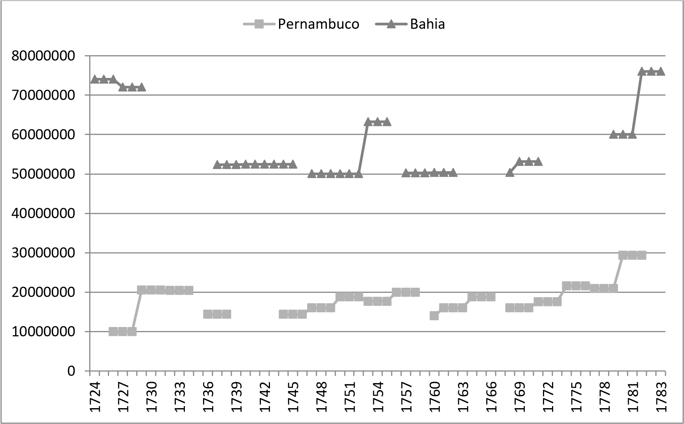
Sources: Carrara 2009, pp. 253; Paiva 2016, pp. 111-117.

FIGURE A5
Tithes Revenues for Salvador’s Customs, in contos de réis – 1770-1806

0
20
40
60
80
100
120
1770
1772
1774
1776
1782
1784
1787
1789
1791
1793
1795
1797
1799
1801
1803
1805
Sources: Arquivos Nacionais/Torre do Tombo/Fundo Erário Régio/Série Capitanias do Brasil, volumes 151 a 195. There is a record of the income of all taxes collected and gathered by Bahia’s Customs: Biblioteca Nacional do Rio de Janeiro/Divisão de Manuscritos/“RESUMO de todo o rendimento em bruto que tem produzido o dízimo da alfândega da cidade da Bahia desde o ano de 1769, até o de 1799 inclusive, debaixo da administração da Junta da Real Fazenda; Bahia, 29 de março de 1800” [BN, I-31, 30, 082] [SUMMARY of the gross income produced by customs’ tithing for the city of Bahia from 1769 up to and including 1799, under the administration of the Board of Royal Treasury; Bahia, March 29, 1800].

FIGURE A6
Revenues of tithes, customs, sugar subsidy, and pennant cotton subsidy of Pernambuco (in contos de réis), 1772-1806

0
10
20
30
40
50
60
70
80
90
100
1772
1775
1777
1778
1781
1782
1783
1784
1785
1786
1788
1789
1791
1792
1793
1794
1796
1797
1798
1799
1800
1801
1802
1803
1804
1805
1806
Dízima e donativo da
Alfândega
Dízimos reais de Pernambuco
Subsídio do algodão em
pluma
*Dízima e donativo da Alfândega (Import duties and Custom’s donative); Dízimos reais de Pernambuco (Royal Tithes of Pernambuco); Subsídio do algodão em pluma (pennant cotton subsidy).
Sources: Carrara 2009, pp. 254, annex 14-C: Rendimento dos tributos sob contrato das capitanias de Pernambuco e Itamaracá, 1770-1802 [Income from taxes under contracts of the captaincies of Pernambuco and Itamaracá, 1770-1802].

FIGURE A7
Value of Maranhão’s tithing contract, in réis, 1724-1805

0
10,000,000
20,000,000
30,000,000
40,000,000
50,000,000
60,000,000
70,000,000
80,000,000
1724
1727
1730
1733
1736
1739
1742
1745
1748
1751
1754
1757
1760
1763
1766
1769
1772
1775
1778
1781
1784
1787
1790
1793
1796
1799
1802
1805
Sources: Martins 2015, pp. 97. The author kindly shared his spreadsheet with us with the complete series, taken from the following documents of the AHU, for Maranhão: 1393, 1807, 2315, 2654, 2788, 2891, 3667, 4620, 4880, 5354, 5576, 6867, 10090. For a complete reference of the documents, see the guide “documentos avulsos do Maranhão”:
https://bndigital.bn.gov.br/dossies/projeto-resgate-barao-do-rio-branco/acervohttps://bndigital.bn.gov.br/dossies/projeto-resgate-barao-do-rio-branco/acervo-digital/capitanias/maranhao/digital/capitanias/maranhao/

b) Slave imports and tropical products exports.

FIGURE B1
Slave imports per captaincy
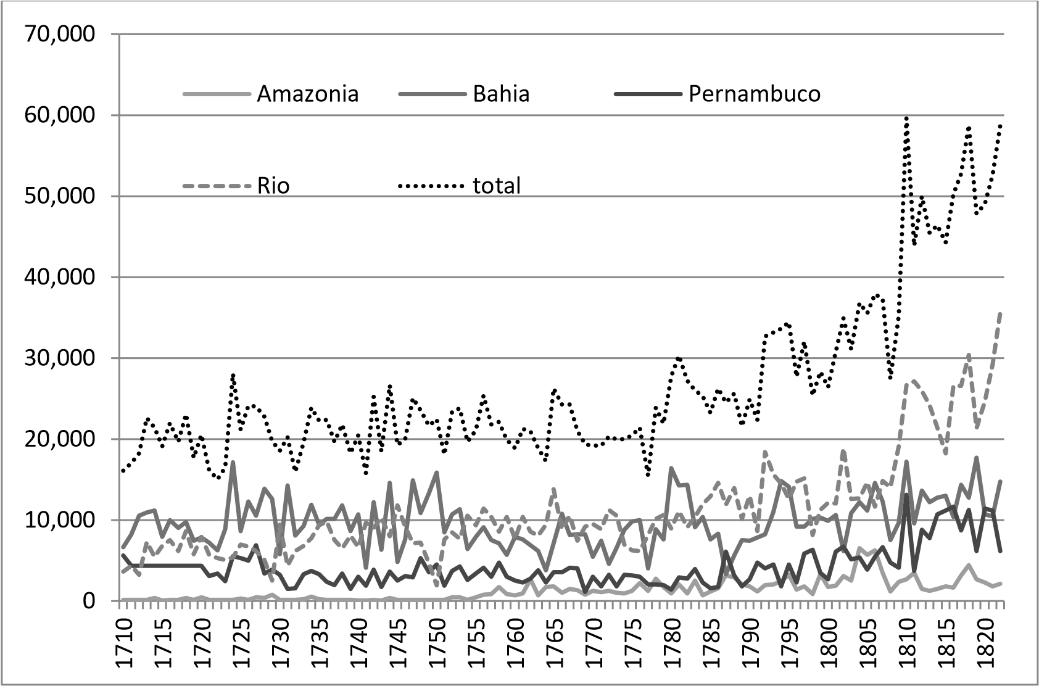
Source: ELTIS, David et. al. “Voyages: The Trans-Atlantic Slave Trade Database” (2008), www.slavevoyages.org, accessed on November 12th, 2012.

FIGURE B2
Amazon’s Main Exports (in arrobas; 1 arroba = approx. 14,7 kilos)

-
100,000
200,000
300,000
400,000
500,000
600,000
1760
1762
1764
1766
1768
1770
1772
1774
1776
1778
1780
1782
1784
1786
1788
1790
1792
1794
1796
1798
1800
1802
1804
1806
Algodão
Cacau
Arroz
*Algodão (Cotton); Cacau (Cocoa); Arroz (Rice)
Sources: Data from Maranhão and Grão-Pará were organized by Michelle C. Brito and Diego Martins. Part of the material is in Martins (2015).

FIGURE B3
Brazil’s sugar exports (metric tons) versus sugar price per kilo in Portugal (in réis)
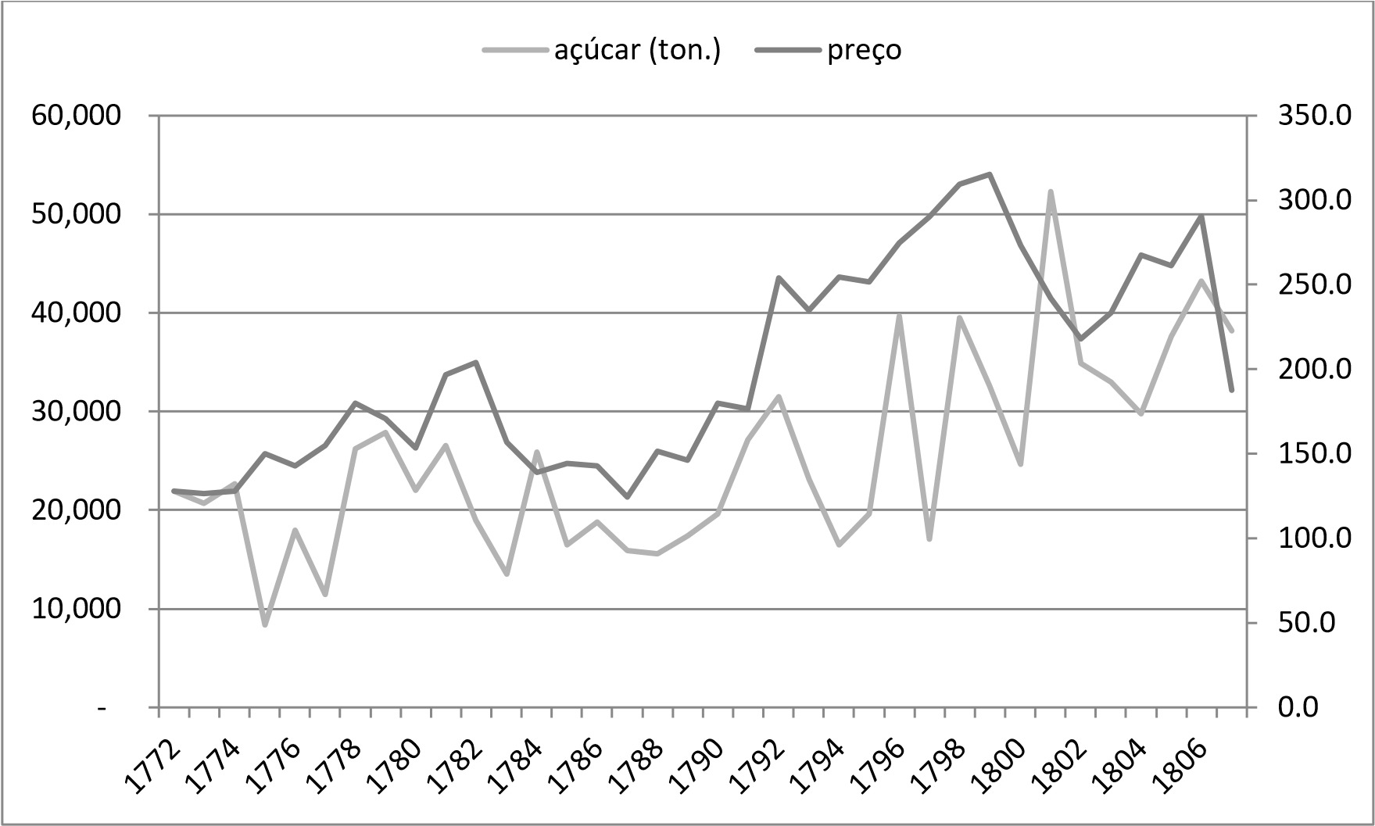
*Açúcar (Sugar); Preço (Price)
Sources: sugar exports, see text below. Prices: PWR Project – Prices, Wages and Rents in Portugal, c. 1300-1910 (http://pwr-portugal.ics.ul.pt/?page_id=56), accessed on February 7th, 2018).

TABLE B4
Brazil’s sugar exports (metric tons), per captaincy

 | Pernambuco  (PE) | Rio de Janeiro  (RJ) | Bahia  (BA) |  | Total | Sources
1751 | 8,422 | 1,953 | No fleet |  | 10,376 | (Morineau, 1985 e Pinto, 1975)
1752 | 5,144 | No fleet | 8,889 |  | 14,033 | BA (Morineau) PE (Almeida, 1971)
1753 | No fleet | 3,184 | 7,971 |  | - | BA (Almeida e Pinto) RJ (Pinto)
1754 | 9,778 | 1,620 | 2,600 |  | 13,998 | BA e RJ (Almeida e Pinto) PE (Morineau)
1755 | 3,984 | 619 | 4,804 |  | 9,407 | BA (AHU, Bahia/CA, cx. 10, doc. 1786), RJ (Almeida e Pinto), PE (Pinto)
1756 | 3,323 | - | 7,581 |  |  | BA (Schwartz, p. 404), RJ (Almeida) PE (AHU_ACL_CU_015, Cx. 81. D. 6767)
1757 | 4,616 | 1,169 | 7,716 |  | 13,501 | BA (AHU, Bahia/CA, cx. 14, 2482), RJ (AHU_ACL_CU_017, Cx. 52, D. 5248) PE (AHU_ACL_CU_015, Cx. 84, D. 6992 e 6997)
1758 | No fleet | 1,157 | 8,561 |  | 9.718 | BA (Schwartz, p. 404), RJ (AHU_ACL_CU_017, Cx. 53, D. 5311)
1759 | 8,225 | 1,866 | 9,189 |  | 19,281 | BA (AHU, Bahia/CA, cx. 24, doc. 4722) RJ (AHU_ACL_CU_017, Cx. 56, D. 5480) PE (AHU_ACL_CU_015, Cx. 90, D. 7246, 7267, 7268 e 1792)
1760 | 151 | - | No fleet |  |  | PE (AHU_ACL_CU_015, Cx. 110, D. 8507)
1761 | 10,049 | 2,046 | 11,111 |  | 23,206 | BA (Schwartz, p. 404), RJ (AHU_ACL_CU_017, Cx. 56, D. 5480) PE (AHU_ACL_CU_015, Cx. 95. D. 7502 e 7503)
1762 | 7,575 | - | 12,593 |  | - | BA (Schwartz, p. 404) PE (AHU_ACL_CU_015, Cx. 110, D. 8507)
1763 | 4,371 | 93 | 17,037 |  | 21,501 | BA (Schwartz, p. 404), RJ (AHU_ACL_CU_017, Cx. 70, D. 6457) e PE (AHU_ACL_CU_015, Cx. 110, D. 8507)
1764 | 7,533 | No fleet | 5,185 |  | 12.718 | BA (Schwartz, p. 404) e PE (Mapas de carga)
1765 | 3,156 | - | No fleet |  |  | RJ (AHU_ACL_CU_017, Cx. 76, D. 6902) e PE (Mapas de carga)
1766 | 6,170 | 4,148 | 10,579 |  | 20,897 | BA (AHU, Bahia/CA, cx. 39, doc. 7381), RJ (Morineau) e PE (Mapas de carga)
1767 | 5,111 | - | - | - |  | Mapas de carga
1768 | 4,936 | - | - | - |  | Mapas de carga
1769 | 6,183 | - | - | - |  | Mapas de carga
1770 | 4,929 | - | - | - |  | Mapas de carga
1771 | 5,211 | - | - | - |  | Mapas de carga
1772 | 9,875 | 5,745 | 6,351 | 21,971 |  | BA e RJ (marco dos navios) PE (mapas de carga)
1773 | 7,822 | 3,665 | 9,208 | 20,694 |  | BA e RJ (marco dos navios) PE (mapas de carga)
1774 | 6,445 | 6,999 | 9,216 | 22,660 |  | BA e RJ (marco dos navios) PE (mapas de carga)
1775 | 6,623 | 1,059 | 683 | 8,365 |  | BA e RJ (marco dos navios) PE (mapas de carga)
1776 | 5,107 | 2,487 | 10,398 | 17,991 |  | BA e RJ (balanças de comércio) PE (mapas de carga)
1777 | 4,685 | 2,423 | 4,339 | 11,447 |  | BA e RJ (balanças de comércio) PE (mapas de carga)
1778 | 5,369 | 10,105 | 10,757 | 26,232 |  | BA e RJ (marco dos navios) PE (mapas de carga)
1779 | 9,603 | 5,724 | 12,527 | 27,853 |  | BA e RJ (marco dos navios) PE (mapas de carga)
1780 | 6,807 | 6,926 | 8,283 | 22,017 |  | BA (AHU, BA/CA,cx. 55, doc. 10717), RJ (marco dos navios) e PE (mapas de carga)
1781 | 8,077 | 5,304 | 13,193 | 26,574 |  | BA (AHU, Bahia/CA, cx. 57, doc. 10937), RJ (marco dos navios) e PE (mapas de carga)
1782 | 7,222 | 3,574 | 8,123 | 18,920 |  | BA e RJ (marco dos navios) PE (mapas de carga)
1783 | 4,078 | 3,282 | 6,150 | 13,509 |  | BA e RJ (marco dos navios) PE (mapas de carga)
1784 | 9,244 | 6,520 | 10,087 | 25,851 |  | BA e RJ (marco dos navios) Mapas de carga
1785 | 4,140 | 3,617 | 8,692 | 16,448 |  | BA e RJ (marco dos navios), PE Mapas de carga
1786 | 5,329 | 3,045 | 10,408 | 18,782 |  | BA e RJ (marco dos navios), PE Mapas de carga
1787 | 4,140 | 4,219 | 7,561 | 15,920 |  | BA e RJ (marco dos navios), PE Mapas de carga
1788 | 5,121 | 3,613 | 6,864 | 15,598 |  | BA (AHU, Bahia/CA, cx. 68, doc 13144), RJ (marco dos navios) e PE (Mapas de carga)
1789 | 6,139 | 3,924 | 7,321 | 17,384 |  | BA (Biblioteca Nacional do Rio de Janeiro i29, 19, 9) PE (Mapas de carga)
1790 | 4,556 | 3,954 | 11,123 | 19,634 |  | BA (AHU, Bahia/CA, cx 73, doc 14253) RJ (marco dos navios) e PE (Mapas de carga)
1791 | 7,458 | 6,120 | 13,551 | 27,129 |  | BA (AHU, Bahia/CA, cx 76, doc. 14826.) e PE (Mapas de carga)
1792 | 8,274 | 8,118 | 15,147 | 31,539 |  | BA e RJ (marco dos navios) PE (mapas de carga)
1793 | 4,066 | 6,733 | 12,369 | 23,168 |  | BA e RJ (marco dos navios) PE (mapas de carga)
1794 | 4,836 | 4,722 | 6,919 | 16,477 |  | BA e RJ (marco dos Navios), PE (mapas de carga)
1795 | 6,738 | 11,513 | 1,396 | 19,647 |  | BA (marco dos navios) RJ (AHU_ACL_CU_017, Cx. 160, doc. 12.027) PE (Mapas de Carga)
1796 | 8,103 | 10,004 | 21,582 | 39,688 |  | BA e RJ (Arruda, p. 360-361 e 375-376.) PE (mapas de carga)
1797 | 4,245 | 4,946 | 7,833 | 17,024 |  | BA e RJ (Arruda, p. 360-361 e 375-376.) PE (mapas de carga)
1798 | 7,404 | 18,017 | 14,053 | 39,474 |  | BA e RJ (Arruda, p. 360-361 e 375-376.) PE (mapas de carga)
1799 | 8,234 | 11,728 | 12,583 | 32,545 |  | BA e RJ (Arruda, p. 360-361 e 375-376.) PE (mapas de carga)
1800 | 7,710 | 5,670 | 11,265 | 24,645 |  | BA e RJ (Arruda, p. 360-361 e 375-376.) PE (mapas de carga)
1801 | 11,758 | 22,224 | 18,315 | 52,297 |  | BA e RJ (Arruda, p. 360-361 e 375-376.) PE (mapas de carga)
1802 | 7,746 | 15,919 | 11,208 | 34,873 |  | BA e RJ (Arruda, p. 360-361 e 375-376.) PE (mapas de carga)
1803 | 4,653 | 11,556 | 16,786 | 32,995 |  | BA e RJ (Arruda, p. 360-361 e 375-376.) PE (mapas de carga)
1804 | 8,283 | 9,376 | 12,094 | 29,753 |  | BA e RJ (Arruda, p. 360-361 e 375-376.) PE (mapas de carga)
1805 | 9,702 | 11,055 | 16,829 | 37,586 |  | BA e RJ (Arruda, p. 360-361 e 375-376.) PE (mapas de carga)
1806 | 12,259 | 14,401 | 16,540 | 43,200 |  | BA e RJ (Arruda, p. 360-361 e 375-376.) PE (mapas de carga)
1807 | 6,873 | 13,632 | 17,655 | 38,160 |  | BA e RJ (Arruda, p. 360-361 e 375-376.) PE (mapas de carga)

Sources: See text below. We discovered the fleet-free years through the documentation of the Livro de lembranças das entradas e saídas das frotas portuguesas, (ANTT, Junta do Comércio, liv. 74).

TABLE B5
Brazilian exports of gold and some colonial goods (annual averages, in réis), 1750-1807.

Decades | Gold | Colonial goods | Total
1751-1760 | 4.405.280.765 | 1.643.575.615 | 6.048.856.380
1761-1770 | 3.885.877.429 | 2.278.092.739 | 6.163.970.168
1771-1780 | 2.471.757.137 | 3.050.419.523 | 5.522.176.660
1781-1790 | 688.109.500 | 4.349.700.599 | 5.037.810.099
1791-1800 | 765.994.649 | 9.497.728.598 | 10.263.723.247
1801-1807 | 862.232.237 | 14.375.995.642 | 15.238.227.879

Sources: Gold: Costa, Rocha and Sousa, 2013, pp. 72-75 (data also available online: https://aquila.iseg.ulisboa.pt/aquila/investigacao/ghes/investigacao/bases-de-dados). Colonial goods: Açúcar (Sugar), see bellow; Algodão e Arroz da Amazônia (Cotton and Rice from Amazon), see Martins, 2015; Algodão de Pernambuco (Cotton of Pernambuco): Melo, 2017. Tabaco (Tobacco): Nardi, 1996, pp. 366-368, 405. The values exported were multiplied by Lisbon’s prices (Project PWR. Prices, Wages and Rents in Portugal 1300-1910 (http://pwr-portugal.ics.ul.pt/?page_id=56, accessed on February 7th, 2018).
The PWR series are consumer prices and, therefore, are much higher than the entry prices by which trade balances had to be calculated. A comparison with Rio de Janeiro’s sugar prices recorded by Arruda (1980, pp. 360-61, table 50) shows that consumer prices exceeded the prices of trade balances by between 37% and 97%. Exclusively for tobacco, preference was given to the wholesale prices collected by Nardi, since the PWR series is incomplete, and the difference between consumer prices and wholesale prices is absurd, perhaps as a result of the control over the income earned by the tobacco monopoly contracts. For more about this topic, see Salvado (2014).
Thus, although the list of the goods used is incomplete, the totals may not be so far from reality (at least, we try not to underestimate the value of imports of colonial products), considering that for the period between 1796 and 1800, according to trade balances, Brazilian exports averaged 10,332.56 contos de réis annually and between 1801-7 the yearly average was 12,813.19 contos. There are no complete and fully comparable figures for previous periods, but we know that the average of imports of colonial products between 1776 and 1777 was 1,918,034,415 réis (AHMOP, Superintendência Geral dos Contrabandos. Balanças do Comércio do Reino de Portugal com os seus Domínios, 1776, 1777). On the other hand, our estimates of annual imports of colonial products during the 1770s amounted to 3,050,419,523 réis. Also, when examining the export records (mapas de exportação) of Bahia, we find that in 1780-1781 the annual average of all tropical products exported was 1,183,323,478 réis and that in the years 1788, 1790, and 1791 the annual average was 1,375,840,433 réis, all at Brazilian prices. For the 1780s, we estimated an average of imports, only of sugar from Bahia, at 1,126,752,710 réis based on Lisbon prices (AHU, BA/CA,cx. 55, doc. 10717, AHU, Bahia/CA, cx. 57, doc. 10937, AHU, Bahia/CA, cx. 68, doc 13144, AHU, Bahia/CA, cx 73, doc 14253, AHU, Bahia/CA, cx 76, doc. 14826).

FIGURE B6:
Brazilian exports of gold, sugar and other products (annual averages, in réis), 1750-1807

Sources: Same as table 2.

c) The series and estimates of sugar production.

There are a few sugar export indicators before the 1760s, such as the Portuguese gazettes used by Almeida (1971) in his work; the records of French consuls, analyzed in Pinto’s work (1979); and the Dutch gazettes employed by Morineau (1985). Sometimes the authors arrived at different export figures. The information provided is in boxes of sugar, which we have converted into arrobas, considering that each box contained 40 arrobas. The other export values were collected from primary sources: export records, cargo records, marco dos navios, and trade balances. The cargo and export records register the sugar exports in arrobas, boxes, fechos, caras, and sacks. To convert the arrobas of sugar into tons, it was taken that one ton of volume was equivalent to 54 arrobas (Costa 2002, pp. 310, 371; 377). A box had about 40 arrobas, a fecho 20 arrobas, a cara weighed one arroba, a sack 4 arrobas, equivalences that we found in the cargo maps. Other figures we used for the reconstituting of exports, especially for the 1750s, were taken from the previously-mentioned works of Almeida (1971), Pinto (1975), and Morineau (1985), as well as the monographs by Stuart Schwartz and José Jobson Arruda. When different sources exist for the same year, we adopted the following two criteria: firstly, we chose the data collected directly in the archives; and secondly, when faced with discrepancies, we always used the largest numbers.
The Mapas de Exportação (export records) report in a single record the annual sugar exports, unlike the Mapas de Carga (cargo records) that individually record the sugar that each vessel loaded. The two sources have in common the colony as a place of production. Both are dispersed among the various documents of the Arquivo Histórico Ultramarino (Overseas Historical Archive; henceforth AHU) and, to a lesser extent, the records of the Junta do Comércio (Board of Trade) collection held at the National Archives Torre do Tombo, in Lisbon. The records of the Marco dos Navios (Vessels’ tonnage tax), deposited in the Arquivo Histórico da Câmara Municipal de Lisboa (Lisbon’s Municipal Historical Archive), also provide information regarding how much sugar each vessel carried individually. However, the latter records were produced in Lisbon, as were the Balanças de Comércio (trade balance sheets), which are held for the most part in the Arquivo do Instituto Nacional de Estatística de Portugal (Archive of the National Institute of Statistics of Portugal) and which provide total annual exports. Therefore, export records and cargo records refer to quantities leaving the colony; tonnage tax and trade balance sheets correspond to what arrived in the metropolis. This explains the differences between exports when comparing these documents.
The Pernambuco series is the most complete and uniform, based almost exclusively on AHU cargo records. It covers both Porto and Lisbon, with the latter accounting for about 80% to 90% of the sugar reception. For Rio de Janeiro and Bahia, we found it necessary to use a diversity of sources: trade balances, general cargo records and the records of marco dos navios, which concern vessels that arrived in Lisbon. Therefore, they do not cover vessels that went to Porto. Besides, although the marco dos navios theoretically cover all vessels entering the port of Lisbon, comparing these data with other sources has shown a downward bias in some of the years examined. To circumvent these problems, we have corrected the value of Lisbon's exports, whilst estimating Porto's share.
Thus, the first task was to compare the export series from Pernambuco to Lisbon, built from the AHU cargo records, with data from the marco dos navios. Accordingly, we found that in the 1770s, the AHU records surpassed the marco by 32%; in 1780, the difference was 5%; in 1790, it was 44%. These quotations were therefore applied to the data collected in the marco for Rio de Janeiro and Bahia. It is possible that this has introduced some statistical distortion, and the estimates for individual years should be used with some reservations.
The second step was to calculate Porto's share. For Rio de Janeiro, we used a sample (based on data from Arruda, trade balances and export records that exist between 1772 and 1795) comparing sources with information regarding the number of exports to Lisbon and Porto with the values of Lisbon’s imports. We estimated that imports from the north of Portugal amounted to 72% of imports of the Brazilian capital. This proportion was then added to the corrected values of the marco dos navios. We did the same for Bahia, where we concluded that 27% of arrobas went to Porto, and Rio de Janeiro was used to correct the series of the former capital of Brazil. Thus, the estimates cover 40 entries of the 151 that were possible to gather, concentrating on the 1770s and 1780s and the Rio de Janeiro and Bahia series, as already mentioned.
The reliability of our figures has been tested by comparing some data sets and documents. Table 3 compares the estimated values from the Marco dos Navios with data collected from other sources. It is worth mentioning that we always used the data collected from the sources, when they existed, and we only used estimates when there was no option.

TABLE C1
Comparison between estimates based on the Marco dos Navios (MN) and numbers employed in this article (A) (in tons)
 | Rio de Janeiro |  |  | Bahia
Years | MN | A | Difference | MN | A | Difference
1776 | 4.448 | 2.487(a) | 44% | 14.590 | 10.398(a) | 29%
1777 | 2.610 | 2.423(a) | 7% | 3.306 | 4.339(a) | -31%
1781 |  |  |  | 12.149 | 13.193(b) | -9%
1783 |  |  |  | 6.354 | 6.150(b) | 3%
1788 |  |  |  | 6.566 | 6.864(b) | -5%
1790 |  |  |  | 8.071 | 11.123(b) | -38%
1791 |  |  |  | 12.179 | 13.551(b) | -11%
1795 | 4.358 | 11.513(b) | -164%
1796 | 7.111 | 10.004(a) | -41% | 15.658 | 21.582(a) | -38%
(a) = trade balance sheets. (b) = export records.

For Bahia, for which we have more observations, the difference between the estimates and the “real numbers” are between 3% and 38% (calculated on the estimate), which suggests that the data are relatively reliable for this port, mainly for the 1780s when it was possible to compare the estimate and the “real value” on four occasions. As for Rio de Janeiro, the difference stood between 4% and 164%, but the number of observations is very small and is concentrated in periods affected by sea wars, when oscillations and differences between records (due to the increase in illegal activities) would probably grow.
Three important considerations: 1) The estimated individual figures for the 1790s seem much less reliable, but the averages for Rio de Janeiro and Bahia were constructed with only four estimated years. The remaining years were taken from the trade balance sheets and the export records; 2) For the 1780s, the entire Rio de Janeiro series was estimated, but the comparison with Bahia suggests that the estimate is safe; 3) For the 1770s there is an apparent upward bias in our estimates, but this does not alter our arguments at all.
In any case, comparing isolated years is problematic, since the corrections we employed were based on averages for specific periods, built from the Pernambuco series (1772-1780; 1781-1790; 1791-1795). That is why we use averages per decade. Furthermore, differences between sources also make it difficult to compare specific years. As previously mentioned, the cargo records (mapas de carga) and export records were registered in colonial ports, while Marco dos Navios and trade balance sheets were produced in Lisbon from the entry records. In addition, they had different purposes and methodologies: the Marco dos Navios and the cargo records are a fiscal source. Trade balance sheets and export records systematized data from different sources to support Portuguese economic policy.
A very simple comparison illustrates this argument. For the period between 1796 and 1807, in addition to the trade balance sheets, there are three export records of Rio de Janeiro that allow us to see the difference between the two sources:

TABLE C2
Sugar exports from Rio de Janeiro, according to export records (ER) and Trade Balance Sheets (TB) (in tons)
 |  | ER | TB | Difference (ER/TB)
1796 | 837.728 | 15.513 | 10.004 | 36%
1803 | 79.885 | 8.887 | 11.556 | -30%
1804 | 442.863 | 8.201 | 9.376 | -14%

Export records sources: for 1796, see AHU, Avulsos Rio de Janeiro, cx. 160, doc. 12027. For 1803 and 1804, see Biblioteca Nacional (RJ), Seção de Manuscritos, I, 17, 12, 1 n. 12.

The differences between two official sources are also large, on the same scale that we find between our estimates and data from Bahia, for example. In fact, these distortions are not surprising to any historian familiar with the sources of the pre-statistical period and with debates about the numbers of the slave trade, for example.

This huge difference in 1795 seems to be the result of changes in the Portuguese navigation regime, affected by the French privateering wars. That year, as a safety measure, the Crown began to encourage vessels to sail together (em comboio) on their way to Brazil. Soon after, Portugal reintroduced the fleet system in Europe and America, prohibiting vessels from sailing alone. See Edital de 05/02/1795 in ANTT, Papéis do Brasil, Avulsos, M-3, doc. 22, AHU, ROR, Cód. 574, Rodrigo de Souza Coutinho, 30/07/1798. It is likely that the participation of the port of Lisbon was affected by these measures, with the captains of vessels looking for other Portuguese ports to escape from enemy ships. In 1796, for example, only half of the sugar exported from Rio de Janeiro came to Lisbon, as indicated by trade balance data.
Curtin, Philip. The Atlantic Slave Trade: A Census. Wisconsin: University of Wisconsin Press, 1969. Eltis, David and David Richardson (ed.). Extending the Frontiers: Essays on the New Transatlantic Slave Trade Database. New Haven: Yale University Press, 2008. TSTD estimates have also been discussed and questioned by recent historiography.

