APPENDIX

A. Gross and net enrolment rates in upper secondary education, Brazil
Enrolment rates in ensino médio between 1940 and 2004 are plotted in Figure A1. The number of enrolments is almost identical compared to Maduro (Pearson correlation of 0.999) (Maduro 2007). Here, we also kept the time span as constructed by Maduro (until 2004) for comparisons (Maduro 2007).
Net enrolment rates are found from 1970 onwards in the case of ensino médio. In 1970, only 5 per cent of the children aged between 15 and 17 were enrolled in the upper secondary. Although improvements occurred, only a third of the children at this age group were in the schooling level considered adequate for their age in 2000. In 2010, this figure was around 54 per cent (Figure A2).

FIGURE A1
Gross enrolment rates, new secondary education (ensino médio / upper secondary level - EM), Brazil, 1933-2010
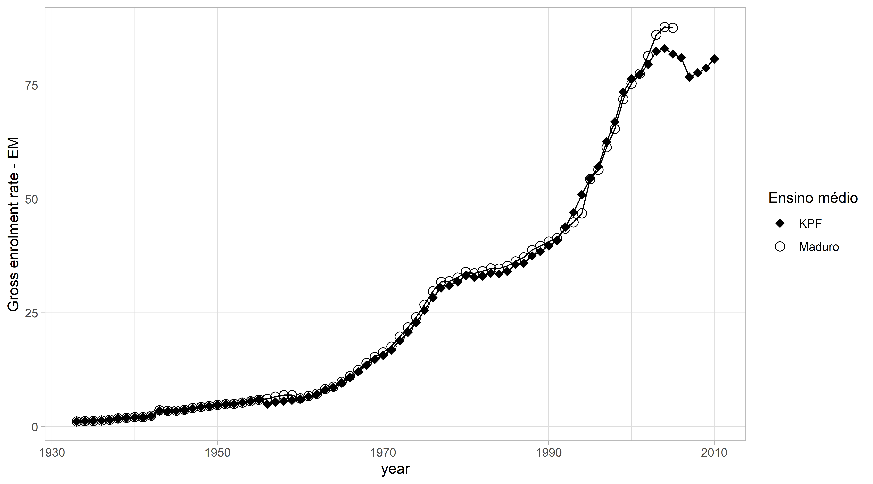
Sources: Maduro (2007) and see Section 2.

FIGURE A2
Net and gross enrolment rates, ensino médio (upper secondary level), Brazil, 1981-2006

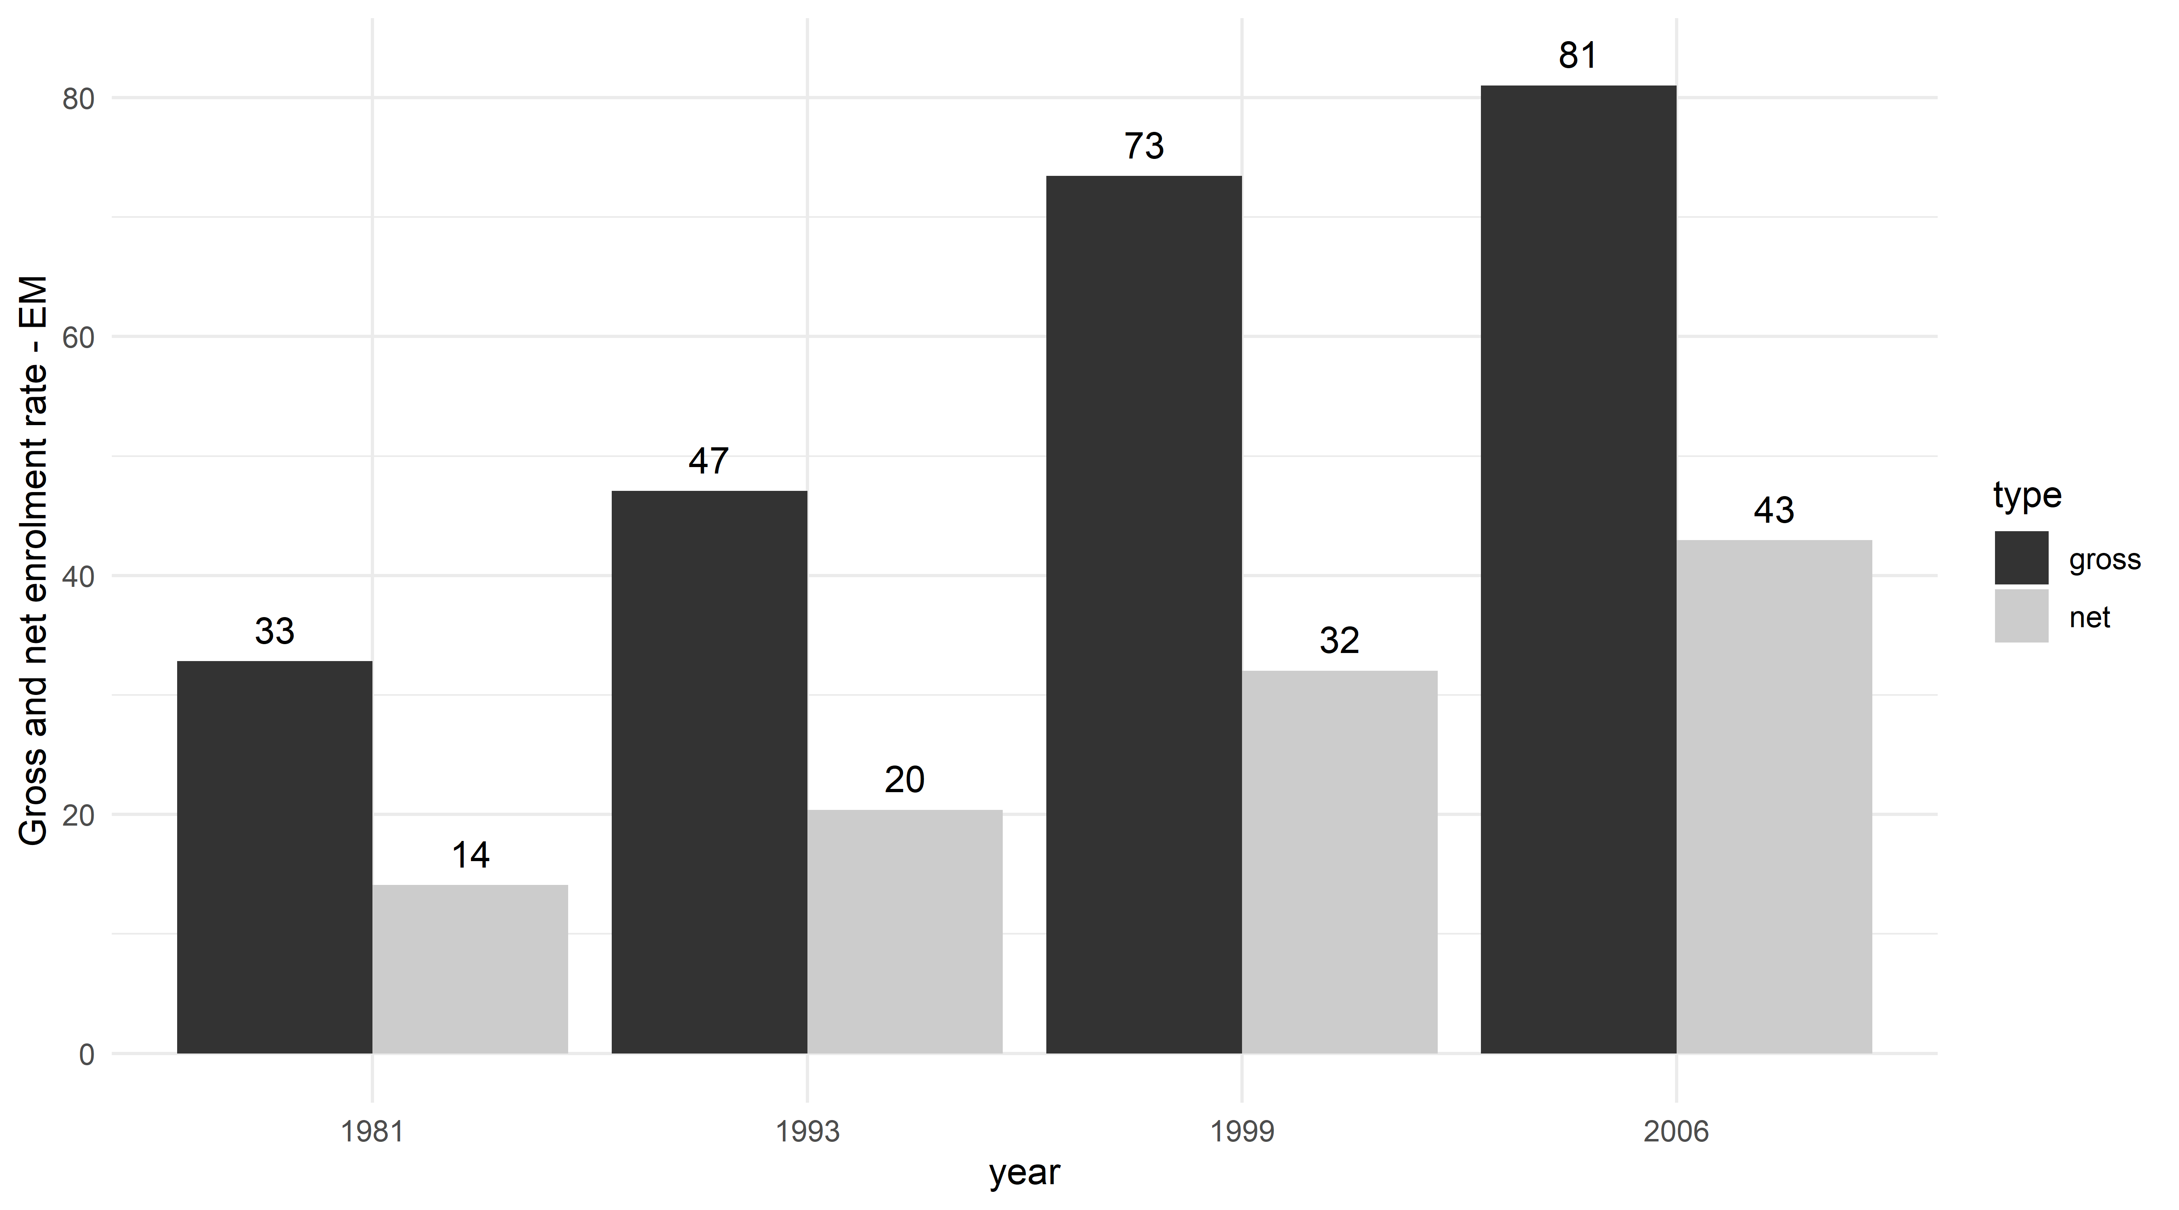
Sources: see Section 2.

B. GDR in Brazilian states, 1960-2000
GDR in Brazil demands special attention. In 1960, the Latin American GDR was 0.41. Caribbean islands such as Trinidad y Tobago, Guyana and Barbados presented GDR above 0.80. Among Latin American countries, Argentina (0.63), Uruguay (0.58) and Panama (0.57) stood out (Frankema 2009). On the other hand, Brazil presented a GDR of 0.19 according to our dataset (Frankema found an even lower GDR: 0.17 in 1960). This index was comparable only to countries such as Nicaragua (0.18), Honduras (0.20) and Colombia (0.20). The first grid in Figure 15 illustrates this; Brazilian GDR was comparatively low, considering Latin American standards.
Applying GDR to Brazilian regions and states shows that the situation was even worse. In 1960, the North and the Northeast both had a GDR of 0.13, which is lower than any other small Central American country according to Frankema's dataset. The industrial Southeast presented a less unbalanced pattern of enrolment across grades (0.23), close to the result presented by the Dominican Republic (0.24) but far from the results of neighbouring countries such as Uruguay (0.58) and Argentina (0.63). Hence, it becomes clear how unequal schooling was in different parts of Brazil since GDR in most states was lower than almost all Latin American countries. The wealthier states of São Paulo and Rio de Janeiro in the Southeast region presented relatively better indicators. The backward situation in the Northeast becomes clear in Figure 7, which shows the distribution of enrolments by the eight grades of the new primary education in the Northeast and the Southeast in 1960. Although the Southeast’s results were already worrying, 60 per cent of pupils in the new primary education were enrolled in the first grade in the Northeast. This proportion cannot be clearly attributed to a mass schooling policy or any demographic phenomenon.
We carried out an extensive analysis of 1970 in the present study. In 1980, Brazil's GDR was 0.46, which is still much lower than the Latin American average (0.68). The Northeast (0.30) and the North (0.32) achieved levels similar to Nicaragua (0.32), which occupied the last position in the ranking of Latin American countries. The South and the Southeast (0.59 and 0.58, respectively) had better indicators than Paraguay and El Salvador, but still worse than Ecuador (0.64), Mexico (0.64) and even the Latin American average (0.68). Despite considerable improvements until 1980, the more impoverished regions still had a long way to go in order to overtake some poor Central American countries.
Brazilian figures were not available for 1990, so we selected 1991 indicators. Democracy seems to have influenced Brazilian elementary education since results became relatively better in the early 1990s (0.68 against 0.75 of Latin America). These figures seem consistent with the literature on late twentieth-century democratisation in Latin America and Brazil (Brown 2002; Brown and Hunter 2004). In regional terms, the Northeast and the North (both 0.45) were stuck at levels not substantially better than those of Nicaragua (0.41). In 2000, the centre-south portion of the country was clearly ahead the rest of Latin America. Finding the reasons for such a transition in the 1990s in a comparative perspective is also an important research agenda.
FIGURE A3
GDR 1-6, Latin American countries and Brazilian states, 1960, 1980 and 2000.

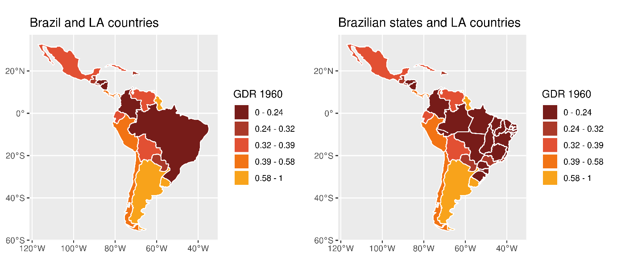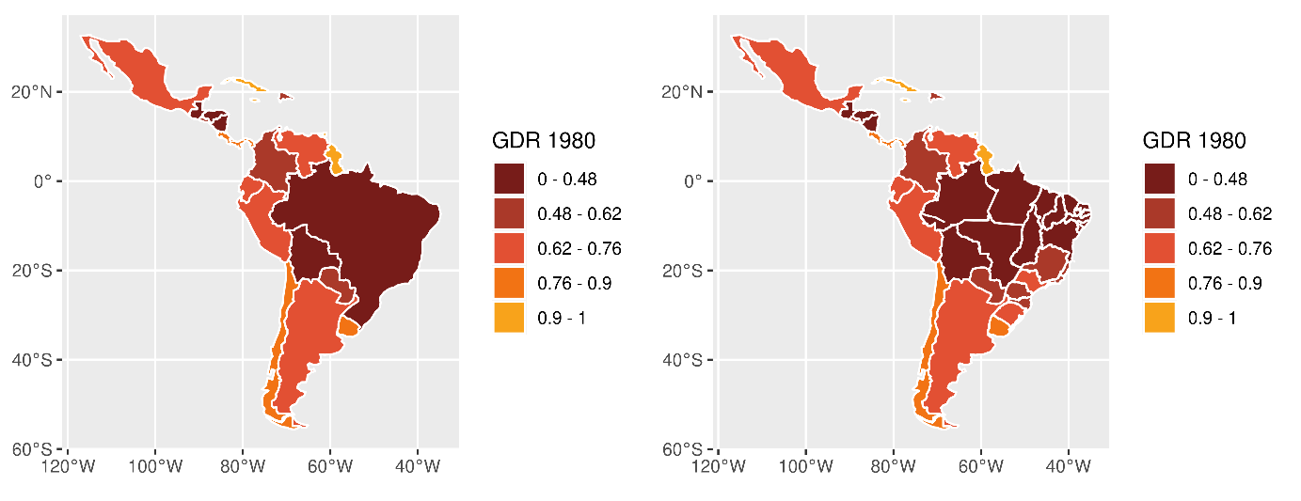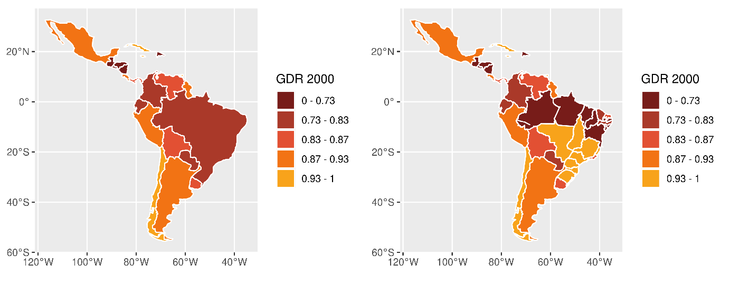
Sources: see Section 2.

C. Gross enrolment rates, states, 1955-2010
Estimates of gross enrolment rates are, to a large extent, based on Goldenberg (1990). Summarising state-level enrolments did not match national figures in several years, which led us to adopt a mathematical adaptation to make the dataset consistent. The differences between the original numbers and the standardised rate that we adopted are small (Figure 16).
Some outliers, such as Espírito Santo in 1980 and Goiás in 1981, draw our attention. Although these are apparent mistakes, it is not clear how we should proceed to correct the data. Minas Gerais reportedly adopted an extra school year that was not documented in Goldenberg (1990) in the late 1980s, explaining the sudden drop during that period. Even though we are confident about the large majority of the estimates, specific information for a particular year and state should be analysed with care.

FIGURE A4
Gross enrolment rates, new primary education (ensino fundamental - EF), states, Brazil, 1955-2010

Sources: mostly from Goldenberg (1990) (see Sections 2 and 3).

