Supplementary photos to post online/Chris Chan article in ILWCH 83

Honda workers gathered inside the factory complex in Foshan, Guangdong province
during strike in 2010
(photo posted online during the strike. Source cannot be traced as the blog has since been removed)
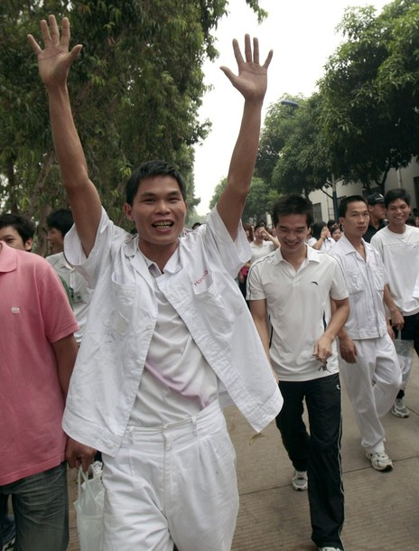
Honda workers after the 2010 strike in Foshan, Guangdong province
(photo posted in website during the strike. Source cannot be traced as the blog has been removed)

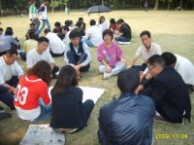
Chinese migrant workers participating in leisure activities organized by an NGO.
(picture by Workers’ Empowerment [this is Chris Chan’s organization]. Reprint permission has been granted)

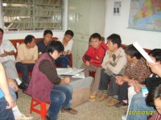
Workers’ group meeting at a labor NGO
(picture by Workers’ Empowerment. Reprint permission has been granted)

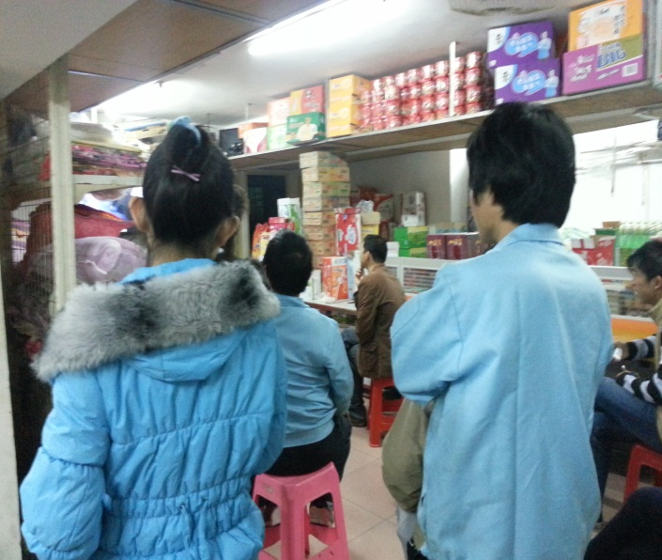
Workers watching TV in a shop inside a Taiwanese electronic factory complex in Shenzhen (picture by the author)

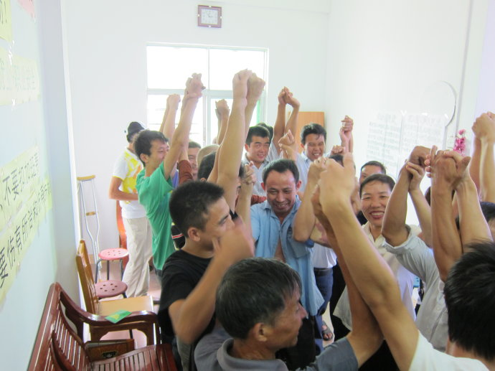
Activist workers at a training session sponsored by a labor NGO
(picture by Workers’ Empowerment. copyrights has been granted)

