Appendix: Variable description

Variables by neighbourhood:
- Smallpox death rate: The number of deaths due to smallpox per 1000 people in 1871. This is the dependent variable in the OLS regressions. The 43 smallpox cases out of the 2165 which do not have a recorded residential address were left out of the analysis.
- Average crude death rate: The crude death rate is the total number of deaths per 1000 people. To proxy the general mortality pattern by neighbourhood we calculate the average of the crude death rates in the four preceding years of the peak of the smallpox epidemic, 1867 to 1870. This variable makes it possible to investigate if the spatial distribution of the smallpox epidemic follows the general mortality distribution.
- Wealth: There are two potential sources to capture the wealth of neighbourhoods, however, both sources are from a period relatively long before the smallpox epidemic. First, Israëls (1862) provides a categorisation of all the 50 neighbourhoods into “poor”, “rather poor”, “rather wealthy” and “wealthy” based on Teixeira de Mattos (1865) and his own knowledge of the city. Second, we have estimates of the rental value of buildings. The rental values are calculated with a simple formula based on the taxable yield (belastbare opbrengst) obtained from the 1832 land register as discussed in Lesger and van Leeuwen (2012) and linked to the 1874 addresses. We calculate not only the mean of the rental values but their standard deviation as well to account for potential socioeconomic inequalities. Using these measures to explain smallpox mortality patterns in 1871 is based on the assumption that the relative wealth position of the neighbourhoods did not change between the 1830s and 1870s. Fortunately, we have information on the share of tax declarations above the 10th class (i.e., high tax values) in 1897/98 by neighbourhood. Figure A1 shows a high correspondence between mean rental values in our database and the share of high tax values in 1897/98. Thus, we do not reject the assumption of the stability of relative wealth position in the period of interest.
- Housing density: The average number of people by inhabitable building by neighbourhood. The number of buildings is obtained from the census in 1869 and we assume that it did not change until 1871.
- Jewish neighbourhood: A binary variable with the value of one if the dominant religion in a neighbourhood was Jewish. The source of this variable is the 1851-1853 population register (Amsterdam City Archive, Ekamper and van Poppel 2019) which includes socio-demographic information on residents living at a certain address at a certain point in time. Neighbourhoods are considered to be predominantly Jewish if the proportion of Jewish main occupants is above 30%. Jewish neighbourhoods are C, P, Q, R, S, V, W. We experimented with the threshold of 50% (Jewish neighbourhoods are P, Q, R, S) but the empirical results did not change significantly.
- Birth rate: Although we do not have information on birth rates from 1871, digitised birth certificates from 1874 are available from the Amsterdam City Archive to calculate the number of live births by 1000 people by neighbourhood. Birth rate is often included in studies on infectious diseases to proxy the number of susceptible population.
- Neighbourhoods with hospital: Based on a wide range of sources, we created a binary variable with the value of one if a neighbourhood had at least one hospital in 1871. Hardy, for instance, observed a positive relationship between smallpox mortality and the presence of smallpox hospital in London (Hardy 1993, p. 137-140). Hospital neighbourhoods are B, CC, K, LL, V, W, XX, Z.
The descriptive statistics of the discussed variables are presented in Table A1.

Figure A1 Mean rental value and the share of high tax value
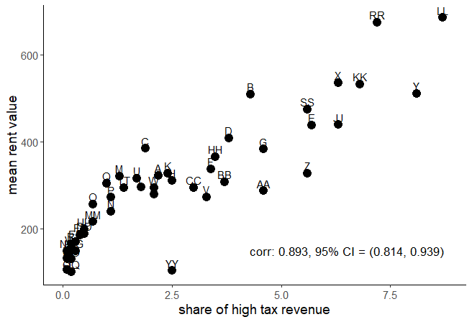

Figure A2 Jewish neighbourhoods and the wealth classification of neighbourhoods by Israëls
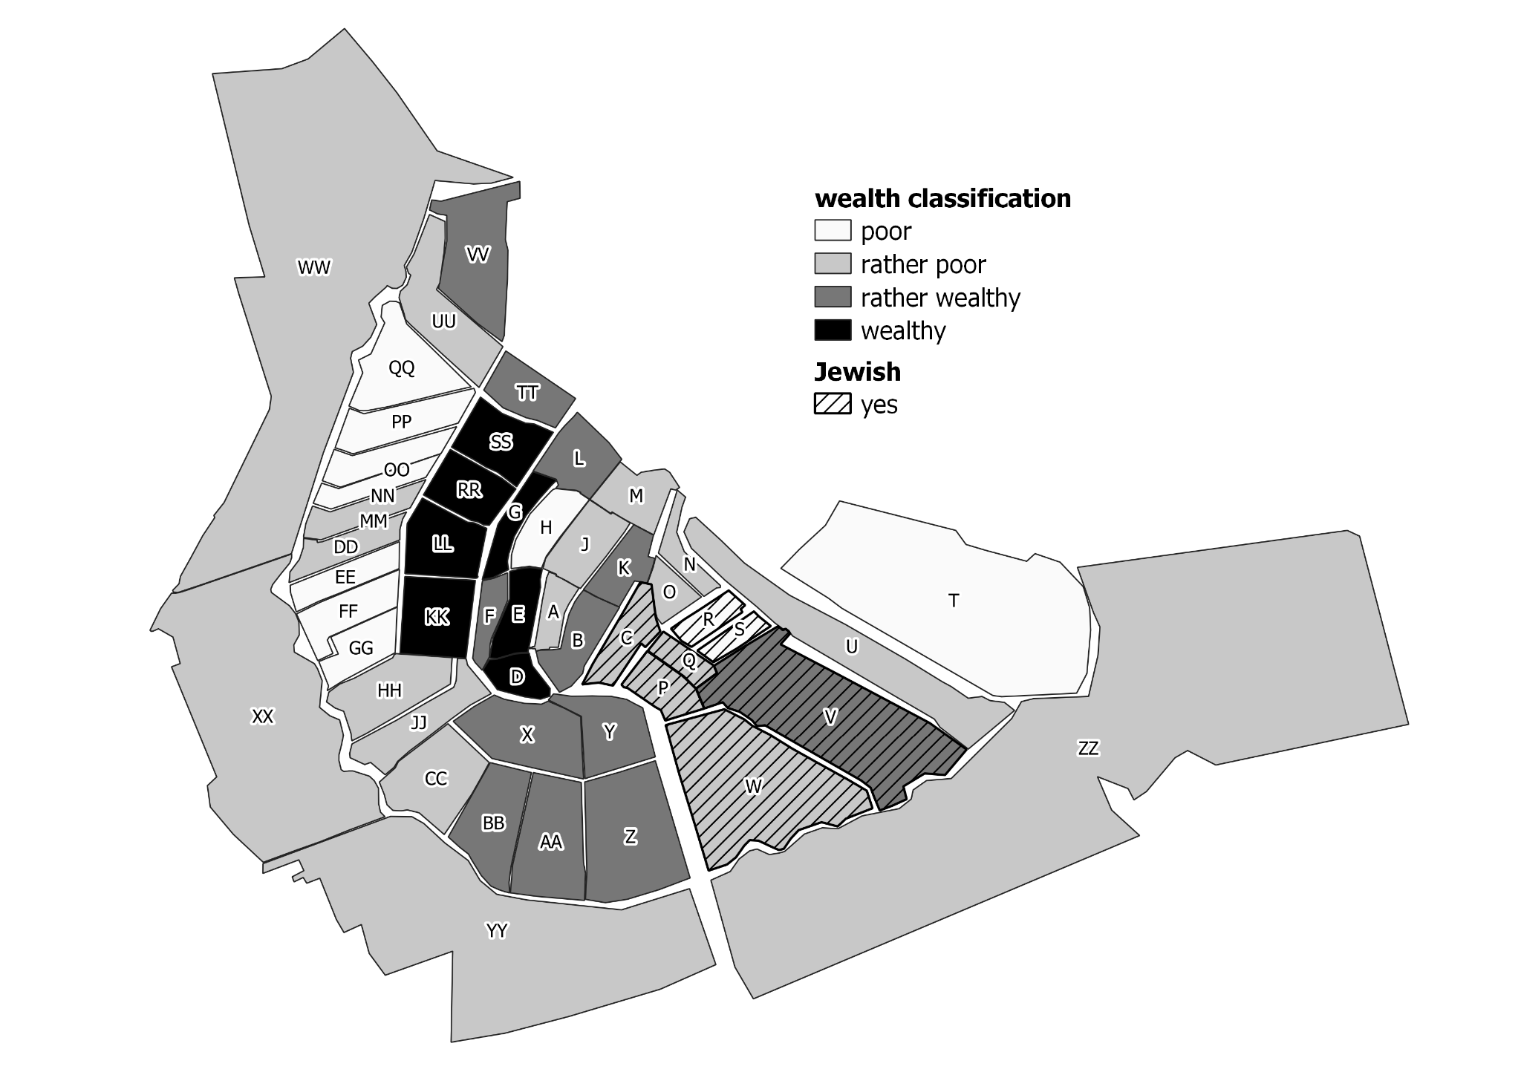
Table A1 Descriptive statistics of variables measured at the neighbourhood level
 | N | Mean | Std. dev. | Min | Max
smallpox DR | 50 | 6.986 | 4.307 | 0 | 19.046
average CDR | 50 | 26.804 | 3.818 | 19.069 | 37.672
poor | 50 | 0.220 | 0.418 | 0 | 1
rather poor | 50 | 0.400 | 0.495 | 0 | 1
rather wealthy | 50 | 0.240 | 0.431 | 0 | 1
wealthy | 50 | 0.140 | 0.351 | 0 | 1
log rental value | 47 | 5.608 | 0.488 | 4.619 | 6.528
std. of rental value | 47 | 233.602 | 110.204 | 80.632 | 497.227
house density | 47 | 11.067 | 2.991 | 12.07 | 18.394
Jewish neighbourhood | 50 | 0.140 | 0.351 | 0 | 1
birth rate | 50 | 27.859 | 9.774 | 4.653 | 71.610
hospital | 50 | 0.160 | 0.370 | 0 | 1

