Supplementary Materials
Part One: Yankee Fathers and Sons in 1850
Figure 1S: Distance of adult sons from living fathers, 1850 vs contemporary
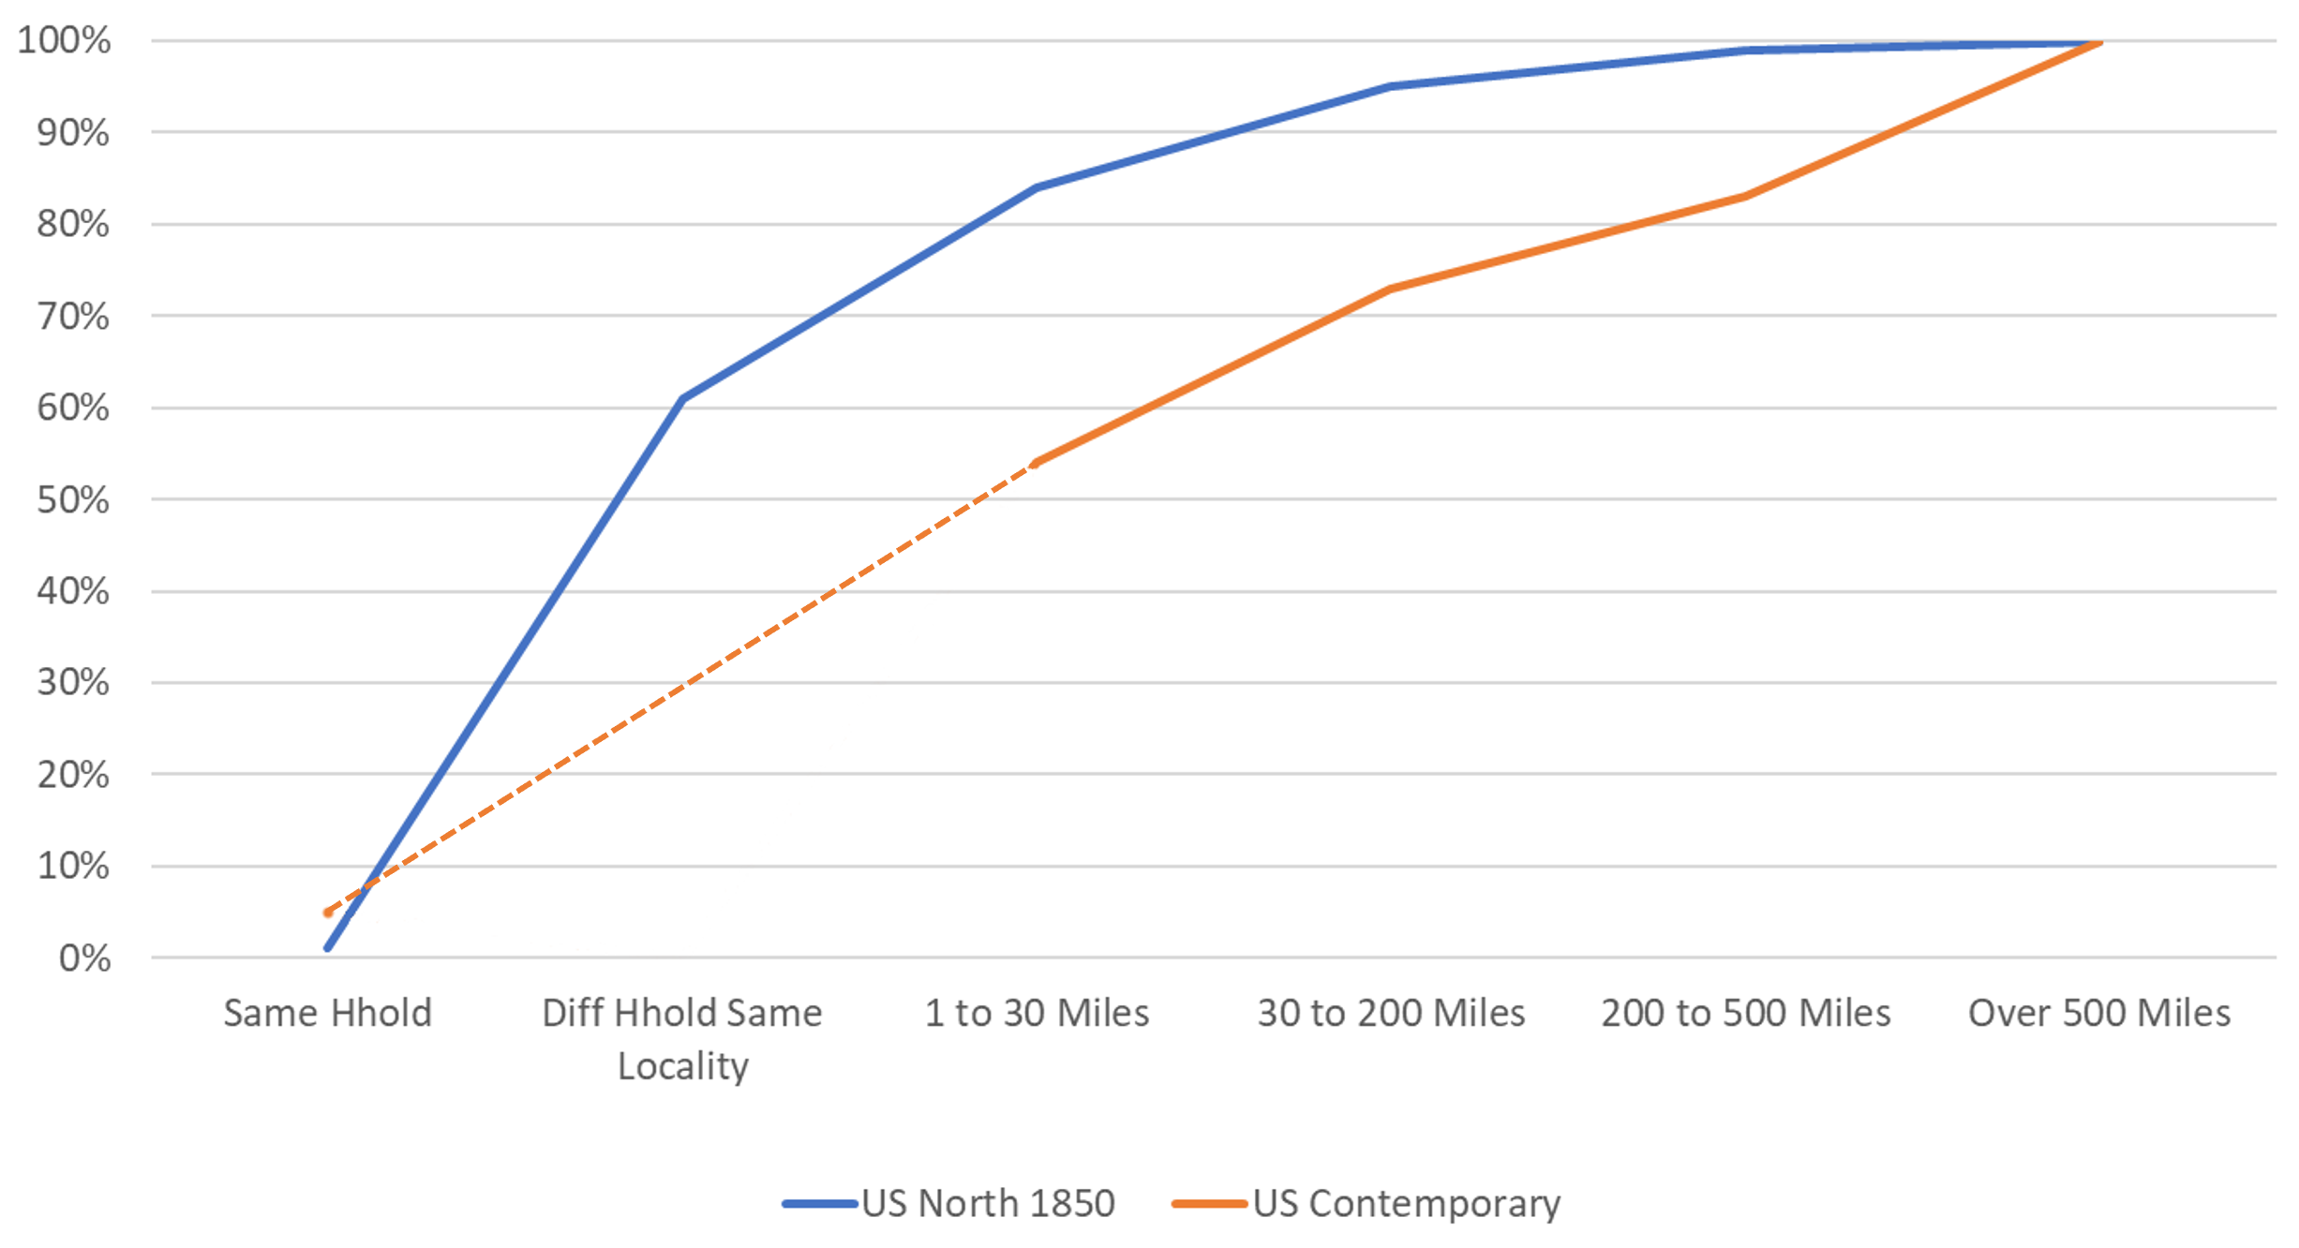
Figure 2S: Distribution of Distances of Adult Sons from fathers in 1850
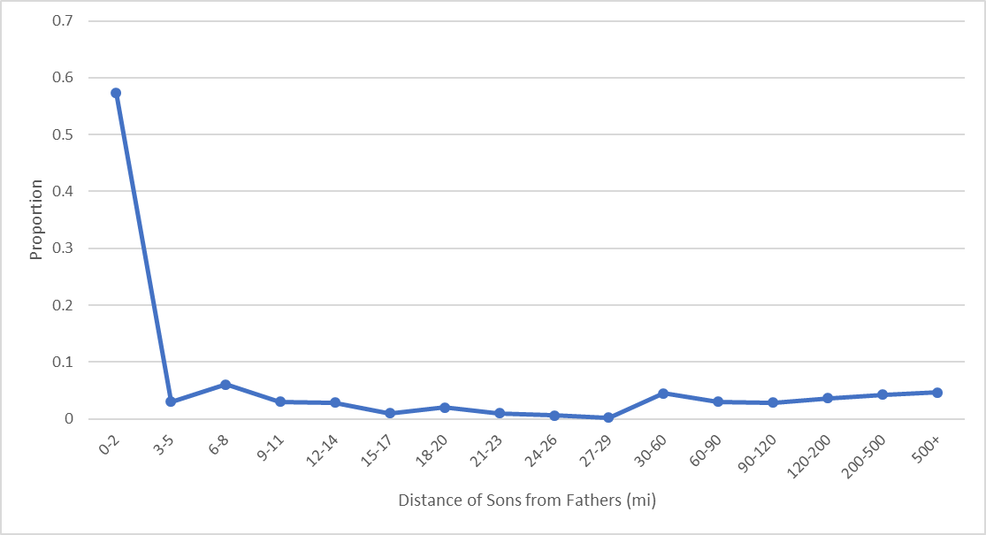

Part Two: Representativeness: Tree sample vs 1880 Census
We used individuals in the Trees data who had an event both before and after 1880 in the United States. The individual was then “placed” in the state where they lived on the date closest to 1880.
Figure 3S: State of Birth: Family Trees vs 1880 Census

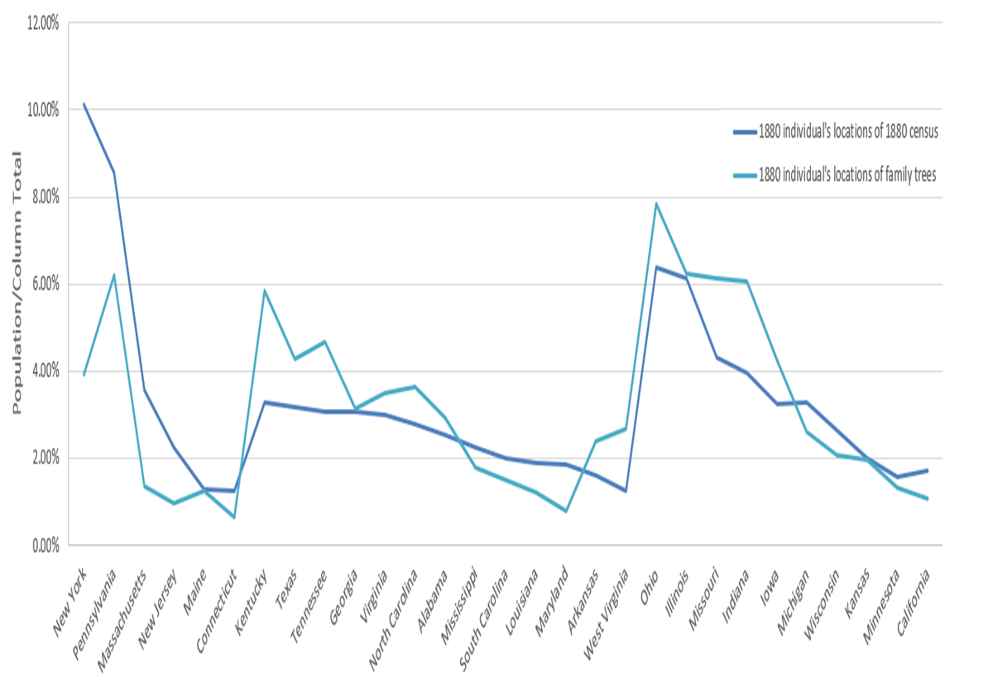

Figure 4S: Children of Native born Mothers living in each state in 1880: Family Trees vs 1880 Census

Comparisons of family trees and 1880 census for those who were born in the U.S. and their parents were also born in the U.S. and family trees and 1880 census for those who were alive in 1880 and live in the U.S. based on locations in the contiguous U.S. 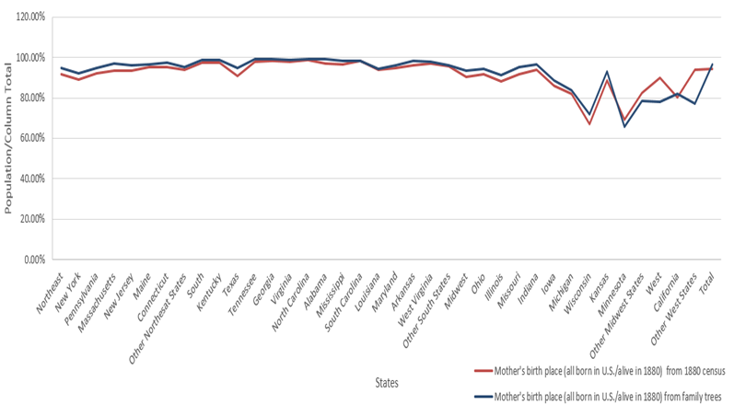

Even though there are fewer immigrants in Trees than in the general population, they could be representative of people born in those countries. At least some evidence of their similarity is shown by the locations of members of a very large family tree in our data many of whose ancestors came from Germany. In 1870, they were located almost exactly where the map of German immigration made from the 1870 census had them. Even the small offshoot groups were present in the data from just one tree, albeit a large one. However, it could be that the immigrants are more apt to be included if they married into the White founding population.

Figure 5S: Map of individuals born in Germany living in the United States in 1870

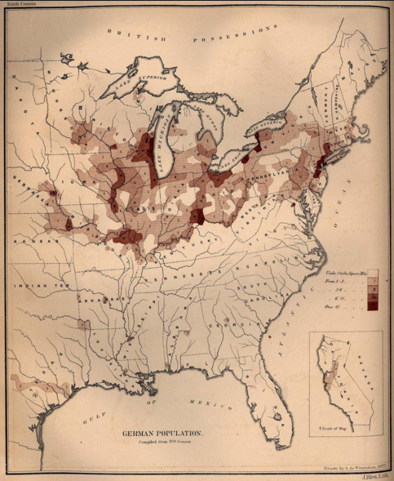
Source: The Statistics of the Population of the United States, map by Francis Amasa Walker, Compiled from the Original Returns of the Ninth Census, 1872. Perry-Castañeda Library Map Collection.

Figure 6S: Locations of individuals from a tree of German immigrants to the United States in 1870
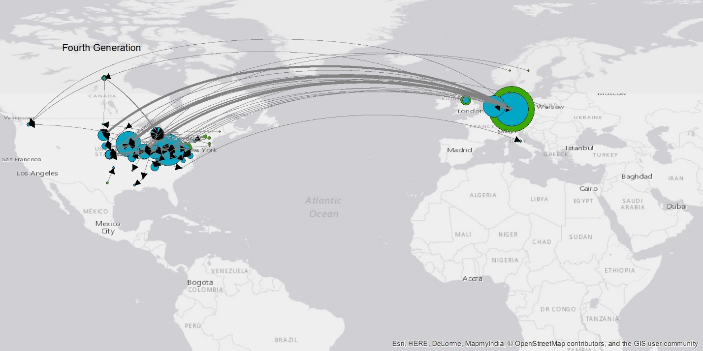

The Tree data was much more male than the 1880 population even though the Tree data shared certain peculiarities found in 1880: deficits in the 1880 population representing the lack of births during the Civil War ( at ages 15 and 19). Requiring an event after 1880 probably pruned more women from the trees than men since so many born into families were probably not followed at marriage.

