List of supplementary material
Appendix S1. Be Your Best: Health and Wellbeing Survey 2018
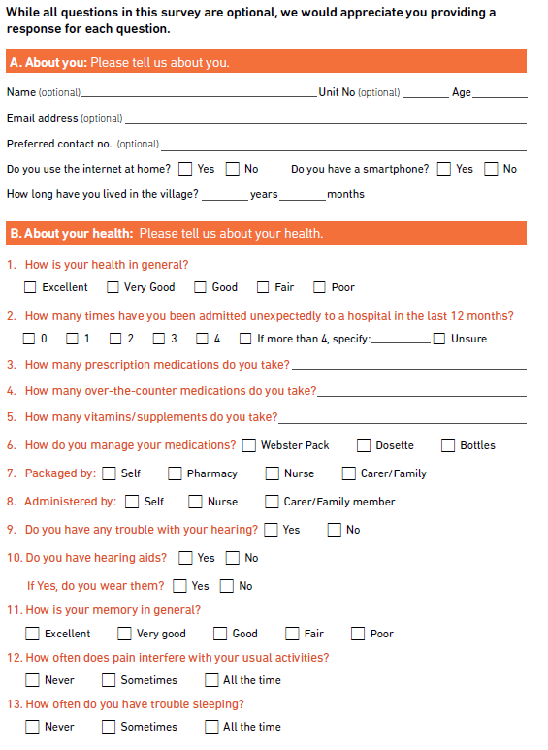

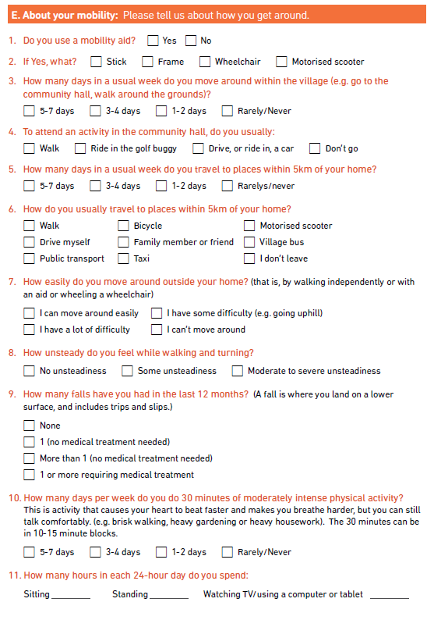

Appendix S2. Variables used to generate a latent class model of wellbeing
Four variables, selected as indicators of overall wellbeing, were dichotomised for use in latent class modelling. A retirement village identifier (numeric value 1 to 14) was included to account for clustering of respondents in 14 distinct retirement villages.

Indicator variables |  | Survey respondents aged ≥65 years
 |  |  | number |  | per cent
Self-rated health
Satisfactory health (Excellent/Very Good/Good) |  |  | 580 |  | 69.0
Fair/Poor |  |  | 261 |  | 31.0
Unplanned hospital admissions, in past 12 months
No unplanned hospitalisations |  |  | 568 |  | 69.4
≥1 admission |  |  | 251 |  | 30.6
Self-rated memory
Satisfactory memory (Excellent/Very Good/Good) |  |  | 662 |  | 78.0
Fair/Poor |  |  | 187 |  | 22.0
Time spent with someone who does not live with you
Frequent socialisation (3-7 days per week) |  |  | 421 |  | 49.9
1-2 days per week/ Rarely/ Never |  |  | 423 |  | 50.1
Clustering variable |  | Number of residents | Survey respondents aged ≥65 years
 |  |  | number |  | per cent of residents in village |  | per cent of total number of respondents aged ≥65 years
Retirement village | 1 | 29 | 8 |  | 27.6 |  | 0.9
 | 2 | 50 | 26 |  | 52.0 |  | 3.0
 | 3 | 55 | 24 |  | 43.6 |  | 2.8
 | 4 | 66 | 44 |  | 66.7 |  | 5.0
 | 5 | 75 | 58 |  | 77.3 |  | 6.7
 | 6 | 75 | 48 |  | 64.0 |  | 5.5
 | 7 | 92 | 67 |  | 72.8 |  | 7.7
 | 8 | 95 | 16 |  | 16.8 |  | 1.8
 | 9 | 106 | 48 |  | 45.3 |  | 5.5
 | 10 | 112 | 84 |  | 75.0 |  | 9.6
 | 11 | 165 | 73 |  | 44.2 |  | 8.4
 | 12 | 168 | 113 |  | 67.3 |  | 13.0
 | 13 | 195 | 156 |  | 80.0 |  | 17.9
 | 14 | 223 | 106 |  | 47.5 |  | 12.2
 | total | 1506 | 871 |  |  |  | 100.0

Appendix S3. Multinomial logistic regression to determine factors associated with membership into the Moderate and Low Wellbeing groups when each is compared to High Wellbeing as the reference group. Wellbeing group membership was regressed on resident characteristics.
Variable | Univariate - unadjusted analysis |  |  | Multivariable - adjusted analysisª  Model 1^{b} |  |  | Multivariable – adjusted analysisª  Model 2^{c}
 | RRR (95% CI) | p-value | RRR (95% CI) |  | p-value |  | RRR (95% CI) | p-value
AGE (years) (n=780)^{d} |  | 0.003 |  |  |  | 0.06e |  | 0.07e
Moderate wellbeing
65-74 (reference) | 1.00 |  | 1.00 |  |  |  | 1.00
75-84 | 1.72 (0.97 to 3.05) | 0.07 | 2.04 (1.09 to 3.83) |  |  | 0.03 | 2.00 (1.07 to 3.75) | 0.03
≥85 | 2.75 (1.55 to 4.88) | 0.001 | 2.42 (1.27 to 4.60) |  |  | 0.01 | 2.36 (1.24 to 4.47) | 0.01
Low wellbeing
65-74 (reference) | 1.00 |  | 1.00 |  |  |  | 1.00
75-84 | 0.98 (0.60 to 1.62) | 0.95 | 0.97 (0.55 to 1.70) |  |  | 0.91 | 0.98 (0.55 to 1.72) | 0.93
≥85 | 1.44 (0.87 to 2.38) | 0.15 | 1.00 (0.55 to 1.81) |  |  | 0.99 | 0.99 (0.55 to 1.78) | 0.96
PRESCRIPTION MEDICATIONS (number taken) (n=819)^{d} |  | <0.001
Moderate wellbeing
0 (reference) | 1.00
1-2 | 1.85 (0.34 to 6.56) | 0.34
3-4 | 2.96 (0.86 to 10.20) | 0.09
≥5 | 5.22 (1.54 to 17.65) | 0.01
Low wellbeing
0 (reference) | 1.00
1-2 | 0.66 (0.22 to 1.95) | 0.45
3-4 | 1.89 (0.69 to 5.18) | 0.22
≥5 | 3.45 (1.29 to 9.23) | 0.01
HEARING DIFFICULTIES (n=830)^{d} |  | 0.03
Moderate wellbeing
No (reference) | 1.00
Yes | 0.79 (0.55 to 1.12) | 0.18
Low wellbeing
No (reference) | 1.00
Yes | 1.37 (0.97 to 1.93) | 0.07
PAIN (n=850)^{d} |  | <0.001 |  |  |  | <0.001^{c} |  | <0.001^{c}
Moderate wellbeing
Never interferes with usual activities (ref) | 1.00 |  | 1.00 |  |  |  | 1.00
Sometimes interferes with usual activities | 1.46 (0.95 to 2.24) | 0.09 | 1.03 (0.63 to 1.68) |  |  | 0.92 | 1.09 (0.67 to 1.77) | 0.74
Interferes with usual activities all the time | 2.62 (1.44 to 4.77) | 0.002 | 1.83 (0.97 to 3.05) |  |  | 0.10 | 1.89 (0.94 to 3.82) | 0.07
Low wellbeing
Never interferes with usual activities (ref) | 1.00 |  | 1.00 |  |  |  | 1.00
Sometimes interferes with usual activities | 3.21 (1.86 to 5.43) | <0.001 | 2.48 (1.31 to 4.69) |  |  | 0.005 | 2.51 (1.33 to 4.72) | 0.004
Interferes with usual activities all the time | 9.30 (4.86 to 17.79) | <0.001 | 5.33 (2.41 to 11.08) |  |  | <0.001 | 5.65 (2.60 to 12.25) | <0.001
SLEEP DIFFICULTIES (n=851)^{d} |  | 0.09 |  |  |  | 0.55^{c}
Moderate wellbeing
Never (reference) | 1.00 |  | 1.00
Sometimes | 1.26 (0.82 to 1.94) | 0.28 | 1.36 (0.97 to 3.05) |  |  | 0.34
All the time | 1.18 (0.62 to 2.24) | 0.62 | 1.02 (0.97 to 3.05) |  |  | 0.39
Low wellbeing
Never (reference) | 1.00 |  | 1.00
Sometimes | 1.16 (0.76 to 1.78) | 0.49 | 0.99 (0.59 to 1.62) |  |  | 0.98
All the time | 2.05 (1.16 to 3.62) | 0.01 | 1.20 (0.59 to 2.45) |  |  | 0.61
CLEANING HOME (n=826)^{d} |  | <0.001
Moderate wellbeing
All cleaning by myself (reference) | 1.00
All cleaning by myself with some difficulty | 2.10 (1.20 to 3.66) | 0.01
Can do only some/none of the cleaning | 3.73 (2.39 to 5.82) | <0.001
Low wellbeing
All cleaning by myself (reference) | 1.00
All cleaning by myself with some difficulty | 1.93 (1.04 to 3.58) | 0.04
Can do only some/none of the cleaning | 5.45 (3.40 to 8.74) | <0.001
MEAL PREPARATION (n=840)^{d} |  | <0.001 |  |  |  | <0.001^{c} |  | <0.001^{c}
Moderate wellbeing
All meals by myself (reference) | 1.00 |  | 1.00 |  |  |  | 1.00
All meals by myself with some difficulty | 2.01 (1.15 to 3.85) | 0.02 | 1.82 (0.93 to 3.53) |  |  | 0.08 | 1.78 (0.92 to 3.45) | 0.09
Prepare only some/no meals by myself | 3.21 (2.07 to 4.96) | <0.001 | 2.43 (1.46 to 4.04) |  |  | 0.001 | 2.35 (1.42 to 3.90) | 0.001
Low wellbeing
All meals by myself (reference) | 1.00 |  | 1.00 |  |  |  | 1.00
All meals by myself with some difficulty | 2.86 (1.58 to 5.18) | 0.001 | 1.85 (0.93 to 3.68) |  |  | 0.08 | 1.88 (0.95 to 3.72) | 0.07
Prepare only some/no meals by myself | 5.91 (3.90 to 8.96) | <0.001 | 3.63 (2.21 to 5.97) |  |  | <0.001 | 3.70 (2.26 to 6.08) | <0.001
PERSONAL CARE (showering, bathing, dressing) (n=854)^{d} |  | <0.001
Moderate wellbeing
By myself (reference) | 1.00
By myself with some difficulty | 2.73 (1.41 to 5.30) | 0.003
Require some or a lot of help | 1.90 (0.84 to 4.27) | 0.12
Low wellbeing
By myself (reference) | 1.00
By myself with some difficulty | 5.99 (3.35 to 10.73) | <0.001
Require some or a lot of help | 4.71 (2.40 to 9.22) | <0.001
MOBILITY AID USE (n=849)^{d} |  | <0.001
Moderate wellbeing
No (reference) | 1.00
Yes | 3.08 (2.16 to 4.39) | <0.001
Low wellbeing
No (reference) | 1.00
Yes | 4.40 (3.08 to 6.29) | <0.001
UNSTEADINESS, while walking or turning (n=840)^{d} |  | <0.001
Moderate wellbeing
None (reference) | 1.00
Some | 2.32 (1.60 to 3.37) | <0.001
Moderate to severe | 2.28 (1.10 to 4.73) | 0.03
Low wellbeing
None (reference) | 1.00
Some | 3.62 (2.41 to 5.44) | <0.001
Moderate to severe | 8.46 (4.55 to 15.72) | <0.001
FALLS, in last 12 months (n=852)^{d} |  | <0.001 |  |  |  | <0.001^{c} |  | <0.001^{c}
Moderate wellbeing
None (reference) | 1.00 |  | 1.00 |  |  |  | 1.00
≥1 no med treatment required | 1.68 (1.11 to 2.54) | 0.02 | 1.37 (0.85 to 2.20) |  |  | 0.20 | 1.36 (0.84 to 2.18) | 0.21
≥1 requiring medical treatment | 7.40 (4.08 to 13.45) | <0.001 | 6.40 (3.24 to 12.62) |  |  | <0.001 | 6.31 (3.20 to 12.44) | <0.001
Low wellbeing
None (reference) | 1.00 |  | 1.00 |  |  |  | 1.00
≥1 no med treatment required | 1.47 (0.97 to 2.23) | 0.07 | 1.14 (0.69 to 1.87) |  |  | 0.61 | 1.15 (0.70 to 1.88) | 0.59
≥1 requiring medical treatment | 6.64 (3.67 to 12.03) | <0.001 | 4.45 (2.15 to 9.18) |  |  | <0.001 | 4.64 (2.26 to 9.53) | <0.001
PHYSICAL ACTIVITY, 30 mins moderately intense (n=829)^{d} |  | <0.001 |  |  |  | 0.003^{c} |  | 0.004^{c}
Moderate wellbeing
Rarely/never (reference) | 1.00 |  | 1.00 |  |  |  | 1.00
1-2 days per week | 0.58 (0.36 to 0.91) | 0.02 | 0.62 (0.37 to 1.04) |  |  | 0.07 | 0.64 (0.38 to 1.06) | 0.09
3-4 days per week | 0.48 (0.30 to 0.79) | 0.004 | 0.58 (0.33 to 1.03) |  |  | 0.06 | 0.59 (0.33 to 1.04) | 0.07
5-7 days per week | 0.50 (0.30 to 0.83) | 0.007 | 0.61 (0.34 to 1.11) |  |  | 0.10 | 0.60 (0.33 to 1.08) | 0.09
Low wellbeing
Rarely/never (reference) | 1.00 |  | 1.00 |  |  |  | 1.00
1-2 days per week | 0.39 (0.25 to 0.60) | <0.001 | 0.44 (0.26 to 0.74) |  |  | 0.002 | 0.44 (0.26 to 0.73) | 0.002
3-4 days per week | 0.30 (0.19 to 0.49) | <0.001 | 0.41 (0.23 to 0.75) |  |  | 0.003 | 0.41 (0.23 to 0.74) | 0.003
5-7 days per week | 0.18 (0.10 to 0.32) | <0.001 | 0.28 (0.14 to 0.56) |  |  | <0.001 | 0.29 (0.15 to 0.58) | <0.001
ª Adjusted for all variables listed in the column
^{b} Number of observations used to generate Model 1 = 731
^{c} Model 2 is reported in the main text of the article; number of observations used to generate Model 2 = 733
^{d} Number of observations in the univariate analysis; total number respondents aged ≥65 years = 871
^{e} Overall Likelihood Ratio Test p-value
Abbreviations: RRR= relative risk ratio; CI=confidence interval

