Supplementary Material
Figure S1 Procedures of sample selection
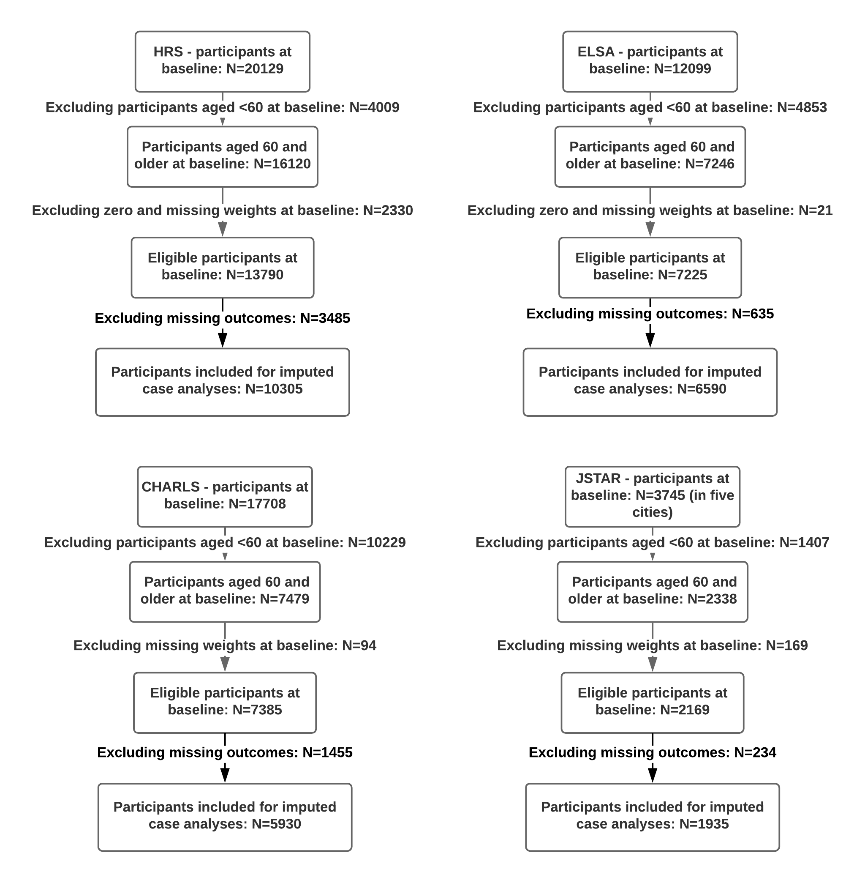
Table S1 Indicators of healthy ageing index and harmonising strategies
Variables | Categories | Scores
Verbal Memory - 10 words immediate recall | 0-10 | 0-2=0
 |  | 3-4=25
 |  | 5-6=50
 |  | 7-8=75
 |  | 9-10=100
Verbal Memory - 10 words delayed recall | 0-10 | 0-2=0
 |  | 3-4=25
 |  | 5-6=50
 |  | 7-8=75
 |  | 9-10=100
Orientation - date naming- month | 0.incorrect | 0=0
 | 1.correct | 1=100
Orientation - date naming- day of month | 0.incorrect | 0=0
 | 1.correct | 1=100
Orientation - date naming- year | 0.incorrect | 0=0
 | 1.correct | 1=100
Orientation - date naming- day of week | 0.incorrect | 0=0
 | 1.correct | 1=100
ADL: some diff. in dressing | 0. No | 0=100
 | 1. Yes | 1=0
ADL: some diff. in bathing, shower | 0. No | 0=100
 | 1. Yes | 1=0
ADL: some diff. in eating | 0. No | 0=100
 | 1. Yes | 1=0
ADL: some diff. in get in/out bed | 0. No | 0=100
 | 1. Yes | 1=0
ADL: some diff. in using the toilet | 0. No | 0=100
 | 1. Yes | 1=0
ADL: some diff. in taking medications | 0. No | 0=100
 | 1. Yes | 1=0
ADL: some diff. in shop for grocery | 0. No | 0=100
 | 1. Yes | 1=0
ADL: some diff. in prepare hot meal | 0. No | 0=100
 | 1. Yes | 1=0
Some diff. in get up from chair | 0. No | 0=100
 | 1. Yes | 1=0
Some diff. in climb several flat stairs | 0. No | 0=100
 | 1. Yes | 1=0
Some diff. in reach/extend arms up | 0. No | 0=100
 | 1. Yes | 1=0
Some diff. in stoop/kneel/crouch | 0. No | 0=100
 | 1. Yes | 1=0
Some diff. in lift/carry 10lbs | 0. No | 0=100
 | 1. Yes | 1=0
Some diff. in pick up a dime | 0. No | 0=100
 | 1. Yes | 1=0
Grip strength (kg) – Left hand | kg (quintiles) | 1=0
 |  | 2=25
 |  | 3=50
 |  | 4=75
 |  | 5=100
Grip strength (kg) – Right hand | kg (quintiles) | 1=0
 |  | 2=25
 |  | 3=50
 |  | 4=75
 |  | 5=100
CES-D score* | 0-8 (quintiles) | 0=100
 |  | 1-3=75
 |  | 4-5=50
 |  | 6-7=25
 |  | 8=0
CES-D score** | 0-30 (quintiles) | 0-6=100
 |  | 7-13=75
 |  | 14-20=50
 |  | 21-26=75
 |  | 27-30=0
Self-reported life satisfaction | 0. Very satisfied | 0=100
 | 1. Satisfied | 1=75
 | 2. Somewhat satisfied | 2=50
 | 3. Unsatisfied | 3=25
 | 4. Very unsatisfied | 4=0
High blood pressure | 0. No | 0=100
 | 1. Yes | 1=0
Diabetes | 0. No | 0=100
 | 1. Yes | 1=0
Cancer | 0. No | 0=100
 | 1. Yes | 1=0
Lung disease | 0. No | 0=100
 | 1. Yes | 1=0
Stroke | 0. No | 0=100
 | 1. Yes | 1=0
Heart problem | 0. No | 0=100
 | 1. Yes | 1=0
Psychological problem | 0. No | 0=100
 | 1. Yes | 1=0
Arthritis | 0. No | 0=100
 | 1. Yes | 1=0
Participations in social activities | 0.No | 0=0
 | 1. Yes | 1=100
* CES-D scores for HRS and ELSA ** CES-D scores for CHARLS and JSTAR

Table S2 Correlation between HAIs across waves in HRS, ELSA and CHARLS
HRS | Wave 7 | Wave 8 | Wave 9 | Wave 10 | Wave 11 | Wave 12
Wave 7 | 1.000
Wave 8 | 0.811 | 1.000
Wave 9 | 0.769 | 0.792 | 1.000
Wave 10 | 0.732 | 0.771 | 0.792 | 1.000
Wave 11 | 0.697 | 0.720 | 0.773 | 0.820 | 1.000
Wave 12 | 0.652 | 0.693 | 0.709 | 0.788 | 0.812 | 1.000
ELSA | Wave 1 | Wave 2 | Wave 3 | Wave 4 | Wave 5 | Wave 6 | Wave 7
Wave 1 | 1.000
Wave 2 | 0.847 | 1.000
Wave 3 | 0.803 | 0.835 | 1.000
Wave 4 | 0.773 | 0.797 | 0.844 | 1.000
Wave 5 | 0.756 | 0.763 | 0.811 | 0.845 | 1.000
Wave 6 | 0.720 | 0.737 | 0.790 | 0.821 | 0.841 | 1.000
Wave 7 | 0.694 | 0.670 | 0.750 | 0.776 | 0.800 | 0.848 | 1.000
CHARLS | Wave 1 | Wave 2 | Wave 4
Wave 1 | 1.000
Wave 2 | 0.685 | 1.000
Wave 4 | 0.680 | 0.738 | 1.000

Table S3 Scale reliability coefficients for the HAI at each wave in HRS, ELSA and CHARLS
Cronbach’s α | Wave 1  (7 in HRS) | Wave 2  (8 in HRS) | Wave 3  (9 in HRS) | Wave 4  (10 in HRS) | Wave 5  (11 in HRS) | Wave 6 | Wave 7
HRS | 0.819 | 0.831 | 0.832 | 0.833 | 0.840 | 0.836 | -
ELSA | 0.815 | 0.827 | 0.829 | 0.831 | 0.847 | 0.851 | 0.840
CHARLS | 0.849 | 0.834 | - | 0.858 | - | - | -

Table S4 Comparison of predictive performance between phenotypic frailty and HAI by Area Under Curves (AUCs) in each study
Studies | AUCs | Standard Errors | 95%CIs | P-values
US (N=1837)
PF-Criterion | 0.676 | 0.011 | (0.655 to 0.698) | 0.410
HAI | 0.687 | 0.012 | (0.662 to 0.711)
England (N=3548)
PF-Criterion | 0.671 | 0.010 | (0.651 to 0.690) | 0.177
HAI | 0.684 | 0.011 | (0.664 to 0.705)
China (N=3015)
PF-Criterion | 0.628 | 0.025 | (0.580 to 0.678) | 0.166
HAI | 0.589 | 0.031 | (0.528 to 0.649)

Figure S2 Empirical Receiver Operating Characteristic (ROC) curves of phenotypic frailty and HAI in the US (N=1837), England (N=3548) and China (N=3015)

Table S5 Semi-harmonising strategies for occupational measures
Variables | Original categories | Harmonised categories
US (2004-2014)
Occupation | 0. Managerial specialty operators | I Managerial and professional specialty occupation
 | 1. Professional specialty opera. /technical sup.
 | 2. Sales | II Technical, sales and administrative support
 | 3. Clerical/administration support
 | 4. Service: private household/ clean/bldg. | III Service occupations
 | 5. Service: protection
 | 6. Service: food preparation
 | 7. Health service
 | 8. Personal service
 | 9. Farming/forestry/fishing | IV Farming, forestry and fishing occupations
 | 10. Mechanics/repair | V Precision production, craft, and repair occupations
 | 11. Construct trade/extractors
 | 12. Precision production
 | 13. Operators: machine | VI Operators, fabricators and labours
 | 14. Operators: transport, etc
 | 15. Operators: handlers, etc
 | 16. Member of armed forces | VII Others
 | 7. Retired | VIII Retired
 | 8. Unemployed | IX Unemployed
 | 9. Disabled | X Disabled
 | 10. Not in the labour force | XI Not in the labour force
Father’s occupation | 0. Managerial and professional specialty occupation | I Managerial and professional specialty occupation
 | 1. Technical, sales and administrative support | II Technical, sales and administrative support
 | 2. Service occupations | III Service occupations
 | 3. Farming, forestry and fishing occupations | IV Farming, forestry and fishing occupations
 | 4. Precision production, craft, and repair occupations | V Precision production, craft, and repair occupations
 | 5. Operators, fabricators and labours | VI Operators, fabricators and labours
 | 6. Unclassifiable | VII Unclassifiable
England (2002-2015)
Occupation | 0. Higher managerial occupations | I Higher managerial and professional employers
 | 1. Higher professional occupations
 | 2. Lower professional & higher technical occupations | II Lower managerial and professional employers
 | 3. Lower managerial occupations
 | 4. Intermediate | III Intermediate employees
 | 5. Employers in small organisations | IV Small employers and own account workers
 | 6. Own account workers
 | 7. Lower supervisory occupations | V Lower supervisory, craft and related employees
 | 8. Lower technical occupations
 | 9. Semi-routine occupations | VI Employees in semi-routine occupations
 | 10. Routine occupations | VII Employees in routine occupations
 | 11. Never worked | VIII Never worked
Father’s occupation | 0. Professional or technical | I Professional or technical
 | 1. Manager or senior official | II Manager, senior official, admin, cleric or secretarial
 | 2. Administrative, clerical or secretarial
 | 3. Running his own business | III Own business, or skilled trade
 | 4. Skilled trade
 | 5. Caring, leisure, travel or personal service | IV Service-skilled non-manual
 | 6. Sales or customer service
 | 7. Plant process or machine drivers or operation | V Service-skilled manual
 | 8. Armed forces | VI Others
 | 9. Other jobs
 | 10. Something else
 | 11. Casual jobs
 | 12. Retired | VII Retired
 | 13. Unemployed | VIII Unemployed, sick or disabled
 | 14. Sick/disabled
China (2011-2015)
Occupation* | - | I Officials/managers/leaders or Clerk/paid workers
 | - | II Self-employed workers
 | - | III Unpaid family business
 | - | IV Others
 | - | V Only agricultural work
Father’s occupation | 0. Manager | I Manager
 | 1. Professional and technician | II Professional and technician
 | 2. Clerk | III Clerk
 | 3. Commercial and service worker | IV Commercial and service worker
 | 4. Agricultural, forestry, husbandry and others | V Agricultural, forestry, husbandry and others
 | 5. Production and transportation workers | VI Production and transportation workers
 | 6. Cannot be specified | VII Others
Japan (2006-2011)
Occupation** | 0. Specialist and technical workers | I Highest
 | 1. Administrative and managerial workers
 | 2. Clerical workers | II Intermediate
 | 3. Sales workers
 | 4. Security workers
 | 5. Service workers | III Lowest
 | 6. Agriculture, forestry and fishery workers
 | 7. Transport and communication workers
 | 8. Production process and related workers
 | 9. Workers not classifiable by occupation | IV Others
 | 10. Unclassifiable | V Unclassifiable
Father’s occupation | 0. Employed (including public employee) | I Employed (including public employee)
 | 1. Executive of company or organization
 | 2. Self-employed (including self-employed farmer) | II Self-employed (including self-employed farmer)
 | 3. Assisted a self-employed person | III Others
 | 4. Worked at home
 | 5. Other (specify)
 | 6. Did not work | IV No work (including father passed away when participants was 15 years)
 | 7. Not applicable (already passed away when respondent was fifteen)
* There was no occupational variable in CHARLS. A new variable was derived based on information of major employment type, working status and current position.
** Occupation was re-categorised into three categories according to a new theory-based social classification in Japan, which was derived by Hiyoshi, et al (2013).

Table S6 Percentages of missingness in socioeconomic exposures and covariates at each wave in each study
 | US |  |  |  |  |  | England |  |  |  |  |  |  | China |  |  | Japan
Time-varying variables | Wave 7 | Wave 8 | Wave 9 | Wave 10 | Wave 11 | Wave 12 | Wave 1 | Wave 2 | Wave 3 | Wave 4 | Wave 5 | Wave 6 | Wave 7 | Wave 1 | Wave 2 | Wave 4 | Wave 1 | Wave 2 | Wave 3
Income | 0.00 | 0.00 | 0.00 | 0.00 | 0.00 | 0.00 | 1.37 | 0.86 | 2.56 | 2.71 | 2.86 | 5.95 | 2.82 | 15.76 | 30.78 | 7.32 | 29.14 | 6.29 | 6.97
Wealth | 0.00 | 0.00 | 0.00 | 0.00 | 0.00 | 0.00 | 1.36 | 0.86 | 2.56 | 2.71 | 2.86 | 2.62 | 2.82 | 28.57 | 53.44 | 19.05 | 5.62 | 34.22 | 87.85
Occupation | 1.83 | 0.52 | 0.41 | 0.19 | 0.16 | 0.11 | 4.38 | 0.00 | 0.00 | 0.00 | 0.00 | 0.00 | 9.09 | 62.33 | 61.57 | 50.85 | 3.78 | 6.20 | 6.89
Age | 0.00 | 0.00 | 0.00 | 0.00 | 0.00 | 0.00 | 0.00 | 0.00 | 0.00 | 0.00 | 0.00 | 0.00 | 0.00 | 0.00 | 0.00 | 0.00 | 0.00 | 0.00 | 0.00
Marital status | 0.06 | 0.00 | 0.01 | 0.01 | 0.01 | 0.00 | 0.01 | 0.02 | 0.02 | 0.00 | 0.03 | 0.00 | 0.00 | 0.08 | 0.03 | 2.45 | 0.00 | 2.22 | 3.41
Smoking | 0.94 | 0.87 | 0.89 | 0.85 | 0.82 | 0.89 | 1.90 | 0.07 | 0.09 | 1.33 | 2.15 | 0.10 | 0.16 | 3.63 | 26.32 | 45.71 | 4.47 | 10.73 | 4.57
Drinking | 0.01 | 0.02 | 0.01 | 0.02 | 0.01 | 0.15 | 1.45 | 17.31 | 21.72 | 21.00 | 17.87 | 20.71 | 21.28 | 7.33 | 1.06 | 0.67 | 5.76 | 2.03 | 5.11
Baseline variables
Education | 0.01 |  |  |  |  |  | 0.17 |  |  |  |  |  |  | 0.12 |  |  | 0.46
Gender | 0.00 |  |  |  |  |  | 0.00 |  |  |  |  |  |  | 0.01 |  |  | 0.00
Ethnicity | 0.02 |  |  |  |  |  | 0.04 |  |  |  |  |  |  | 14.88 |  |  | -
Self-rated health in childhood | 5.74 |  |  |  |  |  | 49.22 |  |  |  |  |  |  | 2.69 |  |  | -
Father’s occupation | 19.62 |  |  |  |  |  | 1.65 |  |  |  |  |  |  | 46.58 |  |  | 28.91

Figure S3 Example illustrating the derivation of socioeconomic rank score using education*
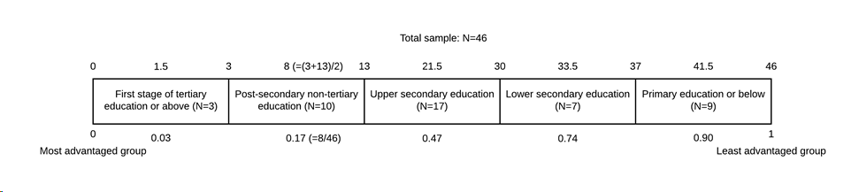
* Steps in the calculation of the educational rank score were: the sample of interest in each country was sorted, from the most advantaged to the least advantaged group based on the classification of education; the number of cases in each educational group was counted; then a midpoint value was calculated for each category of educational group; finally each midpoint was divided by the total sample size to generate a standardised educational rank score, ranging from 0 to 1.

