Running Head: EDUCATION, RETIREMENT, AND HEALTH

Healthy Retirement Begins at School:

Educational Differences in the Health Outcomes of Early Transitions into Retirement

APPENDIX

Table A1. Propensity score logistic estimation of the probability of retirement
Variables | Coeff. | SD | p-value
Health outcomes
Subjective health | 0.48 | 0.21 | 0.021
Subjective health squared | -0.07 | 0.04 | 0.053
Physical health | 0.17 | 0.43 | 0.696
Physical health squared | -0.02 | 0.04 | 0.544
Formal education
Years of education | 0.02 | 0.01 | 0.024
Covariates
Current age (centred) | -0.03 | 0.07 | 0.722
Current age squared (centred) | -0.33 | 0.08 | 0.000
Income (in $1,000) | 0.01 | 0.00 | 0.024
Income Squared (in $1,000) | 0.00 | 0.00 | 0.054
No spouse | -0.37 | 0.10 | 0.000
Spouse not employed | -0.16 | 0.09 | 0.091
Functional limitations index | -0.11 | 0.28 | 0.690
Functional limitations index squared | 0.01 | 0.04 | 0.772
Psychological health | 0.10 | 0.07 | 0.150
Psychological health squared | -0.01 | 0.01 | 0.079
Ever smoked | 0.24 | 0.09 | 0.012
Current smoker | 0.28 | 0.11 | 0.009
Soft drinking behaviour | 0.10 | 0.09 | 0.248
Moderate drinking behaviour | -0.04 | 0.19 | 0.844
Heavy drinking behaviour | 0.38 | 0.22 | 0.081
Women | 0.04 | 0.08 | 0.610
Indigenous ethnicity | 0.08 | 0.18 | 0.660
Blue-collar worker | 0.07 | 0.12 | 0.551
Clerical/sale/service worker | -0.15 | 0.14 | 0.286
Constant | -1.19 | 1.31 | 0.362
Number of observations | 2,430
Notes: Reference categories for categorical variables are employed spouse and professional/managerial worker.

Table A2. Poisson regression results for the average effects on physical health
Variables | IRR | SD | p-value
Retirement timing
Retirement status | 0.93 | 0.01 | 0.000
Age | 0.96 | 0.01 | 0.000
Age squared | 1.00 | 0.00 | 0.601
Interactions
Retirement x Age | 1.11 | 0.02 | 0.000
Retirement x Age squared | 0.97 | 0.01 | 0.000
Retirement x Years of education | 1.01 | 0.00 | 0.000
Retirement x Years of education x Age | 0.98 | 0.00 | 0.000
Retirement x Yrs. of educ. x Age squared | 1.01 | 0.00 | 0.000
Age x Years of education | 1.00 | 0.00 | 0.178
Age squared x Years of education | 1.00 | 0.00 | 0.956
Covariates
Income (in $1,000 and logged) | 0.99 | 0.01 | 0.028
No spouse | 0.96 | 0.01 | 0.000
Spouse not employed | 1.01 | 0.00 | 0.001
Not in the labour force | 0.99 | 0.00 | 0.003
Functional limitations index | 1.00 | 0.00 | 0.174
Psychological health | 1.01 | 0.00 | 0.000
Ever smoked | 1.01 | 0.00 | 0.025
Current smoker | 1.04 | 0.00 | 0.000
Soft drinking behaviour | 1.01 | 0.00 | 0.016
Moderate drinking behaviour | 1.02 | 0.01 | 0.001
Heavy drinking behaviour | 1.03 | 0.01 | 0.000
Constant | - | - | -
Number of individuals | 2,430
Number of observations | 6,276
Notes: Poisson model estimated using inverse-probability-weighting and robust standard errors. IRR stands for incidence rate ratios.

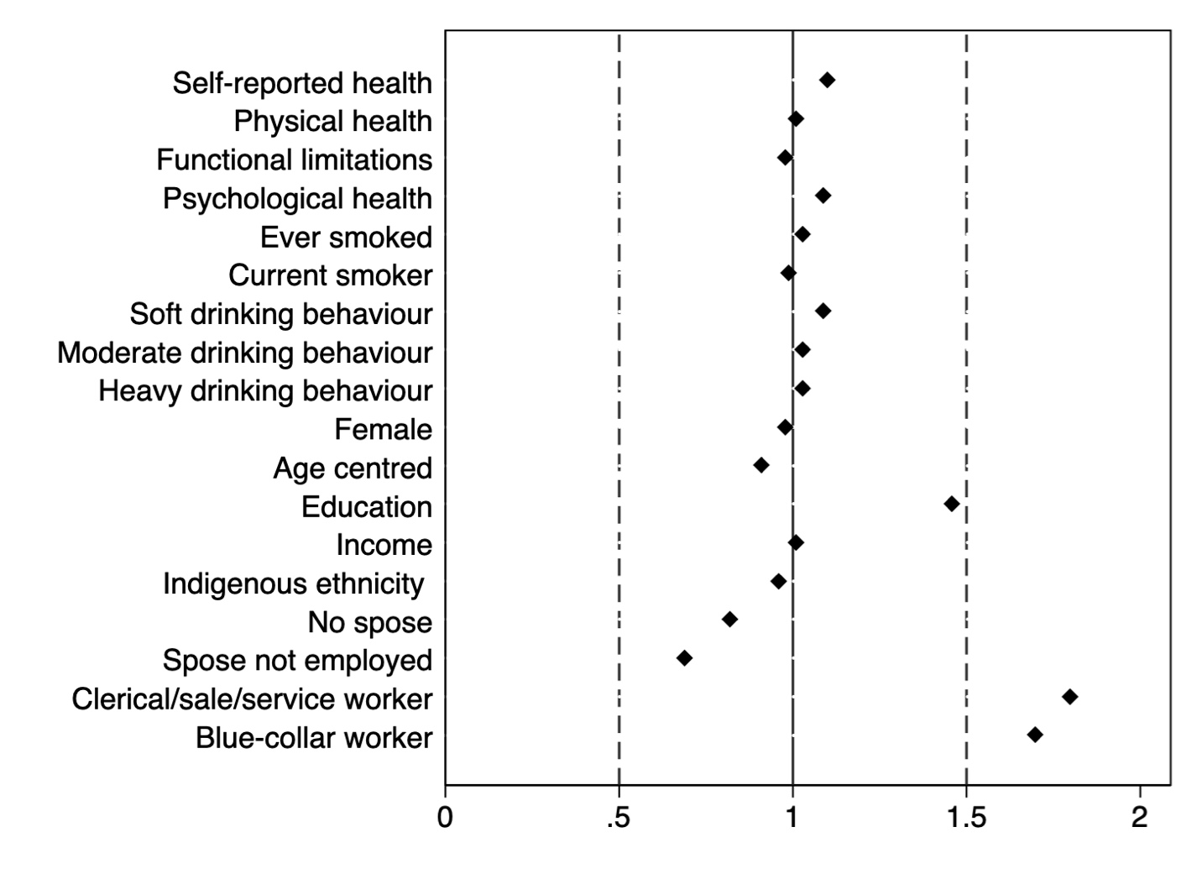
Figure A1: Logistic regression results for sample selectivity at baseline (N= 13,541)

Notes: Standardized odds ratios reported for individuals in our analytic sample (n=2,430) relative to MHAS individuals that were not included in the sample (n=11,111). Reference categories are White collar worker and employed spouse.

Figure A2. Distributions of subjective and physical health

Output for comment 1b by reviewer 1

