Online Supporting Information (Not for Publication)
SI A: Samples in Chinese Provinces and American States
Table A-1. Samples in Chinese Provinces
Provinces | Frequency | Percentage
Anhui | 19 | 2.9
Beijing | 31 | 4.8
Chongqing | 9 | 1.4
Fujian | 17 | 2.6
Gansu | 8 | 1.2
Guangdong | 80 | 12.4
Guangxi | 11 | 1.7
Guizhou | 6 | 0.9
Hainan | 5 | 0.8
Hebei | 37 | 5.7
Heilongjiang | 15 | 2.3
Henan | 48 | 7.4
Hongkong | 1 | 0.2
Hubei | 63 | 9.8
Hunan | 23 | 3.6
Inner Mongolia | 14 | 2.2
Jiangsu | 35 | 5.4
Jiangxi | 28 | 4.3
Jilin | 10 | 1.5
Liaoning | 20 | 3.1
Ningxia | 2 | 0.3
Shaanxi | 17 | 2.6
Shandong | 36 | 5.6
Shanghai | 21 | 3.3
Shanxi | 21 | 3.3
Sichuan | 19 | 2.9
Tianjin | 6 | 0.9
Tibet | 1 | 0.2
Xinjiang | 4 | 0.6
Yunnan | 10 | 1.5
Zhejiang | 27 | 4.2
Not specified | 3 | 0.4
Total | 646 | 100.0

Table A-2. Samples in American States
States | Frequency | Percentage
Alabama | 9 | 0.7
Alaska | 1 | 0.1
Arizona | 24 | 1.8
Arkansas | 10 | 0.8
California | 134 | 10.1
Colorado | 17 | 1.3
Connecticut | 9 | 0.7
Delaware | 2 | 0.2
DC | 1 | 0.1
Florida | 100 | 7.5
Georgia | 40 | 3.0
Hawaii | 5 | 0.4
Idaho | 8 | 0.6
Illinois | 52 | 3.9
Indiana | 27 | 2.0
Iowa | 9 | 0.7
Kansas | 7 | 0.5
Kentucky | 15 | 1.1
Louisiana | 10 | 0.8
Maine | 6 | 0.5
Maryland | 22 | 1.7
Massachusetts | 30 | 2.3
Michigan | 42 | 3.2
Minnesota | 23 | 1.7
Mississippi | 8 | 0.6
Missouri | 15 | 1.1
Montana | 2 | 0.2
Nebraska | 4 | 0.3
Nevada | 12 | 0.9
New Hampshire | 5 | 0.4
New Jersey | 31 | 2.3
New Mexico | 8 | 0.6
New York | 78 | 5.9
North Carolina | 65 | 4.9
North Dakota | 2 | 0.2
Ohio | 46 | 3.5
Oklahoma | 14 | 1.1
Oregon | 31 | 2.3
Pennsylvania | 47 | 3.5
Rhode Island | 7 | 0.5
South Carolina | 21 | 1.6
South Dakota | 1 | 0.1
Tennessee | 26 | 2.0
Texas | 82 | 6.2
Utah | 7 | 0.5
Vermont | 3 | 0.2
Virginia | 37 | 2.8
Washington | 26 | 2.0
West Virginia | 9 | 0.7
Wisconsin | 21 | 1.6
Wyoming | 2 | 0.2
Not specified | 112 | 8.5
Total | 1325 | 100.0
SI B: Mean of Behavioral Intentions for Four Actions

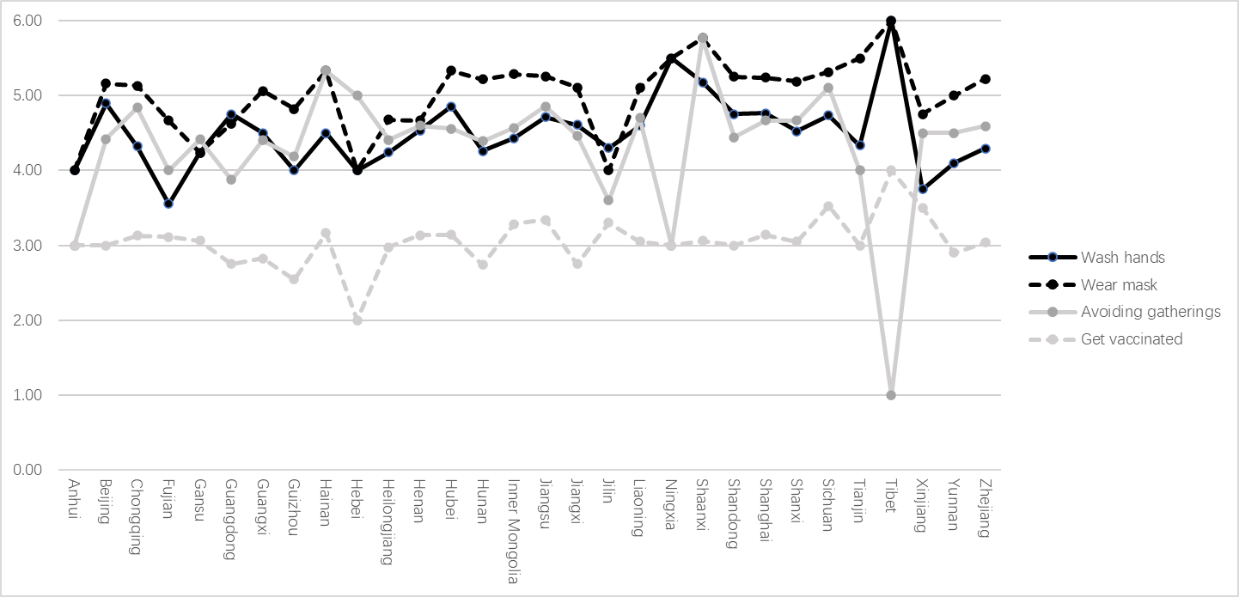
Figure B-1. Mean of Behavioral Intentions for Four Actions in Each Chinese Province

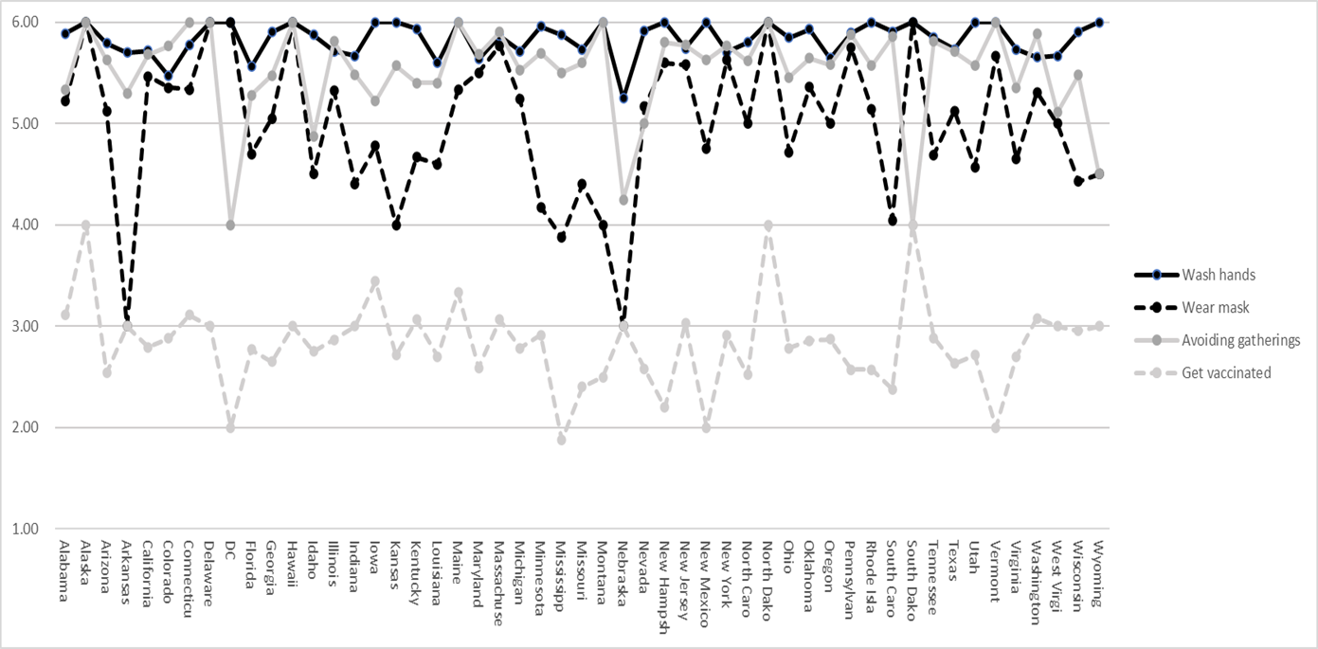
Figure B-2. Mean of Behavioral Intentions for Four Actions in Each American State
SI C: Model Fit Statistics Using Full Sample Before Removal of Speeders and Straightliners
Table C-1. Model fits statistics of measurement models using full sample
 |  | χ2 | RMSEA | SRMR | CFI | TLI
Wash hands | Configural invariance model | 1780.394* | 0.054 | 0.054 | 0.929 | 0.912
 | Metric invariance model | 2144.616* | 0.059 | 0.061 | 0.912 | 0.895
 | Scalar invariance model | 3684.799* | 0.079 | 0.073 | 0.837 | 0.812
Wear mask | Configural invariance model | 1855.170* | 0.056 | 0.056 | 0.927 | 0.908
 | Metric invariance model | 2161.056* | 0.060 | 0.062 | 0.912 | 0.895
 | Scalar invariance model | 3622.142* | 0.078 | 0.073 | 0.843 | 0.818
Avoid gatherings | Configural invariance model | 1808.826* | 0.055 | 0.054 | 0.933 | 0.916
 | Metric invariance model | 2098.799* | 0.059 | 0.060 | 0.920 | 0.904
 | Scalar invariance model | 3315.599* | 0.075 | 0.069 | 0.865 | 0.844
Get vaccinated | Configural invariance model | 1958.120* | 0.058 | 0.058 | 0.927 | 0.908
 | Metric invariance model | 2267.259* | 0.061 | 0.064 | 0.913 | 0.896
 | Scalar invariance model | 3451.417* | 0.076 | 0.072 | 0.861 | 0.839

Table C-2. Model fits statistics of structural models using full sample
 | China (N=1301) |  |  |  |  | The U.S. (N=1613)
 | χ2 | RMSEA | SRMR | CFI | TLI | χ2 | RMSEA | SRMR | CFI | TLI
Wash hands | 1193.931* | 0.065 | 0.072 | 0.894 | 0.867 | 752.254* | 0.043 | 0.047 | 0.952 | 0.940
Wear mask | 1222.276* | 0.066 | 0.074 | 0.888 | 0.861 | 900.38* | 0.049 | 0.053 | 0.943 | 0.928
Avoid gatherings | 1168.902* | 0.064 | 0.069 | 0.908 | 0.885 | 890.032* | 0.049 | 0.053 | 0.942 | 0.928
Get vaccinated | 1251.647* | 0.067 | 0.071 | 0.885 | 0.856 | 971.331* | 0.051 | 0.062 | 0.942 | 0.928

SI D: Statistical Results of SEMs Using Full Sample Before Removal of Speeders and Straightliners
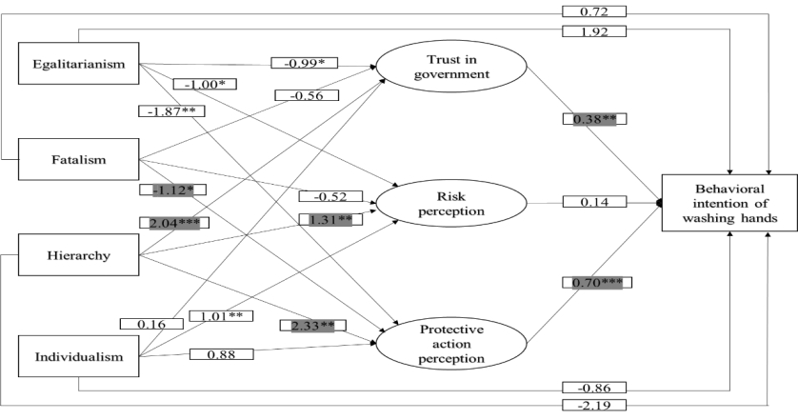
Figure D-1. SEM of behavioral intention of washing hands using full sample (China)
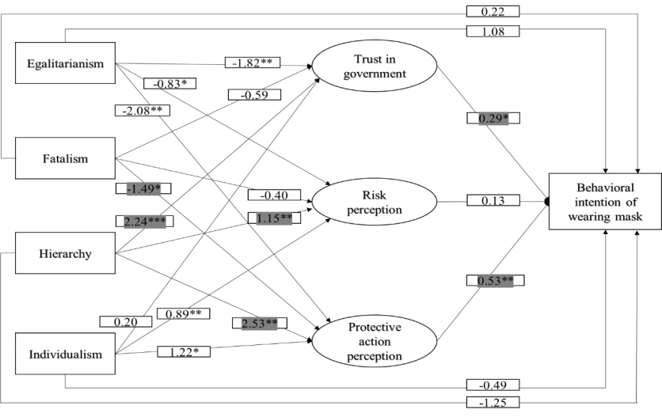
Figure D-2. SEM of behavioral intention of wearing mask using full sample (China)
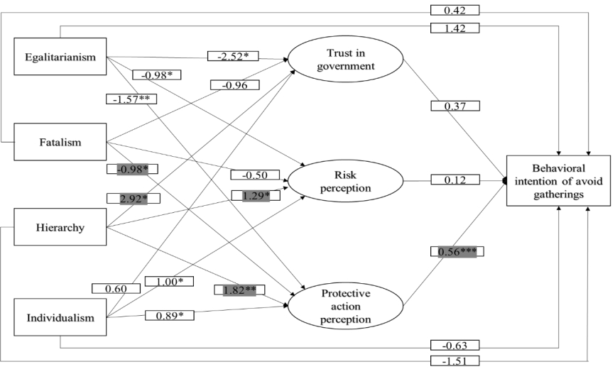
Figure D-3. SEM of behavioral intention of avoid gatherings using full sample (China)
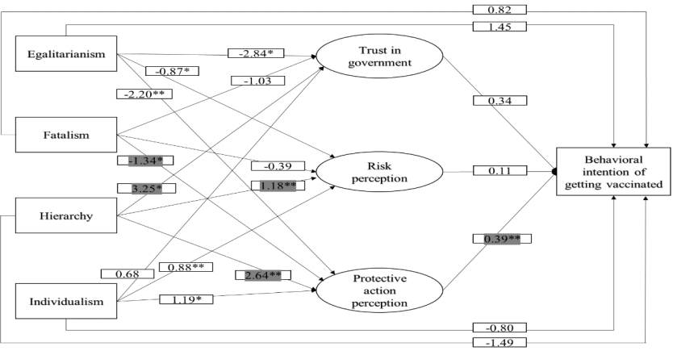
Figure D-4. SEM of behavioral intention of getting vaccinated using full sample (China)
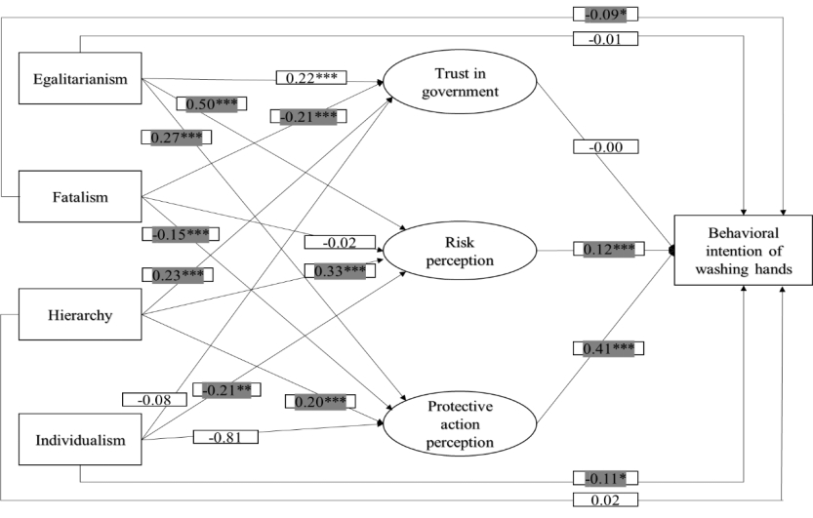
Figure D-5. SEM of behavioral intention of washing hands using full sample (U.S.)
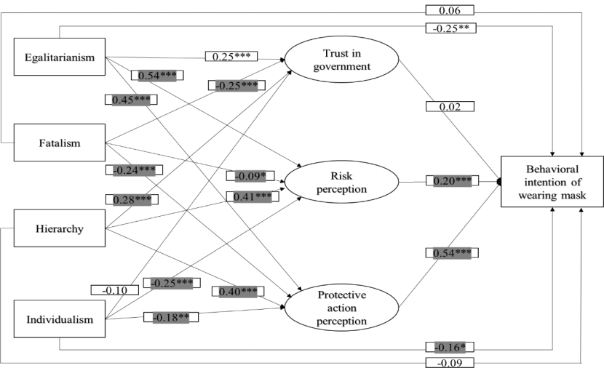
Figure D-6. SEM of behavioral intention of wearing mask using full sample (U.S.)
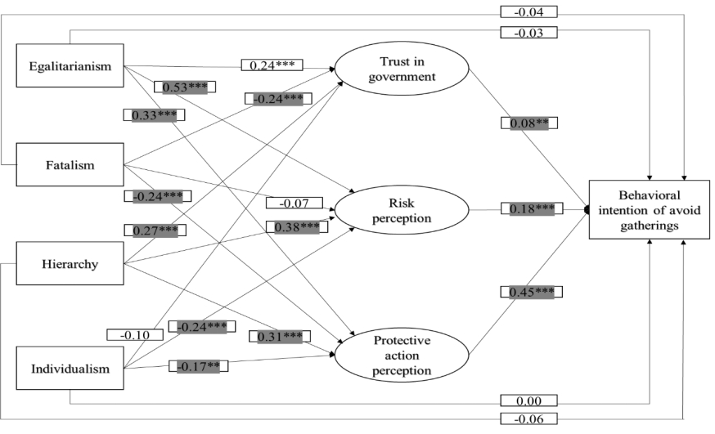
Figure D-7. SEM of behavioral intention of avoid gatherings using full sample (U.S.)
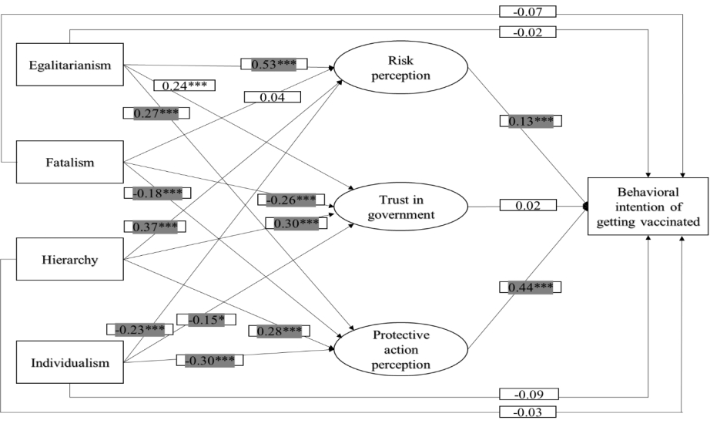
Figure D-8. SEM of behavioral intention of getting vaccinated using full sample (U.S.)

