Supplementary Material

Supplementary Material A
Table A1. Variable definition and sources
 | Variable | Details / Manipulation | Source
Health Inequality Measures | - Univariate Inequality  Cowell Flachaire Index of Inequality  - Income-related inequalities Concentration Index | Self-Assessed Health (SAH)  SAH and income (based on a categorical variable, obtained by an interval regression and a linear prediction | ESS
Democracy Measures
 | Democracy time | Time as a democracy as defined by  Polity IV. A country as a democracy if its score ranges from +6 to +10 in a specific year. | Polity IV
Controls | - Gender | Share of Male Population | ESS
 | - Age | Share of Population over 65 | ESS
 | - GDP per capita |  | Worldbank
 | - Average Income | Average Individual Income (missing values were replaced by a linear imputation) | ESS
 | - Average Education | Average education of the sample | ESS
 | - GINI - Gini Coefficient Income | Missing values were substituted with the average between 2002-2014 | Worldbank

Table A2: Health Inequality Indices and Average Self-Assessed Health (2002-2018)
 | 2002 |  | 2010 |  | 2018
 | Mean | (St.Err.) | Mean | ( St.err.) | Mean | (St.Err.)
Cowell Up | .603 | (.03) | .611 | (.03) | .604 | (.03)
Cowell Down | .519 | (.04) | .529 | (.04) | .526 | (.03)
Concentration Index | .039 | (.01) | .047 | (.01) | .046 | (.01)
Average Health | 2.19 | (.26) | 2.27 | (.31) | 2.219 | (.23)
Source: own estimates using stata software. European Social Survey 2002-2018 estimated, Worldbank, Polity IV indices.

Table A3. Interval Regression for Income
 | (1) | (2)
Gender | -432.3***
 | (57.54)
Age | -13.38***
 | (2.260)
Unemployed | -844.4***
 | (125.1)
Occupation | -180.4***
 | (23.04)
Education | 186.9***
 | (69.26)
Constant | 4.268*** | 7.512***
 | (480.8) | (0.106)
Observations | 214,450 | 214,450
Note: Robust standard errors in parentheses*** p<0.01, ** p<0.05, * p<0.1 Source: own depiction, European Social Survey 2002-2018 estimated, World Bank, Polity IV
Table A4. First Stage regression – Exposure to a democracy (Democracy Time $D_{ct}$)
 | (1) | (2) | (3)
$$D_{ct-15}$$ | 0.923*** | 0.917*** | 0.903***
 | (0.0412) | (0.0466) | (0.0671)
Age | 36.49 | 28.57 | 32.06
 | (31.45) | (26.95) | (23.39)
Female | 88.91 | 72.28 | 46.63
 | (54.66) | (47.73) | (39.20)
Time | -0.283 | -0.220 | -0.364
 | (0.188) | (0.165) | (0.249)
Education |  | 0.743 | -0.0676
 |  | (0.698) | (0.723)
GINI |  |  | -0.415
 |  |  | (0.319)
GDP per capita |  |  | 0.000266
 |  |  | (0.000247)
GDP per capita² |  |  | -2.12e-09
 |  |  | (1.71e-09)
Constant | 540.0 | 423.0 | 732.9
 | (350.2) | (308.0) | (483.2)
Observations | 210 | 210 | 202
R² | 0.965 | 0.966 | 0.972
F | 510.7 | 297.1 | 297.0
Note: Robust standard errors in parentheses*** p<0.01, ** p<0.05, * p<0.1 Source: own depiction, European Social Survey 2002-2018 estimated, Worldbank, Polity IV
Table A5. Estimates with regional fixed effects
 | (1) | (2) | (3)
Concentration Index | -0.000167*** | -0.000177*** | -0.000108**
 | (3.53*10⁻⁵) | (2.73*10⁻⁶) | (4.04*10⁻⁴)
Cowell Up | -0.000276 | 0.000784 | -0.000174
 | (0.00407) | (0.00365) | (0.00325)
Cowell Down | -0.00253 | 0.00361 | 0.00234
 | (0.00399) | (0.00355) | (0.00325)
Partial Controls | No | Yes | Yes
Full controls | No | No | Yes
Note: Robust standard errors in parentheses*** p<0.01, ** p<0.05, * p<0.1 Source: own depiction, European Social Survey 2002-2018 estimated, Worldbank, Polity IV
Table A6. OLS Regression estimates with full set of controls (Concentration Index)
 | (1) | (2) | (3)
$$D_{ct}$$ | -0.000184*** | -0.000166*** | -7.34e-05**
 | (3.25e-05) | (2.92e-05) | (3.54e-05)
Age | 0.0763*** | 0.0923*** | 0.0799***
 | (0.0221) | (0.0232) | (0.0229)
Female | -0.0595* | -0.0227 | 0.00143
 | (0.0301) | (0.0262) | (0.0255)
Time | -2.61e-05 | -0.000160 | 0.00011
 | (0.00013) | (0.00014) | (0.00015)
Education |  | -0.00178** | -0.00111
 |  | (0.000663) | (0.000742)
GINI |  |  | -0.000190
 |  |  | (0.000225)
GDP per capita |  |  | -5.66e-07**
 |  |  | (2.35e-07)
GDP per capita² |  |  | 0.00001
 |  |  | (0.0002)
Constant | 0.117 | 0.365 | -0.174
 | (0.266) | (0.270) | (0.294)
Observations | 218 | 218 | 209
R² | 0.597 | 0.652 | 0.709
Note: Robust standard errors in parentheses*** p<0.01, ** p<0.05, * p<0.1 Source: own depiction, European Social Survey 2002-2018 estimated, Worldbank, Polity IV

Table A7 Instrumental variable estimates with full set of controls (Concentration Index IV)
 | (1) | (2) | (3)
$$D_{ct}$$ | -0.000203*** | -0.000189*** | -0.000102**
 | (3.27e-05) | (2.51e-05) | (3.83e-05)
Age | 0.0681*** | 0.0841*** | 0.0765***
 | (0.0231) | (0.0237) | (0.0236)
Female | -0.0601* | -0.0267 | -0.0140
 | (0.0332) | (0.0300) | (0.0264)
Time | 3.85e-05 | -8.92e-05 | 0.000114
 | (0.000142) | (0.000137) | (0.000151)
Education |  | -0.00155** | -0.00118
 |  | (0.000640) | (0.000719)
GINI |  |  | -0.000261
 |  |  | (0.000223)
GDP per capita |  |  | -4.45e-07*
 |  |  | (2.39e-07)
GDP per capita² |  |  | 0.00002
 |  |  | (0.0003)
Constant | -0.00863 | 0.228 | -0.171
 | (0.277) | (0.266) | (0.296)
Observations | 210 | 210 | 202
R² | 0.650 | 0.692 | 0.723
F | 32.93 | 32.38 | 32.14
Robust standard errors in parentheses
*** p<0.01, ** p<0.05, * p<0.1
Source: own depiction, European Social Survey 2002-2018 estimated, Worldbank, Polity IV

Table A8. Regression Estimates Full set of controls (Cowell down OLS)
 | (1) | (2) | (3)
$$D_{ct}$$ | -0.000560*** | -0.000554*** | -1.03e-05
 | (0.000150) | (0.000151) | (0.000191)
Age | 0.258*** | 0.263*** | 0.172***
 | (0.0588) | (0.0610) | (0.0600)
Female | -0.0241 | -0.0116 | 0.133
 | (0.105) | (0.119) | (0.104)
Time | -0.000816* | -0.000862** | 0.000952*
 | (0.000413) | (0.000421) | (0.000543)
Education |  | -0.000612 | 0.00424
 |  | (0.00262) | (0.00263)
GINI |  |  | -0.000420
 |  |  | (0.000926)
GDP per capita |  |  | -3.45e-06***
 |  |  | (8.03e-07)
GDP per capita² |  |  | 0.0001***
 |  |  | (0.001)
Constant | 2.152** | 2.238** | -1.392
 | (0.820) | (0.829) | (1.081)
Observations | 219 | 219 | 210
R² | 0.429 | 0.430 | 0.613
Robust standard errors in parentheses
*** p<0.01, ** p<0.05, * p<0.1
Source: own depiction, European Social Survey 2002-2018 estimated, Worldbank, Polity IV

Table A9. Regression Estimates Full set of controls (Cowell down IV)
 | (1) | (2) | (3)
$$D_{ct}$$ | -0.000661*** | -0.000667*** | -0.000138
 | (0.000161) | (0.000159) | (0.000279)
Age | 0.253*** | 0.247*** | 0.181***
 | (0.0567) | (0.0568) | (0.0622)
Female | 0.0234 | 0.0106 | 0.111
 | (0.115) | (0.133) | (0.114)
Time | -0.000652 | -0.000603 | 0.000861
 | (0.000417) | (0.000399) | (0.000614)
Education |  | 0.000594 | 0.00397
 |  | (0.00257) | (0.00284)
GINI |  |  | -0.000489
 |  |  | (0.000945)
GDP per capita |  |  | -2.93e-06**
 |  |  | (1.06e-06)
GDP per capita² |  |  | 0.00004**
 |  |  | (.00001)
Constant | 1.811** | 1.720** | -1.204
 | (0.822) | (0.780) | (1.215)
Observations | 210 | 210 | 202
R² | 0.466 | 0.466 | 0.610
F | 37.40 | 28.50 | 28.43
Note: Robust standard errors in parentheses*** p<0.01, ** p<0.05, * p<0.1 Source: own depiction, European Social Survey 2002-2018 estimated, World bank, Polity IV

Table A10. Regression Estimates Full set of controls (Cowell up OLS)
 | (1) | (2) | (3)
$$D_{ct}$$ | -0.000246* | -0.000230 | 1.47e-05
 | (0.000125) | (0.000138) | (0.000160)
Age | 0.149* | 0.164** | 0.124**
 | (0.0742) | (0.0678) | (0.0603)
Female | 0.195** | 0.229** | 0.296***
 | (0.0916) | (0.0919) | (0.0772)
Time | -0.000399 | -0.000523 | 0.000237
 | (0.000367) | (0.000351) | (0.000370)
Education |  | -0.00166 | 0.000673
 |  | (0.00288) | (0.00303)
GINI |  |  | 5.20e-05
 |  |  | (0.00111)
GDP per capita |  |  | -1.35e-06**
 |  |  | (6.03e-07)
GDP per capita² |  |  | 0
 |  |  | (0)
Constant | 1.297* | 1.528** | -0.00645
 | (0.710) | (0.680) | (0.730)
Observations | 219 | 219 | 210
R² | 0.127 | 0.138 | 0.199
Robust standard errors in parentheses
*** p<0.01, ** p<0.05, * p<0.1
Source: own depiction, European Social Survey 2002-2018 estimated, Worldbank, Polity IV

Table A11. Regression Estimates Full set of controls (Cowell up IV)
 | (1) | (2) | (3)
$$D_{ct}$$ | -0.000250* | -0.000241* | 2.59e-06
 | (0.000128) | (0.000136) | (0.000195)
Age | 0.140* | 0.151** | 0.122**
 | (0.0749) | (0.0679) | (0.0595)
Female | 0.197* | 0.220** | 0.278***
 | (0.101) | (0.101) | (0.0806)
Time | -0.000385 | -0.000470 | 0.000128
 | (0.000380) | (0.000363) | (0.000374)
Education |  | -0.00103 | 0.000754
 |  | (0.00281) | (0.00297)
GINI |  |  | 5.91e-05
 |  |  | (0.00112)
GDP per capita |  |  | -1.26e-06*
 |  |  | (6.96e-07)
GDP per capita² |  |  | 0.0001
 |  |  | (0.0001)
Constant | 1.271* | 1.429* | 0.218
 | (0.734) | (0.703) | (0.735)
Observations | 210 | 210 | 202
R-squared | 0.117 | 0.122 | 0.189
F | 2.312 | 2.167 | 2.134
Note: Robust standard errors in parentheses*** p<0.01, ** p<0.05, * p<0.1
Source: own depiction, European Social Survey 2002-2018 estimated, Worldbank, Polity IV

Supplementary Material B

Supplementary Material B1: Comparison of the ranks of the different inequality measures (mean)

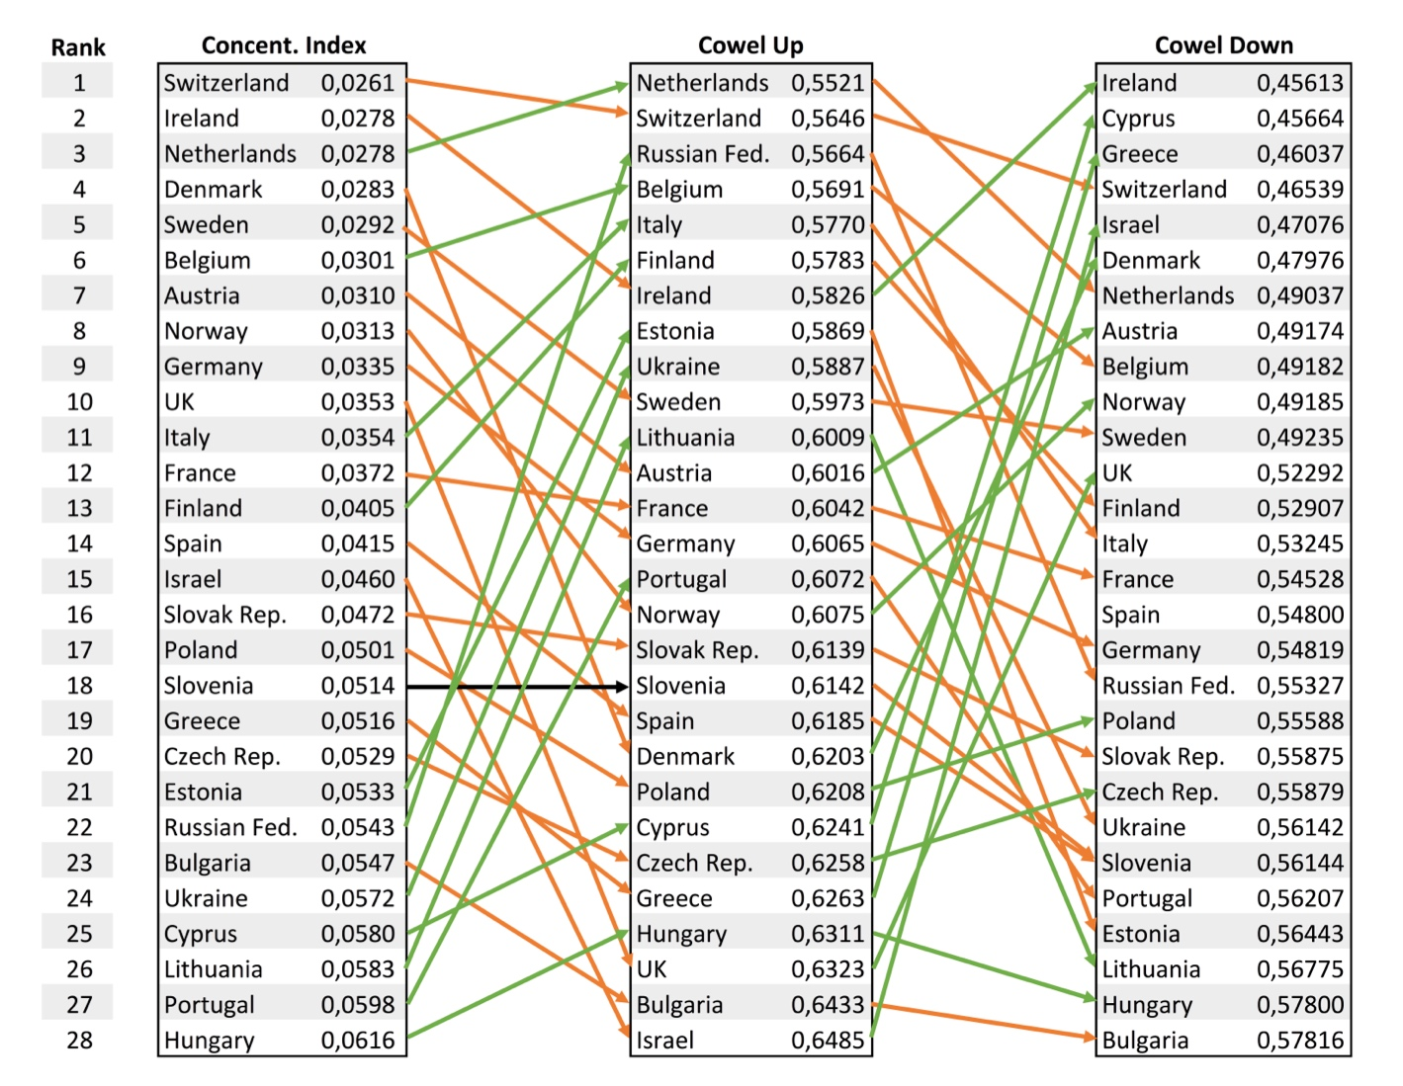
Source: own depiction, European Social Survey 2002-2018 estimated, Worldbank, Polity IV

Supplementary Material B2: Correlation between the different measures of inequality (means)

Correlation between the rankings:

Correlation | Cowell Up | Cowell Down | Concentration. Index
Cowell Up | 1
Cowell Down | 0.43 | 1
Concentration. Index | 0.61 | 0.68 | 1
All p-values < 0,05

Correlations between the measures:

Correlation | Cowell Up | Cowell Down | Concentration. Index
Cowell Up | 1
Cowell Down | 0.28 | 1
Concentration. Index | 0.43 | 0.63 | 1
All p-values < 0,05

