Online Annex
Coding Manual (excerpt)
Basic Coding Procedure and Main Concepts
At the most basic level, the coders have to identify single events of policy change in the collected legal documents and, for each single event, assess the direction of change, i.e., whether the event of policy change represents the introduction or abolishment of a given target-instrument-combination.
To come into consideration, a policy change has to meet the following requirements in form and content. Formally, a relevant policy change is any measure or provision in the collected legislation (and where necessary respective administrative circulars specifying these rules) that 1) was published during the observation period, which starts on January 1, 1975, ad ends on December 31, 2020, and 2) was adopted at the national level. The second point clearly excludes measures by sub-national jurisdictions such as regional or local bodies, even if the latter are state-like entities with far-reaching competencies as in federal states
Coding categories
The method used to assess and code policy change, is intended to be universally applicable, i.e. over a wide range of countries, irrespective of differing legal and administrative traditions. Thus, the coding rules comprise two invariant general categories. These are policy targets and policy instruments.
By means of these two categories, we seek to measure developments over time in a nuanced manner. Moreover, in order to assess whether a change represents the introduction or abolishment, we are interested in policy change relative to the previous state. Thus, as will be explained in more detail in this section, relative changes to the previous targets and instruments need to be coded. We are interested in the introduction and abolishment of (new) policy target (guiding question: what is addressed?), of policy instruments (how is something addressed?).
Recalling the observation period (January 1, 1975 to December 31, 2020), this stated focus on change has one important implication: Although the relevant information for deciding whether a legal act falls into the observation period is the date of publication, it might be the case that coders need to consult legislation originating from some year before 1980 in order to reconstruct the occurrence and the direction of change. For instance, if a law adopted in 2008 changes a law enacted in 1973, the latter legislation has to be considered in order to make a statement about the direction and nature of change taking place through the 2008 legislation.
Coding category 1: Policy Targets
The first and most general coding category is policy targets. For analytical reasons, we use a very narrow conception of policy targets. By policy targets, we mean a very specific activity within a subarea of a policy field guided by the question: who or what is addressed? More specifically, a policy target is subject to state activities in order to achieve a political objective within a specific area. The tables below contain the policy targets this project is exclusively interested in. Thus, when screening the legislative acts, please identify the presence and/or abolishment of any policy targets from these lists and indicate these events of policy change as either introduction or termination.
One single target has to be coded only once per legislative act – it must not be coded multiple times. Any instrument concerning this specific target will be attributed to the one single target. If a policy target from the list is introduced for the first time, i.e. subject to governmental action for the first time, this particular event must be coded as policy introduction. If, by contrast, a policy target from the list is abolished, i.e. is not subject to governmental action anymore, this particular event must be coded as policy termination. Please note that the termination of a target entails the termination of all attached instruments, which have to be coded separately. The same is true when a target is addressed for the first time.

Table A1: Environmental Policy Targets
Clean Air Policy
- Air quality standards for nitrogen oxides (NOx)
- Air quality standards for sulphur dioxide (SO2)
- Air quality standard for carbon monoxide (CO)
- Air quality standard for particulate matter
- Air quality standard for ozone (O3)
- Air quality standard for lead
- Nitrogen oxide (NOx) emissions from large combustion pants using coal
- Nitrogen oxide (NOx) emissions from passenger vehicles using unleaded gasoline
- Nitrogen oxide (NOx) emissions from heavy duty vehicles using diesel
- Sulphur dioxide (SO2) emissions from large combustion plants using coal
- Sulphur dioxide (SO2) emissions from passenger vehicles using unleaded gasoline
- Sulphur dioxide (SO2) emissions from heavy duty vehicles using diesel
- Carbon dioxide (CO2) emissions from large combustion plants using coal
- Carbon dioxide (CO2) emissions from passenger vehicles using unleaded gasoline
- Carbon monoxide (CO) emissions from large combustion plants using coal
- Carbon monoxide (CO) emissions from passenger vehicles using unleaded gasoline
- Particulate matter emissions from large combustion plants using coal
- Arsenic emissions from stationary sources
- Maximum permissible limit for the lead content of gasoline
- Maximum permissible limit for the sulphur content of diesel
- Carbon dioxide (CO2) emissions from aviation activities
- Maximum permissible limits for the sulphur content of petrol (gasoline, benzine, fuel)
Water Protection Policy
- Lead in continental surfaces water (i.e. water that flow or which are stored on the surface, and include natural water channels like rivers, surface runoff, streams, lakes and others)
- Copper in continental surfaces water
- Nitrate (NO3-) in continental surfaces water
- Phosphates in continental surfaces water
- Zinc in continental surfaces water
- Oils in continental surfaces water
- Pesticides (fungicides, herbicides, insecticides, exempt DDT) in continental surfaces water
- DDT (Dichloro-Diphenyl-Trichloroethane) in continental surfaces water
- Phenols (as total C) in continental surfaces water
- BOD (Biochemical Oxygen Demand) of continental surfaces water
- Lead from industrial discharges into continental surfaces water
- Copper from industrial discharges into continental surfaces water
- Nitrate (NO3-) from industrial discharges into continental surfaces water
- Phosphates from industrial discharges into continental surfaces water
- Chloride (Cl-) from industrial discharges into continental surfaces water
- Sulphates from industrial discharges into continental surfaces water
- Iron from industrial discharges into continental surfaces water
- Zinc from industrial discharges into continental surfaces water
- Oils and greases from industrial discharges into continental surfaces water
- Pesticides and herbicides from industrial discharges into continental surfaces water
- Phenols (as total C) from industrial discharges into continental surfaces water
- Coliform bacteria from industrial discharges into continental surfaces water
- BOD (Biochemical Oxygen Demand) from industrial discharges into continental surfaces water
- COD (Chemical Oxygen Demand) from industrial discharges into continental surfaces water
Conservation Policy
- Native forests
- Nature protection areas and reserves
- Import and export of endangered species
- Import and export of endangered plants

Coding Category 2: Policy Instruments
We define a policy instrument as a tool or means adopted to achieve the underlying political objective of the selected environmental policy target. A policy instrument thus describes the type of governmental action adopted for a given policy target. A policy instrument is intended to have a regulating and/or guiding effect on people’s actions. The tables below contain all potential policy instruments for environmental policy. For each policy targets, if addressed, there is at least one policy instrument defined as a tool to achieve the underlying political objective. Yet, any given policy target may be addressed by means of various policy instruments. For each addressed policy target, the coders are asked to identify all instruments. Please note that a given policy instrument belongs to one type/group only. The following table is exhaustive, containing the most common environmental policy instruments.

Table A2: Environmental Policy Instruments
Instrument | Description | Example
Obligatory standard | A legally enforceable numerical standard, typically involving a measurement unit, e.g. mg/l | Limit value for lead emissions in surface water, e.g. 50 mg/l
Prohibition/ban | A total or partial prohibition/ban on certain emissions, activities, products etc. | Ban on importation of products containing flurochlorocarbons
Technological prescription | A measure prescribing the use of a specific technology or process | Installations have to be operated in accordance with the principle of ‘best available techniques’ (BAT)
Tax/levy | A tax or levy for a polluting product or activity | Tolls and road user charges for trucks depending on the emission class
Subsidy/tax reduction | A measure by which the state grants a financial advantage to a certain product or activity | Tax reduction for vehicles in series production complying with a regulation
Liability scheme | A measure that allocates the costs of environmental damage to those who have caused the damage | Establishment of an emission trading system
Planning instrument | A measure defining areas or times that deserve particular protection | Action plans indicating the measures to be taken during times when there is a risk of the limit being exceeded
Public investment | A specific public investment | Programs given financial support for the retrofitting of in-use vehicles and for scrapping old vehicles
Data collection/monitoring programs | A specific program for collecting data | Establishment of measuring stations designed to supply the data necessary for the application of a certain regulation
Voluntary measure | Voluntary agreements or commitments between the state and private actors or by private actors alone | Manufacturers can apply for the CO2 savings achieved as a result of eco-innovation (if approved can used to contribute to manufacturer’s specific emissions target)
Information-based instrument | Information provided by the state or the polluters indicating the environmental externalities of a certain product or activity | Label on fuel economy and CO2 emissions of a vehicle displayed at the point of sale
Other | Any instrument that cannot be assigned to the other categories | (…)

Figure A1: Policy Portfolio Development of Full Country Sample – Side-by-side Plots
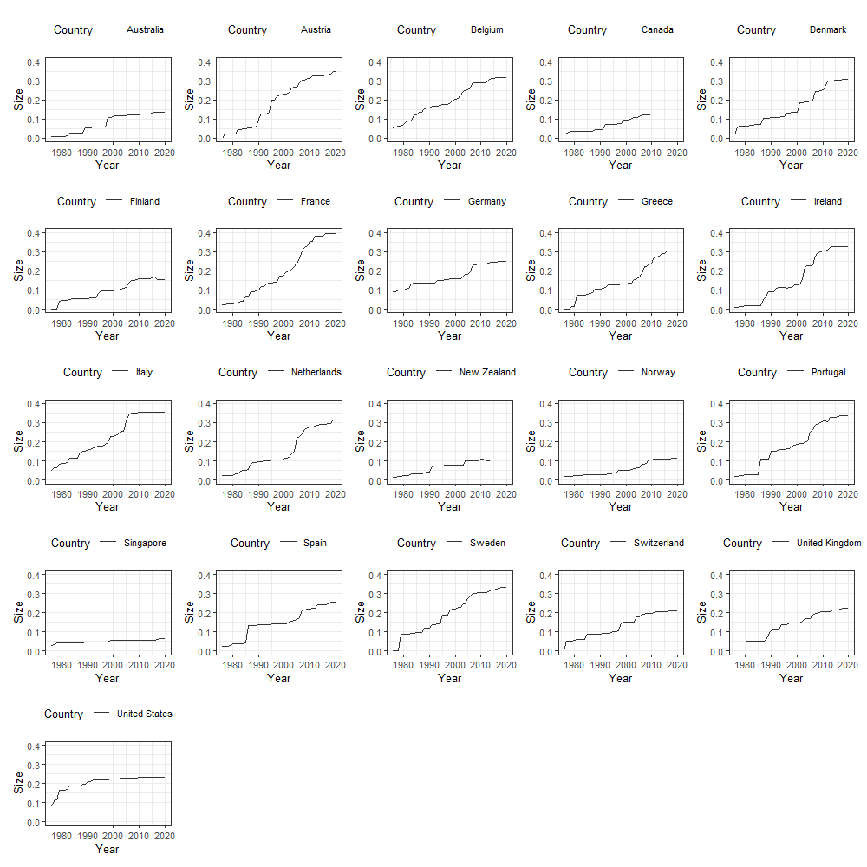
Note: The data on the policy portfolios in 21 OECD countries is taken from the ACCUPOL dataset.

Policy Accumulation in Asia and Oceania
Figure A2: Regional policy growth (Asia and Oceania)
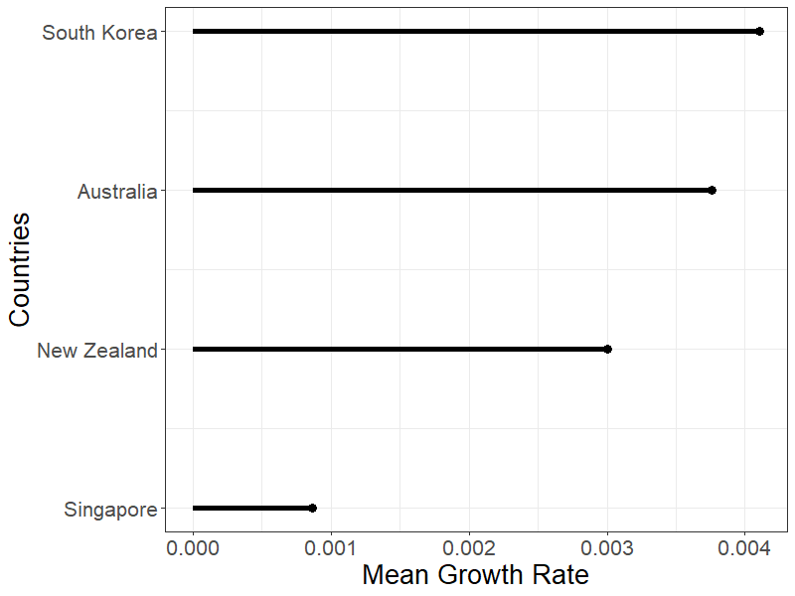
Note: The data is taken from the ACCUPOL dataset.

Policy Accumulation in non-EU countries
In the realm of environmental policy, EU membership has been viewed as a vehicle for innovative environmental policy, which in regulations and directives has been either directly implemented or transposed nationally into the national policy portfolios of EU member states. This could be an alternative explanation of the lower policy growth in Singapore by comparison. However, if we look exclusively at non-EU member countries (Figure A3), we find that non-EU countries also exhibit higher policy growth than the Singaporean case.

Figure A3: Policy Growth in Non-EU countries
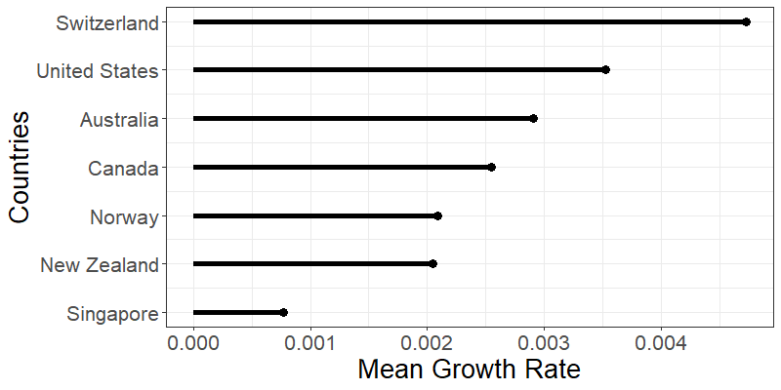
Note: The data on the policy portfolios in 21 OECD countries is taken from the ### dataset.

On population density
Another argument could be done for Singapore as an exceptional case. As a densely populated city-state, Singapore could exhibit traits that induce “naturally” lower policy growth than for less densely populated countries, maybe because of a lack of necessity for large amounts of environmental policy. If we compare Singapore to the most densely populated countries in our sample, we observe that Singapore again falls short to countries with a long history of competitive democratic elections (Figure A4). Additionally, we can infer from the literature on environmental policy-making in Singapore that environmental concerns are of vital importance in the city-state since at least the 1970s – especially so in the sub-sectors of clean air policies and water protection (Chia and Chionh 1987; Tortajada et al. 2013). This is also supported when we take into account data on environmental awareness (Haerpfer et al. 2022).

Figure A4: Policy Growth in countries with high population density
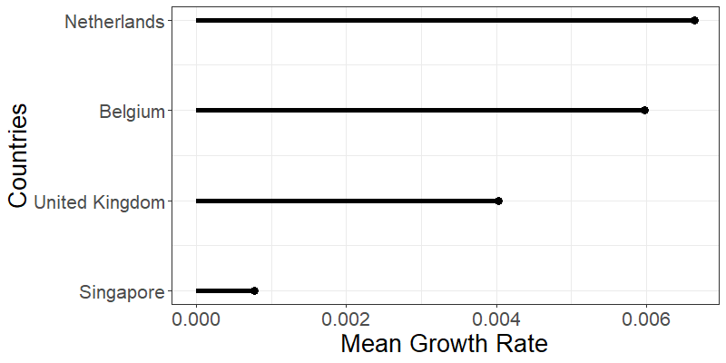
Note: The data on the policy portfolios in 21 OECD countries is taken from the ### dataset. Data on population density comes from the (United Nations 2022)

On policy effectiveness
When looking at the policy portfolio of Singapore, we contend that policy ambition does counteract the small size of policy outputs. Furthermore, this gets added credence when looking at the carbon footprint per capita in comparison (Figure A5). Here, Singapore with a number of other countries, like the US, belongs to the group at the top. Considering Singapore’s small portfolio, it stands to surmise that the city-state could lower this measure if they would exhaust the possibilities for growth in their environmental policy portfolio.

Figure A5: Carbon footprint per capita (t), year 2020
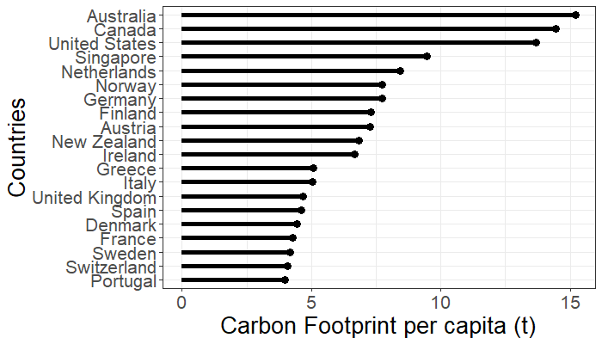
Note: Data on carbon footprints taken from World Population Review (United Nations 2022).

References

Chia, Lin Sien, and Yan Huay Chionh. 1987. “Singapore.” In Environmental Management in Southeast Asia: Directions and Current Status, ed. Lin Sien Chia. Singapore: Faculty of Science, National University of Singapore, 109–68.
Haerpfer, Christian et al. 2022. “World Values Survey Wave 7 (2017-2022) Cross-National Data-Set.” http://www.worldvaluessurvey.org/WVSDocumentationWV7.jsp (March 31, 2022).
Tortajada, Cecilia, Yugal Kishore Joshi, and Asit K. Biswas. 2013. The Singapore Water Story: Sustainable Development in an Urban City State. London: Routledge.
United Nations. 2022. “World Population Prospects 2022.” https://population.un.org/wpp/ (August 10, 2022).

