Methodological appendix [Online only]
Climate policy for the public? Affluence, congruence and lobbying success in EU climate policy
Iskander De Bruycker & Francesca Colli
Table of Contents
1. Sampling strategy of the research project 1
2. Selection of media sources 4
3. Content analysis of media statements and quality controls 6
4. The survey project 8
5. Robustness check with attributed influence 10
6. Robustness check with staff 12
7. Robustness check including groups with an unclear position 13
8. Robustness check including groups’ lobbying budgets over time 16
9. Robustness check without imputation for lobbying budgets 18
10. References 20

Sampling strategy of the research project
The starting point for the project is a sample of 41 issues drawn from Eurobarometer polls for which the fieldwork concluded between January 1, 2012, and December 31, 2014. Eurobarometer, a policy tool of the European Commission, comprises a collection of surveys on various topics across the EU member states. The tool keeps track of important dynamics and preferences within the European demos. The standard Eurobarometer survey is repeated biannually, while the Special and Flash Eurobarometer studies are conducted ad hoc and revolve around specific topics or trends.
In this study, an issue is operationalized as a specific policy topic for which the EU is at least partially competent and for which citizens in all EU member states were surveyed. First, only questions that were surveyed in all EU member states and that dealt with citizens (as opposed to companies) were selected. Second, only issues that could be connected to a specific policy were retained. Third, since EU policymakers cannot be responsive to issues for which they lack competence, issues for which the EU has no policy competence were therefore excluded from the sample. Finally, we considered only questions that pertained to the opinion of citizens in terms of agreement or disagreement about a specific policy (see Rasmussen et al., 2018) or objective, such as the financial transaction tax, the banking union or a free trade agreement between the US and the EU. With this operationalization, less than 1% of the questions raised in Eurobarometer surveys qualified as issues.
The operationalization of issues and the criteria resulting from this operationalization can be summarized by the acronym DISCO:
- Data availability: Public opinion data are available on the topic.
- Inclusive: Citizens in all EU member states were surveyed.
- Specific: The survey question deals with specific policy.
- Competence: The topic of the question falls (partially) within the competences of the EU.
- Opinion: The question pertains to agreement or disagreement vis-à-vis EU policy.
This case selection resulted in 41 different issues. The first key source of variation across policy issues concerns their public salience. We know from former research that public salience can increase the responsiveness of public policy to public opinion (Page and Shapiro, 1983; Wlezien, 2004). One important concern for studies that rely exclusively on cases for which public opinion surveys were conducted is that they involve only issues that are already salient to the public and media, which therefore biases the sample of cases (Burstein, 2014). To assess this concern, we tracked the media salience of the sampled set of cases in eight European media outlets: Euractiv, Le Monde, Financial Times, Corriere Della Sera, Aftonbladet, De Telegraaf, Fakt and Frankfurter Algemeine Zeitung (see section 3 for more information on the news media selection). The media salience of issues across the different media outlets is highly correlated, with an average correlation of 0.6. This result indicates that the aggregate measure of media salience (the sum of all articles across media outlets) is a reliable measure of media salience.
Figure A1 portrays the distribution of media articles that discussed the sampled set of issues across the selected media outlets. The distribution clearly shows that these policy cases varied with regard to media salience. Some issues, such as the financial transaction tax, received a lot of media attention, while other issues received no media attention at all. These distributions of media attention also resemble the distributions of media attention found in other projects, most notably the INTEREURO project, which relied on a random sample of policy proposals (De Bruycker and Beyers, 2015).
Figure A1. Media salience of the sampled cases

The sample of issues also strongly varies in terms of the policy areas addressed. Figure A2 illustrates the distribution of the cases across policy areas, operationalized by the directorate generals (DGs) responsible for the policy issue. The sampled issues are thus situated in different policy areas, and the results derived from the analysis are not specific to one policy area.
Figure A2. Distribution of sampled issues across policy areas

From the 41 issues sampled, the six issues that dealt directly with climate-relevant topics were selected for this paper. As with any research dealing with policy issues, these issues are interrelated and there may be some overlap, as many relate in some way to emissions of greenhouse gases; however, each issue has a different substantial focus and scope. Where it was impossible to separate lobbying strategies and influence on issues, these were combined (as for instance was the case with biodiversity, ID22).

Table A1. Sampled issues and corresponding Eurobarometer questions (n = 6)
ID | Issue | Eurobarometer Question
5 | National emission ceilings | Do you believe that the existing national emission ceilings should be strengthened?
12 | Air quality | Do you believe that the existing EU air quality standards should be strengthened?
24 | Shale gas | Do you totally agree, tend to agree, tend to disagree or totally disagree with the following statement: Harmonised and consistent approaches should be developed in the EU to manage unconventional fossil fuels extraction, such as shale gas
39 | Greenhouse gas | Thinking about each of the following objectives to be reached by 2020 in the EU, would you say that it is too ambitious, about right or too modest? To reduce EU greenhouse gas emissions by at least 20% by 2020 compared to 1990
40 | Energy efficiency | Thinking about each of the following objectives to be reached by 2020 in the EU, would you say that it is too ambitious, about right or too modest? To increase the energy efficiency in the EU by 20% by 2020
The following three issues on Biodiversity subsidies were collapsed in the survey project because lobbying strategies and influence could not be neatly separated.
22 | Biodiversity | In order to protect biodiversity please tell me if you agree or disagree that the EU should take each of the following measures…  1.Make sure that subsidies to sectors like agriculture or fisheries also take account of biodiversity  2.Create financial rewards (e.g. for farmers or fishermen) for nature conservation  3.Expand the areas where nature is protected in Europe

Selection of media sources
For the selection of news media outlets, a ‘most different case selection design’ was applied to maximize the possible sources of relevant extraneous variance. We selected media outlets from different countries geographically located in different parts of Europe, with different journalistic styles that vary in format and adhere to diverse political orientations. Because of the central research objectives of the project to study the links between elites and the public, we prioritized news outlets with a wide circulation to ensure that their coverage had the potential to reach a wide range of European citizens. To ensure that we would have a substantive corpus of statements from political elites and stakeholders on the sampled set of issues, we selected four news outlets that were studied in former research projects on EU representation (most notably the DEU and INTEREURO projects) and that extensively covered EU-related topics.

Table A2. Overview of eighth selected media outlets
News outlet | Country | Format | Journalistic Style | Political orientation | Studied in former large projects on EU representation | Daily paid circulation in 2016 | Number of articles identified
1. Aftonbladet | Sweden | Tabloid | Sensational | Left wing, populist | No | 154,900 (2014) | 99
2. Corriere  Della Sera | Italy | Broadsheet | Quality press | Centrist, liberal | No | 310,437 | 262
3. De Telegraaf | Netherlands | Tabloid | Sensational | Right wing, populist | No | 382,000 | 176
4. EurActiv | Europe-wide | Online | Quality press | Centrist, Europhile | Yes | 794,992 (free) | 623
5. Fakt | Poland | Tabloid | Sensational | Centrist, populist | No | 270,331 | 40
6. Financial  Times | United Kingdom | Broadsheet | Quality press | Liberal-conservative | Yes | 193,211 | 411
7. Frankfurter  Allgemeine  Zeitung | Germany | Nordisch | Quality press | Centre-right, liberal-conservative | Yes | 256,188 | 279
8. Le Monde | France | Berliner | Quality press | Centre-left | Yes | 267,897 | 195

Content analysis of media statements and quality controls
The relevant media coverage related to the sampled set of cases was assembled manually by the principal investigator and two student-assistants involved in the project. To increase the quality of the media searches, researchers focused on media outlets from their own country. The search in media archives was based on keywords that were carefully selected based on the name of the issue, the corresponding Eurobarometer question and extensive desk research. For newspapers in a language non-native to the research team, external experts were consulted. All the keywords used are documented and will be published on the project’s website. Importantly, not all articles that resulted from keyword searches were retained. Each article was screened by the researcher in question for its relevance. Only articles that were directly related to the sampled cases were used. Articles that only vaguely or indirectly related to the legislative proposal were omitted. Keyword searches were finalized only when an information saturation point was met, namely, when the addition of new keyword searches did not result in additional articles. The results were centralized and stored by the principal investigator, who conducted an additional consistency check.
Based on extensive keyword searches, 2,085 articles were identified. Additional recall tests were performed when the media salience for certain issues strongly varied across media sources. For these issues, recall tests varied from 77% to 89% overlap (with an average overlap of 83%). For the other issues, recall tests were performed randomly and gave satisfactory results (more than 90% overlap). Furthermore, an extensive precision test was conducted by hand coding all the collected articles and their constituting statements. Namely, each article was coded for its relevance to the sampled case. This approach resulted in a precision of 97% for articles and 93% for statements. Non-relevant articles were excluded from further analyses. From all the assembled statements, 7% were not directly connected to the legislative proposals and were therefore also excluded from further analyses.

Table A3. Distribution of statements for different actor types
Actor type | Freq. | Percent
Council and member states | 1,913 | 34%
European Commission | 857 | 12%
European Members of Parliament | 608 | 11%
National Member of Parliament | 368 | 6%
Interest organizations | 1,715 | 30%
Regulatory agencies & central banks | 264 | 5%
International organizations | 65 | 1%
Other (individual citizens, journalists, etc.) | 101 | 2%

Once articles were mapped, the statements made by political actors in these articles were archived and coded. A statement is a quote or paraphrase in the news that can be connected to a specific actor. In total, 5,891 statements were identified from various political actors. Four student-assistants as well as the principal investigator were involved in the collection of articles and archiving of statements. An overview of the different actor types that made statements and their prominence is provided in Table A3. The statements of these actors were coded for the positions adopted for or against policy change and the various arguments articulated. Two student-assistants did the coding of statements. Intercoder reliability checks of the statement coding (based on 180 double coded statements) proved satisfactory with Krippendorff's alpha ranging from 0.7 to 0.9. The descriptive overview of media statements by political actor is presented below.
Figure A3. Overview of actors’ positions from media statements

The survey project
To identify all interest groups that sought to influence policy decisions on the 41 sampled issues, we conducted an analysis of news media articles and an expert survey with spokespersons from interest groups. Via an extensive media search in the previously mentioned news outlets we identified 452 interest groups active on our cases. We approached these interest group representatives with an online survey in the period between June 2017 and August 2018. We asked them which other groups were active on our cases and identified an additional 169 relevant interest organizations that did not appear in the news media. These additional groups were contacted in a second wave of the survey. In total, we approached 613 organizations of which 183 completed the survey. Our response rate of 30% is comparable to previous survey projects on EU lobbying (Chalmers, 2013; Crepaz and Hanegraaff, 2019). Al contacted experts were sent three reminders via email and were given the chance to participate in a telephone interview to increase the response rate.
The survey questionnaire was informed by key questions that drive the research project and are based on best practices in other survey or interview projects, most notably the Comparative Interest Group Survey Project (www.cigsurvey.eu) and the INTEREURO project (www.intereuro.eu). The survey was sent out for each issue separately. For instance, for the issue ‘tax on financial transactions’ we targeted all interest groups identified as active on this particular topic. Afterwards the survey was sent to interest groups active on the next issue, and so forth.
As the subsequent Figure A4 shows, a little more than half of the respondents come from civil society groups (NGOs and trade unions), 40% represent business interests (business associations, associations of professionals and firms) and the remaining 3% are research organizations or associations of regional/local authorities. This distribution strongly resembles the distribution of the population of groups that we identified as active on the issues in our sample. Civil society is slightly overrepresented, with a share of 57% of the survey respondents versus 48% in the population.
Figure A4. Survey respondents (n=183) Population of active interest groups (N=713)

Robustness check with attributed influence
As a robustness check we used an alternative measure for lobbying success based on attributed influence. Respondents in the expert survey were asked to identify which interest organizations were able to significantly impact the EU decision making process on the issue in question. Groups could also mention their own organization. 31 (20%) out of the 157 interest groups in our dataset were indicated to be influential by at least one of our respondents. Because of the dichotomous nature of this variable, we computed a binary logit model. In the regression analysis below, the group type variable needed to be recoded to a dichotomous variable and the level of mobilization variable had to be omitted to avoid separation problems. Our first hypothesis regarding resources is corroborated, but not our second hypothesis regarding congruence. The finding shows that congruence leads to increased levels of preference attainment, but not perceived influence. The interaction terms included in Model A2 are not significant. Yet, the marginal effects presented in Figure A5 demonstrate that groups with relatively more economic resources are only considered significantly more influential by experts for congruence levels between 40% and 80% This corroborates our findings presented in the paper.
Table A4. Binary logistic regression of perceived influence
 | Model A1 |  |  | Model A2
Main effects | β |  | S.E. | β |  | S.E.
Intercept | 0.31 |  | (1.15) | -0.08 |  | (1.95)
Financial resources
- High (more than 1 million) | 1.72 | * | (0.86) | 2.36 |  | (2.00)
- Middle (100,000 – 1 million) | 1.24 |  | (0.88) | 1.46 |  | (2.05)
- Low (up to 100,000) (ref.)
Public congruence | 0.01 |  | (0.03) | 0.01 |  | (0.04)
Position
- Support policy change | -1.26 |  | (1.49) | -1.21 |  | (1.52)
- Oppose policy change (ref.)
Media access | -0.24 |  | (0.79) | -0.28 |  | (0.82)
Media salience (logged) | -0.81 |  | (0.93) | -0.80 |  | (1.00)
Group type
- Business | -0.25 |  | (0.68) | -0.28 |  | (0.67)
- Civil society (ref.)
Coalition | 0.40 |  | (0.59) | 0.43 |  | (0.60)
Interaction effects
- High resources x congruence |  |  |  | -0.01 |  | (0.03)
- Medium resources x congruence |  |  |  | -0.00 |  | (0.03)
- Low resources x congruence (ref.)
Model fit
N | 109 |  |  |  |  | 109
Wald Chi 2 | 13.33 |  |  |  |  | 13.89
Pseudo R2 | 0.13 |  |  |  |  | 0.14
Robust standard errors in parentheses with significance levels indicated by † P<0.10, *P<0.05 and **P<0.01
Figure A5. Marginal effects of budget invested in lobbying for different levels of congruence
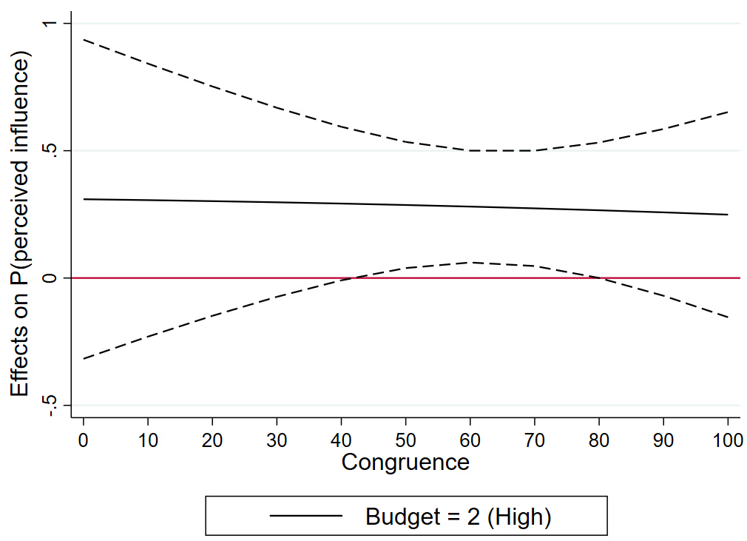

Robustness check with staff
As a second robustness check we present models using staff (FTEs) active in the Brussels office rather than the financial resources invested in lobbying. These results corroborate the findings presented in the paper, though the interaction effect is less pronounced and only holds for congruence levels of 40% and 60%.
Table A5. Binary logistic regression of preference attainment with staff as an alternative measure for financial resources
 | Model A3 |  |  | Model A4
Main effects | β |  | S.E. | β |  | S.E.
Intercept | -6.12 | * | (2.70) | -7.50 | † | (4.22)
Staff resources
- High (more than 1 million) | 3.50 | † | (1.95) | 3.69 |  | (5.37)
- Middle (100,000 – 1 million) | 3.31 | * | (1.56) | 6.24 |  | (5.89)
- Low (up to 100,000) (ref.)
Public congruence | 0.35 | ** | (0.11) | 0.39 | * | (0.16)
Position
- Support policy change | -7.59 | † | (4.16) | -8.40 | * | (4.55)
- Oppose policy change (ref.)
Media access | -2.25 | * | (1.29) | -2.25 | * | (1.29)
Media salience (logged) | 0.08 | † | (1.57) | -0.68 |  | 1.63
Level of mobilization
- International | 0.01 | * | (1.75) | -0.39 |  | (1.93)
- EU-level | 0.08 | † | (1.67) | -0.20 |  | (1.83)
- National (ref.)
Group type
- Business encompassing | -4.74 | * | (2.19) | -4.95 | † | (2.89)
- Business specific | -1.33 |  | (1.77) | -1.71 |  | (1.99)
- Firm | -2.60 |  | (2.19) | -3.03 |  | (2.08)
- Civil society (ref.)
Mobilization density (logged) | -1.02 |  | (0.80) | -0.66 |  | (0.82)
Coalition | -4.14 | ** | (1.01) | -4.30 | ** | (1.24)
Interaction effects
- High staff resources x congruence |  |  |  | 0.00 |  | (0.10)
- Medium staff resources x congruence |  |  |  | -0.05 |  | (0.08)
- Low staff resources x congruence (ref.)
Model fit
N | 109 |  |  | 109
Wald Chi 2 | 62.92 |  |  | 67.52
Pseudo R2 | 0.67 |  |  | 0.68
Robust standard errors in parentheses with significance levels indicated by † P<0.10, *P<0.05 and **P<0.01

Figure A6. Marginal effects of budget invested in lobbying for different levels of congruence
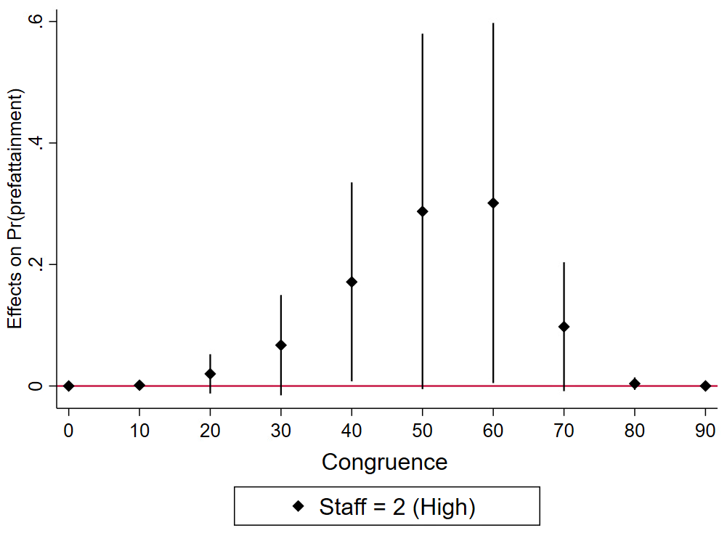

Robustness check including groups with an unclear position

As an additional robustness check we consider the interest groups for which no clear policy position could be determined based on media coding and the surveys. These groups are listed below in Table A6. Excluding these groups altogether from the analysis may lead us to underestimate the lobbying camps opposing stricter climate regulations, as such groups may deliberately position themselves ambivalently in climate policy debates while they are in fact trying to water down climate policies. Therefore we present alternative models in which we presume that the interest groups with ambivalent or unobservable positions were actually against new policy initiatives. As the models presented in Table A7 and marginal effects in Figure A7 demonstrate, our result hold true when incorporating these organizations in the analyses.

Table A6. Active interest groups for which no clear position was determined on an issue
IssueID | Organisation | GroupType
24 | BusinessEurope | business encompassing
24 | European Steel Association | business specific
39 | Renewable Energy Producers Association | business specific
39 | European Automobile Manufacturers Association | business specific
40 | COGEN Europe | business specific
40 | European Steel Association | business specific
40 | Renewable Energy Producers Association | business specific
12 | AirClim | civil Society
12 | Legambiente | civil Society
39 | Puraction | civil Society
39 | Climate Alliance Germany | civil Society
39 | Aviation Environment Federation | civil Society
39 | German environmental aid | civil Society
40 | ShareAction | civil Society
40 | Climate Savers Computing | civil Society
40 | Fondation Nicolas Hulot | civil Society
22 | Anti-Vivisection League LAV | civil Society
22 | Ente Nazionale Protezione Animali | civil Society
22 | LIDA | civil Society
22 | Organizzazione Internazionale Protezione Animali | civil Society
22 | State Forestry Body | civil Society
24 | Shell Nederland | firm
24 | ENI | firm
24 | ExxonMobil | firm
24 | Gasunie | firm
24 | Centrica | firm
24 | Bloomberg | firm
24 | Citigroup | firm
24 | Talisman Energy Poland | firm
24 | 3Legs Resources | firm
24 | Cuadrilla | firm
24 | DONG energy | firm
24 | BG Group | firm
39 | Airbus | firm
39 | Volkswagen | firm
39 | Barclays | firm
39 | Volvo group | firm
39 | UPS | firm
39 | Climate Advisers | firm
39 | Ecofys consultancy | firm
39 | Energy Circle | firm
39 | Pratt & Whitney | firm
40 | Total | firm
40 | Enea Energy Efficiency Unit | firm
40 | Marshal of Pomorskie Voivodeship | firm
40 | Delta Energy and Environment | firm
40 | Futerra | firm
40 | WysokieNapiecie | firm

Table A7. Binary logistic regression of preference attainment including groups for which no clear position was observed
 | Model A5 |  |  | Model A6
Main effects | β |  | S.E. | β |  | S.E.
Intercept | -3.70 |  | (2.63) | -3.25 |  | (2.81)
Financial resources
- High (more than 1 million) | 1.68 | * | (0.84) | -3.41 |  | (2.21)
- Middle (100,000 – 1 million) | 0.86 |  | (0.97) | -0.29 |  | (1.70)
- Low (up to 100,000) (ref.)
Public congruence | 0.30 | ** | (0.05) | 0.25 | ** | (0.06)
Position
- Support policy change | -6.31 | ** | (2.56) | -5.66 | * | (2.54)
- Oppose policy change (ref.)
Media access | -0.80 |  | (1.28) | -0.51 |  | (1.25)
Media salience (logged) | -3.10 | * | (1.54) | -2.68 |  | (1.72)
Level of mobilization
- International | 0.15 |  | (1.19) | 0.19 |  | (1.11)
- EU-level | 0.28 |  | (1.48) | 0.15 |  | (1.56)
- National (ref.)
Group type
- Business encompassing | -2.49 | † | (1.51) | -1.85 |  | (1.62)
- Business specific | 0.43 |  | (2.06) | 0.65 |  | (1.87)
- Firm | 1.71 |  | (1.94) | 1.72 |  | (1.79)
- Civil society (ref.)
Mobilization density (logged) | -0.72 |  | (1.49) | 0.00 |  | (1.46)
Coalition | -1.69 |  | (1.29) | -1.65 |  | (1.44)
Interaction effects
- High resources x congruence |  |  |  | 0.14 | * | (0.07)
- Medium resources x congruence |  |  |  | 0.02 |  | (0.04)
- Low resources x congruence (ref.)
Model fit
N | 157 |  |  | 157
Wald Chi 2 | 122.74 |  |  | 113.03
Pseudo R2 | 0.72 |  |  | 0.74
Robust standard errors in parentheses with significance levels indicated by † P<0.10, *P<0.05 and **P<0.01

Figure A7. Marginal effects of budget invested in lobbying for different levels of congruence
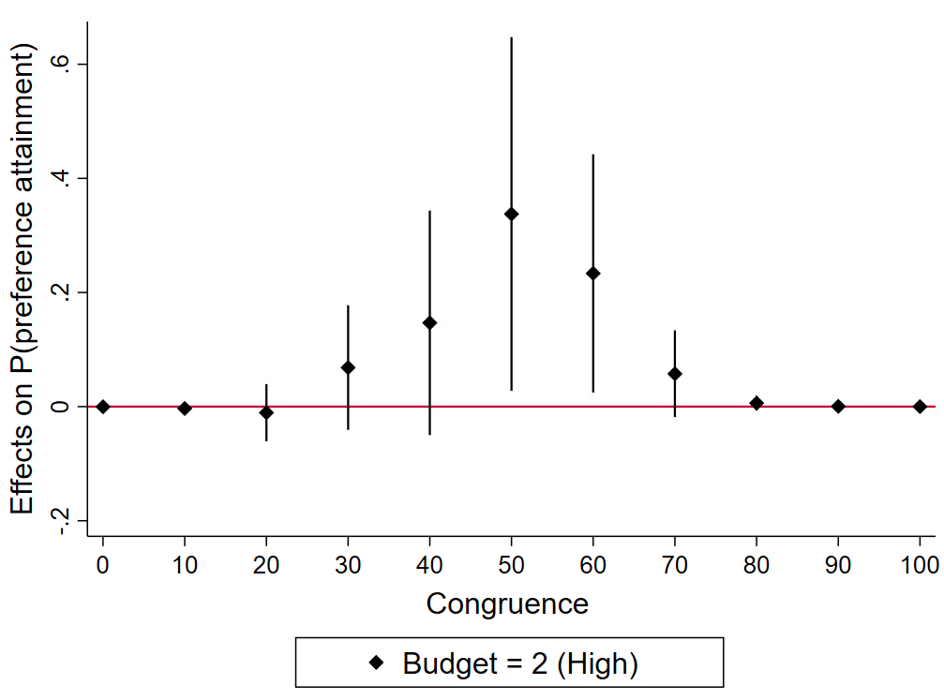

Robustness check including groups’ lobbying budgets over time

As a final robustness check we consider changes in lobby groups’ annual EU lobbying budgets over time. We took the time-period between 2012-2017 as this nicely overlaps with the time period considered by the project and we could not retrieve reliable data earlier than 2012. The 2012 data could be retrieved from the website lobbyfacts.eu which archives historical data from the EU transparency register. Below, we estimate our models using changes in EU lobbying expenditures (2012-2017). These changes are operationalized based on our trichotomous coding explained earlier. If an interest organization moved a category up or down between 2012 and 2017 these were coded “2” and “0” respectively. If the budget stayed the same this was coded as “1”. The models below use such changes in lobby groups’ budgets as an alternative (dynamic) measure of economic resources. The models test whether an increased or decreased financial investment resulted in higher levels of preference attainment. The models indeed corroborate our earlier findings, both for the main effects of resources and congruence and for their interaction effects.

Table A8. Binary logistic regression of preference attainment with lobbying budget invested over time

 | Model A7 |  |  | Model A8
Main effects | β |  | S.E. | β |  | S.E.
Intercept | -1.22 |  | (2.65) | 7.67 | † | (4.24)
Financial resources
- Increased investment | 4.85 | ** | (1.86) | -43.55 | ** | (5.43)
- Stabilized investment | 2.64 | † | (1.47) | -8.63 | † | (4.49)
- Decreased investment (ref.)
Public congruence | 0.57 | ** | (0.17) | 0.34 | † | (0.18)
Position
- Support policy change | -19.53 | ** | (7.38) | -18.14 | * | (8.73)
- Oppose policy change (ref.)
Media access | -2.35 |  | (1.55) | -1.86 |  | (1.75)
Media salience (logged) | 1.21 |  | (2.30) | 4.35 |  | (3.84)
Level of mobilization
- International | -1.49 |  | (2.74) | -2.08 |  | (2.50)
- EU-level | -1.82 |  | (2.76) | -1.62 |  | (2.75)
- National (ref.)
Group type
- Business encompassing | -11.56 | * | (4.49) | -11.60 | * | (5.26)
- Business specific | -6.42 | † | (3.32) | -8.16 | † | (4.91)
- Firm | -7.91 | * | (3.57) | -7.88 | * | (3.94)
- Civil society (ref.)
Mobilization density (logged) | -2.25 | † | (1.20) | -2.82 |  | (1.75)
Coalition | -5.14 | ** | (1.47) | -5.61 | ** | (0.08)
Interaction effects
- Increased investment x congruence |  |  |  | 1.22 | ** | (0.12)
- Stabilized investment x congruence |  |  |  | 0.20 | ** | (0.08)
- Decreased investment x congruence (ref.)
Model fit
N | 105 |  |  | 105
Wald Chi 2 | 46.29 |  |  | 834.85
Pseudo R2 | 0.72 |  |  | 0.77
Robust standard errors in parentheses with significance levels indicated by † P<0.10, *P<0.05 and **P<0.01

Figure A8. Marginal effects of an increased financial investment in EU lobbying for different levels of congruence
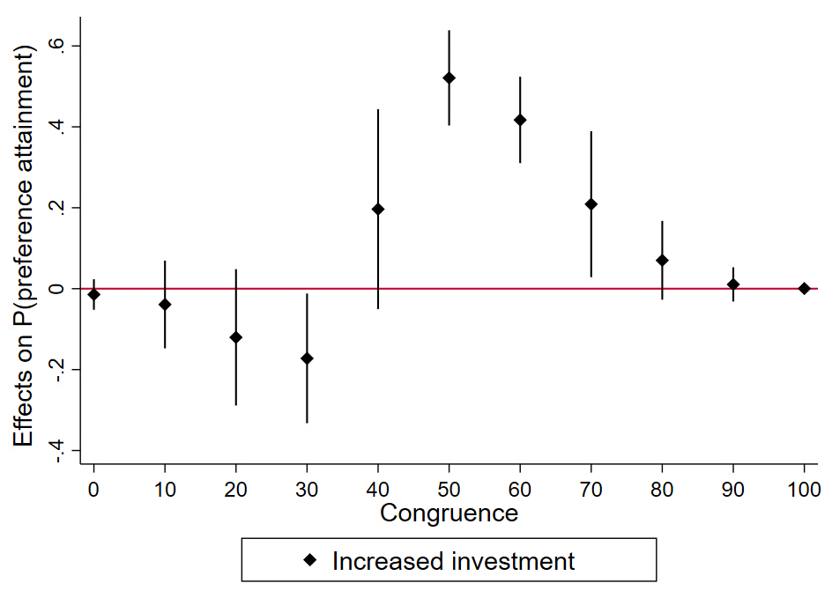

Robustness check without imputation for lobbying budgets

From the 109 interest organizations in our dataset, we could not determine the lobbying budget of 4 organizations based on lobbyfacts.eu and the transparency register. For these groups we imputed the lowest budget category, presuming that organizations with higher lobbying expenses are more likely to register. The models below present the results without this imputation. Results regarding our hypotheses tests remain stable, yet the coefficients of the control variables are more inflated due to determinacy problems (i.e. complete determination of 19 positive observations on the dependent variable). We therefore opted to present the models with n=4 imputed observations in the paper, with more conservative estimates of control variables. Yet, the model below shows that our results hold true without the imputation.

Table A9. Binary logistic regression of preference attainment without imputation for lobbying budgets
 | Model A9 |  |  | Model A10
Main effects | β |  | S.E. | β |  | S.E.
Intercept | -1.58 |  | (2.02) | 5.11 |  | (7.04)
Financial resources
- High (more than 1 million) | 5.74 | * | (2.37) | -8.54 |  | (12.79)
- Middle (100,000 – 1 million) | 2.39 |  | (1.84) | -8.39 |  | (9.26)
- Low (up to 100,000) (ref.)
Public congruence | 0.65 | ** | (0.18) | 0.49 | * | (0.22)
Position
- Support policy change | -19.48 | ** | (6.75) | -19.19 | ** | (5.97)
- Oppose policy change (ref.)
Media access | -4.04 | ** | (1.55) | -3.47 | † | (1.88)
Media salience (logged) | 3.21 |  | (2.07) | 5.66 | † | (1.13)
Level of mobilization
- International | -2.67 |  | (2.45) | -1.98 |  | (2.27)
- EU-level | -3.23 |  | (2.16) | -2.87 |  | (2.46)
- National (ref.)
Group type
- Business encompassing | -14.06 | ** | (4.25) | -13.27 | ** | (3.89)
- Business specific | -6.84 | * | (2.72) | -6.46 | ** | (2.25)
- Firm | -9.29 | ** | (2.92) | -8.86 | ** | (2.92)
- Civil society (ref.)
Mobilization density (logged) | -3.15 | ** | (1.10) | -3.82 | ** | (1.13)
Coalition | -6.08 | ** | (1.88) | -6.13 | ** | (1.63)
Interaction effects
- High resources x congruence |  |  |  | 0.31 |  | (0.26)
- Medium resources x congruence |  |  |  | 0.18 |  | (0.14)
- Low resources x congruence (ref.)
Model fit
N | 105 |  |  | 105
Wald Chi 2 | 30.15 |  |  | 70.87
Pseudo R2 | 0.74 |  |  | 0.75
Robust standard errors in parentheses with significance levels indicated by † P<0.10, *P<0.05 and **P<0.01

References
Burstein P. (2014) American public opinion, advocacy, and policy in congress: What the public wants and what it gets: Cambridge University Press.
Chalmers, A. W. (2013). Trading information for access: informational lobbying strategies and interest group access to the European Union. Journal of European Public Policy, 20(1), 39-58.
Crepaz, M., & Hanegraaff, M. (2019). The funding of interest groups in the EU: are the rich getting richer? Journal of European Public Policy, 1-20.
De Bruycker I and Beyers J. (2015) Balanced or biased? Interest groups and legislative lobbying in the European news media. Political Communication 32: 453-474.
Page BI and Shapiro RY. (1983) Effects of public opinion on policy. American Political Science Review 77: 175-190.
Rasmussen A, Mäder LK and Reher S. (2018) With a Little Help From The People? The Role of Public Opinion in Advocacy Success. Comparative Political Studies. 51(2): 139-164.
Wlezien C. (2004) Patterns of representation: Dynamics of public preferences and policy. Journal of Politics 66: 1-24.

In the survey project we define interest groups as all organizations with a political objective and which aggregate political preferences, such as business associations, labor unions, civil society organizations and social movement organizations. We approached individual firms only if we were unable to contact their respective sectoral association or when the association refused to cooperate.

