**Appendix**

***A1: Detailed description of the eight forums.***

|  |  |  |
| --- | --- | --- |
| General description (issue, purpose, activities, outputs) | # memb. # resp. resp. rate | Sectors (gov-IG- sci) (1, 2) |
| *Working Group on Forest and Wildlife of the Swiss Forestry Association:* Focuses on issues related to the interactions between wildlife and forest functions. Organizes knowledge exchange among experts, supports networking, publishes information materials, position papers and recommendations, organizes training courses and events. | 30  24  80% | 57%  35%  9% |
| *Working Group for the Forest (AfW):* Focuses on interactions among ecological, societal and economic claims on forests. Provides a politically neutral forum for discussion and for finding solutions, organizes round tables, publishes studies. Financially supported by the Federal Office of the Environment (FOEN) based on a performance agreement. | 23  18  78% | 0%  94%  6% |
| *Working Group on Water Body Restoration of the Water Agenda 21:* Focuses on strategies and methods for revitalizing surface waters according to the revised Swiss law on water protection. Supports experts involved in the implementation of the law by maintaining an online knowledge platform and by organizing educational events. Operates on behalf of FOEN, adhering to its own codex. | 28  25  89% | 52%  35%  13% |
| *Swiss Expert Committee for Biosafety (EFBS):* Focuses on issues related to biosafety (mainly genetically modified, pathogenic, or alien organisms). Supports the federal government when preparing regulations relevant to biological security and advises the implementing actors. Is also meant as a platform for stakeholders to present their priorities. Publishes recommendations and assessments. Members are appointed by the Swiss federal government. (M) | 15  12  80% | 0%  67%  33% |
| *Forum Early Detection Biodiversity:* Focuses on early detection of developments which are relevant for biodiversity and landscapes in order to increase the capacity to act of federals and cantonal authorities. Implements expert workshops and hearings and publishes results. Administrative office run by FOEN. (M) | 7  6  86% | 60%  0%  40% |
| *Working Group Geology and Natural Hazards (AGN):* Focuses on early detection and analysis of geological risks, as well as planning and observing natural hazard prevention and protection measures. Structures knowledge exchange among experts, organizes events, publishes information materials, engages with educational matters. | 15  12  80% | 25%  75%  0% |
| *Commission for Flood Protection of the Swiss Society for Water Management (KOHS):* Focuses on issues of flood protection and water engineering. Ensures knowledge exchange, quality standards, and education. Publishes recommendations and other information materials, and organizes congresses, workshops and educational events. | 23  21  91% | 35%  40%  25% |
| *Platform Natural Hazards (PLANAT):* Focuses on improving natural hazard prevention. Consults for the federal authorities and provides stakeholders with a platform to present their priorities. Organizes knowledge exchange, coordinates dispersed efforts, raises awareness among the public and local authorities. Publishes information materials, maintains an online knowledge platform. Members are appointed by the Swiss federal government. (M) | 18  14  78% | 43%  43%  14% |
| *Total* | 159  132  83% | 45%  50%  15% |

Notes: (1) Based on self-declaration by survey respondents. Non-respondents and forum-employees are excluded when calculating the percentages. (2) commercial interest groups, environmental groups, employees’ associations, consumer associations, professional associations, sport-/leisure groups, individual firms and individual persons. (M) = government mandate.

***A2: Importance of outputs by sector.*** For each output, the top bar is for government actors, the middle bar for interest group actors, and the bottom bar for science actors. The category “is not an output” is treated as NA in the regression analyses.



***A3: Importance of outputs by forums***



***A4: Multiple Correspondence Analysis of 13 forum benefit items***

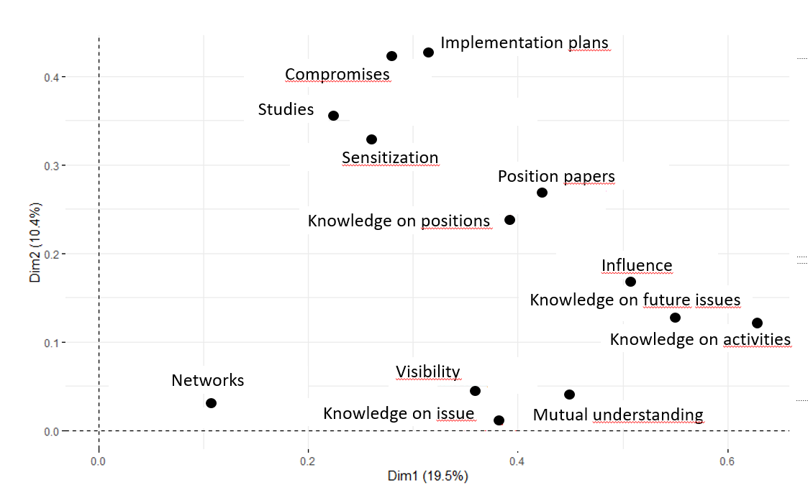

***A5: Alternative model specifications***

***Table A5.1: Results of regression models (linear effects, no random intercepts, logged dep var)***

|  |  |  |  |  |  |  |  |
| --- | --- | --- | --- | --- | --- | --- | --- |
|  | **1a** | **1b** | **1c** | **2a** | **2b** | **2c** | **3** |
| Exchange benefits | **0.64** |  | 0.46 |  |  |  | **0.58** |
|  | **(0.24)** |  | (0.27) |  |  |  | **(0.28)** |
| Policy benefits |  | **0.34** | 0.22 |  |  |  |  |
|  |  | **(0.14)** | (0.16) |  |  |  |  |
| Individual benefits |  |  |  | **0.21** |  | **0.19** | **0.19** |
|  |  |  |  | **(0.09)** |  | **(0.09)** | **(0.09)** |
| Collective benefits |  |  |  |  | 0.20 | 0.15 | 0.00 |
|  |  |  |  |  | (0.12) | (0.12) | (0.14) |
| Government mandate | **0.34** | **0.32** | **0.34** | **0.33** | **0.30** | **0.33** | **0.36** |
|  | **(0.08)** | **(0.08)** | **(0.08)** | **(0.08)** | **(0.08)** | **(0.08)** | **(0.08)** |
| Organizational actors | -0.20 | -0.19 | -0.17 | -0.21 | -0.22 | -0.19 | -0.16 |
|  | (0.12) | (0.12) | (0.12) | (0.12) | (0.12) | (0.12) | (0.12) |
| Number of employees | **0.04** | **0.04** | **0.04** | **0.03** | **0.04** | **0.03** | **0.03** |
|  | **(0.02)** | **(0.02)** | **(0.02)** | **(0.02)** | **(0.02)** | **(0.02)** | **(0.02)** |
| Other channels | **-0.14** | **-0.15** | -0.13 | **-0.15** | **-0.17** | **-0.14** | -0.12 |
|  | **(0.07)** | **(0.07)** | (0.07) | **(0.07)** | **(0.07)** | **(0.07)** | (0.07) |
| Government actor | -0.05 | -0.08 | -0.07 | -0.05 | -0.07 | -0.07 | -0.06 |
|  | (0.07) | (0.08) | (0.07) | (0.07) | (0.08) | (0.08) | (0.07) |
| Leadership position | 0.04 | 0.07 | 0.05 | 0.04 | 0.09 | 0.05 | 0.01 |
|  | (0.07) | (0.07) | (0.07) | (0.07) | (0.07) | (0.07) | (0.08) |
| Reputation | **0.72** | **0.75** | **0.73** | **0.73** | **0.75** | **0.74** | **0.72** |
|  | **(0.16)** | **(0.16)** | **(0.16)** | **(0.16)** | **(0.16)** | **(0.16)** | **(0.16)** |
| Satisfaction leadership | 0.19 | 0.21 | 0.20 | 0.22 | 0.21 | **0.22** | 0.20 |
|  | (0.11) | (0.11) | (0.11) | (0.11) | (0.11) | **(0.11)** | (0.11) |
| _cons | -0.01 | 0.33 | -0.01 | **0.44** | **0.42** | **0.33** | -0.09 |
|  | (0.26) | (0.17) | (0.27) | **(0.15)** | **(0.17)** | **(0.17)** | (0.27) |
| Adjusted R2 | 0.45 | 0.45 | 0.46 | 0.44 | 0.43 | 0.45 | 0.46 |
| N | 114 | 114 | 114 | 114 | 114 | 114 | 114 |
|  |  |  |  |  |  |  |  |

Differences to main models (Figure 1) in terms of significant results are indicated by grey background.

***Table A5.2: Results of ordered logit regression with random intercepts (no log-transformation of dependent variable)***

|  |  |  |  |  |  |  |  |
| --- | --- | --- | --- | --- | --- | --- | --- |
|  | **1a** | **1b** | **1c** | **2a** | **2b** | **2c** | **3** |
| Exchange benefits | **3.51** |  | 2.03 |  |  |  | 2.80 |
|  | **(1.46)** |  | (1.63) |  |  |  | (1.75) |
| Policy benefits |  | **2.34** | **1.83** |  |  |  |  |
|  |  | **(0.82)** | **(0.91)** |  |  |  |  |
| Individual benefits |  |  |  | **1.27** |  | **1.11** | **1.15** |
|  |  |  |  | **(0.53)** |  | **(0.53)** | **(0.54)** |
| Collective benefits |  |  |  |  | **1.49** | 1.24 | 0.48 |
|  |  |  |  |  | **(0.70)** | (0.71) | (0.85) |
| Government mandate | **2.35** | **2.31** | **2.43** | **2.31** | **2.15** | **2.35** | **2.56** |
|  | **(0.54)** | **(0.53)** | **(0.54)** | **(0.53)** | **(0.52)** | **(0.54)** | **(0.56)** |
| Organizational actors | **-1.34** | -1.27 | -1.16 | **-1.51** | **-1.38** | -1.29 | -1.17 |
|  | **(0.70)** | (0.70) | (0.71) | **(0.69)** | **(0.70)** | (0.70) | (0.71) |
| Number of employees | **0.30** | **0.24** | **0.25** | **0.23** | **0.26** | **0.23** | **0.24** |
|  | **(0.10)** | **(0.09)** | **(0.09)** | **(0.09)** | **(0.09)** | **(0.09)** | **(0.09)** |
| Other channels | -0.70 | -0.68 | -0.62 | -0.66 | **-0.80** | -0.64 | -0.53 |
|  | (0.40) | (0.40) | (0.40) | (0.40) | **(0.39)** | (0.40) | (0.40) |
| Government actor | -0.58 | -0.77 | -0.75 | -0.59 | -0.70 | -0.75 | -0.70 |
|  | (0.42) | (0.43) | (0.44) | (0.42) | (0.43) | (0.44) | (0.44) |
| Leadership position | 0.09 | 0.27 | 0.17 | 0.13 | 0.36 | 0.22 | 0.03 |
|  | (0.04) | (0.42) | (0.43) | (0.42) | (0.42) | (0.43) | (0.44) |
| Reputation | **5.02** | **5.34** | **5.32** | **5.01** | **5.26** | **5.29** | **5.21** |
|  | **(1.08)** | **(1.10)** | **(1.11)** | **(1.08)** | **(1.09)** | **(1.10)** | **(1.11)** |
| Satisfaction leadership | 1.01 | **1.20** | 1.13 | **1.26** | 1.11 | **1.22** | 1.17 |
|  | (0.65) | **(0.64)** | (0.65) | **(0.65)** | (0.64) | **(0.64)** | (0.66) |
| Intercept 1-2 | 2.28 | 0.76 | 2.27 | -0.16 | 0.18 | 0.71 | 2.78 |
|  | (1.56) | (0.90) | (1.57) | (0.87) | (0.95) | (0.99) | (1.65) |
| Intercept 2-3 | **4.55** | **3.03** | **4.57** | **2.12** | **2.41** | **3.00** | **5.11** |
|  | **(1.59)** | **(1.01)** | **(1.60)** | **(0.86)** | **(0.96)** | **(1.01)** | **(1.68)** |
| Intercept 3-4 | **7.26** | **5.79** | **7.35** | **4.84** | **5.12** | **5.77** | **7.92** |
|  | **(1.26)** | **(1.12)** | **(1.70)** | **(0.97)** | **(1.06)** | **(1.12)** | **(1.78)** |
| Intercept 4-5 | **10.71** | **9.41** | **10.96** | **8.30** | **8.65** | **9.38** | **11.50** |
|  | **(1.89)** | **(1.44)** | **(1.92)** | **(1.26)** | **(1.37)** | **(1.44)** | **(1.99)** |
| AIC | 265.2 | 262.7 | 235.1 | 265.3 | 266.5 | 264.1 | 263.5 |
| N | 114 | 114 | 114 | 114 | 114 | 114 | 114 |
|  |  |  |  |  |  |  |  |

Differences to main models (Figure 1) in terms of significant results are indicated by grey background.

***Table A5.3: Results of regression models (linear mixed effects, logged dep var) with alternative aggregations of independent variables (only variations of the complete model 3)***

|  |  |  |
| --- | --- | --- |
|  | **R1** | **R2** |
| Exchange benefits | **0.62** | 3.19 |
|  | **(0.23)** | (1.86) |
| Policy benefits |  |  |
|  |  |  |
| Individual benefits | **0.19** | **0.18** |
|  | **(0.09)** | **(0.09)** |
| Collective benefits | -0.01 | 0.01 |
|  | (0.13) | (0.15) |
| Government mandate | **0.37** | **0.37** |
|  | **(0.09)** | **(0.10)** |
| Organizational actors | -0.13 | -0.14 |
|  | (0.12) | (0.12) |
| Number of employees | **0.03** | **0.03** |
|  | **(0.02)** | **(0.02)** |
| Other channels | -0.09 | -0.10 |
|  | (0.07) | (0.07) |
| Government actor | -0.08 | -0.07 |
|  | (0.07) | (0.07) |
| Leadership position | -0.01 | 0.01 |
|  | (0.08) | (0.08) |
| Reputation | **0.71** | **0.71** |
|  | **(0.16)** | **(0.16)** |
| Satisfaction leadership | 0.19 | 0.20 |
|  | (0.11) | (0.11) |
| _cons | -0.11 | -0.05 |
|  | (0.24) | (0.27) |
| sd(cons) | 0.00 | 0.00 |
|  | (0.06) | (0.07) |
| sd(Residual) | 0.10 | 0.11 |
|  | (0.32) | (0.33) |
| N | 114 | 114 |
|  |  |  |

R1: «Exchange» benefits without “mutual understanding” and “networking”.

R2: “Studies” as “collective benefit” instead of “exchange benefit”.

Differences to main model (Figure 1, Model 3) in terms of significant results are indicated by grey background.