Supplementary Materials - From Clubs to Hubs: Analysing Lobbying Networks in EU Financial Regulation After Crisis

Bastiaan Redert

Appendix A: Organized Public Consultations over Time
To construct the lobbying networks, I collected all responses of interest groups to public consultations organised by the ESAs and their predecessors from 2004 to 2014. During this period, the agencies organised 445 consultations. In total, 11,217 responses from 1,735 unique interest groups have been collected. The dataset includes every response of interest groups to ESA consultations, and is thus as comprehensive as it can be. The number of consultations, responses and unique groups presented here concern the complete dataset. Figure A1.1 shows the distribution of the organised consultations per agency per period. Additionally, Figure A1.2 shows the number of attending interest groups per consultation. Logically, both the number of consultations and the number of attending groups affects the structure of the networks. For example, during the pre-crisis period the institutional predecessor of EIOPA, CEIOPS, organized only 18 consultations (see Figure A1.1). Also, the number of attending groups is rather low as shown in Figure A1.2. This results in a small network of a few groups (see also Figure A2.4).

Figure A1.1: Distribution of organised consultations per agency per period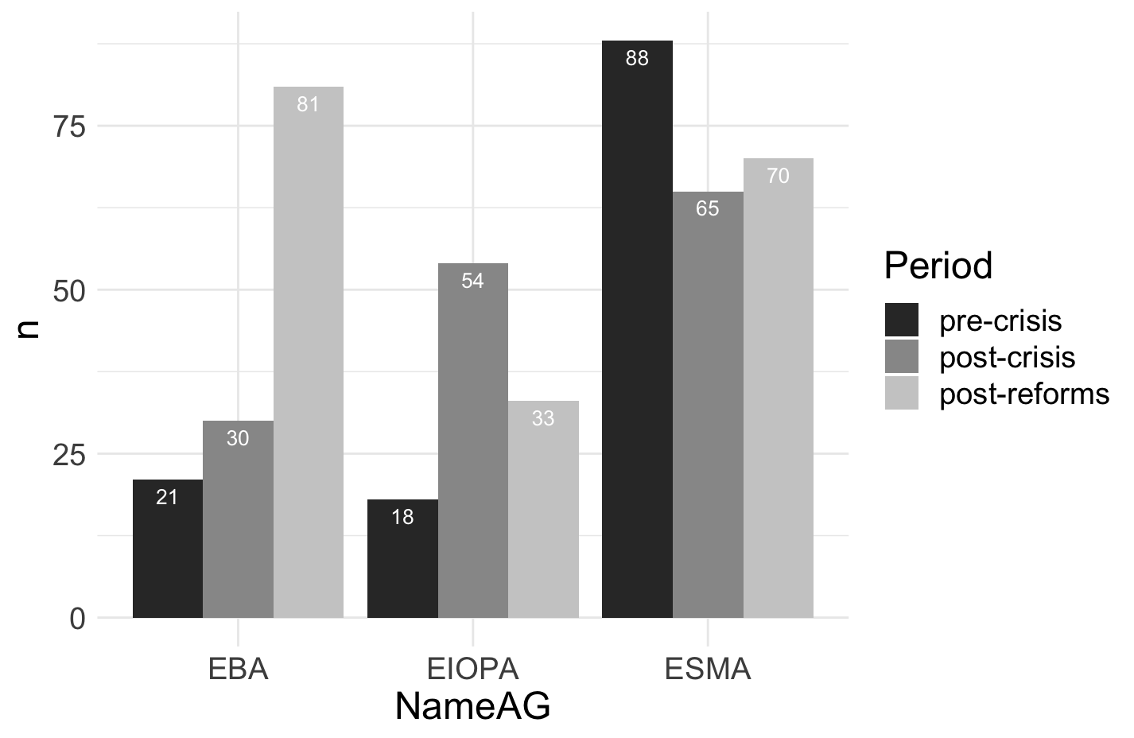

Figure A1.2: Number of Attending Groups per Consultation, ordered across three agencies and three periods.
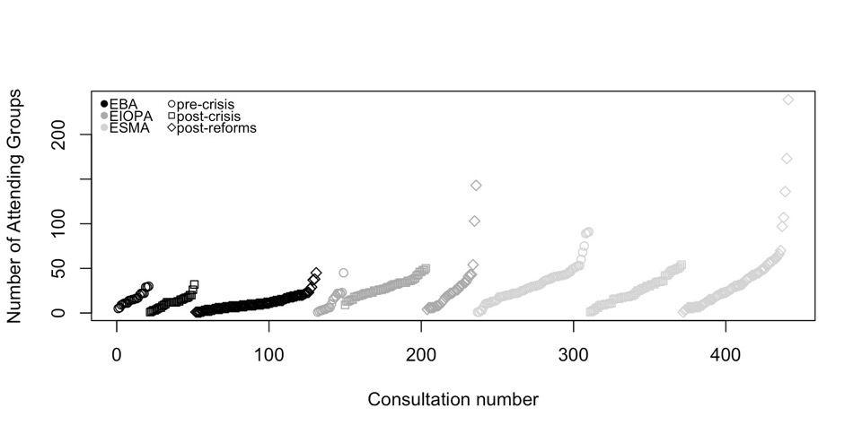

Appendix B: Constructing networks from consultation data
The starting point is the group-consultation network. In this two-mode network, the nodes are both groups and consultations, where a connection or edge is formed when group i participated in consultation j. To illustrate such a network, Figure 2.1 shows a subnetwork extracted from the overall two-mode network.

Figure A2.1. Extracted subnetwork of group-consultation network EBA (2004-2007)

In Figure 2.1, the three black nodes represent three consultations and the grey nodes represent interest groups that participated in those consultations. For the sake of visualization, three distinct consultations have been selected: one on Credit Assessment of financial institutions such as banks, one on Financial Reporting, and one on Commodities. We clearly see that several groups mobilize on one of the consultations, which creates three distinct clusters. However, the clusters are not fully separated from one another. Nodes a10316 (British Bankers Association) and a10698 (European Banking Federation) participated in two consultations. This means that these two interest groups will have a stake in both consultations. We also see that one consultation (03_018_20070615b) is isolated from the other two. This is not a coincidence: the isolated consultation concerns commodities. The groups participating in this consultation are mainly (associations of) electricity producers (such as RWE Group, Eurelectric, and the Zentralverband Elektrotechnik- und Elektronikindustrie). Logically, these groups are less likely to participate in consultations concerning other financial regulations, and thus remain isolated. In other words, these interest groups are more specialized, whereas the British Bankers Association and the European Banking Federation are more likely to be generalists with interests in multiple issues.
If one seeks to analyse how groups are connected (i.e. participate in the same consultation), one can transform the two-mode network into a one-mode network. In such a network, the nodes are individual interest groups and the edges are consultations. Figure 2.2 illustrates the one-mode projection of the two-mode network presented above. In this network, one again sees that those groups participating in the same consultation are connected. Again, the groups participating in the consultation on electricity trading are isolated from the other groups. Also, one sees that nodes a10316 and a10698 are connecting two clusters of interest groups as these nodes participated in two consultations. For example, the European Banking Federation (a10698) connects the Investment Association (a11059) to the European Association of Public Banks (a10692). As such, these interconnecting nodes are important actors in the network.

Figure 2.2. Extracted subnetwork of interest group network EBA (2004-2007)

Appendix C: Network Graphs per Agency per Time Period

In the figures below, the visualizations of the networks are presented. To construct intelligible graphs, the author utilized the NetBioV-package in R (Tripathi, Dehmer, & Emmert-Streib, 2014). Although the package has its roots in biology and medicines, it provides several useful tools to visualize large networks, as is the case in this research. More specifically, this package allows to disentangle the various identified clusters (also see Table 2), and visualize the connections between those clusters (also see Tripathi, Dehmer, & Emmert-Streib, 2014). Figures A3.1-A3.10 present the constructed networks per agency per period. The nodes in the network represent the interest groups and the edges represent consultations. Thus, two nodes are connected with one another when they have participated in the same consultation. The clusters of nodes reflect the communities as detected by the Walktrap-algorithm. The color of the nodes represents its eigen value: the darker the color, the lower the eigen value; and the lighter the color, the higher the eigen value. As such, the visualizations also indicate which nodes are the most central in the network.

Figure A3.1: EBA pre-crisis
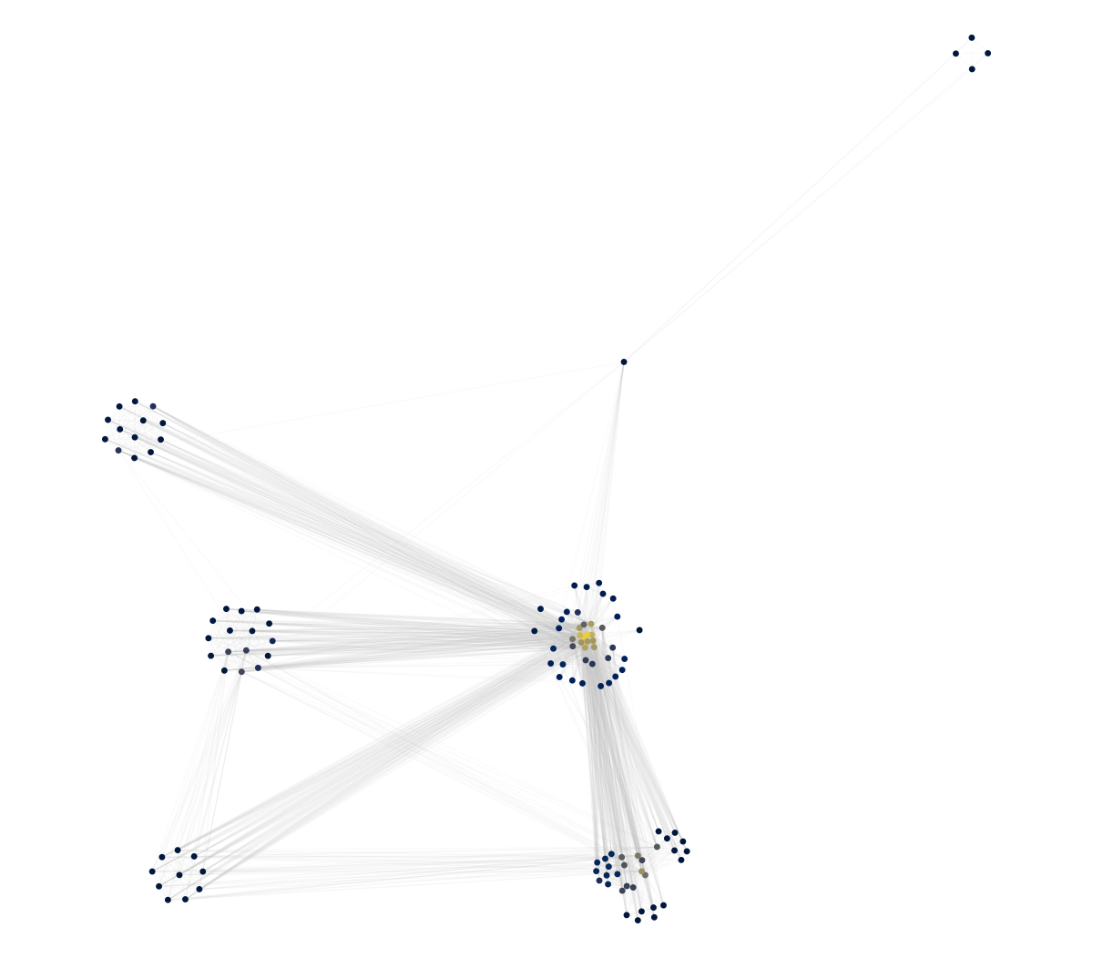

Figure A3.2: EBA post-crisis

Figure A3.3: EBA post-reforms
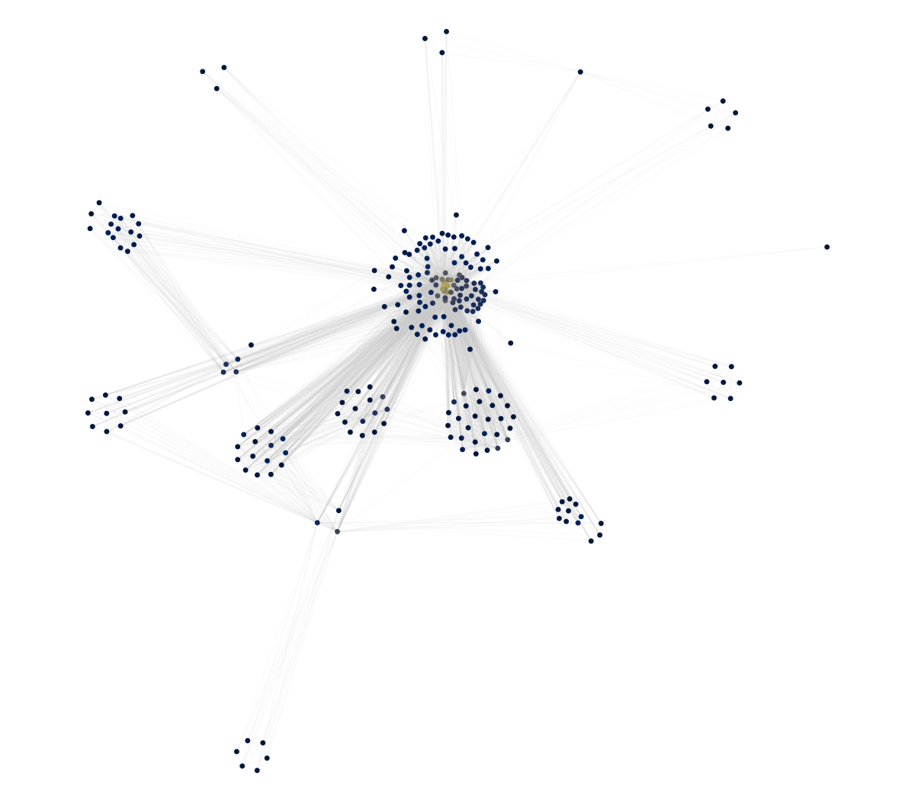
Figure A3.4: EIOPA pre-crisis

Figure A3.5: EIOPA post-crisis
Figure A3.6: EIOPA post-reforms

Figure A3.7: ESMA pre-crisis

Figure A3.8: ESMA post-crisis

Figure A3.9: ESMA post-reforms

Appendix D: Conditional Uniform Graph Tests
To compare the density of the different networks over time, one should control for the difference in size of these respective networks. Density is computed by dividing the realized number of edges (or ties) between the different nodes (or actors) by the number of theoretically possible edges in a certain network. In other words, density is a function of the size of the network. Thus, if one wants to compare the density of networks with varying edges and nodes, one needs to control for differences in size.
Using a Conditional Uniform Graph (CUG) test, one can (albeit partially) control for that. The CUG-tests presented below take the density (or any other network metric) of the realized network and statistically compares that to a high number of randomly generated networks with the same size (n = 5000). More specifically, it measures the likelihood that the empirically observed density score is the result of a random data generating process.
Figures A4.1-9 show the results of the CUG-tests. For all the networks (expect for EIOPAs network before the crisis), the observed density measures (as also presented in Table 3) are significantly lower than the density scores of the randomly generated networks when conditioned for the network’s size. For EIOPA, the observed density of the pre-crisis network is significantly bigger than those from the random networks. The networks’ density scores decrease after the crisis and reforms, and – when conditioned for the networks’ size – are lower than those of the random networks.
The CUG-tests thus demonstrate that the observed density measures are unlikely to be the result of random processes. This means that the density scores as presented in Table 3 can be compared with one another. This robustness check thus indicates that the observed decrease in density might, in fact, be the result of groups’ changing participation.

Figures A4.1-9: Univariate Conditional Uniform Graph Tests per Agency per Period

Appendix E: Visualizations Lorenz Curve Eigencentrality

Figure A5.1: Lorenz-curve Eigencentrality EBA

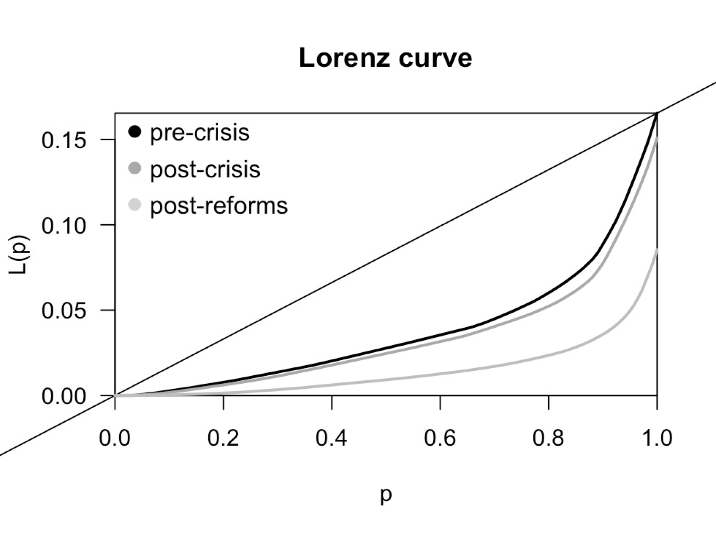

Figure A5.2: Lorenz-curve Eigencentrality EOIPA

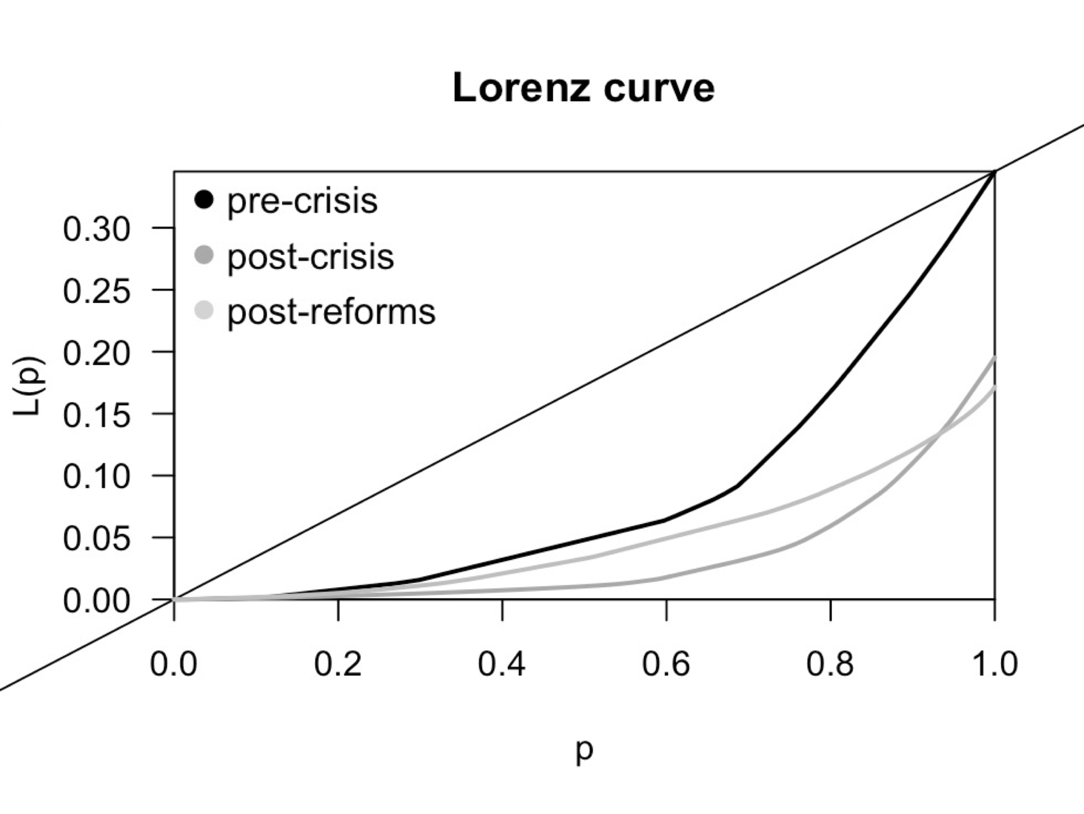

Figure A5.3: Lorenz-curve Eigencentrality ESMA
