Online appendix A. Spatial distribution of homicide rates in 2015, Source: INEGI
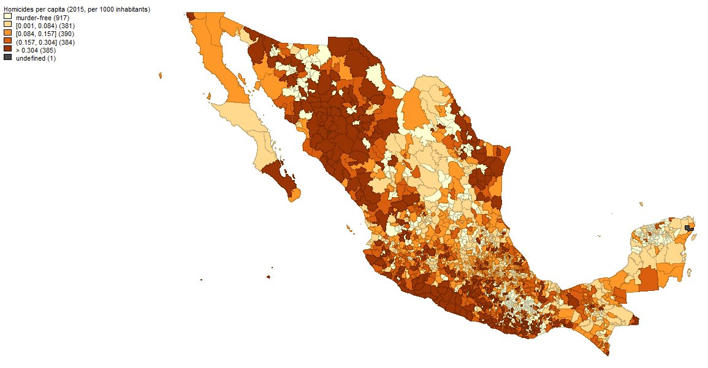
Note: Murder-free municipalities did not report any homicides in 2015; the remaining categories reflect quartiles, conditional on them being positive; ‘undefined’ reflects missing values

Online appendix B. Variable definitions, sources and summary statistics for the baseline model (1995-2015)
Variable | Source | Mean | Std. Dev. |  | Observations
OCVBIN - all homicides | Instituto Nacional de Geografía y Estadísticas (INEGI), SIMBAD database | 0.58 | O | 0.49 | N | 12223
 |  |  | B | 0.37 | n | 2457
 |  |  | W | 0.33 | years | 4.975
 |  |  |  |  | msng (%) | 0
ln(OCVCONT) - all homicides | INEGI SIMBAD database | -1.88 | O | 1.04 | N | 7132
 |  |  | B | 0.93 | n | 2108
 |  |  | W | 0.58 | years | 3.383
 |  |  |  |  | msng (%) | 41.65
Local spending | INEGI SIMBAD database | 2.64 | O | 2.39 | N | 10910
 |  |  | B | 1.67 | n | 2457
 |  |  | W | 1.70 | years | 4.44
 |  |  |  |  | msng (%) | 10.74
Own-source revenues | INEGI SIMBAD database | 10.93 | O | 12.14 | N | 10846
 |  |  | B | 9.54 | n | 2441
 |  |  | W | 7.31 | years | 4.443
 |  |  |  |  | msng (%) | 11.27
Human Development Index | INEGI SIMBAD database | 7.79 | O | 0.88 | N | 9766
 |  |  | B | 0.79 | n | 2456
 |  |  | W | 0.40 | years | 3.976
 |  |  |  |  | msng (%) | 20.1
Female headed households | INEGI SIMBAD database | 22.19 | O | 6.01 | N | 9809
 |  |  | B | 5.05 | n | 2457
 |  |  | W | 3.25 | years | 3.992
 |  |  |  |  | msng (%) | 19.75
Household size | INEGI SIMBAD database | 4.14 | O | 0.58 | N | 9809
 |  |  | B | 0.51 | n | 2457
 |  |  | W | 0.28 | years | 3.992
 |  |  |  |  | msng (%) | 19.75
Population density | INEGI, various databases | 2.65 | O | 11.69 | N | 12218
 |  |  | B | 11.61 | n | 2454
 |  |  | W | 1.11 | years | 4.979
 |  |  |  |  | msng (%) | 0.041
Young males | INEGI SIMBAD database | 25.17 | O | 3.10 | N | 12222
 |  |  | B | 2.50 | n | 2457
 |  |  | W | 1.83 | years | 4.974
 |  |  |  |  | msng (%) | 0.008
Males per females | INEGI SIMBAD database | 96.00 | O | 6.66 | N | 12223
 |  |  | B | 6.01 | n | 2457
 |  |  | W | 2.88 | years | 4.975
 |  |  |  |  | msng (%) | 0
Indigenous population | Comisión Nacional para el Desarrollo de los Pueblos Indígenas (CDI) | 25.32 | O | 35.74 | N | 9809
 |  |  | B | 35.66 | n | 2457
 |  |  | W | 2.54 | years | 3.992
 |  |  |  |  | msng (%) | 19.75
Population | INEGI SIMBAD database | 4.28 | O | 12.65 | N | 12223
 |  |  | B | 12.52 | n | 2457
 |  |  | W | 1.60 | years | 4.975
 |  |  |  |  | msng (%) | 0
Municipality size | INEGI SIMBAD database | 2.50 | O | 1.12 | N | 12223
 |  |  | B | 1.10 | n | 2457
 |  |  | W | 0.18 | years | 4.975
 |  |  |  |  | msng (%) | 0
Electoral competition | Centro de Investigación para el Desarrollo en México (CIDAC, http://cidac.org/), Electoral Institutes of the States | 2.41 | O | 1.03 | N | 11078
 |  |  | B | 0.83 | n | 2457
 |  |  | W | 0.64 | years | 4.509
 |  |  |  |  | msng (%) | 9.368
US border or Pacific coast |  | 0.21 | O | 0.41 | N | 12223
 |  |  | B | 0.41 | n | 2457
 |  |  | W | 0.00 | years | 4.975
 |  |  |  |  | msng (%) | 0

 | Binary Part | Cont. Part
 | (1) | (2)
Local spending (between) | 0.946 | 13.373**
 | (-1.15) | (5.86)
Local spending (within) | 0.998 | 0.568
 | (-0.05) | (0.37)
Own-source revenues (between) | 0.992 | 0.668
 | (-0.06) | (0.23)
Own-source revenues (within) | 0.899 | -3.956
 | (-1.02) | (-1.51)
Local security spending | 0.977 | -0.586
 | (-1.02) | (-0.68)
Local police | 0.952** | 1.690*
 | (-3.84) | (2.51)
Inequality | 1.039 | 4.874
 | (0.28) | (0.94)
Poverty | 0.999 | 0.558**
 | (-0.14) | (3.01)
Female-headed households | 1.041** | 3.082**
 | (2.97) | (5.66)
Household size | 0.993 | -11.403
 | (-0.04) | (-1.75)
Population density | 0.953** | -0.178
 | (-2.87) | (-0.98)
Young males | 1.049 | -0.573
 | (1.88) | (-0.57)
Males per females | 1.027* | 2.881**
 | (1.99) | (5.78)
Indigenous population | 0.996* | -0.222**
 | (-2.15) | (-2.77)
Population | 1.513** | 0.444**
 | (5.82) | (3.58)
Municipality size | 2.399** | -28.024**
 | (6.89) | (-11.40)
Electoral competition | 0.964 | 0.130
 | (-0.56) | (0.07)
US border or Pacific coast | 2.722 | 84.233**
 | (1.89) | (3.49)
2015 | 1.263 | -9.212*
 | (1.81) | (-2.13)
Federal state dummies | x | x
Number of observations | 4099 | 2553
Number of municipalities | 2282 | 1604
R² | - | 0.50
F-value | 10.0 | 44.9
* - significant at 5 %; ** significant at 1 %; z- and t-values in parentheses; logit reported as odds ratios; cont. effect reflects percentage change of dep. variable; heteroscedasticity-corrected standard errors
Online appendix C. Uncorrelated longitudinal TPM for the effect of fiscal decentralization on organized crime violence (2010-2015)

 | Second stage | First stage
Local spending | 9.956** | -0.010
 | (3.15) | (-0.30)
Own-source revenues | -0.052 | -0.004
 | (-0.11) | (-0.62)
Local security spending | 0.361 | 0.017
 | (0.13) | (0.62)
Local police | -2.353 | -0.020
 | (-1.36) | (-1.29)
Inequality | 13.328 | 0.311*
 | (0.98) | (2.28)
Poverty | 0.300 | -0.014**
 | (0.69) | (-2.87)
Female-headed households | 2.554 | 0.026
 | (1.78) | (1.66)
Household size | -33.799* | -0.248
 | (-2.38) | (-1.39)
Population density | 0.157 | -0.003
 | (0.46) | (-0.29)
Young males | 0.427 | 0.040
 | (0.16) | (1.47)
Males per females | 3.303** | 0.031*
 | (2.82) | (2.37)
Indigenous population | -0.760** | -0.004
 | (-2.89) | (-1.42)
Population | - | 0.063**
 |  | (3.59)
Municipality size | -12.871 | 0.491**
 | (-1.45) | (5.97)
Electoral competition | -4.017 | 0.002
 | (-0.69) | (0.04)
US border or Pacific coast | - | 7.273**
 |  | (12.74)
Federal state dummies | x | x
Inverse Mills ratio | 1.070**
 | (-4.26)
Number of observations | 1351
* - significant at 5 %; ** significant at 1 %; t-values in parentheses; Selection variables: population; US border or Pacific coast; first stage: probit
Online appendix D. Heckman selection model for the effect of local spending on OCV for 2010

Online appendix E. Uncorrelated longitudinal TPM including the effect of disasters on organized crime violence (2000-2015)
 | Binary Part | Cont. Part
 | (1) | (2)
Local spending (between) | 0.909** | 13.180**
 | (-3.11) | (8.10)
Local spending (within) | 1.007 | -1.001
 | (0.26) | (-0.88)
Own-source revenues (between) | 1.156 | 0.387
 | (1.79) | (0.18)
Own-source revenues (within) | 0.968 | -1.210
 | (-0.48) | (-0.63)
Hurricanes | 1.447** | 8.066**
 | (3.71) | (2.32)
Earthquakes and volcanic activity | 1.203 | 20.490**
 | (1.14) | (3.90)
Human development | 0.682** | -20.176**
 | (-5.89) | (-7.31)
Female-headed households | 1.050** | 3.015**
 | (5.23) | (7.70)
Household size | 1.200 | -8.767**
 | (1.86) | (-2.03)
Population density | 0.956** | -0.245
 | (-3.75) | (-1.38)
Young males | 0.988 | -1.411**
 | (-0.79) | (-2.24)
Males per females | 1.034** | 2.681**
 | (3.95) | (7.86)
Indigenous population | 0.995** | -0.291**
 | (-4.05) | (-4.67)
Population | 1.561** | 0.411**
 | (8.45) | (3.71)
Municipality size | 2.209** | -31.234**
 | (9.21) | (-18.08)
Electoral competition | 1.013 | -2.849
 | (0.28) | (-1.89)
US border or Pacific coast | 1.461 | 22.036
 | (1.07) | (1.69)
2000 | 0.556** | -21.881**
 | (-3.95) | (-4.67)
2005 | 0.551** | -23.473**
 | (-4.70) | (-6.35)
2010 | 0.778** | 8.399**
 | (-2.49) | (2.45)
Federal state dummies | X | x
Number of observations | 8040 | 4727
Number of municipalities | 2413 | 1896
R² | - | 0.49
Wald-Chi² | 1260.6 | 3715.1
Note: * - significant at 5 %; ** significant at 1 %; z- and t-values in parentheses; logit reported as odds ratios; cont. effect reflects percentage change of dep. variable; heteroscedasticity-corrected standard errors

