Appendix
Contents
Appendix 1
Descriptive statistics 1
Models for economics and fiscal terms 9
Estimated marginal means for politics and policy 10
Models for using absolute word count as dependent variable 11
Models including neutral terms 13
Test for variation within the Eurozone group 16
Descriptive statistics for politics and policy terms by rating decision 18
Model diagnostics from main models in paper 19
Detailed list of categories of words 21

Descriptive statistics
Table A1a: Number of reports per country
Country | Number of reports in sample
Albania | 2
Austria | 10
Belarus | 10
Belgium | 14
Bosnia | 6
Bulgaria | 17
Croatia | 16
Cyprus | 21
Czech | 13
Denmark | 12
Estonia | 21
Finland | 18
France | 10
Germany | 11
Greece | 24
Hungary | 24
Iceland | 26
Ireland | 22
Italy | 19
Latvia | 21
Lithuania | 24
Luxemburg | 9
Macedonia | 8
Malta | 17
Montenegro | 6
Netherlands | 9
Norway | 7
Poland | 19
Portugal | 25
Romania | 21
Russia | 23
Serbia | 11
Slovakia | 17
Slovenia | 13
Spain | 18
Sweden | 13
Switzerland | 5
Turkey | 35
Ukraine | 26
United Kingdom | 12

Table A1b: Number of reports per year
Year | Number of reports
1999 | 28
2000 | 21
2001 | 33
2002 | 42
2003 | 57
2004 | 45
2005 | 43
2006 | 45
2007 | 38
2008 | 55
2009 | 72
2010 | 50
2011 | 74
2012 | 32

Table A1c: Number of reports per country and year
 | 1999 | 2000 | 2001 | 2002 | 2003 | 2004 | 2005 | 2006 | 2007 | 2008 | 2009 | 2010 | 2011 | 2012
Albania | 0 | 0 | 0 | 0 | 0 | 0 | 0 | 0 | 0 | 0 | 0 | 1 | 1 | 0
Austria | 0 | 1 | 0 | 0 | 1 | 1 | 1 | 1 | 1 | 0 | 2 | 0 | 1 | 1
Belarus | 0 | 0 | 0 | 0 | 0 | 0 | 0 | 0 | 1 | 2 | 2 | 1 | 3 | 1
Belgium | 1 | 0 | 0 | 1 | 1 | 1 | 1 | 1 | 1 | 0 | 3 | 1 | 2 | 1
Bosnia | 0 | 0 | 0 | 0 | 0 | 0 | 0 | 0 | 0 | 1 | 1 | 1 | 2 | 1
Bulgaria | 1 | 1 | 1 | 1 | 2 | 1 | 2 | 1 | 1 | 3 | 1 | 1 | 1 | 0
Croatia | 1 | 0 | 1 | 1 | 1 | 2 | 1 | 1 | 1 | 2 | 1 | 2 | 1 | 1
Cyprus | 1 | 1 | 1 | 2 | 1 | 3 | 0 | 1 | 1 | 1 | 1 | 2 | 5 | 1
Czech | 1 | 1 | 0 | 2 | 1 | 1 | 1 | 1 | 1 | 1 | 1 | 1 | 1 | 0
Denmark | 1 | 0 | 1 | 1 | 1 | 1 | 1 | 1 | 1 | 1 | 2 | 0 | 1 | 0
Estonia | 0 | 1 | 1 | 1 | 2 | 1 | 1 | 1 | 1 | 3 | 3 | 2 | 3 | 1
Finland | 1 | 1 | 0 | 1 | 3 | 0 | 2 | 2 | 1 | 1 | 2 | 1 | 2 | 1
France | 0 | 0 | 1 | 1 | 1 | 1 | 0 | 1 | 0 | 0 | 2 | 1 | 1 | 1
Germany | 0 | 0 | 0 | 1 | 1 | 1 | 2 | 1 | 1 | 0 | 2 | 0 | 1 | 1
Greece | 1 | 0 | 1 | 1 | 1 | 2 | 1 | 1 | 1 | 0 | 4 | 4 | 4 | 3
Hungary | 0 | 2 | 0 | 2 | 1 | 2 | 2 | 3 | 1 | 3 | 2 | 2 | 4 | 0
Iceland | 1 | 0 | 2 | 2 | 3 | 0 | 2 | 3 | 1 | 5 | 1 | 3 | 3 | 0
Ireland | 1 | 1 | 1 | 1 | 1 | 1 | 1 | 1 | 1 | 0 | 4 | 3 | 4 | 2
Italy | 1 | 1 | 1 | 0 | 4 | 2 | 1 | 1 | 1 | 0 | 2 | 1 | 3 | 1
Latvia | 1 | 1 | 1 | 1 | 1 | 1 | 1 | 1 | 2 | 4 | 3 | 2 | 1 | 1
Lithuania | 1 | 2 | 1 | 1 | 3 | 1 | 2 | 1 | 2 | 4 | 4 | 1 | 1 | 0
Luxemburg | 1 | 0 | 0 | 1 | 2 | 0 | 0 | 1 | 1 | 0 | 0 | 1 | 1 | 1
Macedonia | 0 | 0 | 0 | 0 | 0 | 0 | 1 | 1 | 1 | 1 | 2 | 0 | 1 | 1
Malta | 1 | 1 | 1 | 1 | 2 | 1 | 1 | 2 | 1 | 1 | 1 | 1 | 2 | 1
Montenegro | 0 | 0 | 0 | 0 | 0 | 1 | 1 | 0 | 1 | 1 | 0 | 1 | 1 | 0
Netherlands | 0 | 0 | 0 | 0 | 2 | 2 | 1 | 1 | 0 | 0 | 1 | 0 | 1 | 1
Norway | 0 | 0 | 0 | 0 | 0 | 0 | 1 | 1 | 1 | 0 | 1 | 1 | 1 | 1
Poland | 2 | 0 | 2 | 1 | 3 | 1 | 2 | 1 | 1 | 3 | 1 | 1 | 1 | 0
Portugal | 0 | 1 | 1 | 3 | 0 | 4 | 1 | 2 | 1 | 0 | 3 | 3 | 5 | 1
Romania | 1 | 1 | 2 | 0 | 4 | 1 | 2 | 1 | 2 | 2 | 1 | 1 | 2 | 1
Russia | 1 | 1 | 4 | 3 | 1 | 2 | 2 | 1 | 1 | 4 | 2 | 0 | 1 | 0
Serbia | 0 | 0 | 0 | 0 | 0 | 0 | 2 | 1 | 2 | 2 | 2 | 0 | 1 | 1
Slovakia | 3 | 1 | 1 | 1 | 0 | 2 | 1 | 1 | 0 | 2 | 1 | 1 | 2 | 1
Slovenia | 1 | 1 | 1 | 1 | 1 | 1 | 1 | 1 | 0 | 0 | 1 | 1 | 2 | 1
Spain | 1 | 0 | 1 | 1 | 2 | 1 | 1 | 1 | 1 | 0 | 3 | 1 | 3 | 2
Sweden | 1 | 1 | 1 | 2 | 0 | 2 | 1 | 1 | 1 | 0 | 2 | 0 | 1 | 0
Switzerland | 0 | 0 | 0 | 2 | 2 | 0 | 0 | 0 | 0 | 0 | 1 | 0 | 0 | 0
Turkey | 3 | 1 | 6 | 5 | 2 | 3 | 1 | 3 | 2 | 4 | 1 | 1 | 2 | 1
Ukraine | 0 | 0 | 0 | 1 | 5 | 2 | 1 | 2 | 2 | 3 | 4 | 4 | 1 | 1
United Kingdom | 0 | 0 | 0 | 0 | 2 | 0 | 1 | 1 | 0 | 1 | 2 | 3 | 1 | 1

Figure A1. Relative share of words related to “Economy” per year 1999-2012
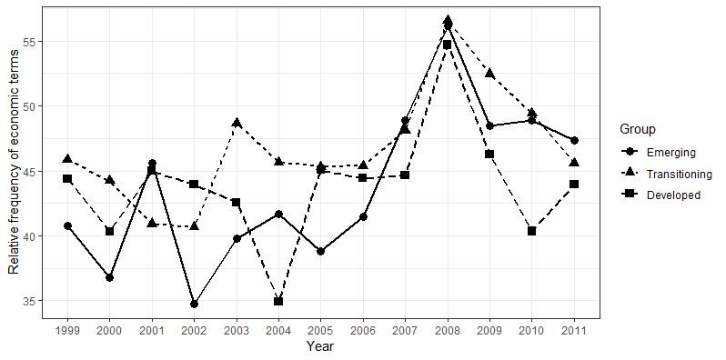
Figure A2. Relative share of words related to “Fiscal” per year 1999-2012
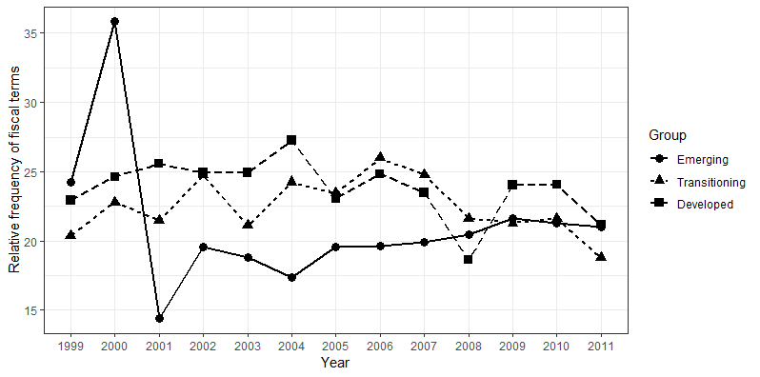

Figure A3. Relative share of words related to “Politics” per year 1999-2012
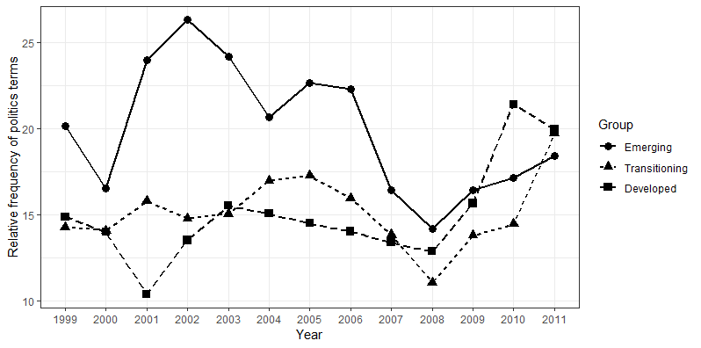
Figure A4. Relative share of words related to “Policy” per year 1999-2012
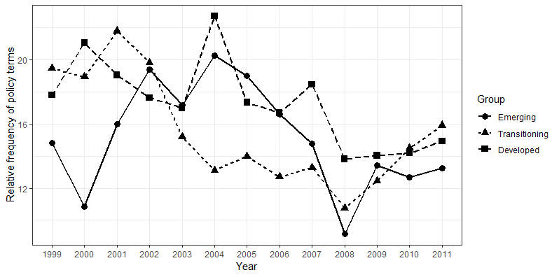
Figure A5: Boxplots of politics as a share of terms (excluding neutral) by country
Figure A6: Boxplots of politics as a share of terms (excluding neutral) by country

Models for economics and fiscal terms
Table A2. Results of the Linear Mixed Effects Models for economics and fiscal terms

 | Dependent variable
 | Economics | Fiscal
Fixed effects:
Country groups¹ (base: Developed)
Transitioning | 0.024  (0.026) | -0.018  (0.014)
Emerging | -0.026  (0.029) | -0.055***  (0.016)
Period² (base: Before crisis )
Onset of crisis | 0.041**  (0.131) | -0.020*  (0.010)
After onset of crisis | 0.002  (0.015) | -0.036***  (0.010)
Interaction: Group*Period (base: Developed*Before crisis)
Transition*Onset of crisis | 0.038  (0.020) | 0.006  (0.014)
Emerging*Onset of crisis | 0.079***  (0.022) | 0.036*  (0.016)
Transition*After crisis | 0.020  (0.019) | -0.005  (0.013)
Emerging*After crisis | 0.067**  (0.022) | 0.051**  (0.016)
Word count of report | 0.000  (0.000) | 0.000  (0.000)
Random effects: | Variance | Variance
Country | 0.004 | 0.001
Residuals | 0.007 | 0.003
Pseudo R-squared
Marginal (for fixed effects) | 0.116 | 0.079
Conditional (for entire model) | 0.454 | 0.284
*** p<0.001, ** p<0.01, * p<0.05 ¹ Country groups are developed/transitioning/emerging. ² Periods are before/during/after the financial crisis. Coefficients are unstandardized. Standard errors are in parentheses. P-values are estimated using the Satterthwaite approximation. Analysis includes 635 reports across 40 countries.

Estimated marginal means for politics and policy
Table A3. Estimated marginal means based on Models 2 and 4 in Table 2
The confidence intervals presented here are those displayed in Figures 3 and 4 in the article. Degrees of Freedom are calculated using the Kenward-Roger method.
 | Politics
 | Country group | Estimated marginal mean | Standard error | Degrees of freedom | 95% confidence interval lower bound | 95% confidence interval upper bound
Before crisis | Developed | 0.140 | 0.009 | 50.0 | 0.121 | 0.159
 | Transitioning | 0.152 | 0.011 | 39.5 | 0.130 | 0.174
 | Emerging | 0.226 | 0.013 | 56.5 | 0.199 | 0.252
Onset of crisis | Developed | 0.155 | 0.011 | 103.3 | 0.133 | 0.178
 | Transitioning | 0.122 | 0.013 | 71.7 | 0.097 | 0.147
 | Emerging | 0.154 | 0.014 | 77.8 | 0.126 | 0.183
After onset of crisis | Developed | 0.208 | 0.011 | 87.4 | 0.186 | 0.229
 | Transitioning | 0.180 | 0.013 | 75.7 | 0.155 | 0.206
 | Emerging | 0.181 | 0.015 | 92.2 | 0.152 | 0.210
 | Policy
 | Country group | Estimated marginal mean | Standard error | Degrees of freedom | 95% confidence interval lower bound | 95% confidence interval upper bound
Before crisis | Developed | 0.181 | 0.009 | 51.0 | 0.163 | 0.199
 | Transitioning | 0.163 | 0.010 | 39.8 | 0.142 | 0.183
 | Emerging | 0.174 | 0.013 | 57.5 | 0.148 | 0.199
Onset of crisis | Developed | 0.145 | 0.011 | 109.3 | 0.123 | 0.167
 | Transitioning | 0.126 | 0.012 | 74.7 | 0.102 | 0.150
 | Emerging | 0.110 | 0.014 | 81.0 | 0.083 | 0.138
After onset of crisis | Developed | 0.148 | 0.010 | 91.8 | 0.127 | 0.168
 | Transitioning | 0.154 | 0.012 | 79.2 | 0.129 | 0.178
 | Emerging | 0.136 | 0.014 | 97.1 | 0.108 | 0.165

Models for using absolute word count as dependent variable
Table A4. Results of the Linear Mixed Effects Models measuring the dependent variable through absolute word count

 | Dependent variable
 | Politics | Policy | Economics | Fiscal
Fixed effects:
Country groups¹ (base: Developed)
Transitioning | 0.581  (1.92) | -2.12  (1.53) | 0.275  (3.05) | -2.27  (1.43)
Emerging | 9.11***  (2.14) | -0.656  (1.75) | -3.51  (3.43) | -4.85**  (1.65)
Period² (base: Before crisis )
Onset of crisis | 0.751  (1.02) | -4.20***  (1.11) | 0.277  (1.78) | -2.00  (1.13)
After onset of crisis | 4.16***  (1.05) | -6.10***  (1.14) | -10.2***  (1.82) | -7.01***  (1.16)
Interaction: Group*Period (base: Developed*Before crisis)
Transition*Onset of crisis | -2.99*  (1.44) | 1.20  (1.56) | 6.50**  (2.49) | 1.85  (1.60)
Emerging*Onset of crisis | -7.95***  (1.60) | -2.26  (1.74) | 10.9***  (2.77) | 2.98  (1.77)
Transition*After crisis | -1.72  (1.33) | 5.08***  (1.45) | 10.1***  (2.31) | 1.61  (1.48)
Emerging*After crisis | -9.15***  (1.60) | 2.04  (1.73) | 18.1***  (2.78) | 7.10***  (1.76)
Word count of report | 0.059***  (0.003) | 0.054***  (0.003) | 0.192***  (0.005) | 0.087***  (0.003)
Random effects: | Variance | Variance | Variance | Variance
Country | 22.64 | 12.2 | 55.7 | 9.88
Residuals | 33.97 | 40.4 | 102.3 | 42.14
Pseudo R-squared
Marginal (for fixed effects) | 0.485 | 0.320 | 0.704 | 0.555
Conditional (for entire model) | 0.691 | 0.478 | 0.808 | 0.640
*** p<0.001, ** p<0.01, * p<0.05 ¹ Country groups are developed/transitioning/emerging. ² Periods are before/during/after the financial crisis. Coefficients are unstandardized. Standard errors are in parentheses. P-values are estimated using the Satterthwaite approximation. Analysis includes 635 reports across 40 countries.

Figure A7 . : Percentage of economics terms by time period and country groups, 1999-2012 (Estimated marginal means based on economics model above)
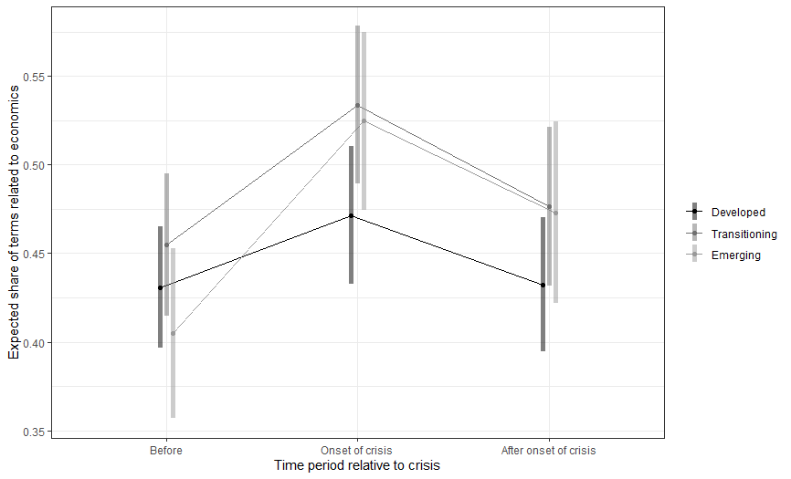
Figure A8: Percentage of fiscal terms by time period and country groups, 1999-2012 (Estimated marginal means based on fiscal model above)
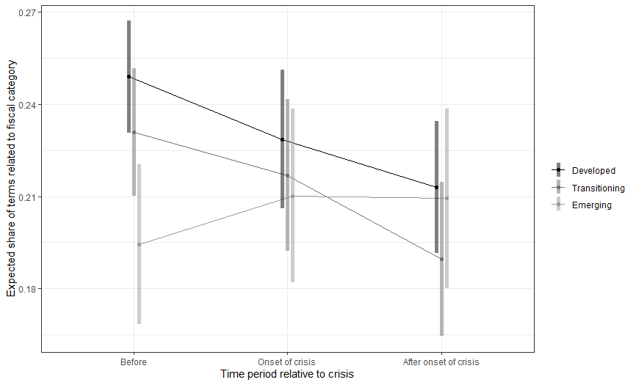

Models including neutral terms

We do not detect any variation in the share of neutral terms across the variables of interest, as shown in Figure A8-A10 below. Therefore, we calculated shares for the main analysis excluding neutral words. The analysis below replicates our analysis in the paper, but the dependent variables are calculated as a share of all terms analyzed including neutral terms. The substantive results are largely similar and the major conclusions of the paper are supported.

Figure A9: Boxplots of share of neutral terms by country group

Figure A10: Boxplots of share of neutral terms by rating
Figure A11: Boxplots of share of neutral terms by time period

Table A5. Results of the Linear Mixed Effects Models including neutral terms when calculating shares

 | Dependent variable
 | Politics | Policy | Economics | Fiscal
Fixed effects:
Country groups¹ (base: Developed)
Transitioning | 0.002  (0.005) | -0.009  (0.005) | 0.000  (0.009) | -0.009  (0.005)
Emerging | 0.032***  (0.006) | -0.004  (0.006) | -0.013  (0.011) | -0.022***  (0.006)
Period² (base: Before crisis )
Onset of crisis | 0.002  (0.003) | -0.018***  (0.004) | 0.004  (0.006) | -0.013**  (0.004)
After onset of crisis | 0.013***  (0.004) | -0.022***  (0.003) | -0.032**  (0.006) | -0.027***  (0.004)
Interaction: Group*Period (base: Developed*Before crisis)
Transition*Onset of crisis | -0.012*  (0.005) | 0.004  (0.005) | 0.024**  (0.008) | 0.009  (0.006)
Emerging*Onset of crisis | -0.029***  (0.005) | -0.007  (0.006) | 0.038***  (0.009) | 0.018**  (0.006)
Transition*After crisis | -0.007  (0.004) | 0.015**  (0.005) | 0.029***  (0.008) | 0.008  (0.005)
Emerging*After crisis | -0.032***  (0.0.005) | 0.006  (0.006) | 0.049***  (0.009) | 0.031***  (0.006)
Word count of report | -0.000  (0.000) | -0.000  (0.000) | 0.000  (0.000) | 0.000  (0.000)
Random effects: | Variance | Variance | Variance | Variance
Country | 0.0001 | 0.0001 | 0.0005 | 0.197
Residuals | 0.0003 | 0.0005 | 0.0011 | 0.728
Pseudo R-squared
Marginal (for fixed effects) | 0.174 | 0.119 | 0.126 | 0.105
Conditional (for entire model) | 0.437 | 0.346 | 0.414 | 0.295
*** p<0.001, ** p<0.01, * p<0.05 ¹ Country groups are developed/transitioning/emerging. ² Periods are before/during/after the financial crisis. Coefficients are unstandardized. Standard errors are in parentheses. P-values are estimated using the Satterthwaite approximation. Analysis includes 635 reports across 40 countries. We did not control for length of report in these models.

Test for variation within the Eurozone group
The results in paper detect increased focus on politics within developed countries. In the context of the Eurozone crisis, we examine whether the effect is driven by periphery countries within the EU. We detect no meaningful difference between Eurozone core and periphery countries. Therefore the heightened attention to politics within developed countries is broader than specific reactions to the Eurozone crisis in periphery countries. This robustness check reinforces the clear finding that discussion of politics escalated in developed countries after the crisis.

Table A6. Results of the Linear Mixed Effects Models for Eurozone countries
Comparing Core and Periphery
 | Dependent variable
 | Politics | Policy
Fixed effects:
Country groups¹ (base: Core)
Periphery | -0.031*  (0.012) | -0.016  (0.019)
Period² (base: Before crisis )
Onset of crisis | -0.018  (0.014) | -0.085***  (0.016)
After onset of crisis | 0.057***  (0.013) | -0.051***  (0.015)
Interaction: Group*Period (base: Core*Before crisis)
Periphery*Onset of crisis | 0.034  (0.018) | 0.049*  (0.020)
Periphery*After crisis | -0.001  (0.015) | 0.049  (0.020)
Word count of report | -0.000  (0.000) | -0.000  (0.000)
Random effects: | Variance | Variance
Country | 0.0003 | 0.0010
Residuals | 0.0019 | 0.0025
Pseudo R-squared
Marginal (for fixed effects) | 0.232 | 0.203
Conditional (for entire model) | 0.321 | 0.433
*** p<0.001, ** p<0.01, * p<0.05 Country groups are core/periphery as defined below. Periods are before/during/after the financial crisis. Coefficients are unstandardized. Standard errors are in parentheses. P-values are estimated using the Satterthwaite approximation. The analysis is based on 220 reports across 17 countries.
Core Eurozone countries: Austria, Belgium, Finland, France, Germany, Luxemburg, the Netherlands
Periphery Eurozone countries: Spain, Portugal, Italy, Greece, Slovenia, Slovakia, Estonia, Latvia, Lithuania, Cyprus, Malta, Ireland
Figure A12: Percentage of politics terms by time period and country groups, 1999-2012 (Estimated marginal means based on politics model for Eurozone countries)
Figure A13: Percentage of policy terms by time period and country groups, 1999-2012 (Estimated marginal means based on politics model for Eurozone countries)

Descriptive statistics for politics and policy terms by rating decision
We also check whether frequency of politics and policy terms varies by rating decision. We do not detect any meaningful variation across rating decisions for either variable.
Figure A14: Boxplots of share of politics terms by rating decision
Figure A15: Boxplots of share of policy terms by rating decision

Model diagnostics from main models in paper
Figure A16. Residual plot for politics model
Figure A17: Q-Q plot of residuals for politics model

Figure A18: Residual plot for policy model
Figure A19: Q-Q plot for residuals for policy model

Detailed list of categories of words
Table A7. List of words in S&P’s credit rating reports (no stop words, top 97 per cent according to frequency)
Economic | Fiscal | Politics | Policy | Neutral
account | accumulated | accession | adopt | ability
accounts | accumulation | administration | adopted | able
activity | asset | administrative | adoption | absence
balance | assets | agenda | aging | absorb
balanced | bond | agreement | ambitious | accelerate
balanceofpayments | bonds | arrangement | assistance | accelerated
balances | borrowing | authorities | austerity | acceleration
bank | budget | bilateral | benefit | access
banking | budgetary | coalition | benefits | accompanied
banks | budgets | consensus | challenge | accordance
boom | consolidate | consensusbased | challenges | according
buoyant | consolidation | constitutional | challenging | accordingly
business | correction | coordination | commitment | achieve
capita | credit | corruption | committed | achieved
capital | creditor | deal | credibility | achieving
cash | creditors | decision | credible | across
commercial | debt | decisionmaking | cut | action
companies | debtor | ecb | cuts | actions
competitive | debttogdp | election | demographic | added
competitiveness | default | elections | effort | addition
confidence | deficit | emu | efforts | additional
construction | deficits | federal | fail | address
consumer | discipline | federation | fails | addressed
consumption | distress | governance | failure | addressing
contract | expenditure | governing | guarantee | adjust
contraction | expenditures | government | guarantees | adjusted
convergence | fiscal | governments | housing | adjustment
corporate | fund | imf | implement | adjustments
cost | funding | independence | implementation | adverse
costs | funds | independent | implemented | affect
crisis | imbalances | institutional | implementing | affected
currency | indebtedness | institutions | labor | affirm
cycle | lending | law | liberalization | affirmation
cyclical | liabilities | legal | package | affirmed
deleveraging | liability | legislation | pension | affirming
demand | loosening | majority | pensions | agreed
deposit | maastricht | member | pillar | ahead
deposits | maturing | members | policies | aim
depreciation | maturity | minister | policy | aimed
disinflation | oneoff | negotiations | policymakers | aims
disposable | prudence | opposition | policymaking | albeit
diversification | prudent | parliament | poor | allow
diversified | rebalancing | parliamentary | privatesector | almost
diversity | receipts | participation | privatization | alone
domestic | refinancing | parties | proactive | along
downturn | reserve | party | program | alongside
dynamic | reserves | political | programs | already
dynamics | revenue | politically | progress | also
economic | revenues | power | public | although
economies | rollover | predictability | publicsector | amid
economy | servicing | presidential | reform | among
economys | slippage | referendum | reforming | amount
employment | slippages | regime | reforms | ample
energy | spending | state | regulatory | analysis
enterprises | spread | summit | resolute | anchor
exchange | stabilization | talks | resolution | andor
export | stabilize | tensions | resolve | announced
exportoriented | standby | union | restraint | annual
exports | subsidies | will | retirement | annually
exposure | surplus | willingness | rigidities | another
external | surpluses |  | social | anticipate
fdi | sustain |  | stateowned | anticipated
finance | sustainability |  | structural | aplus
financed | sustainable |  | tax | appears
finances | tight |  | taxes | approach
financial | tighten |  | transfer | appropriate
financing | tightening |  | transfers | approved
flexibility | trajectory |  | unsustainable | april
flexible |  |  | vat | areas
foreigncurrency |  |  | wage | around
gain |  |  | wages | arrears
gains |  |  | welfare | assessment
gdp |  |  |  | assigned
goods |  |  |  | associated
gross |  |  |  | assumes
grow |  |  |  | assuming
growing |  |  |  | assumption
growth |  |  |  | assumptions
household |  |  |  | aug
households |  |  |  | availability
imbalances |  |  |  | available
imports |  |  |  | average
income |  |  |  | averaged
incomes |  |  |  | averaging
industrial |  |  |  | back
inefficient |  |  |  | backdrop
inflation |  |  |  | background
inflationary |  |  |  | base
inflows |  |  |  | basecase
infrastructure |  |  |  | based
integrated |  |  |  | baseline
integration |  |  |  | basis
interbank |  |  |  | bbb
interest |  |  |  | bbba
interests |  |  |  | become
investment |  |  |  | becoming
investor |  |  |  | begin
investors |  |  |  | beginning
leverage |  |  |  | begun
liquid |  |  |  | behind
liquidity |  |  |  | believe
loss |  |  |  | better
losses |  |  |  | beyond
lossmaking |  |  |  | bill
macroeconomic |  |  |  | billion
manufacturing |  |  |  | board
market |  |  |  | bolster
marketbased |  |  |  | boost
markets |  |  |  | bring
modern |  |  |  | bringing
modernization |  |  |  | broad
monetary |  |  |  | broadening
mortgage |  |  |  | broadly
nominal |  |  |  | brought
nonperforming |  |  |  | buffer
nonresident |  |  |  | buffers
nonresidents |  |  |  | build
oil |  |  |  | burden
outflows |  |  |  | burdens
output |  |  |  | called
overheating |  |  |  | can
parent |  |  |  | capacity
peg |  |  |  | care
performance |  |  |  | cars
portfolio |  |  |  | case
price |  |  |  | category
prices |  |  |  | cause
private |  |  |  | central
product |  |  |  | chance
productivity |  |  |  | change
profile |  |  |  | changes
profitability |  |  |  | characterized
property |  |  |  | check
prosperity |  |  |  | clear
prosperous |  |  |  | close
rates |  |  |  | closely
recapitalization |  |  |  | collection
recapitalize |  |  |  | combined
recession |  |  |  | come
recover |  |  |  | coming
recovers |  |  |  | comparatively
recovery |  |  |  | compared
resilience |  |  |  | compares
resilient |  |  |  | completion
resources |  |  |  | comprehensive
restructuring |  |  |  | con
risk |  |  |  | concern
risks |  |  |  | concerns
robust |  |  |  | conclude
savings |  |  |  | concluded
securities |  |  |  | conditions
security |  |  |  | consequence
service |  |  |  | consequences
services |  |  |  | consequently
severe |  |  |  | conservative
severely |  |  |  | consider
shocks |  |  |  | considerable
slowdown |  |  |  | considerably
subsidiaries |  |  |  | consistent
supply |  |  |  | constrain
technology |  |  |  | constrained
tourism |  |  |  | constraining
trade |  |  |  | constraint
trading |  |  |  | constraints
unemployment |  |  |  | contain
value |  |  |  | context
valueadded |  |  |  | contingent
vulnerabilities |  |  |  | continuation
vulnerability |  |  |  | continue
vulnerable |  |  |  | continued
wealth |  |  |  | continues
wealthy |  |  |  | continuing
workforce |  |  |  | contrast
 |  |  |  | contribute
 |  |  |  | contributed
 |  |  |  | contribution
 |  |  |  | contributions
 |  |  |  | control
 |  |  |  | controlling
 |  |  |  | conversely
 |  |  |  | convertibility
 |  |  |  | core
 |  |  |  | correcting
 |  |  |  | countries
 |  |  |  | country
 |  |  |  | countrys
 |  |  |  | coupled
 |  |  |  | course
 |  |  |  | cover
 |  |  |  | coverage
 |  |  |  | covered
 |  |  |  | create
 |  |  |  | creating
 |  |  |  | creation
 |  |  |  | creditwatch
 |  |  |  | creditworthiness
 |  |  |  | criteria
 |  |  |  | critical
 |  |  |  | crossborder
 |  |  |  | crucial
 |  |  |  | cumulative
 |  |  |  | current
 |  |  |  | currently
 |  |  |  | cushion
 |  |  |  | cyprus
 |  |  |  | data
 |  |  |  | date
 |  |  |  | dec
 |  |  |  | decade
 |  |  |  | december
 |  |  |  | decline
 |  |  |  | declined
 |  |  |  | declining
 |  |  |  | decrease
 |  |  |  | deepening
 |  |  |  | degree
 |  |  |  | delay
 |  |  |  | delayed
 |  |  |  | delays
 |  |  |  | demonstrated
 |  |  |  | denominated
 |  |  |  | depend
 |  |  |  | dependence
 |  |  |  | dependent
 |  |  |  | despite
 |  |  |  | details
 |  |  |  | deteriorate
 |  |  |  | deteriorates
 |  |  |  | deteriorating
 |  |  |  | deterioration
 |  |  |  | development
 |  |  |  | developments
 |  |  |  | difficult
 |  |  |  | difficulties
 |  |  |  | direct
 |  |  |  | double
 |  |  |  | downgrade
 |  |  |  | downside
 |  |  |  | downward
 |  |  |  | drive
 |  |  |  | driven
 |  |  |  | driver
 |  |  |  | due
 |  |  |  | earlier
 |  |  |  | early
 |  |  |  | ease
 |  |  |  | easing
 |  |  |  | effect
 |  |  |  | effective
 |  |  |  | effectively
 |  |  |  | effectiveness
 |  |  |  | effects
 |  |  |  | efficient
 |  |  |  | either
 |  |  |  | emanating
 |  |  |  | enable
 |  |  |  | end
 |  |  |  | enjoy
 |  |  |  | enough
 |  |  |  | ensure
 |  |  |  | entities
 |  |  |  | entry
 |  |  |  | environment
 |  |  |  | equal
 |  |  |  | equity
 |  |  |  | equivalent
 |  |  |  | eroding
 |  |  |  | especially
 |  |  |  | essential
 |  |  |  | established
 |  |  |  | estimate
 |  |  |  | estimated
 |  |  |  | estimates
 |  |  |  | estonia
 |  |  |  | estonias
 |  |  |  | euro
 |  |  |  | europe
 |  |  |  | european
 |  |  |  | euros
 |  |  |  | eurozone
 |  |  |  | eurozones
 |  |  |  | even
 |  |  |  | event
 |  |  |  | eventually
 |  |  |  | evidenced
 |  |  |  | exacerbated
 |  |  |  | example
 |  |  |  | exceed
 |  |  |  | excess
 |  |  |  | excluding
 |  |  |  | existing
 |  |  |  | expand
 |  |  |  | expansion
 |  |  |  | expansionary
 |  |  |  | expect
 |  |  |  | expectation
 |  |  |  | expectations
 |  |  |  | expected
 |  |  |  | expects
 |  |  |  | extend
 |  |  |  | extended
 |  |  |  | extent
 |  |  |  | extremely
 |  |  |  | face
 |  |  |  | faces
 |  |  |  | facilitate
 |  |  |  | facing
 |  |  |  | fact
 |  |  |  | factor
 |  |  |  | factors
 |  |  |  | fall
 |  |  |  | falling
 |  |  |  | falls
 |  |  |  | far
 |  |  |  | fast
 |  |  |  | faster
 |  |  |  | favor
 |  |  |  | favorable
 |  |  |  | feb
 |  |  |  | figure
 |  |  |  | finland
 |  |  |  | first
 |  |  |  | five
 |  |  |  | fixed
 |  |  |  | flows
 |  |  |  | focus
 |  |  |  | follow
 |  |  |  | following
 |  |  |  | footing
 |  |  |  | force
 |  |  |  | forecast
 |  |  |  | forecasts
 |  |  |  | foreign
 |  |  |  | foreseeable
 |  |  |  | form
 |  |  |  | forward
 |  |  |  | four
 |  |  |  | fragile
 |  |  |  | framework
 |  |  |  | full
 |  |  |  | fully
 |  |  |  | furthermore
 |  |  |  | future
 |  |  |  | gap
 |  |  |  | gas
 |  |  |  | general
 |  |  |  | generate
 |  |  |  | germany
 |  |  |  | given
 |  |  |  | global
 |  |  |  | going
 |  |  |  | good
 |  |  |  | gradual
 |  |  |  | gradually
 |  |  |  | greater
 |  |  |  | greece
 |  |  |  | greeces
 |  |  |  | greek
 |  |  |  | half
 |  |  |  | hand
 |  |  |  | hard
 |  |  |  | health
 |  |  |  | healthy
 |  |  |  | heavily
 |  |  |  | heavy
 |  |  |  | heightened
 |  |  |  | held
 |  |  |  | hellenic
 |  |  |  | help
 |  |  |  | helped
 |  |  |  | high
 |  |  |  | higher
 |  |  |  | higherrated
 |  |  |  | highest
 |  |  |  | highly
 |  |  |  | hikes
 |  |  |  | holders
 |  |  |  | holdings
 |  |  |  | horizon
 |  |  |  | however
 |  |  |  | hungary
 |  |  |  | hungarys
 |  |  |  | iceland
 |  |  |  | icelandic
 |  |  |  | icelands
 |  |  |  | immediate
 |  |  |  | impact
 |  |  |  | implications
 |  |  |  | important
 |  |  |  | improve
 |  |  |  | improved
 |  |  |  | improvement
 |  |  |  | improvements
 |  |  |  | improves
 |  |  |  | improving
 |  |  |  | include
 |  |  |  | includes
 |  |  |  | including
 |  |  |  | increase
 |  |  |  | increased
 |  |  |  | increases
 |  |  |  | increasing
 |  |  |  | increasingly
 |  |  |  | indicates
 |  |  |  | indicating
 |  |  |  | indicators
 |  |  |  | influence
 |  |  |  | information
 |  |  |  | inherent
 |  |  |  | initial
 |  |  |  | injections
 |  |  |  | insufficient
 |  |  |  | intends
 |  |  |  | international
 |  |  |  | ireland
 |  |  |  | irelands
 |  |  |  | issuance
 |  |  |  | issue
 |  |  |  | issued
 |  |  |  | issuer
 |  |  |  | issues
 |  |  |  | italy
 |  |  |  | jan
 |  |  |  | january
 |  |  |  | jeopardize
 |  |  |  | join
 |  |  |  | july
 |  |  |  | june
 |  |  |  | just
 |  |  |  | keep
 |  |  |  | key
 |  |  |  | kingdom
 |  |  |  | lack
 |  |  |  | landing
 |  |  |  | large
 |  |  |  | largely
 |  |  |  | larger
 |  |  |  | largest
 |  |  |  | last
 |  |  |  | lasting
 |  |  |  | late
 |  |  |  | later
 |  |  |  | latter
 |  |  |  | latvia
 |  |  |  | latvias
 |  |  |  | lead
 |  |  |  | leading
 |  |  |  | leads
 |  |  |  | least
 |  |  |  | led
 |  |  |  | less
 |  |  |  | level
 |  |  |  | levels
 |  |  |  | light
 |  |  |  | likelihood
 |  |  |  | likely
 |  |  |  | limit
 |  |  |  | limited
 |  |  |  | limits
 |  |  |  | line
 |  |  |  | linked
 |  |  |  | lithuania
 |  |  |  | lithuanias
 |  |  |  | little
 |  |  |  | loan
 |  |  |  | loans
 |  |  |  | local
 |  |  |  | long
 |  |  |  | longand
 |  |  |  | longer
 |  |  |  | longerterm
 |  |  |  | longstanding
 |  |  |  | longterm
 |  |  |  | low
 |  |  |  | lower
 |  |  |  | lowered
 |  |  |  | lowering
 |  |  |  | lowest
 |  |  |  | made
 |  |  |  | main
 |  |  |  | mainly
 |  |  |  | maintain
 |  |  |  | maintained
 |  |  |  | maintaining
 |  |  |  | major
 |  |  |  | make
 |  |  |  | makes
 |  |  |  | making
 |  |  |  | manage
 |  |  |  | managed
 |  |  |  | management
 |  |  |  | manner
 |  |  |  | many
 |  |  |  | march
 |  |  |  | markedly
 |  |  |  | material
 |  |  |  | materialize
 |  |  |  | may
 |  |  |  | means
 |  |  |  | meanwhile
 |  |  |  | measures
 |  |  |  | mechanism
 |  |  |  | median
 |  |  |  | medium
 |  |  |  | mediumterm
 |  |  |  | meet
 |  |  |  | meeting
 |  |  |  | membership
 |  |  |  | methodology
 |  |  |  | mid
 |  |  |  | might
 |  |  |  | million
 |  |  |  | mitigate
 |  |  |  | mitigated
 |  |  |  | mitigating
 |  |  |  | mix
 |  |  |  | moderate
 |  |  |  | moderation
 |  |  |  | modest
 |  |  |  | momentum
 |  |  |  | month
 |  |  |  | months
 |  |  |  | moreover
 |  |  |  | mounting
 |  |  |  | move
 |  |  |  | much
 |  |  |  | multilateral
 |  |  |  | narrow
 |  |  |  | narrowing
 |  |  |  | national
 |  |  |  | natural
 |  |  |  | nature
 |  |  |  | near
 |  |  |  | nearly
 |  |  |  | nearterm
 |  |  |  | necessary
 |  |  |  | need
 |  |  |  | needed
 |  |  |  | needs
 |  |  |  | negative
 |  |  |  | net
 |  |  |  | nevertheless
 |  |  |  | new
 |  |  |  | next
 |  |  |  | nonsovereign
 |  |  |  | notch
 |  |  |  | notches
 |  |  |  | note
 |  |  |  | notwithstanding
 |  |  |  | nov
 |  |  |  | november
 |  |  |  | now
 |  |  |  | number
 |  |  |  | obligations
 |  |  |  | occur
 |  |  |  | oct
 |  |  |  | october
 |  |  |  | official
 |  |  |  | offset
 |  |  |  | offsetting
 |  |  |  | one
 |  |  |  | onehalf
 |  |  |  | oneinthree
 |  |  |  | ongoing
 |  |  |  | open
 |  |  |  | operating
 |  |  |  | operational
 |  |  |  | operations
 |  |  |  | opinion
 |  |  |  | optimistic
 |  |  |  | order
 |  |  |  | outcome
 |  |  |  | outcomes
 |  |  |  | outlook
 |  |  |  | outstanding
 |  |  |  | overall
 |  |  |  | owing
 |  |  |  | pace
 |  |  |  | paper
 |  |  |  | part
 |  |  |  | partial
 |  |  |  | particular
 |  |  |  | particularly
 |  |  |  | partly
 |  |  |  | partners
 |  |  |  | past
 |  |  |  | path
 |  |  |  | pay
 |  |  |  | payment
 |  |  |  | payments
 |  |  |  | peak
 |  |  |  | peers
 |  |  |  | persist
 |  |  |  | persistent
 |  |  |  | place
 |  |  |  | placed
 |  |  |  | placement
 |  |  |  | placing
 |  |  |  | planned
 |  |  |  | plans
 |  |  |  | plus
 |  |  |  | point
 |  |  |  | points
 |  |  |  | poland
 |  |  |  | poors
 |  |  |  | population
 |  |  |  | portugal
 |  |  |  | portugals
 |  |  |  | possible
 |  |  |  | possibly
 |  |  |  | post
 |  |  |  | potential
 |  |  |  | potentially
 |  |  |  | present
 |  |  |  | pressure
 |  |  |  | pressures
 |  |  |  | prevent
 |  |  |  | previous
 |  |  |  | previously
 |  |  |  | primarily
 |  |  |  | primary
 |  |  |  | prime
 |  |  |  | principal
 |  |  |  | prior
 |  |  |  | problems
 |  |  |  | proceeds
 |  |  |  | process
 |  |  |  | project
 |  |  |  | projected
 |  |  |  | projections
 |  |  |  | projects
 |  |  |  | prolonged
 |  |  |  | prompted
 |  |  |  | proportion
 |  |  |  | proposed
 |  |  |  | prospect
 |  |  |  | prospects
 |  |  |  | protracted
 |  |  |  | prove
 |  |  |  | provide
 |  |  |  | provided
 |  |  |  | provides
 |  |  |  | providing
 |  |  |  | published
 |  |  |  | pursue
 |  |  |  | push
 |  |  |  | put
 |  |  |  | putting
 |  |  |  | quality
 |  |  |  | quarter
 |  |  |  | quickly
 |  |  |  | raise
 |  |  |  | raised
 |  |  |  | raising
 |  |  |  | range
 |  |  |  | rapid
 |  |  |  | rapidly
 |  |  |  | rate
 |  |  |  | rated
 |  |  |  | rather
 |  |  |  | rating
 |  |  |  | ratings
 |  |  |  | ratingsdirect
 |  |  |  | ratio
 |  |  |  | rationale
 |  |  |  | ratios
 |  |  |  | reach
 |  |  |  | reached
 |  |  |  | reaching
 |  |  |  | real
 |  |  |  | recent
 |  |  |  | recently
 |  |  |  | recognition
 |  |  |  | record
 |  |  |  | reduce
 |  |  |  | reduced
 |  |  |  | reduces
 |  |  |  | reducing
 |  |  |  | reduction
 |  |  |  | reductions
 |  |  |  | reflect
 |  |  |  | reflected
 |  |  |  | reflecting
 |  |  |  | reflects
 |  |  |  | regard
 |  |  |  | regarding
 |  |  |  | region
 |  |  |  | regional
 |  |  |  | related
 |  |  |  | relating
 |  |  |  | relative
 |  |  |  | relatively
 |  |  |  | reliance
 |  |  |  | remain
 |  |  |  | remainder
 |  |  |  | remained
 |  |  |  | remaining
 |  |  |  | remains
 |  |  |  | removed
 |  |  |  | renewed
 |  |  |  | republic
 |  |  |  | republics
 |  |  |  | require
 |  |  |  | required
 |  |  |  | requirement
 |  |  |  | requirements
 |  |  |  | rescue
 |  |  |  | research
 |  |  |  | respectively
 |  |  |  | response
 |  |  |  | responses
 |  |  |  | restore
 |  |  |  | restricting
 |  |  |  | result
 |  |  |  | resulted
 |  |  |  | resulting
 |  |  |  | results
 |  |  |  | return
 |  |  |  | reversal
 |  |  |  | reverse
 |  |  |  | reversing
 |  |  |  | review
 |  |  |  | revise
 |  |  |  | revised
 |  |  |  | revising
 |  |  |  | revision
 |  |  |  | rise
 |  |  |  | risen
 |  |  |  | rising
 |  |  |  | role
 |  |  |  | romania
 |  |  |  | romanias
 |  |  |  | room
 |  |  |  | rule
 |  |  |  | rules
 |  |  |  | run
 |  |  |  | runup
 |  |  |  | russia
 |  |  |  | russian
 |  |  |  | russias
 |  |  |  | said
 |  |  |  | scale
 |  |  |  | scenario
 |  |  |  | scenarios
 |  |  |  | scheduled
 |  |  |  | scope
 |  |  |  | score
 |  |  |  | scores
 |  |  |  | second
 |  |  |  | sector
 |  |  |  | sectors
 |  |  |  | secure
 |  |  |  | see
 |  |  |  | seen
 |  |  |  | senior
 |  |  |  | sensitive
 |  |  |  | sentiment
 |  |  |  | sept
 |  |  |  | september
 |  |  |  | set
 |  |  |  | several
 |  |  |  | share
 |  |  |  | sharp
 |  |  |  | sharply
 |  |  |  | sheet
 |  |  |  | sheets
 |  |  |  | shift
 |  |  |  | short
 |  |  |  | shortterm
 |  |  |  | side
 |  |  |  | significant
 |  |  |  | significantly
 |  |  |  | signs
 |  |  |  | similar
 |  |  |  | similarly
 |  |  |  | since
 |  |  |  | situation
 |  |  |  | sizable
 |  |  |  | size
 |  |  |  | slightly
 |  |  |  | slow
 |  |  |  | slowed
 |  |  |  | slower
 |  |  |  | slowing
 |  |  |  | slowly
 |  |  |  | small
 |  |  |  | socalled
 |  |  |  | solid
 |  |  |  | somewhat
 |  |  |  | soon
 |  |  |  | sound
 |  |  |  | source
 |  |  |  | sources
 |  |  |  | sovereign
 |  |  |  | sovereigns
 |  |  |  | spain
 |  |  |  | specifically
 |  |  |  | stability
 |  |  |  | stabilizing
 |  |  |  | stable
 |  |  |  | stance
 |  |  |  | standard
 |  |  |  | standards
 |  |  |  | standing
 |  |  |  | start
 |  |  |  | started
 |  |  |  | stated
 |  |  |  | statements
 |  |  |  | states
 |  |  |  | status
 |  |  |  | steadily
 |  |  |  | steady
 |  |  |  | stem
 |  |  |  | stemming
 |  |  |  | stems
 |  |  |  | step
 |  |  |  | still
 |  |  |  | stimulus
 |  |  |  | stock
 |  |  |  | strain
 |  |  |  | strategy
 |  |  |  | strength
 |  |  |  | strengthen
 |  |  |  | strengthened
 |  |  |  | strengthening
 |  |  |  | strengths
 |  |  |  | stress
 |  |  |  | strong
 |  |  |  | stronger
 |  |  |  | strongest
 |  |  |  | structure
 |  |  |  | structures
 |  |  |  | subdued
 |  |  |  | subject
 |  |  |  | subsequent
 |  |  |  | substantial
 |  |  |  | substantially
 |  |  |  | success
 |  |  |  | successful
 |  |  |  | successfully
 |  |  |  | sudden
 |  |  |  | suffer
 |  |  |  | sufficient
 |  |  |  | suggest
 |  |  |  | support
 |  |  |  | supported
 |  |  |  | supporting
 |  |  |  | sustained
 |  |  |  | sweden
 |  |  |  | system
 |  |  |  | systems
 |  |  |  | tackle
 |  |  |  | take
 |  |  |  | taken
 |  |  |  | taking
 |  |  |  | target
 |  |  |  | targeted
 |  |  |  | targets
 |  |  |  | temporary
 |  |  |  | term
 |  |  |  | terms
 |  |  |  | thanks
 |  |  |  | thereafter
 |  |  |  | thereby
 |  |  |  | therefore
 |  |  |  | think
 |  |  |  | third
 |  |  |  | though
 |  |  |  | three
 |  |  |  | throughout
 |  |  |  | thus
 |  |  |  | tighter
 |  |  |  | time
 |  |  |  | timely
 |  |  |  | times
 |  |  |  | today
 |  |  |  | together
 |  |  |  | total
 |  |  |  | toward
 |  |  |  | track
 |  |  |  | transition
 |  |  |  | trend
 |  |  |  | trends
 |  |  |  | turkey
 |  |  |  | turkeys
 |  |  |  | turkish
 |  |  |  | turmoil
 |  |  |  | turn
 |  |  |  | two
 |  |  |  | ukraine
 |  |  |  | ukraines
 |  |  |  | ultimately
 |  |  |  | uncertain
 |  |  |  | uncertainties
 |  |  |  | uncertainty
 |  |  |  | unchanged
 |  |  |  | underlying
 |  |  |  | undermine
 |  |  |  | undermined
 |  |  |  | undermining
 |  |  |  | underpin
 |  |  |  | underpinned
 |  |  |  | underpinning
 |  |  |  | underway
 |  |  |  | unless
 |  |  |  | unlikely
 |  |  |  | unsecured
 |  |  |  | unwind
 |  |  |  | upcoming
 |  |  |  | update
 |  |  |  | upgrade
 |  |  |  | upon
 |  |  |  | upward
 |  |  |  | usable
 |  |  |  | use
 |  |  |  | various
 |  |  |  | versus
 |  |  |  | via
 |  |  |  | view
 |  |  |  | virtually
 |  |  |  | way
 |  |  |  | weak
 |  |  |  | weaken
 |  |  |  | weakened
 |  |  |  | weakening
 |  |  |  | weakens
 |  |  |  | weaker
 |  |  |  | weakness
 |  |  |  | weaknesses
 |  |  |  | weather
 |  |  |  | webbased
 |  |  |  | weigh
 |  |  |  | well
 |  |  |  | widen
 |  |  |  | widened
 |  |  |  | widening
 |  |  |  | within
 |  |  |  | without
 |  |  |  | world
 |  |  |  | worsen
 |  |  |  | worsening
 |  |  |  | year
 |  |  |  | yearend
 |  |  |  | years
 |  |  |  | yet

These values are calculated as the percentage of words with each respective coding as a share of the non-neutral number of words.

