Supplementary Materials (Not for Publication)
Figure A1: Interaction between Ancillary and Primary Measures
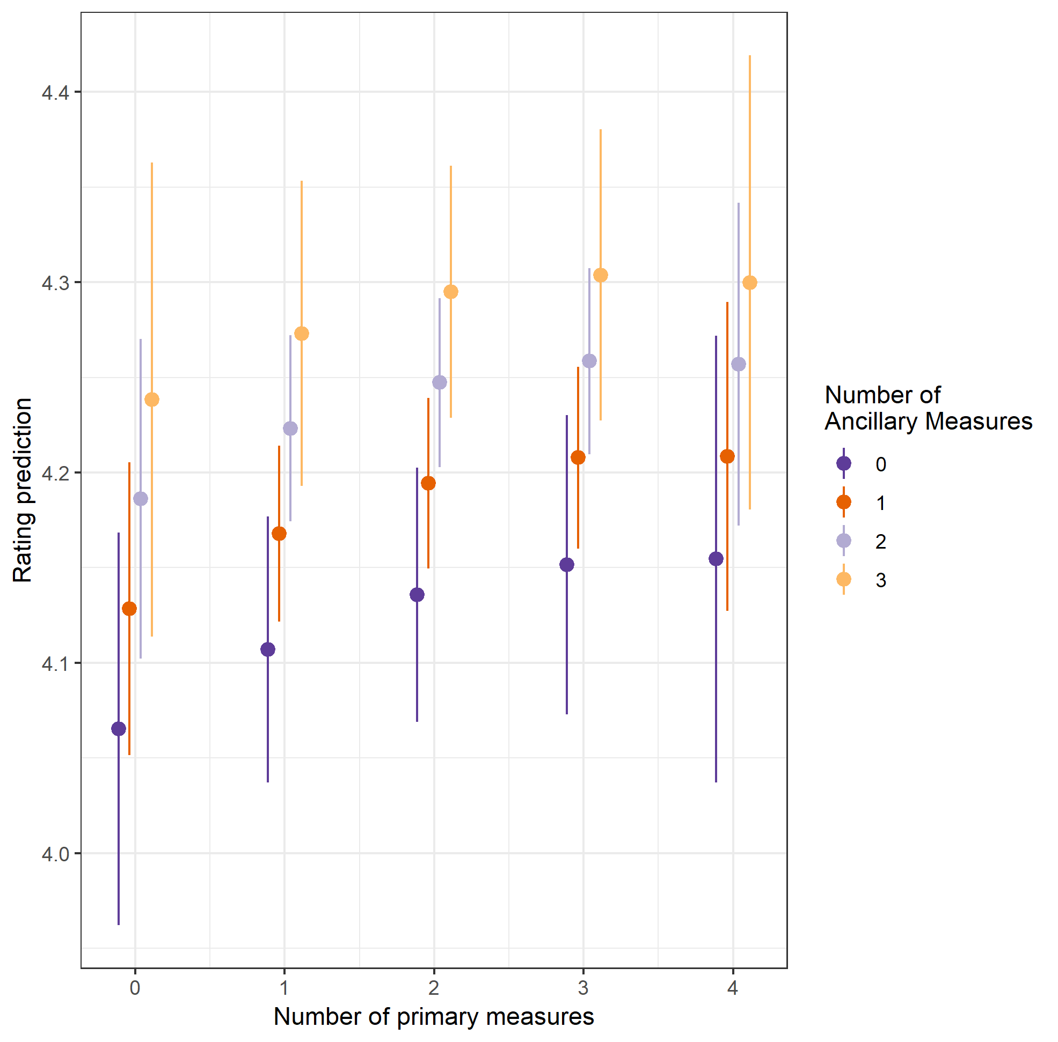

Figure A2: Interaction between Primary and Ancillary Measures
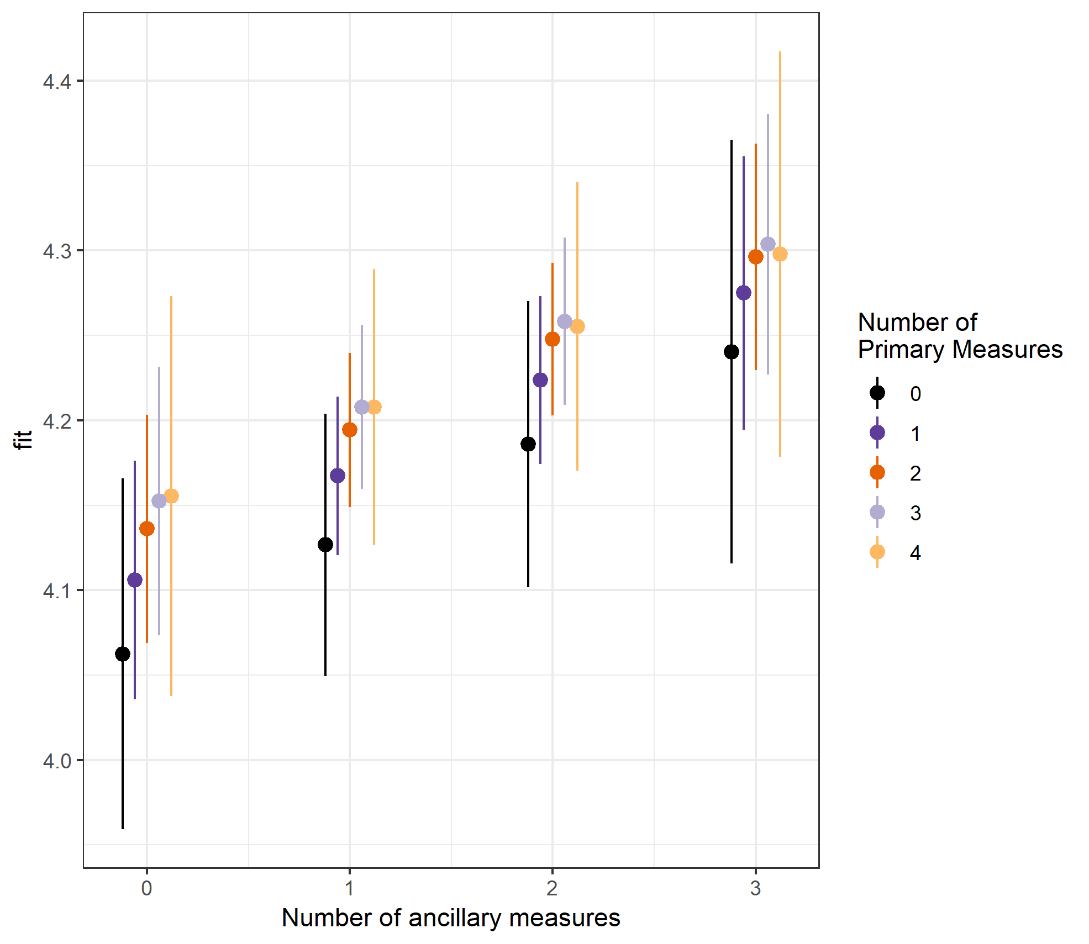

Figure A3: Rating prediction on 7-point scale depending on number of ancillary measures included in the package
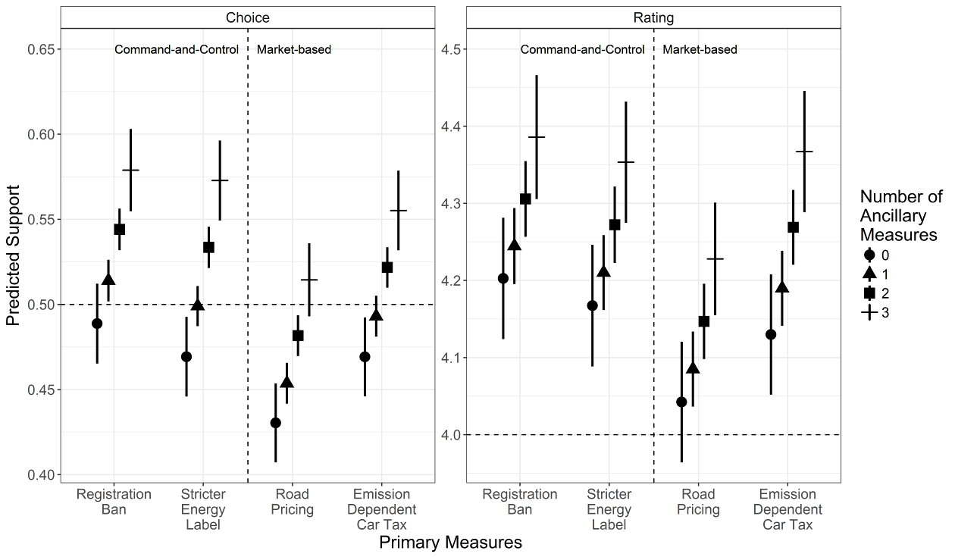

Figure A4: Predicted Rating of policy-packages by primary measures with different ancillary measures included in the package
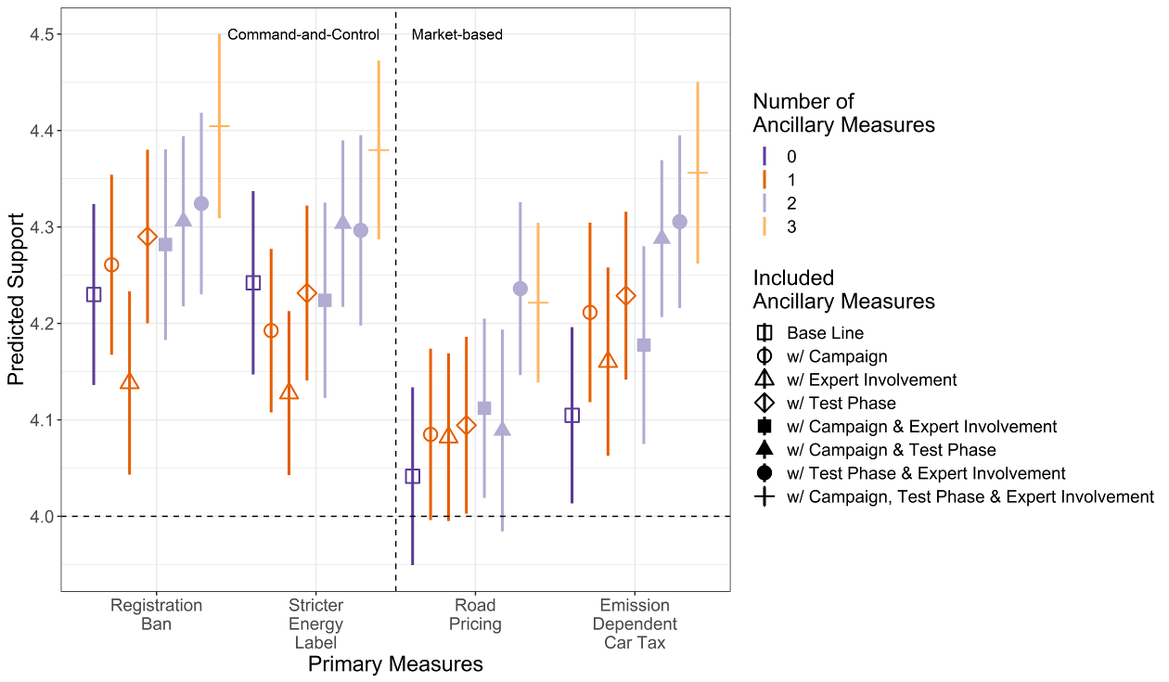

Figure A5: Predicted Choice (margins) of policy-packages by primary measures with different ancillary measures included in the package
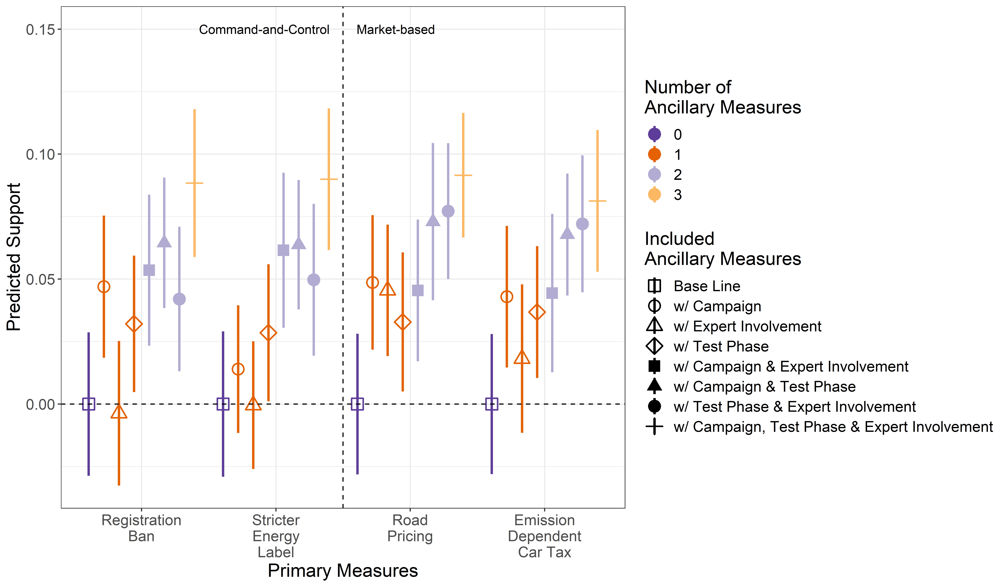

Figure A6: Predicted Rating (margins) of policy-packages by primary measures with different ancillary measures included in the package
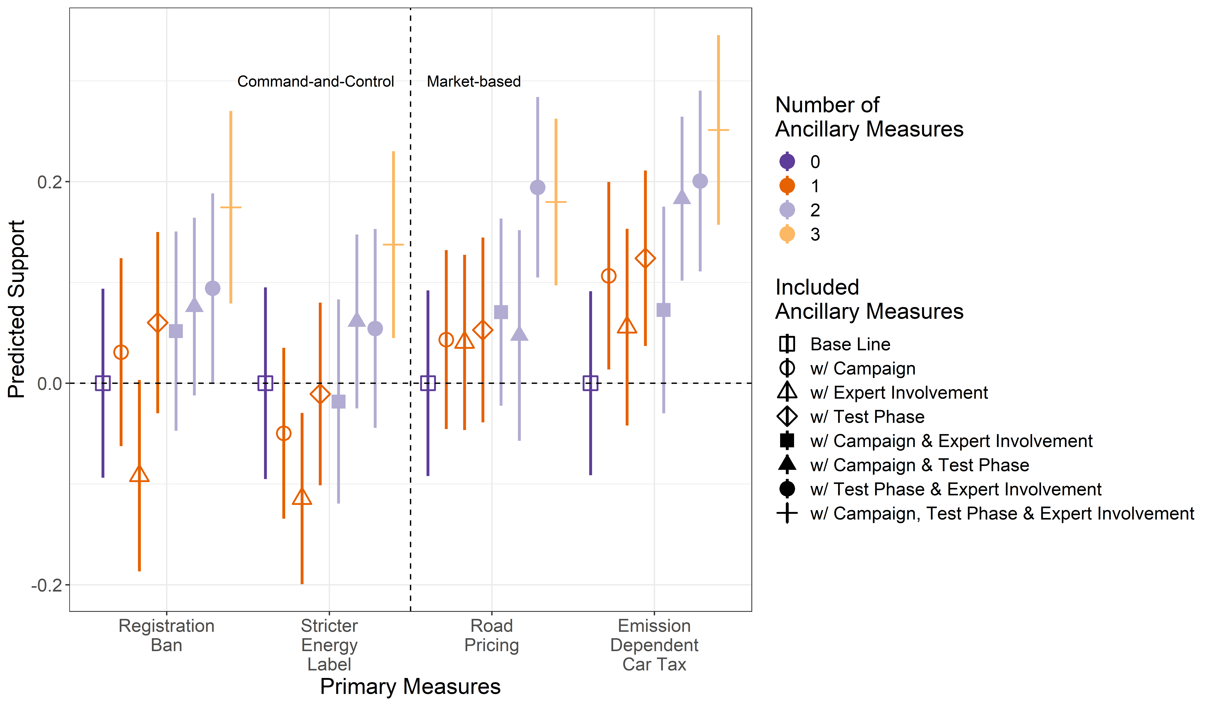

Figure A7: Predicted Choice of policy-packages with different primary measures included in the package
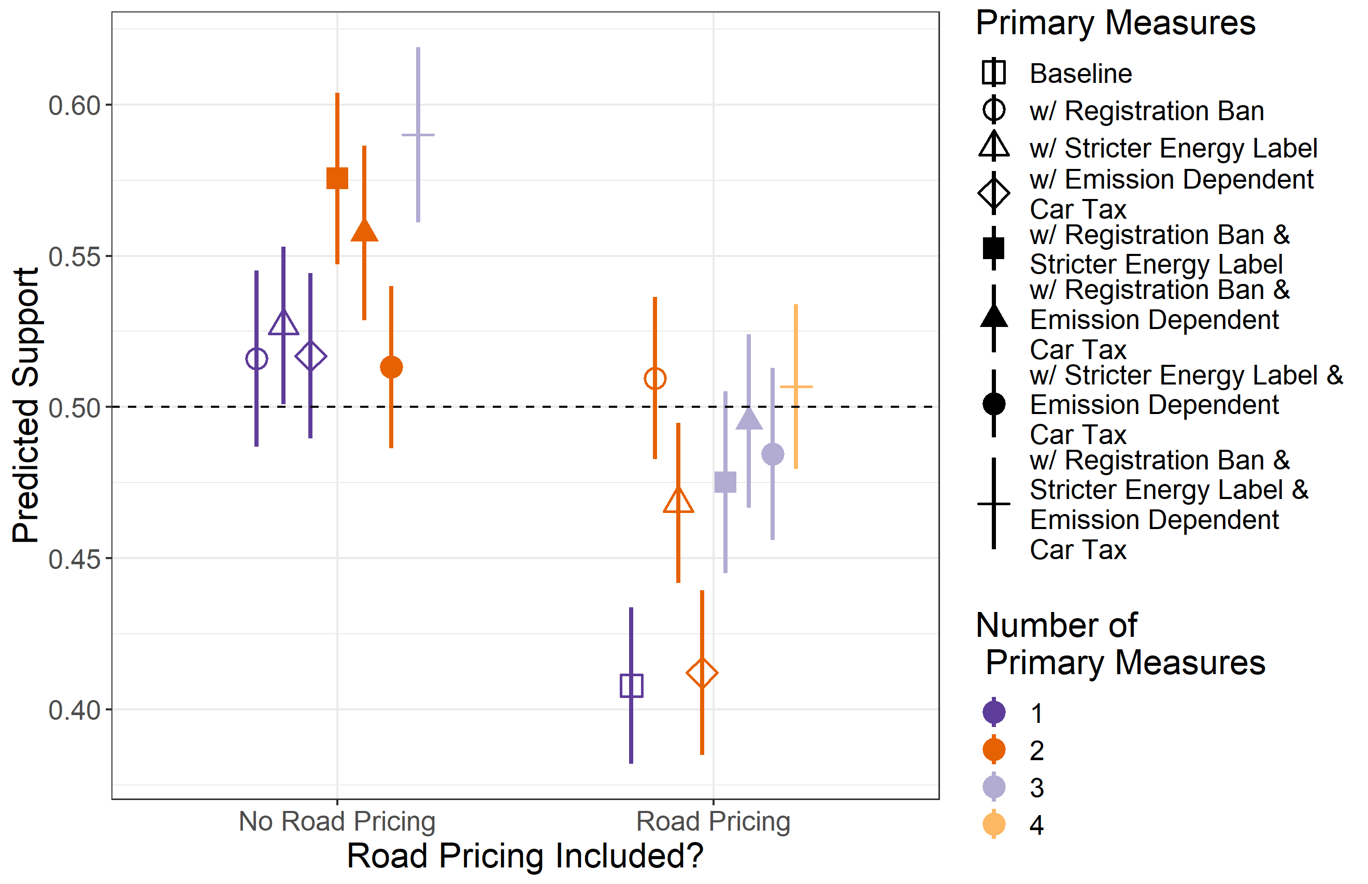

Figure A8: Predicted Rating of policy-packages with different primary measures included in the package
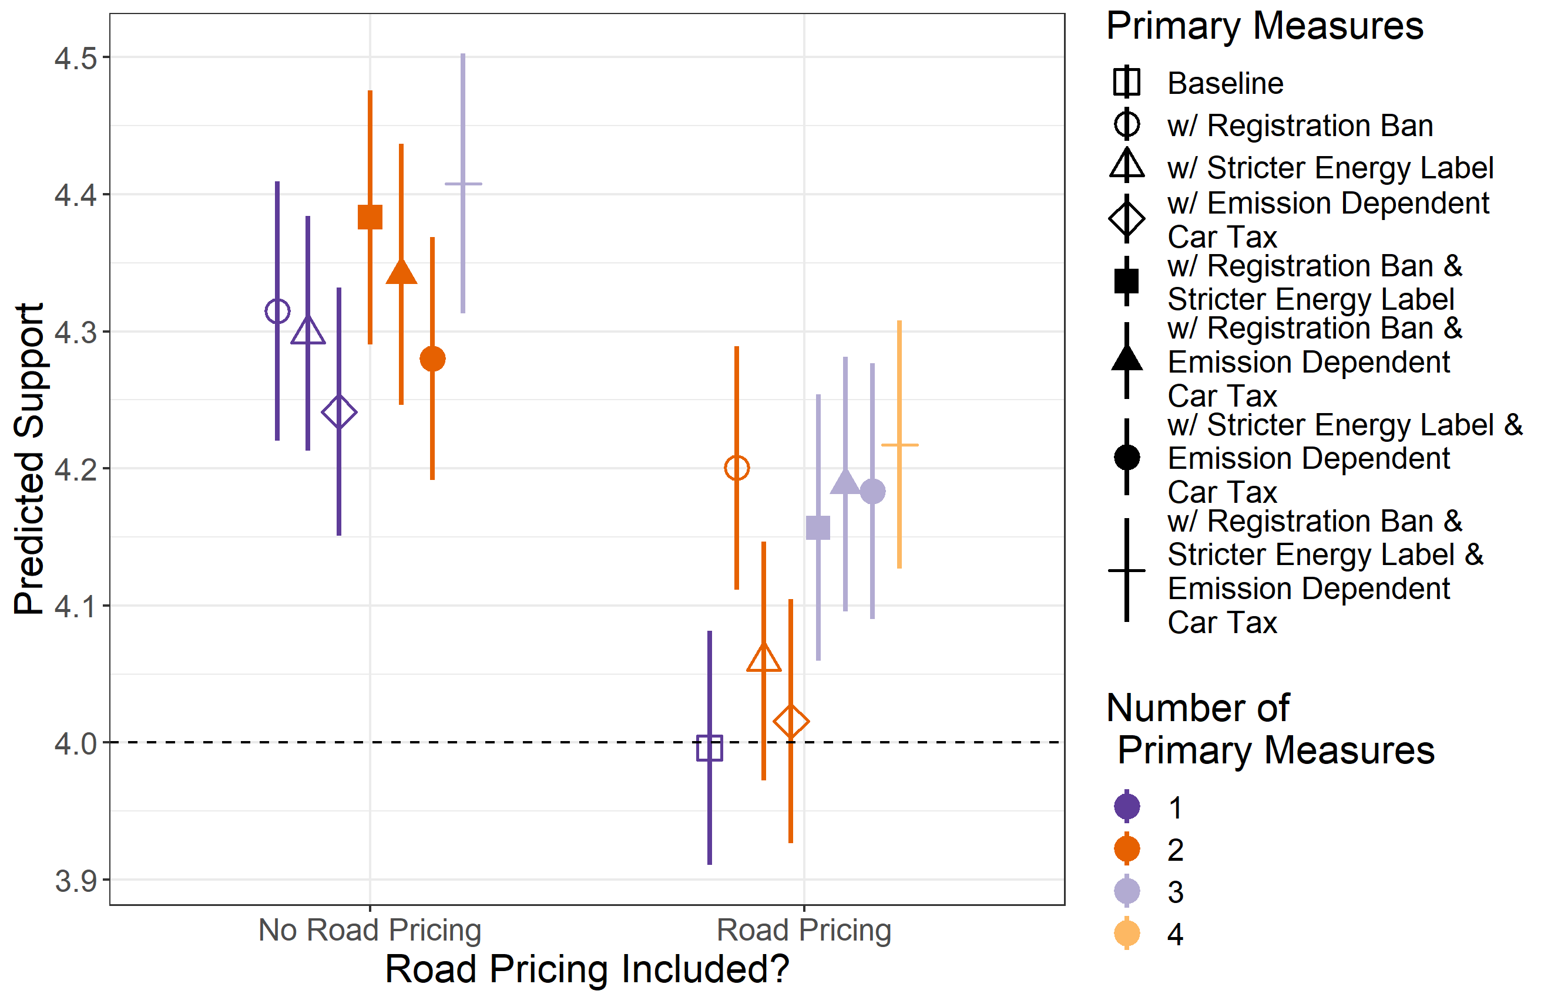

Figure A9: Estimated Average Marginal Component Effects for Choice Task by Round
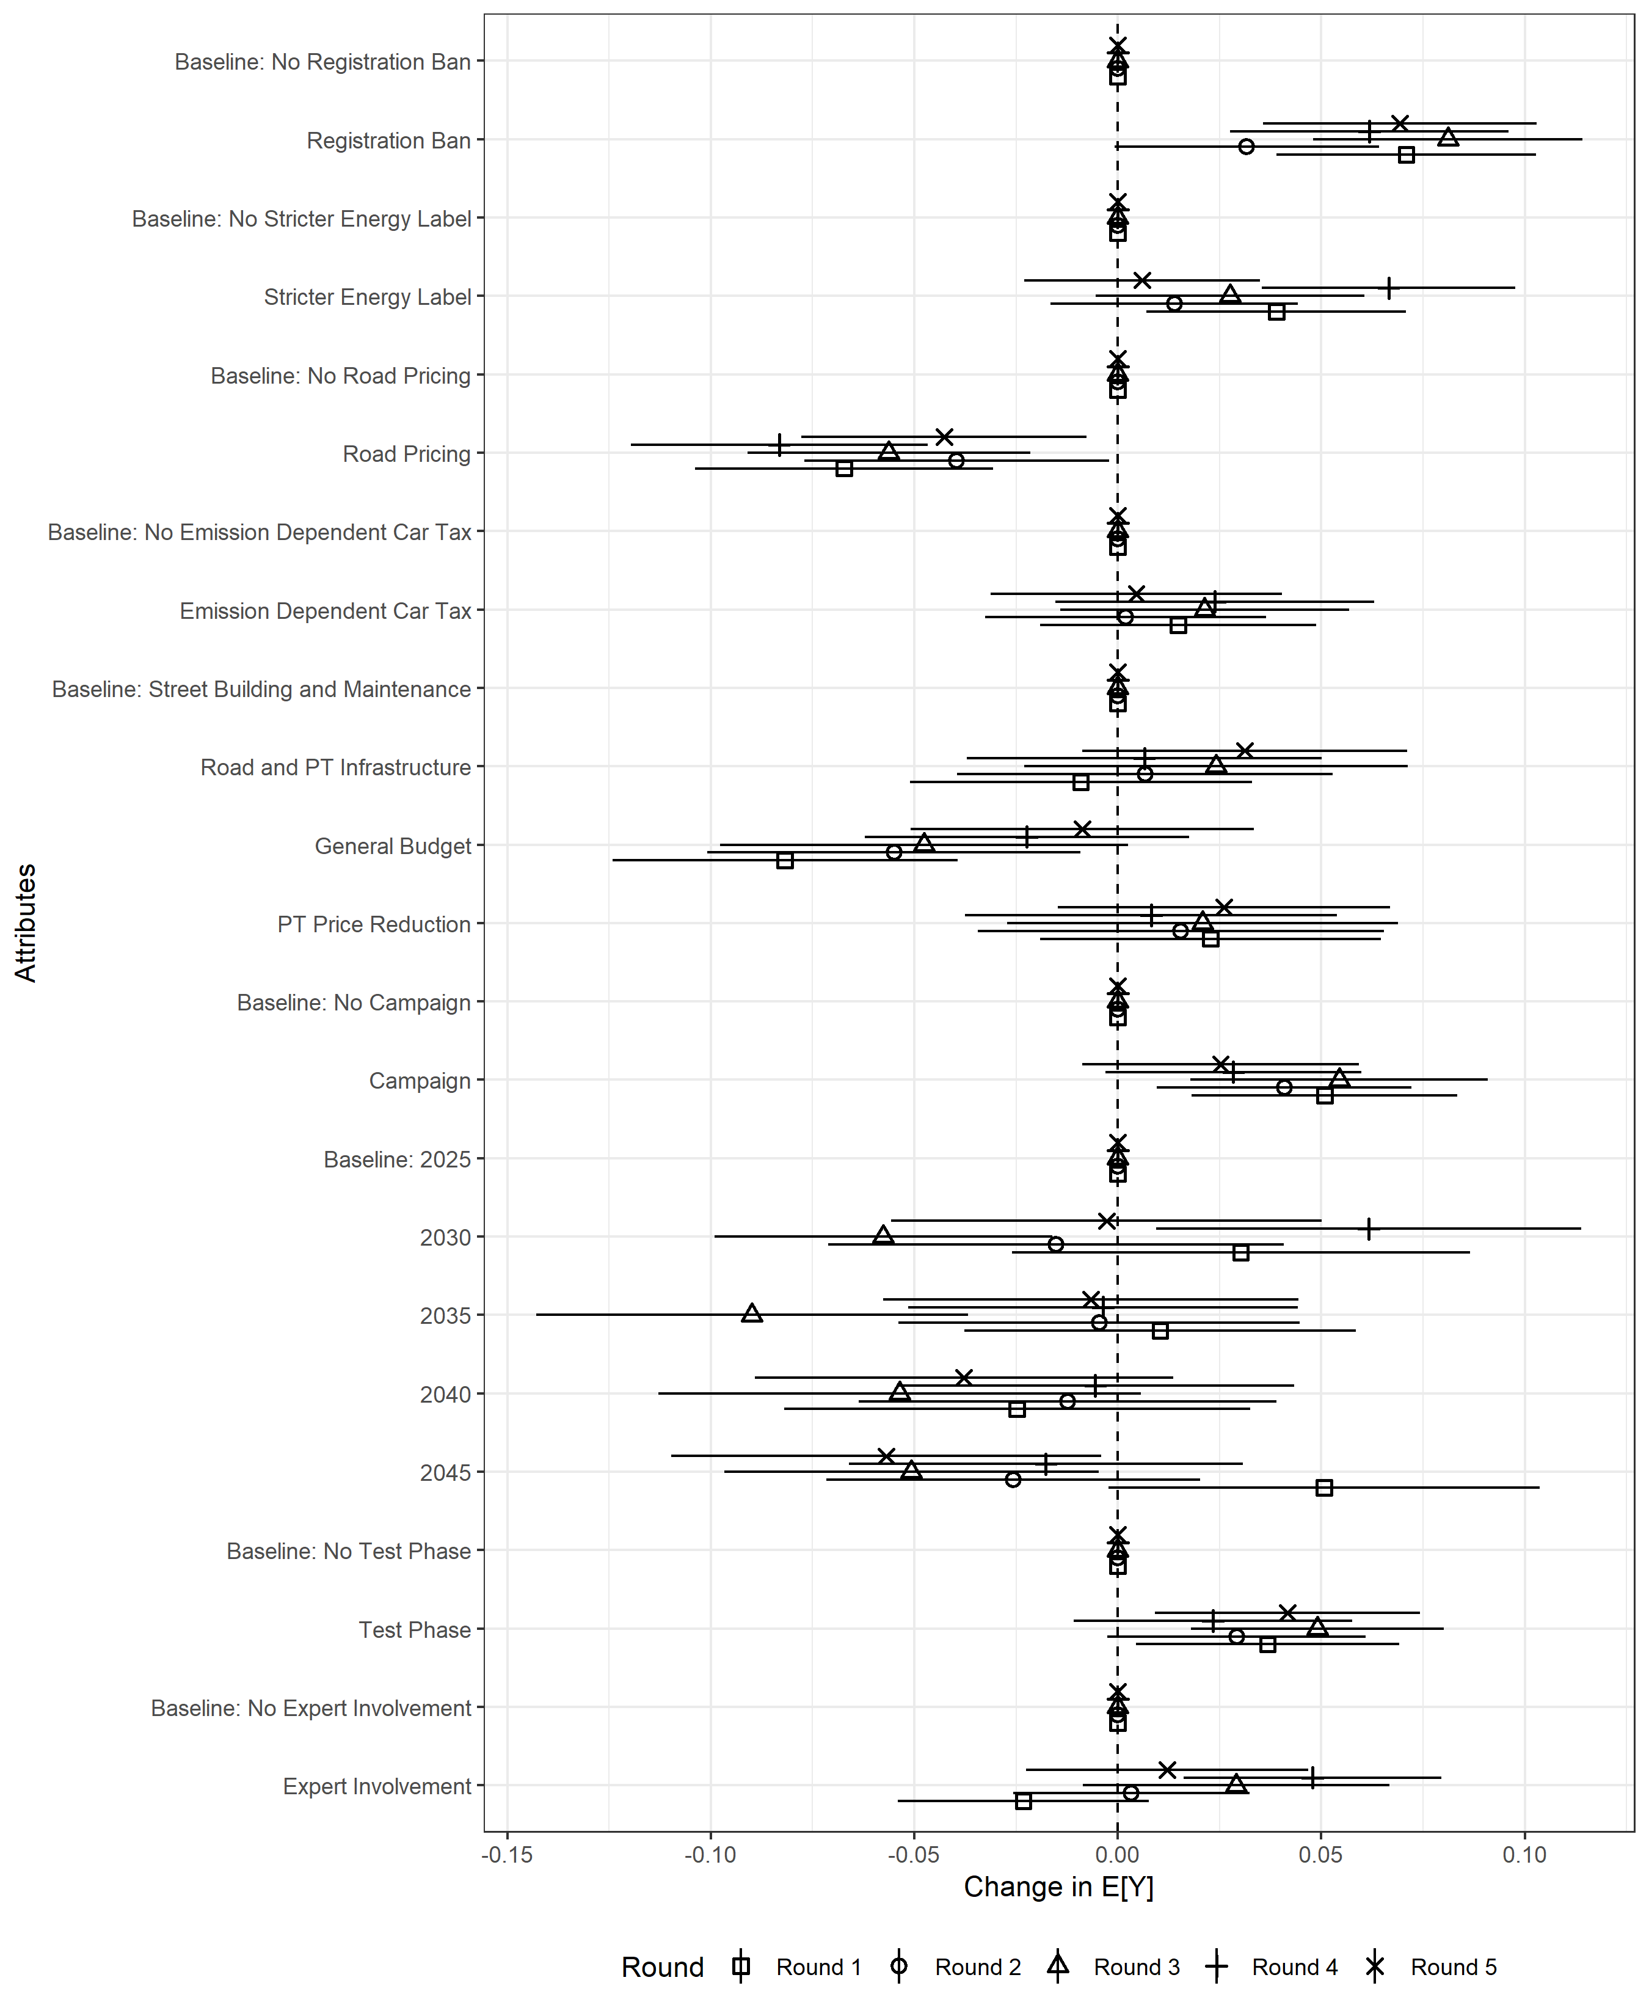

Figure A10: Estimated Average Marginal Component Effects for Rating Task by Round
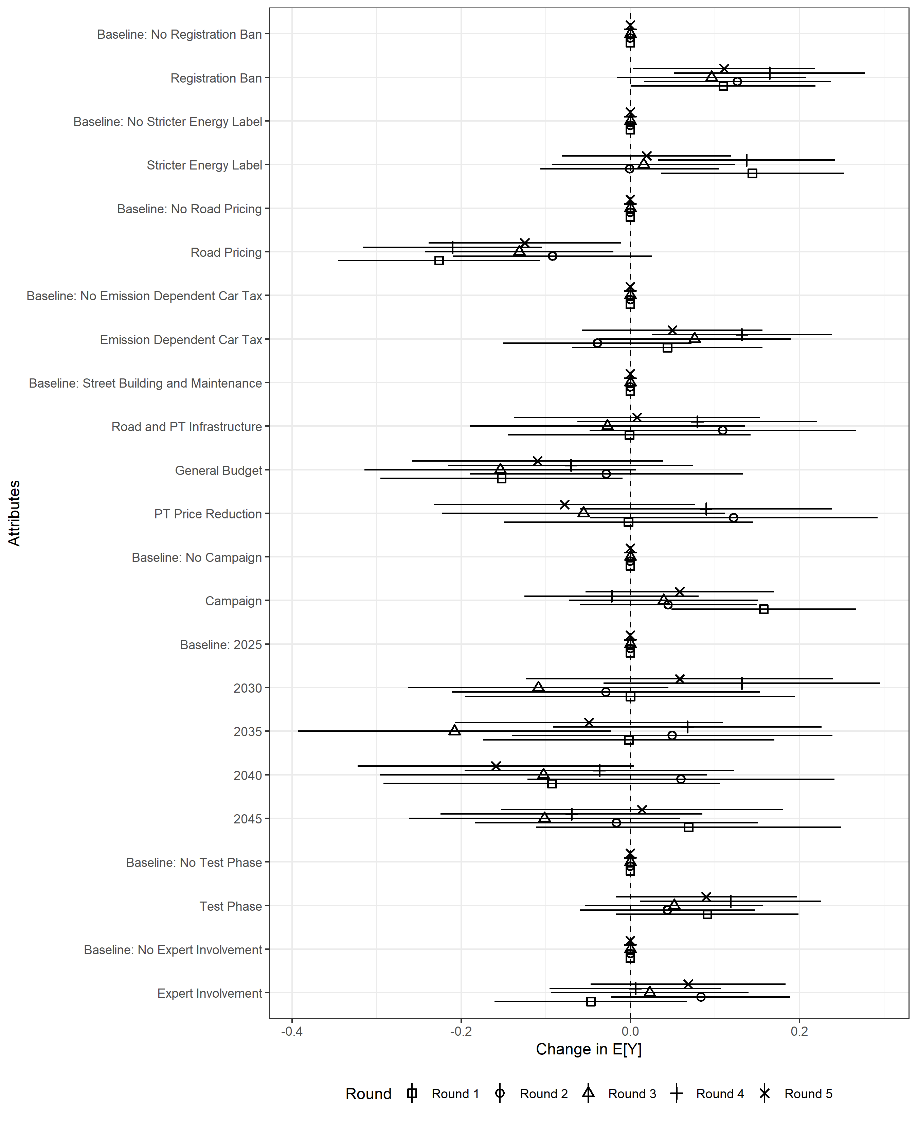

Table A1: Interaction effects Registration Ban and Package Rating
 | Two-Way Interaction | Three-Way Interaction | Four-Way Interaction
(Intercept) | 4.14 (0.05)*** | 4.14 (0.05)*** | 4.15 (0.05)***
Registration Ban | 0.14 (0.04)*** | 0.18 (0.06)*** | 0.18 (0.06)***
Campaign | 0.07 (0.03)** | 0.10 (0.05)** | 0.08 (0.06)
Expert Involvement | 0.09 (0.03)*** | 0.06 (0.05) | 0.04 (0.06)
Test Phase | 0.04 (0.03) | 0.06 (0.05) | 0.04 (0.06)
Stricter Energy Label | 0.07 (0.02)*** | 0.07 (0.02)*** | 0.07 (0.02)***
Road Pricing | -0.18 (0.02)*** | -0.18 (0.02)*** | -0.18 (0.02)***
Emission Dependent Car Tax | 0.04 (0.02)* | 0.04 (0.02)* | 0.04 (0.02)*
RU: Road and PT Infrastructure | 0.02 (0.03) | 0.02 (0.03) | 0.02 (0.03)
RU: General Budget | -0.13 (0.03)*** | -0.13 (0.03)*** | -0.13 (0.03)***
RU: PT Price Reduction | 0.03 (0.03) | 0.03 (0.03) | 0.03 (0.03)
Implementation 2030 | -0.01 (0.04) | -0.02 (0.04) | -0.02 (0.04)
Implementation 2035 | -0.04 (0.03) | -0.04 (0.04) | -0.04 (0.04)
Implementation 2040 | -0.11 (0.04)*** | -0.10 (0.04)*** | -0.10 (0.04)***
Implementation 2045 | -0.04 (0.03) | -0.03 (0.03) | -0.03 (0.03)
Registration Ban x Campaign | -0.01 (0.04) | -0.06 (0.07) | -0.05 (0.08)
Registration Ban x Expert Involvement | 0.01 (0.04) | 0.01 (0.07) | 0.02 (0.08)
Registration Ban x Test Phase | -0.03 (0.04) | -0.14 (0.07)* | -0.14 (0.08)
Campaign x Test Phase |  | 0.02 (0.06) | 0.07 (0.08)
Campaign x Expert Involvement |  | -0.09 (0.06) | -0.04 (0.08)
Test Phase x Expert Involvement |  | 0.05 (0.06) | 0.09 (0.08)
Registration Ban x Campaign x Test Phase |  | -0.06 (0.09) | -0.09 (0.12)
Registration Ban x Campaign x Expert Involvement |  | 0.18 (0.09)** | 0.16 (0.12)
Registration Ban x Test Phase x Expert Involvement |  | 0.06 (0.09) | 0.03 (0.12)
Campaign x Test Phase x Expert Involvement |  |  | -0.10 (0.12)
Registration Ban x Campaign x Test Phase x Expert Involvement |  |  | 0.05 (0.17)
AIC | 76165.45 | 76192.09 | 76199.94
BIC | 76323.85 | 76398.02 | 76421.71
Log Likelihood | -38062.72 | -38070.05 | -38071.97
Num. obs. | 20340 | 20340 | 20340
Num. groups: id | 2034 | 2034 | 2034
Var: id (Intercept) | 0.56 | 0.56 | 0.56
Var: Residual | 2.17 | 2.17 | 2.17
***p < 0.01, **p < 0.05, *p < 0.1, linear mixed effects regression of seven-point Likert scale rating

Table A2: Interaction effects Emission Dependent Car Tax and Package Rating
 | Two-Way Interaction | Three-Way Interaction | Four-Way Interaction
(Intercept) | 4.16 (0.05)*** | 4.19 (0.05)*** | 4.21 (0.05)***
Emission Dependent Car Tax | 0.00 (0.04) | -0.02 (0.06) | -0.05 (0.06)
Campaign | 0.08 (0.03)*** | 0.06 (0.05) | 0.02 (0.06)
Expert Involvement | 0.07 (0.03)** | 0.03 (0.05) | -0.02 (0.06)
Test Phase | 0.02 (0.03) | -0.03 (0.05) | -0.07 (0.06)
Registration Ban | 0.12 (0.02)*** | 0.13 (0.02)*** | 0.12 (0.02)***
Stricter Energy Label | 0.07 (0.02)*** | 0.07 (0.02)*** | 0.07 (0.02)***
Road Pricing | -0.18 (0.02)*** | -0.18 (0.02)*** | -0.18 (0.02)***
RU: Road and PT Infrastructure | 0.02 (0.03) | 0.02 (0.03) | 0.02 (0.03)
RU: General Budget | -0.13 (0.03)*** | -0.13 (0.03)*** | -0.13 (0.03)***
RU: PT Price Reduction | 0.03 (0.03) | 0.03 (0.03) | 0.03 (0.03)
Implementation 2030 | -0.01 (0.04) | -0.01 (0.04) | -0.01 (0.04)
Implementation 2035 | -0.03 (0.03) | -0.03 (0.04) | -0.03 (0.04)
Implementation 2040 | -0.10 (0.04)*** | -0.10 (0.04)*** | -0.10 (0.04)***
Implementation 2045 | -0.04 (0.03) | -0.03 (0.03) | -0.03 (0.03)
Emission Dependent Car Tax x Campaign | -0.02 (0.04) | 0.03 (0.07) | 0.09 (0.08)
Emission Dependent Car Tax x Expert Involvement | 0.06 (0.04) | 0.08 (0.07) | 0.14 (0.08)*
Emission Dependent Car Tax x Test Phase | 0.03 (0.04) | 0.07 (0.07) | 0.13 (0.09)
Campaign x Test Phase |  | 0.00 (0.06) | 0.10 (0.09)
Campaign x Expert Involvement |  | 0.04 (0.06) | 0.12 (0.08)
Test Phase x Expert Involvement |  | 0.07 (0.06) | 0.17 (0.09)*
Emission Dependent Car Tax x Campaign x Test Phase |  | -0.01 (0.09) | -0.14 (0.12)
Emission Dependent Car Tax x Campaign x Expert Involvement |  | -0.08 (0.09) | -0.21 (0.12)*
Emission Dependent Car Tax x Test Phase x Expert Involvement |  | -0.01 (0.09) | -0.14 (0.12)
Campaign x Test Phase x Expert Involvement |  |  | -0.19 (0.13)
Emission Dependent Car Tax x Campaign x Test Phase x Expert Involvement |  |  | 0.27 (0.18)
AIC | 76163.14 | 76194.44 | 76200.31
BIC | 76321.55 | 76400.37 | 76422.08
Log Likelihood | -38061.57 | -38071.22 | -38072.15
Num. obs. | 20340 | 20340 | 20340
Num. groups: id | 2034 | 2034 | 2034
Var: id (Intercept) | 0.56 | 0.56 | 0.56
Var: Residual | 2.17 | 2.17 | 2.17
***p < 0.01, **p < 0.05, *p < 0.1, linear mixed effects regression of seven-point Likert scale rating

Table A3: Interaction effects Stricter Energy Label and Package Rating
 | Two-Way Interaction | Three-Way Interaction | Four-Way Interaction
(Intercept) | 4.14 (0.05)*** | 4.11 (0.05)*** | 4.11 (0.05)***
Stricter Energy Label | 0.08 (0.04)* | 0.18 (0.06)*** | 0.20 (0.06)***
Campaign | 0.08 (0.03)*** | 0.15 (0.05)*** | 0.15 (0.06)***
Expert Involvement | 0.08 (0.03)*** | 0.10 (0.05)* | 0.10 (0.06)*
Test Phase | 0.04 (0.03) | 0.07 (0.05) | 0.07 (0.06)
Registration Ban | 0.12 (0.02)*** | 0.13 (0.02)*** | 0.13 (0.02)***
Road Pricing | -0.18 (0.02)*** | -0.18 (0.02)*** | -0.18 (0.02)***
Emission Dependent Car Tax | 0.04 (0.02)* | 0.04 (0.02)* | 0.04 (0.02)*
RU: Road and PT Infrastructure | 0.02 (0.03) | 0.02 (0.03) | 0.02 (0.03)
RU: General Budget | -0.13 (0.03)*** | -0.12 (0.03)*** | -0.12 (0.03)***
RU: PT Price Reduction | 0.03 (0.03) | 0.03 (0.03) | 0.03 (0.03)
Implementation 2030 | -0.01 (0.04) | -0.01 (0.04) | -0.01 (0.04)
Implementation 2035 | -0.03 (0.03) | -0.03 (0.04) | -0.03 (0.04)
Implementation 2040 | -0.10 (0.04)*** | -0.09 (0.04)** | -0.10 (0.04)***
Implementation 2045 | -0.03 (0.03) | -0.03 (0.03) | -0.03 (0.03)
Stricter Energy Label x Campaign | -0.03 (0.04) | -0.17 (0.07)** | -0.20 (0.08)**
Stricter Energy Label x Expert Involvement | 0.03 (0.04) | -0.08 (0.08) | -0.11 (0.09)
Stricter Energy Label x Test Phase | -0.03 (0.04) | -0.16 (0.07)** | -0.19 (0.08)**
Campaign x Test Phase |  | -0.06 (0.06) | -0.06 (0.08)
Campaign x Expert Involvement |  | -0.09 (0.06) | -0.09 (0.09)
Test Phase x Expert Involvement |  | 0.03 (0.06) | 0.03 (0.09)
Stricter Energy Label x Campaign x Test Phase |  | 0.12 (0.09) | 0.18 (0.12)
Stricter Energy Label x Campaign x Expert Involvement |  | 0.17 (0.09)* | 0.24 (0.12)*
Stricter Energy Label x Test Phase x Expert Involvement |  | 0.08 (0.09) | 0.15 (0.12)
Campaign x Test Phase x Expert Involvement |  |  | 0.00 (0.12)
Stricter Energy Label x Campaign x Test Phase x Expert Involvement |  |  | -0.14 (0.17)
AIC | 76164.64 | 76189.89 | 76197.41
BIC | 76323.05 | 76395.82 | 76419.18
Log Likelihood | -38062.32 | -38068.95 | -38070.70
Num. obs. | 20340 | 20340 | 20340
Num. groups: id | 2034 | 2034 | 2034
Var: id (Intercept) | 0.56 | 0.56 | 0.56
Var: Residual | 2.17 | 2.17 | 2.17
***p < 0.01, **p < 0.05, *p < 0.1, linear mixed effects regression of seven-point Likert scale rating

Table A4: Interaction effects Road Pricing and Package Rating
 | Two-Way Interaction | Three Way Interaction | Four Way Interaction
(Intercept) | 4.14 (0.05)*** | 4.16 (0.05)*** | 4.17 (0.05)***
Road Pricing | -0.17 (0.04)*** | -0.18 (0.06)*** | -0.19 (0.06)***
Campaign | 0.12 (0.03)*** | 0.09 (0.05)* | 0.08 (0.06)
Expert Involvement | -0.02 (0.03) | -0.06 (0.05) | -0.08 (0.06)
Test Phase | 0.10 (0.03)*** | 0.07 (0.05) | 0.05 (0.06)
Registration Ban | 0.13 (0.02)*** | 0.13 (0.02)*** | 0.12 (0.02)***
Stricter Energy Label | 0.06 (0.02)*** | 0.07 (0.02)*** | 0.07 (0.02)***
Emission Dependent Car Tax | 0.03 (0.02) | 0.03 (0.02) | 0.03 (0.02)
RU: Road and PT Infrastructure | 0.02 (0.03) | 0.02 (0.03) | 0.02 (0.03)
RU: General Budget | -0.12 (0.03)*** | -0.13 (0.03)*** | -0.13 (0.03)***
RU: PT Price Reduction | 0.03 (0.03) | 0.03 (0.03) | 0.03 (0.03)
Implementation 2030 | -0.01 (0.04) | -0.01 (0.04) | -0.01 (0.04)
Implementation 2035 | -0.03 (0.03) | -0.04 (0.04) | -0.03 (0.04)
Implementation 2040 | -0.10 (0.04)*** | -0.10 (0.04)*** | -0.10 (0.04)***
Implementation 2045 | -0.03 (0.03) | -0.03 (0.03) | -0.03 (0.03)
Road Pricing x Campaign | -0.10 (0.04)** | -0.05 (0.07) | -0.03 (0.08)
Road Pricing x Expert Involvement | 0.10 (0.04)** | 0.10 (0.07) | 0.12 (0.08)
Road Pricing x Test Phase | -0.01 (0.04) | -0.02 (0.07) | 0.00 (0.09)
Campaign x Test Phase |  | 0.02 (0.06) | 0.05 (0.08)
Campaign x Expert Involvement |  | 0.03 (0.06) | 0.07 (0.09)
Test Phase x Expert Involvement |  | 0.04 (0.06) | 0.09 (0.09)
Road Pricing x Campaign x Test Phase |  | -0.07 (0.09) | -0.10 (0.12)
Road Pricing x Campaign x Expert Involvement |  | -0.04 (0.09) | -0.08 (0.12)
Road Pricing x Test Phase x Expert Involvement |  | 0.06 (0.09) | 0.01 (0.13)
Campaign x Test Phase x Expert Involvement |  |  | -0.09 (0.13)
Road Pricing x Campaign x Test Phase x Expert Involvement |  |  | 0.09 (0.18)
AIC | 76154.86 | 76184.97 | 76193.13
BIC | 76313.26 | 76390.90 | 76414.90
Log Likelihood | -38057.43 | -38066.48 | -38068.56
Num. obs. | 20340 | 20340 | 20340
Num. groups: id | 2034 | 2034 | 2034
Var: id (Intercept) | 0.56 | 0.56 | 0.56
Var: Residual | 2.17 | 2.17 | 2.17
***p < 0.01, **p < 0.05, *p < 0.1, linear mixed effects regression of seven-point Likert scale rating

Table A5: Interaction Effect Registration Ban on Likelihood of Package Choice
 | Two-Way Interaction | Three Way Interaction | Four Way Interaction
(Intercept) | 0.46 (0.01)*** | 0.47 (0.02)*** | 0.48 (0.02)***
Registration Ban | 0.05 (0.01)*** | 0.05 (0.02)*** | 0.05 (0.02)**
Campaign | 0.03 (0.01)*** | 0.02 (0.02) | 0.01 (0.02)
Expert Involvement | 0.03 (0.01)*** | 0.02 (0.02) | 0.01 (0.02)
Test Phase | 0.02 (0.01)* | 0.02 (0.02) | 0.01 (0.02)
Stricter Energy Label | 0.03 (0.01)*** | 0.03 (0.01)*** | 0.03 (0.01)***
Road Pricing | -0.06 (0.01)*** | -0.06 (0.01)*** | -0.06 (0.01)***
Emission Dependent Car Tax | 0.01 (0.01)** | 0.01 (0.01)** | 0.01 (0.01)*
RU: Road and PT Infrastructure | 0.01 (0.01) | 0.00 (0.01) | 0.00 (0.01)
RU: General Budget | -0.05 (0.01)*** | -0.05 (0.01)*** | -0.05 (0.01)***
RU: PT Price Reduction | 0.01 (0.01) | 0.01 (0.01) | 0.01 (0.01)
Implementation 2030 | 0.00 (0.01) | 0.00 (0.01) | -0.00 (0.01)
Implementation 2035 | -0.01 (0.01) | -0.01 (0.01) | -0.01 (0.01)
Implementation 2040 | -0.03 (0.01)** | -0.03 (0.01)** | -0.03 (0.01)**
Implementation 2045 | -0.02 (0.01)** | -0.02 (0.01)* | -0.02 (0.01)*
Registration Ban x Campaign | 0.01 (0.01) | 0.02 (0.02) | 0.03 (0.03)
Registration Ban x Expert Involvement | -0.00 (0.01) | 0.01 (0.02) | 0.03 (0.03)
Registration Ban x Test Phase | -0.01 (0.01) | -0.03 (0.02) | -0.02 (0.03)
Campaign x Test Phase |  | 0.03 (0.02) | 0.05 (0.03)**
Campaign x Expert Involvement |  | -0.01 (0.02) | 0.01 (0.03)
Test Phase x Expert Involvement |  | 0.00 (0.02) | 0.02 (0.03)
Registration Ban x Campaign x Test Phase |  | -0.04 (0.03) | -0.07 (0.04)*
Registration Ban x Campaign x Expert Involvement |  | 0.02 (0.03) | -0.00 (0.04)
Registration Ban x Test Phase x Expert Involvement |  | 0.01 (0.03) | -0.01 (0.04)
Campaign x Test Phase x Expert Involvement |  |  | -0.05 (0.04)
Registration Ban x Campaign x Test Phase x Expert Involvement |  |  | 0.05 (0.06)
AIC | 29421.48 | 29465.21 | 29476.87
BIC | 29579.89 | 29671.14 | 29698.64
Log Likelihood | -14690.74 | -14706.60 | -14710.43
Num. obs. | 20340 | 20340 | 20340
Num. groups: id | 2034 | 2034 | 2034
Var: id (Intercept) | 0.00 | 0.00 | 0.00
Var: Residual | 0.25 | 0.25 | 0.25
***p < 0.01, **p < 0.05, *p < 0.1, linear mixed effects regression of binary choice

Table A6: Interaction Effect Road Pricing on Likelihood of Package Choice
 | Two-Way Interaction | Three Way Interaction | Four Way Interaction
(Intercept) | 0.46 (0.01)*** | 0.48 (0.02)*** | 0.49 (0.02)***
Road Pricing | -0.06 (0.01)*** | -0.08 (0.02)*** | -0.09 (0.02)***
Campaign | 0.05 (0.01)*** | 0.02 (0.02) | 0.01 (0.02)
Expert Involvement | 0.00 (0.01) | -0.02 (0.02) | -0.03 (0.02)*
Test Phase | 0.03 (0.01)*** | 0.02 (0.02) | 0.01 (0.02)
Registration Ban | 0.05 (0.01)*** | 0.05 (0.01)*** | 0.05 (0.01)***
Stricter Energy Label | 0.03 (0.01)*** | 0.03 (0.01)*** | 0.03 (0.01)***
Emission Dependent Car Tax | 0.01 (0.01)* | 0.01 (0.01)* | 0.01 (0.01)*
RU: Road and PT Infrastructure | 0.01 (0.01) | 0.00 (0.01) | 0.00 (0.01)
RU: General Budget | -0.05 (0.01)*** | -0.05 (0.01)*** | -0.05 (0.01)***
RU: PT Price Reduction | 0.01 (0.01) | 0.01 (0.01) | 0.01 (0.01)
Implementation 2030 | 0.00 (0.01) | 0.00 (0.01) | 0.00 (0.01)
Implementation 2035 | -0.01 (0.01) | -0.02 (0.01) | -0.01 (0.01)
Implementation 2040 | -0.03 (0.01)** | -0.03 (0.01)** | -0.03 (0.01)**
Implementation 2045 | -0.02 (0.01)* | -0.02 (0.01)** | -0.02 (0.01)**
Road Pricing x Campaign | -0.03 (0.01)* | 0.02 (0.02) | 0.04 (0.03)
Road Pricing x Expert Involvement | 0.03 (0.01)* | 0.06 (0.02)** | 0.08 (0.03)***
Road Pricing x Test Phase | 0.00 (0.01) | 0.01 (0.02) | 0.02 (0.03)
Campaign x Test Phase |  | 0.02 (0.02) | 0.04 (0.03)
Campaign x Expert Involvement |  | 0.05 (0.02)** | 0.07 (0.03)***
Test Phase x Expert Involvement |  | 0.00 (0.02) | 0.03 (0.03)
Road Pricing x Campaign x Test Phase |  | -0.01 (0.03) | -0.05 (0.04)
Road Pricing x Campaign x Expert Involvement |  | -0.08 (0.03)*** | -0.12 (0.04)***
Road Pricing x Test Phase x Expert Involvement |  | 0.01 (0.03) | -0.03 (0.04)
Campaign x Test Phase x Expert Involvement |  |  | -0.06 (0.04)
Road Pricing x Campaign x Test Phase x Expert Involvement |  |  | 0.08 (0.06)
AIC | 29416.08 | 29454.43 | 29465.22
BIC | 29574.48 | 29660.36 | 29686.99
Log Likelihood | -14688.04 | -14701.22 | -14704.61
Num. obs. | 20340 | 20340 | 20340
Num. groups: id | 2034 | 2034 | 2034
Var: id (Intercept) | 0.00 | 0.00 | 0.00
Var: Residual | 0.25 | 0.25 | 0.25
***p < 0.01, **p < 0.05, *p < 0.1, linear mixed effects regression of binary choice

Table A7: Interaction Effect Emission Dependent Car Tax on Likelihood of Package Choice
 | Two-Way Interaction | Three Way Interaction | Four Way Interaction
(Intercept) | 0.46 (0.01)*** | 0.48 (0.02)*** | 0.48 (0.02)***
Emission Dependent Car Tax | 0.02 (0.01) | -0.00 (0.02) | -0.00 (0.02)
Campaign | 0.05 (0.01)*** | 0.02 (0.02) | 0.02 (0.02)
Expert Involvement | 0.03 (0.01)*** | 0.01 (0.02) | 0.00 (0.02)
Test Phase | 0.01 (0.01) | 0.00 (0.02) | -0.00 (0.02)
Registration Ban | 0.05 (0.01)*** | 0.05 (0.01)*** | 0.05 (0.01)***
Stricter Energy Label | 0.03 (0.01)*** | 0.03 (0.01)*** | 0.03 (0.01)***
Road Pricing | -0.06 (0.01)*** | -0.06 (0.01)*** | -0.06 (0.01)***
RU: Road and PT Infrastructure | 0.01 (0.01) | 0.01 (0.01) | 0.01 (0.01)
RU: General Budget | -0.05 (0.01)*** | -0.05 (0.01)*** | -0.05 (0.01)***
RU: PT Price Reduction | 0.01 (0.01) | 0.01 (0.01) | 0.01 (0.01)
Implementation 2030 | 0.00 (0.01) | 0.00 (0.01) | 0.00 (0.01)
Implementation 2035 | -0.01 (0.01) | -0.01 (0.01) | -0.01 (0.01)
Implementation 2040 | -0.03 (0.01)** | -0.03 (0.01)** | -0.03 (0.01)**
Implementation 2045 | -0.02 (0.01)* | -0.02 (0.01)* | -0.02 (0.01)*
Emission Dependent Car Tax x Campaign | -0.02 (0.01) | 0.02 (0.02) | 0.03 (0.03)
Emission Dependent Car Tax x Expert Involvement | 0.01 (0.01) | 0.03 (0.02) | 0.03 (0.03)
Emission Dependent Car Tax x Test Phase | 0.01 (0.01) | 0.02 (0.02) | 0.02 (0.03)
Campaign x Test Phase |  | 0.04 (0.02)** | 0.06 (0.03)**
Campaign x Expert Involvement |  | 0.02 (0.02) | 0.03 (0.03)
Test Phase x Expert Involvement |  | -0.01 (0.02) | 0.01 (0.03)
Emission Dependent Car Tax x Campaign x Test Phase |  | -0.06 (0.03)* | -0.07 (0.04)*
Emission Dependent Car Tax x Campaign x Expert Involvement |  | -0.04 (0.03) | -0.05 (0.04)
Emission Dependent Car Tax x Test Phase x Expert Involvement |  | 0.02 (0.03) | 0.01 (0.04)
Campaign x Test Phase x Expert Involvement |  |  | -0.03 (0.04)
Emission Dependent Car Tax x Campaign x Test Phase x Expert Involvement |  |  | 0.03 (0.06)
AIC | 29419.66 | 29460.44 | 29472.91
BIC | 29578.07 | 29666.37 | 29694.68
Log Likelihood | -14689.83 | -14704.22 | -14708.45
Num. obs. | 20340 | 20340 | 20340
Num. groups: id | 2034 | 2034 | 2034
Var: id (Intercept) | 0.00 | 0.00 | 0.00
Var: Residual | 0.25 | 0.25 | 0.25
***p < 0.01, **p < 0.05, *p < 0.1, linear mixed effects regression of binary choice

Table A8: Interaction Effect Stricter Energy Label on Likelihood of Package Choice
 | Two-Way Interaction | Three Way Interaction | Four Way Interaction
(Intercept) | 0.47 (0.01)*** | 0.47 (0.02)*** | 0.47 (0.02)***
Stricter Energy Label | 0.02 (0.01) | 0.02 (0.02) | 0.03 (0.02)
Campaign | 0.04 (0.01)*** | 0.04 (0.02)*** | 0.04 (0.02)**
Expert Involvement | 0.02 (0.01)** | 0.01 (0.02) | 0.01 (0.02)
Test Phase | 0.00 (0.01) | 0.01 (0.02) | 0.01 (0.02)
Registration Ban | 0.05 (0.01)*** | 0.05 (0.01)*** | 0.05 (0.01)***
Road Pricing | -0.06 (0.01)*** | -0.06 (0.01)*** | -0.06 (0.01)***
Emission Dependent Car Tax | 0.01 (0.01)* | 0.01 (0.01)** | 0.01 (0.01)*
RU: Road and PT Infrastructure | 0.01 (0.01) | 0.01 (0.01) | 0.01 (0.01)
RU: General Budget | -0.05 (0.01)*** | -0.05 (0.01)*** | -0.05 (0.01)***
RU: PT Price Reduction | 0.01 (0.01) | 0.01 (0.01) | 0.01 (0.01)
Implementation 2030 | 0.00 (0.01) | 0.00 (0.01) | 0.00 (0.01)
Implementation 2035 | -0.01 (0.01) | -0.01 (0.01) | -0.01 (0.01)
Implementation 2040 | -0.03 (0.01)** | -0.03 (0.01)** | -0.03 (0.01)**
Implementation 2045 | -0.02 (0.01)* | -0.02 (0.01)* | -0.02 (0.01)*
Stricter Energy Label x Campaign | -0.00 (0.01) | -0.02 (0.02) | -0.03 (0.03)
Stricter Energy Label x Expert Involvement | 0.02 (0.01) | 0.03 (0.02) | 0.02 (0.03)
Stricter Energy Label x Test Phase | 0.02 (0.01) | -0.00 (0.02) | -0.01 (0.03)
Campaign x Test Phase |  | 0.02 (0.02) | 0.02 (0.03)
Campaign x Expert Involvement |  | -0.03 (0.02) | -0.03 (0.03)
Test Phase x Expert Involvement |  | 0.01 (0.02) | 0.01 (0.03)
Stricter Energy Label x Campaign x Test Phase |  | -0.02 (0.03) | 0.00 (0.04)
Stricter Energy Label x Campaign x Expert Involvement |  | 0.06 (0.03)** | 0.08 (0.04)*
Stricter Energy Label x Test Phase x Expert Involvement |  | -0.01 (0.03) | 0.01 (0.04)
Campaign x Test Phase x Expert Involvement |  |  | -0.00 (0.04)
Stricter Energy Label x Campaign x Test Phase x Expert Involvement |  |  | -0.04 (0.06)
AIC | 29419.60 | 29462.53 | 29474.59
BIC | 29578.00 | 29668.46 | 29696.36
Log Likelihood | -14689.80 | -14705.26 | -14709.30
Num. obs. | 20340 | 20340 | 20340
Num. groups: id | 2034 | 2034 | 2034
Var: id (Intercept) | 0.00 | 0.00 | 0.00
Var: Residual | 0.25 | 0.25 | 0.25
***p < 0.01, **p < 0.05, *p < 0.1, linear mixed effects regression of binary choice

Table A9: Effect of included primary and ancillary measures on choice and rating
 | Choice: Baseline | Rate: Baseline | Rate: Controls | Choice: Full | Rate: Full
No. of Primary Meas. | 0.01** | 0.02 | 0.02* | 0.03* | 0.05
 | (0.00) | (0.01) | (0.01) | (0.01) | (0.04)
No. of Ancillary Meas. | 0.02*** | 0.05*** | 0.05*** | 0.03* | 0.07
 | (0.00) | (0.01) | (0.01) | (0.01) | (0.04)
Interaction |  |  |  | 0.00 | -0.00
 |  |  |  | (0.00) | (0.01)
Primary Meas. sq. |  |  |  | -0.00 | -0.01
 |  |  |  | (0.00) | (0.01)
Ancillary Meas. sq. |  |  |  | -0.00 | -0.00
 |  |  |  | (0.00) | (0.01)
Emission Frame |  |  | 0.07* |  | 0.07*
 |  |  | (0.04) |  | (0.04)
Age |  |  | -0.00** |  | -0.00**
 |  |  | (0.00) |  | (0.00)
Male |  |  | -0.09** |  | -0.09*
 |  |  | (0.04) |  | (0.04)
Other education¹ |  |  | 0.19 |  | 0.19
 |  |  | (0.25) |  | (0.25)
Secondary education¹ |  |  | 0.12 |  | 0.12
 |  |  | (0.10) |  | (0.10)
Tertiary education¹ |  |  | 0.20** |  | 0.20**
 |  |  | (0.10) |  | (0.10)
Weekly Car Usage |  |  | -0.06*** |  | -0.06***
 |  |  | (0.01) |  | (0.01)
Intercept | 0.44*** | 4.09*** | 4.31*** | 0.43*** | 4.28***
 | (0.01) | (0.03) | (0.11) | (0.02) | (0.12)
AIC | 29512.85 | 76223.38 | 76202.62 | 29544.46 | 76229.54
BIC | 29552.45 | 76262.98 | 76297.67 | 29607.83 | 76348.34
Log Likelihood | -14751.42 | -38106.69 | -38089.31 | -14764.23 | -38099.77
Num. obs. | 20340 | 20340 | 20340 | 20340 | 20340
Num. of individuals | 2034 | 2034 | 2034 | 2034 | 2034
Var: id (Intercept) | 0.00 | 0.55 | 0.53 | 0.00 | 0.53
Var: Residual | 0.25 | 2.19 | 2.19 | 0.25 | 2.19
Entries are unstandardized regression coefficients from a linear mixed effects regression.
Choice was rated binary, while rating was conducted on a seven-point Likert scale.
¹Baseline: Primary education
***p < 0.001, **p < 0.01, *p < 0.05.

Table A10: Regression output for choice and rating of policy-packages including interaction effects of primary measures
 | Baseline Choice | 4w Interaction Choice | Baseline Rating | 4w Interaction Rating
Intercept | 0.46 (0.01)*** | 0.45 (0.02)*** | 4.14 (0.04)*** | 4.10 (0.06)***
Registration Ban (RB) | 0.05 (0.01)*** | 0.04 (0.02)** | 0.13 (0.02)*** | 0.16 (0.06)***
Stricter Energy Label (EL) | 0.03 (0.01)*** | 0.05 (0.02)*** | 0.07 (0.02)*** | 0.15 (0.06)**
Road Pricing (RP) | -0.06 (0.01)*** | -0.06 (0.02)*** | -0.18 (0.02)*** | -0.15 (0.06)***
Emission Dependent Car Tax (CT) | 0.01 (0.01)* | 0.04 (0.02)** | 0.04 (0.02)* | 0.09 (0.06)
Revenue Use:
Street Building, Maintenance & PT | 0.01 (0.01) | 0.01 (0.01) | 0.02 (0.03) | 0.03 (0.03)
General Budget | -0.05 (0.01)*** | -0.05 (0.01)*** | -0.13 (0.03)*** | -0.12 (0.03)***
PT Price Reduction | 0.01 (0.01) | 0.01 (0.01) | 0.03 (0.03) | 0.04 (0.03)
Campaign | 0.04 (0.01)*** | 0.04 (0.01)*** | 0.07 (0.02)*** | 0.07 (0.02)***
Implementation 2030 | 0.00 (0.01) | 0.00 (0.01) | -0.01 (0.04) | -0.01 (0.04)
Implementation 2035 | -0.01 (0.01) | -0.01 (0.01) | -0.04 (0.03) | -0.03 (0.04)
Implementation 2040 | -0.03 (0.01)** | -0.03 (0.01)** | -0.10 (0.04)*** | -0.10 (0.04)***
Implementation 2045 | -0.02 (0.01)* | -0.02 (0.01)* | -0.04 (0.03) | -0.04 (0.03)
Test Phase | 0.03 (0.01)*** | 0.03 (0.01)*** | 0.10 (0.02)*** | 0.09 (0.02)***
Expert Involvement | 0.01 (0.01)* | 0.02 (0.01)** | 0.03 (0.02) | 0.03 (0.02)
RB x EL |  | 0.01 (0.03) |  | -0.08 (0.09)
RB x RP |  | 0.06 (0.03)** |  | 0.04 (0.08)
EL x RP |  | 0.01 (0.03) |  | -0.08 (0.08)
RB x CT |  | -0.00 (0.03) |  | -0.06 (0.09)
EL x CT |  | -0.06 (0.03)** |  | -0.11 (0.08)
RP x CT |  | -0.04 (0.03) |  | -0.07 (0.08)
RB x EL x RP |  | -0.10 (0.04)** |  | -0.03 (0.12)
RB x EL x CT |  | 0.03 (0.04) |  | 0.11 (0.12)
RB x RP x CT |  | -0.02 (0.04) |  | 0.03 (0.12)
EL x RP x CT |  | 0.07 (0.04)* |  | 0.21 (0.12)*
RB x EL x RP x CT |  | 0.00 (0.06) |  | -0.14 (0.17)
AIC | 29396.64 | 29458.19 | 76146.52 | 76199.77
BIC | 29531.28 | 29679.96 | 76281.17 | 76421.54
Log Likelihood | -14681.32 | -14701.09 | -38056.26 | -38071.89
Num. obs. | 20340 | 20340 | 20340 | 20340
Num. groups: id | 2034 | 2034 | 2034 | 2034
Var: id (Intercept) | 0.00 | 0.00 | 0.56 | 0.56
Var: Residual | 0.25 | 0.25 | 2.17 | 2.17
Entries are unstandardized regression coefficients from a linear mixed effects regression.
Choice was rated binary, while rating was conducted on a seven-point Likert scale.
***p < 0.001, **p < 0.01, *p < 0.05.

Table A11: Interview Overview
Interview | Description
1 | Cantonal MP of a left wing party
2 | Cantonal MP of a left wing party and representative of interest group
3 | Executive of a Cantonal Office of Transport
4 | Cantonal MP of a centre-left party
5 | Cantonal MP of a right-wing party
6 | National MP of a liberal party
7 | Representative of interest group promoting E-Mobility
8 | Car industry interest group
9 | National MP of a centre-left party
10 | National MP of a left-wing party
Note: More information are available upon request.

Table A12: Policy Instruments
 | Instrument | Description
Primary Measures | Emission Dependent Car Tax | [To promote switching to electric vehicles / to promote switching from highly emitting to low emission cars] in Switzerland, it is proposed to adjust and harmonise the car tax on the federal level. The car tax would then mainly consider the respective cars’ emissions and be more similar for all of Switzerland. Until now, the annual car tax considers several factors such as a car’s age, weight, power and partly its emissions. The federal government would bear the costs of implementing this policy. With this policy, [electric vehicles / low emission cars] would pay fewer taxes than [other cars / highly emitting cars]. Thereby, the switch [to electric vehicles / from highly emitting to low emission cars] would be promoted.
 | Registration Ban on High Emission Cars | [To promote switching to electric vehicles / to promote switching from highly emitting to low emission cars] in Switzerland, it is proposed to ban cars with high emissions from the registration. The registration of cars should be restricted based on the respective car’s emissions. Until now, no uniform restriction of registration promotes electric vehicles. The federal government would bear the costs of implementing this policy. With this policy, [electric vehicles / highly emitting cars], [which do not produce emissions / ], would be [favoured / disadvantaged] compared to [other cars / low emission cars] as they are [exempted / harmed] from this ban. Thereby, the switch [to electric vehicles / from highly emitting to low emission cars] would be promoted.
 | Road Pricing | [To promote switching to electric vehicles / to promote switching from highly emitting cars to low emission cars] in Switzerland, it is proposed to implement usage fees for roads. This measure is often called “road pricing” and means that car drivers now have to pay a fee, which depends on the driven distance and emissions. Until now, there is only a motorway permit sticker with a fixed price, and the price does not reflect emissions and distance. The federal government would bear the costs of implementing this policy. With this policy, [electric vehicles / highly emitting cars] would be pay [lower / higher] fees than [other cars / low emission cars] as they produce [no / more] emissions. Thereby, the switch [to electric vehicles / from highly emitting to low emission cars] would be promoted.
 | Stricter Energy Labels | [To promote switching to electric vehicles / to promote switching from highly emitting cars to low emission cars] in Switzerland, it is proposed to tighten rules for the mandatory energy label. Energy labels would have to display real emissions and consumption values which stem from independent tests. Until now, there is a federal energy label which displays lower emission and consumption values which stem from the car producers. The federal government would bear the costs of implementing this policy. With this policy, [electric vehicles / highly emitting cars] would be [favoured / disadvantaged] compared to [other cars / low emission cars] as the consciousness concerning emissions and fuel costs increases. Thereby, the switch [to electric vehicles / from highly emitting to low emission cars] would be promoted.
Ancillary Measures | Information Campaign | To increase the public's understanding of the policy-package, the government could launch a nationwide campaign to explain the content and benefits of the package and respond to possible public concerns.
 | Test Phase and Evaluation | To ensure the effectiveness of the policy-package, the measures could be introduced in a two-year test phase. In this test phase, the broader impact of the measures on society will be examined in more detail. The package of measures will be evaluated after these two years. It will also examine whether the package of measures is suitable for implementation throughout Switzerland or not. Only then, by this evaluation, will it be decided whether the package of measures will be implemented definitively.
 | Expert Involvement | To implement the policy-package as efficiently as possible, experts can be involved in the implementation and design of the package. Experts can use their knowledge to help prevent undesired effects of the package and, if necessary, counteract them.
Note: Bold text highlights the differences between the frames. The first part in the brackets refers to the EV frame; the second text contains the emission-reduction frame.

Table A13: Policy Instruments German
 | Instrument | Description
Primary Measures | Anpassung und Harmonisierung der Motorfahrzeugsteuer auf Bundesebene | [Um den Umstieg weg von Autos mit vielen Abgasen hin zu abgasarmen Autos in der Schweiz zu fördern / Um den Umstieg auf Elektroautos in der Schweiz zu fördern], wird vorgeschlagen, die Motorfahrzeugsteuer anzupassen und auf Bundesebene zu harmonisieren. Die Motorfahrzeugsteuer würde sich dann neu vor allem an den Abgasen des betreffenden Autos orientieren und in der ganzen Schweiz einheitlicher bzw. kantonal weniger unterschiedlich ausgestaltet werden. Bisher orientiert sich die jährlich zu bezahlende Motorfahrzeugsteuer an mehreren Faktoren wie Alter, Gewicht, Leistung und nur teilweise an den Abgasen des Autos. Die anfallenden Kosten für die Umsetzung dieser Massnahme würden vom Bund getragen. Mit dieser Massnahme würden [Elektroautos / Autos mit hohen Abgasen] im Vergleich zu [anderen Autos / abgasarmen Autos] künftig höher besteuert. Der Umstieg [auf Elektroautos / weg von Autos mit vielen Abgasen hin zu abgasarmen Autos] würde damit gefördert.
 | Zulassungsbeschränkung für neue Autos gemäss Abgaswerten | [Um den Umstieg weg von Autos mit vielen Abgasen hin zu abgasarmen Autos in der Schweiz zu fördern / Um den Umstieg auf Elektroautos in der Schweiz zu fördern], wird vorgeschlagen, Neuzulassungen von Autos mit besonders hohen Abgaswerten zu verbieten. Neuzulassungen sollen auf Grundlage der Abgase des betreffenden Autos beschränkt werden. Bisher spielen Abgaswerte bei der Zulassung von Autos in der Schweiz keine Rolle. Die anfallenden Kosten für die Umsetzung dieser Massnahme würden vom Bund getragen. Mit dieser Massnahme würden, [Elektroautos, die keine Abgase verursachen / Autos mit hohen Abgasen], im Vergleich zu [anderen Autos bevorzugt / abgasarmen Autos benachteiligt] da sie von dieser Zulassungsbeschränkung [ausgenommen / betroffen] sind. Der Umstieg [auf Elektroautos / weg von Autos mit vielen Abgasen hin zu abgasarmen Autos] würde damit gefördert.
 | Abgas- und kilometerabhängige Nutzungsgebühr für Strassen (Road Pricing) | [Um den Umstieg weg von Autos mit vielen Abgasen hin zu abgasarmen Autos in der Schweiz zu fördern / Um den Umstieg auf Elektroautos in der Schweiz zu fördern], wird vorgeschlagen, Nutzungsgebühren für Strassen einzuführen. Diese Massnahme wird häufig auch „Road Pricing“ genannt und bedeutet, dass Autofahrer neu eine Gebühr zahlen müssen, die von den Abgaswerten und den gefahrenen Kilometern des Autos abhängt. Bisher gibt es in der Schweiz nur die Autobahnvignette, deren Preis fix ist und nicht von den Abgaswerten und den gefahrenen Kilometern abhängt. Die anfallenden Kosten für die Umsetzung dieser Massnahme würden vom Bund getragen. Mit dieser Massnahme würden [Elektroautos / Autos mit hohen Abgasen] gegenüber [anderen Autos weniger / abgasarmen Autos höhere] Gebühren zahlen, weil sie [keine / mehr] Abgase verursachen. Der Umstieg [auf Elektroautos / weg von Autos mit vielen Abgasen hin zu abgasarmen Autos] würde damit gefördert.
 | Verschärfung der Vorschriften zur Energieetikette | [Um den Umstieg weg von Autos mit vielen Abgasen hin zu abgasarmen Autos in der Schweiz zu fördern / Um den Umstieg auf Elektroautos in der Schweiz zu fördern], wird vorgeschlagen, die Regeln für die verpflichtende Energieetikette für Autos zu verschärfen. Neu müssten auf der Energieetikette die in unabhängigen Tests ermittelten tatsächlichen Abgase und der Treibstoffverbrauch einheitlich gekennzeichnet werden. Bisher gibt es in der Schweiz eine Energieetikette durch den Bund, welche aber ausschliesslich die meist tiefer liegenden Normwerte der Autohersteller angibt. Die anfallenden Kosten für die Umsetzung dieser Massnahme würden vom Bund getragen. Mit dieser Massnahme würden [Elektroautos / Autos mit hohen Abgasen] im Vergleich zu [anderen Autos beworben / abgasarmen Autos weniger attraktiv] da das Bewusstsein über Abgasausstoss und Treibstoffkosten erhöht wird. Der Umstieg [auf Elektroautos / weg von Autos mit vielen Abgasen hin zu abgasarmen Autos] würde damit gefördert.
Ancillary Measures | Begleitkampagne | Um das Verständnis des Massnahmenpakets in der Bevölkerung zu erhöhen, könnte der Bund eine schweizweite Begleitkampagne den Inhalt und die Vorteile des Politikpakets erklären sowie möglichen Bedenken in der Bevölkerung entgegnen.
 | Testphase und Evaluation | Um die Wirksamkeit des Massnahmenpakets sicherzustellen, könnten die Massnahmen mit einer zweijährigen Testphase eingeführt werden. In dieser Testphase sollen die breiteren Auswirkungen der Massnahmen auf die Gesellschaft allgemein genauer untersucht werden. Das Massnahmenpaket wird nach diesen zwei Jahren evaluiert. Dabei wird auch geprüft, ob sich das Massnahmenpaket für eine schweizweite Umsetzung eignet oder nicht. Erst dann wird, aufgrund dieser Evaluation, entschieden ob das Massnahmen-Paket definitiv umgesetzt wird.
 | Experteneinbezug | Um das Massnahmenpaket so wirksam wie möglich umzusetzen, können Experten bei der Umsetzung und Ausgestaltung des Pakets miteinbezogen werden. Experten können dabei mit ihrem Wissen dazu beitragen, nicht gewünschte Auswirkungen des Pakets zu vermeiden und diesen gegebenenfalls entgegen zu wirken.
Note: Bold text highlights the differences between the frames. The first part in the brackets refers to the EV frame; the second text contains the emission-reduction frame.

