Online Appendix
Busemeyer, Marius R./Goerres, Achim: Policy Feedback in the Local Context: Analyzing Fairness Perceptions of Public Childcare Fees in a German Town, Journal of Public Policy

Appendix A: Additional information on the survey methodology

As mentioned in the main part of the article, the survey was conducted online. Individuals who were selected into the sample but did not have access to the internet were given a paper-and-pencil version of the survey. If they refused to participate, they were not contacted again. In the panel study, respondents were asked to participate in one survey per year. Out of the 1255 respondents for whom we have data, 38.3 % were recruited fresh in the latest wave of recruitment (the seventh for the larger project). A further 32.2 % were recruited in waves four to six (2011-13). The remaining 29.0 % were recruited between 2007 and 2010. We also have data on the city areas that the respondents lived in, out of the 14 possible areas. We can thus merge contextual residential data, for instance purchasing power, with the survey information. The populations of the city areas in Konstanz varied between about 800 and 12,000 residents in 2014.

Appendix B: Composition of vignettes and balance of vignette dimensions

Mathematically, the vignette universe contains 6*2*4*4*2*6*3*3=20,736 combinations. From this universe, a fractionalized sample of 350 vignettes was drawn with a level of efficiency of 90.3 (out of 100), simultaneously maximizing the level of independence between the dimensions as well as the prevalence of each trait level across the drawn vignettes. The 350 vignettes were distributed evenly across 70 decks. Each respondent was allocated one deck of five vignettes whose sequence per respondent was determined randomly. Thus, each vignette level was shown as often as possible and within a constellation of other vignette levels that maximized the level of independence between them. In total, 6,268 personal ratings were entered. Each vignette was rated between 14 and 20 times with a mean of 17.9 times. The vignette was extensively pre-tested on a student sample. The correlations between the vignette dimensions are low – between .09 and -.03. – which is to be hoped for. All five vignettes were rated by 93.9 % of respondents. We checked that the rank order of an individual rating within the five vignettes had no systematic influence in the models.
Table Appendix.1: The vignette dimensions and their proportions in the overall number of ratings
 | Vignette dimension | Proportion in ratings in %
X1 (Fee Level, 6 groups) | 0 | 16.1
 | 100 | 16.5
 | 200 | 16.9
 | 300 | 16.5
 | 400 | 17.2
 | 500 | 16.8
X2 (Single parent or co-habiting) | single parent | 50.5
 | co-habiting | 49.5
X3 (Employment mother) | Looking for a job | 24.6
 | homemaker | 24.1
 | part-time employed | 25.0
 | full-time employed | 26.4
X4 (Employment father) | Looking for a job | 24.2
 | homemaker | 24.0
 | part-time employed | 25.6
 | full-time employed | 26.2
X5 (Grandparental help available) | yes | 49.7
 | no | 50.3
X6 (Income) | 750 (1050) | 16.7
 | 1000 (1400) | 16.6
 | 1250 (1750) | 17.3
 | 1500 (2100) | 17.7
 | 2000 (2800) | 17.2
 | 5000 (7000) | 14.5
X7 (Roots) | in Konstanz | 33.5
 | in Germany, not Konstanz | 34.1
 | abroad | 32.4
X8 (Religion) | Christian | 33.58
 | Muslim | 34.49
 | No Religion | 31.94

Appendix C: Screenshot of the vignette
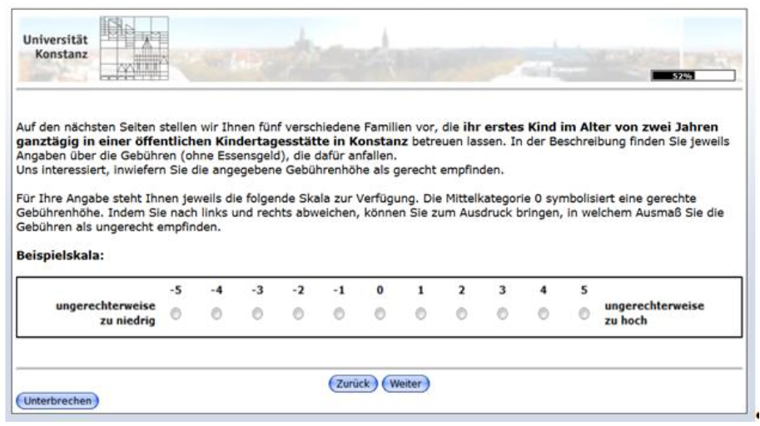

Appendix D: Interaction analysis: Income as respondent characteristic and vignette trait
We centered the three variables – income class, respondent household income and purchase power – and created two 2-way product terms and one 3-way product term. We ran the baseline model without any product terms (model A), then included the 2-way product term vignette income X respondent income (model B). The comparative F-test revealed a p-value of .001. In addition, we tried the inclusion of vignette income X purchase power that yielded a p-value of .133 (compared to model A). The third model C had both 2-way product terms and gave an F-test p-value of .167 (compared to model B). Finally, we ran a model D with all product terms and compared it against model B. The p-value was .378. We concluded that only the 2-way interaction between respondent income and vignette income improved the statistical fit of the model and interpreted it in more detail.

