Supplementary Material
Contents
- Spatial illustrations of the theoretical reasoning (Figures A1 and A2)
- Descriptive statistics (Table A1)
- Validating the measures of party positions (Table A2a,b and Table A3)
- Public opinion and policy change: descriptive and bivariate analyses (Figures A3 and A4)
- Additional logistic regression models of policy change (Table A4)
- Additional figures illustrating the interaction effects (Figures A5:A7)
- Time until policy change: duration analysis (Figure A8 and Table A5)

1. Spatial illustrations of the theoretical reasoning
This part of the Supplementary Material provides spatial illustrations of the theoretical arguments presented in the main text of the article. The purpose of these illustrations is to clarify further the logic behind the hypotheses we propose.
First, we deal with the aggregation of party preferences into a single government position. In Figure A1 the horizontal line represents a single policy dimension i (i.e. a continuum of ordered possible choices of policies on an issue; for example, the level of taxation or the strictness of immigration policy). The point labelled SQ_{i} stands for the status quo policy, and A_{i} is the policy alternative under consideration. In accordance with the standard postulates of spatial analysis, a policy alternative A_{i} is adopted if and only if it is preferred to the status quo by the government G_{j} (i.e. the alternative A_{i} is closer in spatial terms to the government’s most-preferred policy or ‘ideal point’ G^{j}_{i}). Note that the model takes the policy alternative under consideration versus the status quo as exogenous, i.e. determined outside the model. This is a major simplifying assumption as it relieves us from the burden of finding the policy that maximizes the government’s utility: we ‘only’ need to compare the exogenously given alternative to the status quo. But the empirical data we use to test the model is structured in terms of support for particular policy alternatives, which warrants making this simplifying theoretical assumption. Future work should attempt to incorporate the definition of the policy alternative endogenously within the model.
When the government is composed of a single unified party P^{k=1,Gj} that controls the necessary majorities in the legislature to adopt policies, we can take the ideal point P^{k=1,Gj}_{i} of this government party as the ideal point of the government as such. When there are multiple parties, things are more complicated and we need further assumptions to aggregate the positions of the coalition partners.
One possible aggregating assumption we can make is that each party in the coalition holds veto power over each policy alternative on all issues. This would lead to the expectation that only alternatives that make all government parties better off than the status quo will be adopted. For example, looking back at Figure 1, when we consider government G²composed of parties P^{1,G2} and P^{2,G2} we will expect under this ‘veto power’ assumption that the government will support the SQ_{i} versus A_{i} because the ideal point of the second government party P^{2,G2}_{i} is closer to the SQ_{i} than to the policy alternative A_{i}.
Another assumption we can make is that government positions are formed as the weighted average of the positions of the coalition parties with the weights corresponding to the relative size of the party in the coalition. In the preference configuration shown in Figure A1, this assumption will declare G²_{i} , which is equidistant from P^{1,G2} and P^{2,G2} , to be the ideal point of government G² (if the coalition partners have equal size; if not, the ideal point will be shifted towards the bigger partner). Hence, the government G² would be to closer the policy alternative A_{i} than to the SQ_{i} and would be predicted to adopt the policy alternative.

Figure A1. A spatial model of policy change as a function of party government preferences
P^{2,G2}_{i}

G²_{i}
G¹_{i} = P^{1,G1}_{i}
policy dimension
SQ_{i}
A_{i}
P^{1,G2}_{i}
Having clarified the aggregation of party preferences into a government position, we turn towards the issues of how the substantive, policy-related preferences of the government and their concern about public opinion combine.

Figure A2. A spatial model of policy change with governments having substantive policy preferences and concerned about public support
A_{i}`
G_{i}`
A_{i}
SQ_{i}`
G_{i}
policy dimension
public support versus SQ
50%
100%
0%
SQ_{i}
Figure A2 illustrates how the policy choices of governments are influenced both by their position on the substantive policy dimension and by their concerns about the popularity of different policy alternatives. The government’s ideal point, aggregated from party positions as discussed above, on the substantive policy dimension is G_{i}. The government’s utility declines with policies that are further away on the policy (horizontal) dimension and with lower public support for the policy alternatives (the vertical dimension). Public support is represented on the y-axis and runs from +100% support for a policy alternative versus the status quo (at the bottom) to 0% support (at the top) (hence, 100% prefer the status quo versus the alternative). The status quo’s position SQ_{i} on the policy dimension is always at 50% public support (because public support is expressed vis-à-vis the status quo). The thick solid black line running through points SQ_{i} and A_{i} represents the range of possible policy alternatives with their implied positions on the substantive policy dimension and their levels of public support compared to the status quo.
In the example illustrated in Figure 2, the government’s ideal point G_{i} is closer to the SQ_{i} than to the policy alternative A_{i}, as the distance between G_{i} and SQ_{i} is smaller than the distance between G_{i} and A_{i}. The government will prefer a policy alternative to the status quo only in the region of the line between SQ_{i} and SQ_{i}` Hence, the government will choose SQ_{i} over A_{i}, which is preferred to the status quo by less than 50% per cent of the population.
However, if A_{i} had the same level of public support as the status quo (i.e. 50%), the government would have chosen A_{i}, since it is closer to its ideal point it terms of the substantive policy that A_{i} implies. This is seen by comparing the distance between the points G_{i}` and A_{i}`, which are the projections of G_{i} and A_{i} on the 50% line, with the distance between G_{i}` and SQ_{i}. In other words, if public opinion did not matter (or if it was the same for A_{i} and SQ_{i}), A_{i} would have been chosen, but given that public support matters, and the way it is distributed, the government prefers SQ_{i}.

2. Descriptive statistics

Table A1. Descriptive statistics
Variable | Minimum | Mean |  | Median | Maximum | St. dev.
Public support | 0.04 | 0.51 |  | 0.52 | 0.97 | 0.21
Net public support | -0.90 | 0.12 |  | 0.17 | 0.96 | 0.40
Media salience | 0.00 | 10.66 |  | 4.00 | 153.00 | 18.38
Duration of policy change (in months); censored at 48 months | 0.00 | 14.97 |  | 10.00 | 46.00 | 13.54
Mean governmnet position (centered) | -1.73 | 0.42 |  | 0.07 | 2.63 | 1.27
Minimum governmnet position (centered) | -3.80 | -0.36 |  | -0.17 | 2.11 | 1.52
Maximum governmnet position (centered) | -1.40 | 1.12 |  | 1.50 | 3.19 | 1.35
Range government position | 0.00 | 1.48 |  | 0.93 | 4.02 | 1.32
Variable | Distribution
Existing proposal [yes/no] | 17% / /83%
Direction of policy change [right/left] | 56%/ / 44%
Policy change [yes/no] | 39%/ / 61%
Policy scale [general LR/econ./GALTAN] | 38% / /45%/ / 18%

3. Validating the measures of party positions
This part of the Supplementary Material explores the validity of the expert and manifesto-based measures of party positions. To do that, we obtained direct measures of the party positions for 102 policy issues in Germany on the basis of a comprehensive media search in German newspapers, starting with Süddeutsche Zeitung and Frankfurter Allgemeine Zeitung and extending the search when necessary (reference forthcoming). On the basis of this media search, the party positions on each issues had been coded as ‘In favor’ of the call for action on the policy issues, “Against”, or ‘Neutral’. We focus on the four parties that have been in government during our period of observation in Germany: CDU/CSU, SPD, FDP, and Die Grünen.
To compare this set of direct measures to the expert and manifesto-based ones, first we cross-tabulate them in order to examine the overlap and then we regress the directly-measured party positions on the general policy scale measures. The expert-based policy scale measures are based on the Chapel Hill dataset (Bakker et al. 2015). All 102 issues are assigned to one of the three main scales in this expert survey: general left-right, socio-economic left-right and GAL/TAN (green, alternative, liberal vs. traditional, authoritarian, nationalist). The manifesto-based measures are based on data from the Manifesto Project (Klingemann et al. 2007). In this dataset, all 102 issues are assigned to 12 different scales (education spending, environmental protection, foreign alliances, free market economy, internationalism, justice and freedom, macroeconomy, militarism, multiculturalism, target groups, traditional morality, welfare state), and the party positions on each scale are scaled according to the method proposed by Lowe et al. (2011).
To examine the overlap, we dichotomized the direct measures into ‘opposition’ or ‘’no opposition’ (support or neutral) to the implied policy change, and we dichotomized the expert- and manifesto-based measures at the midpoints of the scales (5 and 0, respectively). Parties to the right of the midpoint can be considered right-wing, and parties to the left of the scales can be considered left-wing. We would expect right-wing parties to oppose policy changes moving the status quo towards the left and not to oppose policy changes moving the status quo to the right. Similarly, we would expect left parties to oppose right-leaning policy changes and not to oppose left-leaning ones.
Tables A2a and A2b present the results of the comparison. The entries in each cell show the number of positions in the respective category and indicate in brackets the shares from all positions (the ‘correct’ classifications are in green and the incorrect ones in red). For example, when we look at Table A2a that focuses on the Chapel Hill (CH) data, for left-leaning changes (changes that would move the status quo to the left) in 21 cases parties to the left of the midpoint of the relevant CH scale have actually opposed the changes (14% of the total), in 58 cases left parties have not opposed such changes (38% of the total), parties to the right of the midpoint have opposed left-leaning changes in 47 of the cases (31%) and have not opposed them in 26 cases (17%).

Table A2a. Comparison between directly-measures positions and expert survey-based positions on three scales (CH)
Left-leaning changes (46%) | CH position left of middle | CH position right of middle
Against | 21 (14%) | 47 (31%)
Not against (in favour/neutral) | 58 (38%) | 26 (17%)

Right-leaning changes (54%) | CH position left of middle | CH position right of middle
Against | 48 (27%) | 29 (16%)
Not against (in favour/neutral) | 46 (26%) | 53 (30%)

Table A2b. Comparison between directly-measures positions and Manifesto-based positions on 12 scales (M)
Left-leaning changes (46%) | M position left of middle | M position right of middle
Against | 36 (24%) | 32 (21%)
Not against (in favour/neutral) | 63 (41%) | 21 (14%)

Right-leaning changes (54%) | M position left of middle | M position right of middle
Against | 43 (24%) | 34 (19%)
Not against (in favour/neutral) | 40 (23%) | 59 (34%)

Overall, with the Chapel Hill data (Table 2Aa), 63% of the cases are correctly classified. For left-leaning changes, 69% of the cases are correctly classified (parties left of the middle not opposing the changes and parties right of the middle opposing them). For right-leaning changes, 57% of the cases are correctly classified. When it comes to left parties on right-leaning changes, the match is not very good.
Overall, with the Manifesto data (Table 2Ab), 59% of the cases are correctly classified. For left-leaning changes, 62% of the cases are correctly classified (parties left of the middle not opposing the changes and parties right of the middle opposing them). For right-leaning changes, 57% of the cases are correctly classified. When it comes to left parties on right-leaning changes, the match is not very good. The expert survey-based positions (Chapel Hill data) provide a better match to the directly-measured positions. Compared to the Manifesto positions, these measures do better in particular when identifying the opposition of right parties to left-leaning changes.
Another way in which we can explore the relationships between the direct positions measures and the party positions on the expert- and manifesto-based scales is to regress one of the position categories (‘opposition’) on the party positions measured on the relevant scales. Table A3 presents the result of such logistic regressions (separately for left- and right-leaning changes and for the two scale measures). We would expect significant negative coefficients of the scaled positions on right-leaning changes (the further to the right a party is on the scale, the less likely to oppose policy changes moving the status quo to the right) and significant positive coefficients for left-leaning changes.

Table A3. Logistic regression models of party opposition
 | CH data  Left-leaning changes | CH data  Right-leaning changes | Manifesto data  Left-leaning changes | Manifesto data  Right-leaning changes
Intercept | -2.90 (0.60)  p-value<0.001 | 0.68 (0.47)  p-value=0.15 | -0.12 (0.17)  p-value=0.50 | -0.25 (0.15)  p-value=0.10
Party position on the relevant scale | 0.52 (0.11)  p-value<0.001 | -0.18 (0.09)  p-value=0.04 | 0.19 (1.08)  p-value=0.01 | -0.01 (0.08)  p-value=0.89
N | 151 | 175 | 151 | 175
Note: Logistic regression models (with logit link). Dependent variable: party opposition to policy change. Unit of analysis is a party/policy issue. Unstandardized and unexponentiated coefficients.
The results from the regression analyses show that the expert survey-based (CH) scaled positions are highly and significantly predictive of opposition to policy change, both for left- and right-leaning changes. The Manifesto-based scaled positions perform worse, especially when it comes to right-leaning changes where the coefficient of the scaled positions is practically zero. This conclusion is in line with the inferences from the cross-tabulations presented above, which indicated that the Chapel Hill data provide a better fit to the directly-measured positions.

4. Public opinion and policy change: Descriptive and bivariate analyses

Figure A3. Public opinion and policy change in Western Europe: responsiveness and congruence
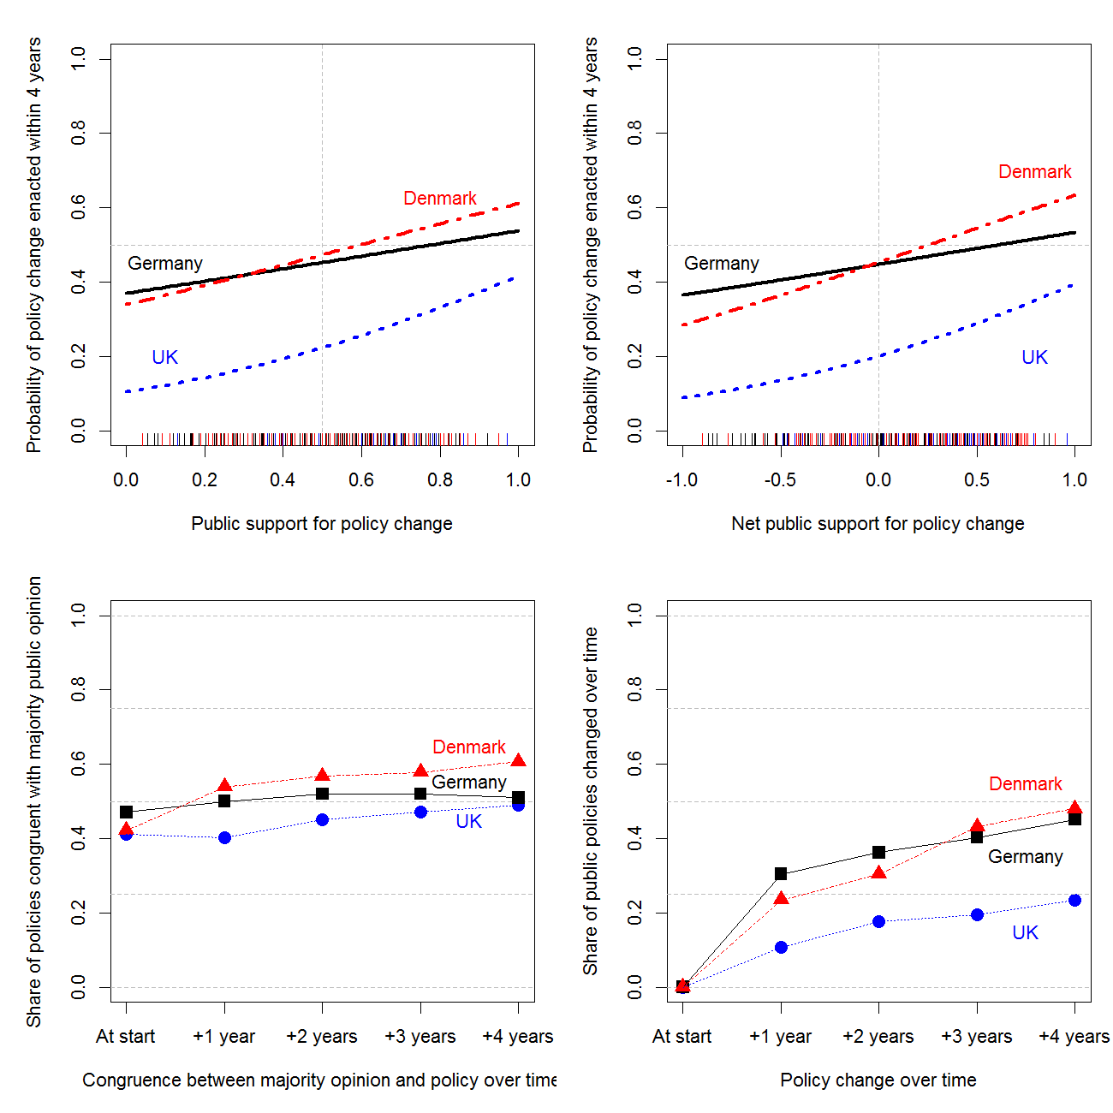
The top two panels of Figure A3 show how the likelihood of policy change varies with the percentage support for policy change (top-left) and with net public support for policy change (top-right). The lines for each of the three countries are based on the estimates from country-level logistic regression models of policy change regressed on public support and net public support, respectively. Clearly, in all three countries the likelihood of policy change increases with higher levels of public support, both absolute and net.
The strength of responsiveness is greatest in the UK and smallest in Germany. In substantive terms, however, the effect of public opinion is relatively small – for a change in the share of the public supporting policy change from 0 to 1 (a rather unlikely change), the likelihood of the government adopting the policy only shifts from 37% to 54% in Germany, from 34% to 61% in Denmark, and from 10% to 30% in the UK. For an increase in public support of 10 percentage points (still large, but more realistic), the likelihood of policy change increases with around 1.6 percentage points in Germany, around 2.6 percentage points in Denmark, and with around 3 percentage points in the UK. Also, note that the lines cross the y-axis at rather high points meaning that policy change has a substantial chance of happening even in the complete lack of public support.
The positive relationship between public support and the likelihood of policy change is not statistically significant in the country-level models without additional covariates. It is also worth noting that a policy change needs to enjoy at least 60% public support in Denmark and 80% in Germany to have a 50% or higher chance of being enacted within the next four years. In the UK sample, the bias towards the status quo is even more pronounced with policy change having an estimated maximum likelihood of only 42% even with maximum public support.
Another way to explore the relationship between public opinion and policy change is to examine the percentage of policies that are congruent with majority public opinion (meaning that the policy status quo at the time has the support of the majority of the public). The bottom-left panel of Figure A3 tracks average congruence for each country over our four-year period of observation. The three countries start with similar levels of congruence at the time when the opinions polls are taken (with public support favouring the status quo in 41% in Denmark and the UK and 48% in Germany). Over time, congruence rises to 50% in the UK, to 51% in Germany, and to 61% in Denmark. In sum, for the set of policy issues in our sample, four years after the initial call for public action congruence with public opinion is present in around half of the cases in Germany and the UK and round 3 out of 5 cases in Denmark.
These very modest levels of congruence between policy and majority public opinion and even more modest levels of improvements in congruence over time happen despite a considerable degree of policy-making activity, as evidenced in the bottom-right panel of Figure A3. The plot shows the share of policies in the sample that experienced policy change (no matter whether favoured by public opinion or not) over four years. In the UK, around one quarter of the policies in the sample are changed within our period of observation; in Germany and Denmark, a little less than half. This implies that while policy change occurs frequently, it often goes against majority public opinion, and it does not necessarily happen for all policies that have majority support.
The varying rates of policy change across the three countries evident in the plot also explain how the UK can be the most responsive to public opinion and the least congruent at the same time. While the overall level of policy-making change in the UK is low, when change happens, it is relatively responsive to public opinion support. On the contrary, Germany changes relatively many of its policies, but the ones that lack public support are almost as likely to be changed as ones that enjoy the support of the majority.
The analysis so far implicitly assumed that the effect of (net) public opinion is linear (on the scale of the predictor) in the logistic regression curves presented in the top two panels. It turns out that the effect is more complex than that. Figure A4 plots the predicted effect of public support (left panel) and net public support (right panel) on the likelihood of policy change as estimated by the non-linear local polynomial regression fitting (loess) function.

Figure A4. The relationship between public opinion and policy change
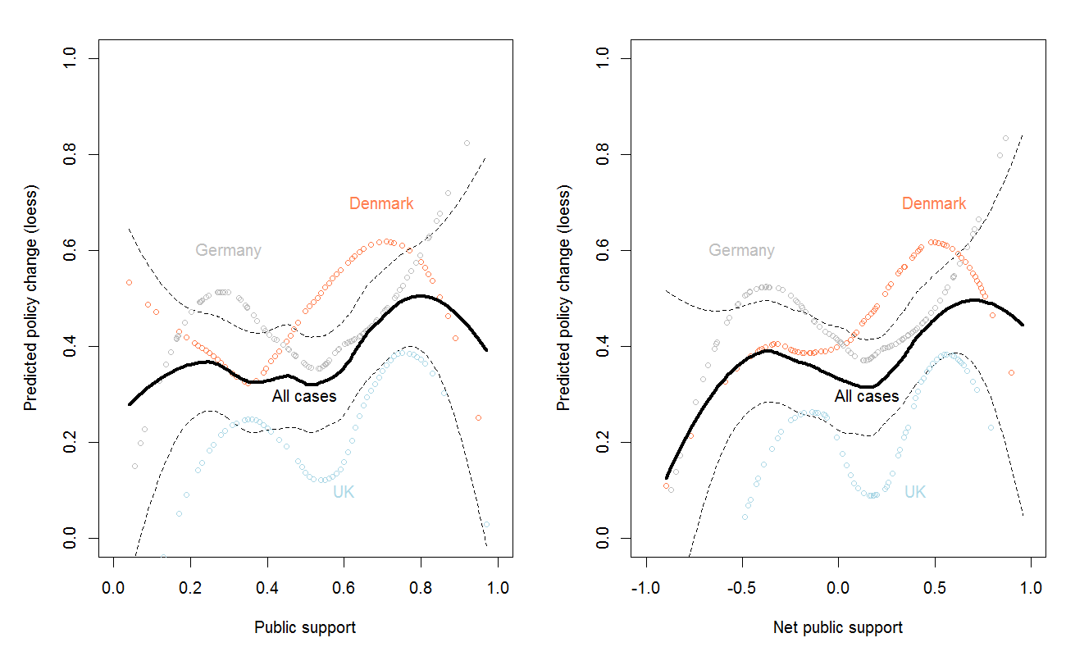
The solid black lines show the effect in the combined dataset while the dotted lines show the effect in models estimated on country-specific data. In the general case, it appears that as public support for policy increases from 0 to about 20% (and net support increases from -1 to about -0.5), the probability of policy change grows. However, between 20% and 50% support (and between -0.5 and +0.1 net support), the probability of change slightly decreases. Once support passes the 50% threshold (and +0.1 net support), the probability of policy change starts to increase again, but then for very high values of support, it decreases once more. The patterns differ somewhat among the three countries and given the relatively small sample size (especially at more extreme values of public opinion), we should be careful not to overinterpret these results. But they remain suggestive as to the non-linearity of the effect of public opinion on policy change. Because the form of the effect does not match a simple polynomial function (such as quadratic or log), we do not attempt to model it in the multivariate models we present below. As a precaution to nonlinearity, we also estimate the multivariate models with the public support variable dichotomized at the 50% mark.
We should also note the difference between the effects of (absolute) public support and net public support. While the effect on policy change of both these variables is positive, there is an important subtlety. When we dichotomize public support into just two categories (above and below 50%), the observed frequency of policy change is higher when a majority of the public supports policy change (43% vs. 33%), in line with theoretical expectations. However, the conclusion changes when we consider net public support. If we just dichotomize net public support into less than 0 (hence, net opposition) and above zero (hence, net support), the observed frequencies of policy change are almost exactly the same. This implies that when an absolute majority of public support is absent but the percentage of the public supporting the policy is still larger than the percentage opposing it, no policy change happens (from the 23 cases where there is no majority support but still there is net public support, 21 experience no policy change and only 2 do). In sum, it is not so much the relative share of policy supporters versus opponents that matters for the likelihood of policy change, but the absolute share of supporters from all citizens (including those without strong opinions on the issue).

5. Additional logistic regression models of policy change

Table A4. Additional logistic regression models of policy change
 | Model A1 | Model A2 | Model A3 | Model A4
Intercept | -2.46 (0.84)  p-value=0.003 | -3.07 (0.79)  p-value<0.001 | -2.42 (0.83)  p-value=0.004 | -2.27 (0.82)  p-value=0.006
Public support | 4.31 (1.95)  p-value=0.027 | 3.37 (1.78)  p-value=0.059 | 3.57 (1.87)  p-value=0.057 | 3.39 (1.95)  p-value=0.082
Government support | 0.10 (0.08)  p-value=0.224 | 0.11 (0.08)  p-value=0.204 | 0.15 (0.09)  p-value=0.100 | 0.13 (0.09)  p-value=0.129
Public support*Gov. support | -0.69 (0.36)  p-value=0.057 | -0.29 (0.40)  p-value=0.476 | -0.35 (0.39)  p-value=0.367 | -0.44 (0.41)  p-value=0.277
Number of parties in government | -0.20 (0.28)  p-value=0.475 | -0.02 (0.24)  p-value=0.936 | -0.26 (0.27)  p-value=0.342 | -0.30 (0.26)  p-value=0.249
Public support*Number of parties | -0.54 (0.88)  p-value=0.081 | -0.72 (0.63)  p-value=0.252 | -0.98 (0.82)  p-value=0.228 | -1.04 (0.85)  p-value=0.218
Media salience | 0.33 (0.10)  p-value=0.002 | 0.34 (0.10)  p-value=0.001 | 0.32 (0.10)  p-value=0.002 | 0.32 (0.10)  p-value=0.003
Public support*Media salience | / | / | / | 0.22 (0.43)  p-value=0.604
Existing proposal | 0.95 (0.29)  p-value=0.001 | 0.99 (0.29)  p-value=0.001 | 0.92 (0.29)  p-value=0.002 | 0.92 (0.29)  p-value=0.002
Remaining months | 0.04 (0.01)  p-value<0.001 | 0.04 (0.01)  p-value<0.001 | 0.04 (0.01)  p-value<0.001 | 0.04 (0.01)  p-value<0.001
Denmark | 0.28 (0.33)  p-value=0.394 | 0.43 (0.36)  p-value=0.239 | 0.22 (0.33)  p-value=0.496 | 0.25 (0.33)  p-value=0.450
United Kingdom | -1.28 (0.46)  p-value=0.007 | -0.97 (0.44)  p-value=0.026 | -1.41 (0.46)  p-value=0.002 | -1.32 (0.46)  p-value=0.004
AIC | 518 | 519 | 517 | 515
Note: Logistic regression models (with logit link). Dependent variable: occurrence of policy change. Unit of analysis is a government spell; N=525. Unstandardized and unexponentiated coefficients. Public opinion centered at 0.5. Government positions centered at 0. Media saliency is logged.
Model A1 features a measure of government support that is calculated under the assumptions that every government party has veto over the proposals (rather than the weighted average measure reported in the other models). Note that the statistical significance of the interactions in this model is not robust to entering the interactions one by one. Models A2 features measures of the number of coalition partners and government preferences that take into account unofficial coalition partners of the Danish minority government parties. Model A3 uses an alternative measure of public support calculated as percentage from respondents excluding 'don't knows'. Model A4 enters all interactions in the same model.

6. Additional figures illustrating the interaction effects

Figure A5. Interactions between public support and government support.
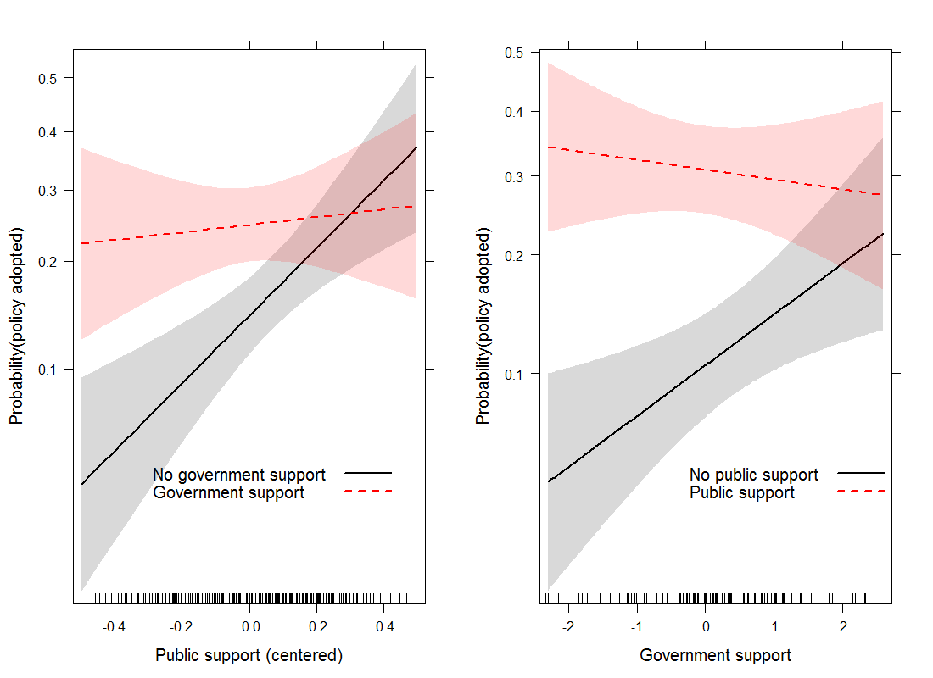
The illustrated interaction effect is based on the estimates of Model 3 in the main text. The shaded regions indicate 75% (thus, not the more usual 95%) confidence limits. On the left panel, public opinion runs from no support to full support on the x-axis and the two regression slopes are drawn for issues with (+2.6) and without government support (-2.3). On the right panel, government support run from the observed minimum to the observed maximum on the x-axis and the two regression slopes for the effects on policy change (represented on the y-axis) are drawn for issues that have total public support (+0.45) and no support (-.045) at all.

Figure A6. Interactions between public support and number of parties in government.
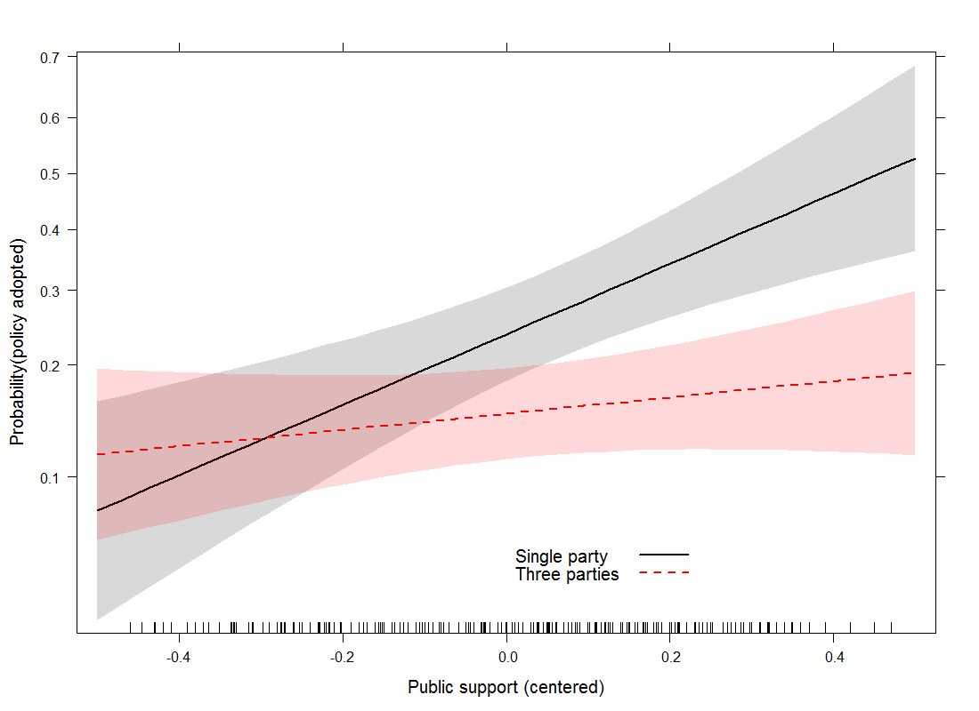
The illustrated interaction effect is based on the estimates of Model 3 in the main text. The shaded regions indicate 75% (thus, not the more usual 95%) confidence limits. Public opinion runs from no support to full support on the x-axis and the two regression slopes are drawn for issues under a single government and under a three party-government.

Figure A7. Interactions between public support and salience.
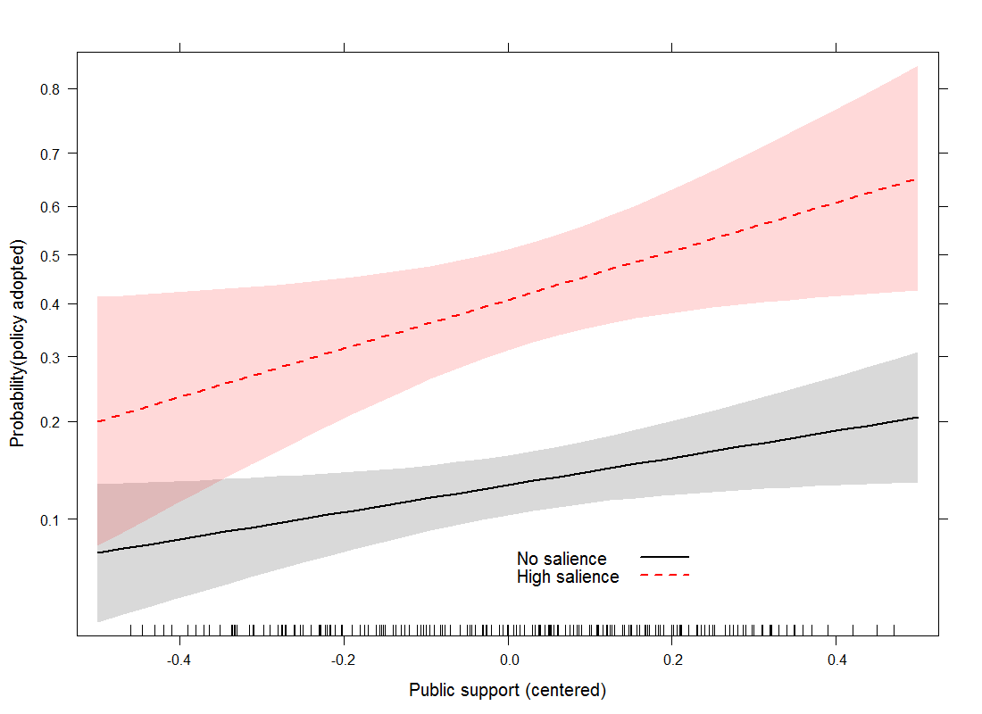
The illustrated interaction effect is based on the estimates of Model 4 in the main text. The shaded regions indicate 75% (thus, not the more usual 95%) confidence limits. Public opinion runs from no support to full support on the x-axis and the two regression slopes are drawn for issues with no salience and issues with high salience (fixed at the maximum observed value in the data).

7. Time until policy change: duration analysis

Figure A8. Kaplan-Meier survival curves: share of policy issues on which policy change is enacted over time, per different types of proposals
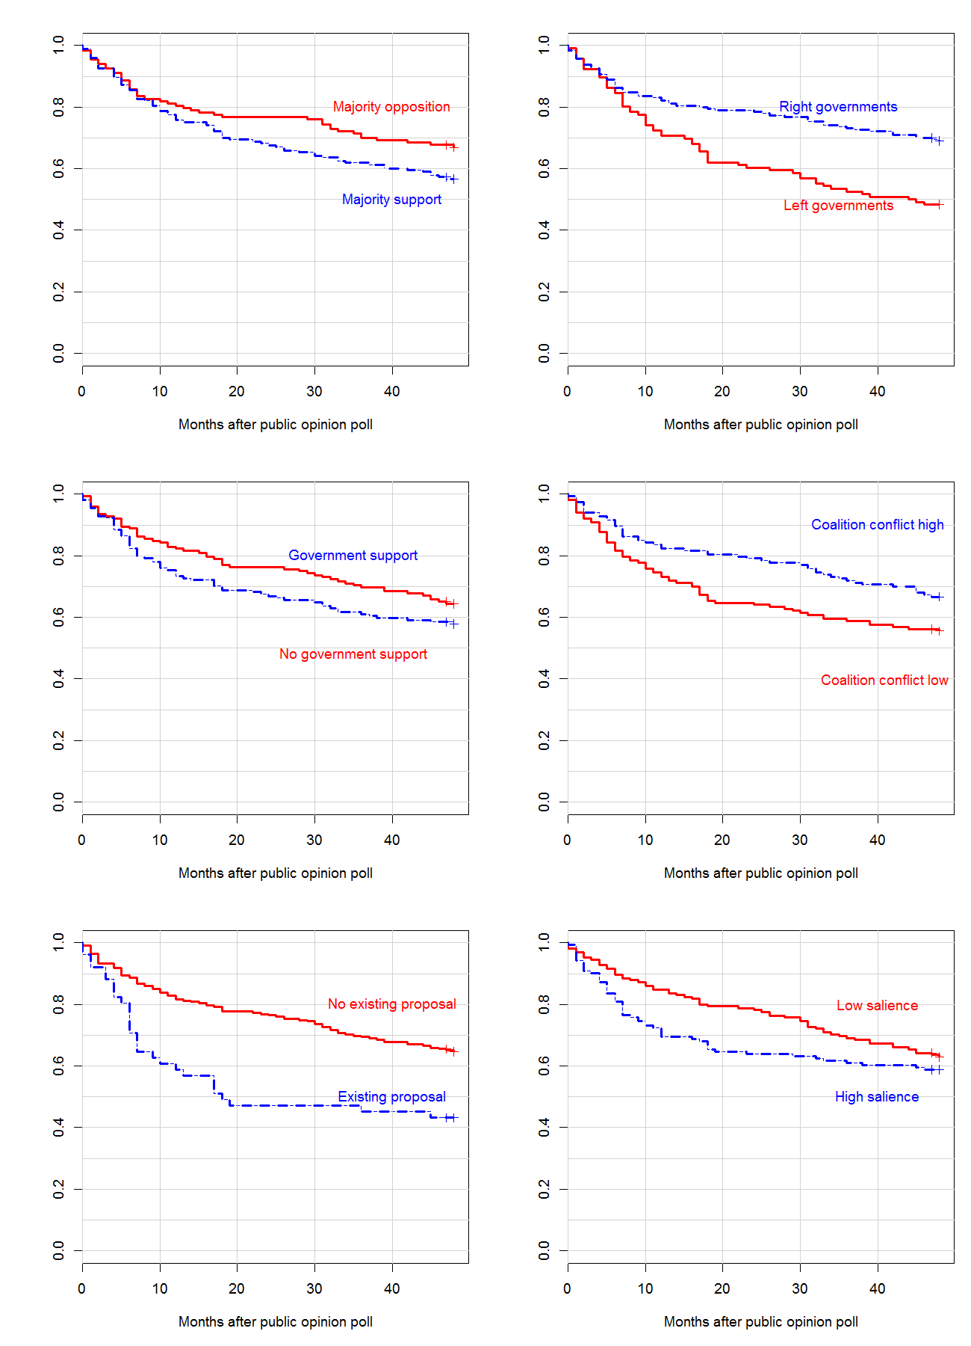
The plots trace the share of non-adopted proposals for different subgroups of cases over each month of the observation period (up to 48 months). Note that the starting observation date for each case – the date of the opinion poll – is to some extent arbitrary. However, there should be no systematic bias across the major variables of interest in terms of the starting dates. The different panels of the figure show the survival curves for cases with majority public support or not; decided under left/GAL and right/TAN governments; with implied policy direction consistent with the government position or not; under higher or lower than average coalition conflict; for cases with pre-existing bill or not, and for cases of higher or lower than average salience. The steeper the slopes of the lines, the faster the specific types of cases represented by the lines get adopted. The greater the distance between the two curves on each plot, the bigger the difference in the relative share of adopted cases from the two respective groups of cases at the point of time indicated by the x-axis.
We can see from the plot in the top-left corner of Figure A8 that during the first 8 months of the lifetime of cases, majority public support does not make a difference on the probability of policy change enactment. After this point, a difference appears that grows until about month 30, and then starts to shrink somewhat. The dynamic is similar for cases that differ in implied direction of the policy changed (in line with government positions or not).
Looking at the difference between governments with left/GAL and right/TAN positions (top-right panel), the former appear to enact a higher share of cases (consistent with the insights from the previous analyses), and the difference grows over time. The effect of coalition conflict sets in a few months earlier, but starts to disappear after month 16. The effect of having an existing proposal is greatest in terms of size (bottom-left panel), but it is mostly due to changes that accumulate in the first twelve months of the lifetime of cases: if a policy change has not been enacted within this period, it makes little difference whether an existing bill has been in place or not in the beginning of the observation period. The (smaller in absolute size) effect of media salience also sets in early and starts to decline after month 18 or so. Altogether, Figure A8 shows that the effects of all variables considered so far are not very stable over time, and most effects are rather small altogether.
The analyses so far focused on the question whether policy change occurred at all within a four-year period after the public opinion survey was conducted. The speed of policy change, however, is another important aspect that deserves attention in its own right. In addition, the event history analysis can address the complication that for many of our cases the observation time is censored at four years, which is the length of time we followed each policy issue.
Table A5 presents the results of three Cox proportional hazards models with time-varying measures of government positions and coalition conflict. Model A5 has the main effects of interest, while Models A6 and A7 add the two interactions – between coalition conflict and public support and between government support and public support, respectively. The findings are very similar to the logistic regressions of the likelihood of policy change presented above. Public support has a consistently positive and significant (in Models A5 and A7) effect on the hazard of policy change (hence, it is associated with shorter durations until change occurs). Coalition conflict has no effect, while the main effect of government support is positive and marginally significant leaving some evidence that policy changes in line with the general positions of the government tend to occur faster.

Table A5. Cox Proportional Hazards models with time-varying covariates
 | Model A5 | Model A6 | Model A7
Public support | 0.94 (0.45) * | 0.72 (0.77) | 1.05 (0.45) *
Coalition conflict | 0.03 (0.09) | 0.02 (0.09) | 0.02 (0.09)
Government support | 0.10 (0.06)’ | 0.10 (0.06)’ | 0.12 (0.07)’
Public support*Coalition conflict | / | 0.14 (0.38) | /
Public support*Government support | / | / | -0.40 (0.29)
Media saliency | 0.26 (0.09) ** | 0.26 (0.09) ** | 0.27 (0.09) **
Existing proposal | 0.80 (0.22)*** | 0.80 (0.22)*** | 0.81 (0.21) ***
Note: Cox Proportional Hazards models with time-varying covariates. Dependent variable: occurrence of policy change on a policy in a month. N=10815. The models are stratified by country and clustered by case id. Unstandardized and unexponentiated coefficients. Public opinion centered at 0.5. Media saliency is logged. Significance levels: 0 < *** < 0.001 < ** < 0.01 * < 0.05 ` < 0.1

