Appendix
A goodness of fit test is performed by simulating a distribution of networks using the results from our ERGM and then comparing the observed network data to the distribution of a selection of network statistics in the simulated data that are not included in our model. A model is considered a good fit if the observed network configurations lie within the simulated distributions of these configurations. In figure A1, we compare the following network statistics: (1) Dyad-wise shared partners distribution, (2) the edgewise-shared partner distribution, (3) the in-degree distribution, and (4) geodesic distances distribution. The lines going horizontally across the figures above represent the observed network data, and the boxplots represent the distribution of the configurations that were simulated using the parameter estimates from model 5. The figures show that the observed networks lie within the distributions for the four different configurations, implying our ERGM is a good fit.

Table A1 Goodness of fit plots for model 5
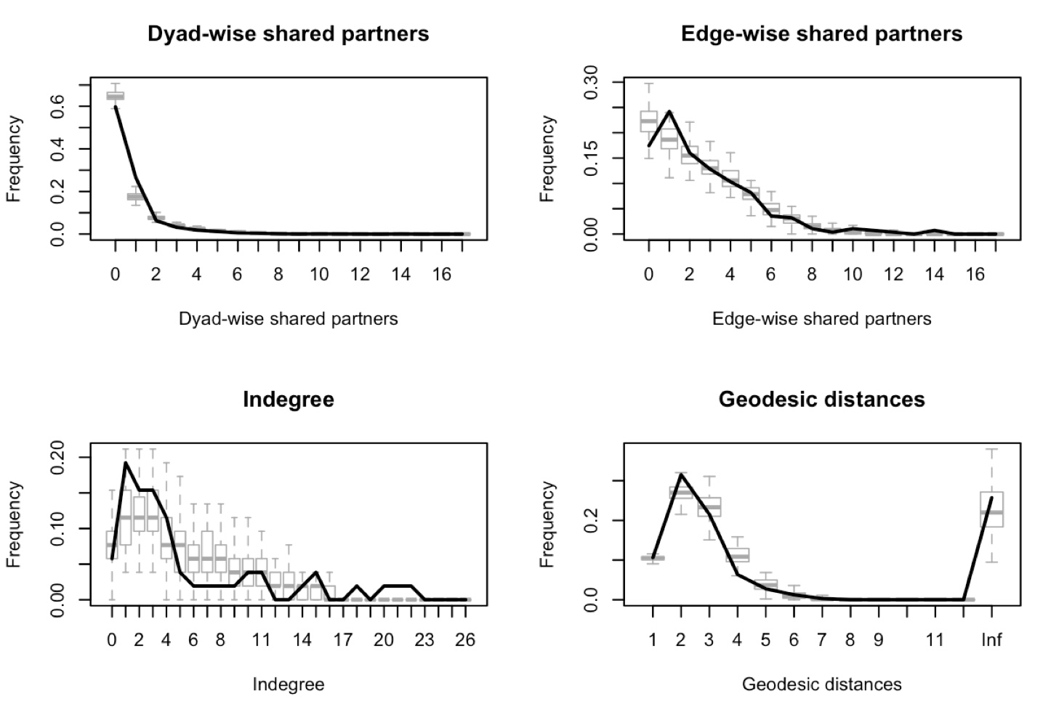

Survey Questions
Which measures make a sensible contribution to tackling the challenges of climate change? (Five point Likert scale)

- Voluntary action by businesses
- Emission trading within EU
- Self-commitment of individual states to reduce GHG-emissions
- Expansion of nuclear energy
- Subvention of renewable energy
- Increased use of bio fuels
- Use of CCS-technology (carbon capture storage)
- Reforestation and avoided deforestation strategies
- Reduction of fuel consumption in transportation
- Private action to minimize the individual ecological footprint
- Carbon offsetting
- Lower speed limits
- Tax on CO2
- Sector specific goals to reduce GHG-emission
- Sector specific legal limits to GHG-emission
- Developing cleantech business solutions

Do you agree or disagree with the following statements: (five point Likert scale)

- My country should take a leading international role in GHG reduction
- GHG-emission have negative impacts on the economy.
- GHG reduction creates jobs and opportunities for economic growth
- Securing the national energy supply is more important than the reducing emission.
- The current GHG reduction target of my government is too ambitious.
- The transition to renewable energy supply is too costly.
- In the long term, energy supply can be secured exclusively by renewable energies.
- Nuclear energy is the most realistic alternative to fossil fuels.
- In the long term, the economy profits from the transition to renewable energies.
- The target of my country's government for renewable energy is too ambitious.

