Online Appendix 1: List of Actors

 | Acronym | Actors | Actor type | Conflict | Level
1 | ARPEA | Western Swiss Association for Water and Air Protection | Environmental association | Environment | Regional
2 | BAFU-Chem | Federal Office for the Environment, Department of Air Protection and Chemicals | Federal government, parliament | Other | National
3 | BAFU-W/UVEK | Federal Office for the Environment, Department for Water | Federal government, parliament | Other | National
4 | BAG | Federal Office for Health | Federal government, parliament | Other | National
5 | BLW | Federal Office for Agriculture | Federal government, parliament | Other | National
6 | BMG | BMG Engineering AG | Science | Other | National
7 | BPUK | Conference of Cantonal Directors of Construction, Planning and Environmental Protection | Water association, local/cantonal actor | Environment | Regional
8 | CERCL | Cercl’eau | Water association, local/cantonal actor | Environment | Regional
9 | CVP | Christian Democratic People's Party | Political parties | Other | National
10 | ECON/SAV | Economiesuisse / Swiss Employers' Association | Industrial/agricultural association | Economy | National
11 | ERFA | Sewage Treatment Plants in Large Cities Initiative | Water association, local/cantonal actor | Environment | Local
12 | FDP | Free Democratic Party. The Liberals | Political parties | Other | National
13 | FISCH | Swiss Fishery Association | Environmental association | Environment | National
14 | GPS | Swiss Green Party | Political parties | Other | National
15 | HKBB | Basel Chamber of Commerce | Industrial/agricultural association | Economy | Regional
16 | HUNZIKER | Hunziker-Betatech | Science | Other | National
17 | KI/SSV/SGV | Communal Infrastructure / Swiss Cities Association / Swiss Municipalities Association | Water association, local/cantonal actor | Environment | Local
18 | KVU | Conference of Heads of Cantonal Offices for Environmental Protection | Water association, local/cantonal actor | Environment | Regional
19 | OEKOTOX | Ecotox Centre | Science | Other | National
20 | PRONA | Pro Natura | Environmental association | Environment | National
21 | SBV | Swiss Farmers' Association | Industrial/agricultural association | Economy | National
22 | SGV | Swiss Trade Association | Industrial/agricultural association | Economy | National
23 | SP | Swiss Social Democratic Party | Political parties | Other | National
24 | SVGW | Swiss Gas and Water Industry Association | Water association, local/cantonal actor | Environment | National
25 | SVP | Swiss People's Party | Political parties | Other | National
26 | UBAS | University of Basel | Science | Other | Regional
27 | UREKN | National Council's Committee on the Environment, Spatial Planning and Energy | Federal government, parliament | Other | National
28 | UREKS | Council of State's Committee on the Environment, Spatial Planning and Energy | Federal government, parliament | Other | National
29 | VKCS | Association of Cantonal Chemists of Switzerland | Water association, local/cantonal actor | Environment | Regional
30 | VSA | Swiss Water Association | Water association, local/cantonal actor | Environment | National
31 | WWF | World Wide Fund For Nature Switzerland | Environmental association | Environment | National
Model 1 includes one more actor (who exhibits missing data on the variable “similarity of objectives” in Model 2):
32 | EFV | Swiss Finance Administration | Federal government, parliament | Other | National

Online Appendix 2: Robustness Checks and Alternative Specifications
This online appendix addresses questions related to the statistical model and its robustness and quality. All robustness checks are carried out on the basis of Model 2.

Multicollinearity
Three operationalizations of policy objectives (H1a-H1c) and three operationalizations of interconnectedness (H2a-H2c) are included in Models 1 and 2. To rule out multicollinearity within each group of covariates as well as between the two hypotheses, variance inflation factors (VIF) were computed from 1,000 simulations based on Model 2. VIF are normally computed based on explained variance in a regression model. This is not feasible in an ERGM context because the observations are not independent. Duxbury (2017) suggested VIF for ERGMs based on simulated statistics instead. VIF scores above 20 are concerning and above 100 would indicate severe multicollinearity (Duxbury 2017). The VIFs scores for the two main hypotheses, H1c and H2a, are 2.26 and 7.88, respectively, and therefore do not indicate any multicollinearity.
The VIF scores for the non-significant H1a, H1b, H2b, and H2c in Model 2 are 35.33, 31.71, 23.14, and 1.70, respectively. This seems logical as they are all alternative indicators of the respective main hypotheses, policy objectives and interconnectedness. To rule out that this moderate collinearity has an impact on the findings, Model 2a in the table below reports a version of Model 2 without these four non-significant model terms. With the omission of these terms, the results do not change substantively. Hence multicollinearity is not an issue here.

Overarching instrument categories
One may object that the 15 policy instruments are sub-instruments of broader categories, such as market-based, regulatory, and information-based instruments (see Table 1). To test for the differential popularity of each of these categories of instruments, we introduce a separate model term for each category separately in Models 2b, 2c, and 2d below. None of these effects change the substantive conclusions on policy objectives and interconnectedness substantively, and none of the instrument categories seems to stick out as particularly prominent targets of rejection. Model 2e furthermore introduces a homophily term for instrument types (“Instrument type match”), which tests whether an actor more likely chooses an instrument if the actor also chooses other instruments from the same broad category. This adds some explanatory power to the model and yields a significant estimate. At the same time, the effect for conflict line (H1c) is still significant while interconnectedness (H2a) drops out of significance. This suggests that instrument type clustering may partly covary with interconnectedness. However, introducing instrument clustering is a form of restricting the variance of the dependent variable artificially; hence this result should be treated with caution. Furthermore, the overall model fit as indicated by the Bayesian Information Criterion (BIC) improves only by a small margin.

The role of government actors
One may object that government actors (including federal, regional, and local government agencies, (state-led) water associations, parliament, and political parties) may perform a special role in environmental policy because, as decision makers, they may be naturally more inclined to hold rejecting policy instrument preferences or to hold coherent views that differ from the remaining actors. To test for this possibility and assess its effect on the other model terms, two additional terms are included in Model 2f: a main effect that tests whether government actors reject more or fewer instruments than other actors (“Government actor”), and a homophily effect that tests whether a government actor chooses a policy instrument if many other government actors also choose this instrument (“Government actor homophily”). The results indicate that the parameters are insignificant and do not affect any other substantive conclusions.

Geographic proximity
Another potential confounder may be geographic proximity. The extent of the micropollution problem varies geographically, and we need to rule out that the other model terms capture similarity in terms of spatial clustering.
Let $S$ be a weighted $32×32$ matrix indicating the geographic/spatial distance between actors $i$ and $k$ in meters. Then inserting the function
$$f_{geogrprox}(i, k, S)=\log{\frac{1}{1+S_{ik}}}$$
into a bipartite homophily model term measures the tendency of actors to reject instruments that other actors to whom they are spatially proximate also reject. In other words, this term tests whether geographic proximity is associated with similar policy preferences. The results from Model 2g demonstrate that this is not the case and that the inclusion of geographic proximity in the model does not change any other substantive conclusions.

Actor type match
Another alternative explanation for similar policy preferences may be homophily with regard to actor type similarity. For example, environmental associations may have similar views among each other, or industry and agricultural associations may have similar instrument preferences among each other. Actor type was coded at six levels (1 = federal, parliament; 2 = parties; 3 = cantonal, state-led water association, local government; 4 = environmental association; 5 = industry, agricultural association; 6 = science). The actor type match homophily term in Model 2h captures the tendency of an actor to reject an instrument if the same instrument is also rejected by other actors of the same type. This controls effectively for clustering of preferences within different functional roles of actors. The results indicate that actor type homophily does not contribute to our understanding of instrument preferences and that its inclusion does not alter the other coefficients substantively.

Maximum Pseudolikelihood Estimation (MPLE)
Maximum Pseudolikelihood Estimation (MPLE) is an alternative estimation technique for ERGMs. It is known to be severely biased, but may serve as an additional simple robustness check. If the results are roughly identical with the MCMC-MLE-based results, then this increases our confidence in the original results. This is the case here, as Model 2i, a replication of Model 2 with MPLE, yields identical substantive conclusions.

Details of the MCMC-MLE approach
Models 1, 2, and 2a-2h were estimated using Markov Chain Monte Carlo Maximum Likelihood Estimation (MCMC-MLE) with an MCMC sample size of 8,000, a thinning interval of 2,000, and a burn-in of 32,000 steps (total: 16 million steps for Model 2). All model terms show close to zero autocorrelation after 10,000 steps. Degeneracy checks have been carried out, and all models converge. The trace plots and density plots for Model 2 are shown below.

Summary statistics
The final table contains summary statistics with regard to each model term. As all model terms are specified as counts of sub-graph products, there is no intuitive way of summing up the distributions. Here, we chose to convert all model terms into change statistics and summarize these change statistics instead of the counts. This corresponds to the MPLE formulation of the statistical model, where each dyad is predicted using logistic regression.
 | Hypothesis | 2a | 2b | 2c | 2d | 2e
Endogenous controls
Edges | control | -2.80*** | -2.90*** | -2.92*** | -2.73*** | -3.33***
 |  | (0.26) | (0.39) | (0.38) | (0.36) | (0.39)
Actor degree: 0 | control | 1.25* | 1.21 | 1.33 | 1.09 | 1.17
 |  | (0.52) | (0.77) | (0.69) | (0.84) | (0.67)
Two-stars (centered on policy instruments) | control | -0.16** | -0.23** | -0.21** | -0.24** | -0.10
 |  | (0.05) | (0.07) | (0.06) | (0.07) | (0.08)
Non-edgewise shared partners (fixed at 2.0) | control | 0.37*** | 0.38*** | 0.38*** | 0.39*** | 0.27***
 |  | (0.06) | (0.06) | (0.06) | (0.06) | (0.08)
Exogenous controls
Centrality in the collaboration network | control | -0.07** | -0.06* | -0.06* | -0.06* | -0.04
 |  | (0.02) | (0.03) | (0.03) | (0.03) | (0.03)
Competence level: non-adjacent | control | 0.04 | 0.01 | 0.02 | 0.01 | -0.03
 |  | (0.08) | (0.08) | (0.08) | (0.08) | (0.08)
Policy objectives
Policy objectives | H1a |  | 0.09 | 0.07 | 0.08 | 0.10
 |  |  | (0.11) | (0.11) | (0.11) | (0.11)
Agenda priorities: structural similarity | H1b |  | 0.06 | 0.05 | 0.05 | 0.06
 |  |  | (0.12) | (0.12) | (0.13) | (0.13)
Water/environment vs. industry/agriculture | H1c | -0.61** | -0.60** | -0.59* | -0.61** | -0.51*
 |  | (0.23) | (0.22) | (0.23) | (0.23) | (0.23)
Interconnectedness
Collaboration | H2a | 0.36*** | 0.31* | 0.31* | 0.31* | 0.22
 |  | (0.08) | (0.13) | (0.13) | (0.13) | (0.15)
Collaboration: structural similarity | H2b |  | 0.00 | -0.00 | 0.00 | -0.00
 |  |  | (0.03) | (0.03) | (0.03) | (0.03)
Co-membership in water basin organizations | H2c |  | -0.11 | -0.08 | -0.10 | -0.07
 |  |  | (0.32) | (0.33) | (0.33) | (0.37)
Additional controls
Regulatory instrument | control |  | 0.01
 |  |  | (0.29)
Market-based instrument | control |  |  | 0.01
 |  |  |  | (0.27)
Information-based instrument | control |  |  |  | -0.41 | 0.16
 |  |  |  |  | (0.34) | (0.32)
Instrument type match | control |  |  |  |  | 0.38***
 |  |  |  |  |  | (0.11)
AIC |  | 383.29 | 390.56 | 390.77 | 388.90 | 375.30
BIC |  | 416.42 | 444.41 | 444.62 | 442.74 | 433.29
***p < 0.001, **p < 0.01, *p < 0.05

 | Hypothesis | 2f | 2g | 2h | 2i
Endogenous controls
Edges | control | -2.70*** | -2.93*** | -3.00*** | -2.84***
 |  | (0.38) | (0.33) | (0.34) | (0.46)
Actor degree: 0 | control | 1.27 | 1.17 | 1.42* | 0.63
 |  | (0.81) | (0.80) | (0.67) | (0.59)
Two-stars (centered on policy instruments) | control | -0.23** | -0.23** | -0.21*** | -0.41**
 |  | (0.08) | (0.07) | (0.06) | (0.14)
Non-edgewise shared partners (fixed at 2.0) | control | 0.38*** | 0.39*** | 0.38*** | 0.41***
 |  | (0.07) | (0.06) | (0.06) | (0.08)
Exogenous controls
Centrality in the collaboration network | control | -0.06* | -0.06* | -0.05 | -0.07
 |  | (0.03) | (0.03) | (0.03) | (0.04)
Competence level: non-adjacent | control | -0.00 | 0.02 | 0.01 | 0.01
 |  | (0.09) | (0.09) | (0.08) | (0.10)
Policy objectives
Policy objectives | H1a | 0.05 | 0.07 | 0.02 | 0.32
 |  | (0.12) | (0.13) | (0.12) | (0.20)
Agenda priorities: structural similarity | H1b | 0.06 | 0.03 | 0.06 | 0.20
 |  | (0.13) | (0.17) | (0.12) | (0.19)
Water/environment vs. industry/agriculture | H1c | -0.61** | -0.61** | -0.49* | -0.67**
 |  | (0.23) | (0.22) | (0.25) | (0.23)
Interconnectedness
Collaboration | H2a | 0.30* | 0.30* | 0.29* | 0.35*
 |  | (0.14) | (0.14) | (0.13) | (0.17)
Collaboration: structural similarity | H2b | -0.00 | -0.00 | -0.00 | -0.01
 |  | (0.03) | (0.03) | (0.03) | (0.03)
Co-membership in water basin organizations | H2c | -0.19 | -0.10 | -0.13 | -0.12
 |  | (0.36) | (0.33) | (0.33) | (0.39)
Additional controls
Geographical proximity | control |  | 0.00
 |  |  | (0.01)
Government actor | control | -0.32
 |  | (0.30)
Government actor homophily | control | 0.13
 |  | (0.10)
Actor type match | control |  |  | 0.14
 |  |  |  | (0.16)
AIC |  | 390.80 | 390.39 | 389.96 | 380.05
BIC |  | 448.79 | 444.24 | 443.80 | 429.75
***p < 0.001, **p < 0.01, *p < 0.05

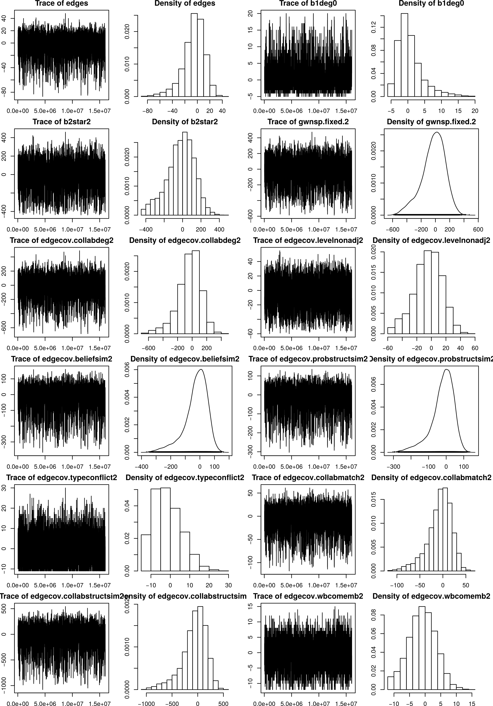

Summary statistics based on change statistics for all model terms:
 | Min. | 1st Qu. | Median | Mean | 3rd Qu. | Max. | SD
Instrument rejection | 0.00 | 0.00 | 0.00 | 0.21 | 0.00 | 1.00 | 0.41
Edges | 1.00 | 1.00 | 1.00 | 1.00 | 1.00 | 1.00 | 0.00
Actor degree: 0 | -1.00 | 0.00 | 0.00 | -0.18 | 0.00 | 0.00 | 0.38
Two-stars (centered on policy instruments) | -0.00 | 3.00 | 5.00 | 6.26 | 7.00 | 19.00 | 4.73
Non-edgewise shared partners (fixed at 2.0) | 1.00 | 5.00 | 6.49 | 7.45 | 8.31 | 19.81 | 4.29
Centrality in the collaboration network | 2.00 | 6.00 | 8.00 | 9.48 | 11.00 | 41.00 | 7.30
Competence level: non-adjacent | 0.00 | -0.00 | 0.00 | 0.53 | 1.00 | 14.00 | 1.49
Similarity of objectives | -0.00 | 1.19 | 2.16 | 2.66 | 2.93 | 11.52 | 2.28
Agenda priorities: structural similarity | -0.00 | 1.13 | 1.86 | 2.28 | 2.58 | 12.40 | 1.88
Water/environment vs. industry/agriculture | 0.00 | -0.00 | -0.00 | 0.41 | 0.00 | 4.00 | 0.94
Collaboration | 0.00 | 0.00 | 0.00 | 0.75 | 1.00 | 12.00 | 1.33
Collaboration: structural similarity | 0.00 | 2.00 | 6.00 | 7.95 | 10.00 | 69.00 | 9.13
Co-membership in water basin organizations | -0.00 | 0.00 | 0.00 | 0.09 | -0.00 | 3.00 | 0.37
Regulatory instrument | 0.00 | 0.00 | 1.00 | 0.53 | 1.00 | 1.00 | 0.50
Market-based instrument | 0.00 | 0.00 | 1.00 | 0.53 | 1.00 | 1.00 | 0.50
Information-based instrument | 0.00 | 0.00 | 0.00 | 0.27 | 1.00 | 1.00 | 0.44
Instrument type match | -0.00 | 0.00 | 0.00 | 0.86 | 1.00 | 6.00 | 1.29
Government actor or party | 0.00 | 0.00 | 0.00 | 0.45 | 1.00 | 1.00 | 0.50
Government actor match | 0.00 | 0.00 | 0.00 | 1.03 | 2.00 | 10.00 | 2.10
Geographic proximity | -0.00 | 32.83 | 51.28 | 61.38 | 66.79 | 211.35 | 47.75
Actor type match | 0.00 | 0.00 | 0.00 | 0.77 | 1.00 | 5.00 | 1.03

