Online Supplementary Material
We investigated the use of the Jaccard similarity index to provide a threshold minimum number of common consultations that was required for an edge to exist between two groups (see, for example, Borgatti 2012). The Jaccard similarity index for two respondents i and j for a given period was calculated as a/(a+b+c), where a is the number of consultations that i and j both responded to, b is the number of consultations that i responded to (but j did not respond to), and c is the number of consultations that j responded to (but i did not respond to). The Jaccard similarity index ranges between 0 and 1 with higher values indicating increasing similarity between the two respondents being compared. The literature on constructing one-mode networks using a Jaccard similarity index threshold does not provide any guidance on what threshold should be; 0.4 is commonly used (see, for example, Borgatti 2012), but the choice is apparently arbitrary.
However while it seems reasonable to use the Jaccard index (or another measure of similarity) to determine a threshold level of co-responses that must exist for two respondents to be connected in the respondent network, we found that this approach is not viable for this particular dataset. The reason is that the Jaccard index is by construction dependent on the total number of consultations responded to by each group (this is evident in the formula for the Jaccard index, given above). Figure 3 shows that the distribution of number of consultations responded to during the period 2001-04 was highly skewed: 63% of groups responded to only one consultation over the period, while 95% responded to fewer than 10 consultations. In contrast, 10 groups were very active, responding to over 50 consultations.
This marked variation in the activity levels of groups results in the structure of the respondent network being highly sensitive to changes in the Jaccard similarity index threshold. This is best illustrated by looking at two measures of node centrality in the respondent network, calculated for two example groups the Law Society of Scotland and the Friends of the Ochils (Figures OA2 and OA3). Degree centrality is the number of ties, while betweenness centrality measures the extent to which the node plays a ‘bridging’ role, and is calculated for a given node i by summing up the proportion of minimum paths between all other pairs of nodes that pass through node i.
In the respondent network for 2001-04 constructed with a Jaccard similarity threshold of 0 (i.e. there needs to be only one co-response for two groups to be connected in this network), the Law Society of Scotland (which responded to 87 consultations) has a degree centrality of 1280 (the second highest) and is ranked 1st in terms of betweenness centrality. In contrast the Friends of the Ochils (which responded to only 3 consultations) has a degree centrality of 494 (ranked 47th on this basis) and is ranked 130th in terms of betweenness centrality. As the Jaccard threshold is increased, the relative centrality of these two groups is quickly reversed: with Jaccard similarity of 0.15 the Friends of the Ochils is the most central group in the respondent network (based on both degree and betweenness centrality) and the Law Society of Scotland has a marginal network position.
In summary, we found that the use of the Jaccard similarity index for determining the existence of ties between nodes in the respondent network led to highly active groups being overly ‘punished’ and thus relegated to implausibly marginal positions in the respondent network. For this reason, we decided to not use the Jaccard similarity index in the construction of the respondent network, or equivalently, we set the Jaccard similarity index threshold at 0.

Figure OA1. Number of consultations responded to by groups, 2001-04
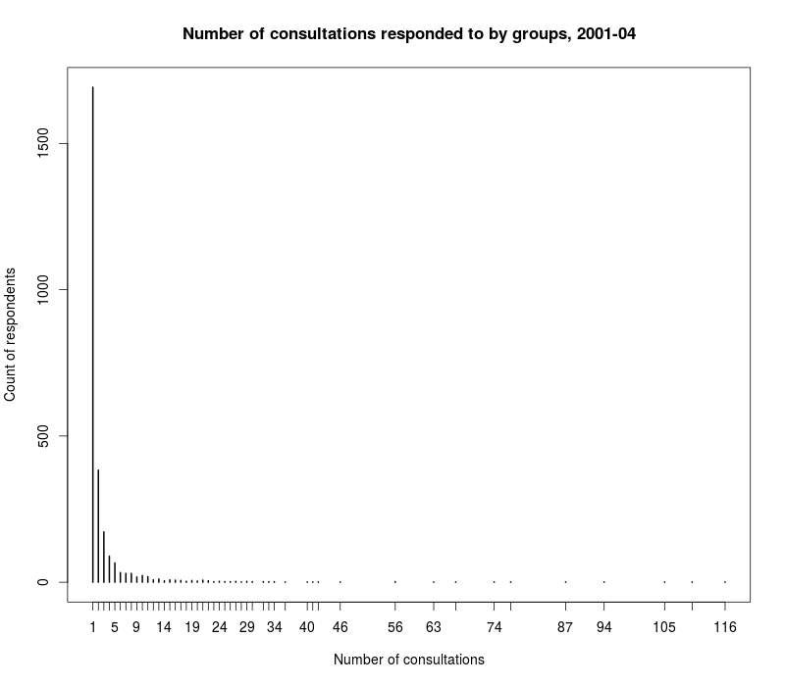

Figure OA2. Effect of Jaccard similarity threshold on degree centrality, respondent network (2001-04)
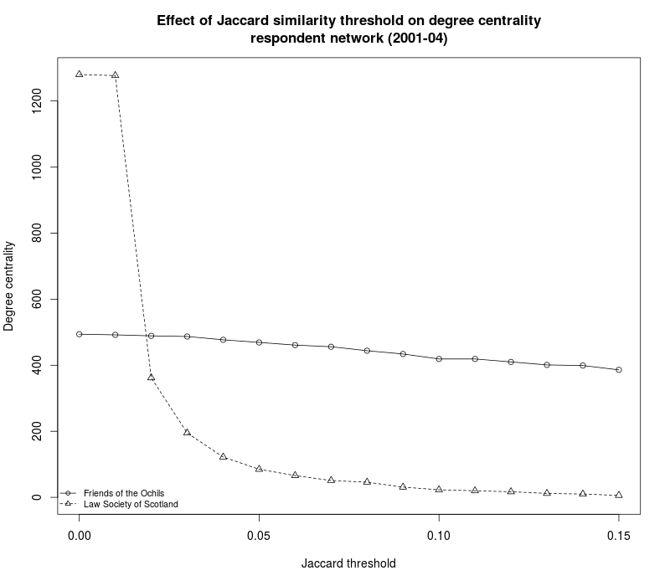

Figure OA3. Effect of Jaccard similarity threshold on betweenness centrality rank, respondent network (2001-04)
