Appendix: supplementary material
Figure 2: Two-mode network with groups and coalitions
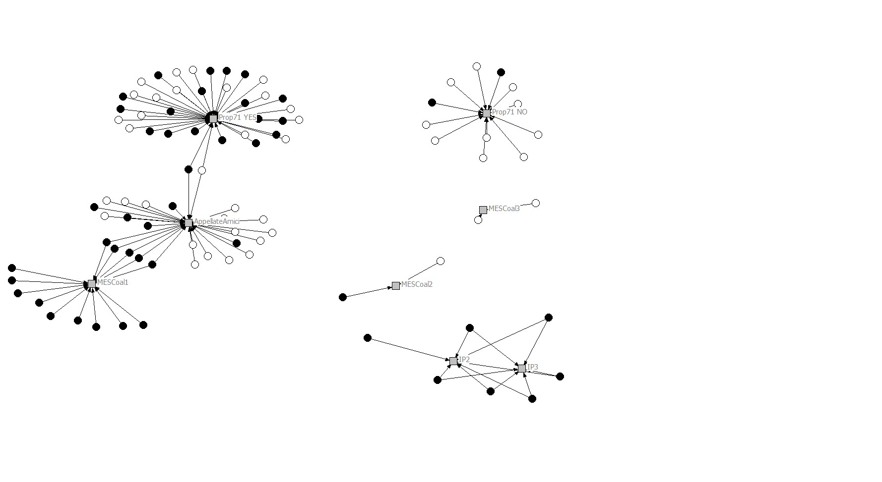
Note: black nodes = business and occupational groups; white nodes = union, religious and public interest groups; grey nodes = coalitions
Table 7: Regressions analyses for variables influencing IGs advocacy success

 | Model 1 | Model 2 | Model 3 | Model 4 | Model 5
R² | 0.2444 | 0.2363 | 0.2334 | 0.2292 | 0.2212
F | 6.008 | 8.149 | 8.037 | 13.296 | 38.619
Prob > F | 0.011 | 0.004 | 0.004 | 0.000 | 0.000
 | Coefficient | Coefficient | Coefficient | Coefficient | Coefficient
Pro-Status quo | 0.517*** (0.139; 0.000) | 0.547*** (0.138; 0.000) | 0.479*** (0.110; 0.000) | 0.523*** (0.096; 0.000) | 0.530*** (0.096; 0.000)
nBetw decisions | -4.830 (3.873; 0.201) |  | -4.769 (3.849; 0.205) | -0.126 (1.550; 0.937)
nDegree coalitions | 0.987 (0.925; 0.284) | 0.980 (0.921; 0.285) |  | 0.474 (0.444; 0.284)
Interaction Status quo/Betwee | 6.576 (5.171; 0.189) |  | 6.401 (5.120; 0.199)
Interaction Status quo/Degree | -0.601 (1.050; 0.567) | -0.607 (1.038; 0.550)
IG Business | 0.043* (0.083; 0.091) | 0.045* (0.076; 0.091) | 0.031* (0.082; 0.090)
Age | 0.042 (0.166; 0.801) | 0.051 (0.161; 0.751) | 0.062 (0.061; 0.712)
Residual group | 0.210 (0.205; 0.000) | 0.183 (0.200; 0.000) | 0.284 (0.130; 0.000) | 0.237 (0.089; 0.000) | 0.272 (0.079; 0.000)

Note: Levels of statistical significance: * p ≤ 0.1, ** p ≤ 0.05, *** p ≤ 0.01 As not for all actors previously included in the analysis, the variable age could be investigated, the number of actors included for this analysis is the following: STEM n= 138. First number between brackets are “standard errors”, second number are the “proportions as extreme as the real coefficient”. Permutation standard errors (as obtained by the QAP regression provided on UCINET Version 6.582 run here) are the standard deviation of the coefficients obtained by running the regression with the Y values permuted. This does not correspond to the classical standard error test where estimated betas could have varied given sampling variation. Therefore, and in permutations as displayed here, the p-value is obtained by counting how often a coefficient from a randomly permuted regression was as large (or small, thus extreme) as the real coefficient (see second number between brackets).

Table 8: Correlations analysis

 |  | 1 | 2 | 3 | 4 | 5 | 6 | 7 | 8
 |  | nDegree coalitions | nBetw decisions | Pro-Status Quo | Status Quo/Betwee | Status Quo/Degree | Age | IGBusiness | Success
1 | nDegree coalitions | 1
2 | nBetw decisions | -0.032 | 1
3 | Pro-Status Quo | 0.058 | -0.081 | 1
4 | Status Quo/Betwee | -0.034 | 0.937 | 0.024 | 1
5 | Status Quo/Degree | 0.84 | -0.068 | 0.426 | -0.031 | 1
6 | Age | 0.038 | 0.101 | 0.15 | 0.135 | 0.052 | 1
7 | IG Business | -0.075 | -0.078 | 0.305 | -0.029 | 0.07 | 0.285 | 1
8 | Success | 0.117 | -0.047 | 0.47 | 0.034 | 0.257 | 0.12 | 0.191 | 1

