ONLINE APPENDIX

Table 1: Legislative Comprehensiveness Controlling for Competition-Based Diffusion

 | One Policy Adopted | Two Policies Adopted | Three Policies Adopted
Neighboring States | 3.13***  (0.57) | 2.93***  (0.66) | 4.99***  (0.76)
% Dems in the Senate | 0.62  (1.33) | 0.88  (1.42) | -2.46  (1.71)
Professionalized Legislature | 0.64**  (0.32) | -0.87***  (0.33) | -0.50  (0.34)
Illegal Population | -22.29  (23.67) | 89.89***  (22.88) | 20.72  (26.68)
Violent Crime | 186.22  (125.82) | -326.57*  (179.51) | -170.32  (169.69)
Border State | -0.63  (0.97) | -0.47  (0.95) | 0.42  (1.05)
Population (In Millions) | 0.15***  (0.06) | -0.09*  (0.06) | 0.06  (0.06)
Surplus (In Millions) | -1.15  (261.88) | -237.88  (321.75) | -66.54  (258.42)
Constant | -6.17***  (1.91) | 0.03  (1.76) | -1.18  (1.86)
N | 276
X2 (df= 24) | 142.24
Pseudo R2 | 0.2273
Robust standard errors in parentheses, clustered by state.
Year dummies not reported due to space considerations.
***p < 0.01, **p < 0.05, *p < .10

Table 2: Legislative Comprehensiveness Controlling for Learning-Based Diffusion

 | One Policy Adopted | Two Policies Adopted | Three Policies Adopted
% Country Covered | 4.64***  (0.70) | 6.41***  (1.00) | 7.11***  (1.04)
% Dems in the Senate | -0.44  (1.29) | -1.20  (1.58) | -3.74**  (1.67)
Professionalized Legislature | 0.18  (0.31) | -1.25***  (0.38) | -0.76**  (0.35)
Illegal Population | -4.69  (24.35) | 120.45***  (0.06) | 48.17*  (28.65)
Violent Crime | 290.52***  (121.31) | -219.87  (187.06) | 9.70  (164.77)
Border State | -0.31  (0.98) | -0.63  (1.09) | 0.22  (1.13)
Population (In Millions) | 0.07  (0.05) | -0.15***  (0.06) | 0.01  (0.06)
Surplus (In Millions) | 258.48  (270.06) | 79.52  (1.09) | 126.21  (267.35)
Constant | -4.93***  (1.81) | -0.17  (1.98) | -1.60  (1.94)
N | 288
X2 (df= ) | 197.38
Pseudo R2 | 0.30
Robust standard errors in parentheses, clustered by state.
Year dummies not reported due to space considerations.
***p < 0.01, **p < 0.05, *p < .10

Table 3: Legislative Comprehensiveness Controlling for Females in Legislature

 | One Policy Adopted | Two Policies Adopted | Three Policies Adopted
% Females in the Senate | 2.88  (2.04) | 12.13***  (2.87) | 0.83  (2.65)
% Dems in the Senate | 0.57  (1.15) | -0.23  (1.49) | -1.70  (1.43)
Professionalized Legislature | 0.50*  (0.28) | -0.69**  (0.34) | -0.31  (0.28)
Illegal Population | -30.59  (22.23) | 62.87***  (23.34) | 13.67  (24.35)
Violent Crime | 288.23***  (105.55) | -153.05  (163.22) | 25.55  (137.17)
Border State | -0.41  (0.87) | -1.03  (1.00) | 0.19  (0.93)
Population (In Millions) | 0.09*  (0.05) | -0.06  (0.05) | 0.04  (0.05)
Surplus (In Millions) | 230.50  (221.39) | 25.27  (293.10) | -115.13  (198.50)
Constant | -5.03***  (1.69) | -2.40  (1.88) | -0.59  (1.66)
N | 288
X2 (df= ) | 83.18
Pseudo R2 | 0.12
Robust standard errors in parentheses, clustered by state.
Year dummies not reported due to space considerations.
***p < 0.01, **p < 0.05, *p < .10

Table 4: Legislative Comprehensiveness Controlling for Diffusion & Female Representation

 | One Policy Adopted | Two Policies Adopted | Three Policies Adopted
Neighboring States | 0.69  (1.20) | -1.90  (1.30) | 1.11  (1.20)
% Country Covered | 3.81***  (1.19) | 8.81***  (1.73) | 6.06***  (1.57)
% Females in the Senate | 4.87**  (2.56) | 13.44***  (3.61) | 3.74  (3.31)
% Dems in the Senate | -1.10  (1.46) | -3.57*  (1.93) | -4.30***  (1.81)
Professionalized Legislature | 0.49  (0.34) | -1.33***  (0.44) | -0.71**  (0.37)
Illegal Population | -17.01  (26.28) | 102.69***  (31.20) | 39.34  (30.87)
Violent Crime | 307.13**  (133.56) | -56.66  (199.53) | 23.46  (173.33)
Border State | -0.57  (1.00) | -1.11  (1.21) | 0.32  (1.12)
Population (In Millions) | 0.12**  (0.06) | -0.13*  (0.07) | 0.01  (0.06)
Surplus (In Millions) | 206.73  (279.75) | 422.19  (424.78) | 193.36  (283.15)
Constant | -6.81***  (2.07) | -2.96  (2.28) | -2.25  (2.15)
N | 276
X2 (df= 24) | 215.85
Pseudo R2 | 0.34
Robust standard errors in parentheses, clustered by state.
Year dummies not reported due to space considerations.
***p < 0.01, **p < 0.05, *p < .10

Figure 1: Predicted Probability of Passing Legislation with One Anti-Trafficking Provision Given Varying Levels of Females in the House and Proportion of Country Covered

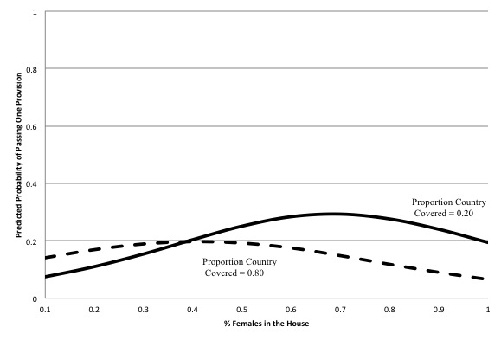

Figure 2: Predicted Probability of Passing Legislation with Two Anti-Trafficking Provisions Given Varying Levels of Females in the House and Proportion of Country Covered

