Online Appendix. Summary of REMI Macroeconomic Modeling

The purpose of this Appendix is to describe the Regional Economic Models, Inc. (REMI) Policy Insight Plus (PI+) Model used in this study to estimate macroeconomic impacts. Section 1 provides an overview of the model and its underlying assumptions. Section 2 describes the data and the estimation methods. Section 3 presents an example of how we translate the results of the microeconomic analysis into REMI simulation policy variables, as well as how the input data are further refined and linked to key structural and policy variables in the Model.

1. Description of the REMI Model

The REMI model consists of thousands of simultaneous equations. The overall structure of the model can be summarized in five major blocks: 1) Output and Demand, 2) Labor and Capital Demand, 3) Population and Labor Supply, 4) Compensation, Prices and Costs, and 5) Market Shares. The blocks and their key interactions are shown in Figure A1.

The Output and Demand block includes gross output (sales), industry demand, personal consumption, investment, government spending, imports, product access, and exports. Output for each industry is determined by industry demand in a given region and its trade with the U.S. and foreign markets. For each industry, input demand is determined by the amount of output, consumption, and investment demand in that industry. Personal consumption depends on real disposable income per capita, relative prices, differential income elasticities, and population. Input productivity depends on access to inputs. Investment occurs to fill the difference between optimal and actual capital stock for residential, non-residential and equipment investment. Government spending changes are determined by changes in the population.

The Labor and Capital Demand block includes the determination of labor productivity, labor intensity and the optimal capital stocks. Industry-specific labor productivity depends on the availability of workers with differentiated skills for the occupations used in each industry. Occupational labor supply and commuting costs determine firms’ access to a specialized labor force.

Labor intensity is determined by the cost of labor relative to the other factor inputs, capital and fuel. Demand for capital is driven by the optimal capital stock equation for both non-residential construction capital and equipment. Optimal capital stock for each industry depends on the relative cost of labor and capital, and the employment weighted by capital use for each industry. Employment in private industries is determined by the value added and employment per unit of value added in each industry.

The Population and Labor Supply block is based on detailed demographic information about the region. Population data is given for age and gender, with birth and survival rates for each group. The size and labor force participation rate of each group determines the labor supply. Participation rates respond to changes in employment relative to the potential labor force and to changes in real after tax compensation rates. Economic migration is determined by the relative real after-tax compensation rate, relative employment opportunity and consumer access to a variety of goods and services.

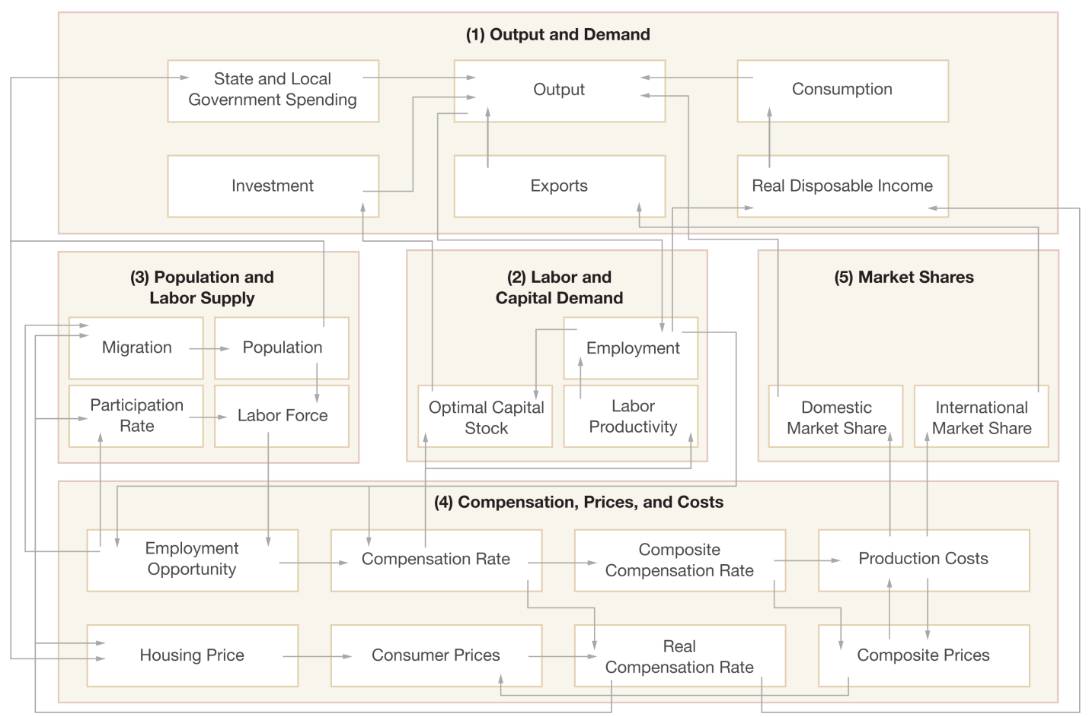

Figure A1. REMI Model Linkages (Excluding Economic Geography Linkages)
Source: REMI (2012).

The Compensation, Prices, and Costs block includes delivered prices, production costs, equipment cost, the consumption deflator, consumer prices, the price of housing, and the wage equation. Economic geography (relative competitiveness and location) concepts account for the productivity and price effects of access to specialized labor, goods and services. These prices measure the value of the industry output, taking into account the access to production locations. This access is important due to the specialization of production that takes place within each industry and because of the transportation and transaction costs associated with distance. Composite prices for each industry are then calculated based on the production costs of the supplying regions, the effective distance to these regions and the index of access to the variety of output in the industry relative to the access by other uses of the product.

The cost of production for each industry is determined by cost of labor, capital, fuel, and intermediate inputs. Labor costs reflect a productivity adjustment to account for access to specialized labor, as well as underlying compensation rates. Capital costs include costs of non-residential structures and equipment, while fuel costs incorporate electricity, natural gas and residual fuels.

The consumption deflator converts industry prices to prices for consumption commodities. For potential migrants, the consumer price is additionally calculated to include housing prices. Housing price changes from their initial level depend on changes in income and population density. Regional employee compensation changes are due to changes in labor demand, supply conditions and the national compensation rate. Changes in employment opportunities relative to the labor force and occupational demand change determine compensation rates by industry.

The Market Shares equations measure the proportion of local and export markets that are captured by each industry. These depend on relative production costs, the estimated price elasticity of demand and effective distance between the home region and each of the other regions. The change in share of a specific area in any region depends on changes in its delivered price and the quantity it produces compared with the same factors for competitors in that market. The share of local and external markets then drives the exports from and imports to the home economy.

The Labor and Capital Demand block includes labor intensity and productivity, as well as demand for labor and capital. The labor force participation rate and migration equations are in the Population and Labor Supply block. The Compensation, Prices, and Costs block includes composite prices, determinants of production costs, the consumption price deflator, housing prices, and the wage equations. The proportion of local, interregional and international markets captured by each region is included in the Market Shares block.

Several major assumptions used in the REMI Model are summarized below:

- The production of goods and services is characterized by a Cobb-Douglas production function for each sector. It allows for substitution among labor, capital, and fuel (an elasticity of substitution of unity) with constant factor shares. However, intermediate goods are assumed to be used in constant proportions (fixed coefficients).
- The major dynamic feature of the model is reflected by its incorporation of a capital stock adjustment process. The investment for each year is determined by the difference between the optimal (or desired) level and actual (or existing) level of capital. The actual level of capital in each year is computed starting from the base year estimate, with investment added and depreciation subtracted annually. For each industry, the optimal capital stock is based on production levels measured in terms of capital-weighted employment and the relative cost of capital to labor.
- The implicit Autonomous Energy Efficiency Improvement (AEEI) embedded in the model is about 1.5% annually for the U.S. as a whole but differs by sector.
- Economic geography is incorporated into the model by two indexes. The commodity access index reflects the relationship between the production cost reduction and competitiveness enhancement of an industry and its increased access to intermediate inputs. This index is also included in the migration equation. Higher access to consumer goods is a factor that attracts in-migration. The labor access index captures the favorable effect on labor productivity when local firms have better access to labor.

2. Data and Estimation Methods

The primary sources of economic, demographic and energy data for the historical years of the REMI model include the U.S. Bureau of Economic Analysis (BEA), Bureau of Labor Statistics (BLS), Census Bureau, and Energy Information Administration (EIA). The last historical year of data in the U.S. REMI model we used is for 2007, based on the historical time series between 1990 and 2007. As for the baseline forecast, REMI obtains its short-term economic forecast from the Research Seminar in Quantitative Economics (RSQE) of the University of Michigan. REMI also obtains the 2018 employment forecast from the BLS Employment Outlook.

The core of the REMI model is a national input-output table obtained from BEA. The projected input-output tables are constructed based on the BLS 2018 projected “Make” (production, including joint products) and “Use” (input demand) I-O tables. Then, for the non-benchmark years between 2008 and 2018, a compound growth rate formula is used to calculate the average annual growth rate (AAGR) for the key economic variables. For years beyond 2018, the projections are extrapolated forward to 2050 by adjusting the AAGR for individual industrial sectors.

The REMI model is constructed by inferential statistical estimation of key parameters using pooled time series and state level cross-section (panel) data. Various econometric techniques are used to estimate the parameters of each equation in the model separately. In many cases, ordinary least squares (OLS) is used in the estimation of equation parameters. For example, OLS is used in the estimation of the speed of adjustment for the residential and non-residential investments in structures. In addition, when estimating the regression coefficient, the first difference, rather than the level value of the historical time series data, is used to avoid the potential problem of non-stationary data series. In other cases, where the problem of endogeneity exists in the economic relationships (the independent variables are correlated with the error terms of the regression equation), econometric techniques, such as General Method of Moments (GMM) or two-stage least squares (2SLS) are adopted to utilize instrumental variables. GMM is used if the relationship between the error term and the endogenous regressor is heteroskedastic; if the relationship is homoscedastic, 2SLS is used.

A number of studies have evaluated the predictive accuracy of the REMI Model (see e.g., Treyz et al. 1991; Cassing and Giarratani 1992). Post-sample period forecasts are computed, and the predicted values are then compared with the actual values, with the prediction error measured by the mean absolute percentage error (MAPE). Both studies indicate that the REMI model produces very good forecasts over short periods of time beyond the historical data sample, while, as expected, the prediction accuracy deteriorates for longer periods.

3. Data Inputs into REMI Simulations of Climate Action Plans

The major data sources of the macroeconomic modeling are the microeconomic analysis results of the GHG mitigation policy options reported in individual state Climate Action Plans (see, e.g., FGAT 2008; MCAC 2008). The development of these state climate action plans were facilitated by a non-profit organization, The Center for Climate Strategies (CCS). CCS has worked for several years directly in partnership with state government leaders and other groups to identify, design and implement policies that address climate, energy, and economic needs and opportunities. These Climate Action Plans have been developed through a stakeholder-based, fact-finding and consensus-building process in about 20 states, at times with over 1,500 stakeholder and technical work group experts. The development and analysis of policy options occurs at two levels. First, the “commission” is created, which is composed of governor-appointed representatives of groups, interests and parties that have a direct stake in the effects of climate change or efforts to mitigate them. Second, a set of sector-focused Technical Working Groups (TWGs) or subcommittees are developed, which are made up of members of the commission plus other individuals with particular expertise in the topic area of focus for the TWG (Rose et al. 2009).

In order to facilitate the impact analysis at the federal level in this study, 23 policy bundles, or “super-options”, were identified from the state Climate Action Plans. These super-options were chosen because they were viewed as: 1) having the greatest GHG reduction potential; 2) being gateway options with limited near-term reduction potential but holding great promise in later years (carbon capture and storage or reuse, nuclear); or 3) having limited potential statewide but as highly cost-effective and important for other reasons (solar or LED street lighting). These 23 super-options represent more than 90% of the overall GHG reductions in state Climate Action Plans analyzed by CCS.

The quantification analysis of the costs/savings of policy options in the microeconomic analysis of this study is limited to the direct effects of their implementation. For example, the direct costs of an energy efficiency option include the energy customers’ expenditure on energy efficiency equipment and devices. The direct benefits of this option include the savings on energy bills of the customers.

Before undertaking any economic simulations, the costs and savings for the policy options are translated to model inputs. This step involves the selection of appropriate economic activity levers in the REMI model to simulate the policy’s changes. Major inputs to the REMI model include:

  - Change in upfront capital investments by sector
  - Change in annualized capital costs by sector
  - Change in O&M expenditures by sector
  - Change in fuel expenditures by fuel type by sector
  - Program implementation and administrative costs
  - Proportion of public funding and private debt financing
  - Federal or state subsidies/tax credits

In Table A1, we present one example option, Demand-Side Management (DSM), to illustrate how we translate, or map, the microeconomic quantification results into REMI economic variable inputs. The first set of inputs in the table is the increased cost to the commercial, industrial and residential sectors from the purchase of energy-efficient equipment and appliances. For the commercial and industrial sectors, this is simulated in REMI by increasing the value of the “Capital Cost” variable of individual commercial sectors and individual industrial sectors under the “Compensation, Prices, and Costs Block.” For the residential sector, the program costs (which represent total incremental costs of new equipment over conventional equipment) are simulated by increasing the “Consumer Spending” on “Kitchen & Other Household Appliances” (and decreasing all other consumption accordingly).

The second set of inputs is the corresponding stimulus effect to the economy from increased spending on efficient equipment and appliances, i.e., the increase in the final demand for goods and services from the industries that supply energy efficient equipment and appliances. This is simulated in REMI by increasing the “Exogenous Final Demand” of the following sectors: Ventilation, Heating, Air-Conditioning, and Commercial Refrigeration Equipment Manufacturing; Electric Lighting Equipment Manufacturing; Electrical Equipment Manufacturing; and Other Electrical Equipment and Component Manufacturing. The interest payment due on the financing of the capital investment is simulated as the “Exogenous Final Demand” increase of the Monetary Authorities, Credit Intermediation sector. The administrative cost of the DSM program is simulated as the “Exogenous Final Demand” increase of the Management, Scientific, and Technical Consulting Services sector.

The third set of inputs is the energy savings of the commercial, industrial and residential sectors resulted from the DSM program. For the commercial and industrial sectors, the energy savings are simulated in REMI by decreasing the value of the “Electricity/Natural Gas/Residual Fuel Cost of All Commercial/Industrial” sector variables. For the residential sector, the energy savings are simulated by decreasing the “Consumer Spending” on “Electricity”, “Gas” and “Fuel Oil” (and increasing all the other consumption categories correspondingly).

The last set of inputs is the corresponding damping effects on the energy supply sector from the decrease in demand from the customer sectors. These effects are simulated by reducing the “Exogenous Final Demand” of the Electric Power Generation, Transmission, and Distribution sector, Natural Gas Distribution sector, and Petroleum and Coal Products Manufacturing (Refining) sector in REMI. For the Residential sector, the model internally converts the change in the Consumer Spending (amount) policy variable into changes in final demand for the corresponding sectors. For the non-residential sectors, the decreased demand from the commercial and industrial sectors needs to be manually entered into the model as final demand change for the energy supply sectors.

Table A1. Mapping the Microeconomic Quantification Results of RCI Option #1 Demand-Side Management into REMI Inputs

Quantification Results |  | Policy Variable Selection in REMI
Customer Outlay on Energy Efficiency (EE) | Businesses (Commercial and Industrial Sectors) | Compensation, Prices, and Costs Block →Capital Cost (amount) of individual commercial sectors→Increase
 | Households (Residential Sector) | Output and Demand Block→Consumer Spending (amount)→Kitchen & other household appliances→Increase  Output and Demand Block→Consumer Spending (amount)→ Bank service charges, trust services, and safe deposit box rental→Increase  Output and Demand Block →Consumption Reallocation (amount)→All Consumption Sectors →Decrease
Investment on EE Technologies |  | Output and Demand Block →Exogenous Final Demand (amount) for Ventilation, Heating, Air-conditioning, and Commercial Refrigeration Equipment Manufacturing sector; Electric Lighting Equipment Manufacturing sector; Electrical Equipment Manufacturing sector; and Other Electrical Equipment and Component Manufacturing sector→Increase
Interest Payment of Financing Capital Investment |  | Output and Demand Block →Exogenous Final Demand (amount) for Monetary Authorities, Credit Intermediation sector→Increase
Administrative Outlays |  | Output and Demand Block →Exogenous Final Demand (amount) for Management, Scientific, and Technical Consulting Services sector→Increase
Energy Savings of the Customers | Businesses (Commercial and Industrial Sectors) | Compensation, Prices, and Costs Block→ Electricity, Natural Gas, and Residual (Commercial Sectors) Fuel Cost (share) of All Commercial Sectors→Decrease  Compensation, Prices, and Costs Block→ Electricity, Natural Gas, and Residual (Industrial Sectors) Fuel Cost (share) of All Industrial Sectors→Decrease
 | Households (Residential Sector) | Output and Demand Block→Consumer Spending (amount)→Electricity, Gas, and Fuel Oil→Decrease  Output and Demand Block →Consumption Reallocation (amount)→All Consumption Sectors →Increase
Energy Demand Decrease from the Energy Supply Sectorsª |  | Output and Demand Block →Exogenous Final Demand (amount) for Electric Power Generation, Transmission, and Distribution sector; Natural Gas Distribution sector; and Petroleum and Coal Products Manufacturing sector→Decrease
ª The final demand change here only reflects the energy consumption reductions from the commercial and industrial sectors. The residential sector energy consumption reductions are entered into the model through the “Consumer Spending” variable.

Source: Compiled by the authors.

