SUPPLEMENTARY MATERIALS

A. FILLER SENTENCES AND COMPREHENSION QUESTIONS 1
B. MODEL RESULTS 4
Model estimates for total sentence reading times 4
Model estimates for eye tracking measures in the pre-critical region (adverbial) 5
Model estimates for eye tracking measures in the critical region I (subject) 7
Model estimates for eye tracking measures in the critical region II (verb) 9
Model estimates for eye tracking measures in the post-critical region (object) 11
Model estimates for eye tracking measures in the wrap-up region (adverbial) 13
C. POST-HOC ANALYSIS OF COMBINED CRITICAL REGIONS 15
Model estimates for post-hoc analysis of combined subject-verb region 15
D. FIGURES 16

A. FILLER SENTENCES AND COMPREHENSION QUESTIONS
Below is a list of all filler items. Half of the fillers contain various types of morphological anomalies (*underlined).

- Nede ved vannet ser Morten *et elg. ‘Down by the water, Morten sees an elk.’ (*The article is neuter gender instead of masculine, en).
- På skolen syr jenta en jakke til hunden. ‘At school, the girl makes a jacket for the dog.’
- I Trondheim kjører Linda på sparkesykkel hver helg . ‘In Trondheim, Linda rides a kick scooter every weekend.’
- I skogen løper Karin ofte med venninner. ‘In the forest, Karin often jog with friends.’
- I *en sjøen fanger Øystein masse laks. ‘In a/the (?) lake, Øystein catches lots of salmon.’ (*Both the indefinite article en and the suffix –en denoting definite form is used simultaneously).
- Mandag den 8. november åpner den nye *butikk i sentrum. ‘Monday the 8th of November, the new store opens in the city centre.’ (*The suffix -en denoting definite form is missing).
- Etter skitur bestiller skitreneren takeaway til kveldsmat. ‘After the ski tour, the ski instructor orders take away for dinner.
- Stort sett *hvert helg drikker Steinar cider på et utested. ‘Almost every weekend, Steinar drinks cider in a bar.’ (The determiner has a suffix -t denoting neuter gender instead of masculine, hver).
- På onsdager kjøper mannen kaker til hele familien *sitt. ‘On Wednesdays, the man buys cakes for his whole family.’ (*The determiner is neuter gender, and not masculine: sin).
- Neste uke feirer jenta bursdag hos en venninne. ‘Next week, the girl celebrates her birthday at a friend’s house.’
- Hvis det regner, sykler ikke Bjørn til universitetet. ‘If it rains, Bjørn does not bike to the university.’
- Når klassen skal på tur, planlegger læreren turen godt på forhånd. ‘When the class is going on excursion, the teacher plans the trip well in advance.’
- Selv om pappa mosjonerer hver *dager, går han ikke ned i vekt. ‘Even though dad exercises every days, he does not lose weight.’ (*The plural form of the noun is used instead of singular dag).
- Podcast hører Espen alltid på om morgenen. ‘Podcasts, Espen always listens to in the morning.’
- Sjokoladekake fra bakeriet elsker mannen. ‘Chocolate cake from the bakery, the man loves.’
- Maraton løper Einar *hver år i juni. ‘Marathon, Einer runs every year in June. (*The determiner, now in its masculine/feminine form, is missing the neuter suffix -t).
- Bilen blir angrepet av *et grizzlybjørn 100 meter fra hytta. ‘The car is attacked by a grizzly bear 100 meters from the cabin.’ (*The article is neuter gender instead of masculine, en).
- Kanelbollen blir spist av gutten på *kjøkkenen. ‘The cinnamon bun is eaten by the boy in the kitchen.’ (*The masculine suffix -en is used instead of the neuter -et to denote definite form of the noun).
- Kaffen blir drukket av en hipster på kaféen. ‘The coffee is drunk by a hipster in the cafe.’
- Hunden blir sett på gata i Oslo. ‘The dog is seen in the street in Oslo.’
- Jenta blir sur fordi faren hennes er *kleint på bussen. ‘The girl gets angry because her father is annoying on the bus.’ (*The neuter form of the adjective, with the suffix -t, is used instead of the masculine form klein).
- Turid blir glad fordi solen skinner utenfor. ‘Turid becomes happy because the sun is shining outside.’
- Mekanikeren reparerer kun bilen sin når været er *god. ‘The mechanic only fixes his car when the weather is nice.’ (*The adjective, now in its masculine/feminine form, is missing a neuter suffix -t).
- Inger hekler om *kveldet selv om hun er trøtt. ‘Inger crochets in the evening even though she is tired.’ (*The neuter suffix -et is used instead of the masculine -en to denote definite form of the noun).
- Tanten hennes, som bor i Trondheim, elsker opera. ‘Her aunt, who lives in Trondheim, loves opera.’
- Terje, som er glad i mat, arbeider som *kokker på en restaurant. ‘Terje, who loves food, works as a chefs in a restaurant.’ (*The plural form of the noun is used instead of the singular kok).
- Jenta, som går i barnehage, er alltid *glade. ‘The girl, who goes to kindergarten, is always happy.’ (*The plural form of the adjective is used instead of the singular form glad).
- Anita, som er meget aktiv, investerer penger i aksjer hver måned. ‘Anita, who is very active, invests money in stocks every month.’
- Det er kaféen som er populær. ‘It is the cafe which is popular.’
- Det er lillesøster som tegner på bordet. ‘It is little sister who is drawing on the table.’
- Det er gutten som reparerer den *fin stolen på verkstedet. ‘It is the boy who is repairing the nice chair in the workshop.’ (*The indefinite form of the adjective is used instead of the definite form with -e).
- Det er Bjørg som går ned en halv kilo i uken. ‘It is Bjørg who is losing half a kilo a week.’
- Bestemor syr *flott klær til hele familien. ‘Grandmother makes nice clothes for the whole family.’ (*The singular form of the adjective is used instead of the plural form with -e).
- Bente mosjonerer i skogen på onsdager. ‘Bente exercises in the forest on Wednesdays.’
- Frode planlegger *et hyttetur med vennene sine. ‘Frode is planning a cottage trip with his friends.’ (*The article is neuter gender instead of masculine, en).
- Legen går på skøyter to ganger i uken. ‘The doctor goes ice skating twice a week.’
- Maria går på kino i helgen. ‘Maria goes to the cinema in the weekend.’
- Bjørnen fisker ørret i *et vannet i skogen. ‘The bear catches trout in a/the (?) lake in the forest.’ (*Both the indefinite article et and the suffix -et denoting definite form is used simultaneously).
- Gartneren luker *ugresser hver måned om sommeren. ‘The gardener weeds every month during the summer.’ (*The plural form of the noun is ugress, without the plural suffix -er).
- Plenklipperen klipper automatisk *gressen i hagen hver uke. ‘The lawn mowerautomatically cuts the grass in the garden every week.’ (*The masculine suffix -en is used instead of the neuter -et to denote definite form of the noun).

Comprehension questions
Below are all comprehension question for the target and filler sentences.

Target sentences
1. Leser pappa romaner på sofaen? ‘Does dad read novels on the sofa?’ No.
2. Lufter mannen hunden sin i parken? ‘Does the man walk his dog in the park?’ Yes.
7. Sender bestefar julekort i november? ‘Does grandfather send Christmas cards in November?’ No.
8. Spiller gutten fotball med faren sin? ‘Does the boy play football with his father?’ No.
13. Vasker Harald på mandager? ‘Does Harald wash on Mondays?’ Yes.
16. Danser Svein folkedans om høsten? ‘Does Svein dance folk dance in the fall?’ Yes.
20. Hekler Kristin vesker til familien? ‘Does Kristin crochet bags for the family?’ No.
22. Maler barna påskeegg i barnehagen? ‘Do the children paint Easter eggs in the kindergarten?’ Yes.
25. Besøker pensjonistene en pub i mars? ‘Do the pensioners visit a pub in March?’ No.
27. Henter Astrid tvillingene klokken fem i oddetallsuker? ‘Does Astrid pick up the twins at five o’clock in odd weeks?’ No.
29. Selger Eirik blomster i august? ‘Does Eirik sell flowers in August?’ Yes.
33. Stjeler vennene godteri på butikken? ‘Do the friends steal candy from the store?’ No.
35. Spiser sjefen en kanelbolle i bilen før lunsj? ‘Does the boss eat a cinnamon bun in the car before lunch?’ No.
36. Synger Berit karaoke på puben i kveld? ‘Does Berit sing karaoke in the pub tonight?’ Yes.
39. Baker Ingrid rundstykker etter jobb? ‘Does Ingrid bake buns after work?’ Yes.

Filler sentences
1. Ser Morten en rein ved vannet? ‘Does Morten see a reindeer by the water?’ No.
3. Kjører Linda på sparkesykkel? ‘Does Linda ride a kick scooter?’ Yes.
6. Åpner butikken den 8. november? ‘Does the store open on the 8th of November?’ Yes.
9. Kjøper mannen grønnsaker? ‘Does the man buy vegetables?’ No.
11. Sykler Bjørn til universitetet i regnvær? ‘Does Bjørn bike to the university in rainy weather?’ No.
13. Går pappa ned i vekt? ‘Does dad lose weight?’ No.
15. Elsker mannen sjokoladekake fra bakeriet? ‘Does the man love chocolate cake from the bakery?’ Yes.
19. Drikker hipsteren kaffen? ‘Does the hipster drink coffee?’ Yes.
24. Strikker Inger om kvelden? ‘Does Inger knit in the evening?’ No.
26. Er Terje glad i mat? ‘Does Terje love food?’ Yes.
30. Er det gutten som tegner på bordet? ‘Is it the boy who is drawing on the table?’ No.
32. Går Bjørg ned en halv kilo i uken? ‘Does Bjørg lose half a kilo a week?’ Yes.
35. Planlegger Frode en hyttetur? ‘Does Frode plan a cottage trip?’ Yes.
37. Går Maria på kino i helgen? ‘Does Maria go to the cinema in the weekend?’ Yes.
38. Fisker bjørnen gjedde i et vann i skogen? ‘Does the bear catch pike in a lake in the forest?’ No.

B. MODEL RESULTS

Model estimates for total sentence reading times
Table 6. Model estimates for total sentence reading times in ms
Random effects | Variance | Std. Dev.
Participant (Intercept) | 558973 | 747.6
Item (Intercept) | 76336 | 276.3
Residual | 533671 | 730.5
Fixed effects | Estimate | Std. Error | t-value | p-value
(Intercept) | 2875.377 | 121.477 | 23.670 | < 2e-16 ***
GRAM | 409.925 | 69.746 | 5.877 | 4.97e-09 ***
LENGTH | 749.937 | 34.036 | 22.033 | < 2e-16 ***
TRIAL | -15.012 | 1.530 | -9.812 | < 2e-16 ***
GRAM:LENGTH | -24.326 | 68.214 | -0.357 | 0.721431
GRAM:TRIAL | -11.022 | 3.075 | -3.584 | 0.000347 ***

Model estimates for eye tracking measures in the pre-critical region (adverbial)
Table 7. Model estimates, first fixation duration in ms (pre-critical region)
Random effects | Variance | Std. Dev.
Participant (Intercept) | 479.37 | 21.89
Item (Intercept) | 35.04 | 5.92
Residual | 4131.69 | 64.28
Fixed effects | Estimate | Std. Error | t-value | p-value
(Intercept) | 177.7608 | 4.5557 | 39.020 | < 2e-16 ***
GRAM | 6.4307 | 6.2977 | 1.021 | 0.30734
LENGTH | -8.2289 | 3.0684 | -2.682 | 0.00739 **
TRIAL | 0.1178 | 0.1381 | 0.853 | 0.39378
GRAM:LENGTH | -6.4615 | 6.1343 | -1.053 | 0.29233
GRAM:TRIAL | -0.1437 | 0.2761 | -0.520 | 0.60285

Table 8. Model estimates, gaze duration (pre-critical region)
Random effects | Variance | Std. Dev.
Participant (Intercept) | 36796 | 191.82
Item (Intercept) | 6562 | 81.01
Residual | 60948 | 246.88
Fixed effects | Estimate | Std. Error | t-value | p-value
(Intercept) | 726.870 | 32.822 | 22.146 | < 2e-16 ***
GRAM | 29.803 | 24.330 | 1.225 | 0.2208
LENGTH | 649.976 | 11.802 | 55.073 | < 2e-16 ***
TRIAL | -1.368 | 0.532 | -2.571 | 0.0102 *
GRAM:LENGTH | -17.877 | 23.599 | -0.758 | 0.4488
GRAM:TRIAL | -1.233 | 1.069 | -1.154 | 0.2489

Table 9. Model estimates, regression path duration (pre-critical region)
Random effects | Variance | Std. Dev.
Participant (Intercept) | 36737 | 191.7
Item (Intercept) | 6528 | 80.8
Residual | 60809 | 246.6
Fixed effects | Estimate | Std. Error | t-value | p-value
(Intercept) | 728.0229 | 32.7855 | 22.206 | < 2e-16 ***
GRAM | 32.2441 | 24.3017 | 1.327 | 0.18474
LENGTH | 650.1281 | 11.7885 | 55.150 | < 2e-16 ***
TRIAL | -1.4108 | 0.5314 | -2.655 | 0.00801 **
GRAM:LENGTH | -17.5830 | 23.5715 | -0.746 | 0.45580
GRAM:TRIAL | -1.3255 | 1.0674 | -1.242 | 0.21448

Table 10. Model estimates, total duration (pre-critical region)
Random effects | Variance | Std. Dev.
Participant (Intercept) | 77812 | 278.95
Item (Intercept) | 9404 | 96.97
Residual | 158157 | 397.69
Fixed effects | Estimate | Std. Error | t-value | p-value
(Intercept) | 924.2121 | 47.0358 | 19.649 | < 2e-16 ***
GRAM | 149.4711 | 37.9209 | 3.942 | 8.41e-05 ***
LENGTH | 780.9166 | 18.5271 | 42.150 | < 2e-16 ***
TRIAL | -3.7648 | 0.8323 | -4.524 | 6.49e-06 ***
GRAM:LENGTH | -1.0636 | 37.1209 | -0.029 | 0.97715
GRAM:TRIAL | -4.3122 | 1.6711 | -2.580 | 0.00995 **

Table 11. Model estimates, first-pass skipping ratio (pre-critical region)
Random effects | Variance | Std. Dev.
Participant (Intercept) | 2.5903 | 1.6095
Item (Intercept) | 0.6542 | 0.8088
Fixed effects | Estimate | Std. Error | z-value | p-value
(Intercept) | -8.4905 | 32.0664 | -0.265 | 0.7912
GRAM | 7.9819 | 64.1256 | 0.124 | 0.9009
LENGTH | -10.9765 | 64.1277 | -0.171 | 0.8641
TRIAL (rescaled) | -1.0604 | 0.4762 | -2.227 | 0.0259 *
GRAM:LENGTH | 16.3876 | 128.2511 | 0.128 | 0.8983
Since the model would not converge, the interaction between grammar and trial was removed. The optimizer BOBYQA was used as well.

Model estimates for eye tracking measures in the critical region I (subject)
Table 12. Model estimates, first fixation duration in ms (critical region I, subject)
Random effects | Variance | Std. Dev.
Participant (Intercept) | 1001.9 | 31.65
Item (Intercept) | 147.8 | 12.16
Residual | 4854.7 | 69.68
Fixed effects | Estimate | Std. Error | t-value | p-value
(Intercept) | 230.2834 | 6.0435 | 38.104 | < 2e-16 ***
GRAM | 6.7504 | 6.9281 | 0.974 | 0.3300
LENGTH | 8.1628 | 3.3909 | 2.407 | 0.0162 *
TRIAL | -0.2346 | 0.1520 | -1.544 | 0.1228
GRAM:LENGTH | 11.4659 | 6.7839 | 1.690 | 0.0912
GRAM:TRIAL | 0.3604 | 0.3046 | 1.183 | 0.2368

Table 13. Model estimates, gaze duration in ms (critical region I, subject)
Random effects | Variance | Std. Dev.
Participant (Intercept) | 2845 | 53.34
Item (Intercept) | 2632 | 51.30
Residual | 13934 | 118.04
Fixed effects | Estimate | Std. Error | t-value | p-value
(Intercept) | 283.2806 | 12.6286 | 22.432 | < 2e-16 ***
GRAM | 46.6087 | 11.7717 | 3.959 | 7.84e-05 ***
LENGTH | -0.2837 | 5.7484 | -0.049 | 0.9607
TRIAL | -0.6614 | 0.2579 | -2.565 | 0.0104 *
GRAM:LENGTH | 3.2586 | 11.5013 | 0.283 | 0.7770
GRAM:TRIAL | -0.2153 | 0.5180 | -0.416 | 0.6778

Table 14. Model estimates, regression path duration in ms (critical region I, subject)
Random effects | Variance | Std. Dev.
Participant (Intercept) | 7516 | 86.69
Item (Intercept) | 4935 | 70.25
Residual | 49229 | 221.88
Fixed effects | Estimate | Std. Error | t-value | p-value
(Intercept) | 372.5903 | 20.0359 | 18.596 | <2e-16 ***
GRAM | 149.4993 | 22.1085 | 6.762 | 1.89e-11 ***
LENGTH | -27.9815 | 10.8021 | -2.590 | 0.00967 **
TRIAL | -2.2105 | 0.4845 | -4.563 | 5.42e-06 ***
GRAM:LENGTH | -21.5756 | 21.6121 | -0.998 | 0.31828
GRAM:TRIAL | -2.2828 | 0.9727 | -2.347 | 0.01904 *

Table 15. Model estimates, total duration in ms (critical region I, subject)
Random effects | Variance | Std. Dev.
Participant (Intercept) | 9321 | 96.55
Item (Intercept) | 7573 | 87.02
Residual | 35819 | 189.26
Fixed effects | Estimate | Std. Error | t-value | p-value
(Intercept) | 387.4995 | 21.5467 | 17.984 | < 2e-16 ***
GRAM | 170.7236 | 18.0732 | 9.446 | < 2e-16 ***
LENGTH | -13.0142 | 8.8177 | -1.476 | 0.140146
TRIAL | -2.2524 | 0.3963 | -5.683 | 1.54e-08 ***
GRAM:LENGTH | -29.2804 | 17.6731 | -1.657 | 0.097742
GRAM:TRIAL | -2.9220 | 0.7969 | -3.667 | 0.000253 ***

Table 16. Model estimates, first-pass skipping ratio (critical region I, subject)
Random effects | Variance | Std. Dev.
Participant (Intercept) | 1.5101 | 1.2289
Item (Intercept) | 0.2826 | 0.5316
Fixed effects | Estimate | Std. Error | z-value | p-value
(Intercept) | -3.0275 | 0.3013 | -10.048 | < 2e-16 ***
GRAM | 0.2371 | 0.3725 | 0.637 | 0.524
LENGTH | 0.1259 | 0.1855 | 0.679 | 0.497
TRIAL (rescaled) | -0.2294 | 0.3339 | -0.687 | 0.492
GRAM:LENGTH | -0.4488 | 0.3760 | -1.194 | 0.233
GRAM:TRIAL | -0.8462 | 0.6716 | -1.260 | 0.208

Table 17. Model estimates, first-pass regression ratio (critical region I, subject)
Random effects | Variance | Std. Dev.
Participant (Intercept) | 0.3944 | 0.6280
Item (Intercept) | 0.2018 | 0.4492
Fixed effects | Estimate | Std. Error | z-value | p-value
(Intercept) | -2.07715 | 0.20200 | -10.283 | < 2e-16 ***
GRAM | 1.12744 | 0.31894 | 3.535 | 0.000408 ***
LENGTH | -0.28370 | 0.16219 | -1.749 | 0.080256
TRIAL (rescaled) | -0.45080 | 0.28771 | -1.567 | 0.117151
GRAM:LENGTH | -0.06884 | 0.32393 | -0.213 | 0.831694
GRAM:TRIAL | -0.54672 | 0.57543 | -0.950 | 0.342054

Model estimates for eye tracking measures in the critical region II (verb)
Table 18. Model estimates, first fixation duration in ms (critical region II, verb)
Random effects | Variance | Std. Dev.
Participant (Intercept) | 1242.05 | 35.243
Item (Intercept) | 33.84 | 5.817
Residual | 6514.73 | 80.714
Fixed effects | Estimate | Std. Error | t-value | p-value
(Intercept) | 238.1546 | 6.5218 | 36.517 | < 2e-16 ***
GRAM | 22.5873 | 7.9474 | 2.842 | 0.00454 **
LENGTH | 12.0798 | 3.8742 | 3.118 | 0.00185 **
TRIAL | -0.1508 | 0.1746 | -0.864 | 0.38780
GRAM:LENGTH | 0.2275 | 7.7457 | 0.029 | 0.97657
GRAM:TRIAL | -0.4458 | 0.3491 | -1.277 | 0.20187

Table 19. Model estimates, gaze duration in ms (critical region II, verb)
Random effects | Variance | Std. Dev.
Participant (Intercept) | 2588.7 | 50.88
Item (Intercept) | 247.1 | 15.72
Residual | 12643.1 | 112.44
Fixed effects | Estimate | Std. Error | t-value | p-value
(Intercept) | 278.8768 | 9.5329 | 29.254 | < 2e-16 ***
GRAM | 32.6015 | 11.1027 | 2.936 | 0.00337 **
LENGTH | 5.1584 | 5.3988 | 0.955 | 0.33948
TRIAL | -0.3599 | 0.2436 | -1.477 | 0.13979
GRAM:LENGTH | 2.8138 | 10.7962 | 0.261 | 0.79441
GRAM:TRIAL | -0.9459 | 0.4883 | -1.937 | 0.05288

Table 20. Model estimates, regression path duration in ms (critical region II, verb)
Random effects | Variance | Std. Dev.
Participant (Intercept) | 5344.9 | 73.11
Item (Intercept) | 452.4 | 21.27
Residual | 57486.2 | 239.76
Fixed effects | Estimate | Std. Error | t-value | p-value
(Intercept) | 401.4608 | 16.1897 | 24.797 | < 2e-16 ***
GRAM | 161.6043 | 23.6185 | 6.842 | 1.09e-11 ***
LENGTH | -1.7611 | 11.5067 | -0.153 | 0.878375
TRIAL | -2.6121 | 0.5186 | -5.037 | 5.24e-07 ***
GRAM:LENGTH | 22.1857 | 23.0086 | 0.964 | 0.335069
GRAM:TRIAL | -3.4970 | 1.0379 | -3.369 | 0.000771 ***

Table 21. Model estimates, total duration in ms (critical region II, verb)
Random effects | Variance | Std. Dev.
Participant (Intercept) | 6978.6 | 83.54
Item (Intercept) | 902.5 | 30.04
Residual | 29997.5 | 173.20
Fixed effects | Estimate | Std. Error | t-value | p-value
(Intercept) | 368.4372 | 15.3435 | 24.013 | < 2e-16 ***
GRAM | 88.0624 | 16.4911 | 5.340 | 1.05e-07 ***
LENGTH | 0.3660 | 8.0677 | 0.045 | 0.96382
TRIAL | -1.6012 | 0.3622 | -4.421 | 1.04e-05 ***
GRAM:LENGTH | 15.9832 | 16.1593 | 0.989 | 0.32275
GRAM:TRIAL | -2.4024 | 0.7264 | -3.307 | 0.00096 ***

Table 22. Model estimates, first-pass skipping ratio (critical region II, verb)
Random effects | Variance | Std. Dev.
Participant (Intercept) | 2.9490 | 1.7173
Item (Intercept) | 0.1249 | 0.3534
Fixed effects | Estimate | Std. Error | z-value | p-value
(Intercept) | -3.81898 | 0.41509 | -9.200 | < 2e-16 ***
GRAM | -0.46246 | 0.44455 | -1.040 | 0.298
LENGTH | -0.01809 | 0.22274 | -0.081 | 0.935
TRIAL (rescaled) | -0.38926 | 0.40199 | -0.968 | 0.333
GRAM:LENGTH | -0.38665 | 0.45299 | -0.854 | 0.393
GRAM:TRIAL | 0.52301 | 0.81229 | 0.644 | 0.520

Table 23. Model estimates, first-pass regression ratio (critical region II, verb)
Random effects | Variance | Std. Dev.
Participant (Intercept) | 0.26693 | 0.5166
Item (Intercept) | 0.03104 | 0.1762
Fixed effects | Estimate | Std. Error | z-value | p-value
(Intercept) | -1.5538 | 0.1692 | -9.181 | < 2e-16 ***
GRAM | 1.1061 | 0.2914 | 3.796 | 0.000147 ***
LENGTH | -0.2724 | 0.1542 | -1.767 | 0.077250
TRIAL (rescaled) | -0.9734 | 0.2801 | -3.475 | 0.000511 ***
GRAM:LENGTH | 0.4479 | 0.3084 | 1.452 | 0.146476
GRAM:TRIAL | 0.1825 | 0.5596 | 0.326 | 0.744366

Model estimates for eye tracking measures in the post-critical region (object)
Table 24. Model estimates, first fixation duration in ms (post-critical region)
Random effects | Variance | Std. Dev.
Participant (Intercept) | 1138.2 | 33.74
Item (Intercept) | 326.9 | 18.08
Residual | 6657.5 | 81.59
Fixed effects | Estimate | Std. Error | t-value | p-value
(Intercept) | 244.12372 | 6.88529 | 35.456 | < 2e-16 ***
GRAM | -3.01105 | 7.92019 | -0.380 | 0.704
LENGTH | -2.13152 | 3.87091 | -0.551 | 0.582
TRIAL | -0.03601 | 0.17429 | -0.207 | 0.836
GRAM:LENGTH | -10.21189 | 7.74877 | -1.318 | 0.188
GRAM:TRIAL | -0.33795 | 0.35000 | -0.966 | 0.334

Table 25. Model estimates, gaze duration in ms (post-critical region)
Random effects | Variance | Std. Dev.
Participant (Intercept) | 5701 | 75.70
Item (Intercept) | 7805 | 88.34
Residual | 23313 | 152.68
Fixed effects | Estimate | Std. Error | t-value | p-value
(Intercept) | 349.7868 | 19.1919 | 18.226 | < 2e-16 ***
GRAM | -6.2397 | 14.8570 | -0.420 | 0.674550
LENGTH | -26.6994 | 7.2452 | -3.685 | 0.000236 ***
TRIAL | -0.5049 | 0.3266 | -1.546 | 0.122270
GRAM:LENGTH | -26.7907 | 14.5076 | -1.847 | 0.064969
GRAM:TRIAL | -0.2497 | 0.6570 | -0.380 | 0.703943

Table 26. Model estimates, regression path duration in ms (post-critical region)
Random effects | Variance | Std. Dev.
Participant (Intercept) | 7454 | 86.34
Item (Intercept) | 10790 | 103.88
Residual | 64631 | 254.23
Fixed effects | Estimate | Std. Error | t-value | p-value
(Intercept) | 422.4931 | 23.9980 | 17.605 | < 2e-16 ***
GRAM | 18.7818 | 24.7191 | 0.760 | 0.44747
LENGTH | -34.3612 | 12.0618 | -2.849 | 0.00444 **
TRIAL | -1.1531 | 0.5434 | -2.122 | 0.03398 *
GRAM:LENGTH | -57.3454 | 24.1506 | -2.374 | 0.01768 *
GRAM:TRIAL | -0.8285 | 1.0929 | -0.758 | 0.44851

Table 27. Model estimates, total duration in ms (post-critical region)
Random effects | Variance | Std. Dev.
Participant (Intercept) | 14619 | 120.9
Item (Intercept) | 13784 | 117.4
Residual | 43283 | 208.0
Fixed effects | Estimate | Std. Error | t-value | p-value
(Intercept) | 464.1927 | 27.3271 | 16.987 | < 2e-16 ***
GRAM | -12.0881 | 19.8730 | -0.608 | 0.543
LENGTH | -15.7605 | 9.6932 | -1.626 | 0.104
TRIAL | -2.1637 | 0.4357 | -4.965 | 7.51e-07 ***
GRAM:LENGTH | -27.2042 | 19.4291 | -1.400 | 0.162
GRAM:TRIAL | -0.5737 | 0.8764 | -0.655 | 0.513

Table 28. Model estimates, first-pass skipping ratio (post-critical region)
Random effects | Variance | Std. Dev.
Participant (Intercept) | 2.453 | 1.566
Item (Intercept) | 2.104 | 1.451
Fixed effects | Estimate | Std. Error | z-value | p-value
(Intercept) | -5.6856 | 0.6190 | -9.185 | < 2e-16 ***
GRAM | 0.2087 | 0.6436 | 0.324 | 0.7457
LENGTH | 0.2541 | 0.2927 | 0.868 | 0.3852
TRIAL (rescaled) | 1.0681 | 0.5451 | 1.959 | 0.0501
GRAM:LENGTH | 0.4985 | 0.6276 | 0.794 | 0.4270
GRAM:TRIAL | -0.1362 | 1.0616 | -0.128 | 0.8979

Table 29. Model estimates, first-pass regression ratio (post-critical region)
Random effects | Variance | Std. Dev.
Participant (Intercept) | 0.2056 | 0.4534
Item (Intercept) | 0.1427 | 0.3778
Fixed effects | Estimate | Std. Error | z-value | p-value
(Intercept) | -2.11818 | 0.18676 | -11.341 | < 2e-16 ***
GRAM | 0.24894 | 0.31588 | 0.788 | 0.4307
LENGTH | -0.05718 | 0.16217 | -0.353 | 0.7244
TRIAL (rescaled) | -0.57119 | 0.29355 | -1.946 | 0.0517
GRAM:LENGTH | -0.30082 | 0.32542 | -0.924 | 0.3553
GRAM:TRIAL | -0.20932 | 0.58877 | -0.356 | 0.7222

Model estimates for eye tracking measures in the wrap-up region (adverbial)
Table 30. Model estimates, first fixation duration in ms (wrap-up region)
Random effects | Variance | Std. Dev.
Participant (Intercept) | 2296.4 | 47.92
Item (Intercept) | 423.2 | 20.57
Residual | 12269.5 | 110.77
Fixed effects | Estimate | Std. Error | t-value | p-value
(Intercept) | 270.8234 | 9.2838 | 29.172 | < 2e-16 ***
GRAM | -8.6469 | 10.5794 | -0.817 | 0.414
LENGTH | -1.8581 | 5.1741 | -0.359 | 0.720
TRIAL | -0.2279 | 0.2323 | -0.981 | 0.327
GRAM:LENGTH | -0.0949 | 10.3644 | -0.009 | 0.993
GRAM:TRIAL | 0.3049 | 0.4661 | 0.654 | 0.513

Table 31. Model estimates, gaze duration in ms (wrap-up region)
Random effects | Variance | Std. Dev.
Participant (Intercept) | 32051 | 179.0
Item (Intercept) | 18518 | 136.1
Residual | 67280 | 259.4
Fixed effects | Estimate | Std. Error | t-value | p-value
(Intercept) | 631.6596 | 35.8227 | 17.633 | < 2e-16 ***
GRAM | -20.7221 | 24.8454 | -0.834 | 0.4044
LENGTH | -20.2776 | 12.1192 | -1.673 | 0.0945
TRIAL | -3.7880 | 0.5448 | -6.952 | 5.04e-12 ***
GRAM:LENGTH | -5.6171 | 24.2921 | -0.231 | 0.8172
GRAM:TRIAL | 0.8911 | 1.0957 | 0.813 | 0.4162

Table 32. Model estimates, regression path duration in ms (wrap-up region)
Random effects | Variance | Std. Dev.
Participant (Intercept) | 149799 | 387.0
Item (Intercept) | 22218 | 149.1
Residual | 332035 | 576.2
Fixed effects | Estimate | Std. Error | t-value | p-value
(Intercept) | 1037.623 | 66.547 | 15.592 | < 2e-16 ***
GRAM | 72.722 | 55.111 | 1.320 | 0.187
LENGTH | 138.705 | 26.920 | 5.152 | 2.86e-07 ***
TRIAL | -8.721 | 1.209 | -7.210 | 8.25e-13 ***
GRAM:LENGTH | 39.346 | 53.940 | 0.729 | 0.466
GRAM:TRIAL | -3.660 | 2.429 | -1.507 | 0.132

Table 33. Model estimates, total duration in ms (wrap-up region)
Random effects | Variance | Std. Dev.
Participant (Intercept) | 41910 | 204.7
Item (Intercept) | 20299 | 142.5
Residual | 72238 | 268.8
Fixed effects | Estimate | Std. Error | t-value | p-value
(Intercept) | 731.3359 | 39.2874 | 18.615 | <2e-16 ***
GRAM | 12.4040 | 25.6733 | 0.483 | 0.629
LENGTH | -2.6183 | 12.5227 | -0.209 | 0.834
TRIAL | -5.2596 | 0.5630 | -9.343 | <2e-16 ***
GRAM:LENGTH | 15.3464 | 25.1004 | 0.611 | 0.541
GRAM:TRIAL | -0.7581 | 1.1321 | -0.670 | 0.503

Table 34. Model estimates, first-pass skipping ratio (wrap-up region)
Random effects | Variance | Std. Dev.
Participant (Intercept) | 4.0888 | 2.0221
Item (Intercept) | 0.2737 | 0.5232
Fixed effects | Estimate | Std. Error | z-value | p-value
(Intercept) | -6.97366 | 1.34224 | -5.196 | 2.04e-07 ***
GRAM | 0.88255 | 0.70241 | 1.256 | 0.209
LENGTH | 0.45213 | 0.66106 | 0.684 | 0.494
TRIAL (rescaled) | -0.01681 | 1.14651 | -0.015 | 0.988

The model would not converge, when including interactions. Both interactions were thus removed.

Table 35. Model estimates, first-pass regression ratio (wrap-up region)
Random effects | Variance | Std. Dev.
Participant (Intercept) | 1.52616 | 1.2354
Item (Intercept) | 0.02937 | 0.1714
Fixed effects | Estimate | Std. Error | z-value | p-value
(Intercept) | -0.83171 | 0.21641 | -3.843 | 0.000121 ***
GRAM | 0.07071 | 0.23384 | 0.302 | 0.762363
LENGTH | 0.40196 | 0.11800 | 3.407 | 0.000658 ***
TRIAL (rescaled) | -0.66588 | 0.21266 | -3.131 | 0.001741 **
GRAM:LENGTH | 0.08641 | 0.23547 | 0.367 | 0.713648
GRAM:TRIAL | -0.45728 | 0.42446 | -1.077 | 0.281332

C. POST-HOC ANALYSIS OF COMBINED CRITICAL REGIONS

Model estimates for post-hoc analysis of combined subject-verb region
Table 36. Model estimates, total duration in ms (critical regions I+II)
Random effects | Variance | Std. Dev.
Participant (Intercept) | 31162 | 176.5
Item (Intercept) | 10714 | 103.5
Residual | 76250 | 276.1
Fixed effects | Estimate | Std. Error | t-value | p-value
(Intercept) | 755.6856 | 32.9995 | 22.900 | < 2e-16 ***
GRAM | 258.0955 | 26.3659 | 9.789 | < 2e-16 ***
LENGTH | -13.0605 | 12.8685 | -1.015 | 0.31
TRIAL | -3.8282 | 0.5785 | -6.618 | 4.83e-11 ***
GRAM:LENGTH | -13.5326 | 25.7897 | -0.525 | 0.60
GRAM:TRIAL | -5.2642 | 1.1629 | -4.527 | 6.39e-06 ***

D. FIGURES
Figure 3. Total duration on the sentence-initial adverbial: Effect plot of grammaticality and trial order

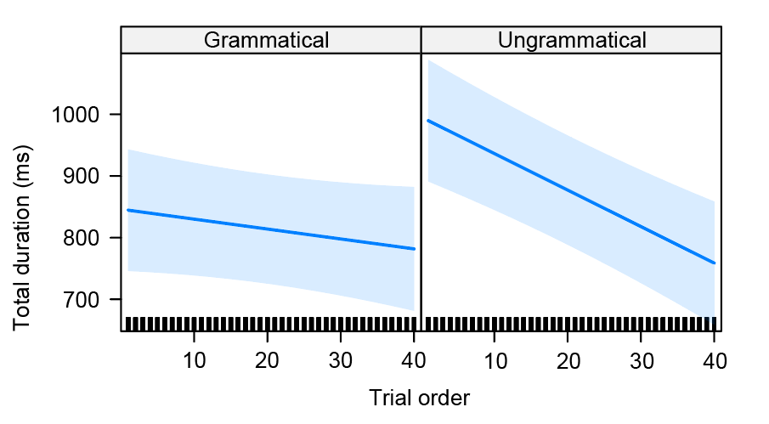

Figure 4. Regression path duration on the subject: Effect plot of grammaticality and trial order

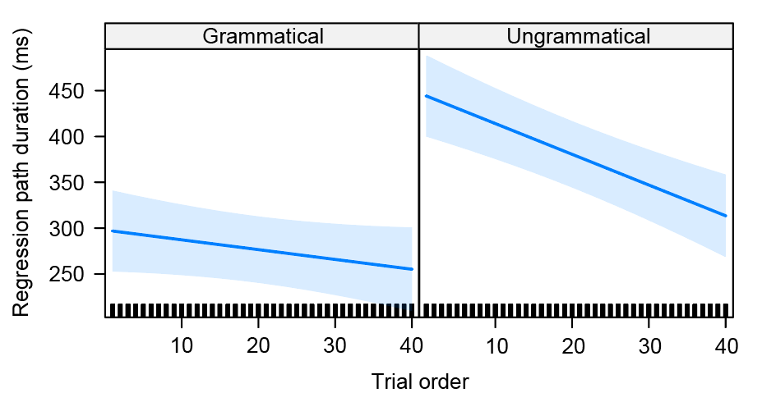

Figure 5. Total duration on the subject: Effect plot of grammaticality and trial order

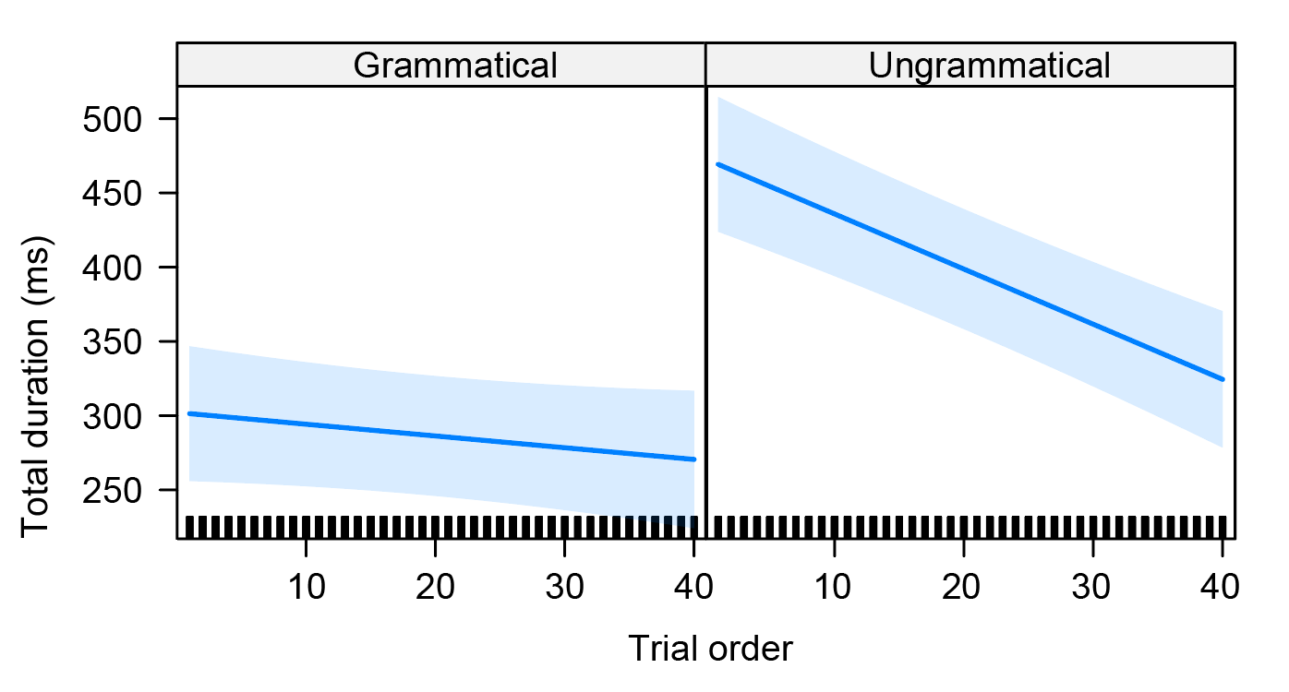

Figure 6. Regression path duration on the verb: Effect plot of grammaticality and trial order

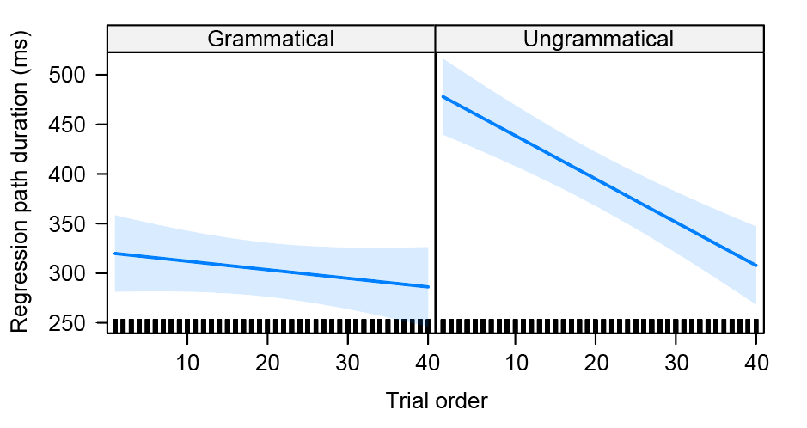
Figure 7. Total duration on the verb: Effect plot of grammaticality and trial order

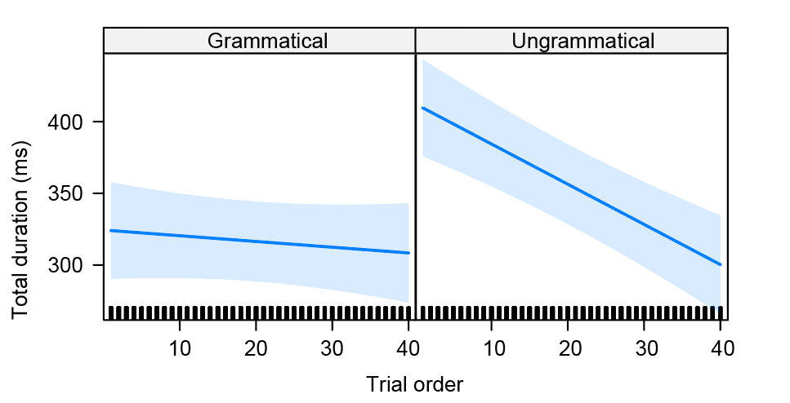

Figure 8. Effect plot of regression path duration in ms in the post-critical region (object)

