Supplementary Materials
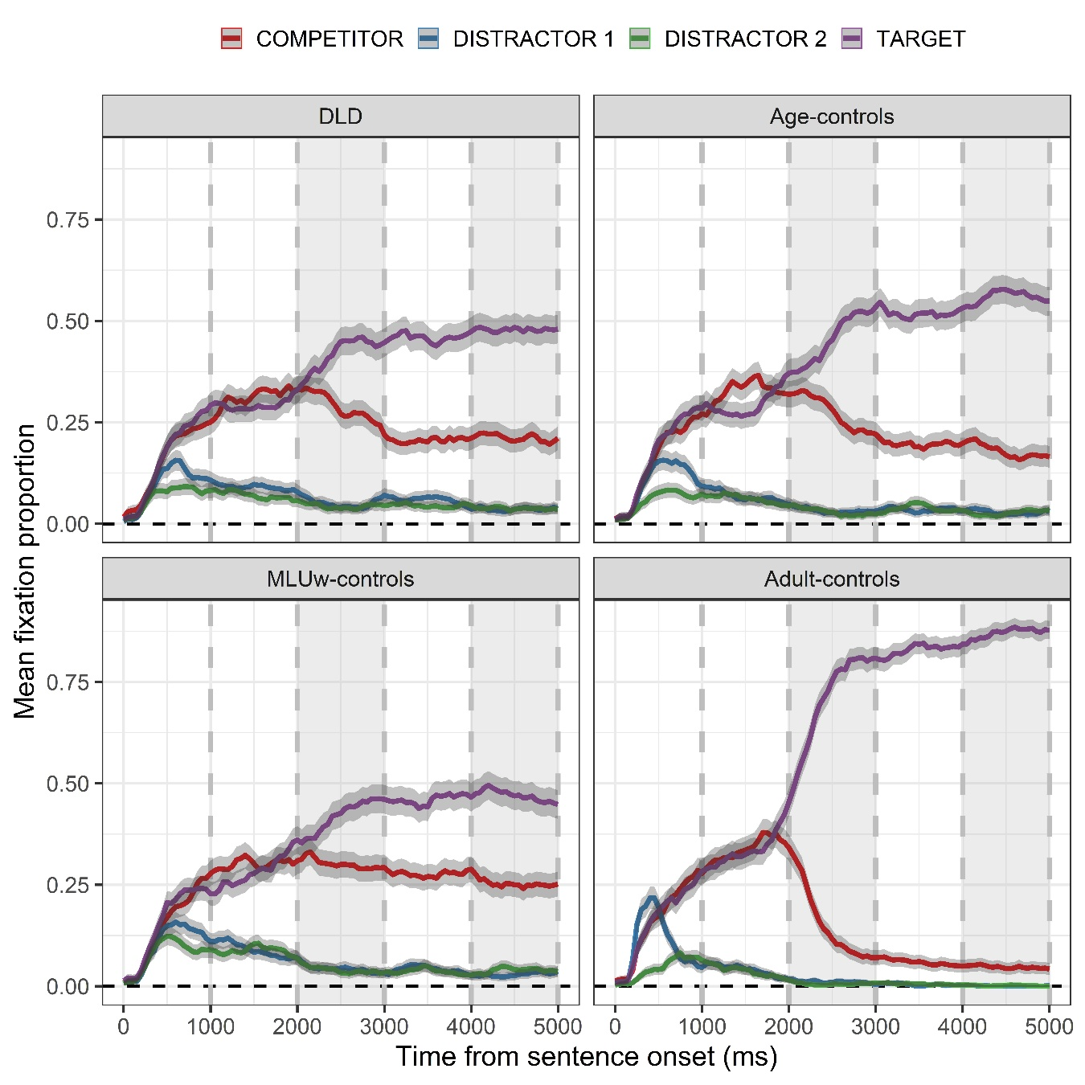
Figure 1S. Mean fixation proportion as a function of group (panels: DLD, Age-controls, MLUw-controls, Adult-controls) and image (color lines: Target, Competitor, Distractor 1, Distractor 2) in the visual context from the onset of the sentence. Gray area surrounding color lines represent 95% within-subject adjusted confidence intervals. Shaded time windows (2000-3000, 4000-5000) mark silent time window.

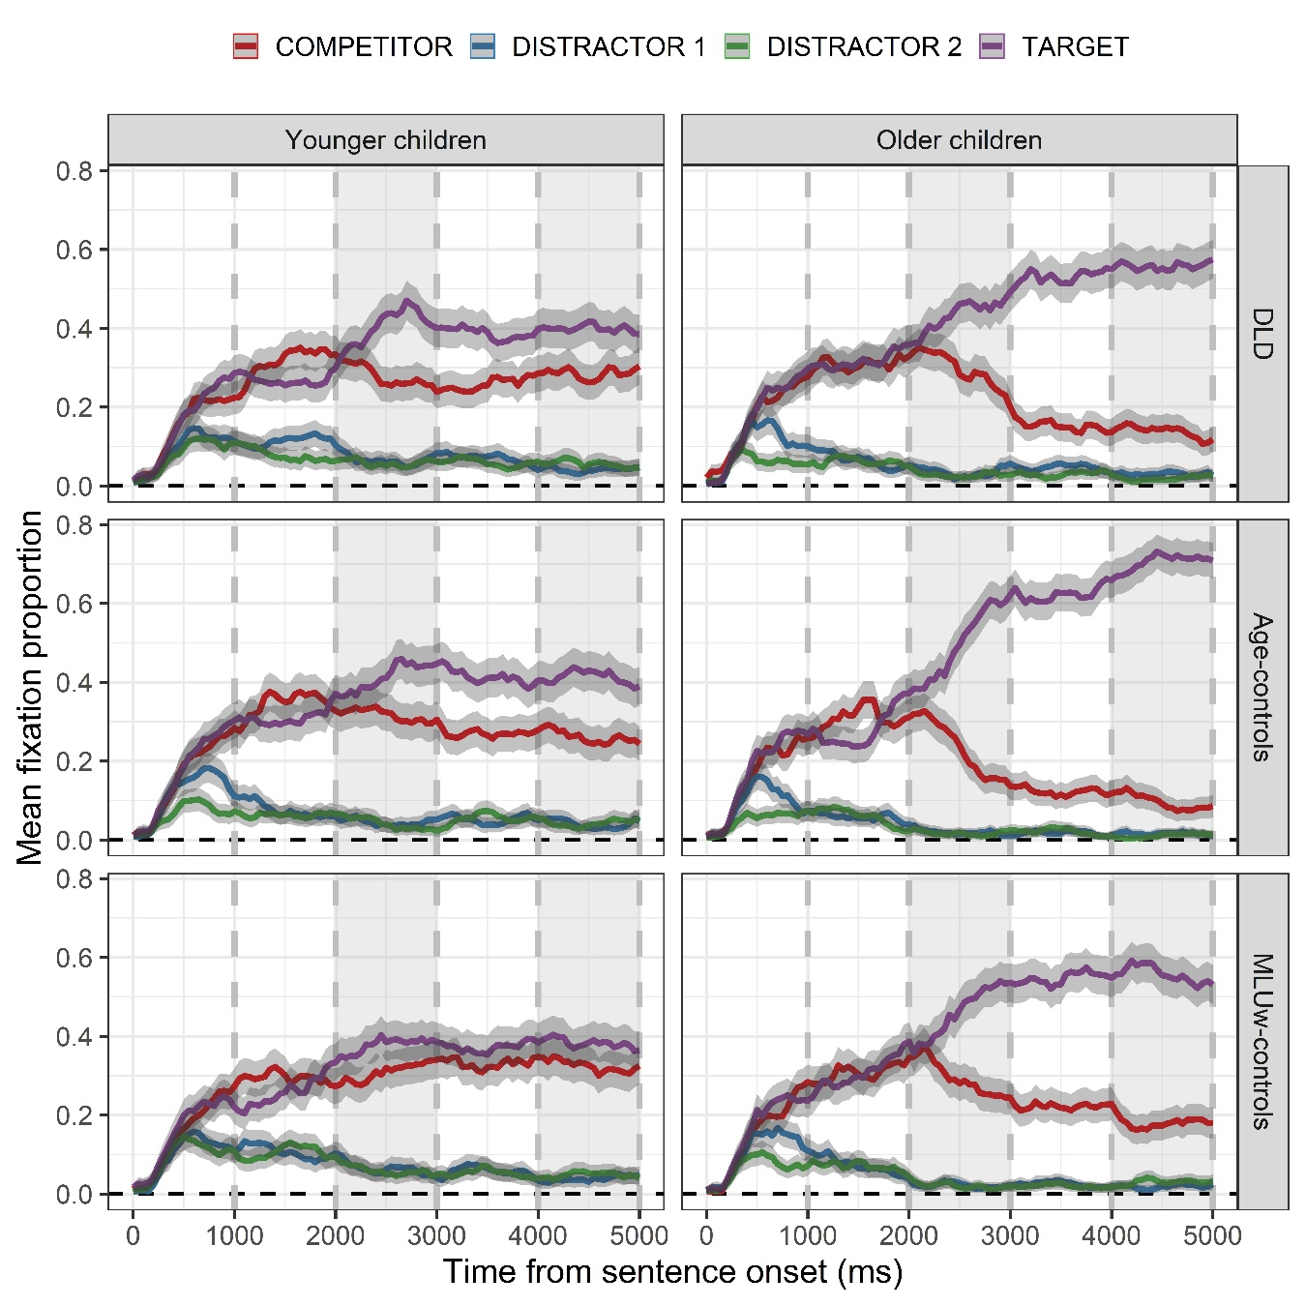
Figure 2S. Mean fixation proportion as a function of group (panels: DLD, Age-controls, MLUw-controls), age (Younger children, Older children) and image (color lines: Target, Competitor, Distractor 1, Distractor 2) in the visual context from the onset of the sentence. Gray area surrounding color lines represent 95% within-subject adjusted confidence intervals. Shaded time windows (2000-3000, 4000-5000) mark silent time window.
Figure 3S. Frecuency distribution for absolute effect size (fixation proportion difference) per cluster. The figure shows the fixation proportion differences for every time window within significant clusters, plotted as histograms containing the collections of all effects size in a cluster.

Visual materials and corresponding sentences used in the experiment
AUDIO  1. La niña pondrá la sopa en el plato [The girl will put the soup in the plate]. | IMAGE  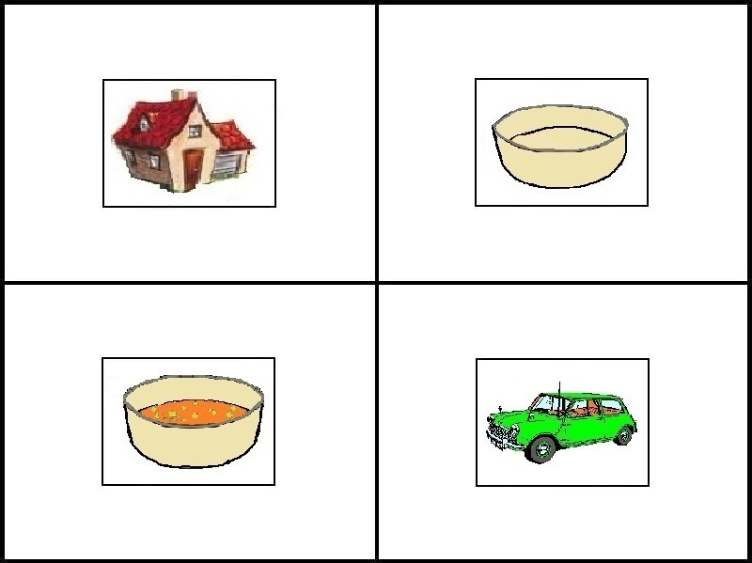 | TARGET/COMPETITOR  TARGET:  empty plate  COMPETITOR:  full plate
2. El niño comió el pastel de cumpleaños [The boy ate the birthday cake]. | 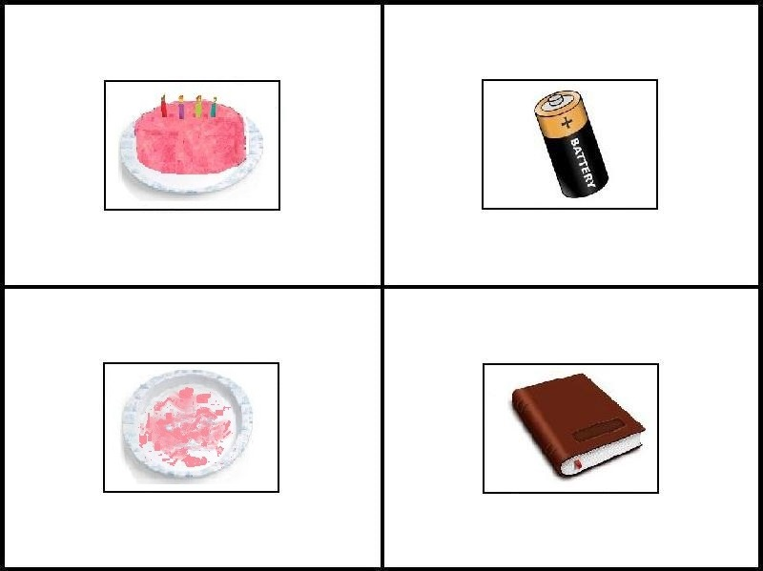 | TARGET:  eaten cake  COMPETITOR:  entire cake
3. El avión aterrizará en el aeropuerto [The plane will land at the airport]. | 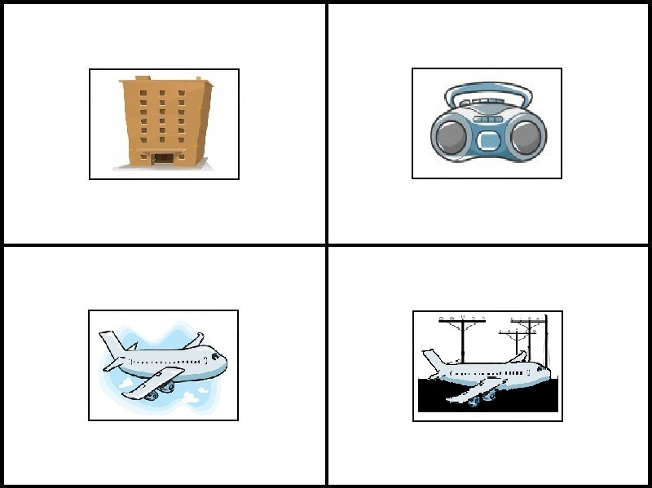 | TARGET:  flying plane  COMPETITOR:  landed plane
4. Mi abuela encendió la chimenea [My grandmother lit the fireplace]. | 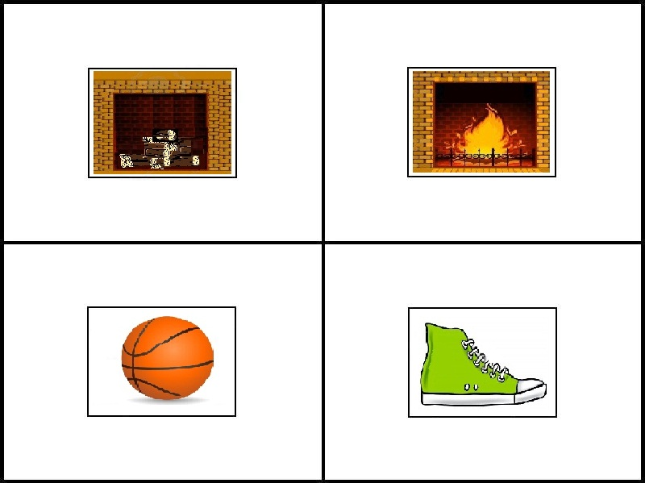 | TARGET:  lighted fireplace COMPETITOR:  fireplace without fire
5. La niña subirá al árbol [The girl will climb the tree]. | 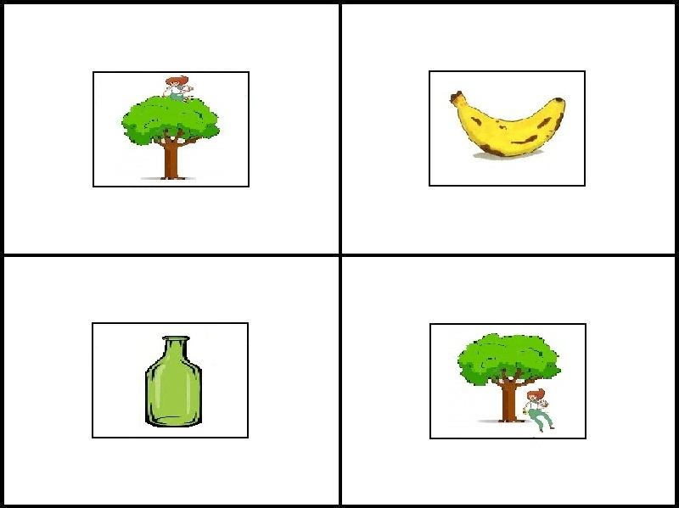 | TARGET:  girl in front of the tree COMPETITOR:  girl on the tree
6. El hombre cortó la leña [The man cut the wood]. | 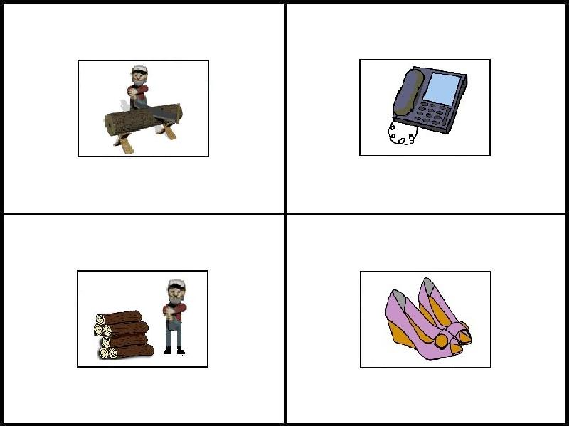 | TARGET:  cut wood  COMPETITOR:  uncut wood
7. El niño saltará a la piscina [The boy will jump in the swimming pool]. | 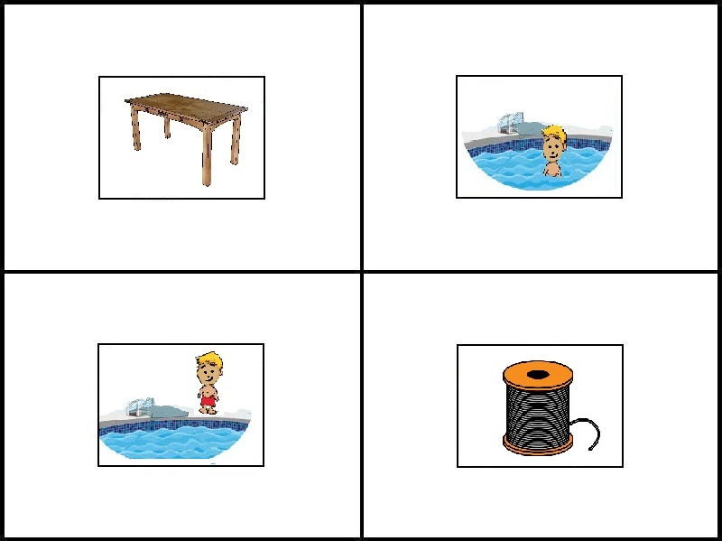 | TARGET:  boy outside the pool  COMPETITOR:  boy inside the pool
8. El niño cogió la pelota [The boy caught the ball]. | 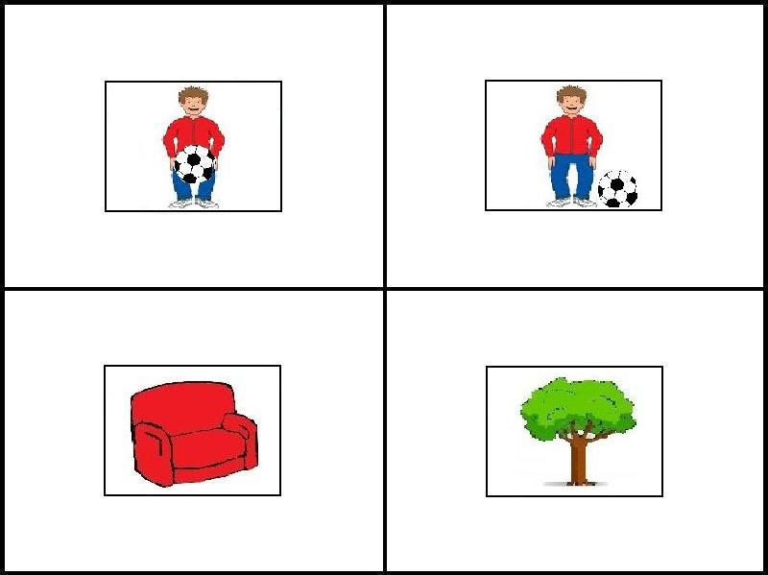 | TARGET:  boy with the ball  COMPETITOR:  boy without the ball
9. El pájaro atrapará al gusano [The bird will catch the worm]. | 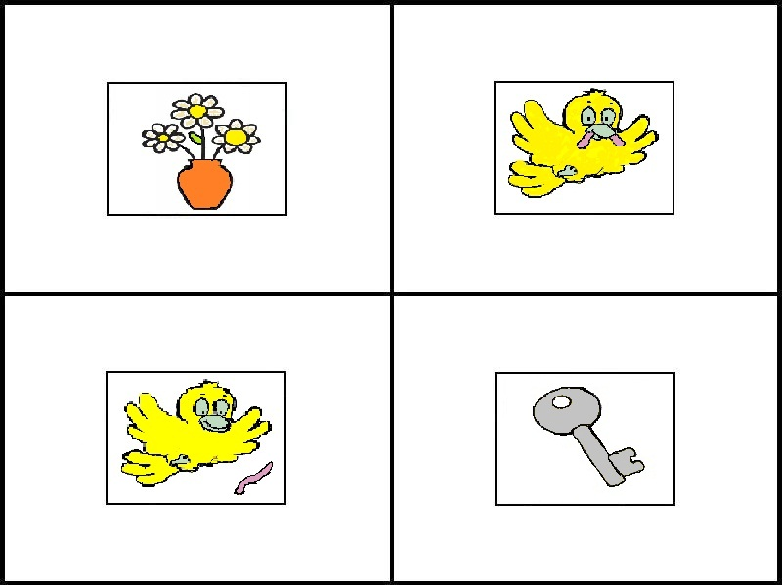 | TARGET:  worm on ground COMPETITOR:  worm eaten by the bird
10. El niño metió un mensaje dentro de una botella [The boy put a message inside the bottle]. | 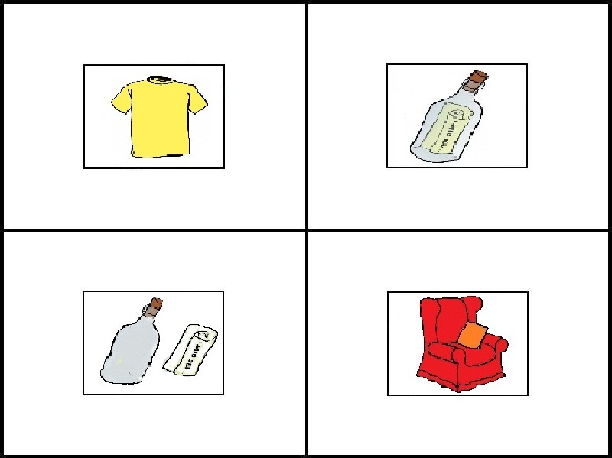 | TARGET:  bottle with the message  COMPETITOR:  empty bottle
11. La niña decorará el árbol de navidad [The girl will decorate the Christmas tree]. | 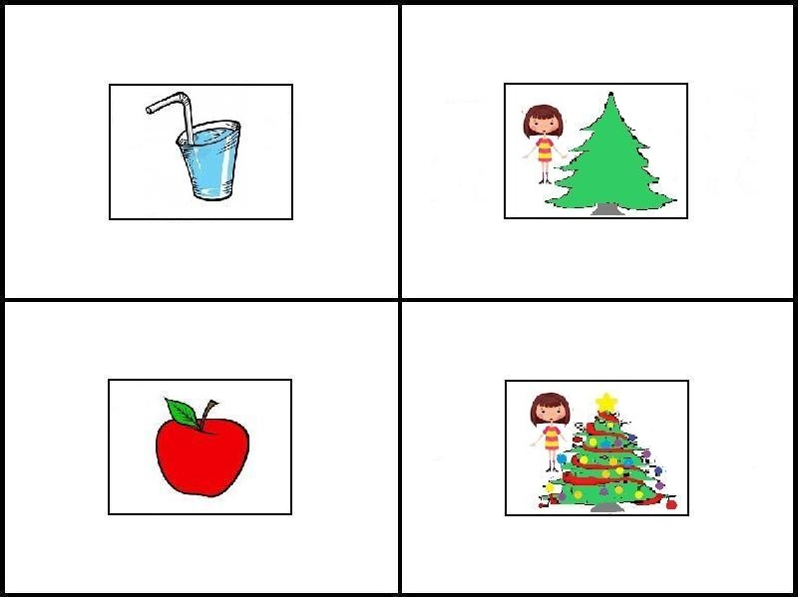 | TARGET:  undecorated tree COMPETITOR:  decorated tree
12. La maestra mordió una manzana en el descanso [The teacher bit an apple during the break]. | 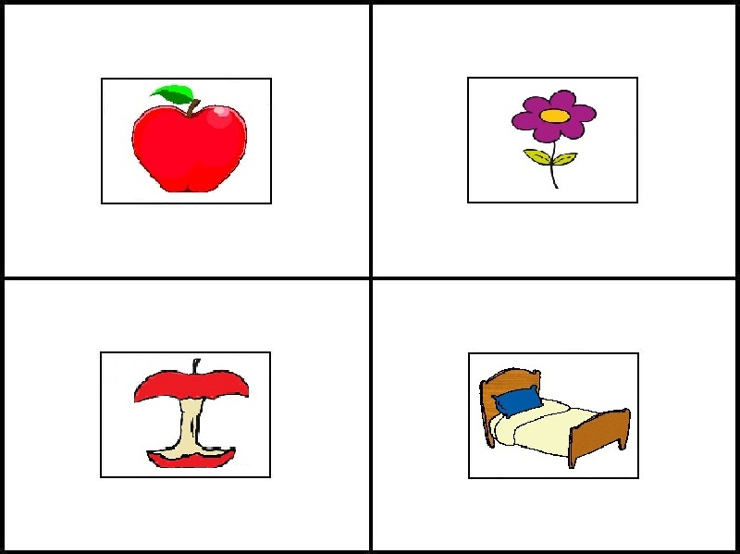 | TARGET:  bitten apple  COMPETITOR:  entire apple
13. Mi abuela encenderá una vela [My grandmother will light a candle]. | 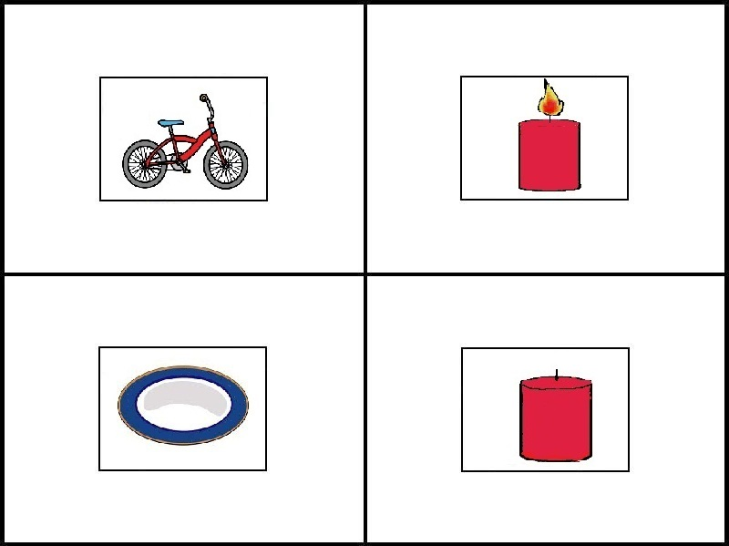 | TARGET:  candle off  COMPETITOR:  lighted candle
14. Mi abuelo bebió un vaso de agua [My grandfather drank a glass of water]. | 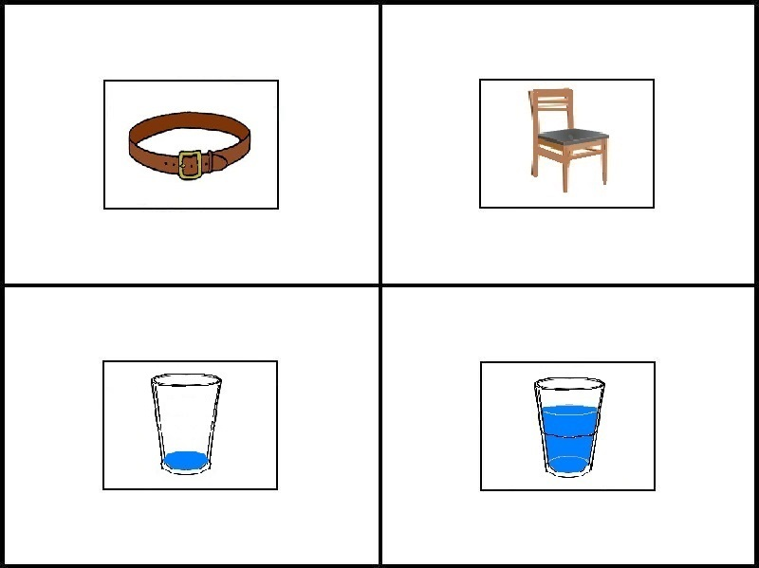 | TARGET:  empty glass  COMPETITOR:  glass with water
15. El niño recogerá sus juguetes [The boy will pick up his toys]. | 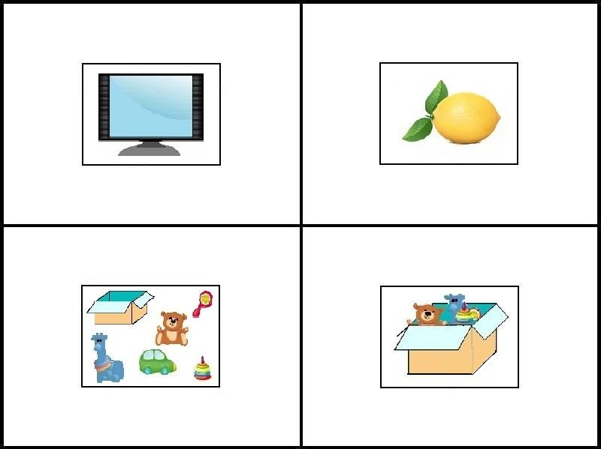 | TARGET:  toys on the floor COMPETITOR:  toys in the box
16. La niña abrió su regalo [The girl opened her present]. | 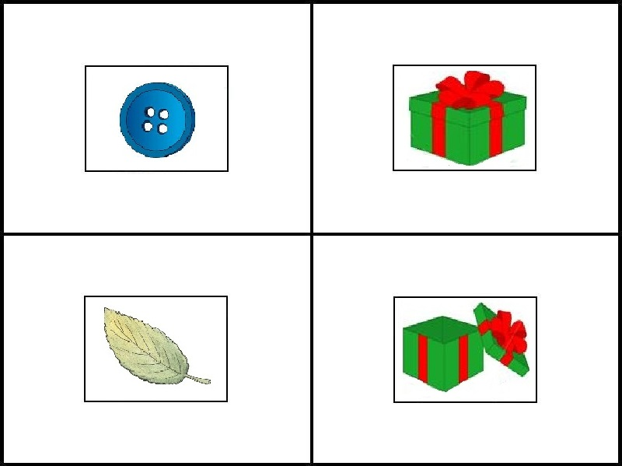 | TARGET:  opened present COMPETITOR:  wrapped present
17. El chico atará sus zapatos [The boy will tie his shoes]. | 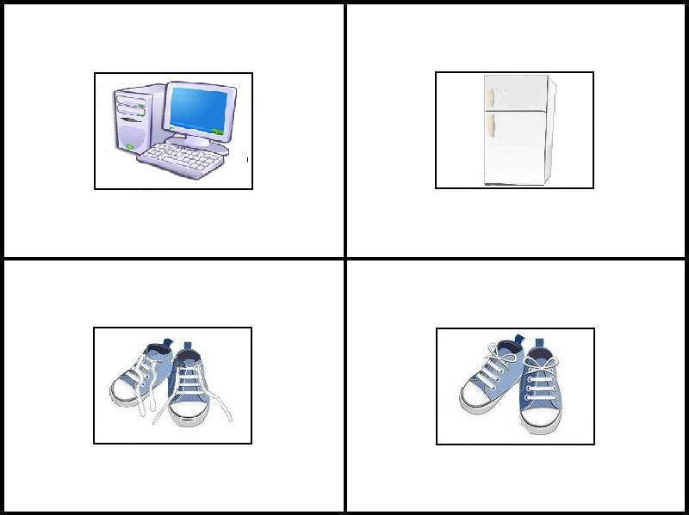 | TARGET:  shoes untied  COMPETITOR:  tied shoes
18. El niño rompió la ventana [The boy broke the window]. | 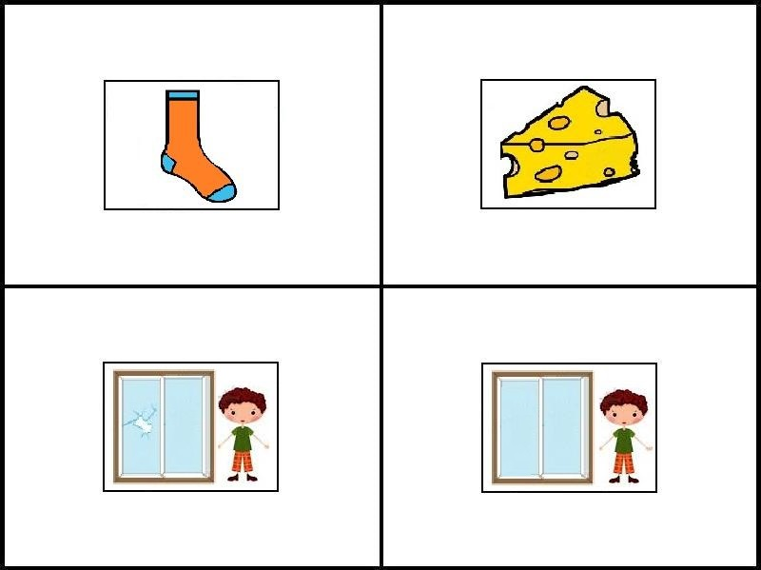 | TARGET:  broken window COMPETITOR:  window unbroken
19. El señor abrirá la puerta [The gentleman will open the door]. | 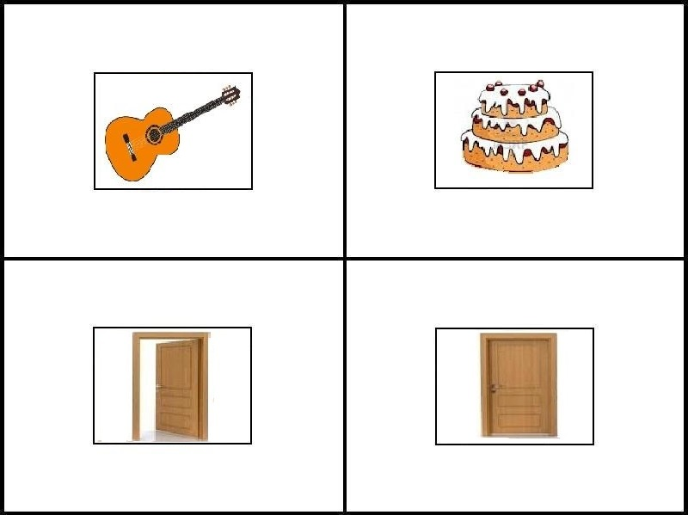 | TARGET:  closed door  COMPETITOR:  opened door
20. El niño subió las escaleras [The boy went up the stairs]. | 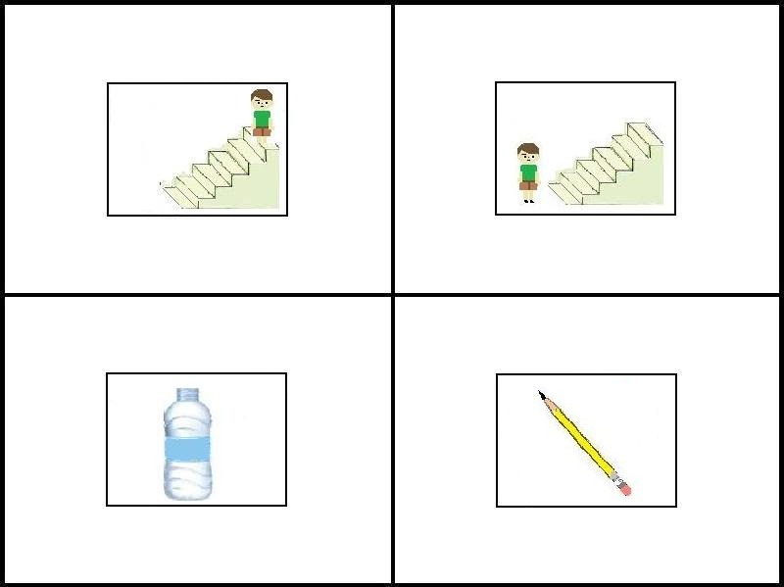 | TARGET:  boy at the top  COMPETITOR:  boy at the bottom
21. Joan escribirá una carta [Joan will write a letter]. | 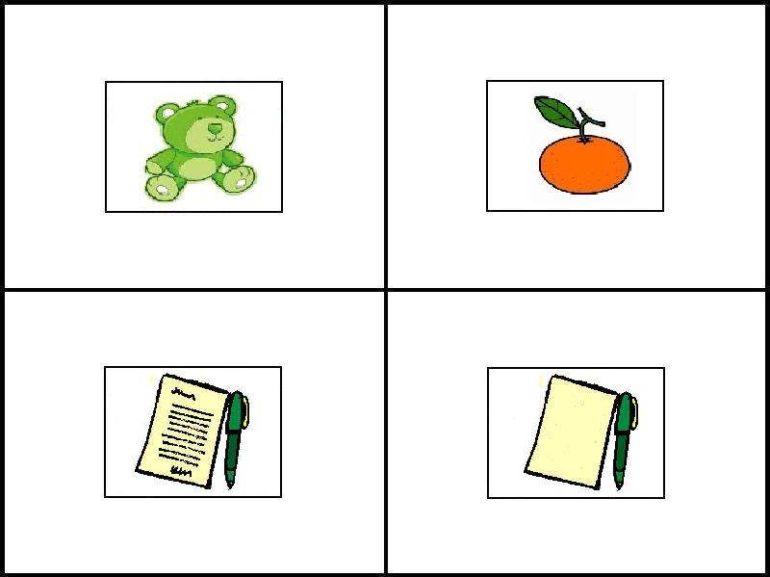 | TARGET:  blank paper  COMPETITOR:  written paper
22. La niña comió un helado [The girl ate the ice cream]. | 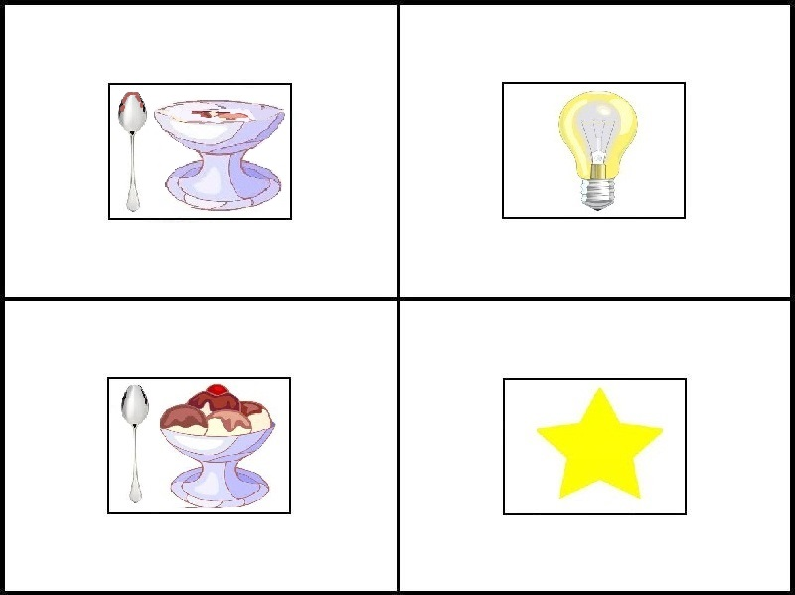 | TARGET:  glass without ice cream COMPETITOR:  glass with ice cream
23. El señor pintará la pared [The gentleman will paint the wall]. | 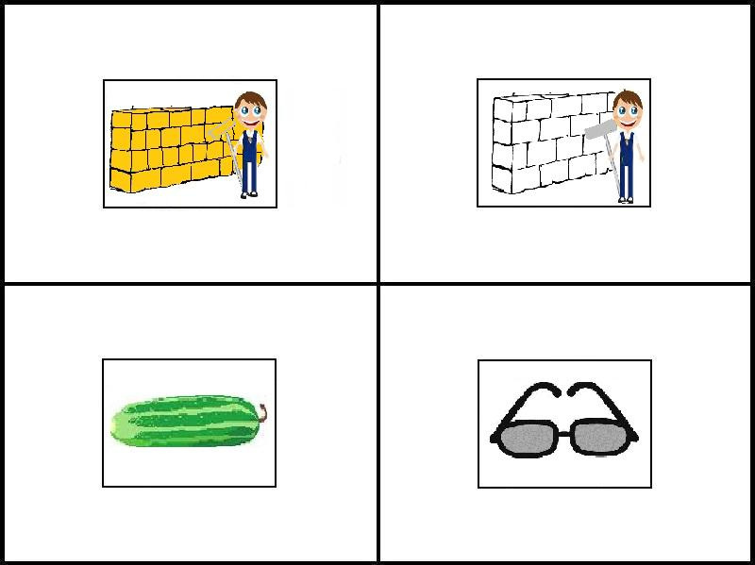 | TARGET:  white wall  COMPETITOR:  painted wall
24. El hombre bañó al perro [The man bathed the dog]. | 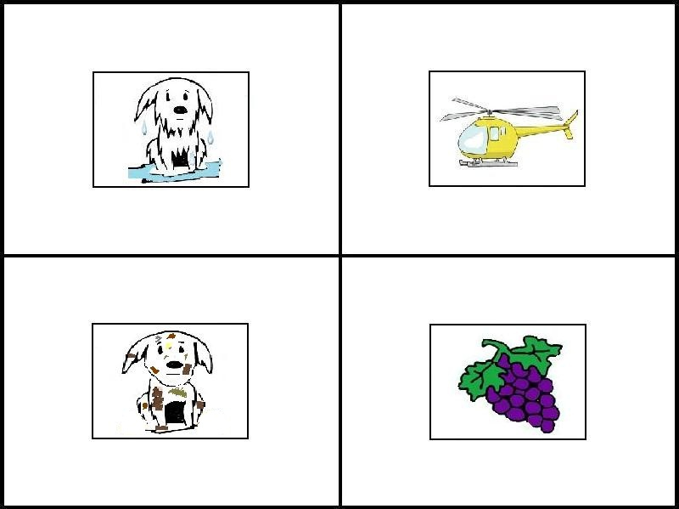 | TARGET:  bathed dog  COMPETITOR:  unbathed dog
25. El niño manchará su ropa [The boy will stain his clothes]. | 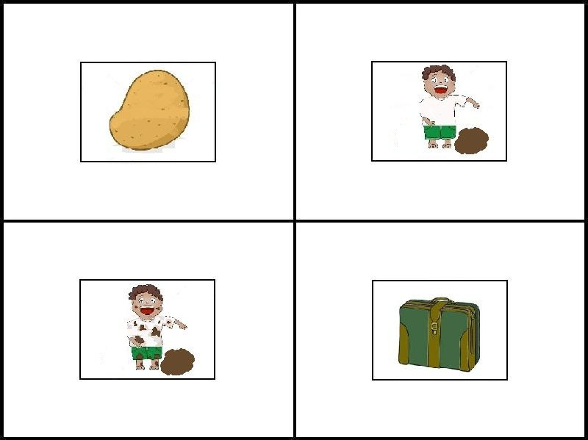 | TARGET:  boy with clean T-shirt COMPETITOR:  boy with stained T-shirt
26. El hombre construyó el muro [The man constructed the wall]. | 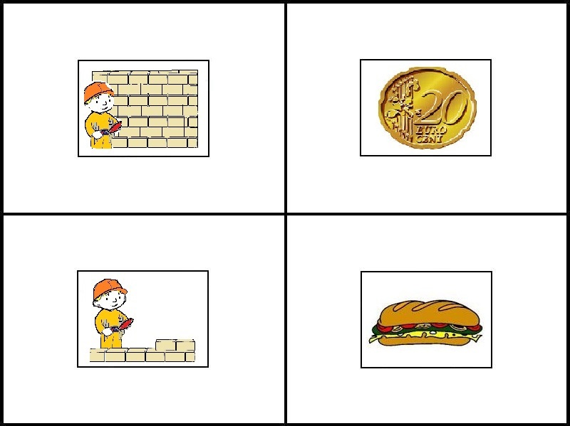 | TARGET:  constructed wall COMPETITOR:  wall under construction
27. La niña dibujará en una hoja [The girl will draw on a paper]. | 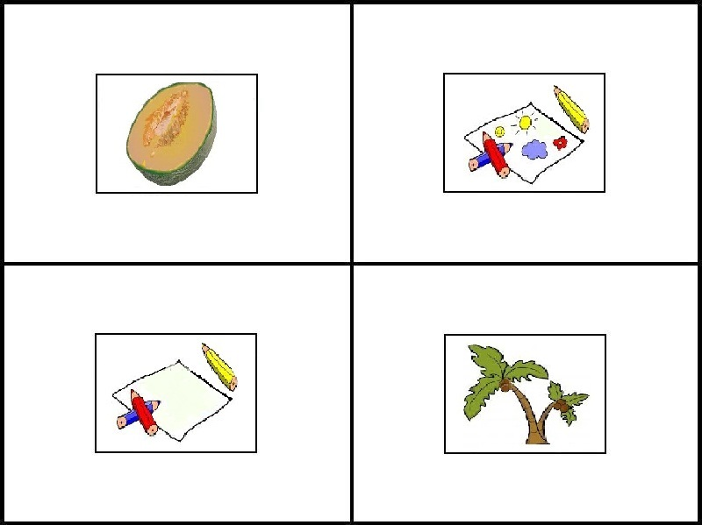 | TARGET:  white paper  COMPETITOR:  paper with drawings
28. El cartero entregó un paquete [The postman delivered the package]. | 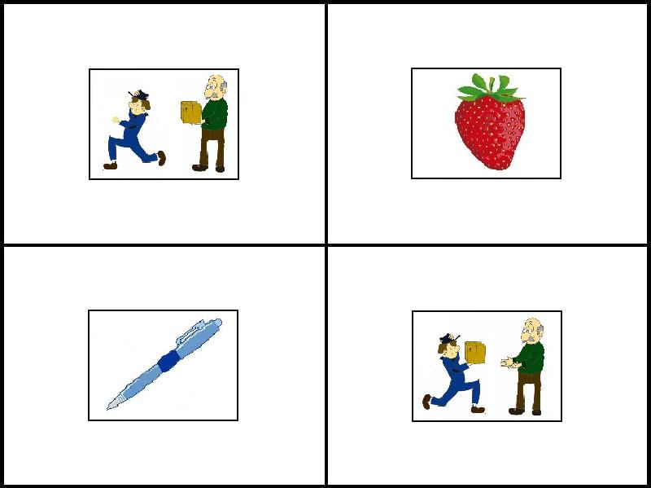 | TARGET:  postman without package  COMPETITOR:  postman with the package
29. El chico tirará la pelota [The boy will throw the ball]. | 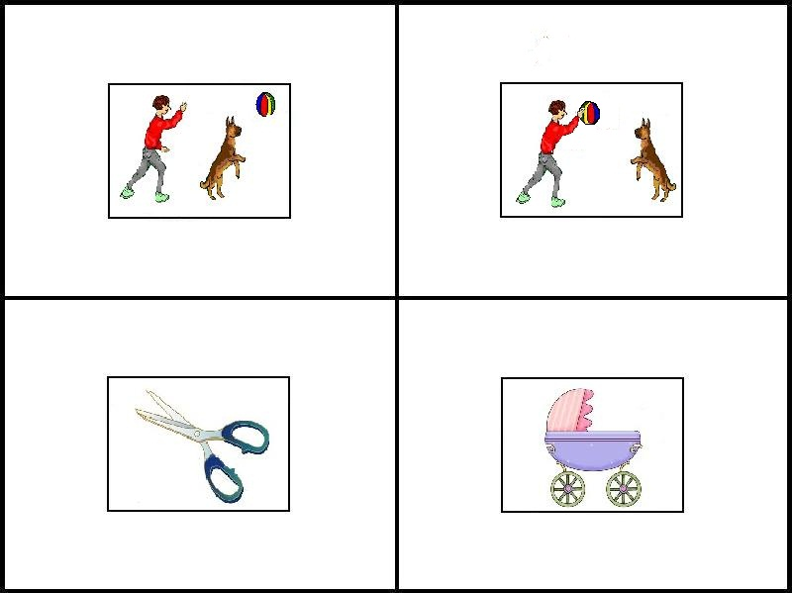 | TARGET:  boy with the ball COMPETITOR:  boy without the ball
30. La planta creció en la maceta [The plant grew in the pot]. | 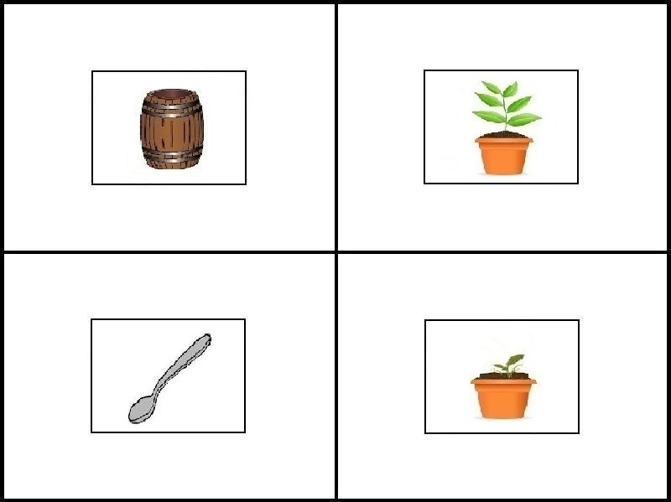 | TARGET:  big plant  COMPETITOR:  growing plant

