Appendix S1. The number of participants identified as outliers in the current analyses.
Training Data (Day 1)
- Articulation rate
  - Blocked = 1 (Subject#100)
- Mid-clause pause duration
  - Blocked = 1 (Subject#123)
  - Interleaved = 2 (Subject#6, Subject#98)
- Clause-final pause duration
  - Interleaved = 2 (Subject#107, Subject#98)
- Repetition
  - Interleaved = 1 (Subject#85)
Training Data (Day 2)
No outlier was identified.
Training Data (Day 3)
- Articulation rate
  - Interleaved = 1 (Subject#97)
- Clause-final pause duration
  - Blocked = 2 (Subject#101, Subject#108)
  - Interleaved = 1 (Subject#107)
- Repetition
  - Blocked = 1 (Subject#116)
  - Interleaved = 1 (Subject#26)
- Repairs
  - Interleaved = 2 (Subject#26, Subject#103)
Pretest and posttest data
- Mid-clause pause duration
  - Blocked = 2 (Subject#105, Subject#112)
- Clause-final pause duration
  - Interleaved = 2 (Subject#98, Subject#107)
  - Blocked = 1 (Subject#105)
- Clause-final pause frequency
  - Blocked = 1 (Subject#126)
- Repairs
  - Interleaved = 1 (Subject#26)

Appendix S2. Descriptive statistics for fluency data.
[Total Speech Time (in seconds)]
 | Blocked Group |  |  | Interleaved Group
 | M | SD |  | M | SD
Pretest | 88.14 | 26.11 |  | 95.77 | 26.34
Posttest | 95.05 | 24.50 |  | 101.47 | 22.56
Training Day 1_1 | 101.06 | 39.77 |  | 118.15 | 40.03
Training Day 1_2 | 114.79 | 39.20 |  | 121.60 | 33.37
Training Day 1_3 | 114.60 | 38.33 |  | 122.36 | 32.34
Training Day 2_1 | 98.28 | 37.42 |  | 103.73 | 34.56
Training Day 2_2 | 102.12 | 39.91 |  | 113.54 | 33.76
Training Day 2_3 | 109.58 | 37.57 |  | 119.65 | 36.74
Training Day 3_1 | 103.30 | 45.10 |  | 103.22 | 40.58
Training Day 3_2 | 107.42 | 35.19 |  | 111.40 | 34.96
Training Day 3_3 | 105.68 | 39.44 |  | 112.72 | 38.51

[Training Data for Analyses]
Articulation rate
 | Blocked Group |  |  |  |  | Interleaved Group
 |  |  | 95% CI |  |  |  |  | 95% CI
Trial | M | SD | Lower | Upper |  | M | SD | Lower | Upper
Day 1_1 | 152.73 | 28.51 | 140.50 | 163.92 |  | 154.88 | 24.72 | 145.60 | 164.44
Day 1_2 | 160.54 | 26.88 | 149.03 | 171.55 |  | 155.12 | 27.27 | 144.35 | 166.45
Day 1_3 | 170.14 | 25.92 | 158.72 | 180.63 |  | 155.22 | 23.16 | 146.19 | 164.69
Day 2_1 | 160.20 | 24.09 | 149.21 | 169.90 |  | 167.26 | 24.48 | 158.25 | 177.04
Day 2_2 | 163.06 | 27.64 | 149.08 | 174.62 |  | 166.64 | 26.78 | 156.71 | 178.24
Day 2_3 | 168.05 | 23.80 | 156.99 | 177.78 |  | 161.21 | 24.38 | 151.88 | 170.63
Day 3_1 | 160.92 | 22.11 | 151.39 | 170.03 |  | 168.73 | 26.73 | 159.29 | 178.65
Day 3_2 | 165.98 | 24.08 | 156.14 | 176.07 |  | 168.48 | 26.98 | 158.64 | 179.56
Day 3_3 | 167.60 | 22.87 | 157.78 | 176.85 |  | 163.91 | 24.24 | 155.14 | 173.13

Mid-clause pause duration
 | Blocked Group |  |  |  |  | Interleaved Group
 |  |  | 95% CI |  |  |  |  | 95% CI
Trial | M | SD | Lower | Upper |  | M | SD | Lower | Upper
Day 1_1 | 0.52 | 0.12 | 0.47 | 0.57 |  | 0.63 | 0.23 | 0.55 | 0.72
Day 1_2 | 0.50 | 0.16 | 0.43 | 0.58 |  | 0.61 | 0.26 | 0.52 | 0.72
Day 1_3 | 0.48 | 0.16 | 0.41 | 0.54 |  | 0.59 | 0.18 | 0.52 | 0.67
Day 2_1 | 0.61 | 0.20 | 0.53 | 0.69 |  | 0.51 | 0.15 | 0.46 | 0.56
Day 2_2 | 0.50 | 0.13 | 0.45 | 0.55 |  | 0.48 | 0.12 | 0.44 | 0.53
Day 2_3 | 0.48 | 0.14 | 0.43 | 0.54 |  | 0.57 | 0.18 | 0.50 | 0.64
Day 3_1 | 0.57 | 0.22 | 0.47 | 0.66 |  | 0.45 | 0.14 | 0.40 | 0.51
Day 3_2 | 0.47 | 0.20 | 0.39 | 0.56 |  | 0.46 | 0.11 | 0.42 | 0.51
Day 3_3 | 0.42 | 0.17 | 0.36 | 0.50 |  | 0.47 | 0.15 | 0.41 | 0.53

Clause-final pause duration
 | Blocked Group |  |  |  |  | Interleaved Group
 |  |  | 95% CI |  |  |  |  | 95% CI
Trial | M | SD | Lower | Upper |  | M | SD | Lower | Upper
Day 1_1 | 1.06 | 0.55 | 0.86 | 1.27 |  | 0.97 | 0.36 | 0.83 | 1.11
Day 1_2 | 1.00 | 0.46 | 0.85 | 1.19 |  | 1.05 | 0.38 | 0.92 | 1.19
Day 1_3 | 0.94 | 0.41 | 0.79 | 1.11 |  | 1.16 | 0.58 | 0.95 | 1.40
Day 2_1 | 1.02 | 0.40 | 0.88 | 1.19 |  | 0.95 | 0.34 | 0.83 | 1.10
Day 2_2 | 0.93 | 0.50 | 0.74 | 1.13 |  | 0.96 | 0.36 | 0.82 | 1.11
Day 2_3 | 0.99 | 0.51 | 0.78 | 1.22 |  | 1.07 | 0.46 | 0.91 | 1.26
Day 3_1 | 1.09 | 0.60 | 0.87 | 1.32 |  | 0.87 | 0.31 | 0.77 | 0.99
Day 3_2 | 0.91 | 0.40 | 0.75 | 1.06 |  | 0.93 | 0.32 | 0.81 | 1.06
Day 3_3 | 0.86 | 0.37 | 0.70 | 1.02 |  | 1.00 | 0.40 | 0.84 | 1.18

Mid-clause pause frequency
 | Blocked Group |  |  |  |  | Interleaved Group
 |  |  | 95% CI |  |  |  |  | 95% CI
Trial | M | SD | Lower | Upper |  | M | SD | Lower | Upper
Day 1_1 | 18.89 | 6.02 | 16.27 | 21.50 |  | 19.58 | 6.07 | 17.19 | 21.72
Day 1_2 | 20.03 | 5.22 | 17.99 | 22.19 |  | 20.30 | 6.04 | 17.92 | 22.63
Day 1_3 | 18.97 | 5.11 | 17.00 | 21.22 |  | 19.06 | 5.97 | 16.87 | 21.51
Day 2_1 | 18.42 | 5.55 | 16.17 | 20.53 |  | 19.71 | 5.04 | 17.90 | 21.67
Day 2_2 | 19.04 | 4.83 | 17.17 | 21.12 |  | 19.93 | 6.43 | 17.78 | 22.28
Day 2_3 | 17.75 | 4.71 | 15.72 | 19.80 |  | 18.87 | 4.98 | 17.07 | 20.71
Day 3_1 | 17.37 | 4.74 | 15.51 | 19.46 |  | 17.65 | 4.82 | 15.94 | 19.54
Day 3_2 | 17.36 | 5.17 | 15.27 | 19.78 |  | 17.26 | 5.31 | 15.52 | 19.29
Day 3_3 | 17.20 | 5.40 | 14.71 | 19.88 |  | 17.60 | 5.07 | 15.84 | 19.63

Clause-final pause frequency
 | Blocked Group |  |  |  |  | Interleaved Group
 |  |  | 95% CI |  |  |  |  | 95% CI
Trial | M | SD | Lower | Upper |  | M | SD | Lower | Upper
Day 1_1 | 8.00 | 2.91 | 7.03 | 9.13 |  | 6.57 | 2.16 | 5.79 | 7.30
Day 1_2 | 7.69 | 2.65 | 6.63 | 8.84 |  | 5.98 | 1.94 | 5.28 | 6.72
Day 1_3 | 8.17 | 2.82 | 7.07 | 9.33 |  | 6.42 | 1.89 | 5.77 | 7.10
Day 2_1 | 7.41 | 1.94 | 6.63 | 8.25 |  | 7.90 | 2.86 | 7.02 | 8.79
Day 2_2 | 8.24 | 3.33 | 6.98 | 9.54 |  | 7.66 | 2.04 | 6.96 | 8.50
Day 2_3 | 8.67 | 3.42 | 7.37 | 10.10 |  | 6.98 | 2.19 | 6.20 | 7.82
Day 3_1 | 8.61 | 3.55 | 7.35 | 10.05 |  | 9.30 | 2.01 | 8.62 | 10.01
Day 3_2 | 9.37 | 3.33 | 7.94 | 10.68 |  | 9.13 | 1.95 | 8.45 | 9.80
Day 3_3 | 10.35 | 3.62 | 8.98 | 11.76 |  | 8.50 | 1.95 | 7.78 | 9.23

Repetitions
 | Blocked Group |  |  |  |  | Interleaved Group
 |  |  | 95% CI |  |  |  |  | 95% CI
Trial | M | SD | Lower | Upper |  | M | SD | Lower | Upper
Day 1_1 | 2.33 | 2.42 | 1.32 | 3.31 |  | 4.04 | 4.26 | 2.43 | 5.81
Day 1_2 | 2.71 | 2.76 | 1.65 | 3.83 |  | 3.84 | 3.16 | 2.61 | 5.10
Day 1_3 | 2.76 | 3.13 | 1.56 | 3.97 |  | 3.72 | 3.59 | 2.43 | 5.13
Day 2_1 | 2.00 | 1.95 | 1.29 | 2.75 |  | 3.32 | 3.58 | 1.96 | 4.91
Day 2_2 | 1.38 | 1.69 | 0.81 | 2.00 |  | 4.44 | 5.43 | 2.65 | 6.64
Day 2_3 | 1.86 | 1.65 | 1.18 | 2.55 |  | 3.80 | 4.84 | 2.24 | 5.69
Day 3_1 | 2.00 | 2.59 | 1.07 | 3.00 |  | 2.44 | 3.80 | 1.23 | 4.03
Day 3_2 | 1.62 | 1.72 | 1.00 | 2.26 |  | 3.08 | 4.25 | 1.52 | 4.76
Day 3_3 | 2.29 | 3.49 | 1.05 | 3.65 |  | 3.68 | 5.19 | 1.91 | 5.83

Repairs
 | Blocked Group |  |  |  |  | Interleaved Group
 |  |  | 95% CI |  |  |  |  | 95% CI
Trial | M | SD | Lower | Upper |  | M | SD | Lower | Upper
Day 1_1 | 5.27 | 4.74 | 3.36 | 7.55 |  | 6.24 | 4.01 | 4.62 | 7.67
Day 1_2 | 5.86 | 4.95 | 3.87 | 7.91 |  | 6.16 | 4.80 | 4.46 | 7.95
Day 1_3 | 5.05 | 4.33 | 3.35 | 7.14 |  | 7.08 | 5.69 | 4.98 | 9.23
Day 2_1 | 4.18 | 2.94 | 3.04 | 5.47 |  | 5.12 | 4.43 | 3.58 | 6.88
Day 2_2 | 5.00 | 3.93 | 3.58 | 6.88 |  | 5.56 | 5.98 | 3.53 | 7.96
Day 2_3 | 4.09 | 2.93 | 2.92 | 5.45 |  | 5.76 | 6.02 | 3.66 | 8.12
Day 3_1 | 4.68 | 3.94 | 3.04 | 6.45 |  | 5.52 | 5.45 | 3.48 | 7.73
Day 3_2 | 4.50 | 3.46 | 3.34 | 5.95 |  | 5.88 | 4.99 | 4.04 | 7.79
Day 3_3 | 4.23 | 3.79 | 2.76 | 5.94 |  | 4.40 | 3.85 | 3.04 | 5.75

[Pretest-Posttest Data for Analyses]
 | Blocked Group |  |  |  |  | Interleaved Group
 |  |  | 95% CI |  |  |  |  | 95% CI
 | M | SD | Lower | Upper |  | M | SD | Lower | Upper
Pretest
Articulation rate | 163.19 | 22.66 | 153.62 | 172.76 |  | 162.97 | 24.38 | 153.12 | 172.81
Mid-clause pause duration | 0.72 | 0.48 | 0.52 | 0.93 |  | 0.60 | 0.26 | 0.49 | 0.70
Clause-final pause duration | 0.85 | 0.37 | 0.69 | 1.01 |  | 0.88 | 0.37 | 0.72 | 1.04
Mid-clause pause frequency | 19.00 | 5.65 | 16.62 | 21.39 |  | 21.37 | 5.75 | 19.05 | 23.69
Clause-final pause frequency | 7.88 | 2.58 | 6.76 | 8.99 |  | 7.14 | 2.37 | 6.18 | 8.09
Repetitions | 1.55 | 1.24 | 1.02 | 2.07 |  | 2.62 | 2.48 | 1.62 | 3.63
Repairs | 1.79 | 1.42 | 1.19 | 2.39 |  | 1.59 | 1.07 | 1.15 | 2.03
Posttest
Articulation rate | 180.64 | 26.99 | 169.24 | 192.03 |  | 168.80 | 20.68 | 160.45 | 177.15
Mid-clause pause duration | 0.46 | 0.15 | 0.40 | 0.52 |  | 0.48 | 0.16 | 0.42 | 0.55
Clause-final pause duration | 0.72 | 0.22 | 0.63 | 0.82 |  | 0.84 | 0.34 | 0.69 | 0.98
Mid-clause pause frequency | 21.32 | 5.11 | 19.16 | 23.47 |  | 21.02 | 4.87 | 19.06 | 22.99
Clause-final pause frequency | 9.45 | 2.20 | 8.50 | 10.41 |  | 8.09 | 2.23 | 7.19 | 9.00
Repetitions | 1.39 | 1.57 | 0.73 | 2.05 |  | 2.20 | 2.34 | 1.25 | 3.15
Repairs | 1.90 | 1.55 | 1.25 | 2.56 |  | 1.94 | 1.57 | 1.29 | 2.58

Appendix S3.
Intercorrelations for aptitude scores and fluency changes.

 | NWRT | TMT | LLAMA_B
Day 1
Articulation rate | .28 | .09 | .02
Mid-clause pause dur. | -.33* | -.10 | .06
Clause-final pause dur. | .25 | -.11 | .07
Mid-clause pause freq. | .03 | .19 | .16
Clause-final pause Freq. | .08 | -.19 | -.34*
Repetitions | .06 | -.10 | .11
Repairs | -.06 | .25 | .03
Day 2
Articulation rate | .19 | .25 | .07
Mid-clause pause dur. | -.18 | -.12 | -.03
Clause-final pause dur. | -.10 | -.05 | .02
Mid-clause pause freq. | -.24 | .22 | .21
Clause-final pause Freq. | .35* | -.17 | -.27
Repetitions | -.16 | -.11 | .08
Repairs | -.04 | .26 | .03
Day 3
Articulation rate | .10 | .18 | .18
Mid-clause pause dur. | -.03 | -.13 | -.26
Clause-final pause dur. | -.02 | -.20 | -.12
Mid-clause pause freq. | -.37* | .22 | -.17
Clause-final pause Freq. | .18 | .10 | .26
Repetitions | .10 | -.10 | .06
Repairs | -.13 | -.01 | .11
Pretest-Posttest
Articulation rate | .08 | .19 | .24
Mid-clause pause duration | -.14 | .14 | .20
Clause-final pause duration | -.05 | .04 | -.10
Mid-clause pause frequency | -.09 | .10 | -.12
Clause-final pause frequency | .23 | -.04 | .29*
Repetitions | .11 | -.04 | .17
Repairs | .23 | .14 | -.16
Note. * p < .05.
Appendix S4.
Hierarchical multiple regression results.
Day 1
[Articulation Rate]
 | Coefficients |  |  |  |  | Model
Variable | B | 95% CI for B | p for B | β |  | R2 | ∆R2 | p for R2 | p for ∆R2
Step 1 |  |  |  |  |  | .13 | .13 | .014 | .01
Constant | 14.13 | [6.18,22.08]
Group | -14.08 | [-25.11,-3.05] | .01 | -.37
Step 2 |  |  |  |  |  | .20 | .06 | .060 | .37
Constant | 13.11 | [5.03,21.19]
Group | -12.10 | [-23.48,-0.73] | .04 | -.31
NWR | 0.86 | [-0.15,1.86] | .09 | .26
TMT | 0.14 | [-0.2,0.47] | .41 | .13
LLAMA_B | -0.02 | [-1.5,1.46] | .98 | .00

[Mid-Clause Pause Duration]
 | Coefficients |  |  |  |  | Model
Variable | B | 95% CI for B | p for B | β |  | R2 | ∆R2 | p for R2 | p for ∆R2
Step 1 |  |  |  |  |  | .00 | .00 | .77 | .77
Constant | -0.03 | [-0.09,0.04]
Group | 0.01 | [-0.08,0.1] | .77 | .05
Step 2 |  |  |  |  |  | .17 | .17 | .12 | .07
Constant | -0.01 | [-0.07,0.05]
Group | -0.01 | [-0.1,0.07] | .73 | -.05
NWR | -0.01 | [-0.02,0] | .01 | -.41
TMT | 0.00 | [0,0] | .13 | -.25
LLAMA_B | 0.01 | [-0.01,0.02] | .30 | .16
Step 3 |  |  |  |  |  | .23 | .06 | .07 | .098
Constant | -0.01 | [-0.07,0.05] | .78 | .00
Group | -0.01 | [-0.1,0.07] | .78 | -.04
NWR | -0.01 | [-0.02,-0.01] | .00 | -.61
TMT | 0.00 | [0,0] | .09 | -.27
LLAMA_B | 0.00 | [-0.01,0.02] | .43 | .12
Group x NWR | 0.01 | [0,0.03] | .098 | .32

[Clause-Final Pause Duration]
 | Coefficients |  |  |  |  | Model
Variable | B | 95% CI for B | p for B | β |  | R2 | ∆R2 | p for R2 | p for ∆R2
Step 1 |  |  |  |  |  | .10 | .10 | .04 | .03
Constant | -0.12 | [-0.31,0.08]
Group | 0.29 | [0.02,0.56] | .03 | .31
Step 2 |  |  |  |  |  | .19 | .09 | .07 | .22
Constant | -0.14 | [-0.33,0.05]
Group | 0.33 | [0.06,0.6] | .02 | .36
NWR | 0.02 | [0,0.05] | .052 | .30
TMT | 0.00 | [-0.01,0.01] | .90 | -.02
LLAMA_B | 0.00 | [-0.03,0.04] | .90 | .02

[Mid-Clause Pause Frequency]
 | Coefficients |  |  |  |  | Model
Variable | B | 95% CI for B | p for B | β |  | R2 | ∆R2 | p for R2 | p for ∆R2
Step 1 |  |  |  |  |  | .00 | .00 | .69 | .69
Constant | 0.01 | [-1.92,1.93]
Group | -0.53 | [-3.2,2.14] | .69 | -.06
Step 2 |  |  |  |  |  | .05 | .05 | .67 | .53
Constant | -0.04 | [-2.02,1.94]
Group | -0.44 | [-3.23,2.35] | .75 | -.05
NWR | 0.04 | [-0.2,0.29] | .73 | .06
TMT | 0.04 | [-0.04,0.12] | .31 | .17
LLAMA_B | 0.13 | [-0.23,0.49] | .47 | .12

[Clause-Final Pause Frequency]
 | Coefficients |  |  |  |  | Model
Variable | B | 95% CI for B | p for B | β |  | R2 | ∆R2 | p for R2 | p for ∆R2
Step 1 |  |  |  |  |  | .01 | .01 | .53 | .53
Constant | 0.26 | [-0.68,1.21]
Group | -0.42 | [-1.73,0.9] | .53 | -.10
Step 2 |  |  |  |  |  | .14 | .13 | .18 | .12
Constant | 0.19 | [-0.74,1.12]
Group | -0.27 | [-1.58,1.04] | .68 | -.06
NWR | 0.03 | [-0.09,0.14] | .66 | .07
TMT | -0.01 | [-0.05,0.03] | .52 | -.10
LLAMA_B | -0.18 | [-0.35,-0.01] | .04 | -.32

[Repetitions]
 | Coefficients |  |  |  |  | Model
Variable | B | 95% CI for B | p for B | β |  | R2 | ∆R2 | p for R2 | p for ∆R2
Step 1 |  |  |  |  |  | .01 | .01 | .54 | .54
Constant | 0.22 | [-1.04,1.47]
Group | -0.54 | [-2.28,1.2] | .54 | -.09
Step 2 |  |  |  |  |  | .04 | .04 | .76 | .69
Constant | 0.30 | [-1,1.6]
Group | -0.70 | [-2.53,1.14] | .45 | -.12
NWR | 0.00 | [-0.16,0.16] | .97 | -.01
TMT | -0.02 | [-0.08,0.03] | .38 | -.15
LLAMA_B | 0.12 | [-0.12,0.36] | .32 | .16

[Repairs]
 | Coefficients |  |  |  |  | Model
Variable | B | 95% CI for B | p for B | β |  | R2 | ∆R2 | p for R2 | p for ∆R2
Step 1 |  |  |  |  |  | .03 | .03 | .28 | .28
Constant | -0.16 | [-1.96,1.64]
Group | 1.37 | [-1.13,3.86] | .28 | .16
Step 2 |  |  |  |  |  | .10 | .07 | .35 | .35
Constant | -0.32 | [-2.14,1.5]
Group | 1.67 | [-0.89,4.24] | .20 | .20
NWR | 0.04 | [-0.19,0.26] | .75 | .05
TMT | 0.07 | [-0.01,0.14] | .07 | .29
LLAMA_B | -0.07 | [-0.41,0.26] | .66 | -.07

Day 2
[Articulation Rate]
 | Coefficients |  |  |  |  | Model
Variable | B | 95% CI for B | p for B | β |  | R2 | ∆R2 | p for R2 | p for ∆R2
Step 1 |  |  |  |  |  | .19 | .19 | .00 | .00
Constant | 8.03 | [1.59,14.47]
Group | -14.22 | [-23.16,-5.28] | .00 | -.44
Step 2 |  |  |  |  |  | .27 | .08 | .01 | .21
Constant | 7.21 | [0.78,13.65]
Group | -12.65 | [-21.71,-3.59] | .01 | -.39
NWR | 0.54 | [-0.26,1.34] | .18 | .19
TMT | 0.24 | [-0.03,0.51] | .08 | .26
LLAMA_B | 0.12 | [-1.06,1.29] | .84 | .03

[Mid-Clause Pause Duration]
 | Coefficients |  |  |  |  | Model
Variable | B | 95% CI for B | p for B | β |  | R2 | ∆R2 | p for R2 | p for ∆R2
Step 1 |  |  |  |  |  | .25 | .25 | .00 | .00
Constant | -0.11 | [-0.18,-0.05]
Group | 0.17 | [0.08,0.25] | .00 | .50
Step 2 |  |  |  |  |  | .28 | .03 | .01 | .69
Constant | -0.11 | [-0.17,-0.04]
Group | 0.16 | [0.07,0.25] | .00 | .48
NWR | 0.00 | [-0.01,0] | .36 | -.13
TMT | 0.00 | [0,0] | .47 | -.11
LLAMA_B | 0.00 | [-0.01,0.01] | .76 | -.04
Step 3 |  |  |  |  |  | .33 | .05 | .01 | .09
Constant | -0.11 | [-0.18,-0.05] | .00 | .00
Group | 0.15 | [0.06,0.24] | .00 | .47
NWR | 0.00 | [-0.01,0.01] | .76 | .05
TMT | 0.00 | [0,0] | .56 | -.08
LLAMA_B | 0.00 | [-0.01,0.01] | .97 | -.01
Group x NWR | -0.01 | [-0.03,0] | .09 | -.30

[Clause-Final Pause Duration]
 | Coefficients |  |  |  |  | Model
Variable | B | 95% CI for B | p for B | β |  | R2 | ∆R2 | p for R2 | p for ∆R2
Step 1 |  |  |  |  |  | .03 | .03 | .24 | .24
Constant | -0.05 | [-0.2,0.09]
Group | 0.12 | [-0.08,0.32] | .24 | .18
Step 2 |  |  |  |  |  | .04 | .01 | .79 | .95
Constant | -0.05 | [-0.2,0.11]
Group | 0.10 | [-0.11,0.32] | .33 | .15
NWR | -0.01 | [-0.02,0.01] | .59 | -.09
TMT | 0.00 | [-0.01,0] | .68 | -.07
LLAMA_B | 0.00 | [-0.03,0.03] | .86 | .03

[Mid-Clause Pause Frequency]
 | Coefficients |  |  |  |  | Model
Variable | B | 95% CI for B | p for B | β |  | R2 | ∆R2 | p for R2 | p for ∆R2
Step 1 |  |  |  |  |  | .00 | .00 | .87 | .87
Constant | -0.66 | [-2.27,0.95]
Group | -0.18 | [-2.42,2.05] | .87 | -.02
Step 2 |  |  |  |  |  | .13 | .13 | .21 | .13
Constant | -0.47 | [-2.05,1.12]
Group | -0.56 | [-2.79,1.68] | .62 | -.08
NWR | -0.15 | [-0.35,0.04] | .12 | -.24
TMT | 0.02 | [-0.04,0.09] | .50 | .11
LLAMA_B | 0.20 | [-0.09,0.49] | .18 | .21
Step 3 |  |  |  |  |  | .31 | .18 | .02 | .01
Constant | -0.29 | [-1.75,1.17] | .69 | .00
Group | -0.29 | [-2.34,1.77] | .78 | -.04
NWR | -0.25 | [-0.48,-0.03] | .03 | -.40
TMT | 0.03 | [-0.03,0.09] | .32 | .15
LLAMA_B | 0.44 | [0.09,0.78] | .01 | .47
Group x NWR | 0.40 | [0.03,0.77] | .04 | .38
Group x LLAMA_B | -0.69 | [-1.23,-0.16] | .01 | -.49

[Clause-Final Pause Frequency]
 | Coefficients |  |  |  |  | Model
Variable | B | 95% CI for B | p for B | β |  | R2 | ∆R2 | p for R2 | p for ∆R2
Step 1 |  |  |  |  |  | .16 | .16 | .01 | .01
Constant | 1.22 | [0.13,2.3]
Group | -2.16 | [-3.67,-0.66] | .01 | -.40
Step 2 |  |  |  |  |  | .31 | .15 | .003 | .04
Constant | 1.03 | [0,2.07]
Group | -1.81 | [-3.26,-0.35] | .02 | -.33
NWR | 0.14 | [0.01,0.27] | .04 | .30
TMT | -0.01 | [-0.05,0.03] | .67 | -.06
LLAMA_B | -0.17 | [-0.36,0.02] | .08 | -.25

[Repetitions]
 | Coefficients |  |  |  |  | Model
Variable | B | 95% CI for B | p for B | β |  | R2 | ∆R2 | p for R2 | p for ∆R2
Step 1 |  |  |  |  |  | .02 | .02 | .34 | .33
Constant | -0.25 | [-1.38,0.88]
Group | 0.76 | [-0.81,2.33] | .33 | .15
Step 2 |  |  |  |  |  | .08 | .06 | .50 | .48
Constant | -0.09 | [-1.25,1.07]
Group | 0.45 | [-1.19,2.08] | .58 | .09
NWR | -0.09 | [-0.24,0.05] | .20 | -.21
TMT | -0.03 | [-0.07,0.02] | .26 | -.18
LLAMA_B | 0.09 | [-0.12,0.3] | .40 | .14

[Repairs]
 | Coefficients |  |  |  |  | Model
Variable | B | 95% CI for B | p for B | β |  | R2 | ∆R2 | p for R2 | p for ∆R2
Step 1 |  |  |  |  |  | .02 | .02 | .32 | .32
Constant | -0.12 | [-1.68,1.44]
Group | 1.09 | [-1.08,3.26] | .32 | .15
Step 2 |  |  |  |  |  | .11 | .08 | .32 | .30
Constant | -0.27 | [-1.85,1.3]
Group | 1.39 | [-0.83,3.61] | .21 | .19
NWR | 0.04 | [-0.15,0.24] | .67 | .07
TMT | 0.06 | [0,0.13] | .06 | .31
LLAMA_B | -0.07 | [-0.35,0.22] | .65 | -.07

Day 3
[Articulation Rate]
 | Coefficients |  |  |  |  | Model
Variable | B | 95% CI for B | p for B | β |  | R2 | ∆R2 | p for R2 | p for ∆R2
Step 1 |  |  |  |  |  | .14 | .14 | .01 | .01
Constant | 4.99 | [-2.21,12.19]
Group | -12.96 | [-22.95,-2.97] | .01 | -.37
Step 2 |  |  |  |  |  | .20 | .06 | .06 | .38
Constant | 4.96 | [-2.37,12.28]
Group | -12.89 | [-23.2,-2.57] | .02 | -.37
NWR | 0.19 | [-0.72,1.1] | .68 | .06
TMT | 0.12 | [-0.18,0.43] | .41 | .13
LLAMA_B | 0.81 | [-0.53,2.16] | .23 | .18

[Mid-Clause Pause Duration]
 | Coefficients |  |  |  |  | Model
Variable | B | 95% CI for B | p for B | β |  | R2 | ∆R2 | p for R2 | p for ∆R2
Step 1 |  |  |  |  |  | .27 | .27 | .00 | .00
Constant | -0.12 | [-0.18,-0.07]
Group | 0.15 | [0.07,0.22] | .00 | .52
Step 2 |  |  |  |  |  | .38 | .11 | .00 | .09
Constant | -0.13 | [-0.18,-0.08]
Group | 0.16 | [0.09,0.23] | .00 | .57
NWR | 0.00 | [0,0.01] | .51 | .09
TMT | 0.00 | [0,0] | .91 | .01
LLAMA_B | -0.01 | [-0.02,0] | .02 | -.33

[Clause-Final Pause Duration]
 | Coefficients |  |  |  |  | Model
Variable | B | 95% CI for B | p for B | β |  | R2 | ∆R2 | p for R2 | p for ∆R2
Step 1 |  |  |  |  |  | .24 | .24 | .00 | .00
Constant | -0.16 | [-0.29,-0.03]
Group | 0.32 | [0.14,0.5] | .00 | .49
Step 2 |  |  |  |  |  | .28 | .04 | .01 | .50
Constant | -0.16 | [-0.3,-0.03]
Group | 0.33 | [0.14,0.51] | .00 | .50
NWR | 0.00 | [-0.01,0.02] | .75 | .05
TMT | 0.00 | [-0.01,0] | .44 | -.11
LLAMA_B | -0.01 | [-0.04,0.01] | .33 | -.14

[Mid-Clause Pause Frequency]
 | Coefficients |  |  |  |  | Model
Variable | B | 95% CI for B | p for B | β |  | R2 | ∆R2 | p for R2 | p for ∆R2
Step 1 |  |  |  |  |  | .00 | .00 | .91 | .91
Constant | 0.07 | [-1.42,1.56]
Group | -0.12 | [-2.18,1.95] | .91 | -.02
Step 2 |  |  |  |  |  | .19 | .19 | .07 | .04
Constant | 0.13 | [-1.28,1.55]
Group | -0.24 | [-2.23,1.75] | .81 | -.04
NWR | -0.18 | [-0.36,-0.01] | .04 | -.32
TMT | 0.03 | [-0.02,0.09] | .24 | .18
LLAMA_B | -0.16 | [-0.42,0.1] | .22 | -.19
Step 3 |  |  |  |  |  | .30 | .11 | .01 | .01
Constant | 0.27 | [-1.06,1.61] | .68 | .00
Group | -0.13 | [-2,1.74] | .89 | -.02
NWR | -0.34 | [-0.55,-0.13] | .00 | -.59
TMT | 0.03 | [-0.03,0.08] | .30 | .15
LLAMA_B | -0.21 | [-0.46,0.04] | .09 | -.24
Group x NWR | 0.42 | [0.09,0.75] | .01 | .44

[Clause-Final Pause Frequency]
 | Coefficients |  |  |  |  | Model
Variable | B | 95% CI for B | p for B | β |  | R2 | ∆R2 | p for R2 | p for ∆R2
Step 1 |  |  |  |  |  | .22 | .22 | .00 | .00
Constant | 1.48 | [0.52,2.43]
Group | -2.30 | [-3.63,-0.98] | .00 | -.47
Step 2 |  |  |  |  |  | .32 | .10 | .00 | .13
Constant | 1.52 | [0.57,2.46]
Group | -2.38 | [-3.7,-1.05] | .00 | -.48
NWR | 0.04 | [-0.08,0.15] | .55 | .08
TMT | 0.00 | [-0.04,0.04] | .96 | .01
LLAMA_B | 0.19 | [0.01,0.36] | .04 | .30

[Repetitions]
 | Coefficients |  |  |  |  | Model
Variable | B | 95% CI for B | p for B | β |  | R2 | ∆R2 | p for R2 | p for ∆R2
Step 1 |  |  |  |  |  | .00 | .00 | .98 | .98
Constant | 0.30 | [-1.08,1.69]
Group | -0.02 | [-1.95,1.9] | .98 | .00
Step 2 |  |  |  |  |  | .02 | .02 | .93 | .83
Constant | 0.32 | [-1.13,1.77]
Group | -0.05 | [-2.09,1.99] | .96 | -.01
NWR | 0.04 | [-0.14,0.22] | .68 | .07
TMT | -0.02 | [-0.08,0.04] | .56 | -.10
LLAMA_B | 0.06 | [-0.2,0.33] | .63 | .08
Step 3 |  |  |  |  |  | .12 | .10 | .41 | .046
Constant | 0.22 | [-1.18,1.61] | .76 | .00
Group | 0.00 | [-1.96,1.97] | 1.00 | .00
NWR | 0.07 | [-0.11,0.25] | .43 | .13
TMT | 0.04 | [-0.04,0.12] | .33 | .23
LLAMA_B | 0.08 | [-0.18,0.33] | .54 | .10
Group x TMT | -0.11 | [-0.22,0] | .046 | -.45

[Repairs]
 | Coefficients |  |  |  |  | Model
Variable | B | 95% CI for B | p for B | β |  | R2 | ∆R2 | p for R2 | p for ∆R2
Step 1 |  |  |  |  |  | .00 | .00 | .83 | .83
Constant | -0.35 | [-1.65,0.95]
Group | -0.19 | [-2,1.61] | .83 | -.03
Step 2 |  |  |  |  |  | .04 | .04 | .78 | .64
Constant | -0.19 | [-1.54,1.15]
Group | -0.49 | [-2.38,1.41] | .61 | -.08
NWR | -0.09 | [-0.26,0.08] | .29 | -.18
TMT | -0.02 | [-0.07,0.04] | .58 | -.10
LLAMA_B | 0.11 | [-0.14,0.36] | .37 | .15

Pretest-Posttest
[Articulation Rate]
 | Coefficients |  |  |  |  | Model
Variable | B | 95% CI for B | p for B | β |  | R2 | ∆R2 | p for R2 | p for ∆R2
Step 1 |  |  |  |  |  | .07 | .07 | .07 | .07
Constant | 17.45 | [8.26,26.64]
Group | -11.62 | [-24.37,1.13] | .07 | -.27
Step 2 |  |  |  |  |  | .15 | .08 | .14 | .28
Constant | 17.54 | [8.28,26.81]
Group | -11.79 | [-24.84,1.25] | .08 | -.27
NWR | 0.20 | [-0.95,1.35] | .73 | .05
TMT | 0.15 | [-0.24,0.53] | .44 | .12
LLAMA_B | 1.26 | [-0.44,2.96] | .14 | .23

[Mid-Clause Pause Duration]
 | Coefficients |  |  |  |  | Model
Variable | B | 95% CI for B | p for B | β |  | R2 | ∆R2 | p for R2 | p for ∆R2
Step 1 |  |  |  |  |  | .02 | .02 | .31 | .31
Constant | -0.18 | [-0.27,-0.09]
Group | 0.06 | [-0.06,0.19] | .31 | .16
Step 2 |  |  |  |  |  | .08 | .06 | .48 | .49
Constant | -0.17 | [-0.26,-0.08]
Group | 0.05 | [-0.08,0.18] | .42 | .13
NWR | 0.00 | [-0.02,0.01] | .49 | -.11
TMT | 0.00 | [0,0] | .63 | .08
LLAMA_B | 0.01 | [-0.01,0.03] | .28 | .17

[Clause-Final Pause Duration]
 | Coefficients |  |  |  |  | Model
Variable | B | 95% CI for B | p for B | β |  | R2 | ∆R2 | p for R2 | p for ∆R2
Step 1 |  |  |  |  |  | .02 | .02 | .37 | .37
Constant | -0.13 | [-0.26,0.01]
Group | 0.08 | [-0.1,0.27] | .37 | .14
Step 2 |  |  |  |  |  | .04 | .02 | .80 | .84
Constant | -0.13 | [-0.27,0.01]
Group | 0.10 | [-0.1,0.29] | .33 | .16
NWR | 0.00 | [-0.02,0.02] | .99 | .00
TMT | 0.00 | [0,0.01] | .61 | .09
LLAMA_B | -0.01 | [-0.04,0.01] | .40 | -.14
Step 3 |  |  |  |  |  | .17 | .13 | .18 | .02
Constant | -0.14 | [-0.27,-0.01] | .04 | .00
Group | 0.08 | [-0.1,0.27] | .38 | .14
NWR | 0.00 | [-0.02,0.01] | .62 | -.08
TMT | 0.00 | [-0.01,0.01] | .91 | .02
LLAMA_B | -0.03 | [-0.07,0] | .03 | -.45
Group x LLAMA_B | 0.06 | [0.01,0.1] | .02 | .50

[Mid-Clause Pause Frequency]
 | Coefficients |  |  |  |  | Model
Variable | B | 95% CI for B | p for B | β |  | R2 | ∆R2 | p for R2 | p for ∆R2
Step 1 |  |  |  |  |  | .06 | .06 | .12 | .12
Constant | 2.31 | [-0.09,4.71]
Group | -2.66 | [-5.99,0.68] | .12 | -.24
Step 2 |  |  |  |  |  | .09 | .03 | .43 | .70
Constant | 2.30 | [-0.19,4.8]
Group | -2.65 | [-6.16,0.87] | .14 | -.23
NWR | -0.10 | [-0.41,0.21] | .52 | -.10
TMT | 0.03 | [-0.08,0.13] | .60 | .08
LLAMA_B | -0.16 | [-0.62,0.3] | .48 | -.11

[Clause-Final Pause Frequency]
 | Coefficients |  |  |  |  | Model
Variable | B | 95% CI for B | p for B | β |  | R2 | ∆R2 | p for R2 | p for ∆R2
Step 1 |  |  |  |  |  | .01 | .01 | .49 | .49
Constant | 1.57 | [0.29,2.85]
Group | -0.62 | [-2.39,1.15] | .49 | -.11
Step 2 |  |  |  |  |  | .14 | .13 | .16 | .11
Constant | 1.60 | [0.35,2.86]
Group | -0.67 | [-2.44,1.09] | .45 | -.11
NWR | 0.08 | [-0.07,0.24] | .28 | .17
TMT | -0.01 | [-0.07,0.04] | .61 | -.08
LLAMA_B | 0.23 | [0,0.46] | .048 | .31

[Repetitions]
 | Coefficients |  |  |  |  | Model
Variable | B | 95% CI for B | p for B | β |  | R2 | ∆R2 | p for R2 | p for ∆R2
Step 1 |  |  |  |  |  | .01 | .01 | .62 | .62
Constant | -0.16 | [-0.93,0.61]
Group | -0.26 | [-1.33,0.8] | .62 | -.08
Step 2 |  |  |  |  |  | .05 | .04 | .72 | .60
Constant | -0.13 | [-0.93,0.66]
Group | -0.32 | [-1.43,0.8] | .57 | -.09
NWR | 0.02 | [-0.08,0.12] | .70 | .06
TMT | -0.01 | [-0.04,0.03] | .65 | -.08
LLAMA_B | 0.09 | [-0.06,0.23] | .24 | .19

[Repairs]
 | Coefficients |  |  |  |  | Model
Variable | B | 95% CI for B | p for B | β |  | R2 | ∆R2 | p for R2 | p for ∆R2
Step 1 |  |  |  |  |  | .01 | .01 | .62 | .62
Constant | 0.11 | [-0.56,0.78]
Group | 0.23 | [-0.7,1.16] | .62 | .08
Step 2 |  |  |  |  |  | .19 | .18 | .07 | .04
Constant | -0.06 | [-0.7,0.58]
Group | 0.56 | [-0.34,1.46] | .21 | .18
NWR | 0.09 | [0.01,0.17] | .02 | .36
TMT | 0.03 | [0,0.05] | .047 | .31
LLAMA_B | -0.11 | [-0.23,0.01] | .06 | -.28

Appendix S5. Intercorrelations for aptitude scores and fluency changes by group.
 | Blocked Condition |  |  |  | Interleaved Condition
 | NWRT | TMT | LLAMA_B |  | NWRT | TMT | LLAMA_B
Day 1
Articulation rate | .38 | -.09 | -.14 |  | .01 | .23 | .18
Mid-clause pause duration | -.51* | -.08 | .25 |  | -.02 | -.13 | -.22
Clause-final pause duration | .34 | -.12 | .06 |  | .33 | -.09 | .06
Mid-clause pause frequency | .06 | .18 | .17 |  | -.03 | .19 | .16
Clause-final pause Frequency | .10 | -.03 | -.41 |  | -.01 | -.46* | -.25
Repetitions | .02 | -.17 | .07 |  | .07 | -.05 | .17
Repairs | .00 | .41 | -.25 |  | -.06 | .14 | .25
Day 2
Articulation rate | .21 | .21 | .19 |  | .04 | .29 | .03
Mid-clause pause duration | .14 | -.02 | -.04 |  | -.41 | -.17 | -.10
Clause-final pause duration | -.19 | .02 | -.15 |  | .07 | -.09 | .17
Mid-clause pause frequency | -.46* | .41 | .47* |  | .13 | -.04 | -.18
Clause-final pause Frequency | .42* | -.26 | -.41 |  | .15 | -.17 | -.10
Repetitions | -.19 | -.11 | .00 |  | -.13 | -.10 | .12
Repairs | .15 | .06 | -.02 |  | -.16 | .42* | .05
Day 3
Articulation rate | .35 | .05 | .21 |  | -.30 | .29 | .24
Mid-clause pause duration | .21 | -.02 | -.38 |  | -.16 | -.22 | -.31
Clause-final pause duration | -.01 | .13 | -.36 |  | .18 | -.40 | -.04
Mid-clause pause frequency | -.63** | .33 | -.15 |  | .04 | .09 | -.19
Clause-final pause Frequency | .20 | -.04 | .34 |  | -.01 | .21 | .32
Repetitions | -.15 | .23 | .25 |  | .36 | -.33 | -.08
Repairs | -.14 | -.09 | .08 |  | -.15 | .07 | .14
Pretest-posttest
Articulation rate | -.05 | .02 | .17 |  | .14 | .28 | .36
Mid-clause pause duration | -.02 | .21 | .36 |  | -.21 | .08 | -.02
Clause-final pause duration | .00 | .08 | -.44* |  | -.06 | .02 | .30
Mid-clause pause frequency | -.32 | .10 | -.21 |  | .08 | .07 | .01
Clause-final pause frequency | .23 | -.08 | .49* |  | .20 | .01 | .09
Repetitions | -.01 | .09 | .19 |  | .24 | -.17 | .17
Repairs | .14 | .35 | -.19 |  | .37 | -.01 | -.15

Note. * p < .05, ** p < .01
Supplementary Information for External Review Only (These tests will be made available in IRIS digital depository [https://www.iris-database.org/iris/app/home/index])
Training Pictures
Bicycle
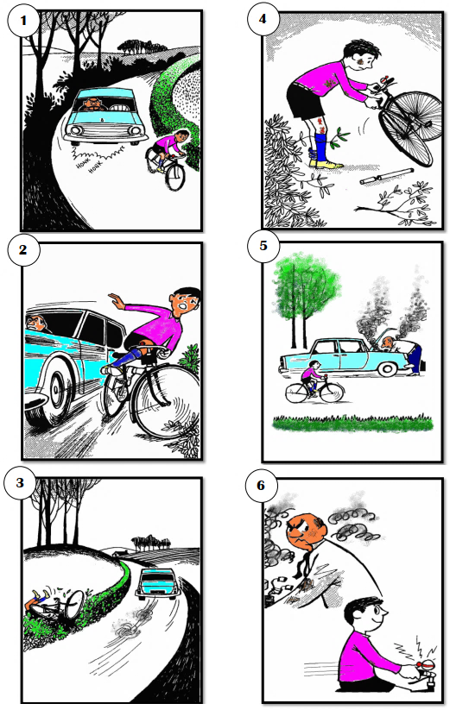

Tiger

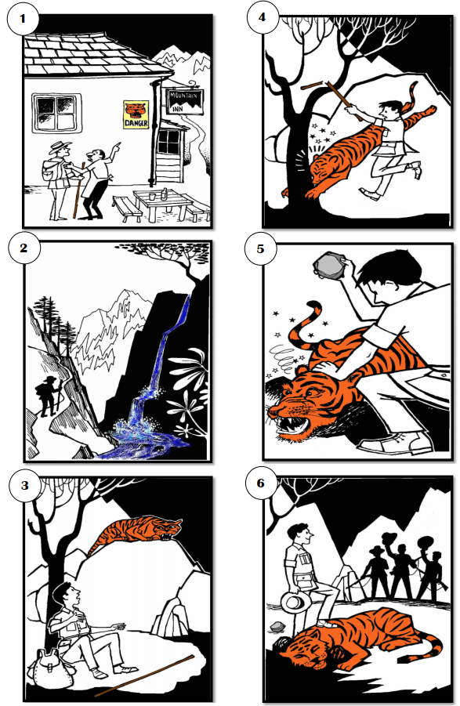

Race
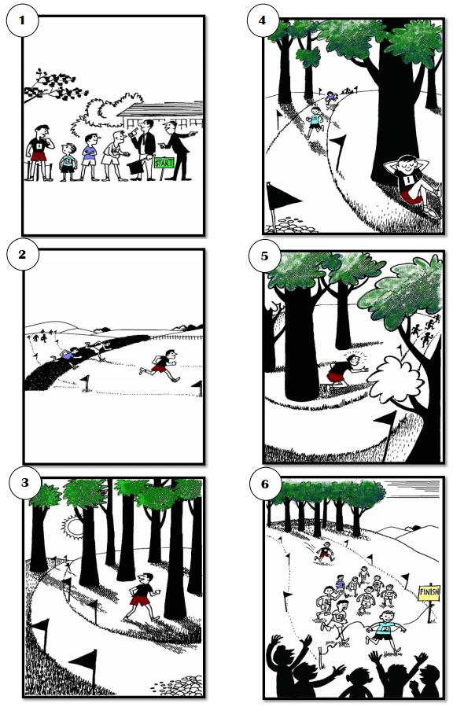

Pretest and Posttest Pictures
Street
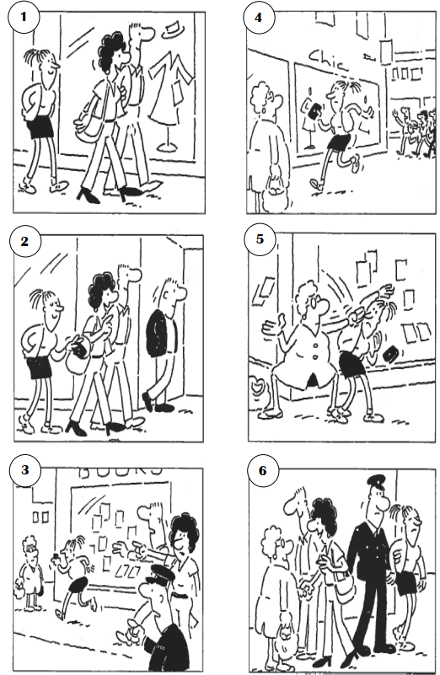

Airport
