Appendix A: Stimuli.
Word frequency (per million) is indicated in the parenthesis
Word (frequency) | Non-word | NSYL | Word (frequency) | Non-word | NSYL
scoff (0.42) | snoff | 1 | osmosis (0.3) | osnosis | 3
graph (0.76) | glag | 1 | median (0.4) | fedian | 3
slope (3) | sloge | 1 | isotope (0.5) | itrophope | 3
flash (15.66) | prash | 1 | electron (0.74) | elestron | 3
mass (17.6) | fazz | 1 | piracy (0.82) | caracy | 3
solve (19.88) | bolve | 1 | density (1.46) | densimy | 3
rope (23.16) | wope | 1 | advertise (1.68) | adverbise | 3
square (32.4) | smare | 1 | transparent (1.84) | cransparent | 3
strength (37.66) | prength | 1 | vertical (2.82) | verchical | 3
gas (69.14) | nas | 1 | institute (3.32) | instipute | 3
fight (205.1) | zight | 1 | triangle (4.36) | triamble | 3
right (4088.56) | pight | 1 | classical (4.48) | brassical | 3
vertex (0.04) | verpex | 2 | creation (6.2) | breation | 3
tantrum (0.9) | tancrum | 2 | develop (9.8) | demelop | 3
axis (1.62) | axip | 2 | pacific (9.86) | pashific | 3
index (2.12) | inrex | 2 | absolute (11.54) | absotute | 3
domain (2.64) | donain | 2 | critical (12.5) | crimical | 3
atom (2.8) | abom | 2 | capital (12.96) | zapital | 3
bagel (3.12) | vagel | 2 | oxygen (14.16) | oxyten | 3
carbon (5.34) | darbon | 2 | reaction (16.6) | reaption | 3
reserve (7.32) | resherve | 2 | occasion (16.88) | offasion | 3
auction (9.08) | augren | 2 | exercise (18.08) | exergise | 3
acid (10.16) | anid | 2 | collection (18.52) | rollection | 3
function (11.3) | sunction | 2 | interrupt (19.1) | inferrupt | 3
circle (21.94) | fircle | 2 | victory (21.88) | nictory | 3
rescue (25.92) | reslue | 2 | vacation (33.46) | macation | 3
garden (27.08) | garpen | 2 | energy (33.56) | enerfy | 3
remain (33.88) | relain | 2 | concentration (5.64) | concenpration | 4
master (89) | masber | 2 | universal (5.98) | cuniversal | 4
power (152) | chower | 2 | original (28.8) | osiginal | 4

Appendix B: The close and far distances of the two speakers used in the experiments
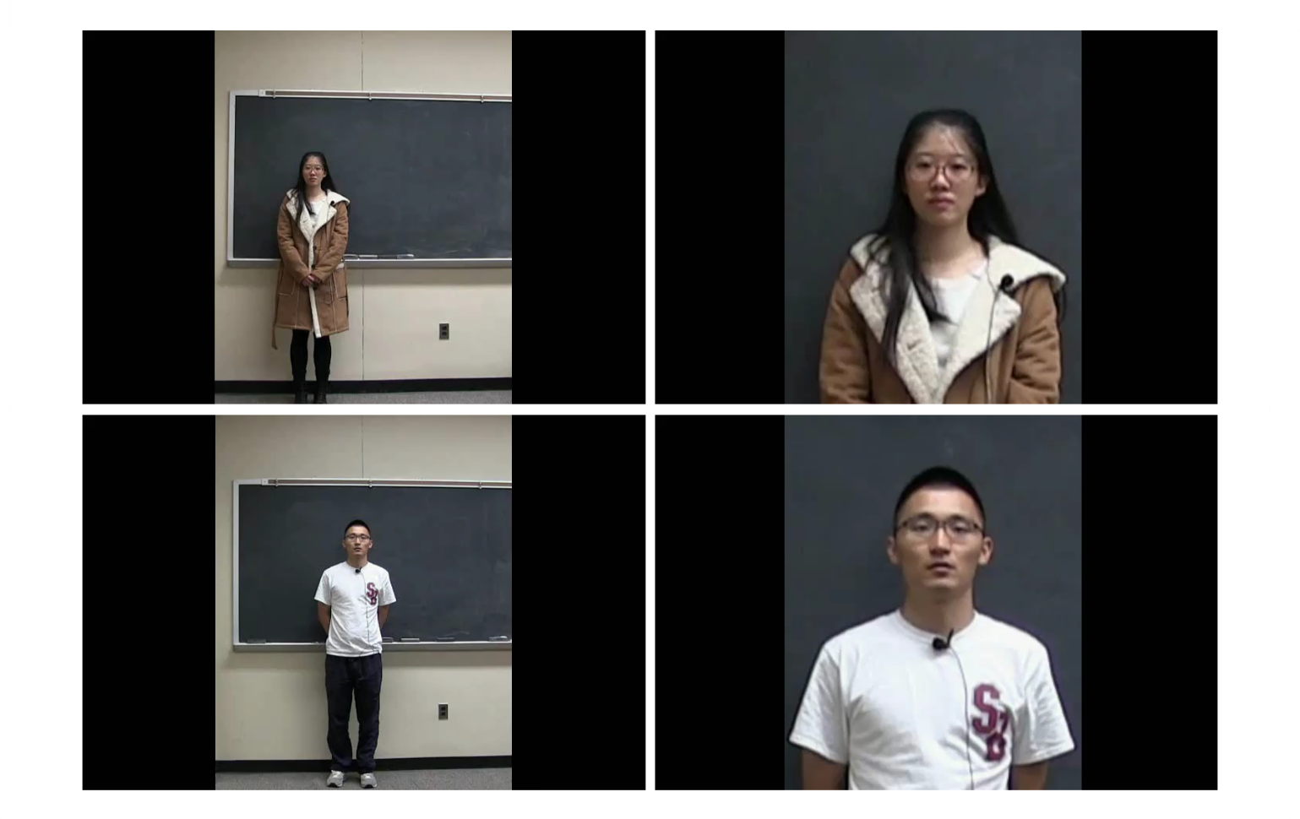

Appendix C
ITA Experience Questionnaire
- Your native language/first language is ________________
- Year (circle one): Freshman, Sophomore, Junior, Senior
- Have you had any international TAs/instructors/professors (i.e., people who speak with foreign accents)? Yes or No
- If your answer to (3) is yes, please indicate below which countries they are from (e.g. China, India, Russia, etc.):_____________________________________________
(5) Have you had any Chinese TAs/instructors/professors? Yes or No
(6) If your answer to (5) is yes, please list below in chronological order (starting from the most recent one) when, in what classes, and how often/much you heard them speak.
When  (e.g. Fall 2016) | What Class | How often: 0-5 (approximately how many days per week?) | How much: (how many hours per week?)

PS: In the second questionnaire, (1) - (4) was replaced by the following two questions:
(1) Do you have any exposure to Chinese accent (family members, friends, teachers, etc.)? Yes or No
(2) If your answer to (1) is yes, please indicate below how familiar you are with this accent (circle a number on the scale below).
1 (not familiar at all) —2—3—4—5 –6—7—8—9—10 (very familiar)

